Hw3 Engineering and Error Analysis with UIMA

1 Task 1

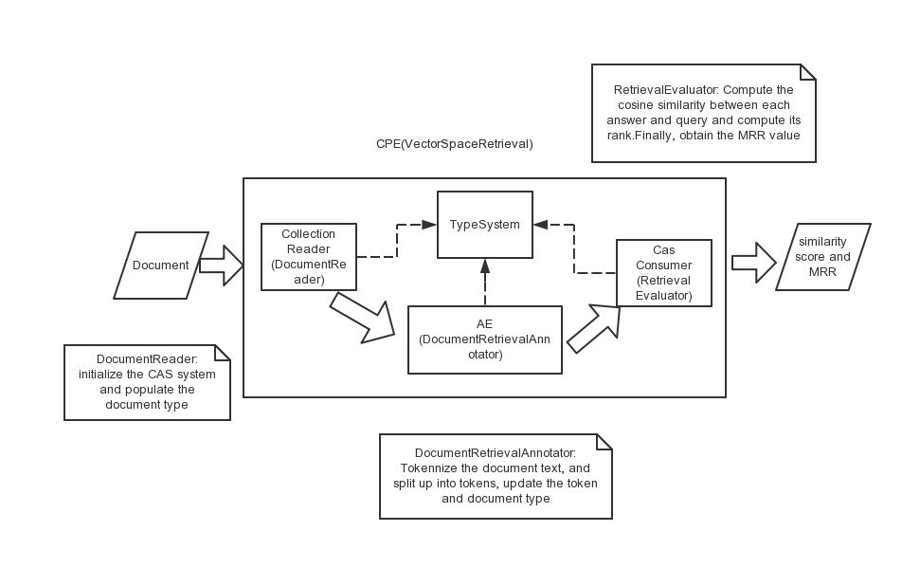
The System Framework(showed in the figure below) is consist of four main components and they are implemented by the following java class.

CPE: VectorSpaceRetrieval.java
CollectionReader: DocumentReader.java.
It reads file and splits each sentence into some parts in order to fill up the properties of document and update CAS.
Annotator: DocumentVectorAnnotator.java.
Here, I use HashMap to store the tokens and their frequency. By reading each document text, I compute the times that each token shows up. Then, I construct a vector of tokens and update the tokenList in CAS.
CasConsumer: RetrievalEvaluator.java.
This is the heart of the whole system, where I calculate cosine similarity between the query and its answer, find out the rank of the given answer sentence with relevance 1, and compute the MRR with all of the ranks.
Here are two main functions that is the processCas(), and collectionProcessComplete(). Because the pipeline processes one CAS at a time, I store data in memory as some private variable members, like query id number list, text relevant values list, rankList storing ranks of each answer with relevance 1.

Here is a flow chart of logical design of processCas() method.

In collectionProcessComplete(), I calculate the final MRR of all the ranks in the rankList.
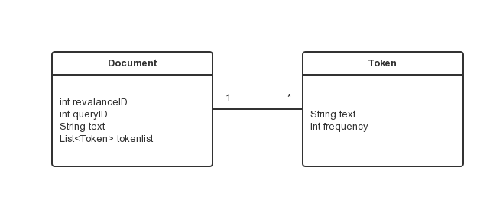
TypeSystem: Token.java, Document.java. Here is a class diagram for the type system.
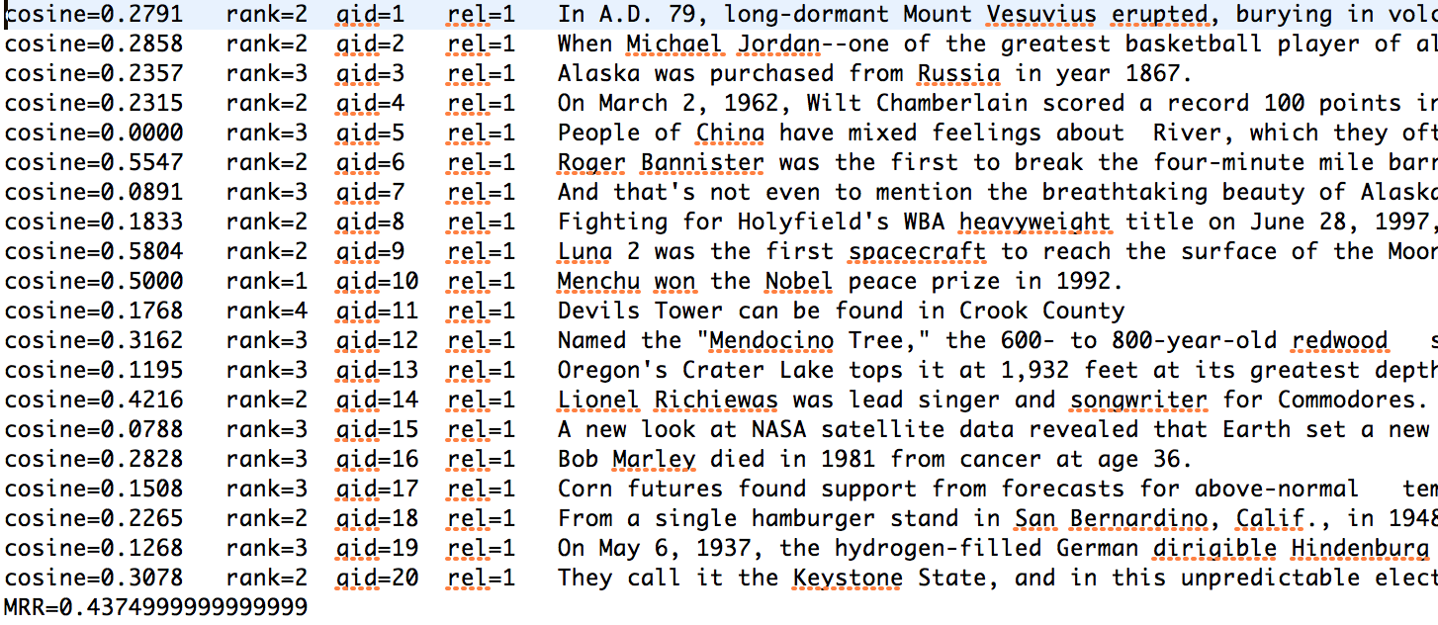
Above is the report results: MRR=0.43749999

2 Task 2 Error Analysis

The following table is a summary of error types.

3. Task 2 Improvements Based on Error Analysis

Based on these types, I camp up with improvements from three aspects.
Here is a table for Improvements.
Note: All the improvements could be checked in my github repository. https://github.com/eyrelzy/hw3-zhiyuel2.

1.Tokenize Improvement:
1) Normalize a token, case conversion:
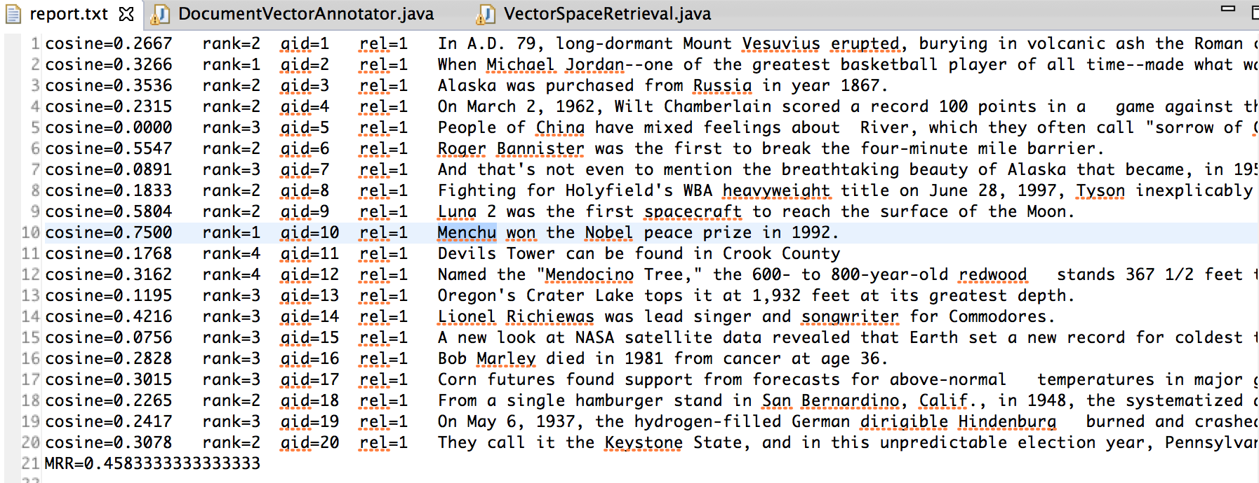
By doing so, MRR increases by 0.4583, three items’ rank increase, and even one successfully selects the most relevant answer.
For exmple:
qid=10 rel=99 Who won the Nobel Peace Prize in 1992?
qid=10 rel=1 Menchu won the Nobel peace prize in 1992.
After turning all the letters into lowercase, query 10 selected the gold answer.

2) Remove ’s and s’ :
Increase two ranks, and hit three gold answers. However, this could also introduce some errors because of the part of speech difference for each word, for example, in general and general’s have different meanings, and we should distinguish them.
i.e. qid=18 rel=99 Where was the first McDonald's built?
Removing “’s” from helps generate a key word “mcdonald".
3) improve punctuation like “,” in token “1823,”:
It enhances 8 ranks, also hit 7 gold answers.
i.e. qid=18 rel=99 Where was the first McDonald's built?
Removing “?” from helps generate a key word “built".

4) misspelling like more than one white spaces:
Trim the text first, and also remove whose length is zero.
i.e. qid=19 rel=1 On May 6, 1937, the hydrogen-filled German dirigible Hindenburg burned and crashed in Lakehurst, N.J., killing 35 of the 97 people on board and a Navy crewman on the ground.
There are more than one spaces between the words in red.

2. Stemming Improvement:
- Given stemming method:
After using the given stemming method, it improves the MRR value due to correcting some morphological variants errors since it enables a broader range of queries to (correctly) match.
i.e. here purchase has morphological variants.
qid=3 rel=99 In which year did a purchase of Alaska happen?
qid=3 rel=1 Alaska was purchased from Russia in year 1867.

After stemming, we have the following sentences.

in which year do a purchase of alaska happen?
alaska be purchase from russium in year 1867.

However, it also lower someone’s rank, such as the 18 query. And the reason is this approach also helps other less related answer increase its cosine similarity.

What’s more, I found out that the given method could not break down an entire compound as two tokens. i.e. “super_testers” will be considered as “super”. Based on this, I made a slight change in the code by splitting up the compounds into separate tokens. (See the comment of deal with compound, to split up into two words in DocumentVectorAnnotator.java)

Another disadvantage is that some morphological variants should not be removed in order to avoid the misunderstanding of sentence. Here is an example.
• “Apple iPods are the new...”Apple
• “Apple picking season has ...” apple
• “Apples are popular food ...” apple
• “Apple sales were up in May.” ✍ apple or Apple
Therefore, stemming is expected to improve when users are tolerant of stemming mistakes because there are so many relevant documents. What’s more, a good stem must be context-dependent, but it is too expensive to do when processing many documents.

2) Remove stop words

Stop words: Words that are discarded from a document representation.
• Typically function words: a, an, and, as, for, in, of, the, to, ...
By removing stop words, we could reduce index size significantly thus improving retrieval accuracy.

Nevertheless, it also has disadvantages.
Discarding stop words makes some queries difficult to satisfy, like “What is the keystone state? “. If we remove the stop words, it leaves only keystone and state. In this case, if the gold answer is quite long, its cosine similarity must be small.
Some other examples like “let it be or not”, will even leave nothing to retrieve. You can see from its results that the MRR value REDUCES to 0.6500.

An increasingly common solution to this problem is to discard stop words from queries and occasionally leave them in the query if they are more than half the query terms or if user indicates that they should be retained. I’ve implemented this rule in this system, results of the given dataset show no difference by doing so, but I believe it do works in a bigger and complicated query set.

Another thing is about the stop word lists, which is always created manually. And the retrieval results also depend on its quality.

As for the given stop word lists, we could see some words like which, what, when, and they frequently appears in the query. In this case, if we remove them according to the rules for stop words, we would misunderstand the meaning of the query document, in a broad sense, it will lead to bad retrieval results.

3) Decompound: Split up compound into several words
By doing so, it increase some cosine similarity value and even higher its rank. For example, there is term “Jordan—one” in the second query sentence, and this approach increases its cosine to about 0.02. And I also successfully divided the following compounds.
[long, dormant]|2
[nba, record]|2
[169, 147]|2
[four, minute]|2
[4, minute]|2
[cool, think]|2
[800, year, old]|3
[370, foot, tall]|3
[singer, songwriter]|2
[above, normal]|2
[fast, food]|2
[hydrogen, fill]|2
[hindenburg, class]|2
The MRR value reaches 0.675 after accumulate all the methods and tricks above.
3. Better or different similarity measures:

1)Dice coefficient and Jaccard coefficient
Actually, they are quite similar to the cosine similarity. They are not metric.

2)unnormalized TF-IDF
As for the methods above, all terms are treated as equally important. TF-IDF introduces an idea of adding weight to some terms. Here is how we calculate normalized TF-IDF, and I implemented one removing the normalization. It is meaningful for some cases like the second query, since it increase its rank by increasing the weight of some query key words only show up in itself. Also, this unnormalized method partly solves over long length issue. And we could see a lot of gold answer document with a long length, which gives rise to its bad rank if using normalization.
However, we could see a lot of zero similarity values, which means it has no words included in the query document. In this case, this method could not be a suitable one for this dataset. What’s more, results showed that the high MRR is due to using the trick that highest relevant document has rank higher than others with the same similarity.

Further looking into the intermediate results, I found that some answer could hit because all of the candidate document has the same tf-idf value and according to our trick about tie that if we have two document with the same similarity value, we give our gold answer with a higher rank. So, I believe this tf-idf method is somewhat overfit for this dataset.
Based on this overfit issue, I slightly change the formula of calculating the tf-idf value by adding one to the idf value, and get a more reliable result by successfully removing some ties.

2)BM25

BM25 is a bag-of-words retrieval function that ranks a set of documents based on the query terms appearing in each document, regardless of the inter-relationship between the query terms within a document (e.g., their relative proximity). Here is its score metric.
After utilizing this approach, I obtained the following results.
Observing its results shows its IDF doesn’t give a positive impact on the dataset.
Furthermore, since there are several methods to calculate the IDF, this inspired me I added one when calculating the IDF. After that, MRR reaches 0.7823, and we have hit 12 correct selected documents.

Why this have a good result?
- every word has a weight
- it considers the length of a document
- tie rule
Since I still found out some pseudo good results based on our tie rules, I tried to slightly change the formula and makes it more reliable. What I found out is that the parameters in the formula is quite important to fit this dataset.
Here is the result of various parameters for the BM25 formula.
Although, I didn’t see any change if slightly adjusting the parameters, I found out that the score changes, and the k1=2.0 makes the least number of ties.

3) cosine similarity
Finally, I returned to the cosine similarity approach. Here is the results after removing the unrelated punctuations and using stem function. There is almost no tie, and the results is more reliable.
4) evaluate the above three methods by p-value:
In statistical significance testing, the p-value is the probability of obtaining a test statistic result at least as extreme or as close to the one that was actually observed, assuming that the null hypothesis is true. A researcher will often "reject the null hypothesis" when the p-value turns out to be less than a predetermined significance level, often 0.05. Such a result indicates that the observed result would be highly unlikely under the null hypothesis. It is quite similar to other statistical method like, student’s t-test.
Here is a statement of how math lab compute the p-value. x,y is the vector of the score value o calculated by each method in the report file.
x=[6.5785, 12.8259, 8.0089,…..,6.5224]
[h,p,ci,stats] = ttest2(x,y)

From its result, I know that the p-value for every two methods is more than 0.5, so I could say that we could not know the reality of these results.

4.Follow-up Thoughts for Improvement:

1.Provide a inverted lists:

The above methods have not considered the relative position two words. For example, some disturbing candidate words have a good result only if they show up. However, they might in a meaningless order.
i.e.
Does Mary love John?
answer 1: Mary loves John.
answer 2: John loves Mary.
If we use the mentioned measures to score, we will have the same score for these two answers. However, they are actually quite difference from the meaning perspective.
To improve this, we could store an relative position for each candidate token. For example, they those three tokens exist in two answers, we rank the first one higher because the tokens have an order the same as the query.
Another problem also comes up if we are doing so, like John is loved by Mary. In this case, although the order is different, it still should be considered as the correct answer. Based on this, we need a smarter stemming method that should think of this condition when turing “loved” to “love”.

2. Morphological variants mismatched issue:

i.e.
qid=13 rel=99 How deep is Crater Lake?
qid=13 rel=1 Oregon's Crater Lake tops it at 1,932 feet at its greatest depth.
From this example, we could see that deep could not be consider the same as depth based on our methods. Because the stem method only care about some morphological variants like tense variants. And it could not recognize token like depth and deep as the same.
3. Vocabulary mismatched issue:

- paraphrase: By scanning the datasets, I found out a lot of gold answers has tokens paraphrasing those in its query document.
For example.
qid=9 rel=99 What was the first spaceship on the moon
qid=9 rel=1 Luna 2 was the first spacecraft to reach the surface of the Moon.
However, our temporary approach could not recognize tokens with the same meaning. What’s more the meaning needs a context-based solution, which has a great cost.

2) Phrase Recognition Methods: Part of Speech Tagging
Different words might have the same meaning, while one word could have multiple meaning, and also many part of speech.
By storing each word’s part of speech information, we could partly put the token’s context into consideration.
i.e. I/NN love/VV this/NN great/JJ city/NN.

4. Formula and parameters Impact

There are several interpretations for IDF and slight variations on its formula. Slightly changing its formula like use log(term frequency)+1, or just use term frequency leads to various results. Some results are overfit for this dataset because of the tie rules.

What’s more, I noted that the formula for IDF that I used shows potentially major drawbacks since most of terms appearing in more than half of the corpus documents. These terms' IDF is negative, so for any two almost-identical documents, one which contains the term and one which does not contain it, the latter will possibly get a larger score. This means that terms appearing in more than half of the corpus will provide negative contributions to the final document score. This is often an undesirable behavior, so many real-world applications would deal with this IDF formula in a different way.

Again, in the calculation of BM25 derivation, the parameters of k1 and b value don’t make any change to the final result, but slightly changes each score.

5. Stem method introduce some drawbacks

With both stemming method and BM25, I have the following results if I didn’t remove “‘” for the “devil’” in each answer document. As you can see, it has four answers with the same score, and due to our tie rule, we make the the relevant one the highest.

i.e. devil tower can be find in crook county
to the west across the wyome border be the staggeringly beautiful devil' tower national monument
devil' tower be an igneous intrusion that rise dramatically 1267 foot (386 m) above the surround terrain
in 1941 petzoldt join other rock climber to rescue a maroon parachutist who have land atop devil' tower
what be the height of the tallest redwood
goldbm in gold query: -2.2809345280805604
answerbm in answer: -2.2809345280805604
answerbm in answer: -2.2809345280805604
answerbm in answer: -2.2809345280805604

After removing “‘”, MRR reduces because now every candidate could hit “devil”, and the each score slightly changes. But, I believe this result is more reliable for a common dataset.
6. misspelling

There are some errors because of misspelling.
i.e. qid=7 rel=0 Aaska is a U.S. state situated in the northwest extremity of the North American continent.

Based on this, I tried to use lingpipe’s spelling corrector. I used the given model, and found out it would not have a better performance for the misspelling words in our document. Here is the results. I also tried to add training documents into its dataset in order to obtain a new model. However, it still doesn’t improve.
You could check my github link https://github.com/eyrelzy/hw3-zhiyuel to see how lingpipe’s corrector works.

7. normalization and unnormalized
I found out an interesting intermediate results that although our gold answer has more words matched, but still got a low rank because of over long length. In this case, we could consider other ways instead of normalization, like Pivoted Document Length Normalization.

8. These mentioned methods all have not thought of the meaning of the query and its answers.
To improve this, we need some methods based on the context. For example, if the query asked for “when”, we could give a bigger weight for answer containing “in” or numbers like ”1967”. However, although it will have a good result for those queries that are asking something, this method is likely to be overfit to those dataset.

5 Reference

1.BM25:
http://en.wikipedia.org/wiki/Okapi_BM25
2.LingPipe spelling corrector
http://alias-i.com/lingpipe/demos/tutorial/querySpellChecker/read-me.html
3. p-value
http://en.wikipedia.org/wiki/P-value
4.TF-IDF
11-442 / 11-642 search engine courseware

