BPMs versus SVMs for Image Classification

Gang Wu

Department of Electrical and
Computer Engineering, UCSB
gwu@engineering.ucsb.edu

Edward Chang

Department of Electrical and
Computer Engineering, UCSB
echang@ece.ucsb.edu

I lost the name of that co-author.
Please add his address here!

IBM

Abstract

The Bayes point machine (BPM) has been theoretically demonstrated to have better learning ability than the Support Vector Machine (SVM). In this paper, we describe these two machines and tell how they differ. We empirically compare the performance of the BPM and the SVM on an image dataset. We conclude that the SVM is more attractive for the image classification task because it requires a much shorter training time, despite the fact that the BPM achieves slightly higher classification accuracy.

1. Introduction

Being able to classify images efficiently and accurately is important for effective image organization and retrieval. Achieving high accuracy, however, is quite challenging. This is partly because images are diversified (each can be characterized by a large set of different features), and partly because semantically related images may not reside contiguously in the feature space, and thus, may not be linearly separable.

In this paper, we focus our study on image classification methods. In particular, we compare the performance of two kernel machines in image classification: the support vector machine (SVM) and the Bayes point machine (BPM). The SVM is a kernel machine based on the statistical learning theory, pioneered by Vapnik [2,3,4,10,11]. We might think of the SVM as an alternative training technique for Polynomial, Radial Basis Function and Multi-Layer Perceptron classifiers, in which solution for the weights of network is treated as a quadratic programming with some constraints. As an approximate implementation of the structural risk minimization, the SVM shows many nice properties, such as good generalization performance. So it has been widely used for pattern classification and nonlinear regression.

In the case of separable patterns, the SVM constructs a hyperplane as the decision surface by maximizing the margin between positive and negative examples. According to [2,3,4,10,11], the error rate of a learning machine on a test point is bounded by the sum of the training-error rate and a term that depends on the Vapnik-Chervonenkis (VC) dimension (details are discussed in Section 2.1).

Recently, Gaussian processes have been used for classification. This scheme, based on the Bayesian learning theory, considers learning as an optimal sampling and voting procedure on the Bayesian posterior. With this background, the BPM was proposed by Ralf Herbrich [6,7] to approximate Bayesian inference for linear classifiers in a kernel space. In contrast to the SVM, according to [6,7], the BPM constructs the hypothesis (functions to map input vector x to its corresponding output y) using the whole version space (a space of all consistent hypotheses given a training set) and find the center of the region bounded by all hyperplanes, each of which bisects the feature space. This center is known as the Bayes point. This classifier (the Bayes point) could be approximated by the center of mass [12], which Ralf [6,7] proposed to estimate by using both a dynamic system that averages over the trajectory of a billiard ball bouncing in version space, and an approximate method that uses the perceptron algorithm trained on permutation of the training set (details are presented in Section 2.2).

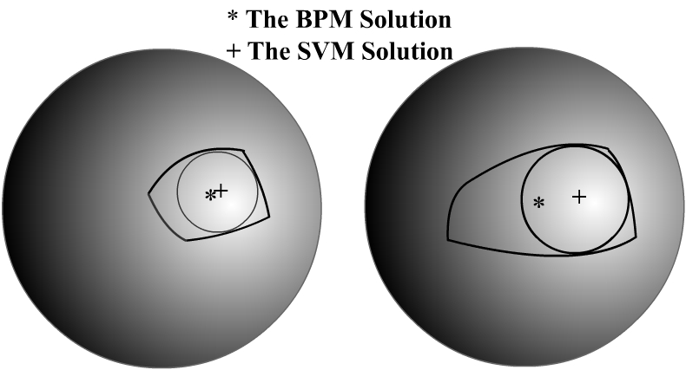

Figure 1: Version spaces of two 3D toy datasets. From the Bayesian perspective, one can see that the SVM approximates the Bayes point (the star symbol, trained by the BPM) by the center of the largest inscribable ball (the addition symbol) in the version space. The SVM could be way off the center-of-mass.

According to [1,6,7], the ideological clash between the SVM and the BPM stems from the disagreement between Bayesian and frequentistic statistics. However, from a Bayesian perspective, the support vector machine can also be viewed as a kind of approximation for the center of mass in the version space [6]. The SVM chooses the hypothesis by maximizing the minimal distance (margin) of examples from the hyperplane. For a classifier in the version space, the margin of examples is the distance of the classifier from its closest boundary. So the maximal margin is just the radius of the largest inscribable ball of the version space. Meanwhile, Ralf [6] found the support vectors are just the training points at which the largest inscribable ball inscribes the boundaries of the version space. Compared with the BPM, which uses the whole version space to construct the hypothesis, the SVM would obtain unreasonable classifiers if this inscribable ball could not cover most volumes of a version space. Figure 1 illustrates this key difference.

The rest of the paper is organized into three sections. Section 2 presents and contrasts the SVM and the BMP. Section 3 presents the experiment setup and results. In Section 4, we offer our concluding remarks.

2. SVMs & BPMs

In this section, we present the SVM and the BPM. For detailed treatments of these two learning machines, please refer to [2,3,4,10,11] for the SVM, and [6,7] for the BPM. In the following subsections, we consider the task of classifying training data 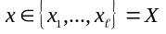 into one of the two classes 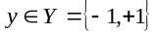 using functions 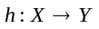 from a given set known as the hypothesis space.

2.1 The Support Vector Machine

Let us start with the simplest form. Suppose X is linearly separable. The goal of an SVM is to find the optimal hyperplane that separates the training data by a maximum margin (see Figure 2). The data vectors that lie closest to the optimal hyperplane are called support vectors, hence the name “support vector machine.” These vectors are the most difficult to classify, but they have a direct bearing on the optimum location of the decision surface.

Now let us extend the operation to the non-linearly separable cases. The SVM projects these training vectors into a high-dimensional feature space F using a kernel function 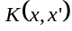 that defines an inner product in this feature space. Then it constructs an optimal hyperplane for separating the features in the projected space. Then its hypothesis space can be formulated thus:
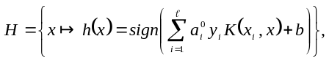 (1)
where the coefficients 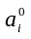 are obtained by maximizing the following functions:
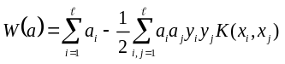, (2)
under the constraints of
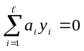 and 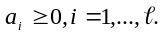, (3)
where are positive Lagrange multipliers introduced for solving the primal problem for the non-separable cases [10,11].
The coefficients define a hyperplane with the maximal margin in F where the data are mapped through a non-linear function such that 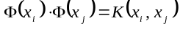. Then we can write the optimal h as 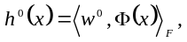

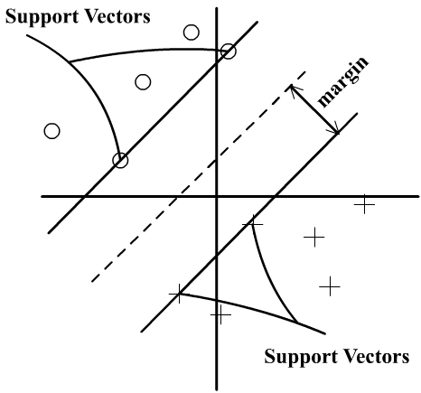

Figure 2: Illustration of a linear support vector machine

where 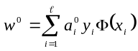 is the optimal weight vector. Commonly used kernel functions include a polynomial kernel 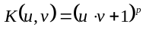, a radial base function kernel 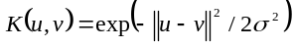, and a two-layer neural network kernel 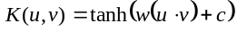.

One interesting and notable phenomenon found by Herbrich [6,7] is that 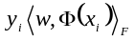 can also be read as the distance of w from the hyperplane with normal 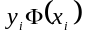 if 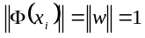. Therefore the task of the SVM can be viewed as finding the center of the largest hypersphere inscribable in the version space (Figure 1).

2.2 The Bayes Point Machine

The BPM approaches the task from the perspective of the Bayes classification strategy. In contrast to the work of the SVM that results in the choice of a single w, the BPM “votes” for the outputs of all valid solutions over the volumes of version space V(z). Let’s consider the above classification task again to see how the BPM works. In order to be consistent with Herbirch’s paper [6], we use the same notations with [6]. Let’s denote the training set by 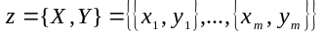, size of z by m.

2.2.1. The Bayes Solution & Bayes Point
The Bayes solution for classification aims to assign a new test data x to the class y with the minimal expected loss, weighted by its posterior probability 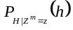:
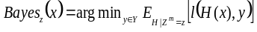, (4)
where the loss function is defined by 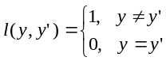.
Basically, the Bayes solution depicted in Equation (4) is the optimal for classification. However, it’s generally impossible to find a unique hypothesis 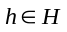for the Bayes solution. Herbrich [6,7] suggests requiring the classifier to lie within a fixed hypothesis space , and then finding a classifier which is the closest to the Bayes solution (4) when given a complete knowledge of x.

At this time, we can approximate 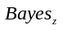 by the following algorithm:
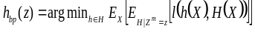 =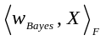 (5)
The classifier 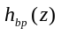 is called the Bayes point, which approximates best the 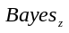. Here, 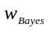 is the weight vector of .

2.2.2 The Center of Mass
Computing Equation (5) requires knowing the input distribution 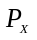, which is hard to obtain. Fortunately, for that two-class classification task mentioned above, Herbrich [6] suggests a way, under the assumption of 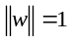, the center of mass in V(z), which is
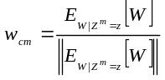, (6)
can be used as an very good approximation to the so-called Bayes point 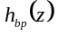 (In [6,7], Herbrich synonymously call 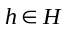and 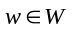a classifier because they have a one-to-one correspondence). It also means we can achieve the optimal weight vector by calculating the 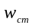. Therefore, the main task of the BPM algorithm is to calculate the center of mass .

2.2.3 Billiard-like Algorithm
In order to calculate the center of mass, Herbrich [6,7] suggests a first-order Markov chain to compute the expectation in Equation (6), which is approximated by uniformly sampling weight vectors w in V(z) and then averaging them. However, it’s very difficult to sample uniformly from version space V(z) because this set of points exits on a convex polyhedron on the unit sphere. Herbrich [6] presents two algorithms that try to achieve this sampling.

The first method is based on a billiard-like algorithm [8,9]. After entering the version space with a perceptron or the SVM algorithm, the classifier is envisioned as a billiard ball that is bounced for a while within the convex polyhedron V(z). Playing billiards in V(z) is possible because each training point 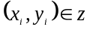 defines a hyperplane 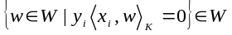 (see Figure 3). After N bounces of the billiard ball the Bayes point can be estimated by 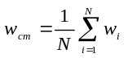. For more detailed description, refer to [6].

This billiard-like algorithm shows good generalization performance, but it suffers from large computational demands. Herbrich [6] suggests that we be content with

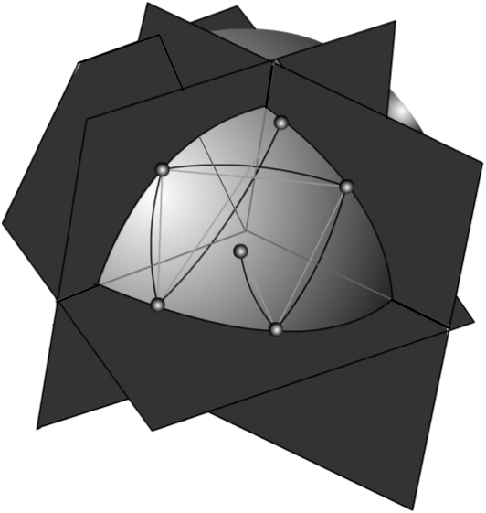
Figure 3: Illustration of the kernel billiard algorithm. Each small ball represents the estimate 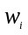 for the center of mass in each bounce step. The final is obtained by averaging all these estimates.

an approximately uniform sampling of version space. This approach is based on the fact that each classifier in the V(z) is optimal. So it uses the perceptron algorithm to obtain different classifiers w simply by permuting the training set [12]. The center of mass is given by their average.

3. Experiments

We compared the learning performance of the SVM and the BPM for multi-class image classification by using the one-per-class (OPC) ensemble scheme, which is also known as ``one against others.'' OPC is simple and gives reasonable performance [5]. We train K classifiers, each of which separates one class from the other (K-1) classes. For each image, we have K decision outputs. Given a point X to classify, the binary classifier with the largest output determines the class of X.

For our empirical evaluation of our learning methods we used a 1,920 fifteen-category image dataset collected from Corel Image CDs and the Internet. The 1,920 images in this dataset belong to fifteen categories --- architecture, bears, clouds, elephants, fabrics, fireworks, flowers, food, landscape, people, objectionable images, textures, tigers, tools, and waves. In this set, a few categories were added to increase the learning difficulty for the SVM and the BPM. To make the landscape category more difficult to learn, we placed images of tigers and elephants on landscape and water backgrounds. Another difficulty was that the objectionable images could be confused with people wearing little clothing. We added colorful fabrics and food to interfere with perception of flowers. Various texture images (e.g., skin, brick, grass, water, etc.) were added to raise the learning difficulty for all categories.

We used two major types of features, color and texture. For color, we had 12 color bins for the 11 culture colors (black, white, red, yellow, green, blue, brown, purple, pink, orange, and gray) and one outlier bin. We characterized each color with color histograms, color mean ( in HSV channels), color variance ( in HSV

Class | SVM-OPC | BPM-OPC
Architecture | 12.0 | 11.3
Bears | 25.3 | 25.1
Elephants | 15.4 | 12.3
Clouds | 16.1 | 14.7
Fabric | 14.9 | 9.9
Fireworks | 6.5 | 4.9
Flowers | 8.7 | 6.8
Food | 7.8 | 6.5
Landscape | 21.2 | 19.8
Obj. Images | 4.9 | 4.1
People | 17.7 | 15.9
Texture | 3.5 | 3.4
Tigers | 8.5 | 6.8
Tools | 0.5 | 0.5
Waves | 13.9 | 10.4

Table 1. Error Rates of the OPC-SVM and the OPC-BPM (using 80% of dataset as training examples and running 10 times for each case to get an average error rate).

channels), elongation, and spreadness. Texture consisted of vertical, horizontal and diagonal orientations. For each orientation, we used texture energy mean, variance, elongation, and spreadness, giving us 12 texture features. For each of these, we extracted coarse, medium and fine texture features. Altogether, we had 108 color and 36 texture features.

To conduct our experiments, we chose an RBF kernel with 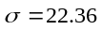 and sampled 80% of images for training. The remaining 20% of images were used as the test examples. We ran SVM-OPC and BPM-OPC each ten times and collected the error rates on the testing data. For the BPM-OPC, we fixed the tolerance TOL for termination of the BPM algorithm to 0.01.
Table 1 shows the error rates by OPC based on the SVM and the BPM. We can see that the BPM-OPC works better than the SVM-OPC for all image classes. The average error rate of the BPM-OPC was lower than that of SVM-OPC by about 1.6%. However, the training time of BPM-OPC is substantially longer than that of SVM-OPC. On a Pentium-IV workstation with 256 Mbytes DRAM, the wall-clock training time (one single run) for SVM-OPC was about 4 hours, while BPM-OPC took was about 12.4 hours.

4. CONCLUSION

In this paper, we have introduced two kernel-learning machines, the support vector machine (which is currently very popular for machine learning), and the Bayes point machine, a newly introduced learning tool. We have explained their working principles and compared their learning performance. We have shown that the BPM outperforms the SVM in classification accuracy on a multi-class image dataset. The performance gain was, however, marginal, while the BPM took substantially longer to train the OPC ensemble. We believe that an attempt to speed up the BPM training could very likely erase its slim advantage over SVM in accuracy. Therefore, we believe that the SVM is currently a more practical learning machine for image classification and retrieval applications.

5. REFERENCES

[1]. Aitchison, J. Bayesian tolerance regions (with discussion). Journal of the Royal Statistical Society – Series B, 26, 161-175.
[2]. Boser, B., Guyon, I., and Vapnik, V.N.(1992). A training algorithm for optimal margin classifiers. In Proceedings of the Fifth Annual Workshop on Computational Learning Theory, pp. 144-152.
[3]. Cortes, C. and Vapnik, V.(1995). Support Vector Networks. Machine Learning, 20, 273-297.
[4]. O.Chapelle, V.Vapnik, O.Bousquet, and S.Mukherjee. Choosing multiple parameters for support vector machines. Machine Learning, 2001. in press
[5]. K. Goh, E. Chang and T. Cheng, SVM Binary Classifier Ensembles for Multi-Class Image Classification, Proceedings of ACM International Conference on Information and Knowledgement Management (CIKM), pp.395-402, Atlanta, November 2001.
[6]. Ralf Herbrich, T alf Herbrich, Thore Graepel, and Colin Campbell. Bayes Point Machines. Journal of Machine Learning Research, 1:245-279,2001
[7]. Ralf Herbrich, Thore Graepel, and Colin Campell. Bayes Point Machines: Estimating the Bayes Point in Kernel Space. In Proceedings of IJCAI Workshop Support Vector Machines, pages 23-27,1999
[8]. P. Ruján and M. Marchand. Computing the bayes kernel classifier. In Advances in Large Margin Classifiers, pages 329-348. MIT Press, 2000.
[9].Pàl Rujàn. Playing billiard in version space. Neural Computation, 9:99-122, 1997
[10]. V. Vapnik. The Nature of Statistical Learning Theory.
[11]. V. Vapnik. Statistical Learning Theory. John Wiley & Sons, 1998
[12]. T. Watkin. Optimal learning with a neural network. Europhysics Letters, 21:871-877, 1993

