Morpho Software Inc.
3944 State Street, Suite #340
Santa Barbara, CA 93105 USA
Tel: 805-569-9022
Fax: 805-569-5382
URL: http://www.morphosoft.com

Perception-Based Image Search Engine (PBIR)

December 2001
Market Need
According to a recent white paper on visual search technology:
- 80 billion new images are created each year.
- There are currently over 1 billion images on the Internet related to commercial transactions, and that number is predicted to grow to 10 billion by 2003.
- Approximately $13 billion was lost by online businesses in 2000, due to frustrated customers not finding what they were looking for.
- The total market for visual search engines in 2005 is estimated to be at least $11 billion.
Given these facts and figures, it is clear that a visual search engine that allows users to effectively, efficiently and accurately search the Web (and other databases) for images is needed. Currently there are image search engines available; however, even a high-level analysis of these solutions makes it obvious that they are neither effective, efficient nor accurate. For example, most of these solutions rely on keyword searches. In other words, a user looking for a picture of a tiger would type the word “tiger” in a search field, and the search engine would return all pictures that have been identified – through a laborious manual process - with that label. Not only can this return literally thousands of results, but also it limits searches to one language (usually English). In addition, many engines using this method require formal query languages, which an average user is not trained to know or understand. And last but not least, different users may use different vocabulary to describe the same image (e.g., “tiger,” “wild cat,” “Siberian Tiger,” etc.).
There are a few visual search engines that rely on content-based information retrieval as a way to solve the aforementioned problems. In this case, a user selects a picture that is similar to what he/she is looking for, and the engine “matches” it to other similar pictures, based on pattern recognition. Yet this method has its own problems and drawbacks. First of all, there is the issue of the original sample picture – where does it come from? If the user has to provide that sample, he/she probably already has the picture he/she is looking for. More serious is the subjectivity that is involved in this matching process. In most cases, the search engine analyzes the picture selected on three or four low-level attributes (e.g., color, texture, shape), and makes a decision as to which pictures are the most like the original. But how does the engine know what it was – color, shape – about the original that the user is trying to match? Perhaps he/she liked the profile picture of the tiger (to continue with the above example), or perhaps he/she liked the idea of many tigers running against a sunset. Because of this, content-based image searching does not actually provide much of an advantage over text-based, and still leaves room for great improvement.
Product Description
Using patent-pending intelligent learning algorithms, our Perception-Based Image Retrieval (PBIR) engine figures out users’ query concepts and thus captures subjective impressions (e.g., color, texture, composition). In other words, our product actually learns what users are – and aren’t – looking for, based on their feedback, which helps them find the images they desire much faster and much more easily. While not necessary, the system can be integrated seamlessly and synergistically into an existing keyword-based image search to help that process along as well. For example, a user selecting “tiger,” would get several – but not thousands – of potential matches. Based on his/her feedback – both positive and negative – to those matches, the product analyzes what it is that the user is looking for, and brings back another iteration of results. This can continue until the user is satisfied or changes his/her preferences (something that cannot be done easily in content- or text-based searches). In preliminary testing, we have discovered that within 3-4 iterations a match usually results. Furthermore, our image retrieval technologies have been recognized by top researchers in the field as “by far the best image search engine and one generation ahead of any other products on the market.”
Product Demonstration
The following example simulates the steps Morpho’s PBIR undertakes when a search is performed. To represent the versatility of the product, we have presented two query scenarios:
- Image browsing: In this situation, a user knows what he/she wants but has difficulty articulating it, and PBIR must learn the user’s preferences through an interactive browsing session.
- Similarity search: Once/If PBIR has determined what the user is looking for, it can perform a traditional similarity search to find data objects that appear similar to that object.
The interactive query session below involves both scenarios, in succession. For this example, the “user’s” concept (which he/she cannot articulate) is “Sports Hat.” (The images in this database are auction items that appear on Ebay under the keyword “Hat”.)

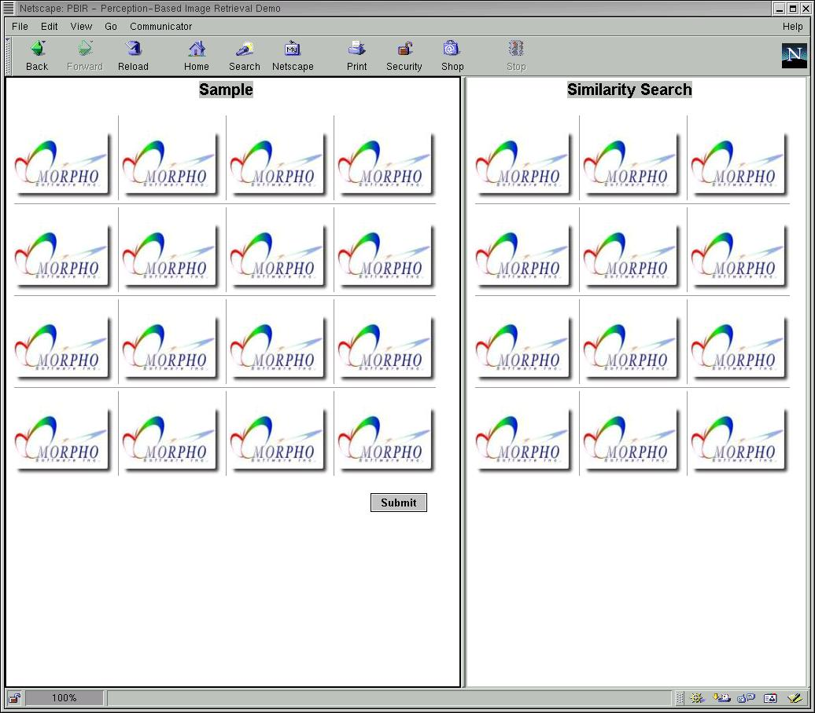
Screen 1: Initial Screen. Our PBIR system presents the initial screen to the user as depicted in this figure. The screen is split into two frames vertically. On the left-hand side of the screen is the learning frame (titled Sample), and on the right-hand side is the Similarity Search frame. Through the learner, PBIR determines what the user wants via an intelligent sampling process. The Similarity Search frame displays what the system thinks the user wants. (The user can set the number of images to be displayed in the frames.) This initial screen can be integrated with a text search engine so that the user can enter a keyword to start the process.
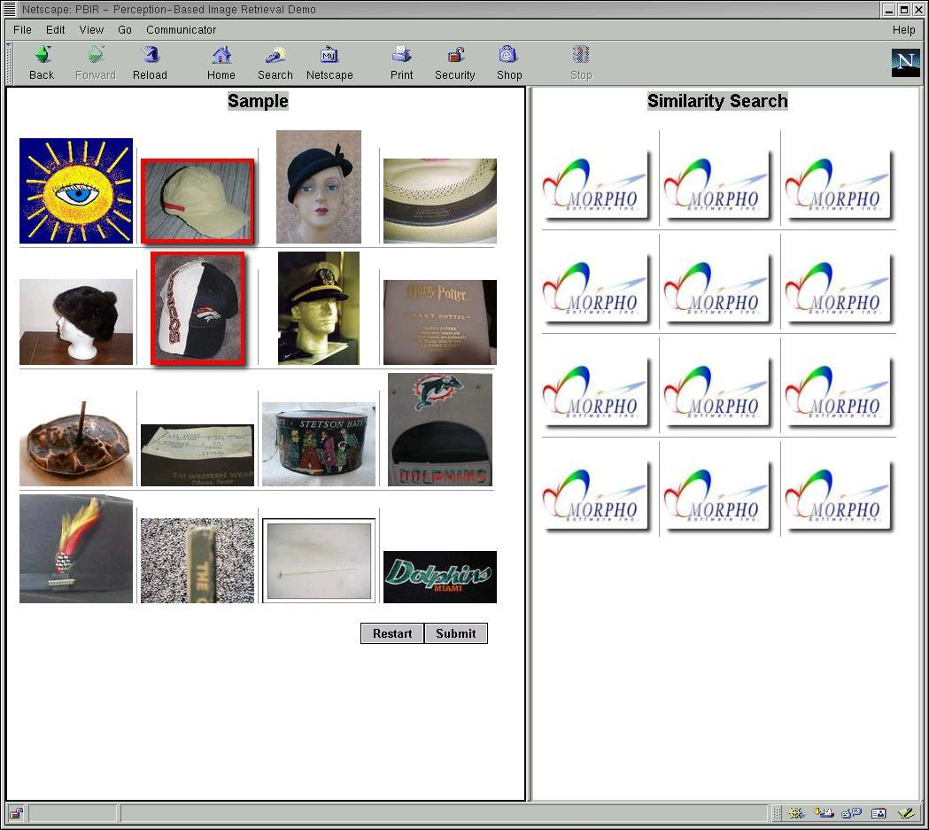
Screen 2: Sampling and Feedback Screen. In this screen, the sampling and relevance feedback starts. Once the user clicks the “submit'” button in the initial frame (above), the sampling and relevance feedback step commences, which enables the PBIR to learn what the user is looking for. The system presents a number of samples in the learner frame, and the user highlights images that are relevant to his/her query concept by clicking on images. As shown in this figure by the red outlines, the user select two images (the 2nd image in rows one and two in the learner frame) as relevant, and the rest of the unmarked images are considered irrelevant. The user indicates the end of his/her selection by clicking on the submit button in the learner screen. This action brings up the next screen.

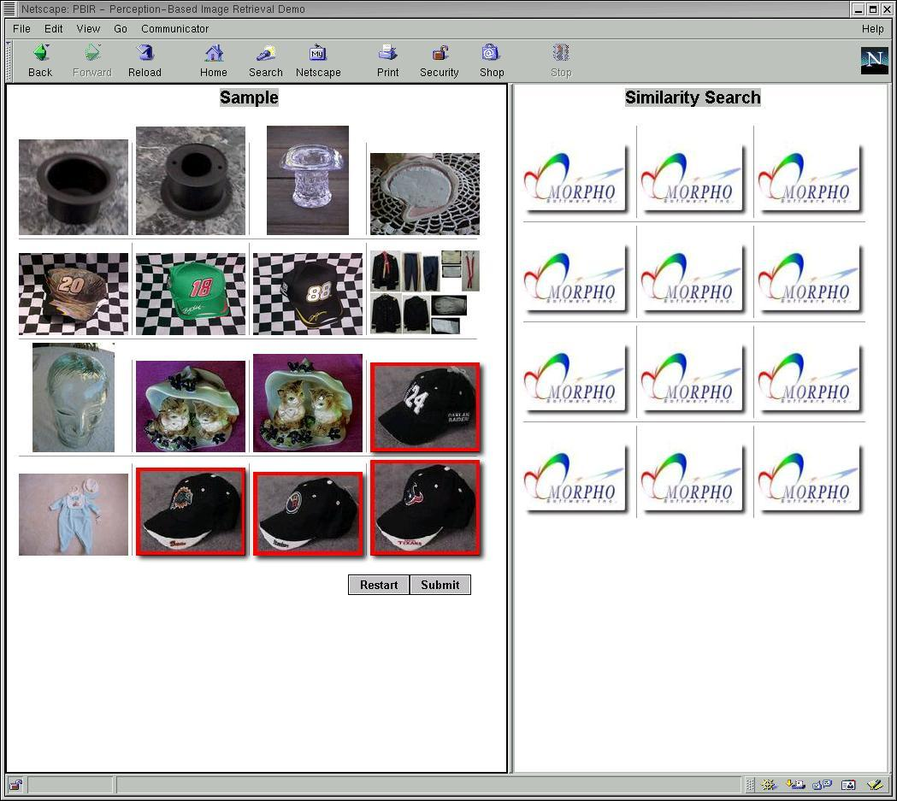
Screen 3: Sampling and Feedback Screen. At first, the Similarity Search frame does not show any images, since the system has not yet been able to grasp the user's query concept. The PBIR system again presents samples in the learner frame to solicit feedback, as in the previous screen. The user selects four images (4th image in the 3rd row and 2nd, 3rd and 4th images in the 4th row) as the images relevant to the query concept “sports hat.”
Screen 4: Sampling and Feedback Screen. After the second feedback iteration, the Similarity Search frame displays what the system thinks will match the user's query concept thus far. As you can see in the figure, even at this early juncture, 14 out of the top 15 returned images fit the concept “sports hat.”
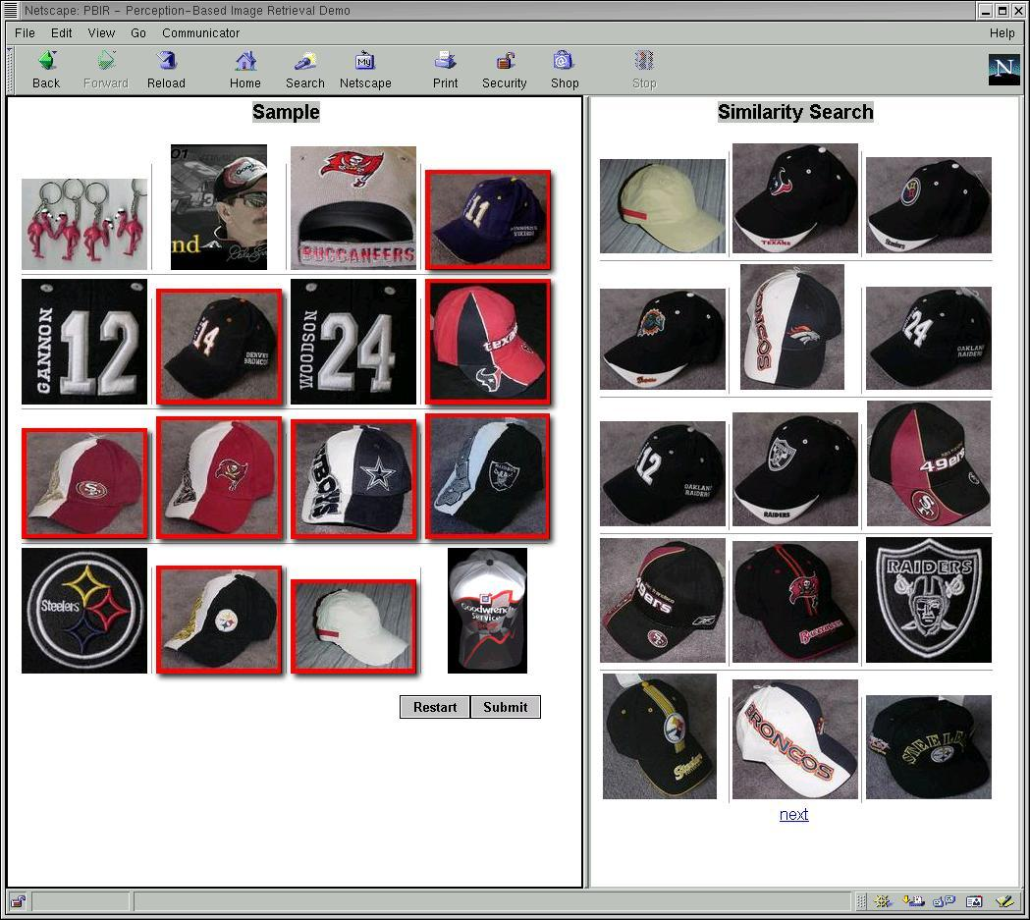
The user's query concept has been captured, though somewhat fuzzily. The user can continue to ask the system to refine the target concept by selecting relevant images in the learner frame, as before. Or, if the desired image(s) are already shown in the Similarity Search frame, the user can start a new search by clicking the “Restart” button in the Sample frame.

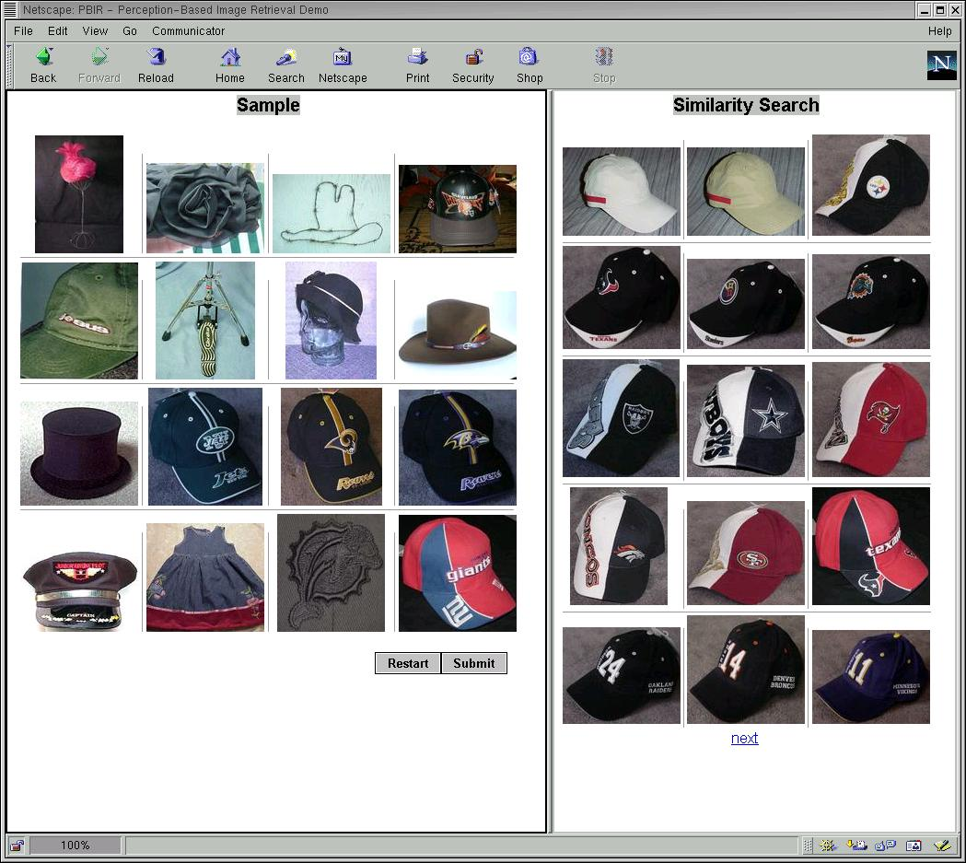
Screen 5: Sampling and Feedback Screen. After another feedback iteration, the similarity search returns 15 images that match the “sports hat” concept. (When another iteration was performed (not shown here), the next 15 images in the Similarity Search window were all sports hat” as well.)
THIS PART IS VERY CONFUSING . . .
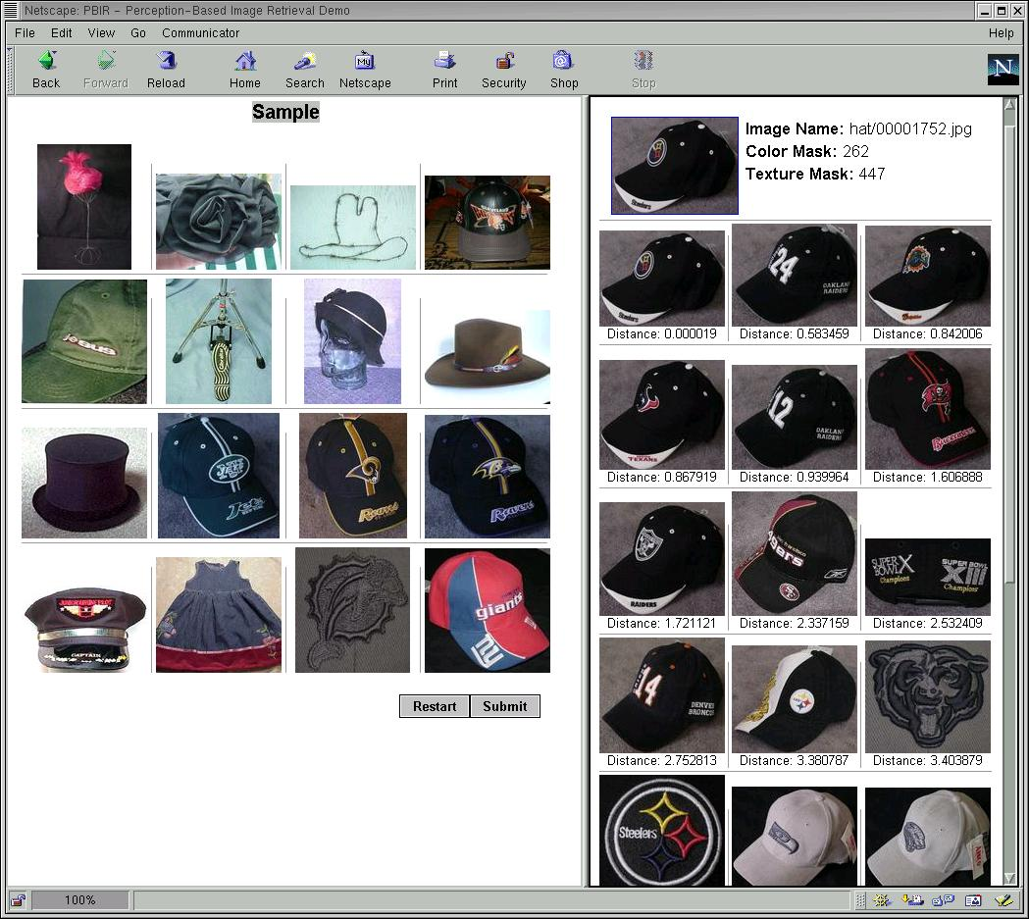
Screen 6: Similarity Search. At any time during this process, the user can click on an image in the Similarity Search frame to request other images that appear similar to those selected. This step allows the user to zoom in on a specific set of images that match some appearance criteria, such as color distribution, texture or shape.
As shown in this figure, after a user selected one of the sports hats returned from the last feedback session, he/she was given 15 matching images in the Similarity Search frame. Notice that sports hats with different colors and shapes are ranked lower than the matching images, since the user has concentrated more on specific appearances than on general concepts (as was being done in the previous screens).
In summary, this example simulates how our PBIR system effectively uses the learner to learn a query concept. The images that match a concept do not have to appear similar in their low-level feature space. The learner is able to match high-level concepts to low-level features directly through an intelligent learning process.
Competitive Product Comparison
The following table summarizes the key players in the image search market, and classifies the type of technology each uses. We are confident, however, that our PBIR is superior to any existing image search, because of our patent-pending intelligent algorithms and our fast, high-dimensional indexing structures (as discussed above, in Product Description). The following table summarizes the competition in the image search market – categorized according to the technologies used for search. As discussed above (Market Need), the majority of existing multimedia search products is keyword- or content-based. Not only is our perception-based technology superior to these alternatives, as previously explained, but also it can be integrated seamlessly into most existing search engines (especially those relying on keywords), thereby enhancing the results. This, of course, means that many of our “competitors,” are actually prospective partners.

Competition: Perception-Based Image Retrieval
Companies/Products | Image Technology Used
Google, AltaVista, Ditto, etc. | Text-based
eVision/Eve | Content-based
Cobion | Content-based
LTU Technologies | Content-based
Morpho/PBIR | Perception-based

Company Background
Morpho Software is a start-up company aimed at providing customers with a variety of fast, effective, easy-to-use, and seamlessly integrated multimedia filtering, retrieval and organization solutions that satisfy their specific information management needs.
Founded in January 2001 by scientists from Univ. of California, Santa Barbara and Stanford who have extensive experience in analysis, indexing and retrieval of multimedia information, Morpho has innovative and patent-pending technologies that support a wide range of applications in multimedia information filtering and retrieval.
Morpho’s products are based on proprietary breakthrough technologies in:
- Intelligent learning algorithms to understand image contents, and
- Innovative image characterization for effective image data representation
These technologies have resulted in one pending patent and four provisional patents.

A New Vision for Internet Search: A Technical White Paper from eVision, July 2001

