PBIR --- Perception-based Information Retrieval

Major Claims

- A query-language-free interface that can formulate users’ complex and subjective query concepts via sampling, learning, and refinement.

- The idea is novel because traditional database or information retrieval systems require users to explicitly specify their query criteria. For multimedia information retrieval where query concepts are complex and subjective to articulate, requiring users to explicitly specify query criteria is not realistic. PBIR formulates query concepts for users.

- PBIR learns a query concept via active learning in two iterative steps.
- Step a. Select most useful samples (the samples that are most ambiguous regarding to their relevance to the concept) to solicit user feedback. This step collects maximum information from users to disambiguate the target concept.
- Step b. Use the feedback to eliminate as many samples as possible from the sampling pool so that the probability to find relevant samples in the pool is increased.
- Go back to Step a until terminated.

- PBIR can employ the following three active learning methods:
- MEGA. See previous patent.
- SVMActive.
- Bayesian method. The Bayesian method proposed by the MIT PicHunter system uses user-feedback to refine the probability of each image with respect to meeting the target query concept.

PBIR User Interface Steps

PBIR splits the screen into two frames, sampling and result frames. In the sampling frame, it displays samples to seek for user feedback to refine the query concept. In the result frame, it returns top instances that match the query concept it has learned so far.

Scenario 1: Relevance feedback

Suppose we have N unlabeled samples in the pool, and n out of N instances match the query concept. PBIR finds a large percentage of these n matching instances at the end of the following steps:

- USER bears a concept C in mind. (PBIR knows nothing about the concept.)
- USER clicks on the start button in the sampling frame to start a query session.
- PBIR generates K random samples in the sampling frame.
- USER clicks on the samples relevant to C (positive instances), and the un-clicked samples are regarded as irrelevant C (negative instances).
- USER clicks on the submit button to submit his or her feedback to PBIR.
- PBIR adds the positive instances to the positive set, and the negative instances to the negative set.
- PBIR learns/refines C using one of the three learning algorithms based on the positive and negative sets.
- PBIR returns the top results matching C in the result frame.
- PBIR shrinks the sample pool N using one of the three learning algorithms.
- PBIR selects next K samples from N that are most ambiguous with respective to their membership or relevance to C.
- Go to Step 4.

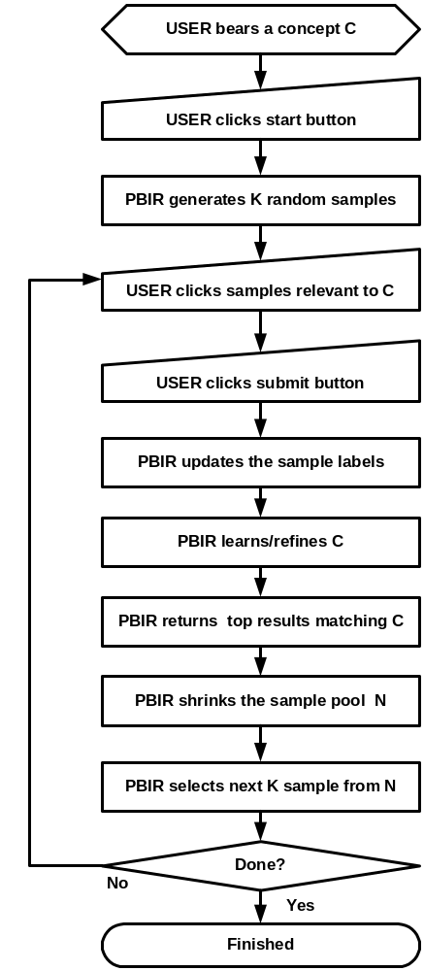

Scenario 2 - 4: Similarity Search, Image Collection, Image Annotation

At any time, USER can interact with the instances in the result frame to perform one of the following three tasks:

- USER performs a similarity search by clicking on a selected image.
- USER places an instance in a collection by clicking on the collection button.
- USER annotates an instance or a collection of instances by providing his or her own keywords or words suggested by PBIR.

Scenario 2: Similarity Search

Similarity search allows USER to zoom into a specific set of images that match some appearance criteria, such as color distribution, textures, and shapes. The similarity search consists of the following steps:

- USER bears a target image T in mind.
- USER clicks on the QBE frame.
- USER clicks on the filter menu to choose the desired matching criteria such as color, texture, or shape.
- USER goes back to the frame where the image T is.
- USER drags and drops the image T on top of QBE frame.
- PBIR analyzes the target image and extracts its features based on the matching criteria selected by USER.
- PBIR searches the database for images whose features are close to the extracted features.
- PBIR returns the top results on the QBE frame.

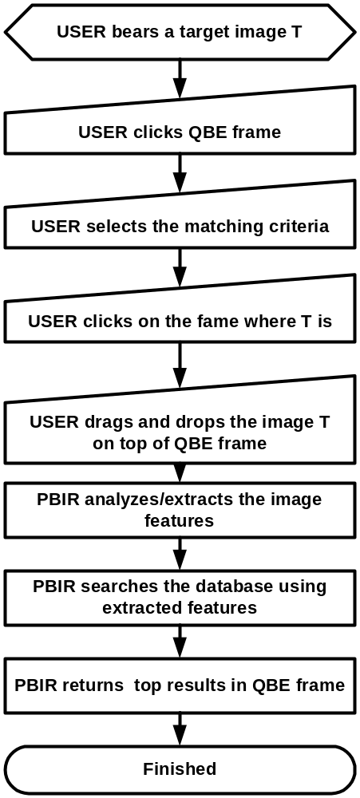

Scenario 3: Image Collection and Image Annotation

Image collection allows USER to gather his/her favorite images into a new image collection or an existing image collection. In addition, USER can annotate the image collection with a keyword. The image collection consists of the following steps:

- USER clicks on the collection frame and choose the new collection entry under the collection menu. An empty image collection is created.
- USER drags and drops a target image on top of the collection frame.
- PBIR adds the target image to the collection frame.
- USER keeps adding all desired images to the collection frame.
- USER clicks on the collection frame and chooses the save collection entry under the collection menu.
- PBIR prompts some suggested keywords for USER to select.
- USER clicks on one of the prompted keywords or types in his own keyword.
- PBIR saves the image collections and names the image collection with the keyword.

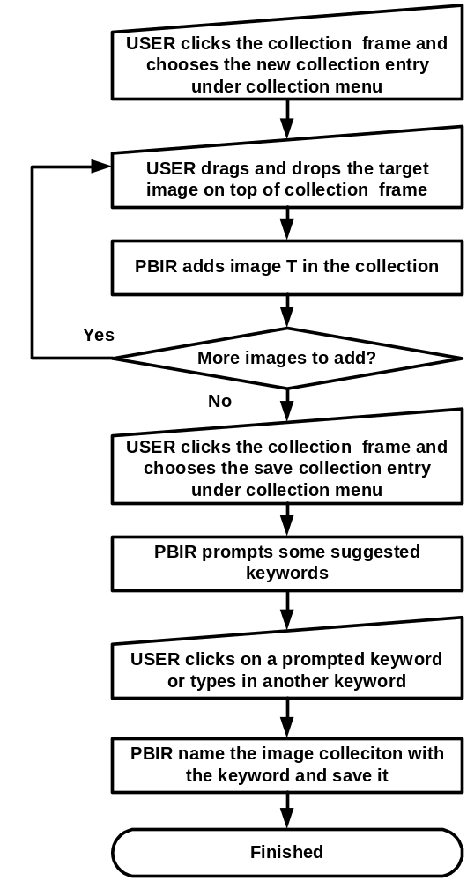

USER can update an existing image collection with the following steps:

- USER clicks on the collection frame.
- USER chooses an existing image collection under the collection menu.
- PBIR reads the selected collection and update the contents in the collection frame.
- USER goes back to PBIR frame or QBE frame.
- USER drags and drops those desired images on top of collection frame.
- PBIR adds those images in the collection frame.
- USER clicks on the collection frame.
- USER chooses the save collection entry under the collection menu.
- PBIR saves the image collection.

