PIWATWO, Inc.

Executive Summary
PIWATWO, Inc. (a Picture Is Worth A Thousand WOrds) has developed a perception based image retrieval system for web based applications. Our product concepts include an Image Search Engine, Objectionable Image Detection and Video Indexing for e and t commerce market applications.

PIWATWO has three unique and innovative patents pending concepts that will extend the current text based search to enable the retrieval of images based on individual users’ perception. There is no comparable technology that exists in the marketplace today to match our capability and efficiency. PIWATWO's ability to catalog, index, cross-reference, retrieve and deliver image content will become the leading edge technology for generating revenues on the web.

Image Library
The 1.5+-Billion stock-photography businesses are now limited by the lack of this new technology. The users have to look through images page-by-page manually; added phone calls, mailing photos back and forth, just to get an image. The recent adaptation of a major image library selling on the web has opened up the market to more users, and thus, reducing the production cost from $238 to $45 per image. Text search is currently used to locate an image. It is a good start, but it still requires users to look at pages of images to find the exact match. PIWATWO’s technology can enhance a user search by selecting an image of his or her liking and immediately locate all the images that are similar. Our ability to quickly zoom in on the exact image immediately will make the selling process less time-consuming and efficient. We are interested in a business model similar to Commission Junction where PIWATWO can be the intermediary search engine broker that link buyers to image libraries. Once the proper image is chosen, we can provide and secure a transaction that generate commissions while at the same time preventing an illegal copying of the image.

Image Search Engine
There are 100M searches conducted each day generating revenue of around $1M/day by search engine service providers such as Inktomi and Google. As more media contents are published on the web, another alternative is to find a web site by using an image rather than text. We would like to imitate Inktomi’s business model here by offering our services to major search engine companies and charge them on a per search basis. At present there are 5 major search engines offering image searches that mostly based on text. We can enhance their capabilities by incorporating our perception based image searches to accelerate their services. In addition, because of our ability to locate similar images quickly we can provide a low cost method for content producers to find illegal usage of their images on the web. Any user can submit their images and locate them efficiently to determine how best to deal with the infringement.

Objectionable Image Detection
In 1997 there are 85.6 million PCs in the US with Internet connections to businesses, families and educational institutions with underage children. Our product can also detect and filter so as to prevent the viewing of these sites using images rather then text. Because our technology is based on images rather then text, it could be used universally around the world even in countries where English is not a spoken word. The total number of PCs that need this protection can easily double in the US, and at $20/copy, the total revenue is $3.4B.

Video
Interactive TV and streaming media are the upcoming technologies. Forrester Research predicts there will be $3.8B revenue generated by enhanced broadcasts in 2004, and iBeam Prospectus predicts that more than 50% of the website will include streaming media by 2001. One of the issues with mega-content available to users is how to find the right program and what portion to watch. Our technology can be expanded to detect scene changes in a video as a way to index video content. It is in a sense, generating a storyboard to provide a means of interactivity for the user to pick the right segment to watch. All content producers, TV and News media can easily enhance their revenue generation capabilities by using this technology.

Marketing Plan
We plan to work closely and develop strategic alliances with image libraries, search engine companies and video producers. In this way we hope to create a safe and efficient income generating business model using our perception based image retrieval technology. We also plan to sell the image browser based products such as the objectionable image detector directly over the web.

Competition
Currently we know of no rival technologies that are capable of competing with us. Other competitors have attempted to perform image searches but has not been successful, because either they are based on text, or their similarity searches uses abstract mathematical assumptions that are not capable of finding valid results efficiently. Due to this technological difficulty, most our competition is focused on speech-to-text technology as way of converting images to text for search purposes. Speech-to-text only works well for a single speaker and not for general video and image applications. Only PIWATWO has the technology to catalog, index and retrieve images based on human perception.

Management
PIWATWO has three diverse and experienced individuals at its helm. Dr. Edward Chang has a Ph.D. from Stanford University and is currently an assistant professor at the ECE department at UCSB. He also has 10 years of R&D working experience with DEC and Sun Microsystems. His main research topics are on multimedia technologies and digital TV. Mr. Chao-Sun Pang is a co-founder of RC Electronics and as VP was responsible for Marketing, Sales, New Business and Product Development for over18 years. He was also a Principal Investigator for a NIH grant using high-speed gigabit switches for Neural Computational Research Applications. Dr. Sao Z. Win, he has over three decades of research, development and manufacturing experience as a founder and CEO of consumer and industrial electronics companies. He was one of the original developers of ARPANET at University of California, Santa Barbara.

Funding
We are looking to obtain seed funding of $5+ million to complete our product development (beta version available), building management, sales team, and develop a business infrastructure to launch our product. PIWATWO then foresees raising additional capital to accelerate market penetration for an IPO or strategic acquisition.

Financial Projections
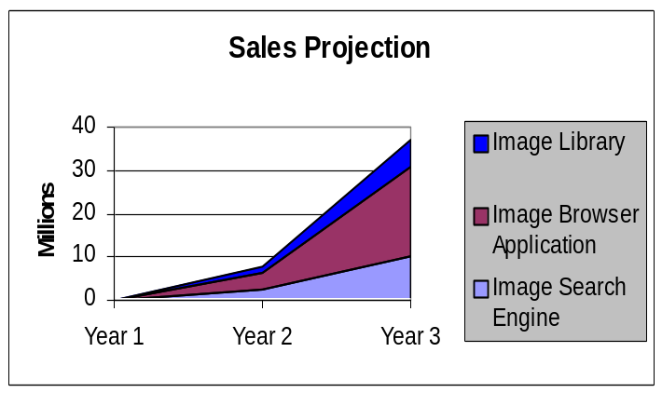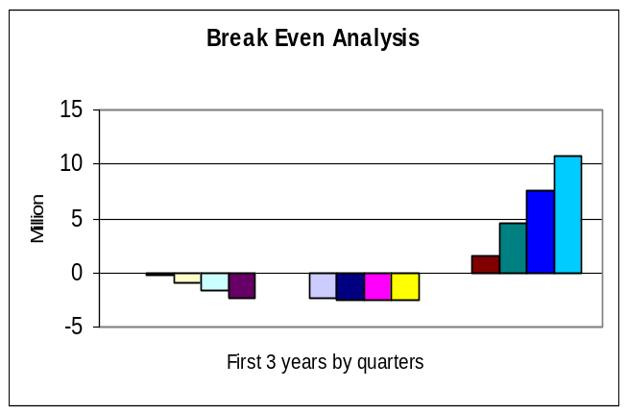

Contact
For additional information on PIWATWO please contact

