ClassAid – A Framework for Automated Lecture Capture and Storage

A Thesis submitted in partial satisfaction of the requirements for the degree Master of Science in Electrical and Computer Engineering.

By Ching-Wei Chen

Abstract
In this paper, the framework for a new system of automated lecture capturing and archival, called ClassAid, is proposed. The two main facets of ClassAid are the automated capturing of a University lecture environment, and the structuring and organization of this captured multimedia data for efficient post-lecture access.

Introduction
Being a teacher has never been easy. As an educator, it is both challenging and critical to hold students’ attentions, and engage them in intellectual discussions, while simultaneously presenting them with a sometimes overwhelming amount of factual data. Students in a classroom are often too busy copying down notes written on the blackboard or whiteboard, or trying to make notes of relevant spoken information, to participate to their fullest extent in the educational environment.
Digital technologies have, without a doubt, revolutionized the University classroom. PowerPoint® presentations on a laptop computer displayed through a video projector are commonplace, as are class Web pages on the Internet, where students are able to contact their instructor, read announcements and notices, download lecture notes, and even participate in discussions with their peers, from virtually anywhere in the world. More recently, lectures are being video recorded in their entirety, and being made available on the Internet within a “Digital Classroom” environment, integrating streaming multimedia with time-synchronized and hyper-linked textual information.
Properly implemented, the use of such tools can help to create an enhanced educational environment, where students can concentrate on listening to the instructor and fully engaging themselves intellectually while in the classroom. After the class, students will be able to access all of the presented material at their convenience, for reference or review.

Existing Digital Classroom Systems
In today’s Internet-enabled University, classes that use some amount of digital technologies are extremely common. Most of the time, this is in the form of a Web site where course descriptions, syllabi, lecture schedules, and topic outlines are posted. To a varying degree, these Web sites also contain downloadable lecture notes, homework assignments and solutions, project specifications, links to external resources, feedback forms, and discussion boards.
In the classroom, many instructors now present lecture materials from digital slides, through a laptop computer projected onto a screen. Internet connections may also be available to the instructor, or even to every student, enabling the presentation of external materials.
The use of digital video for recording a lecture is also becoming more widespread, and several classes offer streaming video presentations of the lecture on their Web site. Some systems incorporate some form of video summarization to create temporal markers, so that a viewer searching for specific information may jump to a relevant segment of the video.
Among the large numbers of available digital classroom systems, two are worth noting here.

eClass (Formerly Classroom 2000)
First developed at the Georgia Institute of Technology in 1995, this is one of the earliest developed digital classroom projects. Formerly known as Classroom 2000, the eClass system is an experimental classroom environment designed to study the effectiveness of ubiquitous computing technologies on education. As such, they have made large contributions to the research community in the field of digital classroom technology.
eClass utilizes a number of digital technologies, including digital slide projection, video capture, and electronic whiteboards. Of particular note is the electronic whiteboard used, the Xerox LiveBoard. This electronic whiteboard is actually a back-projected, touch-sensitive screen that can be used to display a computer screen, while responding to the movement of a pen on its surface. Using the LiveBoard allows an instructor to present prepared slides while simultaneously adding manual annotations to them during the lecture, with both the slides and the annotations being recorded and time-stamped for archival. If prepared digital slides are not used, the LiveBoard will be just be capturing the primary source of written lecture material in a more compact and accurate manner than simply recording a video of the instructor writing on a whiteboard would. This is because it need only save a single pixel of information (location of the pen) at any given time, and does not suffer from the occlusion problems faced by video recording the whiteboard with an instructor walking in front of it.
The Web interface of an eClass fully integrates a large amount of multimodal information, and includes a timeline of events (commonly marked by slide changes), a streaming video presentation, a close-up view of the slides and/or LiveBoard captured annotations, and a search utility. The lecture is completely synchronized and by selecting a particular event in the timeline, the video and close-up view are both updated accordingly. This feature allows users to browse through the lecture content, rather than having to sit through an hour-long video presentation.

Lecture Browser
Developed at the Berkeley Multimedia Research Center (BMRC), this system is also one of the more comprehensive digital lecture systems available. Based in part on work initially done at Cornell University, Lecture Browser incorporates most of the features of the eClass system as described above, in a slightly more pleasing and modern Web interface. Lecture Browser, however, does not utilize any handwriting capturing devices such as the LiveBoard, and as such is limited to displaying prewritten digital slides and, in some cases, snapshots of notes prewritten by hand on a blackboard.

Challenges and Shortcomings
While many instructors have begun to adopt some of these digital technologies, they do have limitations and drawbacks that discourage some teachers from using them. Some argue that prewritten, slide-based lectures decrease interactivity in the classroom, by making it difficult for an instructor to customize the lecture to fit particular students or situations. Therefore, many instructors prefer to manually present lecture materials by writing on a whiteboard or blackboard. But while this gives the instructor more freedom in improvising during a lecture, it also makes the lecture content less easily accessible after the lecture. This problem can be solved by a device such as the LiveBoard, which captures an instructor’s handwriting during the lecture itself. However, the LiveBoard is still very expensive, and is also extremely large and heavy. A combination of its high cost and bulkiness makes a large-scale deployment of this system unfeasible.
Implementing these digital technologies also requires a significant amount of time and effort. Designing or maintaining an effective and user-friendly Web page may not be within the capabilities or time constraints of many instructors. Many video-based digital classrooms, including the eClass and Lecture Browser systems, also require manual synchronization and annotation steps to be performed, which can be an extremely time-consuming process.
Managing and presenting digital video and other multimedia content is another concern. In addition to its high storage and bandwidth requirements, digital multimedia (especially video) requires good presentational organization and structure for it to be of much use to viewers. It is often not sufficient to simply provide a streaming video presentation of the lecture from beginning to end. Users may commonly want to extract specific information from a lecture, for example the definition of a term, or all the references made to a particular concept, and may not necessarily want or need to view the video in its entirety, or at all.
Network bandwidth considerations are also becoming increasingly relevant in a world where the advent of mobile computers, cellular phones, and personal digital assistants (PDAs) has created an extremely heterogeneous network environment. In light of this, a good digital classroom environment should be one that does not rely on streaming digital video as its primary means of presentation. Instead, it should provide different digital representations of the lecture material that are more compact, while remaining thorough, to provide scaleable access to users over widely varying network conditions.

Proposed System
In an attempt to solve the challenges posed in the previous section, we propose the framework for an automated lecture capture and storage system, called ClassAid. ClassAid will incorporate an inexpensive and portable handwriting-capturing device, automated summarization and synchronization of several multimedia sources, automatic extraction of textual information from various multimedia sources, and a well-organized data storage model that will be able to provide scaleable access to all of the lecture content across varying network conditions and user preferences.
The system can be divided into three subsystems: lecture capture, lecture understanding, and lecture archival, as diagrammed in Figure 1.
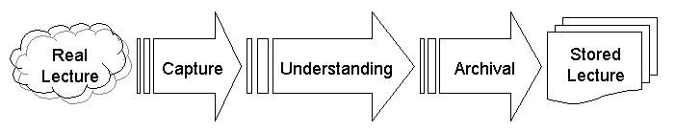
Figure 1: Top-level view of system
Lecture Capture refers to the process of recording all pertinent aspects of a lecture environment into a digital representation. These aspects include, but are not limited to, words spoken by an instructor, words spoken by students, physical movements and gestures of an instructor, and words written on a whiteboard.
Lecture Understanding includes lecture summarization, extraction of textual and non-textual information from multimedia sources, discovery of the associations between lecture concepts, and time-synchronization of multimedia information.
Lecture Archival refers to the schema and data structures used to most efficiently organize and store multimedia information to allow scaleable access to all the lecture content.
Figure 2 shows is a more detailed illustration of the design of the proposed system.
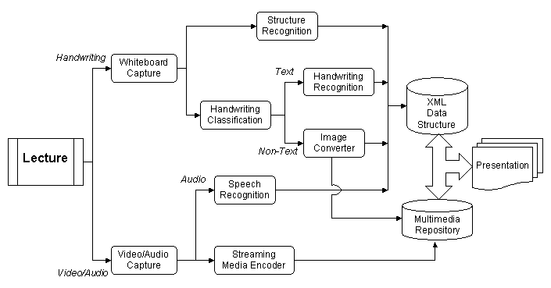
Figure 2: System architecture

Lecture Capture
This section describes the various components of the lecture capture subsystem in further detail.

Whiteboard Capture
In most traditional lecture capturing systems, notes written on a whiteboard are captured either as a full-motion video sequence from a video camera, or as individual “still-shots”, taken at manually selected time instances.
The former method is not ideal in many cases, as the storage and transmission requirements for digital video are generally quite high. Storage of a reasonably good quality MPEG compressed video, for example, can require on the order of 1 megabit per second (Mbps), which is approximately 5–10 megabytes (MB) for a single minute of video. When you consider the possibility of capturing 3 one-hour-long lectures per week for each of, say, 20 courses, over the period of a 10-week academic quarter, the storage considerations become quite apparent.
While the latter method may require much less storage space and lower bandwidth requirements, it is not without its shortcomings. By taking still-shots of a whiteboard, important timing information is lost, which could both limit the accuracy rate of any text recognition process, and possibly cause the captured whiteboard session to lose some of its semantic meaning.
For example, an instructor may draw a line from one object to another to indicate that one causes the other. In watching a video recording of this lecture, it will be clear which object is the cause, and which the effect, based on the direction in which the line is drawn. On the other hand, from a still-shot taken after the line is drawn, it will be unclear as to which object is the cause, and which the effect, since the direction of the drawing motion is not available.
It is clear, then, that a better solution should produce a more compact captured representation of a whiteboard session than a digital video sequence, yet retain critical real-time information that still-shots do not possess. A good example of such a system is the LiveBoard digital whiteboard, as used in the eClass project. But as previously mentioned, the LiveBoard is extremely expensive, and because of its weight and dimensions, is usually only installed in a single designated classroom. If we want to provide these digital capturing and note-taking tools to a wider number of courses, however, our system should also be relatively cheap and portable, such that they might be easily installed in a number of classrooms.
With those requirements in mind, the system we decided to use for was the commercially available eBeam® system, which presented a fairly cheap and portable solution for capturing time-stamped whiteboard events, with minimal storage and transmission requirements.

eBeam® Hardware
This system includes two sensor devices, four marker sleeves, and an eraser unit, as shown in Figure 3.
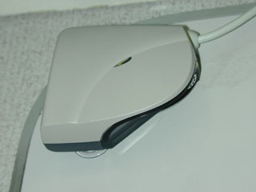 | 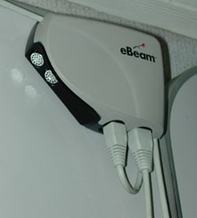 | 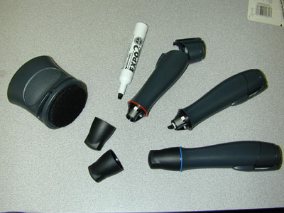
(a) Left corner sensor | (b) Right corner sensor | (c) Marker sleeves and eraser
Figure 3: eBeam® hardware components
The sensor devices have suction cups on one side, and thus may be easily attached to any given whiteboard, and possibly to other smooth surfaces as well. These sensors are generally mounted on opposite corners near the top of a whiteboard. One cable connects the sensors to each other, while another connects the right corner sensor to a host computer, where whiteboard activity may be captured and viewed.
Ordinary dry-erase pens may be inserted into the marker sleeves for writing on the board. Both the marker sleeves and the eraser unit are designed to emit a signal when they are pressed against, moved around on, and removed from the surface of the whiteboard. The signal sent by each of the four marker sleeves and the eraser contains unique information identifying the particular device in use, allowing the system to distinguish between different colored markers. In this system, the eraser is simply treated as another marker with a different color code. The aforementioned sensors then detect this signal, and the exact location of the pen or eraser is triangulated. The sensors then send event-based messages to a computer through a serial port.

Whiteboard Capture File
In conjunction with a software developer’s kit, this system is able to save a log of time-stamped whiteboard events, along with the coordinates and color information associated with each event. Figure 4 shows a sample whiteboard capture file, illustrating the format used to store events.
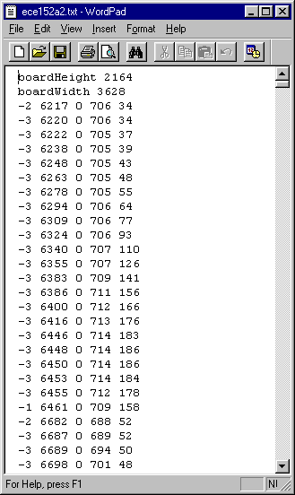
Figure 4: Whiteboard Capture File Format
The first two lines of the file record the height and width of the whiteboard, as reported by the eBeam hardware. Each subsequent lines in the whiteboard capture file records the information that is sent by the hardware when pen event occurs. The first number on each line represents an event type code, where “-2” corresponds to a pen being pressed down onto the whiteboard (PenUp), “-3” corresponds to a pen having moved to a new location on the whiteboard (PenMove), and “-1” corresponds to a pen being lifted off the whiteboard (PenUp). The second number is the timestamp, in milliseconds, of that pen event. The third number denotes the pen color. The final two numbers represent the current x and y coordinates of the pen, respectively.
In comparison to full-motion video sequences and still-image snapshots of a whiteboard, this captured whiteboard capture file requires very little storage space. For example, a one-hour whiteboard session can be stored as an uncompressed text log file using less than 1 MB of disk space (text compression techniques can easily reduce this by at least 50%). This is attributable to the fact that only five numbers need to be stored for each pen event (event type, color, time, horizontal coordinate, and vertical coordinate), and that no data is captured at all during periods of whiteboard inactivity.

Video AND AUDIO CApture
The system we will use for video recording is the commercially available Sony TRV20 camcorder. However, the camcorder’s built-in microphone is too far away from the lecturer to record speech accurately, so a separate audio track is recorded, using a wireless lapel microphone attached to the instructor. This will provide a good quality recording of the lecturer’s voice for later use in speech recognition. The captured video and audio will be compressed and encoded for efficient storage and streaming delivery over the Internet using the RealSystem Producer video encoder from RealNetworks. In addition, the whiteboard capture file is converted into a digital video file, and then compressed and encoded using RealSystem Producer.

Lecture Understanding
Once this raw multimedia data from the lecture is captured, automatic recognition techniques are used to extract meaningful information.
In the case of the captured whiteboard document, this involves obtaining a digital text representation, or transcription, of the instructor’s writing. We will also utilize the whiteboard document’s spatial, temporal, and color information to recognize the logical structure of the handwritten document.
The captured audio stream can also be used to obtain an audio transcription of the lecture, which may be used to improve the performance of the handwriting recognition step. The audio transcription is also important because an instructor’s spoken words commonly present additional information not written on the board.

preprocessing of the whiteboard capture file
Once the whiteboard capture file is obtained, each line in the capture file is read into an Event object, where an Event object contains elements to describe the event type, event time, pen color, and pen x and y coordinates. These individual Event objects are then grouped together into strokes. Each stroke contains an array of Events, beginning with a PenDown event, and ending with the next PenUp event.
Automatic recognition techniques are used for discriminating between handwritten text and non-text, such as drawings, graphs, and equations.

Handwriting Recognition
One of the key features of this project is the ability to automatically extract textual information from a lecture presentation. For this to be successful, we must be able to reliably convert the lecturer’s handwriting into digitally represented text. To do this, we utilized natural handwriting recognition techniques.
In general, there are two approaches to handwriting recognition: off-line and on-line. Off-line handwriting recognition takes as its input a static image of a handwritten document, where that image can be thought of as representing the entire set of positions a pen has visited on a piece of paper up to a certain instant in time. In on-line handwriting recognition, motion (position and time) information is also used, and the input can be thought of as being a video recording of a pen as it is moving around a piece of paper (or, in our case, a log of time-stamped pen events from the eBeam system).
Since the data analyzed in on-line handwriting recognition is a superset of the data required for off-line recognition (you can always take a snapshot from a video sequence), we conclude that on-line recognition rates will be at least as high as those achieved by off-line recognition methods. Hence, for this system, we will use the PenOffice software package, which is a commercially available on-line handwriting recognition engine.

PenOffice Software
This software runs on the Microsoft Windows operating system, and takes as its input the motion from a Windows input device, either a computer mouse or a writing tablet, and outputs recognized text into a text window. Tests have shown this recognition engine to be surprisingly accurate, and fairly robust to different handwriting styles as well.
In order to perform text recognition on our captured whiteboard session, a program was written to simulate mouse movement events in Windows, based on the corresponding pen movement events in the whiteboard document.

Document Structure Recognition
This is the division of a document into hierarchical organizational units (for example chapters, sections, headings, pages, paragraphs, lines, and words to name a few).

Speech Recognition

Multimedia Synchronization

Lecture Archival
This section describes the various components of the lecture archival subsystem in further detail.

XML
One of the goals of this project was to create an efficient data representation and storage model for post-lecture access and presentation. XML was chosen for this task because it provides hierarchical data organization, is a widely accepted standard, and is fully extensible.

XML Overview
It is valuable to note that XML is used for defining and storing textual data structures, and does not inherently provide any mechanisms for describing how that data is to be presented. To be viewable from common Web browsers, for instance, XML data must be translated into a viewable format, such as HTML. It is during this translation step that a developer may design the actual presentation “style” of the data. There exist a plethora of possible methods for online presentation of XML data, including but not limited to JAXP (the Java API for XML Processing), CSS (Cascading Style Sheets), XSL (the eXtensible Stylesheet Language), ASP (Active Server Pages), and JavaScript. For this purposes of this project, JAXP was used, as it not only provided an API for parsing and translating XML data structures, but also allowed for the development of an attractive Java/Swing graphical interface to create a platform independent presentation of XML data.

Structured Document Creation
Unfinished.

Web-based Interface

Multimedia Delivery

Online Lecture Interface

Results

Future Work

Video-based Activity Recognition

References
[1] Abowd, G.D. Classroom 2000: An experiment with the instrumentation of a living educational environment, IBM Systems Journal, Vol 38, No. 4, 1999, pp. 508-530.
[2] Abowd, G.D., Harvel, D.H., Brotherton, J.A., Building a Digital Library of Captured Educational Experiences, Invited paper for the International Conference on Digital Libraries, 2000.
[3] Rowe, L.A., Gonzáles, J. M., Paper in progress.
[4] Mukhopadhyay, S., Smith, B., Passive Capture and Structuring of Lectures, Proc. of ACM Multimedia, 1999, pp. 477-487.
[5] He, L., Sanocki, E., Gupta, A., Grudin, J., Auto-Summarization of Audio-Video Presentations, Proc. of ACM Multimedia, 1999, pp. 489-498.

