ECE 268 Final Report

Feature Exploration In HSV Space

Introduction
Hue, saturation and value (HSV) color space is natural and approximately perceptually uniform. Hue is used to describe colors we perceive and reflects the wave length within the visible-light spectrum at which the energy output from a source is greatest. Saturation refers to the dominance of hue in the color and is an expression for the relative bandwidth of the visible output from a light source. As saturation increases, colors appear more "pure". As saturation decreases, colors appear more "washed-out. Value refers to how light or dark a color is and describes the overall intensity or strength of the light. Figure 1 gives the HSV model graphically [1].

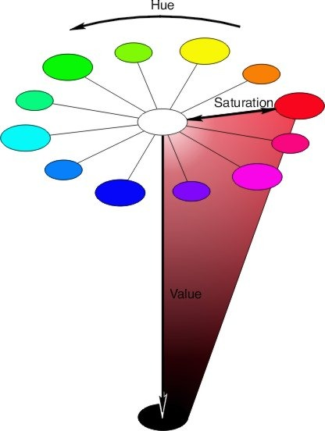

Figure 1: HSV color model

In this report, we describe the methods we use to extract features according to the HSV spaces to differentiate some types images. We choose two types of images. One is landscape images, the other is indoor images.Landscpe images usually has widen views,limit types of objects.and it is usually under natural light. Indoor images usually have narrow views,unlimit types of object and are ususlly under flash light. We hope to find some simple features in HSV space that could differentiate this two types of images. In the second part of the report, we describe the method we used to extract features that differentiate two type of images, in the third part we give some experiments results, the last concludes the report.

Extracting Features to Differentiate Two Types of Images
For a given image, we first translate the image from RGB color space to HSV color spaces. H value is from 0 ~ 360, S value is from 0 ~ 1 and V value is from 0 ~ 1. In Fgure 2, we give an example; Figure 2a is the original RGB color image; 2b is the gray image formed by the tranlated H values; 2c is the gray image formed by the S values; 2d is the gray image formed by the V values.


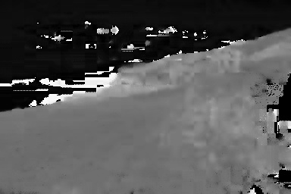

2a
2b

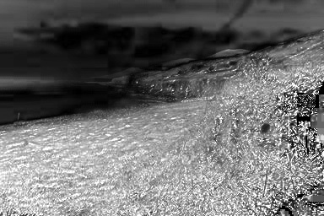
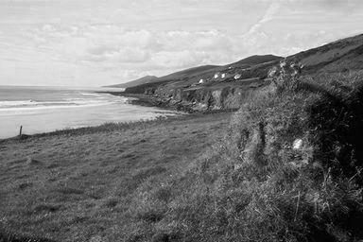

2c
2d
Figure 2: RGB image and its HSV value images

The H,S,V values are divided into NH, NS, NV different segments respecively. The segments of H are 0 ~ 360/NH, 360/NH ~2*360/NH, …… (NH-1)*360/NH ~ 360. The segments of S are 0 ~ 1/NS, 1/NS ~ 2/NS, …… (NS-1)/NS ~ 1. The segments of V are 0 ~ 1/NV, 1/NV ~ 2/NV, ……(NV-1)/NV ~1. According to the segments, we partition the image into continuous blocks. In each block, it contains all the continuous pixels whose H,S and V values are all in one segment respectively, the low bound values of the corresponding H segment , S segment and V segment are taken as the H, S and V values of the block. The H,S and V values of a block form a HSV vector. In our method, the HSV vectors of blocks are used as features for differentiating two types of images. For a type of images, a process called positive learning is first used to extract features from sample images. During positive learning, HSV vectors of blocks whose sizes (the number of pixels in a block) are above a given threshold are obtained from the sample images, the vectors are stored in a feature file of this type of images. For each vector, the number of images it appears in these samples are also saved in the feature file, and for all these vectors we also keep a record of the number of samples that has been used for positive learning in the feature file. For these HSV vectors, we then use sample images of the other type to perform negnative learning. During negative learning, we record the number of images that each HSV appears in these negative samples and the total number of negative samples used in the feature file.

For a HSV vector in the feature file, if the rate it appears in the positive samples is greater than that it appears in negative samples, it is called an effective vector. If the HSV vector of a block is effective, the block is called an effective block. According to the feature file, for an image to be determined, we calculate the number of effective blocks in the image, the number of blocks that have no corresponding HSV vector in the feature file (missed blocks) and the rate between the number of pixels in the effective blocks and the total number pixels in the image. The ratio between the number of effective blocks and missed blocks and the rate between the number of pixels in the effective blocks and the total number pixels in the image are used to determine whether the image belongs to this type. When the two ratios are both above the given threshold, we assert the image belong to this type. In the third part we give the experiment result we did for two type of images: landscape images and indoor images.

Experiment Result
In this experiment, we use two types of images, landscape images and indoor images. We create feature file for landscape images using 30 landscape images for positive learning, 30 indoor images for negative learning. The block size threshold is set to 10 pixels. NH, NS and NV are set to 12, 8 and 8 respectively. The threshold of the ratio between the number of effective blocks is set to 10 and the threshold of the ratio between the number of pixels in the effective blocks and the total number pixels in the image is set to 0.1. According to the created feature file, we test another 30 landscape images and another 30 indoor images, the result is shown in table 1. Figure 3 gives the image that are wrongly recognized as landscape images.

Conclutions
In this report, we give a simple method to differentiate two type of images based on HSV color space. It uses positive learning and negative learning to get the features for a type of images, and recognize images of this type according to the features. Experiment result shows this simple method has some effectiveness but still not very accurate. More complex information is needed to increase the accuracy.

Reference:
[1]. http://www2.ncsu.edu/scivis/lessons/colormodels/color_models2.html
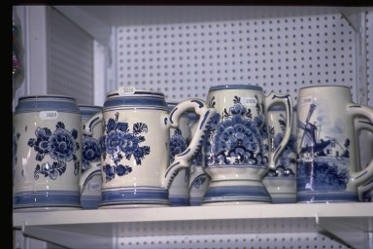
 | # of Images | # of right assert | # of wrong assert
Landscape | 30 | 25 | 5
Indoor | 30 | 29 | 1
Table 1. Result for Recognizing Landscape Images
Figure 3: An indoor image that is wrongly recognized as landscapes.

