Cover Page (Form 1207)

NSF Program Solicitation Number NSF 02-168

NSF CISE Directorate (AIRN)
Secondary unit (Engineering and Communications)

ITR - Photonic Integration for Network Exploration (PINE): Pervasive Access to Gigabit Network Bandwidth

Project Summary
Write this last.
This page needs to explicitly contain the following statements.
- The intellectual merit of the proposed activity
- The broader impacts resulting from the proposed activity
  - Advance Discovery and Understanding While Promoting Teaching, Training and Learning: Include high school students directly in the dark fiber network by holding a gigabit application research competition where students at the Engineering Academy at Dos Pueblos High School in Santa Barbara will submit research proposals to do summer work.
  - Broaden Participation of Underrepresented Groups:
  - Enhance Infrastructure for Research and Education: The establishment of the Transparent Optical Research Network Laboratory (TORNL) will be a fundamental paradigm shift in how physical layer research and education is conducted. It is a unique laboratory environment that is equivalent to the particle accelerators for physicists. It will be used to train students across multiple disciplines in the requirements for bringing photonic technology to IT technology. The DFRNL will be managed by CENIC. mission of CENIC is to CENIC is provides the networking transport for all K-20 education institutions in California serving the research and education needs. Via CalREN, scientists, researchers, educators and students have connectivity to all the major national and international research and education networks and to the commodity internet. CalREN facilitates the resource sharing and collaboration that individuals and groups establish to carry out the mission of research, teaching-learning, and public service. The multi-tiered CalREN network enables the research community to work directly with teachers and students engaged in the education activities of K-20 institutions. In essence, CalREN make it seamless for those that want to interact.
  - Broad Dissemination to Enhance Scientific and Technological Understanding: Today we have the opportunity, as outlined in this ITR proposal, to build a Photonic Integrated Network infrastructure that can have a large impact on IT comparable to the impact of the original ARPAnet. As scientists, we need to build a new community that will “use” photonic technologies much in the way the pioneers of the Internet did with electronics. It is in the cyclic process of integrating photonics and then using photonics that we will move closer to the benefits photonics can offer to information technology and its applications. As a community we need to go through the process of discovery and exploration and we need to take our students through that process with us.

Project Description

Motivation and Challenges
In the 1970’s network researchers had access to rudimentary integrated digital electronics – they were able to breadboard and test new concepts in information technology (IT) that proved to be the precursor of today’s Internet. This exploration in networking involved scores of scientists, engineers and students who developed into a community that utilized the relatively low-bandwidth transmission medium available at the time to develop a highly scalable network protocol. As the complexity of electronic functions and transmission bandwidth continued to increase, the level of electronic functional integration became denser, more complex and was able to scale according to the economics of Moore’s law. The commercial, scientific and educational applications that arose are too numerous to count and the impact on the scientific community, commerce and society has been profound.
The overarching research and education goals of the PINE project are twofold:
- To provide users of information technology with pervasive access to Gb/s bandwidth integrated photonics technology. These compact, highly integrated, low power, all-optical network processing chips can break the ‘bandwidth bottleneck’ that occurs where the optical fiber network enters the users gateway, in essence bringing the fiber network bandwidth directly into the processing and storage elements within the users environment
- To create a community of researchers who will explore the application of integrated photonic information technologies through interaction with a transparent optical research network laboratory (TORNL) infrastructure. This tool will enable physical layer optical network and component researchers to build radically new IT technologies unencumbered by existing network technologies. The TORNL infrastructure will have as lasting and profound an impact in research and education as the original Internet did.
One of the great challenges facing information technology is the pervasive access to Gigabit network bandwidth. The PINE Project challenges the basic notion that gigabit bandwidth cannot be provided on a pervasive basis to users of IT. Solving this problem is so fundamental that if it is solved, the impact will be a wealth of scientific, educational, societal and economic benefits and a flood of high bandwidth applications. For example, pervasive access to Gigabit bandwidth can enhance security and reduce the vulnerabilities of our society by allowing massive amounts of information at the individual level to be relocated and distributed in response to catastrophic events. Today, state-of-the art optical fiber transmission bandwidth has exceeded 10 Terabits-per-second (Tb/s), yet access to the home is relegated to Megabit-per-second (Mb/s), to schools 10-100 Mb/s and the scientific and high-end business communities a Gigabits-per-second (Gb/s). Figure 1 illustrates the current disparity between processor power required to perform operations and services at a gateway using DSL, Cable and Fiber connections. Future applications like home networking and remote medicine, tele-presence and data-mining will require more computer processing power using today’s technology than can be put into a reasonable form factor. The ability for electronics to match the fiber bandwidth to processor power will be challenged as Moore’s law for electronics starts to run out of steam.
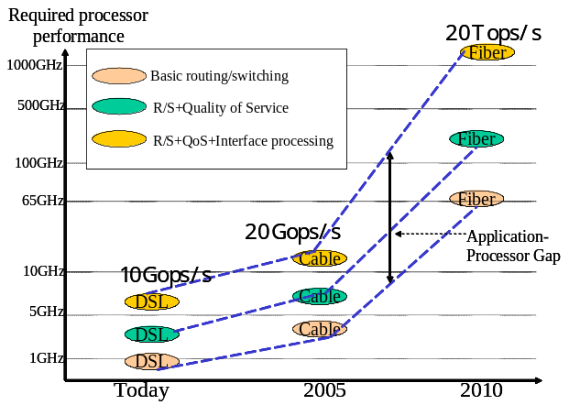
Figure 1. The widening gap between networked processor power and the application processing demand.
Networking researchers who dream of mining the fiber bandwidth and investigating new optical network concepts face numerous hurdles because of the lack of available photonic integration technologies, higher levels of photonic functionality and the availability of advanced networks with which to test these new concepts. Even the optical network and device research communities face significant challenges in prototyping new network concepts because of the overwhelming cost of integration and lack of a flexible transparent physical layer network infrastructure. In essence we find ourselves in a similar position as particle physicists of yesterday who didn’t have access to the computational resources they needed, and went on to become leading supercomputer scientists.
In the PINE vision we propose to conduct photonic integration research in concert with transparent optical network research. This ITR if funded has the potential to impact IT on a scale comparable to that of the original ARPA Net. As scientists, we need to build a community that will “use” photonic technologies much in the way the pioneers of the Internet did with electronics. It is in the cyclic process of integrating photonics and then using photonics that we will move closer to the true benefits that can be offered to information technology and its applications. As a community we need to go through the process of discovery and exploration and we need to take our students through that process with us. Today we stand at the doorway to a new era in photonic integration and functionality. To enter into this new era we must bridge traditional engineering boundaries because the process of discovering the first generation of truly integrated photonic technologies will occur hand-in-hand with the process of discovering new networking principles, information technologies and applications. We must be able to develop the capability to breadboard and explore new concepts through completely new fiber network test infrastructures in order to address engineering issues at the systems level and train future scientists and engineers to handle the multi-faceted nature of these complex systems. At the same time we must ask the questions of how network architectures and applications will take advantage of these systems and the pervasive availability of gigabit bandwidths and provide continual feedback between these aspects of integration and architecture. We must ask the difficult questions of how this technology will allow scientists to do tasks they cannot do today and we must explore the potential impact on educational and teaching models and applications as well as the societal impacts.
We need to build a photonic information technology community, a collective resource that spans multiple disciplines to investigate complex photonic systems issues and their impact. As a community of scientists, educators and students we need an infrastructure that enables us to develop the integrated photonic technologies of tomorrow with an implicit understanding of their applications and impact. As time goes on, we will expand the community and bring others in to utilize these resources and as with previous IT technologies there will be a trickle down to broader segments of society. The research and education project outlined in this pre-proposal is designed to enable the creation of a community that will realize the next generation of integrated photonic technologies and create the infrastructure to explore new concepts in IT, new ways to integrate research and education, new ways to outreach to scientists and engineers that normally would not have access to this type of unique resource, and to improve the diversity and breadth of engineers and researchers who will be the future leaders and innovators of photonic based information technologies.

Relevance to the ITR Program
The PINE Project challenges the basic notion that gigabit bandwidth cannot be provided on a pervasive basis to users of IT. By seeking ways to push the fiber bandwidth deeper into the user network interface, the PINE Project seeks to extend the capability to process, manage, and communicate information on a global scale. The goal of pervasive gigabit access is consistent with ITR program goal to scale up the network infrastructure to include an extremely large number of computing and monitoring systems and appliances and Exploiting the power of IT and networking infrastructures to enable robust, secure and reliable delivery of critical information and services anytime, anywhere, on any device. The research goals are also relevant to the ITR mission to produce fundamental technological breakthroughs that will advance networking and scientific, engineering, and consumer applications that drive economic growth. These breakthroughs will come in the form of radically new integration technologies that enable photonics to deliver the function, size and economics associated with electronic technologies. This effort is relevant to the ITR mission that the research addresses groundbreaking and high-risk research with potential for high payoff. There are aspects of this research that are inherently inter-disciplinary. For example, any photonic function in the end will require control functions and embedded intelligence in order for it to be useful at the systems level. The PINE research team stresses this aspect by bringing materials, photonics, controls and embedded systems researchers together to solve the integration problem. The team will also address challenges that require an understanding what materials choices are suitable for platform integration, circuit design choices among the photonics, optoelectronic, micro-mechanical and electronic circuits and the impact that photonic integration will have on computer, memory and network architectures.
The unique TORNL infrastructure will enable the PINE team to use IT as a tool in science and engineering research and education by enabling physical layer optical network and component researchers to build radically new IT technologies unencumbered by existing network technologies. This approach is critical to expanding the frontiers of IT through research and education and has a profound impact in the laboratory and extended classroom. This type of learning environment is consistent with the ITR goal to create a new generation of scientists and engineers who are capable of fully integrating IT into the whole educational, professional, and creative process of the scientific and engineering disciplines.

Broader Impact
Advance Discovery and Understanding While Promoting Teaching, Training and Learning: Include high school students directly in the dark fiber network by holding a gigabit application research competition where students at the Engineering Academy at Dos Pueblos High School in Santa Barbara will submit research proposals to do summer work.
Broaden Participation of Underrepresented Groups:
Enhance Infrastructure for Research and Education: The establishment of the Transparent Optical Research Network Laboratory (TORNL) will be a fundamental paradigm shift in how physical layer research and education is conducted. It is a unique laboratory environment that is equivalent to the particle accelerators for physicists. It will be used to train students across multiple disciplines in the requirements for bringing photonic technology to IT technology. The DFRNL will be managed by CENIC. mission of CENIC is to CENIC is provides the networking transport for all K-20 education institutions in California serving the research and education needs. Via CalREN, scientists, researchers, educators and students have connectivity to all the major national and international research and education networks and to the commodity internet. CalREN facilitates the resource sharing and collaboration that individuals and groups establish to carry out the mission of research, teaching-learning, and public service. The multi-tiered CalREN network enables the research community to work directly with teachers and students engaged in the education activities of K-20 institutions. In essence, CalREN make it seamless for those that want to interact.
Broad Dissemination to Enhance Scientific and Technological Understanding: Today we have the opportunity, as outlined in this ITR proposal, to build a Photonic Integrated Network infrastructure that can have a large impact on IT comparable to the impact of the original ARPAnet. As scientists, we need to build a new community that will “use” photonic technologies much in the way the pioneers of the Internet did with electronics. It is in the cyclic process of integrating photonics and then using photonics that we will move closer to the benefits photonics can offer to information technology and its applications. As a community we need to go through the process of discovery and exploration and we need to take our students through that process with us.

Integration of Research and Education
In this ITR project we will build an infrastructure that dramatically enhances the relationship between Research and Education and addresses critical issues in how we educate the future scientists and engineers. There has never been a better or more realistic time than now to invest in this type of unique infrastructure. The Committee on Science, Engineering, and Public Policy (COSEPUP) of the National Academy of Sciences published a report in 1995 entitled “Reshaping the Graduate Education of Scientists and Engineers,” which spells out the need for reforming graduate education to meet the increasing diversity and complexity of employment options for students. The following statement from this report applies equally well to all students, K-12 through graduate level and beyond:
“A world of work that has become more interdisciplinary, collaborative and global requires that we produce young people who are more adaptable and flexible, as well as technically proficient.”
We propose to rise to this challenge by building a Transparent Optical Research Network Laboratory (TORNL) infrastructure that will allow students and researchers to explore new modalities of learning optical networks and related technologies. The TORNL is a resource that does not exist in this framework anywhere in the world that we are aware of. This model represents a fundamental paradigm shift in how physical layer research and associated education is conducted. We have in the past implemented radically new course models for optical communication and networks [reference IEEE Trans. paper] and the published results won the IEEE 1999 Best Transaction Paper Award. The TORNL carries the integration of research and education to a real world optical network laboratory with real transmission conditions and allows collaborations with other students at 3 other Universities.
The TORNL will be managed in close partnership with CENIC, a California non-profit organization that manages CalREN, an infrastructure where scientists, researchers, educators and students have connectivity to all the major national and international research and education networks and to the commodity internet. CalREN facilitates the resource sharing and collaboration that individuals and groups establish to carry out the mission of research, teaching-learning, and public service. The multi-tiered CalREN network enables the research community to work directly with teachers and students engaged in the education activities of K-20 institutions. Therefore in essence, CENIC and CalREN make it seamless for those that want to interact with TORNL over time. Additionally, the mission of CENIC is to provide the networking transport for all K-20 education institutions in California serving the research and education needs, and it is this community that will directly benefit from the technologies investigated and developed on the TORNL.

K-12 Education Component
The PINE project and TORNL infrastructure will create pathways for K-12 students to engage in discovery-based learning and career exploration at both the junior high and the high school levels. The total student population in Santa Barbara School District now includes a majority of underrepresented students at the junior high (65%) and at the high school (52%) levels. Yet these Hispanic and Latino students represent no more than 15% of the students in senior level math and science classrooms. We see is as important to create a network of new opportunities both inside the traditional school context as well as in informal summer programs and after school clubs which recruit and engage the students from underserved populations.
PINE researchers will work with the Early Academic Outreach office at UCSB, the MESA schools program (Math, Engineering and Science Achievement) the Santa Barbara School District and local youth organizations so that students will have access to: A summer camp experience in computer technology for junior high students from underserved populations held at the UCSB campus. PINE researchers will assist the science teacher instructors to introduce optical networking and photonic technology concepts and provide students with hands-on activities that enable them to understand the potential of this new technology. Enhanced courses in the Engineering Academy at Dos Pueblos High School, close the UCSB campus. This academy started in 2001 as a result of identifying the need “to provide state of the art advanced learning opportunities and career exploration in the areas of engineering and science.” Faculty and graduate student researchers will partner with the science and math teachers to create new activities for both the Engineering and Computer Science Strands of the program. New investigative activities at after school clubs sponsored by the Endowment for Youth Committee of Santa Barbara and MESA.
The coordination point for these opportunities will be a student project competition that will engage high school sophomores and juniors in groups of two or three to develop new ideas and applications that take advantage of the promise of Gigabits to the user. This program will in a larger context be used to study the potential impact of Gigabit access technologies on the development of Gigabit end-to-end applications. The Education coordinator at PINE will work with both school teachers and informal science coordinators to make sure that all students have the necessary supervision to develop their ideas, proposals and skills. The Center for Entrepreneurial Engineering Management (CEEM) in the College of Engineering at UCSB will assist the students in proposal preparation and pre-analysis. Each year, 6 students whose projects are judged to be most exciting will be offered summer apprenticeships at the UCSB campus where they will be matched with PINE mentors who will supervise their research projects. These high school students will be awarded stipends of $1500 and will join a group of 6 other high school researchers in a program that also offers an introduction to the higher education environment. Funds will be made available to support computing and fiber communication hardware for winning proposals. The students will learn how to communicate and present their research so that they can report on their projects to their student peers and family members.

Higher Education, Outreach and Diversity Recruitment and Retention
PINE and TORNL undergraduate and graduate students will collaborate with each other, with university faculty and K12 students and teachers in the development of their own educational enrichment. We will create coursework, research and training opportunities that will enhance student development of a full range of professional skills in an environment of cross-disciplinary collaboration
Student Professional Development:
- Academic courses to cover different areas of need for Living Learning Lab students:
- TORNL – an inter-campus laboratory will be developed where students attend class locally, but participate in lab activities which run jointly via the transparent optical network. Students will do real transmission experiments and investigate reconfigurable network concepts and impact of integrated photonic technologies.
- Latest Developments in photonics technology, systems integration and information networking. Faculty will team-teach new seminar/special topics courses which will be fibernet-cast to partner campuses. Students will help to organize/determine content of these courses
- Societal Impacts - Students will examine issues related to pervasive information networking technology and its impact on scientific research, education, the economy and national security.
- Seed Project Competition – to promote project development skills. Students will design new research projects and write a proposal in competition for award money. This activity will require students to develop a variety of new skills, and will inform them of the process by which novel ideas are realized into working projects. This will parallel the K12 competition component.
- Professional development workshops: to enhance and enable other program activities, and students’ research efforts in general. Topics will include mentoring and teaching, presentation skills, proposal writing, writing for journal submission, experimental design and methodologies, data analysis, entrepreneurial and management training.
Student Research: Graduate students will commit to a training/research program for the first two years of their doctoral study. Incoming doctoral students will go through a rotation of at least 3 research internships during their first year, and will select their primary doctoral research advisor by the beginning of their second year. There will also be at least one other co-advisor for each student whose research is complementary to that of the primary advisor. Graduate students will spend at least one summer in internship at a partner campus, or with an industrial partner. Undergraduates will on work on research internships under the mentorship of PINE and the TORNL graduate students, and will participate in all relevant professional development workshops. These undergraduate internships will serve a two-fold purpose: graduate students will gain valuable experience in supervising/mentoring younger students, and we can encourage and undergraduate application to graduate school. Students will update the PINE/TORNL community on their research progress throughout the school year in regularly scheduled seminar presentations. All seminars will be fibernet-cast to PINE partners at the other campuses.
Diversity Recruitment and Retention: The greatest need for increased diversity remains in graduate education, where we will focus most of our efforts. We will coordinate with the various graduate divisions in student recruitment and application to science and engineering programs at each campus. We will work with campus offices and with statewide/national organizations which promote the advancement of under-represented/underserved undergraduates in science and engineering. The relative diversity of undergraduates in science and engineering is sizably greater than the diversity of students who chose to apply for graduate school. Approaching students after they have made the decision to apply to graduate school is too late. We will approach this problem through supporting a number of undergraduate internships in the PINE/TORNL programs and by recruiting heavily with undergraduates in other summer internship programs at the participating campuses.
We will promote retention of students through careful, active mentoring/advising and through promoting the collaborative and supportive atmosphere which will be integral to the Living Learning Lab community. We will organize activities such as peer-mentoring with that specific purpose in mind. We will also closely monitor student satisfaction through formal and informal assessment, with an emphasis on the first year of enrollment, the time when most students opt out of a program.

Link to other disciplines
Needs to be written.

Research Problem and Proposed Research
Pervasive access to gigabit network bandwidth is more than simply connecting a fiber to a photodetector and sending the electrical signal to electronics for further processing. It is about how to extend the optical network into the user gateway and leaving data in optical format as long as possible before optoelectronic conversion. It is about the choices of when to manipulate and move data in optical form and when to manipulate and move data in electronic form. It is about what bandwidth and processing bottlenecks can be opened up by handling data in the optical domain, how to overcome interconnect speed limitations. It is about the power and space wasted by using electronics in the wrong place and the potential savings by using optical and photonic technologies in the right places. It is about the integration of photonic technologies to the point where they follow integration scaling laws and play a major role and partner with electronics in applications that are both performance and economically driven. These issues will play a central role in the research done under this ITR and have a fundamental impact on information technologies.
In the future, gigabit network interfaces will moves data from the optical network to a combination of network processors, task processors, embedded processor arrays, hard drive and semiconductor memory arrays. This data may then be piped to a variety of multi-standard outputs for back-end networking as shown in Figure 2. In order to handle real time future applications, the aggregate processing power inside this box can exceed 10 to 100 times that possible with today’s computing technology. There must be a fundamental shift in the underlying technology and the way it is applied to the manipulation and transfer of information. The questions we propose to address in this research program include what is possible in terms of delivering gigabit bandwidth pervasively with a totally new paradigm. For example, what are the boundaries of photonic (all-optical) technologies? Does the introduction of truly integrated photonic technologies open up new capabilities and only then new applications? Is there the possibility of a totally new technology whose outcome would be useful not only in broadband communications but also possibly in other fields? We find ourselves 10 years after the original vision in DARPA of an all-optical network where there are new optical capabilities that have been developed. In light of these, can unleashing the potential of photonics and all-optical processing can be attractive?

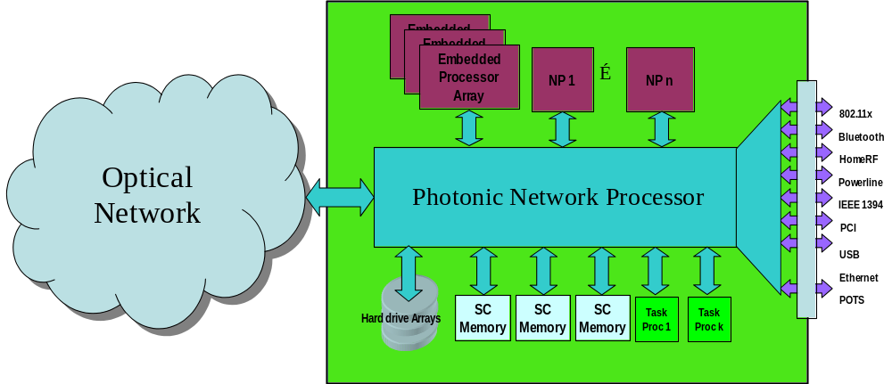
Figure 2. Pervasive Gigabit Access will require new photonic integrated technologies to handle data all-optically in a portion of the network processing architecture.
Pervasive fiber applications like Fiber-to-the-home (FTTH) hold great promise to be the eventual access technology, yet even FTTH is not a solved problem. Therefore investigating the integration of all-optical solutions into these problems has potentially high payoff. In the past when new switching technologies were investigated, all-optical solutions had to be ruled out due to the cost advantages of electronics and also due to Moore's Law (electronics was advancing much faster). However, there are arguments that point to Moore's Law reaching its limits in more complex ways than originally thought. Minimization of power dissipation and footprint, data rate transparency and independence of power dissipation to data rate are a few potential advantages gleaned by removing electronics from the data path. Extending optics from transport to processing is a logical step, especially if new integration and functionality capabilities are in the horizon.
While this proposed research project is not about the study of optimal electrical processing architectures, it is about the pervasive use of photonic technology to solve some of the greatest information technology challenge. What is needed is advances in photonic integration comparable to the revolution in electronic integration in the 1960s. However, the development of integrated photonic technologies cannot be done in a vacuum but must be done in concert with other circuit technologies, with knowledge of how this technology will interplay with the network architecture and it’s functions, the computing architecture and the end user applications. It is equally important to understand the impact on the applications themselves and the way scientists, engineering, students and the general public will do their work and live their lives in the future.

Research Team
The proposed ITR program consists of three tightly coupled research components illustrated in Figure 3. The photonic integration component deals with what photonic technologies can be used to move and process information and how these technologies may be integrated.
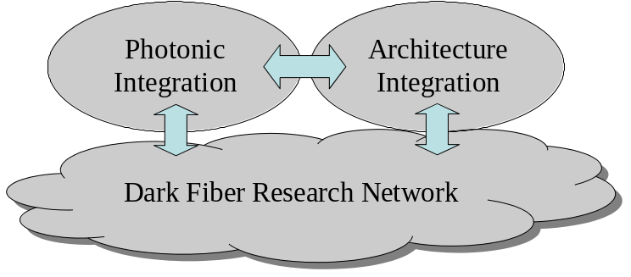
Figure 3. The three tightly coupled research components of PINE.
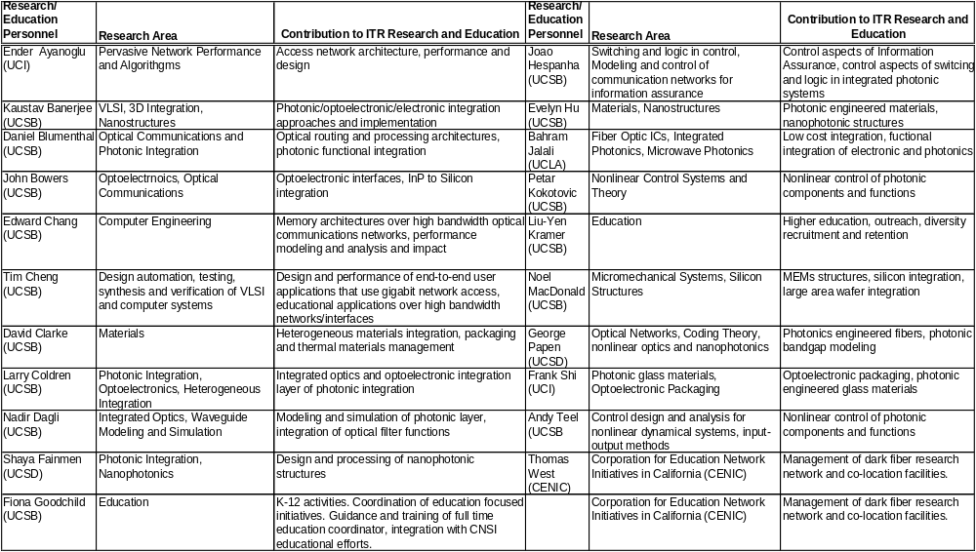
Figure 4. PINE research team and contributions to research and educational areas.

The Photonic Integration Component
This aspect of the program will investigate how to bring photonic circuit integration from its current infancy equivalent to that of electronics in the 1950s to a level needed as a pervasive network technology. This part of the project will deal with functional integration issues consisting of a cross-disciplinary team of researchers in the photonics, controls dynamics and embedded systems areas. We will also investigate what the potential functions that can be processed using photonic technologies are and how to integrate these functions using a variety of available and upcoming circuit technologies. The integration of different kinds of semiconductor materials, such as silicon for electronics and indium phosphide for optical and photonic devices will be investigated. In realizing functionality, a variety of technologies that may be employed including photonics, optoelectronics, micromechanical systems and electronics and tradeoffs need to be understood. This level of integration will bring together researchers and students in VLSI, photonics, solid state, materials, chemical engineering and mechanical engineering. Finally, the choice of platform integration, what choices of materials will be utilized to implement multi-circuit functions including heterogeneous systems and monolithic approaches will be studied including InP and Si semiconductor and glass systems.

The Architecture, Control and Embedded Systems Component
In this part of this effort we will operate under the assumption that a pervasive Gigabit photonic interface technology exists. End-to-end applications will take advantage of and be impacted by this new technology. New pervasive Gigabit applications will be identified, studied and the interfaces prototoyped. We will ask the question of what science will be liberated that is currently blocked by not having this type of networking infrastructure and how this infrastructure will impact the education of future generations. This part of the project will be tightly coupled to the integration project to provide feedback about functional and performance metrics and choices

The Transparent Optical Research Network Laboratory (TORNL)
We propose to build the Transparent Optical Research Network Laboratory (TORNL), a unique infrastructure that will enhance research and education for photonic driven information technologies and networking. This is a truly unique opportunity that has a time window that is now. We can purchase dark fiber to wire four campuses through a centrally located transparent optical switch core (shown in Figure 5) for $403,000. We would own the fiber for 20 years and can use it anyway we need to.
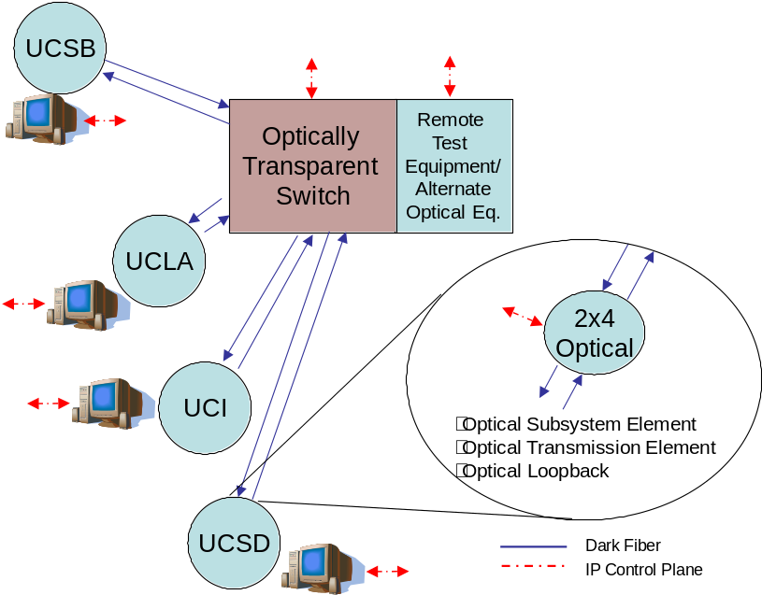
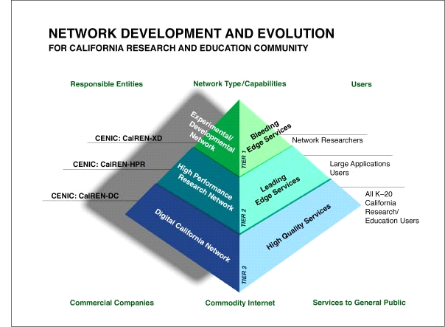
Figure 4. The transparent optical research network laboratory (TORNL) will provide a unique and critical infrastructure to build a strong community and integrate education with research.
The TORNL infrastructure will infuse education with the excitement of discovery by giving students and researchers access to something that does not exist anywhere. This infrastructure will bring the physical layer research directly to the researchers. It will support a truly unique environment for conducting state of the art optical network research at the two levels: RNs enable basic scientific and engineering network research and the testing of component technologies, protocols and network architectures. This infrastructure is needed to design and test new ways to transmit, transport, route, switch, regenerate, manipulate, process and receive data. The research network is also required to investigate new ways to implement data routing and intelligence directly onto the optical physical layer. The ORN Laboratory must facilitate controlled experiments that can be scheduled and run from a single location between multiple sites. Due to the nature of the physical layer research, there should be minimal restriction on optical bandwidth, data-rates or modulation format. The optical bandwidth should be clear (unrestricted) from 1260nm to 162 0nm. The RN researcher must be able to test and pinpoint the health of optical signals at various points in the network and identify where problems may exist. This type of laboratory control through a common secure web browser interface is one of the novel opportunities to build a truly
The Corporation for Education Network Initiatives in California (CENIC) provides the networking transport for all K-20 education institutions in California serving the research and education needs. Via CalREN, scientists, researchers, educators and students have connectivity to all the major national and international research and education networks and to the commodity internet. CalREN facilitates the resource sharing and collaboration that individuals and groups establish to carry out the mission of research, teaching-learning, and public service. The multi-tiered CalREN network enables the research community to work directly with teachers and students engaged in the education activities of K-20 institutions. In essence, CalREN make it seamless for those that want to interact.

Evolution of TORNL into the National Optical Users Network (NOUN) under the National Lightrail Project
For this long term NNUN like model we can establish NOUN (National Optical Users Network) as the model where industry and academia can access the dark fiber research network which could fit under the CENIC National Lightrail Project.

Management Plan
Need text to go with this figure. What other aspects should the management plan include? Reviews, meetings, reports?

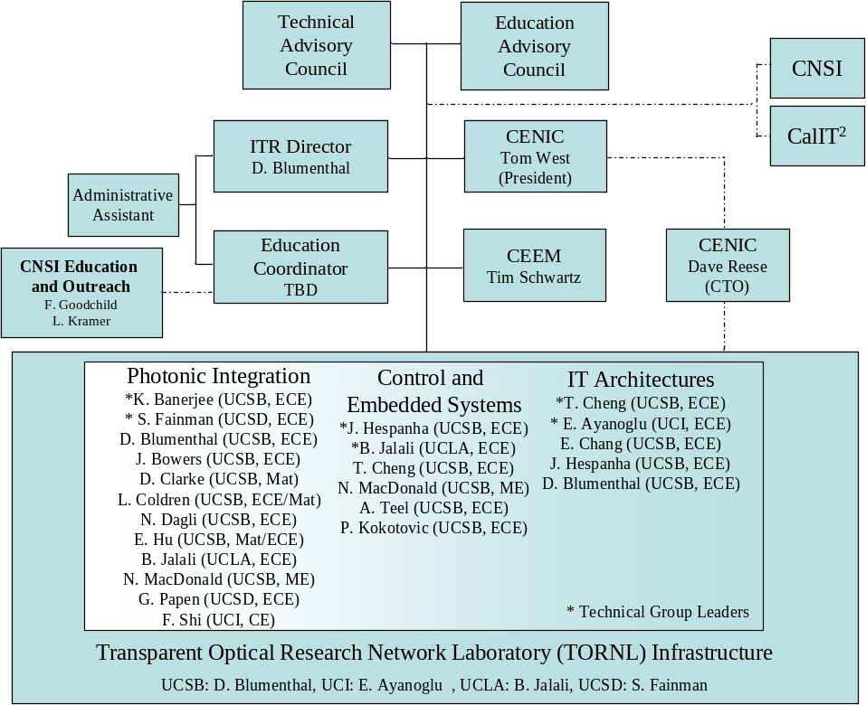
Figure . Proposed PINE ITR research and management structure.
References Cited (One Page)
MONET and other AON networks.
photonic integration
broadband to the home
what other references should we be citing?

Review Criteria
- What is the intellectual merit of the proposed activity?
- How important is the proposed activity to advancing knowledge and understanding within its own field or across different fields? How well qualified is the proposer (individual or team) to conduct the project? (If appropriate, the reviewer will comment on the quality of the prior work.)
- To what extent does the proposed activity suggest and explore creative and original concepts?
- How well conceived and organized is the proposed activity?
- Is there sufficient access to resources?
- What are the broader impacts of the proposed activity?
- How well does the activity advance discovery and understanding while promoting teaching, training, and learning? How well does the proposed activity broaden the participation of underrepresented groups (e.g., gender, ethnicity, disability, geographic, etc.)?
- To what extent will it enhance the infrastructure for research and education, such as facilities, instrumentation, networks, and partnerships? Will the results be disseminated broadly to enhance scientific and technological understanding?
- What may be the benefits of the proposed activity to society?
- Integration of Research and Education: One of the principal strategies in support of NSF's goals is to foster integration of research and education through the programs, projects, and activities it supports at academic and research institutions. These institutions provide abundant opportunities where individuals may concurrently assume responsibilities as researchers, educators, and students and where all can engage in joint efforts that infuse education with the excitement of discovery and enrich research through the diversity of learning perspectives.
- Integrating Diversity into NSF Programs, Projects, and Activities: Broadening opportunities and enabling the participation of all citizens -- women and men, underrepresented minorities, and persons with disabilities -- is essential to the health and vitality of science and engineering. NSF is committed to this principle of diversity and deems it central to the programs, projects, and activities it considers and supports.
- Innovation in Information Technology and its Application to Science or Engineering
- As a part of the intellectual merit of a pre-proposal or full proposal, ITR emphasizes the importance of novel, high-risk, and high- impact research.
- Is the proposal highly innovative, rather than an incremental improvement on standard ideas?
- Does it promise exciting advances, even if there is some chance of failure?

In keeping with the core mandate of NSF, one focus of the competition is the innovative use of IT as a tool in science and engineering research and education. Proposals to the ITR Program should demonstrate how they contribute to expanding the frontiers of IT or its applications through research and education, proposing new tools and applications, new theories and techniques new bridges between existing disciplines or communities. Extends and applies IT through pervasive introduction to the home/school/desk environment via photonic integration. Improves our understanding of IT and its effects and helps prepare our society for the Information Age.
The Program Description for ITR suggests a number of areas of potential interest but construes IT in its broadest sense, encouraging research on computers and computation; networking and communication; information and data storage, manipulation, and presentation; new applications of IT in all science and engineering disciplines; new science and engineering research that is facilitated by IT and by collaboration with computer scientists; and uses of this knowledge and technology to advance social, educational, scientific, and engineering goals.
Extending the capability to process, manage, and communicate information on a global scale beyond what we imagine today. This includes new paradigms for communication, networking and data processing in large-scale, complex systems. Understanding how to extend, or scale up, the network infrastructure to include an extremely large number of computing and monitoring systems, embedded devices and appliances. Exploring new research directions and technical developments to enable wide deployment of pervasive IT through new classes of ubiquitous applications and creation of new ways for knowledge acquisition and management. Exploiting the power of IT and networking infrastructures to enable robust, secure and reliable delivery of critical information and services anytime, anywhere, on any device.

