Morpho Software Inc.

July 2001

This document contains confidential and proprietary information belonging exclusively to Morpho Software Inc.

Morpho Software Inc.
3944 State Street, Suite 340
Santa Barbara, CA 93105, USA
Tel: 805-569-9022
Fax: 805-569-5382
Email: lchang@morphosoft.com

Executive Summary

Introduction
The mission of Morpho Software is to develop multimedia enabling technologies to morph today’s Web into the future. Specifically, Morpho Software offers Perception-based Image Retrieval and Filtering Systems for Web-based applications. Initial products/services include a Perception-based Image Search Engine and an Objectionable Image Filter.

Morpho Software was founded in February 2001 by scientists from Univ. of California, Santa Barbara and Stanford who have extensive experience in analysis, indexing and retrieval of multimedia information. In March 2001, the Company received $1.2M funding from several angel investors for initial product development. Currently, the Company has 5 employees and 2 consultants.

Morpho Software has innovative and patent-pending technologies that provide three unique features:
- Multi-resolution multimedia data characterization,
- Fast high-dimensional indexing, and
- Interactive multimedia information retrieval considering personalization.

The Market

There are about 1.3 billion Web pages today and it is estimated to reach 8 billion Web pages by 2003. Furthermore, higher network bandwidth, higher processing speed and larger and cheaper storage are driving the text-based Web to become more and more multimedia-based. These trends result in explosive image and video Web content, which demands Web tools capable of effectively and efficiently searching for and organizing image and video data. A recent survey indicates that there are more than 200M PC’s today with Internet connections in business, education and families with underage children. There is a very strong demand for tools that are capable of screening unwanted information to avoid exposing bad media data to underage children.

The image library sales are about 1.5 billion today and the number is expected to grow dramatically in the next few years. Tools, beyond current text-based search engine, capable of helping users to efficiently find the desired images will of very strong demand.

Digital TV broadcast will be mandated by 2006. It is believed that in the next few years there will be many new applications with mass market for interactive digital TV, which requires image and video retrieval technologies.

A recent report from the Gartner Group reveals a list of 12 high-impact technologies identified by Gartner Analytics for user enterprises for 2000 to 2010. This list includes wireless Web technologies, biometrics, content-based retrieval, natural language processing, Bluetooth and speech recognition. Content-based retrieval will enable information seekers to retrieve a broader range of media types, including audio, images, video and text, without the need for human indexing. Content-based image/video retrieval will be the key technology to many current and future Web tools and applications.

Morpho’s Unique Technologies

Perception-based multi-resolution multimedia data characterization: Morpho’s technologies are able to map low-level image features to high-level semantics in psychological spaces.

Fast Access Methods: Morpho’s novel indexing structures provide fast and accurate access independent of the number of objects and the dimensionality of the objects in the dataset.

Personalization: Morpho’s models and techniques can learn both long-term habit and short-term behavior of a user with a small number of samples.

Products
Based on the above core technologies, the company are developing the following initial products:
- Perception-Based Image Search Engine: An interactive, perception-based image search engine with our unique personalization features will allow users to find the desired images on the Web with a very small number of iterations. This system, combining
- Objectionable Image Filter: With more than 300 million PCs connecting to the Internet, it is critical to provide client-based filtering mechanisms so that unwanted information such as pornographic images is not passed to underage children. This application aims to detect and filter objectionable media data from invading families and schools.
Morpho’s additional product ideas include Image Copy Detector, Image Classifier/Organizer, Video Summarizer and Video Indexer. These applications will be explored after the development of the initial two products listed above is completed.

Business Strategy and Marketing Plan
Morpho plans to work closely and develop strategic alliances with image libraries, search engine companies, video producers and e-commerce companies. In this way we hope to create a safe and efficient income generating business model using our core technologies. We also plan to employ direct sale for various products and services.

- Strategic alliances: Morpho plans to establish strategic alliances with existing major search engine companies such as Google, AltaVista, InfoSeek, Excite and Lycos, to provide backend service for general image search. Morpho can charge such companies for a fixed amount per user search.
Morpho will provide tools and service to multimedia content companies for organizing image data and for user-centric image search. Morpho can charge commission per sale for such services.
Morpho plans to establish strategic alliances with Internet service provider to offer content-based Objectionable image filtering at the server sides.
Morpho can also license the personalization technologies to B-to-C companies for various applications.

Direct Sales: Morpho will employ direct sales for Image Filter to end users for client-side image filtering. Such tools can be sold on-line as well as through software retailers.

Competition and Market Risk
Image Search Engines for Web.
The following table shows the potential competitors (as well as Morpho’s potential partners of strategic alliances) and the underlining techniques they are employing:
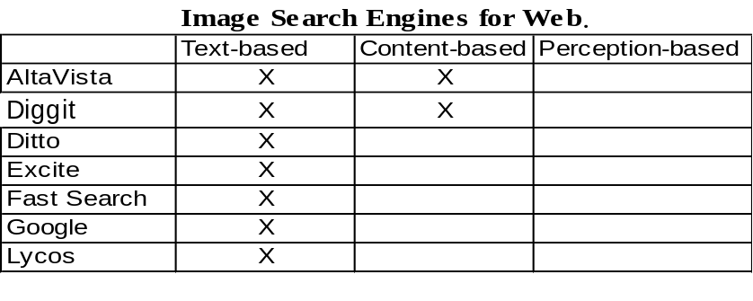
Currently we know of no rival technologies that are capable of performing interactive, perception-based search that Morpho is offering. Most competitors perform image searches based on text, or based on limited content-based similarity searches that are not capable of finding valid results effectively or efficiently. We are confident that Morpho’s technologies are superior to the competitors.

Image search service to portals, destination sites, galleries, etc. The following table shows the potential competitors (as well as Morpho’s potential partners of strategic alliances) for image search as a hosted service to portals, destination sites, corporations, image galleries, etc.,
and the underlining techniques they are employing:

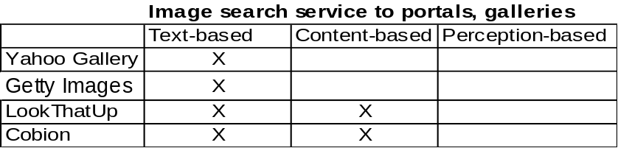

Again, all competitors perform image searches based on text, or based on limited content-based similarity esrach that are not capable of finding valid results effectively or efficiently. We are confident that Morpho’s technologies are superior to the competitors.

Image Filtering Software. The following table shows the potential competitors (as well as Morpho’s potential partners of strategic alliances) and the underlining techniques they are employing:

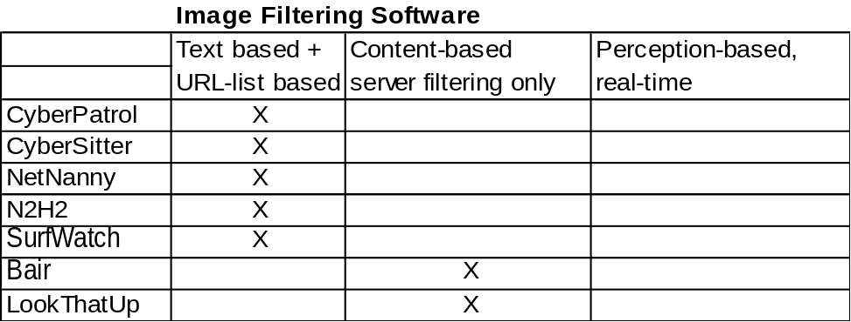

Currently, there are three different types of techniques used in image filtering software. (1)Analyzing the text naming and surrounding the images. To date, this method works for English only. Other major probles include (a) porn’s lexicon also fall into non-porn’s dictionaries (e.g. wren tits, wood screws, breast cancer) and (b) Porn sites often incorporated text directly into image (I.e. jpg/gif) files which invalide the text-based methods. (2) Maintaining a list of blacklisted Web addresses. The main problem is that such lists always out of date and they’re only 60 to 80 percent accurate. (3) Content-based filtering. Compitetor’s techniques in this category are computationally more expensive and this takes unacceptable processing time per image for real-time applications. It has also been reported thar the compitetor products have relative high rate of false positives (I.e. baby pictures) and false negatives. Again, we are confident that Morpho’s technologies are superior to the competitors.

Founding Members
Dr. Edward Y. Chang is a co-founder of Morpho Software.
Background:
–Professor, Electrical and Computer Engineering, Univ. of California, Santa Barbara
–M.S. UC Berkeley, M.S. Stanford, Ph.D. Stanford
–10 years industry experience in large-scale software architecture/development (DEC, SUN Microsystems)
–Executive committee member, Univ. of California Digital Media Innovation Program
–IBM Faculty Partnership Award

Dr. Kwang-Ting (Tim) Cheng is a co-founder of Morpho Software.
Background:
–Professor, Electrical & Computer Engineering, Univ. of California, Santa Barbara
–Director, Computer Engineering Program, Univ. of California, Santa Barbara
–B.S. National Taiwan Univ., PhD. UC Berkeley
–Chief Technology Advisor, Verplex System Inc.
–Technical Advisor of 5 Silicon Valley based high-tech companies
–Consultant of Lucent Technologies, LSI Logic, Institute for Information Industry, Taiwan
–Fellow of IEEE

Technical Advisor

Dr. Hector Garcia-Molina:
–The Leonard Bosack and Sandra Lerner Professor, Departments of Computer Science and Electrical Engineering, Stanford University
–Chairman, Department of Computer Science, Stanford University, starting Jan. 2001
–Director, Computer Systems Laboratory, Stanford University from 1991-1994
–Professor, Computer Science Department, Princeton University from 1979-1991
–Member, United States President's Information Technology Advisory Committee (PITAC).
–Fellow of the ACM

Source: “Twelve Technologies for 2000 to 2010”, by A. Linden and J. Fenn, April 18, 2000, Gartner Analytics, T-10-8085.

