
COMPUTER ARCITECHTURE AND ORGANIZATION
SWEG3105
Generation 2 Computers

Group Members ID
- Lalisa Hailu ETS0847/16
- Lelisa Tamene ETS0849/16
- Leoul Zerihun ETS0852/16
- Nebiyu Yalemgeta ETS1116/16
- Negasi Berihu ETS01117/16
- Robel Wondwossen ETS1187/16

Submitted To:
Submission Date:
Contents
Introduction II
Second Generation Computers based on Structural, Functional, Architectural and Organizational Aspects 3
I. Structural Aspects: The Transistor Revolution 3
II. Organizational Aspects: Compactness and Interconnection 5
III. Architectural Aspects: The Programmer’s View 6
IV. Functional Aspects: Speed, Reliability,and Efficiency 7
General Characteristics of Second Generation Computers 8
Disadvantages of Second Generation Computers 9
Conclusion 10
Reference III

Introduction
The evolution of computing technology has progressed through several distinct phases known as generations, each marked by significant breakthroughs in hardware, software, and system architecture. There are about 5 generations:
    - First Generation Computers (1940 – 1956)
    - Second Generation Computers (1956 – 1963)
    - Third Generation Computers (1964 – 1971)
    - Fourth Generation Computers (1971 – 1980)
    - Fifth Generation Computers (Present and Future)
- The second generation of computers, developed roughly between 1956 and 1963, brought one of the most impactful transformations in the early history of computing.

Second Generation of Computers
It was during this generation that transistors replaced vacuum tubes as the primary switching component, fundamentally altering the size, speed, power consumption, and reliability of computers.
This shift from the bulky, heat-intensive, and fragile vacuum tube to the compact and robust transistor laid the foundation for modern electronics. They produced less heat and consumed less electricity. Programming languages like COBOL and FORTRAN were introduced during this time.
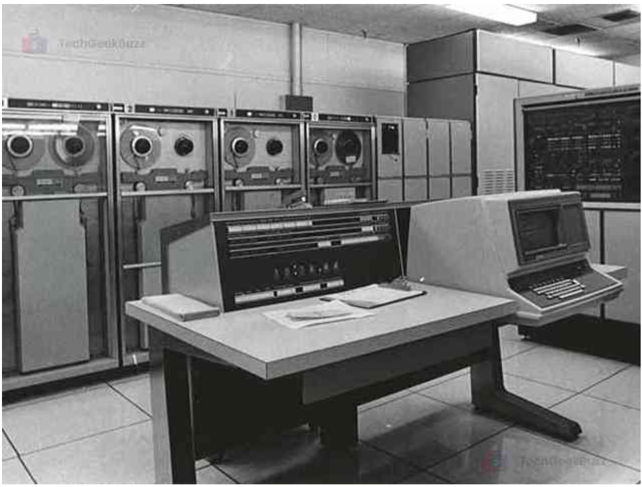

Second Generation Computers based on Structural, Functional, Architectural and Organizational Aspects

Structural Aspects: The Transistor Revolution
The most defining factor of the second generation is the foundational shift in core electronic components. Structurally, the replacement of the vacuum tube by the transistor directly impacted the physical form and composition of computers.

- Core Component and Materiality
The transistor is characterized as a solid-state device. Unlike the vacuum tube, which was large, fragile, and relied on electron flow in a vacuum, the transistor is built using semiconductor material, such as silicon.
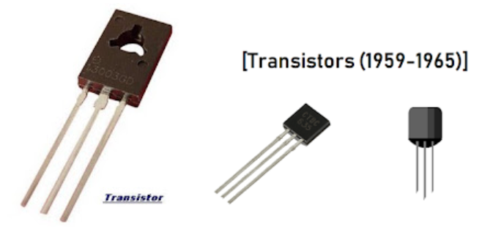

Magnetic Core Memory: A critical enhancement during this generation was the adoption of magnetic core memory, which replaced earlier technologies like delay line memory and drum memory. Magnetic core memory consisted of small magnetic rings (cores) through which wires were threaded to write and read information. Each core stored a single bit of data, and because the memory was non-volatile, it retained data even when the power was turned off.
This type of memory allowed for faster data access and better reliability, which was crucial for both system stability and processing efficiency. Magnetic core memory supported random access, meaning data could be retrieved directly rather than sequentially. This improvement significantly enhanced performance in programming and data processing tasks and became a standard memory technology until the development of semiconductor-based RAM.

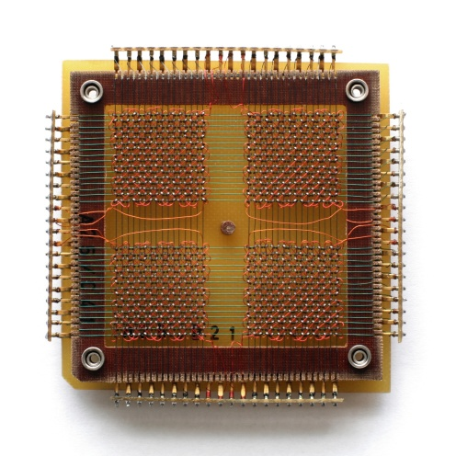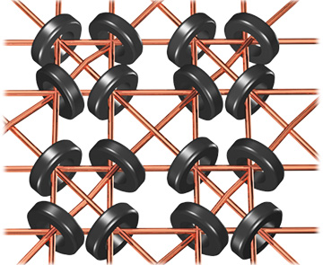

The key structural advantages of this new technology were immediate and dramatic:
- Size Reduction: The transistor is smaller than the vacuum tube it replaced.
- Cost and Manufacturing: Transistors are cheaper to produce than vacuum tubes.
- Heat Management: Transistors generate less heat than vacuum tubes. This structural characteristic reduced the need for massive cooling infrastructure (a major organizational and functional headache of the vacuum tube era).
- Signal Function: Fundamentally, the transistor performs the essential structural function of an electronic device: to amplify a signal or to open or close a circuit. This allows it to serve effectively as a logical switch, the basis of binary operations.

- Impact on Physical Integration
The ability to integrate components more densely was a direct structural consequence of miniaturization. As stated in the sources, the computer is structurally composed of fundamental parts: the CPU, main memory, I/O, and system interconnection mechanisms.
By making the fundamental electronic building block smaller and cooler, the designers could organize more complex logic structures onto compact circuit boards. This initial increase in component density paved the way for the later development of integrated circuits (ICs) in the third generation, but the transistor laid the groundwork by proving solid-state physics could support reliable, high-density electronic assembly.

Organizational Aspects: Compactness and Interconnection
Computer organization focuses on the operational units and their interconnections that realize the architecture. The arrival of the transistor drastically changed how computing hardware could be physically organized.

Reduction in System Footprint
First-generation computers were too bulky in size and not portable. The second generation marked the advent of systems that were less immense and more manageable, though still far from modern definitions of portability. The organizational constraint of physical size was significantly lifted:
- Memory Organization: The transistor enabled the development and organization of faster, more reliable memory systems. Although the specifics of Second Generation memory (like magnetic core) are not detailed in the new sources, the necessity for memory systems that could keep up with the faster processing speeds enabled by transistors became paramount. The general organization of memory involves arranging physical bits to form words, which is a key design issue in random-access memory (RAM) organization. The smaller component size made it feasible to organize larger, faster internal memories.
- I/O Organization: Organizational complexity often stems from connecting disparate components (CPU, memory, I/O). The ability to create smaller, more complex control units allowed for more sophisticated organization of I/O operations, moving away from systems where the CPU was solely responsible for managing every micro-operation.

Operational Unit Complexity
Organizationally, the CPU consists of major components like the Arithmetic and Logic Unit (ALU) and the Control Unit (CU). Due to the increased reliability and reduced size of transistors, designers could incorporate more complex internal structures within these units:
- Instruction Pipeline Overlap: The sources discuss how faster CPUs rely on breaking down the fetch-decode-execute cycle into smaller, overlapping stages (pipelining) to improve speed. While advanced pipelining matured in later generations, the inherent speed of the transistor allowed for the first implementation of instruction prefetch or fetches overlap in the architecture, marking a key organizational improvement over strictly sequential execution. This organizational change required additional registers to store data between stages (instruction buffering).

Architectural Aspects: The Programmer’s View
Computer architecture refers to those attributes of a system visible to a machine language programmer. The superior reliability and performance offered by transistors had a critical architectural impact, enabling the design of more user-friendly and powerful instruction sets.

Instruction Set Design
The shift in hardware reliability enabled the evolution of instruction sets (ISAs). A robust transistor-based system could support complex features without constant hardware failure.
- Operation Repertoire: The second generation saw the proliferation of computer systems utilizing assembly language, marking an architectural step up from the machine code of the first generation (like the IAS machine, which had only machine language). This was essential for bridging the "semantic gap" between human-understandable high-level concepts and machine operations.
- High-Level Languages (HLLs): Architecturally, the second generation facilitated the use of high-level languages (HLLs). Although compilers were still rudimentary, the existence of reliable, transistor-based machines made programming in abstract languages, such as FORTRAN or COBOL (developed during this era, though not explicitly cited in the sources as Second Generation), a practical reality. The move towards HLLs meant that the attributes visible to the programmer became richer, focusing less on individual machine instructions and more on abstract computational structures.
- Addressing Modes: While early, simple architectures like MARIE used limited addressing modes (direct and indirect), the organizational stability of second-generation machines allowed designers to consider and implement more flexible addressing schemes necessary for complex programming tasks. These schemes impact how the programmer references memory and registers (the architecture).

Software Ecosystem (Architectural Support)
The architectural complexity grew as new software layers were introduced to manage the faster hardware:
- Operating System Development: The increasing speed of the CPU (a functional aspect) meant that the CPU risked being idle while waiting for slow I/O operations. To combat this, the organizational capability of the transistor-based machine allowed for the development of multiprogramming operating systems. Multiprogramming allows the machine to execute multiple jobs simultaneously, ensuring the processor stays busy. This is an architectural feature visible to the system programmer who must design code to run concurrently.

Functional Aspects: Speed, Reliability, and Efficiency
Functional requirements describe the operations of the individual parts of the computer system. The switch to the transistor dramatically improved computing functionality across all key performance metrics.

Performance and Speed
The overall speed of computing saw a remarkable improvement.
- Raw Speed: The transistor, being a faster switch than the vacuum tube, enabled significantly higher clock rates and faster overall execution times. This increase in speed translated directly into higher MIPS (Millions of Instructions Per second) rates for these machines.
- I/O Efficiency: While I/O devices (like magnetic disk and tape) remained mechanical and comparatively slow, the internal processing function accelerated. In the first generation, job execution involved periods of processor activity interspersed with waiting for I/O. The functional improvement brought by transistors (speeding up the CPU) meant that sophisticated system software could be run to overlap I/O operations with processing (multiprogramming), functionally increasing overall throughput.

Reliability and Maintenance
The transistor addressed the major functional limitation of the first generation: instability and high maintenance demands.
- Reliability: The solid-state nature of the transistor meant that computers became more reliable. First-generation vacuum tubes would fail frequently, requiring constant maintenance and system downtime. By being intrinsically more reliable, transistors allowed systems to function uninterrupted for longer durations.
- Energy and Heat Efficiency: Computers of the first generation consumed great amounts of electricity and generated a lot of heat. Functionally, transistors reversed this trend: they consume less power and generate less heat. This reduction in energy consumption and thermal output simplified operational demands and improved the longevity of the components.

Component Functionality
The transistor itself functions to amplify a signal or open or close a circuit, which is the operational basis for all digital logic. This efficient switching operation allowed the ALU to perform arithmetic and logic operations at a much faster rate, fulfilling the primary function of calculation with unprecedented speed compared to its predecessor technology.

General Characteristics of Second Generation Computers

Characteristic | Description
Core Technology | Transistors replaced vacuum tubes, making systems smaller and faster.
Size | More compact than first-gen computers, using less physical space.
Speed | Increased processing speed and efficiency.
Reliability | More dependable with fewer system failures.
Cost | Lower operational costs due to improved efficiency and size.
Languages | Introduced FORTRAN and COBOL, enabling easier programming.
Storage | Magnetic core memory and secondary storage (tapes, disks).
Input/output | Punch cards, keyboards, and line printers.
Applications | Used in scientific, business, and early commercial sectors.
Energy Requirement | The second generation of computers requires less amount of energy

Disadvantages of Second Generation Computers
- Cooling System Still Needed: Even though they generate less heat, these systems still require cooling mechanisms to prevent overheating.
- Maintenance Requirements: Regular maintenance is necessary to keep the machines running smoothly, as they can still encounter issues over time.
- High Manufacturing Cost: Producing second-generation computers was still expensive, which limited their widespread availability.
- Limited Application: These computers were mostly used for specific purposes, such as scientific calculations or business data processing, making them less versatile.
- Punch Card Input: They relied on punch cards for input, a relatively slow and cumbersome method compared to modern input devices.

Conclusion
The Second Generation of Computers is characterized by the harmonious integration of the new transistor structure into a more efficient organization, supporting advanced architectures, and yielding superior functional performance.
The structural change from the vacuum tube to the smaller, cheaper, and cooler silicon transistor directly enabled organizational changes, allowing for denser component placement and the physical feasibility of creating more complex internal units (like sophisticated ALUs and Control Units). This increased stability and speed, in turn, drove architectural evolution, making it practical for programmers to use complex, efficient instruction sets (like three-address formats) and high-level languages.
Functionally, the reliability of the transistor, combined with the new organizational strategies (such as pipelining precursors and multiprogramming), resulted in systems with significantly faster processing speeds, lower maintenance needs, and lower power consumption.
In essence, the second generation shifted the design focus from merely making a computing machine work (as was often the goal of vacuum tube systems) to optimizing the entire computing ecosystem for performance and efficiency.

Reference
- GeeksforGeeks, “Second generation of computers,” GeeksforGeeks, Jul. 23, 2025. https://www.geeksforgeeks.org/computer-science-fundamentals/second-generation-of-computers/
- “Second generation of computer: transistor computers,” techgeekbuzz.com. https://www.techgeekbuzz.com/blog/second-generation-of-computer/
- “Second gen computers: 5 Revolutionary features that changed tech | Educatly,” Educatly. https://www.educatly.com/blog/783/second-generation-computers-key-features
- W. Stallings, Computer Organization and Architecture: Designing for Performance. Pearson, 2015.
- L. Null and J. Lobur, The essentials of computer organization and architecture. Jones & Bartlett Learning, 2006.
- Sbgtutorials, “Second generation of computer,” SBGTUTORIALS, Mar. 16, 2022. https://sbgtutorials.blogspot.com/2020/08/second-generation-of-computer.html
- Jan. (2025, January 11). Different Types Of Computer Memory. Pinterest. https://www.pinterest.com/pin/magnetic-core-memory-storing-1024-bits-of-memory-in-2025--272467846201515629/
- National High Magnetic Field Laboratory. (n.d.). Magnetic Core Memory - Magnet Academy. https://nationalmaglab.org/magnet-academy/watch-play/interactive-tutorials/magnetic-core-memory/

