Elements of Cache Design
It provides an overview of cache design parameters and reports some typical results. There are a large number of cache implementations, there are a few basic design elements that serve to classify and differentiate cache architectures.
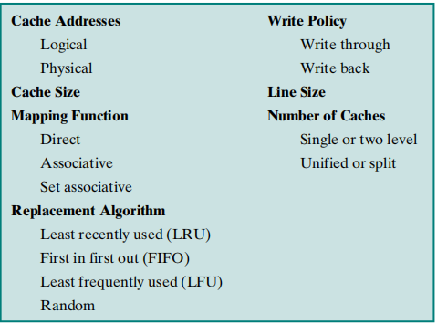

Cache Address
Virtual memory is a facility that allows programs to address memory from logical point of view, without regard to the amount of main memory physically available. For reads to and writes from main memory, a hardware memory management unit (MMU) translates each virtual address into a physical address in memory.
Cache memory can be located either side of a memory management unit or use either physical or logical addresses as its tag data. In terms of performance, the location of the cache can dramatically affect system performance.
With a logical cache, the tag information refers to the logical addresses currently in use by the executing task. If the task is switched out during a context switch, the cache tags are no longer valid and the cache, together with its often hard-won data must be flushed and cleared. The processor must now go to main memory to fetch the first instructions and wait until the second iteration before any benefit is obtained from the cache. However, cache accesses do not need to go through the MMU and do not suffer from any associated delay.
Physical caches use physical addresses, do not need flushing on a context switch and therefore data is preserved within the cache. The disadvantage is that all accesses must go through the memory management unit, thus incurring delays. Particular care must also be exercised when pages are swapped to and from disk.
If the processor does not invalidate any associated cache entries, the cache contents will be different from the main memory contents by virtue of the new page that has been swapped in.
Of the two systems, physical caches are more efficient, providing the cache coherency problem is solved and MMU delays are kept to a minimum. RISC architectures like the PowerPC solve the MMU delay issue by coupling the MMU with the cache system. An MMU translation is performed in conjunction with the cache look up so that the translation delay overlaps the memory access and is reduced to zero. This system combines the speed advantages of a logical cache with the data efficiency of a physical cache.
Most internal caches are now designed to use the physical address (notable exceptions are some implementations of the SPARC architecture which use logical internal caches).

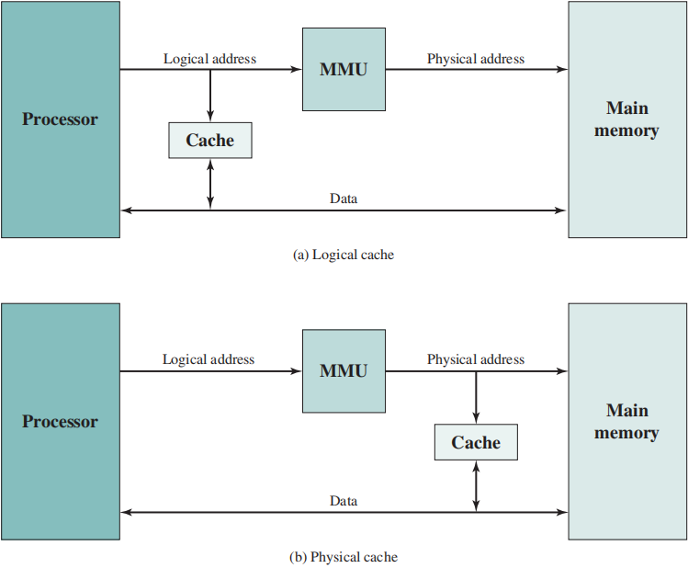

Reference

- Logical versus physical caches. (n.d.). BrainKart. https://www.brainkart.com/article/Logical-versus-physical-caches_7647/
- Stallings, W. (2010). Computer Organization and Architecture: Designing for performance. In Internet Archive (Internet Archive). http://archive.org/details/computerorganiza00stal

