

Practical Malware Analysis & Triage

Malware Analysis Report

Remote Access Trojan Malware

Aug. 2022 | eyyys3c | v1.0

# Table of Contents

Table of Contents 2

Executive Summary 3

Malware Composition 5

msdcorelib.exe 5

Basic Static Analysis 6

Basic Dynamic Analysis 7

Advanced Static Analysis 8

Advanced Dynamic Analysis 9

Indicators of Compromise 10

Network Indicators 10

Host-based Indicators 11

Rules & Signatures 13

Appendices 14

A. Yara Rules 14

B. Callback URLs 14

C. Decompiled Code Snippets 15

# Executive Summary

|  |  |
| --- | --- |
| SHA256 hash |  |

Remote Access Trojans (RATs) are malware designed to allow an attacker to remotely control an infected computer. In this sample, the malware will start to query a specific call back URL to download the initial payload *msdcorelib.exe* which will also open a listening socket on the infected machine.

URL: http://serv1.ec2-102-95-13-2-ubuntu.local/

Open listening socket on port 5555

msdcorelib.exe

# Malware Composition

RAT consists of the following components:

|  |  |
| --- | --- |
| File Name | SHA256 Hash |
| msdcorelib.exe |  |

msdcorelib.exe

The executable that runs after a successfully connecting to the callback URL

# Basic Static Analysis

# Floss/Strings

# 

# Basic Dynamic Analysis

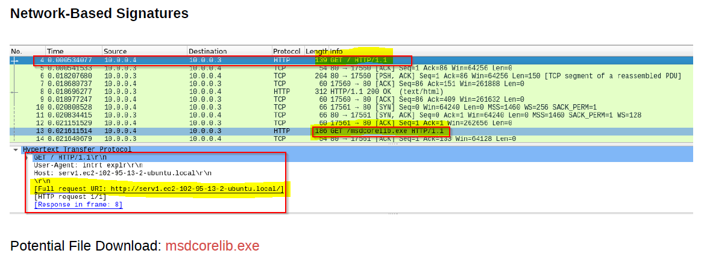

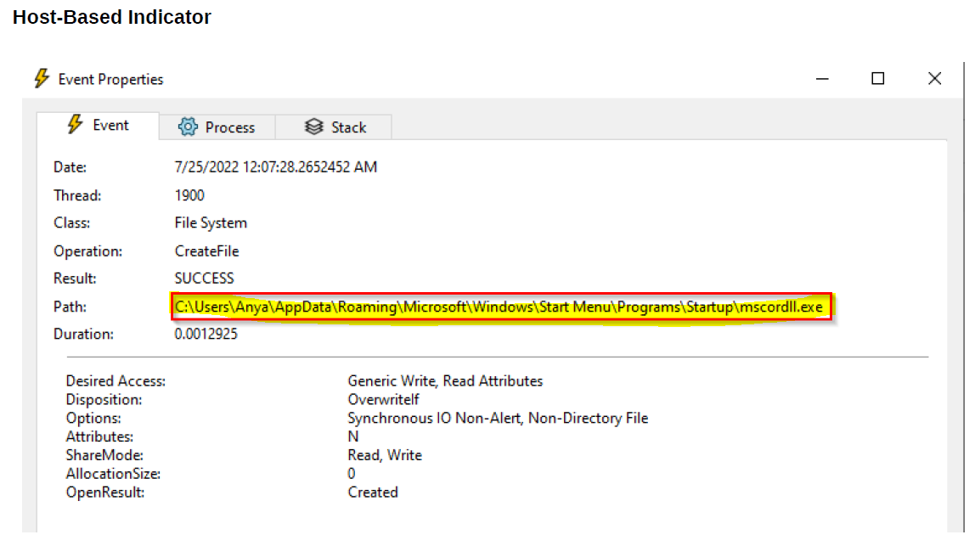

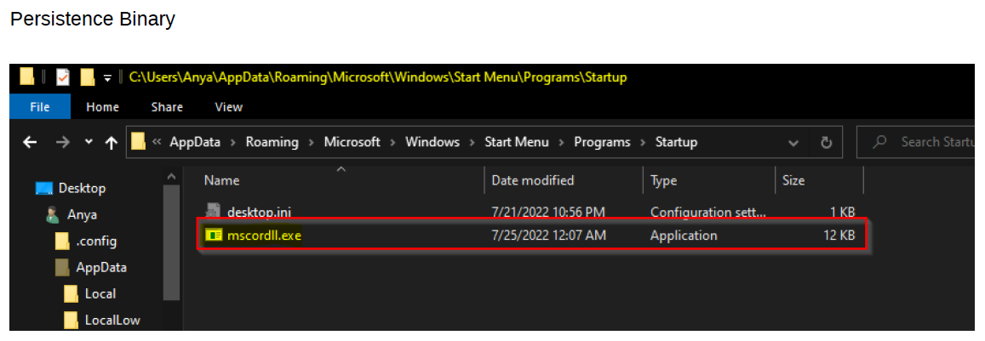

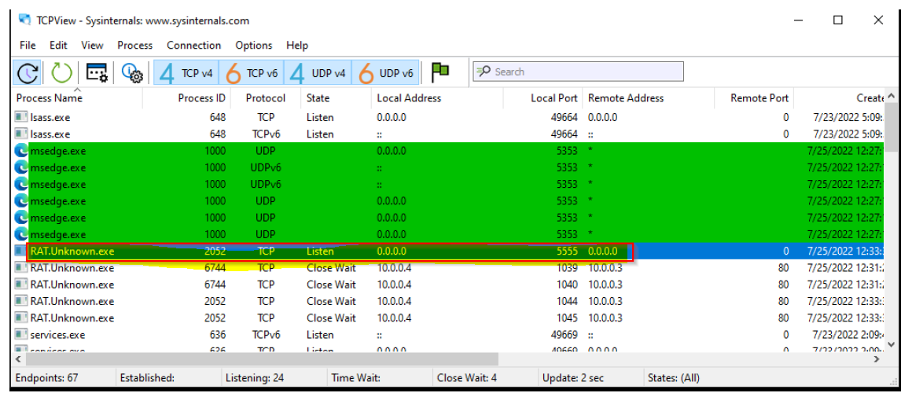

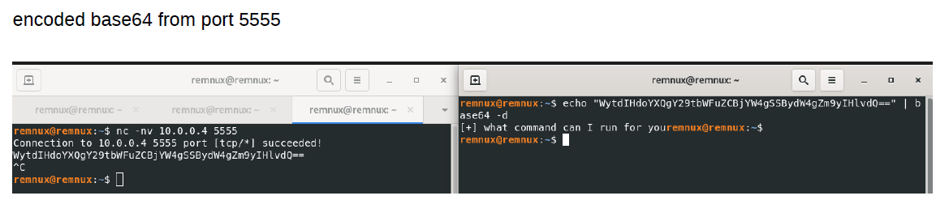

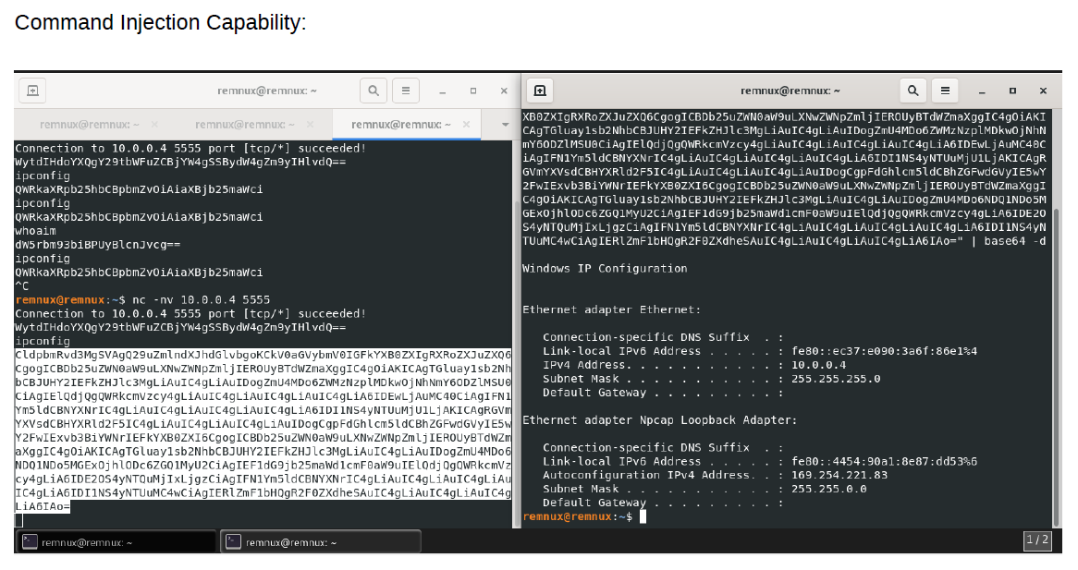

# Advanced Static Analysis

# Advanced Dynamic Analysis

# Indicators of Compromise

The full list of IOCs can be found in the Appendices.

## Network Indicators

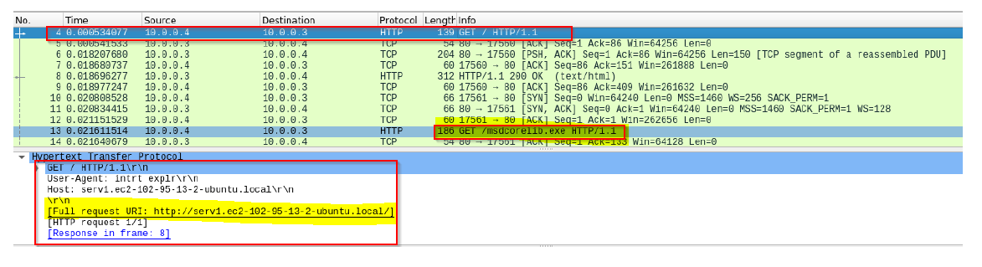

## Host-based Indicators

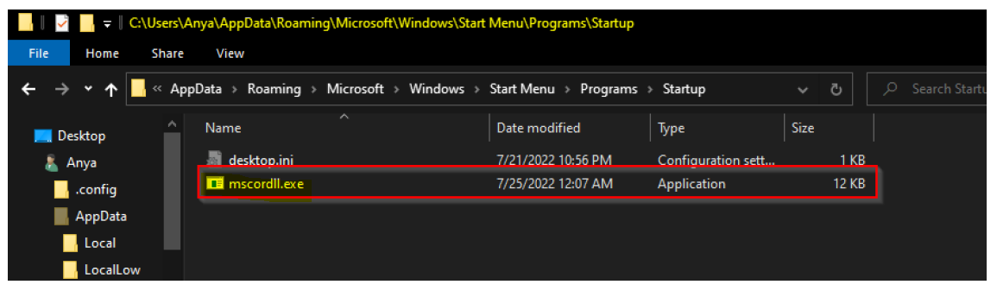

# Rules & Signatures

A full set of YARA rules is included in Appendix A.

# Appendices

## Yara Rules

## Callback URLs

|  |  |
| --- | --- |
| Domain | Port |
| hxxp://serv1.ec2-102-95-13-2-ubuntu.local/ | 80 |

## Decompiled Code Snippets

*Fig 5: Process Injection Routine in Cutter*