
Radio Technical Commission for Maritime Services
1800 N. Kent St., Suite 1060
Arlington, Virginia 22209-2109
www.rtcm.org hq@rtcm.org

Telephone: +1-703-527-2000 Telefax: +1-703-351-9932

July 24, 2009

DGNSS Standards, Version 2.4, Draft 5 - Revision and Issues
Rudy Kalafus, Trimble Navigation

Summary:
Draft 5 of the proposed Version 2.4 DGNSS Standard is contained in this paper. It contains a number of changes from Version 2.3:
- Deleted a number of sections from Chapter 1, "Introduction", in particular the descriptions of aeronautical and maritime navigation systems that are not GNSS's or don't support DGNSS operation.
- Deleted Chapter 2, "The Need for DGNSS Services", which is no longer required.
- Revised Message Type 3, "GPS Reference Station Parameters" to make it a generic message that applies to GLONASS and Galileo, and marked for retirement the corresponding GLONASS Message Type 32. This required a change in the title, but no change in the message format or data fields. This was made possible by the fact that all three existing systems now have reference frames that are adequately characterized by the International Terrestrial Reference Frame (ITRF).
- Modified and made permanent Message Type 4, "Reference Station Datum Message" to add Galileo as a service, and to substitute "ITRF" for "WGS-84/PE-90", thus referencing all GNSS datums to ITRF.
- Marked for retirement Message Type 7, "DGPS Radiobeacon Almanac", as it will be subsumed into the generic Message type 27.
- Made permanent Message Type 17, "GPS Ephemerides", as the same message is in the Version 3 standard.
- Retired Message Types 20 and 21, Pseudorange and Carrier Phase Corrections, as being redundant with respect to the universally utilized Message Types 19 and 20, which employ pseudorange and carrier phase measurements.
- Marked for retirement Message Type 22, "Extended Reference Station Parameters", as it has been subsumed by Message Type 24, "Reference Station Antenna Reference Point (ARP) Parameters"
- Made permanent Message Type 23, "Antenna Type Definition Record" and Message Type 24, "Reference Station Antenna Reference Point (ARP) Parameters"
- Incorporated Message Type 27, "Extended DGPS Radiobeacon Almanac", which was defined in an addendum to Version 2.3, into the standard as a permanent message. Also, modified the title and text to reflect the fact that the message type supports all existing GNSS's, particularly in view of the harmonization of reference frames (see item 3 above).
- Marked for retirement the tentative Message Type 31, "Differential GLONASS Corrections", because the pre-GLONASS-M satellites will soon no longer be in service, making the awkward procedure required to apply this message no longer necessary. The new generic DGNSS message, Message Type 41 will be used for broadcasting DGLONASS differential corrections.
- Marked for retirement the tentative Message Type 32, "GLONASS Reference Station Parameters", because Message Type 3 has been made a generic message for all GNSS's (see Item 3 above).
- Marked for retirement Message Type 33, "GLONASS Constellation Health". The new generic DGNSS message, Message Type 43 will be used for broadcasting a "GNSS Constellation Health" Message.
- Marked for retirement the tentative Message Type 34, "GLONASS Partial Correction Set (N>1)" and "GLONASS Null Frame (N≤1)". The new Message Type 42 serves the same purpose, and will be used instead.
- Marked for retirement the tentative Message Type 35, "GLONASS Radiobeacon Almanac", as it will be subsumed into the generic Message Type 27.
- Made permanent Message Type 36, "GLONASS Special Message", which enables text messages to be broadcast in English or Russian.
- Made permanent Message type 37, "GNSS System Time Offset", which gives the time differences between different GNSS's; added Galileo.
- Added generic GNSS Message Type 41, "GNSS Differential Corrections", which includes differential Galileo corrections. Message Types 41-45 are generic, in that they apply to all known and planned GNSS's.
- Added generic GNSS Message Type 42, "GNSS Partial Correction Sets" and redefined it to also serve as a null frame message, as with the GLONASS Message Type 34; as with Message Type 41, it includes DGalileo.
- Added GNSS Message Type 43, "GNSS Navigation Data Validity and Signal Health Status", which includes Galileo.
- Added GNSS Message Type 44, "GNSS Ionospheric Delay ", applicable to all systems and frequencies, including Galileo.
- Added GNSS Message Type 45, "GNSS Local Integrity Alert", which includes Galileo.
- Reserved Message type 46 for future Galileo Integrity Table message.

GNSS REFERENCE STATION PARAMETERS
The International Terrestrial Reference Frame (ITRF) is now the accepted standard for GNSS's. GPS and GLONASS are the same as ITRF at the 10-centimeter level. The Galileo GTRF frame is within 5 cm of the ITRF standard. As a consequence, Message Types 3, 32, and the recently proposed 43 are redundant for the purposes of DGNSS. That is, the remaining differences between the three datums are a small fraction of the accuracies of the systems. Message Type 3 is defined to be generic. Similarly, Message Type 32 is marked for retirement and replaced with type 3.
In this document, Message Type 13, Ground Transmitter Parameters, which provides the location of the data link transmitters, retains its "Tentative" status. RSIM currently does not support this message, but there may be services which do, and this needs to be reviewed.

GENERIC MESSAGES
System ID:
At the Committee meeting of February 4-5, it was decided that the preferred approach for indicating the identification of the GNSS is to insert a header at the beginning of each generic message.
Signal ID:
In order to define generic message types, it is essential to incorporate frequency and code information, in order to accommodate changes already being planned for GPS and GLONASS, namely L2C and L5. Note that the GPS and GLONASS messages in Version 2.3 assume L1-only operation. In this draft of the Version 2.4 standard, a one-byte header is inserted at the beginning of the message: four bits are apportioned for the GNSS System ID, and four for the Signal ID.
Generic Messages:
Message Types 41-45, GNSS messages that support differential operation of GPS, GLONASS, and Galileo, are defined to be generic. They are expected to support any other satellite positioning services in the future, including SBAS.

OTHER ISSUES
Message Type 11 is currently reserved for L2 C/A code differential correctins. Is there any interest in developing this message for L2C in Version 2.4?



RTCM STANDARD 10402.4,

DIFFERENTIAL GNSS

(GLOBAL NAVIGATION SATELLITE SYSTEMS),

Version 2

DEVELOPED BY

RTCM SPECIAL COMMITTEE NO. 104

JULY, 2009

COPYRIGHT©2009 RTCM

Radio Technical Commission For Maritime Services
1800 N. Kent St., Suite 1060
Arlington, Virginia 22209
E-Mail: hq @rtcm.org
Web Site: http://www.rtcm.org

The Radio Technical Commission For Maritime Services (RTCM) is an incorporated non-profit organization, with participation in its work by international representation from both government and non-government organizations. The RTCM does not work to induce sales, it does not test or endorse products, and it does not monitor or enforce the use of its standards.

The RTCM does not engage in the design, sale, manufacture or distribution of equipment or in any way control the use of this standard by any manufacturer, service provider, or user. Use of, and adherence to, this standard is entirely within the control and discretion of each manufacturer, service provider, and user.

For information on RTCM Documents or on
participation in development of future RTCM documents contact:

Radio Technical Commission For Maritime Services
1800 Diagonal Road, Suite 600
Alexandria, Virginia 22314-2840 USA

Telephone: +1-703-527-2000
Telefax: +1-703-351-9932
E-Mail: hq@rtcm.org

RTCM STANDARD 10402.4,

DIFFERENTIAL GNSS

(GLOBAL NAVIGATION SATELLITE SYSTEMS),

Version 2

DEVELOPED BY

RTCM SPECIAL COMMITTEE NO. 104

JULY 2009

COPYRIGHT©2009 RTCM

Radio Technical Commission For Maritime Services
1800 N. Kent St., Suite 1060
Arlington, Virginia 22209
E-Mail: hq@rtcm.org
Web Site: http://www.rtcm.org

.

This page intentionally left blank

PREFACE

This recommended standards document has been developed by RTCM SC-104 to replace the document entitled "RTCM Recommended Standards for Differential Navstar GPS Service, Version 2.3" issued on August 20, 2001.

The results of usage of the RTCM SC-104 standard have been highly successful. While 8-l0 meters (95%) was originally targeted for shipboard applications, recent results have generally been better than 2 meters, often better than 1 meter. These results have been obtained using the C/A code pseudorange measurements, with varying amounts of carrier phase smoothing. Real-time kinematic (RTK) techniques, which operate over smaller areas, have yielded accuracies at the sub-decimeter level.

Governments have taken advantage of the SC-104 standard by prescribing it as the format for publicly supported radiobeacon broadcasts of differential GPS corrections. Coastal waters all over the world have been equipped with radiobeacon-based differential services. This medium is highly attractive because of its low cost, ease of implementation, and accessibility.

Governmental and private service providers had used the RTK messages in the standard to support real-time positioning for construction, precision farming, and robotic mining.

The major changes effected in Version 2.4 are the following:

- Updated the descriptions of differential GNSS to reflect recent developments in satellite systems;
- Completed a new radiobeacon almanac message that supports multiple reference stations and applies to all GNSS's;
- Developed 5 new generic message types that apply to GPS, GLONASS, Galileo and SBAS systems;
- Incorporated differential GLONASS corrections into the new generic differential GNSS message type, taking advantage of the improved GLONASS-M capabilities;
- Updated the status of a number of messages from "Tentative" to "Permanent" to reflect their acceptance by the DGNSS community, and flagged for retirement some messages that are no longer in use or supported by the DGNSS community.

RTCM SC-104 believes that the new material developed here will prove useful in supporting highly accurate differential and kinematic positioning and navigation applications throughout the next decade.

This page intentionally left blank

TABLE OF CONTENTS
1. INTRODUCTION
1.1 SUMMARY 1-1
1.2 BACKGROUND - SATELLITE NAVIGATION AND POSITIONING
SERVICES 1-2
1.2.1 General 1-2
1.2.2 GPS 1-2
1.2.3 GLONASS 1-3
1.2.4 Galileo 1-4
1.2.5 SBAS/WAAS 1-6
1.3 DIFFERENTIAL GNSS SYSTEMS 1-7
1.3.1 Differential GNSS Description 1-7
1.3.2 Maritime Radiobeacon DGNSS Systems 1-8
1.3.3 Continuously Operating Reference Systems (CORS) 1-9
1.3.4 Loran-Based DGNSS Systems 1-9

2. THE NEED FOR DIFFERENTIAL GNSS SERVICE (Deleted) 2-1

3. EQUIPMENT CONFIGURATION AND DESIGN REQUIREMENTS
3.1 GENERAL 3-1
3.2 REFERENCE STATION 3-1
3.2.1 Components 3-1
3.2.2 Receiver Architecture 3-1
3.2.3 Satellite Acquisition 3-3
3.2.4 Method of Measurement 3-3
3.2.5 Timing Reference of the Corrections 3-3
3.2.6 Satellite Health Assessment 3-5
3.2.7 Ionospheric Effects 3-5
3.2.8 Tropospheric Effects 3-6
3.2.9 Reference Station Clock 3-6
3.2.10 Multipath 3-7
3.2.11 Reference Station Datum Considerations 3-7
3.3 USER EQUIPMENT 3-9
3.3.1 Components 3-9
3.3.2 Sensor Architecture 3-9
3.3.3 Application of the Differential GNSS Corrections 3-9
3.3.4 GPS/GLONASS Receiver 3-10
3.4 DATA LINK 3-10
3.5 PSEUDOLITE TECHNIQUE 3-12
3.6 REAL-TIME KINEMATIC OPERATION 3-13

4. RECOMMENDED DATA MESSAGE FORMAT
4.1 INTRODUCTION 4-1
4.2 GENERAL MESSAGE FORMAT 4-2
4.2.1 First and Second Words 4-2
4.3 MESSAGE TYPE CONTENTS AND FORMATS 4-6
4.3.1 Message Type 1 - Differential GPS Corrections (Permanent) 4-8
4.3.2 Message Type 2 - Delta Differential GPS Corrections (Retired) 4-12
4.3.3 Message Type 3 - GNSS Reference Station Parameters (Permanent) 4-13
4.3.4 Message Type 4 - Reference Station Datum Message (Permanent) 4-15
4.3.5 Message Type 5 - GPS Constellation Health (Permanent) 4-18
4.3.6 Message Type 6 - GPS Null Frame (Permanent) 4-20
4.3.7 Message Type 7 - DGPS Radiobeacon Almanac (To be retired) 4-20
4.3.8 Message Type 8 - Pseudolite Almanac (Tentative) 4-23
4.3.9 Message Type 9 - GPS Partial Correction Set (Permanent) 4-24
4.3.10 Message Type 10 - P-Code Differential Corrections (Reserved) 4-24
4.3.11 Message Type 11 - C/A Code L2 Corrections (Reserved) 4-25
4.3.12 Message Type 12 - Pseudolite Station Parameters (Reserved) 4-25
4.3.13 Message Type 13 - Ground Transmitter Parameters 4-25
4.3.14 Message Type 14 - GPS Time of Week (Permanent) 4-26
4.3.15 Message Type 15 - Ionospheric Delay Message (Permanent) 4-27
4.3.16 Message Type 16 - GPS Special Message (Permanent) 4-29
4.3.17 Message Type 17 - GPS Ephemerides (Permanent) 4-29
4.3.18 Kinematic and High-Accuracy Messages 4-32
4.3.19 Message Type 18 - RTK Uncorrected Carrier Phases (Permanent) 4-38
4.3.20 Message Type 19 - RTK Uncorrected Pseudoranges (Permanent) 4-42
4.3.21 Message Type 20 - RTK Carrier Phase Corrections (Retired) 4-47
4.3.22 Message Type 21 - High-Accuracy Pseudorange Corrections (Retired) 4-47
4.3.23 Message Type 22 - Extended Ref. Station Parameters (To be retired) 4-47
4.3.24 Message Type 23 - Antenna Type Definition Record (Permanent) 4-49
4.3.25 Message Type 24 - Antenna Reference Point (ARP) (Permanent) 4-53
4.3.26 Message Types 25-26 (Undefined) 4-56
    - Message Type 27 - Extended Radiobeacon Almanac (Permanent) 4-56
    - Message Types 28-30 (Undefined) 4-59
    - Message Type 31 - Differential GLONASS Corrections (To be retired) 4-60
4.3.30 Message Type 32 - GLONASS Ref. Station Parameters (To be retired) 4-65
4.3.31 Message Type 33 - GLONASS Constellation Health (To be retired) 4-66
4.3.32 Message Type 34 - GLONASS Partial Correction Set (To be retired) 4-68
4.3.33 Message Type 34 - GLONASS Null Frame (To be retired) 4-69
4.3.34 Message Type 35 - GLONASS Radiobeacon Almanac (To be retired) 4-69
4.3.35 Message Type 36 - GLONASS Special Message (Permanent) 4-73
4.3.36 Message Type 37 - GNSS System Time Offset (Permanent) 4-73
4.3.37 Message Types 38-40 (Undefined) 4-75
4.3.38 Message Type 41 - GNSS Differential Corrections (Tentative) 4-75
4.3.39 Message Type 42 - GNSS Partial Correction Sets (Tentative) 4-82
4.3.40 Message Type 42 - GNSS Null Frame (Tentative) 4-83
4.3.41 Message Type 43 - GNSS Navigation Data Validity (Tentative) 4-83
4.3.42 Message Type 44 - GNSS Ionospheric Delay (Tentative) 4-85
4.3.43 Message Type 45 - GNSS Local Integrity Alert (Tentative) 4-88
4.3.44 Message Type 46 - GNSS Integrity Table (Reserved) 4-90
4.3.45 Message Types 47-58 (Undefined) 4-90
4.3.Message Type 59 - Proprietary Message (Permanent) 4-90
4.3.39 Message Types 60-63 - Multipurpose Usage (Reserved) 4-90

5. GNSS RECEIVER TO DATA LINK EQUIPMENT INTERFACE
5.1 INTRODUCTION 5-1
5.2 INTERFACE SPECIFICATION 5-1
5.3 IMPORTANT INTERFACE RULES 5-2
5.3.1 Byte Format Rule 5-2
5.3.2 Most Significant Bit First Rule 5-2
5.3.3 Bit Slip Rule 5-2
5.3.4 Terminal Equipment Rule 5-3
5.3.5 Complete Message Decode Rule 5-3
5.4 EQUIPMENT OPTIONS 5-3
5.5 DATA LINK INTERFACING EXAMPLES 5-3
5.5.1 Methods of Data Link Interfacing 5-3
5.5.2 Radiobeacon Minimum Shift Keying (MSK) Data Link 5-4
5.6 REFERENCES 5-5

6. RECOMMENDED DATA MESSAGE FORMAT FOR LORAN-COMM
BROADCASTS
6.1 MESSAGE STRUCTURE FOR LORAN-COMM SYSTEMS 6-1
6.1.1 Timing and Modulation 6-1
    - Message Length 6-3
    - Cyclic Redundancy Check (CRC) 6-3
    - Reed-Solomon Algorithm 6-3
    - Data Rate and Message Rate 6-5
6.2 RELATION TO THE CONVENTIONAL DGNSS STANDARD 6-5
6.3 GENERAL LORAN-COMM MESSAGE FORMAT 6-6
    - Type 1, Differential GPS Data 6-6
    - Type 2, Differential GLONASS Data 6-7
    - Type 3, Health Data 6-7
    - Type 4, Time Reference Message 6-7
    - Type 5, Text Message 6-8
    - Type 6, Loran-C Baseline Extension Time Difference 6-8
    - Type 7 Message – Reserved 6-9
    - Type 8 Message – Reserved 6-9

APPENDIX A: DATA QUALITY INDICATOR FOR CARRIER PHASE
CORRECTION AND MEASUREMENT MESSAGES
A.1 INTRODUCTION A-1
A.2 REFERENCE STATION RECEIVER MEASUREMENTS A-1
A.3 DATA QUALITY INDICATOR QUANTIZATION A-4

APPENDIX B: DATA QUALITY AND MULTIPATH ERROR INDICATORS
FOR PSEUDORANGE CORRECTION AND MEASUREMENT MESSAGES
B.1 INTRODUCTION B-1
B.2 DATA QUALITY INDICATOR B-1
B.3 MULTIPATH ERROR INDICATOR B-2

APPENDIX C: GPS SATELLITE POSITION COMPUTATION TEST FILES
C.1 INTRODUCTION C-1
C.2 TEST CASE GENERATION C-1
C.2.1 Earth's Rotation Correction C-1
C.2.2 Test Case Details C-2

APPENDIX D: DATUM SELECTION FOR DIFFERENTIAL GPS REFERENCE
STATIONS D-1

APPENDIX E: SOURCES OF DGNSS INFORMATION
E.1 UNITED STATES - COAST GUARD NAVIGATION INFORMATION E-1
SERVICE (NIS)
E.2 RUSSIA - INTERGOVERNMENTAL NAVIGATION INFORMATION E-2
CENTER (INIC)

APPENDIX F: 8-BIT REPRESENTATION OF RUSSIAN ALPHABET F-1

APPENDIX G: Loran-C UTC Synchronization
G.1 BACKGROUND AND DEFINITIONS G-1
G.1.1 Synchronization G-1
G.1.2 Loran-C Timing G-1
G.1.3 Coordinated Universal Time (UTC) and International Atomic Time (TAI) G-3
G.1.4 UTC and Leap Seconds G-4
G.1.5 CTR Relationship to UTC G-5
G.2 GENERAL DESCRIPTION OF THE ALGORITHM G-5
G.2.1 TOC Interval Computation G-6
G.2.2 TOC_{o} Computation G-7
G.2.3 TOC Before an Arbitrary Time G-8
G.2.4 Loran-C Offset at Any Second (UNTOC) G-9
ATTACHM’T I-A, TOCI COMPUTATION USING EUCLID’S ALGORITHM G-10
ATTACHM’T I-B, JULIAN DAY AND MODIFIED JULIAN DAY G-11

1. INTRODUCTION
1.1 SUMMARY

The Global Positioning System (GPS) and the GLObal NAvigation Satellite System (GLONASS) are satellite-based positioning systems that are currently providing global service 24 hours each day. Augmentation of these systems by geostationary satellites with transponders operating in the same frequency bands is now in the planning and implementation stages. Generically they are called Global Navigation Satellite Systems (GNSS’s). Differential GNSS service, which achieves high accuracies by providing corrections to the GNSS satellite ranging measurements, is accomplished by broadcasting corrections from a reference station placed at a known location. The RTCM Special Committee 104 (SC-104), Differential GNSS Service, has examined the technical and institutional issues, and has formulated recommendations in the following areas:

(1) Data Message and Format - The message elements that make up the corrections, the status messages, the station parameters, and ancillary data are defined in some detail. They are structured into a data format similar to that of the GPS satellite signals, but a variable-length format is employed.

(2) User Interface - A standard interface is defined which enables a receiver to be used with a variety of different data links. For example, using the standard, a receiver can be used with a VHF or radiobeacon data link.

A number of different messages have been defined in the Data Message and Format area, with different levels of finality. Some message types are "permanent", i.e., the data fields and format will not be subject to change (although there may be new text added for clarification). If they prove inadequate in the future for some reason, new messages will be defined to accommodate the new situations; however, the message structure is considered permanent for Version 2. Some message types are considered "tentative", and may become permanent (in their current or altered form) at some future time, if field experience with them justifies it. Still other message types have been reserved for specific use, but their content has not been defined or proposed.

There are two institutional issues associated with the standard: (l) Who assigns the station identification numbers? and (2) Who assigns codes for special-purpose service providers? IALA is now providing coordination of station identification numbers and names for radiobeacon-based systems internationally. For other systems, each service provider has been free to assign station identification numbers at will, and confusion has been avoided because the data links have been distinct, and have not usually interfered with each other. As for the proprietary service provider codes, RTCM assigns them this as the need arises.

The Committee has attempted to accommodate the widest possible user community, including not only marine users, but land-based users as well. Both radiolocation and radionavigation applications are supported. Provision is made for ultra-high accuracy static and kinematic techniques that enable decimeter and even centimeter relative positioning. A standard data link interface is defined which enables a receiver to utilize different data links to receive corrections.

It is expected that the RTCM SC-104 format will support the most stringent and unique applications of this high-accuracy positioning technique.

1.2 BACKGROUND - SATELLITE NAVIGATION AND POSITIONING SERVICES

1.2.1 General

Navigation and positioning systems are used extensively in governmental and commercial activities for a variety of purposes. Radio signals have been used for decades to provide homing references and lines of position. In the past twenty years, satellite-based systems, and Global Navigation Satellite Systems (GNSS's) in particular, have come to be the primary providers of navigation and positioning services. The radiobeacon systems and the long-range, low-frequency systems (LORAN-C and CHAYKA) still operate, and their capabilities have been exploited to provide differential corrections for GNSS's. The following sections describe some of the GNSS's and their differential operation.

1.2.2 GPS

The Global Positioning System (GPS) was developed by the Department of Defense under Air Force Management through the GPS Joint Program Office at the USAF Space Division. The GPS is currently operating in its Final Operational Capability, with 24 Block II satellites deployed. The replacement Block IIR satellites are now being developed. The DoD plans to pursue a replacement program that supports a 98% availability of at least 21 satellites.

GPS is a coarse/fine system that uses the coarse signal (C/A code) for acquisition and data, and the fine system (P-code) for high-accuracy military navigation and positioning. Until May 2000 it was the policy of the U.S. government to provide a Standard Positioning Service (SPS) at a 100 meter (95%) accuracy level. However, Selective Availability has been turned off permanently, so that the SPS now supports an accuracy of about 20 meters (95%). The SPS is provided using the C/A code portion of the GPS signals.

The constellation now consists of about 30 operating satellites in 6 orbital planes. The orbital planes are oriented at about 55 degrees from equatorial. Each satellite transmits at the same frequency, but employs a unique code. The signals are of the spread spectrum type, using biphase coding with a chipping rate of 1 MHz and a repeating sequence of 1023 chips. The frequency of operation is 1575.42 MHz for the Standard Positioning Service (SPS).

In addition to the signal described above, military sets have access to the two-frequency Precise Positioning Service (PPS), which employs very long, encrypted sequences to ensure security of transmission. The second frequency increases the accuracy because the effects of the ionosphere can be ameliorated.

The satellites transmit data at a 50 bps rate. The data message provides health status, identification, ephemeris (orbital) information, satellite clock correction, ionospheric correction coefficients, and a host of other data. The ephemerides of the satellites are referenced to the DoD's World Geodetic System of 1984 (WGS-84).

A user receiver times the arrival of each satellite signal by synchronizing an internal signal having that satellite's code with the satellite signal (code-tracking). Knowledge of the satellite's position is derived from the data transmission. This knowledge, along with the time-of-arrival measurements from 4 or more satellites, enables the user to estimate his position and time. In addition to the code-tracking measurement, it is also possible to phase-lock onto the carrier. This enables a similar estimate of velocity. Advanced processing techniques use the carrier phase measurements to improve position estimates.

There are a number of different receiver design techniques, each tailored to different operating environments. They can be grouped into three basically different approaches: multi-channel parallel, single-channel multiplexed, and single-channel sequential designs. In the multi-channel parallel design, each channel is dedicated to one satellite. In the multiplex design, each satellite signal is sampled very rapidly; it has the multi-channel feature of essentially continuous tracking, with a loss of signal-to-noise ratio. In the sequential design, the receiver dwells for a short time on each satellite. There are variations: some multi-channel designs employ a fifth channel to pre-track the next rising satellite. Due to the fact that the cost for additional channels is becoming a small fraction of the overall receiver costs, most receivers are multi-channel.

The possibility of having a navigation instrument which can be used everywhere, which is available 24 hours a day, and which provides about 20 meter accuracy, is a prospect which will be welcomed in many quarters of the user community. However, there are other users that would like much greater accuracy for their applications. For them, differential GPS may offer an economically viable solution.

1.2.3 GLONASS

Developed and operated by Russia, the GLObal NAvigation Satellite System (GLONASS) is similar to the US GPS in that it is a space-based navigation system providing global, 24 hour, all-weather access to precise position, velocity and time information to a properly equipped user. The constellation design consists of 24 satellites in 3 orbital planes at 19,100 km altitude, corresponding to an 11h 15m period. Orbital inclination is 64.8 degrees, as opposed to the 55 degrees of GPS. As with GPS, each GLONASS satellite continuously broadcasts its own precise position (ephemeris) as well as less precise position information for the entire constellation (almanac). While like GPS the almanac consists of orbital parameters, GLONASS ephemeris data are in the form of Earth-Centered-Earth-Fixed (ECEF) position, velocity and lunar/solar-induced acceleration. In addition, GLONASS ECEF coordinates are referenced to the PE-90 datum (Parameters of the Earth, 1990), not the WGS-84 datum used by GPS, although they are very similar. Parallel, multiplexed, and sequential receiver designs are possible, but most receivers are expected to be multi-channel.

Each GLONASS satellite uses two carrier frequencies in the L band, which, contrary to the GPS implementation, are different for each satellite. The L1 band ranges from 1602.5625 MHz to 1615.5 MHz in steps of 0.5625 MHz, while the L2 band ranges from 1246.4375 MHz to 1256.5 MHz in steps of 0.4375 MHz. Each of these signals is modulated by either or both of a 5.11 MHz High Precision Navigation Signal (HPNS) and/or a 0.511 MHz Standard Precision Navigation Signal (SPNS). The binary signals are formed by a HPNS code or an SPNS code which is modulo-2 added to L1 in phase quadrature (only HPNS is present on L2). The HPNS code is a pseudorandom sequence with a period of one second, while the SPNS code is a pseudorandom sequence with a period of 1 ms. In contrast to GPS where all codes are unique to a specific satellite, a single GLONASS code is used for all satellites. GLONASS receivers duplicate the HPNS and/or SPNS codes and the transmission time is determined by measuring the offset that is to be applied to the locally generated code to synchronize it with the code received from the satellite.

In an effort to reduce the bandwidth utilized by GLONASS as well as to reduce interference in the radio astronomy band, the GLONASS operators have formulated a transitional frequency plan as follows: frequency channels 16 through 20 will be avoided. Channels 13, 14, and 21 will be used, but with some limitations, while channel 15 will not be used. Satellites in the same plane separated by 180 degrees will broadcast on the same frequency. It is expected that future satellites will be equipped with filters which reduce the level of out-of-band emissions in the frequency band 1660-1670 MHz to the level meeting Recommendation ITU-R769 requirements. Channels above 13 will not be used, except for channel 13, which will be used as little as possible. After 2005, the GLONASS L1 band will be shifted to 1598.0625-1605.375 MHz, and the L2 band will be shifted to 1242.9375-1248.625 MHz. Channels will then be designated by the numbers -7 to +6.

Field testing of GLONASS receivers has demonstrated accuracies of 45 meters (95%) or better.

GLONASS time is related to UTC(SU) whereas GPS time is related to UTC(USNO).

A differential GLONASS implementation for both code and carrier phase is useful and feasible. This version of the RTCM standard includes messages for differential GLONASS operation.

1.2.4 Galileo

Galileo provides 10 signals in three frequency ranges 1164-1215 MHz (E5), 1215-1300 MHz (E6) and 1559-1591 MHz (E1), in the Radio-Navigation Satellite Service (RNSS) allocated frequency bands. Table 1-1 and Table 1-2 show the main characteristics of the various signals and range codes as well as allocations with respect to the basic navigation services .

Out of the 10 Galileo signals, 4 are pilot signals which do not carry navigation data and which are intended to increase the tracking robustness at receiver level. This leaves 6 navigation signals, of which 3 are open (free of charge) for use in the Open and Safety of Life services. The two PRS signals and the Commercial service have both code and navdata encrypted.

It should be noted that the E5a and E5b signals will be transmitted coherently as a wide-band Alternative (Alt) BOC(15,10) modulated signal having a side-band sub-carrier rate equal to 15.345 MHz (15x1.023 MHz) and code rate equal to 10.230 MHz (10x1.023 MHz). This signal is then amplified and transmitted at the 1191.795 MHz carrier frequency.
The wide-band AltBOC signal allows the receivers to track the E5a and E5b bands in two modes:
- E5a and E5b separately, on their respective carriers
- E5a and E5b together (E5ab), as one single wide-band signal centered at 1191.795MHz. Tracking the E5a and E5b signals coherently offers enhanced performances in terms of code tracking noise and multipath.

In the practice, one could say that the introduction of AltBOC adds a fifth carrier frequency to the Galileo spectrum: a fully-featured Galileo receiver could produce code and carrier phase observables from the carriers given in Table 1-2 (although most receivers will probably only support a subset of these carriers).

Table 1-1. General Characteristics of Galileo Signals Components

Signal no. | Signal | Carrier frequency (MHz) | Channel designation | Symbol rate Navdata (symbols/s) | Notes ¹⁾
1 | Data signal in E5a | 1176.450 | E5a-I | 50 | OS; open, no encryption
2 | Pilot signal in E5a | 1176.450 | E5a-Q | - | No data
3 | Data signal in E5b | 1207.140 | E5b-I | 250 | OS, SoL; open, no encryption
4 | Pilot signal in E5b | 1207.140 | E5b-Q | - | No data
5 | Data signal in E6 | 1278.750 | E6-A | Classified | PRS; encrypted code and data
6 | Data signal in E6 | 1278.750 | E6-B | 1000 | CS, encrypted code and data
7 | Pilot signal in E6 | 1278.750 | E6-C | - | Encrypted code; No data
8 | Data signal in E1 (L1 band) | 1575.420 | E1-A | Classified | PRS; encrypted code and data
9 | Data signal in E1 (L1 band) | 1575.420 | E1-B | 250 | OS, SoL; open, no encryption
10 | Pilot signal in E1 (L1 band) | 1575.420 | E1-C | - | No data
1) OS: Open Service, CS: Commercial service, SoL: Safety of Life service, PRS: Public Regulated service

Table 1-2. General Characteristics of Galileo Observables

No. | Observable name | Carrier frequency (MHz) | Chip Rate (Mchip/s) | Notes
1 | E5a | 1176.450 | 10.230 | Open code and data
2 | E5b | 1207.140 | 10.230 | Open code and data
3 | E5ab (Alt-BOC) | 1191.795 | 10.230 | High performance signal
4 | E6-A | 1278.750 | 5.115 | Classified
5 | E6-BC | 1278.750 | 5.115 | CS, code and data encrypted
6 | E1-A | 1575.420 | 2.5575 | Classified
7 | E1-BC | 1575.420 | 1.023 | Open code and data

Galileo observables are user measurements provided by Galileo receivers. Each Galileo observable is a set of 4 measurements, which includes a code pseudorange, a carrier phase measurement, a Doppler (or range rate), and an SNR (signal-to-noise ratio). The difference between Table 1-1 and Table 1-2 is due to the fact that according to the design concept of the Galileo signals, the data and pilot components of each signal are tracked together and result in one measurement. Due to the AltBOC modulation scheme, the E5a and E5b signals can also be tracked co-operatively, which leads to a high performance Alt-BOC observable.

The GALILEO Ground Segment includes a global network of Sensor Stations (GSS), collecting navigation data from the GALILEO satellites, and Up-link Stations (ULS) both for Tracking, Telemetry and Command (TT&C) and specific mission related up-links for dissemination of integrity related and other information.

Real-time integrity information is provided by a subset of satellites which are connected to a ULS at any one time, and a minimum of 2 connected satellites are in view at the worst user location world-wide.

The integrity related information is disseminated via the I/NAV navigation message included in the Safety of Life service signals (see Table 1-1), and two kinds of Integrity Data are supplied:
- Integrity Tables that include flags to indicate the integrity status of each navigation data broadcast by each satellite, and
- Integrity Alerts to be broadcast with an alert process that enables to update the integrity information in real-time (each 1 s)

The integrity flags (IF, 4 bits) associated with the Integrity Tables indicate the Monitoring Accuracy of the Signal in Space (SIS), named SISMA, for the specific satellite, while the Integrity Alert Indicator (IAI, 1 bit) associated with the Integrity Alerts only have two values: OK or Not OK.
The IF flag value 0 indicates that the satellite is NOT OK for use, while the IF flag value 15 indicate that the satellite is not monitored.

The GALILEO Integrity Concept also has provision for external Regional Integrity Data in addition to the global data provided by the core Ground Segment. In this way, specific geographic regions may take responsibility for disseminating integrity data for their region.

1.2.5 SBAS/WAAS/EGNOS

Several satellite systems which could augment GPS and GLONASS are currently being considered or developed at this time. These systems are based on the use of additional geostationary satellites.

In the U.S., the Federal Aviation Administration (FAA) is currently developing a Wide Area Augmentation System (WAAS) which will provide integrity information and differential corrections primarily for aeronautical use. This system currently uses INMARSAT-III satellites that contain navigation payloads. These navigation payloads have the ability to provide additional ranging signals to properly designed GPS receivers. They differ from normal GPS signals in that they will not have a large Doppler component associated with satellite motion. The navigation message will be five times longer, and the range of the satellite ID numbers will be from 33-64. The use of the larger data message will provide about 200 bits of information each second for the transmission of wide area correction information for all satellites within the WAAS coverage area. The main advantages of the WAAS are that it requires only a limited number of reference stations, and does not require an additional data link for the broadcast of differential corrections. The main disadvantages of the WAAS are the limited visibility to urban ground-based users, lack of availability at polar latitudes, the need for localized monitors to ensure that all ionospheric effects are accounted for, and the lack of a range rate correction.

The European Space Agency (ESA) also employs a space-based augmentation system (European Global Navigation Overlay System, or EGNOS) on the INMARSAT-III satellites to cover much of Europe. The Japanese government also plans to use their MTSAT satellite to support an augmentation system (Mobile Satellite Augmentation System, or MSAS) in Asia. These systems are similar to, and compatible with, the WAAS. It may prove to be necessary in the future to develop new message types to accommodate these new satellites.

1.3 DIFFERENTIAL GNSS SYSTEMS

1.3.1 Differential GNSS Description

Differential operation of GPS, GLONASS and GALILEO offers the possibility of accuracies of 0.5-3 meters for dynamic, navigation applications. Utilizing kinematic carrier phase techniques, differential GNSS can achieve accuracies better than 10 cm for short baselines, i.e., less than about 20 km. Using networks of reference stations, these accuracies can be obtained over relatively large areas. The basic concept of differential GNSS is simple. A reference receiver is placed at a known, surveyed-in point. Then, since the satellite locations and reference antenna location are known, the ranges can be determined precisely. By comparing these ranges to those obtained from the satellite pseudorange measurements, the pseudorange errors can be accurately estimated, and corrections determined. These corrections can then be broadcast to nearby users, who use them to improve their position solutions. The differential technique works if the preponderant errors are bias errors due to causes outside the receiver. This is the case for GNSS's. The major sources of error are the following:

1. Ionospheric delays - signal propagation group delay, which is typically 20-30 meters during the day to 3-6 meters at night. In two-frequency operation this effect is largely removed by applying the inverse square-law dependence of delay on frequency. Since the paths from the satellite to reference station and mobile user traverse paths very close together through the ionosphere, differential operation cancels most of this out.

3. Tropospheric delays - signal propagation delays caused by the lower atmosphere. While the delays are as much as 30 meters at low satellite elevation angles, they are quite consistent and modellable. Variations in the index of refraction can cause differences (between reference station and user) in signal delays of 1-3 meters for low-lying satellites. Since the paths from the satellite to reference station and mobile user traverse paths very close together through the troposphere, differential operation cancels most of this out as well.

4. Ephemeris error - differences between the actual satellite location and the location predicted by the satellite orbital data. Normally these are quite small, less than 3 meters. Differential operation reduces these to negligible quantities.

5. Satellite clock errors - differences between the satellite clock time and that predicted by the satellite data. The oscillators that time the satellite signal are free-running; the GPS and GLONASS ground control stations monitor their respective satellites, and establish corrections, which are sent up to the satellite to set the data message. The user reads the data and adjusts the signal timing accordingly.

Satellite clock errors are completely compensated by differential operation, as long as both reference and user receivers are employing the same satellite data. Ephemeris errors, unless they are quite large (30 meters or more) are similarly compensated by differential operation. For users near the reference station, the respective signal paths to the satellites are sufficiently close so that compensation is almost complete. As the user-reference station separation is increased, the different ionospheric and tropospheric paths to the satellites will be sufficiently far apart that the atmospheric inhomogeneities may cause the delays to differ somewhat. To the extent they differ, they constitute an error in the differential GNSS measurement, called spatial decorrelation. This type of error will be greater at larger user-station separations, e.g., over several hundred kilometers.

Differential GNSS also provides an integrity monitoring function that detects or ameliorates large satellite signal errors. For many applications, differential GNSS corrections can be used for a satellite even when its message indicates that it is unhealthy.

1.3.2 Maritime Radiobeacon DGNSS Systems

Maritime Radiobeacon DGNSS systems use fixed GNSS reference stations that broadcast pseudo-range corrections using radionavigation radiobeacons. They provide radionavigation accuracy better than 10 meters (2 drms) for harbor entrance and approach areas. Such systems have been deployed in the last few years throughout the world, notably in Canada, Brazil, Scandinavia, and the U.S. The USCG Maritime DGPS Service provides coverage for coastal coverage of the continental U.S., the Great Lakes, Puerto Rico, portions of Alaska and Hawaii, and portions of the Mississippi River Basin (see FRP-99, section 3.2.4). The U.S. also established a Nationwide Differential GPS (NDGPS) service to provide inland coverage for all areas of the U.S. not currently covered by the USCG Maritime DGPS Service.

Maritime Radiobeacon DGNSS systems are usually capable of broadcasting a variety of message types. If an atomic clock reference is available at the ground station, the broadcast usually utilizes Type 9 messages, rather than Type 1 messages, because the resulting service is more robust in the presence of “bursty” background noise that affects low-frequency radiobeacon propagation.

RTCM SC-104 has developed a set of standards for ground stations (RTCM Recommended Standards for Differential Navstar GPS Reference Stations and Integrity Monitors). Version 1.2 of this standard was published by RTCM on August 25, 2006 (RTCM PAPER 221-2006-SC104-STD, "RTCM Standard 10401.2 - RSIM").

1.3.3 Continuously Operating Reference Systems (CORS)

The CORS system is a GPS augmentation being established by the U.S. National Geodetic Service (NGS) to support non-navigation, post-processing applications of GPS. The CORS system provides code range and carrier phase data from a nationwide network of GPS stations for access by the Internet. About 144 stations are currently operating (see FRP-99, section 3.2.4.5).

1.3.4 Loran-Based DGNSS Systems

1.3.4.1 Background
Communication using modulation of the Loran-C radionavigation signal has existed in various forms since the mid-1960’s. However, during the initial design stages of differential global navigation satellite systems (DGNSS), the potential Loran-C data bandwidth was thought to be inadequate for differential corrections. Thus Loran-C was not used in the DGNSS implementations of the early 1990’s. The development of a tri-state pulse position modulation technique by a research team led by Dr. Durk van Willigen at the Technical University of Delft, Netherlands, has proved the utility of Loran-C modulation for the transmission of DGNSS messages. The Delft team called their system “Eurofix”. This standard will refer to systems using these techniques as “Loran-Comm” systems.

The Loran-Comm system, as developed by the Delft team, has demonstrated remarkable accuracy, very long range, and resistance to noise and interference. The system relies on minimized message content, a tri-level pulse position modulation method with data compression, cyclic redundancy coding for integrity, and Reed-Solomon error-correcting coding for resistance to noise and interference. Further, by judicious choice of message content and use of the Loran-C receiver’s database, the output format of the Loran-Comm receiver is made compatible with standard satellite navigation receivers using the RTCM SC-104 DGNSS Standard (Version 2) format for differential corrections. In order to differentiate the standards applicable to the Loran-Comm system, the term “conventional DGNSS” will be used in Version 2.3 to denote the system described in versions of the standard through Version 2.2, i.e., that don’t include Loran-C-based DGNSS transmissions.

The modulation technique used by the Loran-Comm system described in this document is not the only method that can be used with Loran-C without impacting the normal navigation function. The U.S. Coast Guard and Federal Aviation Administration (FAA) are jointly exploring the development of other techniques for modulating the Loran-C signal that may provide significantly higher data rates. The purpose is to determine the potential of such a service to work with the FAA's Wide Area Augmentation System (WAAS), described in Section 1.4 below, by providing additional transmission sources for WAAS broadcasts. It should be noted that the resulting Loran modulation and data format would be incompatible with the Loran-Comm system described in this document. It would be a different system requiring a different Loran receiver design. However, it may prove possible for such a receiver to be designed to output messages described in Chapter 4 of this standard, in a similar manner to Loran-Comm receivers.

1.3.4.2 General Description of the Loran-Comm System

The Loran-Comm system consists of three elements: (1) the reference station and integrity monitor, (2) the users’ Loran-Comm receivers and (3) the messaging standard, described in Chapter 6. Although this document specifically addresses the messaging standard, it assumes certain functional capabilities for the first two elements. The ground station standard, similar to the RSIM standard for radiobeacon based DGNSS, will be developed at some future time.

Compared to a conventional DGNSS ground station, the Loran-Comm ground station has additional capability, based on the co-existence with the Loran-C station timing and control equipment. The timing equipment includes two or three cesium standards, which provide a stable time base for the reference station. The Loran-C station’s uninterruptible power supply supports the RSIM. The stable signal timing permits the use of a synchronous data link (no “start” or “stop” bits are needed). The reference station equipment is different than the conventional equipment in that it does not provide a modulated RF signal, but rather provides two binary data streams, one for use on each Loran-C rate of a dual-rated transmitting station. The Loran-C timing equipment for each rate provides the pulse position modulation based on the binary data stream.

The normal geographic layout of a Loran-C chain is of great importance to the economy and availability of the Loran-Comm service. The Loran-C radionavigation service design includes very high power, long-range (600 nm or more range) transmitters. The signals for all chains are on the same carrier frequency, and for communications purposes are separated by TDMA within a chain and CDMA between chains. This greatly simplifies the user equipment, permitting fixed hardware with software signal selection. The geographic arrangement, which provides for simultaneous reception of three Loran-C stations everywhere in the coverage area, greatly improves the service availability.

The user receiver may be a Loran-C receiver with message demodulation and decoding functions added, or may be a special purpose Loran-Comm receiver. The simplest receiver will likely not have full Loran-C navigation capability, but will nonetheless have the Loran-C system database, necessary to identify and track Loran-C signals. This database, along with the received message content is required to regenerate RTCM SC-104 standard messages of Chapter 4. The full-fledged Loran-C receiver adds the potential: to extend integrity checks to comparison of satellite and Loran-C pseudo-ranges and fixes, to calculate integrated satellite and Loran-C pseudorange position solutions, or to provide velocity aiding to the satellite tracking with low-noise Loran-C velocity data.

1.3.4.3 Unique Functionality for Loran-Comm Receivers

The existence of the Loran-Comm messaging service within a Loran-C chain creates the potential for unique functionality for the user receivers. The Loran-C chain creates multiple message streams of data on each satellite, at least one stream from each transmitting station. Where dual rated Loran-C transmitting stations are operating, there are two time-independent data streams possible from each transmitter. Each data stream carries data on all satellites visible at that transmitter site. However the data streams, which operate at slightly different data rates will provide pseudorange data for each satellite based on observations at different times. These data streams can provide higher equivalent data rates or can improve availability in a high atmospheric noise environment.
Within the Loran-C chain coverage area, at least three transmitting stations will be within receiving range for use of the Loran-Comm signals. This will provide the user with geographically dispersed pseudorange data on those satellites commonly visible to the three transmitting stations. This data may have the potential to be used by the receiver to estimate ionospheric delay variations for these satellites. The receiver then uses this more precise model of the ionosphere for more accurate position determination.

2. THE NEED FOR DIFFERENTIAL GNSS SERVICE

This chapter has been deleted from the standard. It served the purpose of describing the requirements for accurate navigation and positioning community to a community that was not familiar with the concepts of differential GNSS. At this point in time the concept is well-established and well-understood, and there are numerous descriptions on readily available websites and publications, so there is no need to provide such material here.

This page intentionally left blank

3. EQUIPMENT CONFIGURATION AND DESIGN REQUIREMENTS

3.1 GENERAL

Differential operation of GNSS is achieved by placing a reference station with a GNSS receiver at a known location, determining corrections to the satellite ranging signals, and broadcasting these corrections to users of the service. This removes most of the bias errors common to all receivers, and significantly improves the positional accuracy. The accuracy is then limited by user receiver noise, inter-channel biases, and differential station uncertainty. The situation is shown in Figure 3-l.

The Committee decided early on that the corrections should be applied to the user pseudorange measurements, rather than to the measured positions, even though the message is considerably longer as a result. The reason for this is that user and reference station might use different satellites, for a number of reasons. If this happened, even if all but one of the satellites were the same, the positional errors resulting from the one non-common satellite would be far too large. Reasons why different satellites might be employed include the following:

- The receiver criterion for selecting satellites could differ.
- Terrain might block a low-lying satellite from the user or reference station.
- The user receiver might employ an all-in-view strategy, wherein all visible satellites are used to determine position.
- At large user-reference station separations, satellites available at the user location might differ from those available at the reference location.

By broadcasting pseudorange corrections, any satellites that are visible to the reference station can be used by the user receiver in the differential mode to determine position.

3.2 REFERENCE STATION

3.2.1 Components

The reference station consists of a GNSS sensor with antenna, a data processor, a data link transmitter with antenna, and interfacing equipment (see Figure 3-2). The GNSS antenna should be carefully surveyed to determine its phase center position. It and the data link antenna should be located for minimum blockage by surrounding buildings and terrain.

3.2.2 Receiver Architecture

The ideal reference station GPS sensor would be multi-channel, with a separate channel assigned to each satellite for which differential corrections are being generated; for GLONASS, of course, it is essential, because each satellite has a different frequency. With the current GPS satellite constellation of more than 24 satellites, there can be as many as 11 satellites above the horizon, so an all-in-view receiver would be desirable. Another reason for continuously tracking each satellite is that the reference station should acquire the data on the satellite transmission sooner than the user receivers do.

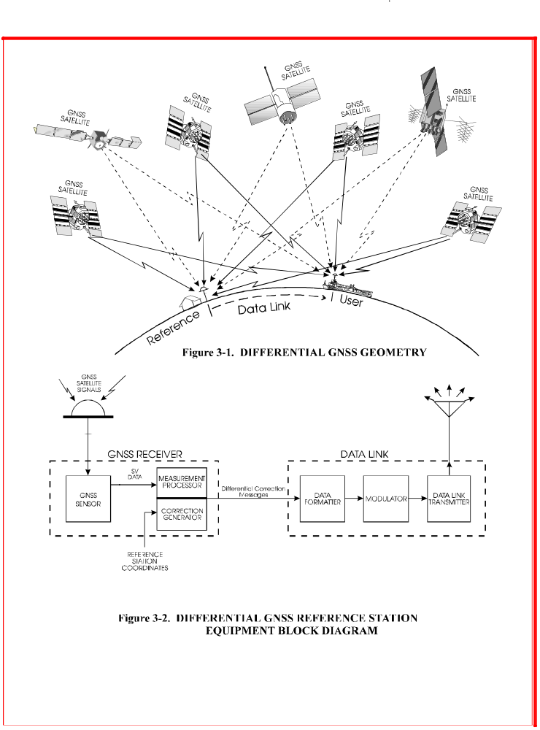
3.2.3 Satellite Acquisition

As a satellite rises, its signal will be received and tracked. When the signal-to-noise ratio has reached an adequate level, and after the range measurement has stabilized sufficiently and pertinent data acquired, the reference station will broadcast the corrections for that satellite. It will continue to do so (as long as the satellite signal is deemed healthy) until the satellite has set. Sometimes as a satellite rises, its signal level may rise above the threshold, only to decrease before stabilizing; this is probably due to fading associate with specular reflection of the signal from the ground. Care should be taken to ensure that broadcast of the correction is not made prematurely. Any code/carrier filters should have time to settle, and the signal-to-noise should be high before corrections are generated. While a manufacturer may choose to implement a mask angle, i.e., inhibit tracking of satellites below a given elevation mask angle, there is no requirement to do so, as long as proper precautions are followed.

3.2.4 Method of Measurement

It is recommended that reference receivers perform phase carrier tracking as well as code tracking. Code tracking is performed by aligning the time delay of an internal signal generator, phase modulated by the known code of the satellite, until it correlates with the satellite signal. The signal carrier can be recovered and synchronously tracked using phase-lock techniques. The time delay of the signal is usually rapidly increasing or decreasing, caused by the motion of the satellite; the motion also results in a Doppler shift of the carrier frequency. Since the satellite position is known quite precisely, the Doppler shift and time delay variation is highly predictable. As a result, the range measurement can be averaged over several tens of seconds to reduce the measurement uncertainty. Since the satellite and reference station positions are both known precisely, the range error can be determined. By using carrier phase tracking, this range rate can be measured quite accurately (typically better than 1 cm/sec).

3.2.5 Timing Reference of the Corrections

Differential satellite navigation systems rely on a known geographic location to serve as the reference point for the differential corrections (Section 3.1). Since GPS and GLONASS are pseudorange systems they also need a time reference for the corrections. Normally this time reference is calculated from the satellite measurements themselves rather than by trying to tie the DGNSS reference station to an earth-bound timing standard. This derivation of time generally has two goals: (1) keep the corrections within the bounds of the RTCM SC-104 format, and (2) achieve sufficient stability in order to propagate Type 9 or Type 34 corrections over several correction epochs (Section 3.2.9).

Any type of DGNSS service must select the satellite-based time reference as a baseline for the differential corrections. Normally, different satellite navigation systems maintain different time references. GPS corrections normally use a reference station derived GPS time to reference the pseudorange corrections. Similarly GLONASS corrections are calculated using a reference station derived GLONASS time. A combination GPS/GLONASS reference station could be built to provide corrections for both systems. A user of such a reference station could mix GPS and GLONASS satellite measurements and their respective differential corrections to calculate a combined differential navigation solution. One of the unknowns in this calculation would be the instantaneous difference between the reference station calculated GPS time reference and the GLONASS time reference. Given enough satellites the user set could resolve this inter-system time bias to some degree of accuracy. Any difference between what the user and reference station calculate for GPS and GLONASS time would directly translate to a non-common mode error in the range measurements going into the navigation filter. If the offset between GPS and GLONASS used at the reference station were known to the user, the user would need less satellites and would gain accuracy in all cases.

For this reason a separate message, Type 37, has been created to give the calculated offset between different satellite systems being mixed in differential mode. Therefore, by definition, Type 1 & 9 are referenced to GPS time as derived by the reference station and Type 31 & 34 are referenced to GLONASS time as derived by the reference station. For this integrated GPS/GLONASS reference station to work with the proposed Type 37 message, this time base offset must be held fixed between the two systems.

It has been suggested that by proper removal of effects of satellite motion and processing of the measurement data, the data could, in principle, be optimally filtered to provide predictions of the range and range rate errors for the next message to be broadcast. The range and range rate error for each satellite could be the value that provided the best RMS estimates over the next message period. The reason for this suggestion is that the ground station, being stationary and processing the carrier phase information, could perform predictive filtering on the satellite signals and could provide better correction estimates than the user receiver could generate.

However, this would only be beneficial for applications where the user population applied corrections at predictable and uniform intervals relative to the corrections' time tags. For general-purpose use, it is recommended that each pseudorange and range rate correction be the best estimates for that instant identified by the time tag.

The time tag applied to the DGNSS corrections is the time count contained in the message header. The relationship of this time tag (t_{o}) to real time (t) has broad effects on the way the user can apply the corrections. Three methods of reference station operation are presented here to give some insight into operating DGNSS with different techniques.

“Past”: the time count could represent some value in the past that has sufficient measurement information before and after the time count (t_{o}) to make a very accurate assessment of the PRC and RRC at the time count (t_{o}). Transmitting corrections based on this technique implies some type of post processing on the part of the user. The user could be operating in near real time by running his solution with a lag of t-t_{o}. The pseudorange measurements would be retained until the correction for that moment is received. The user would then apply the corrections with no lag in the correction information. To obtain real-time navigation information, the user receiver would propagate the position to current time using velocity data, or inertial or other sensors. This technique applies equally well to the “present” method.

“Present”: The time count (t_{o}) for PRC and RRC would be within 0.6 seconds of the last set of measurements used in forming that correction. In this case the only latency in the corrections would be caused by the delays in communicating the corrections out of the reference station through some transmission medium and reception at the user. This method should yield accurate results in real time. The user can compensate for data link latency as in the "Past" technique presented above.

“Future”: The time count (t_{o}) can be propagated into the future to compensate for data link latency. This method would require accurate knowledge of pseudorange acceleration. This method will introduce error into the corrections if the pseudorange acceleration changes significantly between the measurement time and the prediction time. In this case the user would not be able to "back out" this error by applying the corrections at the time of the time count (t_{o}). In a scenario where accelerations are significant and well known this technique could enhance real time user accuracy.

The method chosen by a service provider must be chosen to meet the requirements of the particular service. Many applications requiring high accuracy do not require true real time differential GNSS updates. A near real time (< 30 seconds) capability could suffice. The "present" method provides the best real time performance without contaminating the corrections with the errors of prediction. For real-time users the corrections are easily propagated forward to current time (t) and near real time users can get the best accuracy at the time count (t_{o}).

3.2.6 Satellite Health Assessment

The satellites themselves provide indications of the reliability and accuracy of their signals. The reference station provides an independent check, since it can compare the measured pseudorange against the known range between station and satellite position (as derived from the satellite orbital data). While it is unlikely that a satellite will transmit incorrect signals, there is a remote possibility that the signal could drift out of specification before the GNSS control station could upload a new health message. The reference station is capable of detecting such a condition immediately, and should flag such a condition in the differential broadcast. It can also detect any significant variation in the signal or change in the signal that might be caused by the GPS Selective Availability or some error mechanism.

3.2.7 Ionospheric Effects

The ionosphere can cause a propagation group delay of a satellite signal by as much as 100 meters during peak solar cycle conditions, and more typically causes delays of 20-30 meters. While models exist which account for most of the delay, the Committee decided that the reference station should not attempt to model the ionosphere at all, for the following reasons. A user close to the reference station would receive signals from the satellites through signal paths that would be almost identical to those of the station. As a result, the corrections would exactly compensate for the signal group delays. For users farther away from the station, say several hundred kilometers, the signal paths diverge enough that the respective group delays could differ by as much as a few meters (see Figure 3-3, which is derived from the GPS ionospheric model).

By modeling the ionosphere, e.g., using the coefficients provided in the GPS satellite messages, much of this group delay difference can be removed. The remaining errors are then caused by the deviations of the ionosphere from the model. It can be argued that if both reference station and user applied the model, the results can be improved (to the extent the models were valid). The reason for the Committee's recommendation is that since the user receiver knows the location of the reference station, it can apply the model to both the reference station and user and achieve the same improvement. Furthermore, as better models of the ionosphere are developed, they can be accommodated in newer receiver designs, without constraining the accuracy of future systems to models developed years earlier. This discussion does not apply to GLONASS, which does not output parameters to an ionospheric model.

There is not enough accurate data available yet to predict the residual ionospheric errors at different user-station separations, but since the GNSS is a natural source of unlimited data on the subject, it can be anticipated that improved models will be developed in the future. Moreover, spatial decorrelation caused by ionosphere, troposphere and, for GPS, Selective Availability ephemeris errors can be measured, separately or in composite, by a network of reference stations located around the coverage area.

3.2.8 Tropospheric Effects

The index of refraction in the troposphere is almost, but not quite, unity. It approaches unity at the top of the troposphere. Its value (typically l.0003) depends on the temperature, pressure, and the partial pressure of water vapor. While the time delay caused by the troposphere is typically 3 meters overhead to 50 meters at 3 degrees elevation, a simple model, i.e., one not involving any temperature or pressure measurements, can predict this quite well. Above 5 degrees elevation the unmodelled error is usually less than a meter. Consequently, it is not troublesome for navigation applications, but can be problematical for surveying applications. The model can be improved somewhat by a local measurement of the meteorological parameters.

As with the ionospheric correction, no model is used at the reference station, and the user is expected to bypass any tropospheric model that might be used in non-differential operation. The resulting error will be negligible unless the propagation paths traverse volumes that have significantly different water vapor pressures. A problem could occur if the station and user are at significantly different altitudes, e.g., by several thousand feet. Variations of the index of refraction with height are significant. It is therefore recommended that the user employ a tropospheric model that incorporates the different altitudes of user and reference station for applications where significant differences in height exist.

3.2.9 Reference Station Clock

Even with a quartz oscillator at the reference station it is possible to achieve high accuracy differential positioning. With such an oscillator it is possible to achieve time synchronization with the GNSS of l00 nanoseconds. Thus it appears that for position location and navigation there is no need for a rubidium or cesium standard clock for the reference station. If all the corrections from the reference station are offset by the same amount, say l00 nanoseconds, the resulting positional error is zero, as long as all corrections in a message are referenced to the same instance of time. It is for this reason that it is recommended in Section 4 that Message Types 1 and 31 be ignored if any of the words fail parity: applying the corrections for some satellites and projecting the range rate of the others to estimate their corrections would introduce errors into the solution caused by reference station clock drift. With this caveat, it is adequate for the reference station to be driven by a quartz oscillator for most applications.

However, there are several specialized user applications where the use of a low-drift, high-quality clock for the reference station could be beneficial:

l. Users operating in a time-transfer mode, in which case the reference station clock drift error directly impacts their measurements. Differential operation will improve the time-transfer accuracy.

2. For areas of limited visibility, users employing high-quality clocks at the mobile station can enable operation with 3 satellites or 2 satellites plus fixed altitude. This requires a low-drift reference station clock, because time errors in the corrections caused by reference station clock drift would result in large position errors. Under such conditions it would be possible to "clock-coast" with 3 satellites until a fourth one appeared. This is not recommended under normal circumstances. Situations like this are rare, but could occur in narrow gorges or fjords, for example.

3. For low-baud data links, the use of Type 9 GPS messages provides improved performance in the presence of impulse noise conditions compared to the Type 1 messages. Use of a highly stable clock enables the use of Type 9 messages to reduce the average age of the corrections when the satellite differential corrections are arranged, for example, in groups of three. See Section 4.3.9.

As a result of these considerations, it is recommended for these specialized applications that the reference station employ a high-quality clock with good long-term drift characteristics.

3.2.10 Multipath

Code phase multipath can introduce significant DGNSS errors at both the reference station and user antennas. Reference station signal processing should be designed to minimize the effects of multipath. Also, reference station antennas should be situated to minimize multipath. It may be possible to compensate for multipath effects at fixed reference stations. Message Types 19 and 21 provide for transmission of reference station multipath error estimates specifically, while the UDRE field in Message Types 1, 2, 9, 31 and 34 provide for overall error estimates, which include multipath.

3.2.11 Reference Station Datum Considerations

A DGNSS Reference Station uses its known position to compute DGNSS corrections. Currently, GPS and GLONASS both operate in the ITRF datum, whereas previously GPS receivers operated in the WGS 84 datum, and GLONASS receivers operated in the PE-90 datum; thus no datum transformation is necessary for combined GPS/GLONASS operation. While it is not recommended, DGNSS operators may choose to express the position of the Reference Station antenna in local coordinates. This changing of the datum has the effect of shifting the position solution of the user equipment to the local datum. However, depending on the datum chosen, significant errors may be induced in the process. Appendix D of this document contains a discussion on the errors induced and the advantages and disadvantages of using a local datum for DGPS broadcasts. If a local datum is chosen, it is crucial that Message Type 4 should be broadcast on a periodic basis to inform users of the datum selected at the Reference Station. No matter what datum is used, it is recommended to broadcast a Type 4 message.
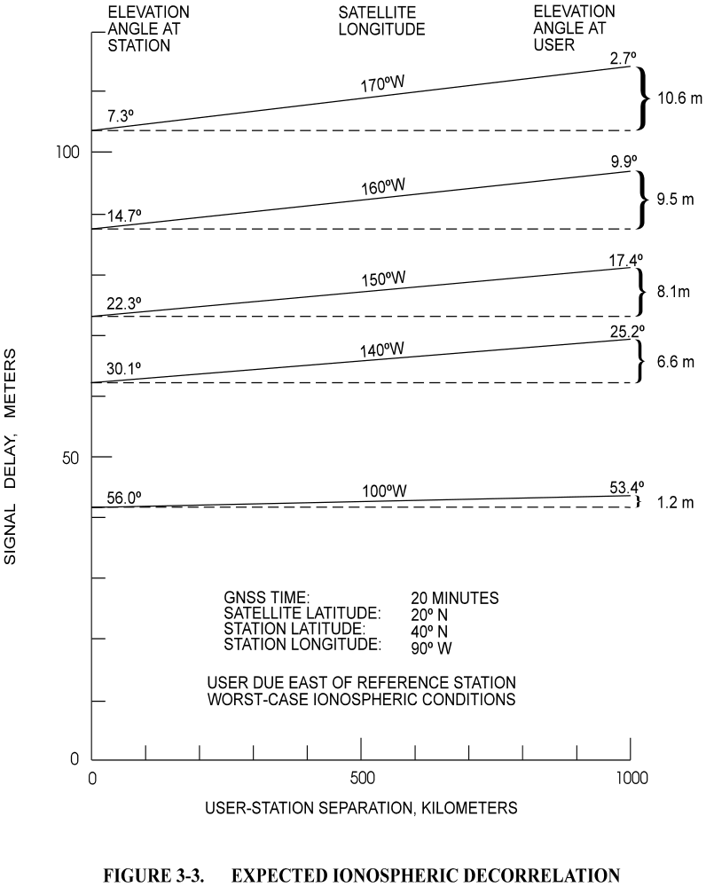

3.3 USER EQUIPMENT

3.3.1 Components

The user equipment consists of a GNSS sensor with antenna, a data processor, a data link receiver with antenna, and interfacing equipment (see Figure 3-4). The data processor applies the corrections received from the reference station to the pseudoranges measured by the sensor.

3.3.2 Sensor Architecture

The GPS sensor architecture can be multi-channel or single/dual channel, employing parallel, sequential, or fast-sequential (multiplexed) techniques, although most differential GPS receivers are of the multi-channel type, and all GLONASS receivers are multi-channel. It can operate with all satellites in view or with the "best" set as determined by any of several criteria. As a result the receiver can be designed for particular applications without compromising other features to accommodate the differential operation.

3.3.3 Application of the Differential GNSS Corrections

For each satellite employed by the user receiver, the correction obtained from the reference station (Message Types 1, 9, 31 or 34) is added to the pseudorange measurement. The correction itself is derived from the range and range-rate, adjusted to account for the time elapsed between the time of reception of the correction and the time of the user pseudorange measurement, as follows:

PRC(t) = PRC(t_{o}) + RRC • [t-t_{o}]

where PRC(t) is the correction to be applied, PRC(t_{o}) is the range correction from the message, RRC is the range-rate correction from the message, t_{o} is the time reference of the correction (see section 3.2.5), and t is the time associated with the pseudorange measurement.

The differential correction message contains information on the satellite health as determined by the ground station. It is described in Section 4.3.1. How the user receiver utilizes the information is left to the receiver designer.

Every so often a Type 2 message may be interspersed among the DGPS correction messages, and it provides a secondary correction. This is done to allow a user to operate with old satellite ephemeris and satellite clock data (e.g., up to two hours old), while the reference station is operating with the most recent data. This correction, called the "delta correction," is added to the normal correction for that satellite. Section 4.3.2 discusses this in detail. The reference station will usually decode the satellite data before the user does, since it is constantly monitoring the data. In the unlikely event that the user does decode the satellite earlier, the receiver should be prevented from using the new satellite data until the reference station has indicated it is using the new data.

The user can utilize carrier phase tracking if required by the application. It is often used for aiding of the code tracking, especially for sequential sets. It can also be used to measure the velocity of the vessel, vehicle, or aircraft.

For surveying applications the instantaneous carrier phase is the primary measurement of each of the satellites. The code tracking is performed primarily for acquisition and removal of ambiguities. The real-time kinematic messages, Types 18-21, have all the information necessary to support such an application.

Real-time kinematic applications of GNSS are now possible using the new Message Types 18-21. In brief, a number of kinematic techniques can be performed in real-time (or more accurately, near real time) utilizing these messages. In addition, new "on-the-fly" techniques for rapid determination of integer ambiguities will remove the need for static calibration points.

3.4 DATA LINK

The data link, which communicates the corrections from the reference station to the user receiver, can take a number of forms and operate at any of several frequencies. Prior to Selective Availability (SA) being turned off, the chief requirement was that the messages be reliably communicated at a data rate of at least 50 baud (continuous transmission) to support GPS operation.

While a minimum update rate and baud rate has not yet been established for GLONASS and GPS without SA, experience with GPS during periods when Selective Availability was turned off suggests that an update rate of once every 30-60 seconds is probably adequate for supporting accurate differential service. However, the service provider should also make the data rate high enough to assure integrity and to accommodate users just acquiring the service. Figure 3-2 shows the reference station data link functions, and Figure 3-4 shows the user data link functions.

In its simplest form, the data link continuously carries the differential GNSS data message without interruption. However, it is transparent to the GNSS receiver whether the data is transmitted continuously or in bursts, or whether protocol overhead is added. For example, each message (or multiple messages, or any fraction of a message) could be transmitted as a short burst at 2400 baud, along with a data link protocol preamble, parity, and even error correction bits. These would be stripped off at the receiver end, and the differential correction bits would be stored in the buffer, to be transferred to the receiver at will.

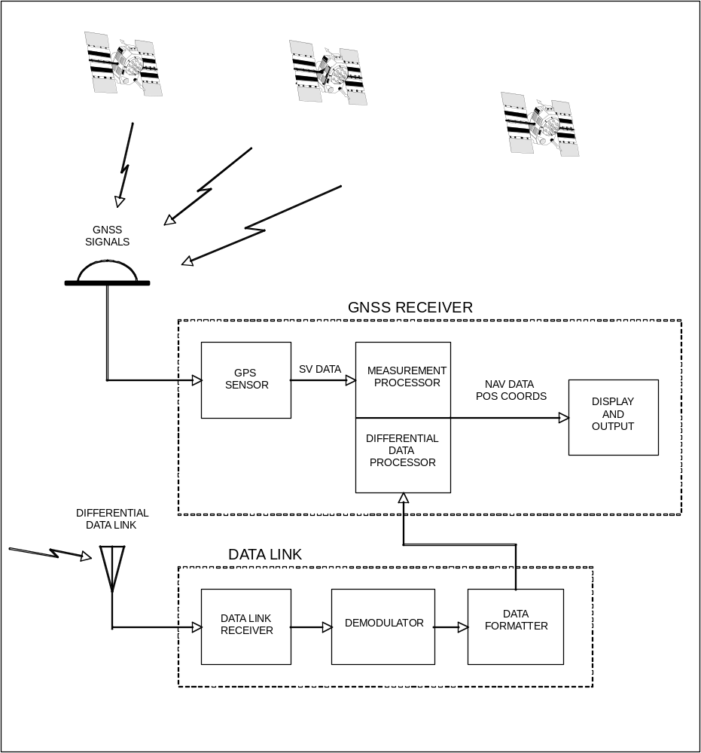
Figure 3-4. User Equipment Block Diagram

Differential GNSS broadcasts intended for general public use require that the data link be a standard published design. For non-public use, however, the reference station, data link, and receivers could be part of an integrated differential GNSS system. In such a case, the data might be encrypted to limit the service to paying customers. The format allows for such operation.

An attractive technique for broadcasting corrections to mariners involves modulating the marine radiobeacon transmitter signals with the differential GNSS message. This technique has the property of over-the-horizon propagation at low powers. It is also relatively straightforward and inexpensive to implement. It has the further advantage that no new frequency allocations are required. Recognizing the potential of radio beacons, state authorities around the world, supported by the International Association of Lighthouse Authorities, have established radiobeacon networks along their coastal areas. Radiobeacons have, in effect, become an international standard for the transmission of differential GNSS corrections.

3.5 PSEUDOLITE TECHNIQUE

A pseudolite (short for pseudo-satellite) is a specific implementation of differential GNSS. In the conventional approach, an external data link is required involving a separate broadcast frequency. The pseudolite signal is designed to resemble the satellite signal, i.e., it uses the same modulation, coding and frequency as the GNSS. For GPS the individual codes of the pseudolites, while having the same length, are distinct from the satellite codes but chosen to give low intermodulation products. For GLONASS, the codes are identical but pseudolites will typically broadcast at frequency channels 0 or 25, which are not assigned to satellites. The data, of course, has a different meaning than the data associated with a real satellite: it includes the differential GNSS corrections. Some pseudolite designs have increased the data rate from 50 to 250 bits per second, which supports higher update rates, e.g., once every 2-3 seconds.

By broadcasting the corrections at the same frequency as the GNSS satellites, the receivers don’t require a separate antenna, data link receiver, and interface. This is a considerable advantage. In addition, receivers can obtain pseudorange measurements from the ground station in addition to those obtained from satellites. This both increases the reliability of the measurement (since only three satellites would be required) and improves the accuracy by improving the dilution of precision measures.

The fact that the GNSS frequency is at L-band means that the pseudolite technique is limited to line-of-sight propagation. As a consequence, it is expected to be most useful for air applications and for land/marine applications within a small area.

The major issue to be resolved for pseudolite operation is whether it can be designed so as not to interfere with the normal reception of GNSS satellites. If the satellite modulation/coding technique were used without modification, receivers near the pseudolite station would be saturated by the pseudolite signal.

3.6 REAL-TIME KINEMATIC OPERATION

Version 2.3 of the Standard includes messages to support real-time kinematic applications, wherein decimeter accuracy or better can be achieved. GNSS carrier phase measurements have been routinely used for the determination of precise positions using static, kinematic and pseudo-kinematic surveying techniques. Early applications involved the initial placement of a rover antenna over a known location, or require several minutes of data recording at a fixed point. Subsequently, "on-the-fly" techniques were developed which eliminated the requirement for performing this initialization process. However, these techniques were all post-processing techniques, not real-time.

It has been demonstrated that "on-the-fly" techniques can operate in real-time as well, an important feature which holds promise of decimeter positioning accuracy in real time with moving platforms, hence the term real-time kinematic, or RTK. In fact, combined GPS/GLONASS receivers have achieved initialization on moving platforms of a few seconds. This requires the addition of a data link to transmit base station measurements to the mobile receiver, which must perform the computations to determine its position relative to the base station.

However, the data update requirement of RTK is much higher than conventional differential GNSS, since it involves double-differencing of carrier measurements. Data are typically updated every 0.5 to 2 seconds. The data rate is driven, not by Selective Availability variations that are no longer relevant, but by the requirements of the RTK technique, which requires measurement-by-measurement processing.

Spatial decorrelation limits the range of decimeter accuracy to a few kilometers or tens of kilometers, so line-of-sight transmission is appropriate for RTK applications.

Potential applications for RTK techniques include construction, dredging, hydrographic survey, land survey, seismic survey, tidal datum determination, vehicle navigation, photogrammetric survey control, reference benchmarks for land surveys, robotic guidance and control, range control and sensor calibration.

This page intentionally left blank

4. RECOMMENDED DATA MESSAGES

4.1 INTRODUCTION

The Committee has determined the data required by various types of differential GNSS users to correct, to the extent possible, for GNSS errors that are common to the reference station and the user. These GNSS errors are the following:

1. Satellite Ephemeris prediction errors
2. Satellite clock prediction errors
3. Ionospheric delay errors
4. Tropospheric delay errors as they appear at the reference station
5. Artificial errors induced by Selective Availability (SA) techniques (GPS only)
6. Differential tropospheric delay errors
7. Reference station clock offsets

The first six of these errors are common to both the user and the reference station for small baselines between reference station and user. This commonality will be reduced for 1, 3, 4, 5, and 6 as the baseline increases. The seventh only affects the user's ability to determine absolute time. Detailed discussions of these effects are provided below.

In addition to measurement correction data, the standard also provides for almanac and health data. The data are separated into types, where the type of data varies either in its frequency of transmission, the type of user it is intended for, or whether or not it is error correction data or almanac data. Each Message Type has a unique identification (one of 64). Several basic message types have been defined in their final form. Several others are defined in preliminary form; manufacturers implementing these standards are advised that these may change after field tests have been performed. A number of the remaining available message types have been left undefined, but are reserved for future use for designated applications.

To provide commonality in user software, provide a strong error detection capability, the data format for differential GNSS was patterned after the GPS data format, although it diverged from it somewhat as different requirements surfaced. However, the GPS word size, word format, parity algorithm and other features survived. The biggest difference is that the differential standard utilizes a variable length message format, whereas the GPS format has fixed length subframes. The surviving features are justified for the following reasons:

1) A strong parity algorithm is required to detect errors in the data, preventing the use of erroneous corrections that could affect user safety.

2) The GPS parity algorithm is a known and proven algorithm with which the users are familiar, and which is already coded in receiver software.

- The parity algorithm overlaps word boundaries and resolves sign ambiguities encountered in bi-phase modulation data transmissions.

4) The 30 bit words (as opposed to 32 bit words) coupled with a 50 Hz transmission rate provides a convenient timing capability where the times of word boundaries are a rational multiple of 0.6 seconds. Every 5th word boundary lands on a multiple of 3 seconds. If 32 bit words had been used, word boundaries would run on multiple integer-seconds only once per 16 seconds.

Now that Selective Availability has been turned off for GPS and does not exist for other GNSS's, the minimum data rate is no longer determined by the variations in the “dither”, but rather is based on other considerations, such as (1) ionospheric variations in time, (2) data link reliability, and (3) time to acquire DGNSS service. On the other hand, the data rate and message repetition rate can be as high as desired, subject only to the limitations of the communications channel. Furthermore, there is no requirement that the broadcast be continuous, so that a short burst of high-rate transmission is quite feasible. Thus a DNSS service can be shared with other broadcast services. It should also be noted that real-time kinematic data rates should be significantly higher (see Section 3.7).

The remainder of this chapter presents the details of the recommended Data Message Format and the Message Content.

4.2 GENERAL MESSAGE FORMAT

The general message format is illustrated in Figure 4-1 with details of the first two thirty-bit words of each frame or message type. Each frame is N+2 words long, where N is the number of message data words. For example, a filler message (type 6 or 34) with no message data will have N=0, and will consist only of two header words. The maximum number of data words allowed by the format is 31, so that the longest possible message will have a total of 33 words. N varies with message type, and may vary even for the same message type. The word size and parity algorithm are identical to that of the GPS navigation message as described in the public release of the GPS/SPS Signal Specification, a document available from the U.S. Coast Guard Navigation Information Service (see Appendix E).

4.2.1 First and Second Words

The first two words of each frame contain data that is pertinent to any type of message: Reference Station information, reference time and information required for user's frame synchronization. Their content is summarized in Figure 4-1 and tabulated in Table 4-1. It should be noted that the Station ID refers to the identification of the differential reference station. It is not intended to identify the data link facility, which for radiobeacon services, for example, is different.

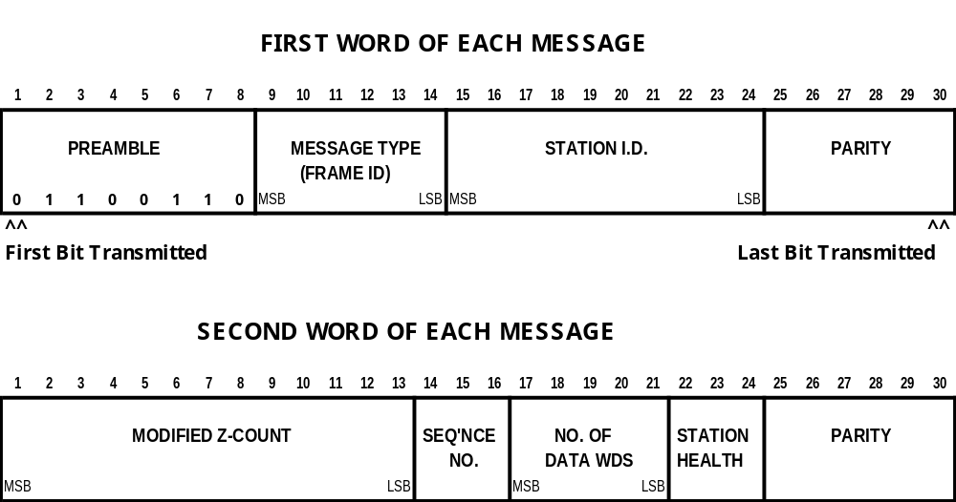

Figure 4-1. 2-WORD HEADER FOR ALL MESSAGES

Table 4-1. CONTENT OF FIRST AND SECOND WORDS

WORD | CONTENT | NUMBER OF BITS | SCALE FACTOR AND UNITS | RANGE
FIRST | PREAMBLE  FRAME ID/MSG TYPE  REFERENCE STATION ID  PARITY | 8  6  10  6 | --  1  1  (Note 2) | --  1-64 (Note 1)  0-1023  --
SECOND | MODIFIED Z-COUNT  SEQUENCE NO.  NO. OF DATA WORDS (N)  STATION HEALTH  PARITY | 13  3  5  3  6 | 0.6 sec  1  1 Word  --  (Note 2) | 0-3599.4 sec  0-7  0-31 Words  8 States

Note 1: 64 is indicated with all zeros.
Note 2: "Global Positioning System Standard Positioning Service Signal Specification", Section 2.5.2, available from the US Coast Guard Navigation Center (see Appendix E).
Frame synchronization can be achieved by the user in a similar manner as performed for the GPS data, with exceptions associated with the variable length frames. The beginning of the first word is a fixed 8-bit preamble for which the user searches. Message type numbers are those in this document. Station ID is arbitrary, and set by the reference station provider.

For pseudolite transmissions, the modified Z-count is the time of the start of the next frame (beginning of preamble) as well as the reference time for the message parameters. In the case of non-pseudolite type transmission, it is the reference time for the message parameters only. The modified Z-count is different from the GPS Z-count in that the LSB has a scale factor of 0.6 seconds, instead of 6 seconds, to account for the variable length frames. Also, the range of the modified Z-count is only one hour in order to conserve bits. The reasoning behind this is that all differential GNSS users will have already initialized via the GNSS system and will know what the time is. It should be noted that the modified Z-count is referenced to GPS or GLONASS time for GPS and GLONASS messages, respectively, and not UTC.

The sequence number aids in frame synchronization for non-pseudolite type transmissions, replacing the sequencing Z-count as an incrementing parameter. It will increment on each frame. The frame length is two more than the number of data words (N) following the header. Thus if N is zero it would mean that no words would follow the header, and the frame length would be 2.

Version 2.2 of the standard redefined the meaning of the three Reference Station Health bits in a manner that will not cause problems in most older receivers. The state “111” shall indicate that the reference station is not working properly, and “110” shall indicate that the transmission is unmonitored, as shown in Table 4-2. The other six states in Table 4-2 denote a scale factor for the UDRE field in the differential correction messages (types 1, 2, 9, 31, and 34). If the user receiver decodes the UDRE scale factor, it shall multiply the scale factor by the UDRE one-sigma differential error values given in Table 4-6 for all the satellites contained in a Type 1, 2, 9, 31, or 34 message; when computing the UDRE, the user receiver shall utilize the upper value of the range in Table 4-6.

Table 4-2. REFERENCE STATION HEALTH STATUS* INDICATOR

CODE | INDICATION
111 | Reference Station Not Working
110 | Reference Station Transmission Not Monitored
101 | UDRE Scale Factor = 0.1
100 | UDRE Scale Factor = 0.2
011 | UDRE Scale Factor = 0.3
010 | UDRE Scale Factor = 0.5
001 | UDRE Scale Factor = 0.75
000 | UDRE Scale Factor = 1
* Station Health refers to the GPS or GLONASS portion of the reference station and is reflected in individual messages. That is, a combined GPS/GLONASS reference station may have different health status indicators for GPS and GLONASS.

Manufacturers and service providers may use this scheme, or may elect to utilize only states "000", "110", and "111". If this scheme is used, states "001" through "101" should be employed only on message types 1, 2, 9, 31, and 34. If any of these messages are transmitted with state "110" or "111", the user receiver should assume a UDRE Scale Factor of unity.

If the scheme in Table 4-2 is not employed, only states "000", "110", or "111" should be utilized in the reference station. Mobile receivers should ignore states "001" through "101"; by ignoring the scale factor mobile receivers will always effectively apply a unity scale factor and thus compute a conservatively high UDRE, which means at worst they will overestimate the uncertainty in corrections received from a station employing the scheme of Table 4-2, which should not cause a problem.
4.3 MESSAGE TYPE CONTENT AND FORMATS

To date there are 40 of a possible 64 message types defined, either tentatively or in final permanent form, retired, or reserved. They are given in Table 4-3. Details of the message type contents and formats are given in sections 4.3.l through 4.3.49.

Table 4-3. MESSAGE TYPES
MESSAGE TYPE NO. | CURRENT STATUS | TITLE
1 | Permanent | Differential GPS Corrections
2 | Retired | Delta Differential GPS Corrections
3 | Permanent | GPS Reference Station Parameters
4 | Permanent | Reference Station Datum
5 | Permanent | GPS Constellation Health
6 | Permanent | GPS Null Frame
7 | Permanent, to be retired | DGPS Radiobeacon Almanac
8 | Tentative | Pseudolite Almanac
9 | Permanent | GPS Partial Correction Set
10 | Reserved | P-Code Differential Corrections
11 | Reserved | C/A-Code L1, L2 Delta Corrections
12 | Reserved | Pseudolite Station Parameters
13 | Tentative | Ground Transmitter Parameters
14 | Permanent | GPS Time of Week
15 | Permanent | Ionospheric Delay Message
16 | Permanent | GPS Special Message
17 | Permanent | GPS Ephemerides
18 | Permanent | RTK Uncorrected Carrier Phases
19 | Permanent | RTK Uncorrected Pseudoranges
20 | Retired | RTK Carrier Phase Corrections
21 | Retired | RTK/Hi-Accuracy Pseudorange Corrections
22 | Permanent, to be retired | Extended Reference Station Parameters
23 | Permanent | Antenna Type Definition Record
24 | Permanent | Antenna Reference Point (ARP)
25-26 | -- | Undefined
27 | Permanent | Extended Radiobeacon Almanac
28-30 | -- | Undefined
31 | Tentative, to be retired | Differential GLONASS Corrections
32 | Tentative, to be retired | Differential GLONASS Reference Station Parameters
33 | Tentative, to be retired | GLONASS Constellation Health
34 | Tentative, to be retired | GLONASS Partial Differential Correction Set (N > 1)  GLONASS Null Frame (N ≤ 1)
35 | Tentative, to be retired | GLONASS Radiobeacon Almanac
36 | Permanent | GLONASS Special Message
37 | Permanent | GNSS System Time Offset
38-40 | -- | Undefined
41 | Tentative | Generic GNSS Basic Differential Corrections
42 | Tentative | Generic GNSS Partial Basic Corrections
43 | Tentative | Generic GNSS Reference Station Parameters
44 | Tentative | Generic GNSS Constellation Health
45 | Tentative | Galileo E1 Ionospheric Delay
46 | Tentative | Generic GNSS Local Integrity Alerts
47 | Reserved | Generic GNSS Integrity Table
48-58 | -- | Undefined
59 | Permanent | Proprietary Message
60-63 | Reserved | Multipurpose Usage
4.3.1 Message Type 1 - Differential GPS Corrections (Permanent)

Figure 4-2 and Table 4-4 present the content of Message Type 1, the differential corrections. This is the primary message type which provides the pseudorange correction (PRC(t)) for any user receiver GPS measurement time "t":

PRC(t) = PRC(t₀) + RRC • [t - t₀] (Eq. 4-1)

where PRC(t₀) is the 16 bit pseudorange correction, RRC is the 8-bit rate of change of the pseudorange correction (range rate correction), and t₀ is the 13-bit modified Z-count of the second word. These parameters are all associated with the satellite indicated by the 5-bit Satellite ID, which indicates its PRN number. The pseudorange measured by the user, PRM(t), is then corrected as follows:

PR(t) = PRM(t) + PRC(t) (Eq. 4-2)

Note that the correction is added to the measurement. PR(t) is the differentially corrected pseudorange measurement that should be processed by the User Equipment navigation filter. Also provided is a l-bit Scale Factor (see Table 4-5) and 2-bit User Differential Range Error ("UDRE" -see Table 4-6). The UDRE is a one-sigma estimate of the uncertainty in the pseudorange correction as estimated by the reference station, and combines the estimated effects of multipath, signal-to-noise ratio, and other effects. It should be noted that the real-time kinematic messages use signal quality indicators which separate out multipath effects from other effects, as described in Appendix B. User receivers applying the UDRE values should utilize the upper values of the range in Table 4-6 to be conservative. Note that the UDRE values should be multiplied by the UDRE scale factor in the Station Health field of the header message, if the user receiver decodes that field.

The Type 1 Message contains data for all satellites in view of the reference station (N_{s}). Since 40 bits are required for the corrections from each satellite, there won't always be an exact integer number of words required. There will be messages that require 8 or 16 bits of fill to finish the frame. The fill will be alternating l's and 0's so as not to be confused with the "preamble" synchronization code. The format of the Type 1 Message is illustrated in Figure 4-2. Each word has one of five formats unless it is the last word in the message. If N_{s} is not a multiple of 3, the last word has one of two formats, containing either 8 or 16 fill bits.

The pseudorange correction PRC(t₀) will diverge from the proper value as it "grows old." Because of this characteristic, it will be updated and transmitted as often as possible. The User Equipment should update the corrections accordingly.

The pseudorange correction PRC(t₀) is the difference between the computed geometric range (see Appendix C) and the adjusted pseudorange. The adjusted pseudorange is the raw pseudorange measurement adjusted for:
a. Receiver clock offset, scaled to meters.
b. T_{gd}, the L1-L2 group delay correction (see GPS/SPS Signal Specification)
c. Satellite clock offset, scaled to meters (see GPS/SPS Signal Specification)
d. Satellite relativistic correction, scaled to meters (see GPS/SPS Signal Specification)
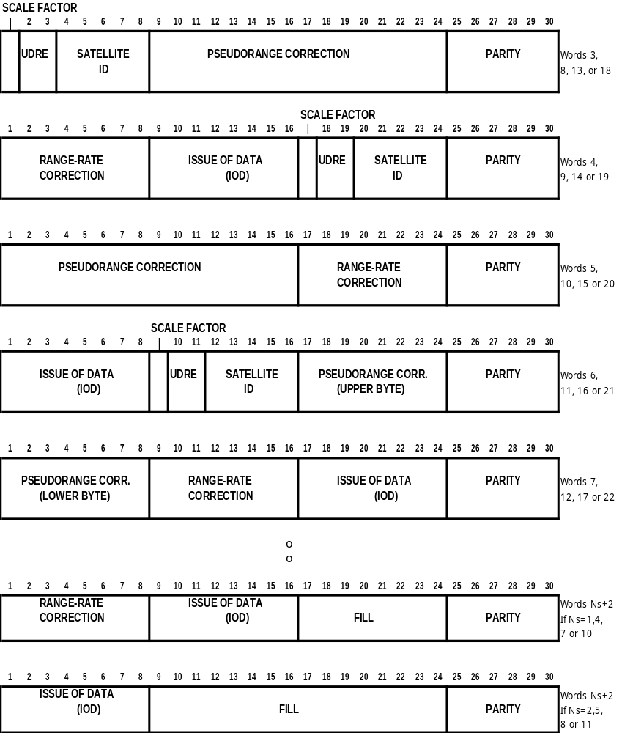

Figure 4-2. MESSAGE TYPE 1 - DIFFERENTIAL GPS CORRECTIONS
Table 4-4. CONTENTS OF A TYPE 1 MESSAGE

PARAMETER | NO. OF BITS | SCALE FACTOR AND UNITS | RANGE
SCALE FACTOR | l | See Table 4-5 | 2 states
UDRE | 2 | See Table 4-6 | 4 states
SATELLITE ID | 5 | l | l-32 (Note 1)
PRC(t₀) (Note 2) | 16 | 0.02 or 0.32 m | +655.34 or +10485.44 m (Note 3)
RRC* (Note 2) | 8 | 0.002 or 0.032 m/s | +0.254 or +4.064 m/s (Note 4)
ISSUE OF DATA | 8 | (Note 5)
Total | 40 x N_{s}
FILL | 8 x [N_{s} mod 3] | bits | 0, 8, or 16
PARITY | N x 6 | (Note 5)

N_{s} = Number of satellite corrections contained in message.
N = Number of words in message containing data. Frame length = N+2 words.

Note 1: Satellite number 32 is indicated with all zeros (00000).
Note 2: 2’s complement
Note 3: Binary 1000 0000 0000 0000 indicates a problem and the User Equipment should immediately stop using this satellite.
Note 4: Binary 1000 0000 indicates a problem and the User Equipment should immediately stop using this satellite.
Note 5: See GPS/SPS Signal Specification, available from U.S. Coast Guard Navigation Information Service, see Appendix E.

The reference station shall apply neither ionospheric nor tropospheric delay models in deriving the differential corrections. The reference station clock offset will be a common offset in all pseudorange corrections, which does not affect position calculations. The reference station may also adjust the PRC(t₀) for multipath effects.

The range rate correction (RRC) is designed to compensate for the predicted rate of change of the pseudorange correction. This is an attempt to "extend the life" of the pseudorange correction as it "grows old." The RRC can also be used to correct the user receiver's velocity. The User Equipment should not use the RRC as a carrier phase correction -- it may degrade that type of measurement. Carrier phase measurements should be corrected only using Message Types 18 or 20.

The Issue of Data (IOD) is included in the message so that the User Equipment may compare it with the IOD of the GPS navigation data being used. The IOD is the key that ensures that the user equipment calculations and reference station corrections are based on the same set of broadcast orbital and clock parameters. If they don't agree, it is the responsibility of the differential user equipment to take the appropriate actions to acquire parameters that match the ones in use at the reference station. This can be done two ways: test the present IOD for a match to the IOD in a Type l or Type 2 message, or acquire another navigation data message from the appropriate satellite. In general, the reference station attempts to use the present navigation data being broadcast by a satellite. The user receiver should be designed to accommodate the possibility that the reference receiver may delay the broadcast of corrections based on a new satellite ephemeris for a period of up to 90 seconds, in order to avoid the necessity of broadcasting Type 2 messages. Note that the Type 5 Message also contains useful information concerning navigation data.

Under no circumstances should a "partial" differential solution be attempted, i.e., processing both differentially corrected and non-differentially-corrected pseudoranges in the same position calculation. The resulting position will usually be no better than a non-differential solution.

Table 4-5. SCALE FACTOR

CODE | NUMBER | INDICATION
0 | 0 | Scale factor for pseudorange correction is 0.02 meter and for range rate correction is 0.002 meter/second
1 | 1 | Scale factor for pseudorange correction is 0.32 meter and for range rate correction is 0.032 meter/second (also refer to Table 4-4)

The rationale for the two-level scale factor is to maintain a high degree of precision most of the time, and allow the ability to increase the range of the corrections on those rare occasions when it is needed.
Table 4-6. USER DIFFERENTIAL RANGE ERROR (UDRE)

CODE | NUMBER | ONE-SIGMA DIFFERENTIAL ERROR
00 | 0 | ≤ l meter
01 | 1 | > 1 meter and ≤ 4 meters
10 | 2 | > 4 meters and ≤ 8 meters
11 | 3 | > 8 meters

Note that the 1-sigma differential errors should be multiplied by the UDRE scale factor provided in the message header.
4.3.2 Message Type 2 - Delta Differential GPS Corrections (Retired)

Message Type 2 was provided for situations where GPS user equipment, which might have been using channel sequencing, would not have been able to quickly read the satellite ephemeris data, thus could have been using old satellite orbit data after the reference station was employing new satellite ephemerides. However, virtually all modern receivers use parallel channels, and the differences in satellite ephemerides after a change-over are now in the sub-meter range. GLONASS and Galileo receivers likewise employ parallel channels. As a consequence, Message Type 2 is no longer necessary, and few if any service providers use it. Thus it is being retired, and service providers should be aware that user equipment will no longer recognize it if it is broadcast. This does not pose a problem, because in ignoring the message, no accuracy is lost.

4.3.3 Message Type 3 - GNSS Reference Station Parameters (Permanent)

This message has been generalized to be a generic GNSS message that provides the location of the reference station antenna reference point in ECEF coordinates. The ECEF coordinates must be associated with a specific coordinate system, usually the ones used by the GNSS in determining the satellite orbital information. Historically GPS has used WGS-84, while GLONASS has used PZ-90, but even these have been modified over time. Now all the GNSS's have been adjusted to conform to the ITRF standard within 50 centimeters, and the "Navigation Data" in the satellite broadcasts reflect this fact. For the purposes of conventional differential services, the datum differences are not significant. Similarly, the periodic upgrades of the ITRF standard do not affect conventional differential services.

Message Type 3 contains reference station information. Figure 4-4 and Table 4-8 give the contents of the Type 3 Message. It consists of four data words (N=4) for a total frame length of six 30-bit words. It includes the GNSS coordinates (Earth-Centered-Earth-Fixed (ECEF)) of the reference station antenna to the nearest centimeter. ITRF is the recommended reference datum for GNSS services.

Table 4-8. CONTENTS OF A TYPE 3 MESSAGE

PARAMETER | NUMBER OF BITS | SCALE FACTOR AND UNITS | RANGE
ECEF X-COORDINATE | 32 | 0.01 meter | +21474836.47 meters (Note 1)
ECEF Y-COORDINATE | 32 | 0.01 meter | +21474836.47 meters (Note 1)
ECEF Z-COORDINATE | 32 | 0.01 meter | +21474836.47 meters (Note 1)
PARITY | 24 | (Note 2)

Note 1: 2’s complement
Note 2: See GPS/SPS Signal Specification, available from U.S. Coast Guard Navigation Information Service, see Appendix E.

While a service provider may provide these coordinates referenced to a local datum, it is not generally recommended, because of the possibility of confusion (see Appendix D). If a local datum is used, Message Type 4 should be broadcast periodically to inform the users of the datum being used for the reference station coordinates. Since the user receiver will assume the coordinates are referenced to ITRF until a Type 4 message is received, significant errors could be experienced until then. It is generally recommended that a Type 4 message be broadcast along with each Type 3 message in order to eliminate any ambiguity on the datum in use.

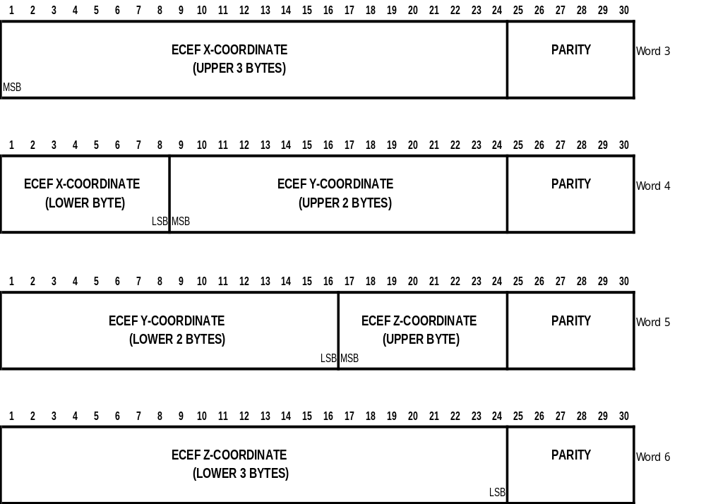

Figure 4-4. MESSAGE TYPE 3 - GNSS REFERENCE STATION PARAMETERS
4.3.4 Message Type 4 - Reference Station Datum Message (Permanent)

Message Type 4 contains the Reference Station datum information. It was originally designed to inform user equipment of the datum used for the reference station coordinates in Message Type 3, 32 or 45 associated with the corrections being broadcast by the Reference Station, whether referenced to a specific GNSS or a local datum. Now that the three major systems have been aligned with the ITRF datum (see the Message Type 3 text), its primary use is to enable a service provider to utilize a local datum. The message provides for an ASCII identification of the datum used, and provides for the offset of the datum at the Reference Station with respect to GNSS ITRF-based reference stations. Table 4-9 and Figure 4-5 show the contents of the Type 4 Message. Service providers should be careful when using local datums because of the potential confusion that can result (see Section 3.2.11 and Appendix D). The correction is exact only at the reference station, and errors will generally increase with the distance between the reference station and mobile user, due to geoidal and rotational differences. It is the responsibility of the service provider to ensure that the errors are acceptable in the area of operation.

Table 4-9. CONTENTS OF A TYPE 4 MESSAGE

PARAMETER | NUMBER OF BITS | SCALE FACTOR AND UNITS | RANGE
DGNSS | 3 | 1 | 000 = GPS  001 = GLONASS  010 = Galileo  011 = Reserved  100 = Reserved  101 = Reserved  110 = Reserved  111 = Reserved
DAT | 1 | 1 | 0 = Local Datum  1 = ITRF
RESERVED | 4 | --
DATUM α CODE CHAR #1 | 8 | --
DATUM α CODE CHAR #2 | 8 | --
DATUM α CODE CHAR #3 | 8 | --
DATUM SUB DIV CHAR #1 | 8 | --
DATUM SUB DIV CHAR #2 | 8 | --
DX (Note 1) | 16 | 0.1 meters | ± 3276.7 meters
DY (Note 1) | 16 | 0.1 meters | ± 3276.7 meters
DZ (Note 1) | 16 | 0.1 meters | ± 3276.7 meters
PARITY | 24 | (Note 2)

Note 1: Two's complement
Note 2: See GPS/SPS Signal Specification, available from U.S. Coast Guard Navigation Information Service, see Appendix E.
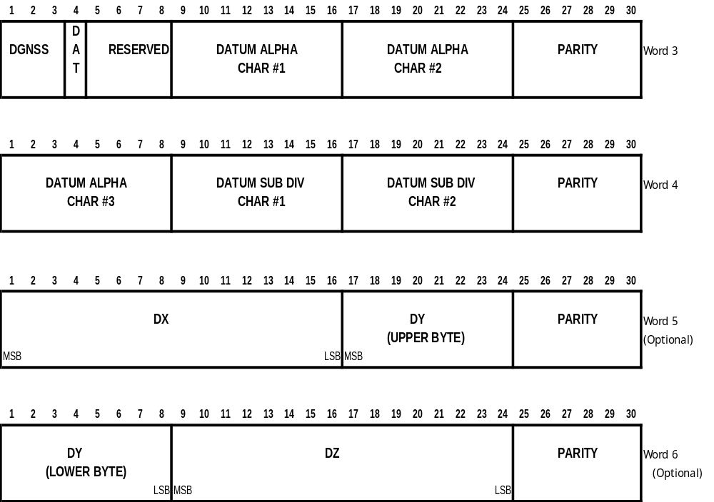

Figure 4-5. MESSAGE TYPE 4 - REFERENCE STATION DATUM

The field DGNSS identifies the DGNSS system of the reference station. A GPS differential broadcast is identified by 000, and a GLONASS differential broadcast by 001.

The field DAT indicates whether the corrections are referenced to the ITRF global terrestrial reference system (http://itrf.ensg.ign.fr/), or to a Local Datum.

The three Datum Alpha Code Characters are used to specify the datum used for the selected DGNSS broadcast using the three character alphabetic code for geodetic datum from the International Hydrographic Organization Publication S-60. If the datum alpha code is unknown, three null characters should be inserted. For a user defined datum, insert “999”.

The two Datum Sub Division Characters, when available, will be as stated in the National Imagery and Mapping Agency publication, Technical Report DMA TR 8350.2 (accessible at the time of this publication at NIMA web page, http://164.214.2.59/GandG/tr8350_2.htm). The first character will always be “-”. The second character will be as designated in the DMA TR 8350.2. If a subdivision code is not applicable or not available, two null characters should be inserted.
The parameters DX, DY, and DZ specify the ECEF offset of the Reference Station coordinates. The sense of the shift is defined for DAT=0 such that if DX, DY and DZ are added to the Reference Station Position, then the position of the reference station is obtained in GNSS coordinates. Note that since the differences between datums are not exactly represented by offsets (e.g., small differential rotations around the coordinate axes are involved), the user positional accuracy may degrade throughout the coverage region of the station especially at large distances between mobile receivers and reference station (see Section 3.2.11 and Appendix D). Note also that for a GPS reference station employing WGS-84 coordinates, or for a GLONASS reference station employing PE-90 coordinates, DAT=1 and DX=DY=DZ=0.

It is recommended that Message Type 4 be broadcast occasionally regardless of the datum employed, but it is especially important where the reference station is broadcasting corrections in a datum other than the reference datum for the GNSS. The broadcast rate for this message should be such that users entering the DGNSS receive the message within a reasonable time. The reason for this is that the default condition for no Message Type 4 is ITRF; thus when a remote receiver first picks up the broadcast, it will output positions in ITRF until it receives the first Type 4 message.
4.3.5 Message Type 5 - GPS Constellation Health (Permanent)

The Type 5 Message provides information that can assist in the operation of differential GPS user equipment. It is a mechanism through which the observations made at the reference station can be automatically used by the user equipment to improve performance without operator intervention. This message can contain information for one or more satellites. The satellite may or may not be in view of the reference station. It will be transmitted periodically as determined necessary by the reference station. The content of a Type 5 Message is described in Table 4-10 and illustrated in Figure 4-6. The first bit is reserved for expansion of satellite ID's beyond 32 to accommodate non-GPS satellites. However, before this happens, a full-scale review of the applicability of the data content would be required.

Table 4-10. CONTENTS OF A TYPE 5 MESSAGE

PARAMETER | NUMBER OF BITS | EXPLANATION
RESERVED | 1 | A single bit reserved for possible future expansion of satellite numbers beyond 32
SATELLITE ID | 5 | Standard format, see Table 4-4.
IOD LINK | 1 | Bit set to 0 indicates this information refers to navigation data with IOD in Message Types 1and 9. Bit set to l indicates this information refers to navigation data with IOD in Type 2 Message
DATA HEALTH | 3 | Standard information concerning satellite navigation data health, see Table 2-9 of the GPS/SPS Signal Specification (Note 1). This field is a repeat of the three Most Significant Bits of the 8-bit health status words pro-vided in the GPS almanac message, Subframes 4 & 5.
C/N_{o} | 5 | Satellite signal to noise ratio as measured at reference station. Scale factor l dB-Hz. Range is 25 to 55 dB-Hz. Bit 15 is LSB. The value "00000" indicates that the satellite is not being tracked by the reference station. The value "00001" = 25 dB-Hz at the low end and the value "11111" = 55 dB-Hz at the high end.
HEALTH ENABLE | 1 | Bit set to l indicates that satellite can be considered healthy by DGPS User Equipment despite the fact that satellite navigation data indicates the satellite is unhealthy.
NEW NAVIGATION DATA | 1 | Bit set to l indicates that new satellite navigation data is being acquired by the reference station and being integrated into the pseudorange correction generation process. There will soon be a new IOD indicated in the Type l or Type 9 Message.
LOSS OF SATELLITE WARNING | 1 | Bit set to 1 indicates that a change in the satellite's health to unhealthy" is scheduled. The "healthy" time remaining is estimated by the following 4 bits.
TIME TO UNHEALTHY | 4 | See bit 18 above. Scale factor is 5 minutes. Range is0 to 75 minutes. Bit 22 is LSB. The value "0000" indicates that the satellite is about to go "unhealthy". The value "1111" indicates the satellite will go "unhealthy" in about 75 minutes.
RESERVED | 2 | TBD
PARITY | 6 | (Note 1)

Note 1: See GPS/SPS Signal Specification, available from U.S. Coast Guard Navigation Information Service, see Appendix E.

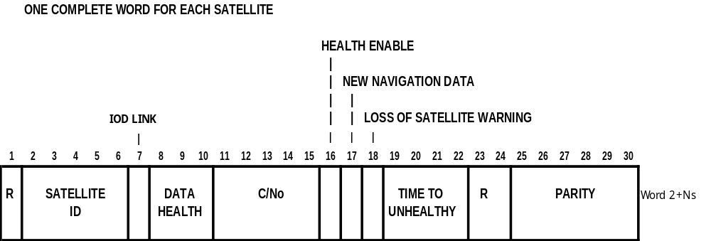

Figure 4-6. MESSAGE TYPE 5 - GPS CONSTELLATION HEALTH
4.3.6 Message Type 6 - GPS Null Frame (Permanent)

The Type 6 Message contains no parameters. It will be used as transmission fill, if required. Its purpose is to provide messages when the GPS Reference Station has no other message ready to send, or to synchronize the beginning of a message to some unspecified epoch. There may never be a reason to send this message. It is only defined as a contingency. It could be used as message fill in the future if higher message rates are not required because of slow error growth. It could also be used to provide an indication of station health, e.g., "Not Operating", when the reference receiver is down. Since it is a short message, it provides the user with additional preambles. Broadcasting this message could aid in establishing and maintaining frame synchronization.

The message contains the first two words as usual with N=0 or 1, depending whether or not an even or odd transmission fill is required. If N=1, then the 24 data bits in the extra word should be filled with alternating 1's and 0's. Parity should be tested as usual.

4.3.7 Message Type 7 -- DGPS Radiobeacon Almanac (Permanent, to be Retired)

Message Type 7 is being replaced by Message Type 27, the Extended Reference Station Parameters message. Manufacturers are urged to implement Message Type 27, as current and future service providers will be broadcasting it instead of Message Type 7, and future services will drop. Similarly, service providers are encouraged to implement Message Type 27 at the next upgrade of their systems.

The radiobeacon almanac provides the location, frequency, service range, and health information for a network of marine radiobeacons equipped to transmit differential GPS data. It also provides the identification of the broadcast station. The information will provide a properly equipped GPS receiver the capability of automatically selecting the optimum differential data transmitter. The radiobeacon location data resolution is coarse (0.3 Km in Latitude and 0.6 Km in Longitude), but it provides sufficient accuracy for determining the next nearest station. The range information is based on the useful service range, as determined by the service provider. The frequency range covers both the marine and aircraft non-directional radiobeacon bands. The beacon health data provides four indications; "Normal", "No Integrity Monitoring", "No Health Information Available", "No Health Information Available", and "Don't Use". The content of this message is given in Table 4-11. The format is illustrated in Figure 4-7.

The message has been designed to accommodate either MSK or FSK modulation. It is left to the service provider to specify the modulation scheme used.

Provision has also been made to indicate both synchronous and asynchronous data synchronization. The preamble of each message type provides the "sync" character for MSK broadcasts. The "start" and "stop" bits provide character synchronization for asynchronous broadcasts. While all bits in a synchronous broadcast are "data" bits, only 6 or 8 bits of each character are "data" bits in an asynchronous broadcast and that convention needs to be established by the provider of the service.

A variety of Forward Error Correcting (FEC) codes (and Forward Error Detection) can be used to improve broadcast performance. A provision is included to indicate that a FEC process is being used to encode the broadcast. Again the provider of the service will have to provide information about the particular code being used in their service.

The radiobeacon almanac update rate does not have to be very high. One message every 10 minutes should be adequate for marine service. A change in the health state of the radiobeacon should prompt it to issue a new message immediately.

In order to implement Type 7 messages properly, the transmitting radiobeacon must have access to information from all the radiobeacons listed in the almanac message. The service provider must implement the network to make this possible. In addition, neighboring service providers may share information in order to facilitate transitions between different jurisdiction zones. In this manner a differential user will always be provided with current almanac data in traversing from one radiobeacon service area to the next.

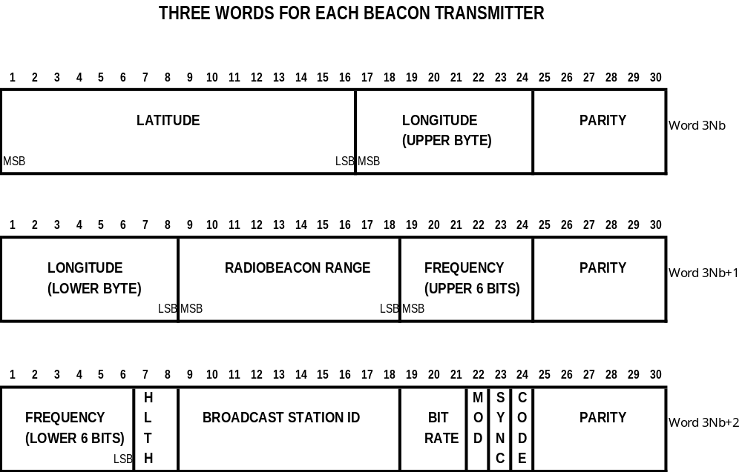

Figure 4-7. MESSAGE TYPE 7 - DGPS RADIOBEACON ALMANAC
Table 4-11. CONTENTS OF A TYPE 7 MESSAGE - DGPS RADIOBEACON ALMANAC

PARAMETER | NUMBER OF BITS | SCALE FACTOR AND UNITS | RANGE
LATITUDE | 16 | 0.002747º | +90º (Notes 1 & 2)
LONGITUDE | 16 | 0.005493º | +180º (Notes 1 & 2)
RADIOBEACON RANGE | 10 | 1 km | 0 to 1023 km
FREQUENCY | 12 | 100 Hz | 190 (all 0's) to 599.5 kHz (all 1's)
RADIOBEACON HEALTH | 2 | -- | “00” - Radiobeacon Operation Normal  “01” - No Integrity Monitor Operating  “10” - No information available  “11” - Don't Use this Radiobeacon
BROADCAST STATION ID | 10 | 1 | 0 to 1023
BROADCAST BIT RATE | 3 | -- | 8 states – (See Note 3)
MODULATION CODE | 1 | -- | "0" – MSK  "1" - FSK
SYNCHRONIZATION TYPE | 1 | -- | "0" – Asynchronous  "1" – Synchronous
BROADCAST CODING | 1 | -- | "0" - No added coding  "1" – FEC coding
Total | 72 x N_{b}
PARITY | N x 6 | (Note 4)

N_{b} -- Number of radiobeacons in message
N = Number of words in message containing data

Note 1: "+" values indicate North Latitude or East Longitude
Note 2: 2's complement
Note 3: Broadcast Bit Rate: 000 (0) 25 bits/sec 100 (4) 150 bits/sec
001 (1) 50 bits/sec 101 (5) 200 bits/sec
010 (2) 100 bits/sec 110 (6) 250 bits/sec
011 (3) 110 bits/sec 111 (7) 300 bits/sec
Note 4: See GPS/SPS Signal Specification, available from U.S. Coast Guard Navigation Information Service, see Appendix E.
4.3.8 Message Type 8 - Pseudolite Almanac (Tentative)

Table 4-12 shows the proposed pseudolite almanac message. It is similar to the beacon almanac message. Latitude and longitude are two's complement binary numbers defining the approximate pseudolite position with a resolution of 180/65,536 degrees for latitude and 360/65,536 degrees for longitude. The appropriate Gold code number is given by the code number in binary form. The health bits are defined by the note below the table. Four 7-bit ASCII alphanumeric characters are provided to name the pseudolite, e.g., LAX1 or JFK3. Four reserved bits are included for future use and to round the message to three whole 30-bit words per pseudolite. The entire almanac message describes three pseudolites, requires 330 bits, and takes 6.6 seconds to transmit.

Table 4-12. CONTENTS OF A TYPE 8 PSEUDOLITE ALMANAC MESSAGE

PARAMETER | NUMBER OF BITS | SCALE FACTOR AND UNITS | RANGE
LATITUDE (Note 1) | 16 | 0.002747º | +90º (Note 2)
LONGITUDE (Note 1) | 16 | 0.005493º | +180º (Note 2)
CODE NUMBER (Note 3) | 6 | 1 | 0-63
HEALTH (Note 4) | 2 | See Table below | 4 states
4 ALPHANUMERIC | 28 | -- | 7-bit ASCII
RESERVED | 4 | --
Total | 72 x N_{p}
PARITY | N x 6 | (Note 5)

N_{p} = the number of pseudolites in the message
N = Number of words in message containing data

Note 1: "+" values indicate North Latitude or East Longitude
Note 2: 2's complement
Note 3: Pseudolite Health States: 00 (0) Pseudolite Operation Normal
01 (1) Undefined
10 (2) Status Unknown
11 (3) Station Down or Don't Use this Pseudolite

Note 4: The Code Numbers indicate codes that don’t duplicate GPS codes
Note 5: See GPS/SPS Signal Specification, available from U.S. Coast Guard Navigation Information Service, see Appendix E.
4.3.9 Message Type 9 -- GPS Partial Correction Set (Permanent)

The Type 9 Message serves the same purpose as the Type 1 Message, in that it contains the primary differential GPS corrections. However, unlike Type 1's, Type 9 Messages do not require a complete satellite set. As a result, they require the use of a more stable clock than a station transmitting only Type 1's, because the satellite corrections have different time references. To prevent degradation of navigation accuracy due to unmodelable clock drift that can occur between Type 9 messages, a highly stable clock source is required. Type 9's are useful in the presence of SA for providing additional updates for satellites whose rate correction variations are high. They are also useful for slow data links in the presence of impulse noise, such as that encountered in radiobeacon operation. During high noise periods, the higher rate of preambles supports a faster re-synchronization.

The Type 9 Message can also be used to improve the performance of data links that are susceptible to interference from impulse noise, such as radiobeacon data links. Grouping satellites in blocks of three significantly improves the data link performance in two ways. First, when Type 9 Messages contain the corrections for three satellites, their initially lower age of corrections more than compensates for their longer propagation time associated with the increased overhead. This is illustrated in Table 4-13. Second, the short length of the Type 9 Message provides increased noise immunity and allows a more rapid re-synchronization, due to the fact that the preamble is transmitted at a much higher rate. Note that unlike the case for Type 1 Messages, corrections from partial Type 9 Messages can be applied as soon as they are received (see Section 5.3.5) thus further reducing the average PRC latency and lowering the susceptibility of the messages to channel noise.

Table 4-13. PRC AGE OF CORRECTIONS AT 100 bps

 | MAXIMUM PRC LATENCY
NO. OF SATELLITES |  | TYPE 1 | TYPE 9 (3 SATS/MSG)
4 |  | 5.4 s | 5.4 s
6 |  | 7.2 s | 6.3 s
8 |  | 9.6 s | 8.1 s
9 |  | 10.2 s | 8.4 s

The content and the format of the Type 9 Message is identical to that of the Type 1 Message, except that N_{s}, the number of satellites, and N, the number of 30 bit words, will be much smaller.

4.3.10 Message Type 10 - P-Code Differential Corrections (Reserved)

Message Type 10 has been assigned to the P-code users, who will want differential corrections for both L1 and L2 frequencies. Its form and content are TBD. It should be noted that Message Types 19 and 21 can be used with P-code signals.

4.3.ll Message Type 11 - C/A Code L2 Corrections (Reserved)

Message Type 11 has been reserved for C/A-code L2 corrections, in case future GPS satellites transmit the C/A code on the L2 frequency. It is expected to be similar to the Message Type l. It should be noted that Message Types 19 and 21 can be used for this purpose.

4.3.12 Message Type 12 - Pseudolite Station Parameters (Reserved)

Message Type 12 has been reserved for a Pseudolite Station Parameter message which will provide clock offset parameters and the location of the phase center of the pseudolite transmitter antenna. It will also give the location of the GPS antenna. The details are TBD.

4.3.13 Message Type 13 - Ground Transmitter Parameters (Permanent)

Message 13 identifies the location and estimated range of the data link transmitter transmitting the differential corrections. In RTCM SC-104 Version 1.0, this information was incorporated in a Message Type 3. It is a brief message, consisting of two words. Table 4-14 gives the details.

Table 4-14. CONTENTS OF A TYPE 13 MESSAGE

PARAMETER | NUMBER OF BITS | SCALE FACTOR AND UNITS | RANGE
STATUS MESSAGE | 1 | See Message Type 16 | Y/N
XMTR RANGE FLAG | 1 | -- | Y/N
RESERVED | 6 | --
XMTR LATITUDE (Note 1) | 16 | 0.01º | +90º (Note 2)
XMTR LONGITUDE (Note 1) | 16 | 0.01º | +180º (Note 2)
XMTR RANGE | 8 | 4 km | 4-1024 km (Note 3)
Total | 48
PARITY | 12 | (Note 4)

Note 1: "+" values indicate North Latitude or East Longitude
Note 2: 2's complement
Note 3: All zeros indicates 1024 kilometers
Note 4: See GPS/SPS Signal Specification, available from U.S. Coast Guard Navigation Information Service, see Appendix E.

If the Status Message flag in bit l is set, it indicates that something unusual is happening or is going to happen, and that the details can be found in a Type 16 message. It also means that a Type 16 (ASCII) message will be broadcast sometime soon. Such a message might, for example, state that the transmitter may be going down for maintenance, and provide the planned outage period. It might also indicate that bad weather is forecast which might reduce the range of the broadcast or disrupt communications. If the Transmitter Range Flag is set, it indicates that the estimated range is different from that found in the Type 7 message (which contains the beacon's listed range). This could be for reasons of atmospheric noise, or because the transmitter power is being reduced.

4.3.14 Message Type 14 - GPS Time of Week (Permanent)

Message Type 14 is a special time tag message intended to supplement the time information provided by the modified Z-count available in the message header. The modified Z-count only provides current time within the hour, but does not indicate the hour or day. This message is necessary for the re-establishment of the recording hour when recorded SC-104 DGPS data is being analyzed.

The time tag message should be transmitted at least twice per hour -- once shortly after the top of the hour rollover, and again at the half-hour mark.

The first 18 bits of this message are used to define the GPS WEEK number and the HOUR OF WEEK parameters, from which hour, day, month and year can be determined. The HOUR OF WEEK can be obtained from the Time of Week (TOW) count in each GPS satellite navigation message. The TOW count is in 1.5-second epochs, so that the HOUR OF WEEK can be obtained by dividing by 2400 (HOUR OF WEEK = Int[TOW/2400]). To enable users to obtain UTC time to better than one-second accuracy using only the broadcast message, the last 6 bits provide the leap second difference between GPS time and UTC time. GPS time is provide to the nearest 0.6 seconds in each message using the modified Z-count, although it should be remembered that the modified Z-count is referenced to the time of the correction, not the time at which the receiver has decoded the message.

This message may be expanded in the future by adding more words to the message. A possible use of an expanded message may include timing relationships between GNSS navigation systems. Table 4-15 shows the content of the Type 14 message. Note that the data occupies only one word.

Table 4-15. CONTENTS OF A TYPE 14 MESSAGE

PARAMETER | NUMBER OF BITS | SCALE FACTOR AND UNITS | RANGE
GPS WEEK (Note 1) | 10 | 1 week | 0-1023 weeks
HOUR OF WEEK (Note 1) | 8 | 1 hour | 0-167 hours
LEAP SECONDS (Note 1) | 6 | 1 sec | 0-63 sec
PARITY | 6 | (Note 1)

Note 1: See GPS/SPS Signal Specification, available from U.S. Coast Guard Navigation Information Service, see Appendix E.
4.3.15 Message Type 15 - Ionospheric Delay Message (Permanent)

Message Type 15 is designed to provide ionospheric delay and delay rate of change along the line-of-sight vector to different satellites. It can be employed by two-frequency users to ameliorate the ionospheric decorrelation that would otherwise be experienced by a user receiver distant from the reference station. It is anticipated that Type 15 messages will be broadcast every 5-10 minutes or so. As a consequence, the reference station should form the rate term to best approximate the ionospheric behavior over the next reporting period.

The Type 15 message is designed to enable the user equipment to continuously remove the ionospheric component from the received pseudorange corrections, to form what are called "iono-free" corrections. The delay and rate terms are added exactly like Type 1 corrections to provide the total ionospheric delay at a given time, and the total ionospheric delay is then subtracted from the pseudorange corrections. The resulting corrections are thus "iono-free". The user equipment similarly subtracts off its own measurements (or estimates) of ionospheric delay from its own pseudorange measurements, and applies the iono-free corrections. Table 4-16 defines the parameters of the Type 15 Message, and Figure 4-8 shows the manner in which the bits are distributed throughout the message. Note that each satellite requires one and one-half words, or 36 bits, of data, exclusive of parity. Also note that a combined GPS-GLONASS receiver should transmit the ionospheric information for each system in separate messages.

Table 4-16. CONTENTS OF A TYPE 15 MESSAGE, EACH SATELLITE

PARAMETER | NUMBER OF BITS | SCALE FACTOR AND UNITS | RANGE
R = RESERVED | 2 | -- | --
G = GNSS SYSTEM IDENTIFIER | 1 | -- | 0=GPS  1=GLONASS
SATELLITE ID | 5 | 1 | 1-32 (Note 1)
IONOSPHERIC DELAY | 14 | 1 cm | 0-16,383 cm
IONO RATE OF CHANGE (Note 2) | 14 | 0.05 cm/min | ± 409.55 cm/min (Note 3)
Total | N_{s} x 36
PARITY | N x 6 | (Note 4)
N_{s} = Number of satellite corrections contained in message
N = Number of words in message containing data

Note 1: Satellite number 32 is indicated by all zeros
Note 2: A binary 10 0000 0000 0000 indicates that the user should stop using iono corrections
Note 3: 2’s complement
Note 4: See GPS/SPS Signal Specification, available from U.S. Coast Guard Navigation Information Service, see Appendix E.

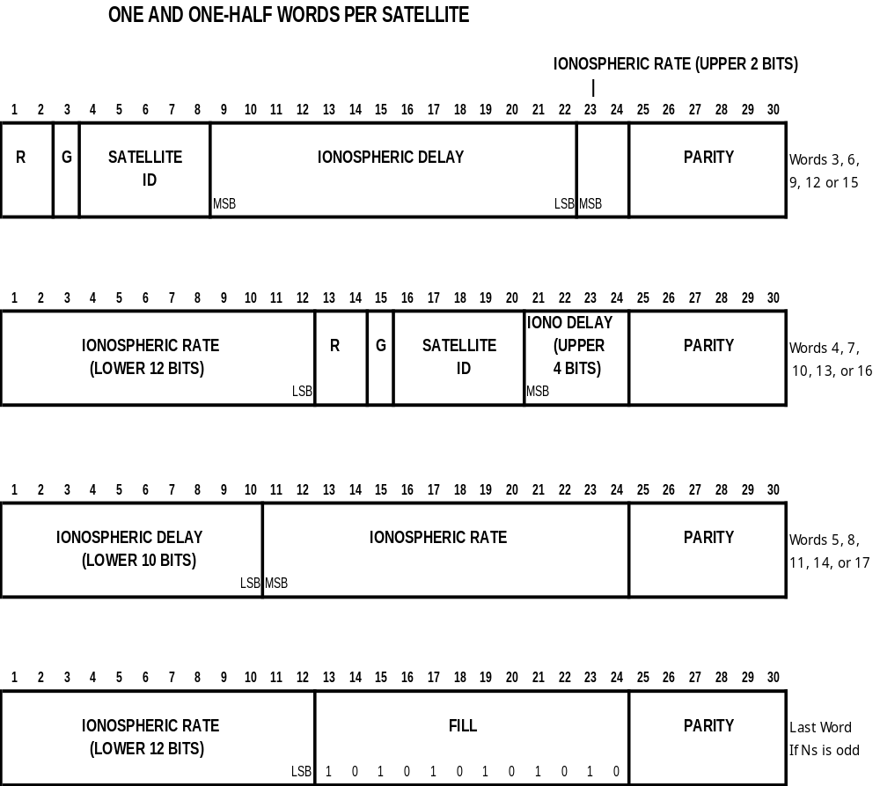

Figure 4-8. MESSAGE TYPE 15 - IONOSPHERIC DELAY PARAMETERS

4.3.16 Message Type 16 - GPS Special Message (Permanent)

Message Type 16 is a special ASCII message that can be displayed on a printer or CRT. Each Type 16 message can be up to 90 characters long. To be consistent with the other messages, the MSB is transmitted first, which means that the "data roll" described in section 5.3.2 applies to this message type as well. The 8-bit ASCII code is employed, but it is anticipated that the MSB will usually be zero, because there is no standard on the meaning of other than 7-bit ASCII characters. If for special purposes a commercial operation or agency elects to use IBM graphics characters, for example, they could be sent using the Type 16 message. Fill bits are zeros for this message, in order to avoid accidental misinterpretation of the alternating l's and 0's found as the fill pattern in other messages.

Figure 4-9 shows how the word "QUICK" would look as a Type 16 message.
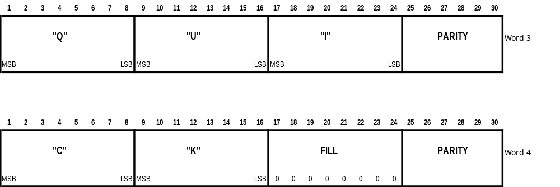

Figure 4-9. MESSAGE TYPE 16 - ASCII ("QUICK")

4.3.17 Message Type 17 - GPS Ephemerides (Permanent)

Message 17 contains GPS satellite ephemeris information. In the event that the IODC does not match the IODE, the differential reference station would continue to base corrections on the previous good satellite ephemeris. Under this condition, the DGPS would need to broadcast the old ephemeris data. This would allow the user equipment just entering the differential system to utilize the corrections being broadcast for that ephemeris. This would enable the use of the satellite for differential navigation despite the fact that the satellite ephemeris was in error. It is anticipated that this message type would be broadcast every 2 minutes or so while this condition persisted. The schedule would be maintained until the satellite broadcast was corrected, or until the satellite dropped below the coverage area of the reference station. Note that this message identifies the satellite by PRN number (Word 21), and that a separate message is required for each satellite.

Table 4-17 defines the parameters of Message 17, showing the locations within the words.

Table 4-17. CONTENTS OF TYPE 17 GPS EPHEMERIS MESSAGE

PARAMETER | WORD NUMBER | NUMBER OF BITS | SCALE FACTOR AND UNITS | RANGE  (Note 1)
WEEK NUMBER | 3 | 10 | l week
I DOT | 3 | 14 | 2⁻⁴³ semi-circles/sec
IODE | 4 | 8 | See GPS/SPS Signal Spec, Section 2.4.4.2 (Note 2)
t_{oc} | 4 | 16 | 2⁴ sec | 604,784 sec
a_{f1} | 5 | 16 | 2⁻⁴³ sec/sec
a_{f2} | 5 | 8 | 2⁻⁵⁵ sec/sec²
C_{rs} | 6 | 16 | 2⁻⁵ meters
DELTA n | 6/7 | 16 | 2⁻⁴³ semi-circles/sec
C_{uc} | 7 | 16 | 2⁻²⁹ radians
ECCENTRICITY (e) | 8/9 | 32 | 2⁻³³
C_{us} | 9 | 16 | C_{us}
A^{1/2} | 10/11 | 32 | 2⁻¹⁹ meters ^{1/2}
t_{oe} | 11 | 16 | seconds | 604,784 sec
Ω_{o} | 12/13 | 32 | 2⁻³¹ semi-circles
C_{ic} | 13 | 16 | 2⁻²⁹ radians
i_{o} | 14/15 | 32 | 2⁻³¹ semi-circles
C_{is} | 15 | 16 | 2⁻²⁹ radians
ω | 16/17 | 32 | 2⁻³¹ semi-circles
C_{rc} | 17 | 16 | 2⁻⁵ meters
dω/dt (OmegaDot) | 18 | 24 | 2⁻⁴³ semi-circles/second
M_{o} | 19/20 | 32 | 2⁻³¹ semi-circles
IODC | 20 | 10 | See GPS/SPS Signal Spec, Section 2.4.4.2 (Note 2)
a_{f0} | 20/21 | 22 | 2⁻³¹ seconds
PRN ID | 21 | 5 | 1 | 1-32 (Note 3)
FILL | 21 | 3 | (Note 4)
t_{GD} | 22 | 8 | 2⁻³¹ seconds
CODE ON L2 | 22 | 2 | 01 = P-code ON  10 = C/A-code ON
SV ACCURACY | 22 | 4 | 0-6: acc = 2^{(1+N/2)} m  6-14: acc = 2^{(N-2)} m  15: Use at own risk
SV HEALTH | 22 | 6 | 0 = L2 P-code data ON  1 = L2 P-code data OFF
L2 P-CODE DATA FLAG | 22 | 1 | 0 = L2 P-code data ON  1 = L2 P-code data OFF
FILL | 22 | 3 | (Note 4)
Total |  | 480
PARITY |  | 120 | See GPS/SPS Signal Spec (Note 2)

Note 1: Range is that obtainable by bit allocation and scale factor unless otherwise indicated
Note 2: Available from U.S. Coast Guard Navigation Information Service (see Appendix E)
Note 3: Satellite number 32 is indicated with all zeros (00000)
Note 4: FILL bits consist of alternating l's and 0's

4.3.18 Kinematic and High-Accuracy Messages

Message Types 18-19 contain information useful for surveying and highly accurate positioning and navigation. The data they provide support real-time kinematic applications that utilize real-time interferometric techniques to resolve integer ambiguities. Message Type 18 provides carrier phase measurements, while Type 19 provides pseudorange measurements. The measurements are not corrected by the ephemerides contained in the satellite message.

Message Types 20 and 21 are corrected by the ephemerides, and are thus referred to as "corrections". They are being retired for the following reasons: (1) they duplicate the capabilities of Message Types 18 and 19, (2) very few services use them, and these services also can provide 18 and 19, and (3) all known manufacturers that have implemented 20 and 21 have also implemented 18 and 19. As a consequence, Message Types 20 and 21 no longer perform a useful service.

The two message types that support kinematic and high-performance differential applications are given in Table 4-18.
Table 4-18. REAL-TIME KINEMATIC (RTK) MESSAGES
MESSAGE  TYPE NO. | MESSAGE NAME
18 | UNCORRECTED CARRIER PHASE MEASUREMENTS
19 | UNCORRECTED PSEUDORANGE MEASUREMENTS

The messages have similar formats. Word 3, the first data word after the header, contains a GNSS TIME OF MEASUREMENT field that is used to increase the resolution of the MODIFIED Z-COUNT in the header. Word 3 is followed by pairs of words containing the data for each satellite observed. Appropriate flags are provided to indicate L1, L2, and C/A or P-code measurements. The carrier smoothing interval for pseudoranges and pseudorange corrections is also furnished.

A. DATA QUALITY REPRESENTATION
A non-linearly quantized data quality indicator is provided for carrier phase measurements. The carrier phase data quality indicator is discussed in Appendix A.

Since reference station code multipath and receiver noise have different temporal characteristics, data quality indicators for both are provided. The pseudorange and multipath data quality indicators are discussed in Appendix B.

B. IMPLEMENTATION ISSUES

a. Satellite Position Computation Accuracy
For precise differential positioning, common satellite positions and satellite clock offsets must have common values (ideally to sub-millimeter accuracy) for both reference and user receivers. The user receiver should use the same algorithms for both sets of measurements so that algorithmic errors cancel when differenced.

b. Antenna Phase Center Stability
The apparent phase center location of an antenna may vary with direction of signal incidence. The phase center stability characteristics can differ for different antenna designs and ground plane configurations. For precise (centimeter level or smaller) positioning, the phase center characteristics of the reference and user receiver antennas must be matched or differences compensated. For local private systems, this often is accomplished by using the same antenna and ground plane design at both locations. Common variations in phase center shift cancel when differenced. However, the system designer may have little control over the phase shift characteristics of antennas used with public access systems. In earlier versions of the document the antenna’s phase center was modeled as a point for each frequency L1 and L2: the extended part of Message Type 22 allows transmitting the offset of the L2 phase center relative to the L1 phase center. Over time investigations showed that this interpretation is oversimplified and does not support the needs of high-precision applications in kinematic GPS surveying. The virtual antenna phase center actually varies depending on the direction, azimuth and elevation of the satellite, and this variation can be different for L1 and L2. The total variation can be up to tens of millimeters away from the modeled phase center point. The resulting accuracy of position estimates will be significantly affected when using two different antenna types at the reference and rover sites.

The scientific community utilizes several different ways of calibrating the antenna phase center variations. The results are represented either in an absolute reference frame or relative to a specific antenna. Model-specific antenna calibration tables are available for most of the survey-type antennas; these tables can be downloaded via the Internet. Independent investigations show that millimeter level accuracy is achievable for model-type calibration values. In principle, it should be possible to model the phase center of the reference station antenna, and include that information in a broadcast message. However, the techniques for determining this information is not yet standardized. As a consequence, this standard leaves it to the user to decide whether to use calibrated antennas, or to accept the lower accuracy that results from using a point phase center model.

In any case, the reference station should supply enough information to the user receiver for complete understanding of the antenna configuration. Message Type 23 has been introduced to allow the reference station to transmit the model type descriptors and setup ID to the user station. The Committee has adopted the naming convention from the IGS equipment-naming table as supplied by the International GPS Service Central Bureau (IGS CB). The table delivers a unique antenna descriptor for antennas used for high-precision surveying type applications. The IGS CB upon request will introduce the unique descriptors of new antennas. The antenna descriptor indicates the antenna model, manufacturer and model type used, as well as accessories such as an attached ground plane and a protection dome, if applicable. The individual antenna is defined through the antenna descriptor in combination with the antenna serial number usually issued by the manufacturer. A setup ID can be allocated as well, which identifies the detailed characteristics for the setup.

The user equipment can look up its calibration values for the best match and correct the observations accordingly. The IGS CB also provides model type calibration values for a variety of antennas. The most important information is the antenna descriptor. As long as antennas with available model type calibration values are used to equip reference stations, the user stations can optimize their coordinate computation accuracy. New antenna models will be calibrated and introduced into the available tables relatively quickly, especially those with high performance that creates a demand. Service providers are advised to equip their reference stations with antenna models already in the publicly available antenna calibration tables. Otherwise, they would be left to support the calibration of the antennas and their introduction into the public tables, or to provide compatible calibration tables on their own initiative. Some service provider may decide to have the reference station antennas individually calibrated, in which case the provider must ensure that the information is distributed to the customers in an appropriate way and format. The information needed to obtain the individual calibration values of antennas and their setups requires the transmission of the complete Message Type 23 to the user receivers. The Committee recommends the IGS standardized format for all distribution.

Version 2.3 included the introduction of Message Type 24, which comprised a desirable alternative to the combination of Types 3 and 22. Message Type 24 avoids the ambiguous definition engendered by the reference to a point phase center. Instead, Message Type 24 solves the problem of referencing the L1 phase center by utilizing the Antenna Reference Point (ARP), following the practice used throughout the International GPS Service (IGS). As a consequence, Message Type 22 will no longer be supported.

c. Issue of Data (GPS), Time of Day (GLONASS)

When using broadcast ephemeris and satellite clock correction data, the same issue of data (GPS) or time of day (GLONASS) must be used at the reference and user sites. When raw measurements are processed for differential positioning, usually the same ephemeris data is used for all sites. When corrections are computed at the reference station and applied at the user's site, the possibility exists that they may be different. Rather than computing and broadcasting corrections for two different issues of data, it is recommended that the reference station wait 90 seconds after acquiring a new issue of data before transmitting corrections computed with the new issue of data. This allows the user receiver sufficient time to acquire the new data set. The issue of data or time of day used to compute corrections always is transmitted with the corrections.

d. Bad Reference Station Data

Erroneous or invalid data for any satellite should not be included in any messages sent by the reference station.

e. Use of "Ionosphere-free" Measurements
When the Committee first considered kinematic measurements, there was a belief that there might be some advantage in providing for an ionosphere-free measurement, whereby the ground station would determine the equivalent L2 phase of the delay caused by the ionosphere. The user receiver would then adjust its L2 phase by this amount, so that the L1 and L2 measurements would then be "ionosphere-free". However, to the committee's knowledge, no manufacturer has implemented kinematic operation in this fashion, and retaining it imposes a burden on manufacturers to design for the unlikely possibility that a broadcast message would use such a mode. As a consequence, the Committee decided not to support this mode of operation.

f. Use of Half Cycle Measurements
Early in the development of surveying and kinematic techniques, the L2 carrier was recovered by "squaring" receivers, which resulted in half cycle measurements. However, the superior signal-to-noise ratio available to receivers capable of tracking full-cycle L2 carrier signals has resulted in a situation where squaring receivers are rarely used, if at all, for kinematic applications. To the committee's knowledge, no manufacturer has implemented kinematic operation in this fashion, and retaining it imposes a burden on other manufacturers to design for the unlikely possibility that a broadcast message would use such a mode. As a consequence, the Committee decided not to support this mode of operation.

g. Clock Rollover Effects
Receiver clocks drift with respect to absolute time. As a consequence, the pseudorange, which is the sum of the actual range plus the receiver clock bias, will occasionally exceed the maximum value of its counter. This means that the receiver must be designed to occasionally adjust the clock bias, which causes an identical jump in all of the satellite pseudorange values. Users who plot code minus carrier values, a common operation, will see a jump in all satellite data. To avoid this, and to achieve interoperability, it is recommended that when such adjustments take place, the carrier phase values should be adjusted by an identical amount as the pseudorange adjustment. This will remove jumps in the plot of code minus carrier. The double difference operation commonly used in real-time kinematic applications will remove this adjustment, so the jump in carrier phase will be transparent to such users.

The pseudorange and carrier phase observables in Message Types 18 and 19 shall appear to be controlled by the same clock. That is, except for dispersive effects associated with the ionosphere, the pseudorange and carrier phase shall track each other such that

|ρ_{j} - ρ_{k}| | φ_{j} - φ_{k} | c
----------- ≈ ------------ * ---
| t_{j} - t_{k}| | t_{j} - t_{k}| f

where ρ_{j} is the pseudorange expressed in meters at time t_{j},
φ_{j} is the carrier phase expressed in cycles, at time t_{j},
t_{j},t_{k} are successive time tags,
c is the speed of light in meters/second (see the GPS/SPS Signal Specification and/or the GLONASS ICD), and
f is the nominal carrier frequency.

h. Mixed P-Code and C/A-Code Operation

Mobile units operating in P-Code (or Y-Code) can operate with ground stations that transmit carrier and pseudorange information based on P-Code (and similarly for C/A-Code), but meter-level errors in pseudorange measurements can occur if one receiver is operating with C/A-Code, the other with P-Code. This is due to the fact that the satellite signals have different bandwidths, and are not perfectly synchronized.

i. Definition of data set

The phrase “data set” used in the text for Message Types 18-19 describes a block of correction messages supporting the same service and having the same time tag. For instance, for GPS service it is desirable to know if a set of L2 phase observations will follow a set of L1 phase observations. By setting the Multiple Message bit to zero for each satellite in the last message of the data set, the user receiver can begin processing the data immediately, and does not have to wait until the next message is received and decoded to determine if it contains information relevant to that message block. This will ensure minimal latency for any user equipment.

Message Types 18 and 19 with the same time tag constitute a “data set”. A reference station supporting both GPS and GLONASS operation should treat GPS and GLONASS message blocks as separate “data sets” if the receiver oscillators are not synchronized (in which case the GPS and GLONASS measurement times would not be the same). However, if the GPS and GLONASS reference receivers are synchronized so that their measurements are taken simultaneously, the resulting broadcast should (1) treat the entire block of GPS and GLONASS messages as a single “data set”, (2) group all GPS messages together, and all GLONASS messages together, and (3) send the GLONASS messages after sending the GPS messages. By conforming to this convention, an user receiver processing both GPS and GLONASS messages will know that all the messages have the same time tag; and a GPS-only user will obtain a positive indication that the message block is complete.

j. Reference Station Networks

The designs of the kinematic messages (Message Types 18-19) are premised on the assumption that a single local reference station was used to determine the message content. However, the use of single reference stations to transmit observation or correction records has some disadvantages. To cover a region of hundreds or thousands of square kilometers requires a large number of reference stations and broadcast facilities, because the accuracy and reliability of integer ambiguity resolution deteriorates a few tens of kilometers from the reference station. In response to this problem, networks of reference stations supporting kinematic applications are currently being developed around the world. Networks can be designed that enable a significantly reduced number of reference stations to cover a large region. Their designs are such that the current kinematic message set does not support their use in an optimum manner. For instance tropospheric and ionospheric delay differences between reference station and user receiver are assumed to be negligible after modeling, but this assumption is not valid over large areas. Thus the network provider needs to model the atmospheric delays and supply this information to the user in some standard format. The current message set does not support this capability.

In one network design approach, the network software creates “virtual” observations that are intended to be equivalent to observations that would be measured at reference stations conveniently located close to the user. These “virtual” observations need to exhibit the same behavior as if they were actual observations collected at the position of that “virtual” station. The tropospheric and ionospheric refraction has to match the refraction expected for a real reference station. The user receiver has to correct for these refraction terms. Similarly, the observation (correction) records have to recreate modeled antenna phase center deviations expected for a real reference station. In order to do so, the observation data may have to be corrected for the various antennas within the network for the computations required, but a reverse reduction to a modeled antenna phase pattern before transmission to user stations is mandatory. For easier handling on the user side the reverse reduction to a specific IGS identified antenna model type with available calibration values is recommended.

It should be noted that the Version 3 standard has been developed and is available, and is being widely used to support network operation. It has the advantage of being much more efficient.

4.3.19 Message Type 18 - RTK Uncorrected Carrier Phases (Permanent*)

* This message is now considered permanent with respect to GPS and GLONASS.

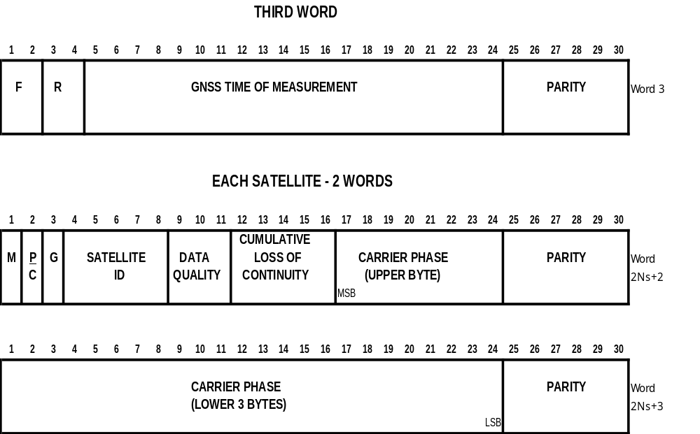

Figure 4-10. MESSAGE TYPE 18 - RTK UNCORRECTED CARRIER PHASES

Table 4-19 shows the contents and meaning of the fields in the Type 18 message.
Table 4-19. CONTENTS OF A TYPE 18 MESSAGE –

UNCORRECTED CARRIER PHASE
PARAMETER | NUMBER OF BITS | SCALE FACTOR AND UNITS | RANGE
F = FREQUENCY INDICATOR | 2 | -- | "00": L1 message  "10": L2 message  "01": Reserved for future augmentations  "11": Reserved for future augmentations
RESERVED | 2 | --
GNSS TIME OF MEASUREMENT | 20 | 1 μs | 0 to 599999 μs (See Note 1)
M = MULTIPLE MESSAGE INDICATOR (See Note 2) | 1 | -- | "0" - Informs the receiver that this is the last message of the data set having this time tag (see definition of “data set” in section 4.3.18C(i))  "1" - Informs the receiver that another message of the same data set with the same time tag will follow
P/C = CA-Code / P-Code INDICATOR | 1 | -- | "0" - C/A-Code  "1" - P-Code (Note 3)
G = GPS/GLONASS SATELLITE CONSTELLATION INDICATOR | 1 | -- | "0" - Message is for GPS satellites  "1" - Message is for GLONASS satellites
SATELLITE ID | 5 | 1 | 0-31 (Note 4)
DATA QUALITY | 3 | -- | (See Note 5 and Table 4-20)
CUMULATIVE LOSS OF CONTINUITY INDICATOR | 5 | 1 | 0 to 31 (Note 6)
CARRIER PHASE | 32 | 1/256 Cycle | ±8,388,608 Cycles (2’s complement) (Note 7)
Total | 48xN_{s}+24 | (Note 8)
PARITY | Nx6 | (Notes 9,10)

Note 1: Expanded Time of Measurement = GNSS TIME OF MEASUREMENT + MODIFIED Z-COUNT (from header). The time shall be referenced to GPS time for GPS satellites and to GLONASS time for GLONASS satellites.
All CARRIER PHASEs in the message shall be determined for the Expanded Time of Measurement. The GNSS TIME OF MEASUREMENT for a message containing L2 shall be the same as that in the corresponding message containing L1 data. Phase is of opposite sign to pseudorange, and is thus different than in the RINEX standard; thus if the range increases, the phase decreases.
The GNSS TIME OF MEASUREMENT shall be an estimate of GNSS time at the time of measurement. This value shall be constructed by using the following formula:

GNSST = RT + CE
where
RT is the receiver time of the measurement, and
CE is the receiver’s estimate of its own clock error.

The receiver time tag RT is the same quantity that is used to compute the pseudoranges in Message Type 19. The pseudorange (PR) is computed by the following formula:
PR = c * (RT - TT)
where PR is the pseudorange to the satellite,
TT is the transmit time, and
c is the speed of light.
There are several constraints that must be observed, in order to support interoperability:
1. The magnitude of the clock error CE shall be kept under 1.1 milliseconds
2. The receiver measurements shall be made at “hard edges” of the receiver clock, with minimum divisions of 10 ms. That is, the receiver shall time measurements to within one microsecond, if possible, of even divisions of a one-second period. This means that if the reference receiver generates data at once per second, the measurements shall be aligned within half a microsecond to integer seconds of the receiver clock. If the reference receiver generates data faster than once per second, the period shall be chosen such that there is always a measurement taken on the second. Thus update periods of 500 ms, 250 ms, 200 ms, 125 ms, 100 ms, 50 ms, 40 m, 25 ms, 20 ms, and 10 ms can be utilized, but no others.
3. Where corrections are transmitted at a rate slower than once per second, mobile receivers should be designed to process corrections received at any second, in order to accommodate multiple reference station operation. However, it is recommended for single-reference station operation, that periods should be chosen such that there is always a measurement taken on the minute; in this case periods of 1s, 2s, 3s, 4s, 5s, 6s, 10s, 12s, 15s, 20s, 30s, or 60s could be utilized, but no others. In all cases reference station receiver measurements should be made at the “hard edges” of the second, as described in item 2 above.
4. Meeting these requirements enables the mobile receiver to recover both the receiver time tag and the receiver clock error from the GNSS TIME OF MEASUREMENT. The most significant bits contain the receiver time tag RT, while the least significant bits contain the clock error CE. The following two examples demonstrate this:
a. Suppose GNSST = 0.471014 s, then
RT = 0.47s and CE = 1014 μs
b. Suppose GNSST = 0.248972 s, then
RT = 0.25 s and CE = -1028 μs

Note 2: If both GPS and GLONASS are used and measurements are taken at exactly the same time, then the multiple message bit applies to all measurements:

GPS type 18, time 1, L1, M=1
type 18, time 1, L2, M=1
type 19, time 1, L1, M=1
type 19, time 1, L2, M=1
GLONASS type 18, time 1, L1, M=1
type 18, time 1, L2, M=1
type 19, time 1, L1, M=1
type 19, time 1, L2, M=0
On the other hand, if both GPS and GLONASS are used, but the measurements are asynchronous, then the multiple message bit applies to one system at a time:
GPS type 18, time 1, L1, M=1
type 18, time 1, L2, M=1
type 19, time 1, L1, M=1
type 19, time 1, L2, M=0
GLONASS type 18, time 2, L1, M=1
type 18, time 2, L2, M=1
type 19, time 2, L1, M=1
type 19, time 2, L2, M=0
NOTE: Since GPS time is different from GLONASS time, one Message Type 18 is generated for GPS satellites and another for GLONASS satellites.

Note 3: Transmitted L1 P-code uncorrected phase measurements shall not be adjusted to C/A-code equivalent measurements or vice versa.

Note 4: PRN number for GPS satellites -- satellite number 32 is indicated by 0; slot number for GLONASS satellites

Note 5: The carrier phase data quality indicator is the estimated one sigma phase measurement error indicated by 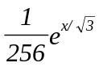cycles where X is the decimal equivalent of the 3-bit indication, as shown in Table 4-20.

Note 6: The CUMULATIVE LOSS OF CONTINUITY INDICATOR shall be incremented each time continuity of the CARRIER PHASE measurement is lost (unfixed cycle slip or loss of lock.)

Note 7: CARRIER PHASE data shall not be transmitted until the correct polarity has been resolved. CARRIER PHASE data for a given satellite shall not be transmitted for those GNSS TIMES OF MEASUREMENT when valid data are not available. The data range for CARRIER PHASE is less than the total possible range measured by the reference receiver. The user must detect "rollovers" in the data and reconstruct the complete phase measurement.
Note 8: N_{s} = Number of satellite corrections contained in message.

Note 9: N = Number of words in message containing data = 2N_{s} +1, and the total message length, or frame length = 2N_{s} + 3 words..

Note 10: See GPS/SPS Signal Specification, available from U.S. Coast Guard Navigation Information Service, see Appendix E.

Table 4-20. DATA QUALITY INDICATOR QUANTIZATION

CODE (X) | DATA QUALITY INDICATION
000 (0) | Phase Error ≤ 0.00391 cycle
001 (1) | ≤ 0.00696 cycle
010 (2) | ≤ 0.01239 cycle
011 (3) | ≤ 0.02208 cycle
100 (4) | ≤ 0.03933 cycle
101 (5) | ≤ 0.07006 cycle
110 (6) | ≤ 0.12480 cycle
111 (7) | > 0.12480 cycle

4.3.20 Message Type 19 - RTK Uncorected Pseudoranges (Permanent*)

* This message is now considered permanent with respect to GPS and GLONASS.

Figure 4-11. MESSAGE TYPE 19 - RTK UNCORRECTED PSEUDORANGES

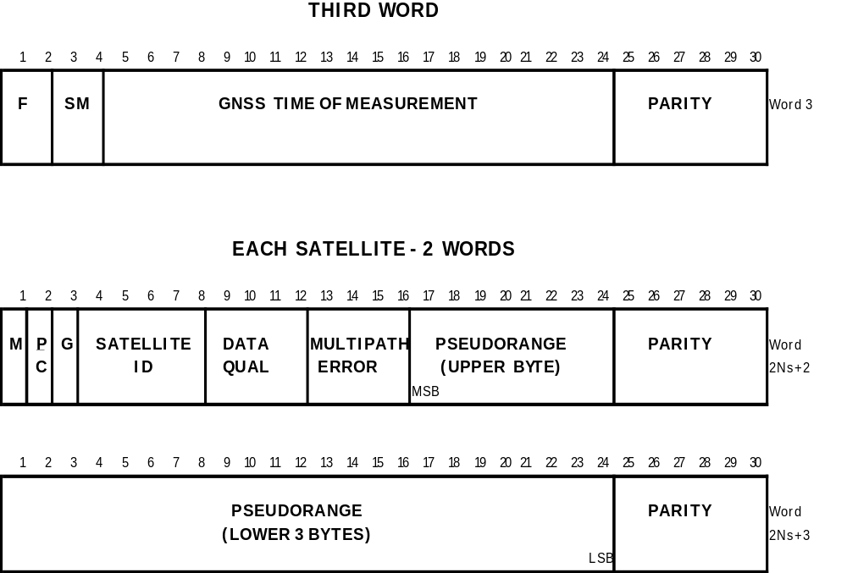

Table 4-21. CONTENTS OF A TYPE 19 MESSAGE –

UNCORRECTED PSEUDORANGES

PARAMETER | NUMBER OF BITS | SCALE FACTOR AND UNITS | RANGE
F = FREQUENCY INDICATOR | 2 | -- | "00": L1 message  "10": L2 message  "01": Reserved for future augmentations  "11": Reserved for future augmentations
SM = SMOOTHING INTERVAL | 2 | -- | (See Note 1 and Table 4-22)
GNSS TIME OF MEASUREMENT | 20 | 1 μs | 0 to 599999 μs (See Note 2)
M = MULTIPLE MESSAGE INDICATOR (See Note 3) | 1 | -- | "0" - Informs the receiver that this is the last message of the data set having this time tag (see definition of “data set” in section 4.3.18C(i))  "1" - Informs the receiver that another message of the same data set with the same time tag will follow
P/C = CA-Code / P-Code INDICATOR | 1 | -- | "0" - C/A-Code  "1" - P-Code (Note 4)
G = GPS/GLONASS SATELLITE CONSTELLATION INDICATOR | 1 | -- | "0" - Message is for GPS satellites  "1" - Message is for GLONASS satellites
SATELLITE ID | 5 | 1 | 0-31 (Note 5)
DATA QUALITY | 4 | -- | (See Note 6 and Table 4-23)
MULTIPATH ERROR | 4 | -- | (See Note 7 and Table 4-24)
PSEUDORANGE | 32 | 0.02 m | 0 to 85,899,345.90 m
Total | 48xN_{s}+24 | (Note 8)
PARITY | Nx6 | (Notes 9,10)

Note 1: Indicates the interval for carrier smoothing of pseudorange data, see Table 4-22.
Note 2: Expanded Time of Measurement = GNSS TIME OF MEASUREMENT + MODIFIED Z-COUNT (from header). The time shall be referenced to GPS time for GPS satellites and to GLONASS time for GLONASS satellites.
All PSEUDORANGES in the message shall be determined for the Expanded Time of Measurement. The GNSS TIME OF MEASUREMENT for a message containing L2 data shall be the same as that in the corresponding message containing L1 data.
The GNSS TIME OF MEASUREMENT shall be an estimate of GNSS time at the time of measurement. The discussion under "GNSS TIME OF MEASUREMENT" in Note 1 for Message Type 18 applies as well to Message Type 19.
Note 3: The discussion under "MULTIPLE MESSAGE BIT" in Note 2 for Message Type 18 applies as well to Message Type 19.
Note 4: If the L2 pseudorange is recovered by adding a cross-correlation L2-L1 measurement to the L1 C/A code pseudorange, then set P = 0 (C/A-code) and F = 10 (L2). See Section 4.3.18C(h).
Note 5: PRN number for GPS satellites -- satellite number 32 is indicated by 0; slot number for GLONASS satellites
Note 6: The data quality indicator is the estimated one sigma pseudorange measurement error indicated as 0.02e^{0.4X} meters where X is the decimal equivalent of the indicator code. Values are given in Table 4-23.
Note 7: The multipath error indicator is the estimated multipath error indicated as 0.1e^{0.4X} meters where X is the decimal equivalent of the indicator code. An X of 15 indicates that multipath error was not determined. . Values are given in Table 4-24.
Note 8: N_{s} = Number of satellite corrections contained in message.
Note 9: N = Number of words in message containing data = 2N_{s} +1, and the total message length, or frame length = 2N_{s} + 3 words..
Note 10: See GPS/SPS Signal Specification, available from U.S. Coast Guard Navigation Information Service, see Appendix E.

Table 4-22. SMOOTHING INTERVAL CODING

SMOOTH CODE | Smoothing Interval (Minutes)
00 (0) | 0 to 1
01 (1) | 1 to 5
10 (2) | 5 to 15
11 (3) | Undefined Smoothing Interval
Table 4-23. PSEUDORANGE DATA QUALITY INDICATOR QUANTIZATION

CODE (X) | DATA QUALITY INDICATION
0000 (0) | Pseudorange Error ≤ 0.020 meter
0001 (1) | ≤ 0.030
0010 (2) | ≤ 0.045
0011 (3) | ≤ 0.066
0100 (4) | ≤ 0.099
0101 (5) | ≤ 0.148
0110 (6) | ≤ 0.220
0111 (7) | ≤ 0.329
1000 (8) | ≤ 0.491
1001 (9) | ≤ 0.732
1010 (10) | ≤ 1.092
1011 (11) | ≤ 1.629
1100 (12) | ≤ 2.430
1101 (13) | ≤ 3.625
1110 (14) | ≤ 5.409
1111 (15) | > 5.409

Table 4-24. PSEUDORANGE MULTIPATH ERROR INDICATOR QUANTIZATION

CODE (X) | MULTIPATH INDICATION
0000 (0) | Multipath Error ≤ 0.100 meter
0001 (1) | ≤ 0.149
0010 (2) | ≤ 0.223
0011 (3) | ≤ 0.332
0100 (4) | ≤ 0.495
0101 (5) | ≤ 0.739
0110 (6) | ≤ 1.102
0111 (7) | ≤ 1.644
1000 (8) | ≤ 2.453
1001 (9) | ≤ 3.660
1010 (10) | ≤ 5.460
1011 (11) | ≤ 8.145
1100 (12) | ≤ 12.151
1101 (13) | ≤ 18.127
1110 (14) | > 18.127
1111 (15) | Multipath error not determined

    - Message Type 20 - RTK Carrier Phase Corrections (Retired)

Message Type 20 has been retired for Version 2.4.

4.3.22 Message Type 21 - RTK/High Accuracy Pseudorange Corrections (Retired)

Message Type 21 has been retired for Version 2.4.

4.3.23 Message Type 22 - Extended Reference Station Parameters (To Be Retired)

Message 24 has been introduced to replace messages 3 and 22 for RTK operation. Message Types 3 and 22 together enable the user receiver to reconstruct the coordinates of the reference station’s L1 phase center, instead of a mechanical marker on the antenna. Unfortunately, the L1 phase center is not a point in space that can be used as a standard reference. The location of L1 phase center is strongly dependent on the antenna calibration method used during the calibration process. Therefore, the location of the L1 phase center may vary between different calibration tables for the same antenna model. Message Type 24 solves the problem of referencing the L1 phase center by utilizing the Antenna Reference Point (ARP), which is used throughout the International GPS Service (IGS).

Message Type 22 provides (1) a means of achieving sub-millimeter precision for base station coordinates in a kinematic application, and (2) base station antenna height above a monument, which enables mobile units to reference measured position to the monument directly in real time.

Message Type 22 has been retained in Version 2.3 of the standard for backward compatibility reasons. Those implementing new services are advised to use Message Types 23 and 24 instead of combinations of Message Types 3, 22, 23, and 32. These latter message types do not allow the transmission of unambiguous millimeter resolution coordinates under all circumstances.

Message Types 3 and 32 provide the position in ECEF coordinates of the base station antenna L1 phase center to the nearest centimeter. The first data word of Message Type 22 provides the corrections to be added to each ECEF coordinate. The corrections may be positive or negative.

The second data word, which may not be transmitted, provides the antenna L1 phase center height expressed in integer and fractional centimeters, and is always positive. It has the same resolution as the corrections. The range is about 10 meters, which should be more than adequate. If N, the number of data words provided in the header, is equal to 1 it means there is no antenna height provided.

If N is equal to 2, it means that the antenna L1 phase center height is provided, but no L2 information.

If N is equal to 3, it means that both L1 and L2 phase center corrections are provided. L1 and L2 corrections are to be added separately to the antenna location components in Message Type 3 or 32. The antenna phase center height refers only to the L1 frequency. If no antenna height information is transmitted, the “NO HEIGHT” bit in the second data word is set to “1". The L2 phase center range accounts for the possibility that the offset may exceed 1 cm.

Figure 4-14 and Table 4-31 show the contents of the Type 22 Message.
Table 4-31. CONTENTS OF A TYPE 22 MESSAGE (Words 3 – 5)
PARAMETER | NUMBER OF BITS | SCALE FACTOR AND UNITS | RANGE
L1 ECEF DELTA-X | 8 | 1/256 cm | (-128 to +127)/256 cm
L1 ECEF DELTA-Y | 8 | 1/256 cm | (-128 to +127)/256 cm
L1 ECEF DELTA-Z | 8 | 1/256 cm | (-128 to +127)/256 cm
RESERVED | 2 | --
GS = GLOBAL NAVIGATION SATELLITE SYSTEM INDICATOR | 1 | -- | “0” = GPS  “1” = GLONASS
AT = ANTENNA TYPE | 1 | -- | “0” - No antenna type definition record follows (see Message Type 23)  “1” = Antenna type definition record follows (see Message Type 23)
AP = ANTENNA REFERENCE POINT | 1 | -- | “0” - No antenna reference point record follows (see Message Type 24)  “1” = Antenna reference point record follows (see Message Type 24)
NH = NO HEIGHT | 1 | -- | “0” = Antenna height information provided  “1” = No antenna height  information provided
If NH = 0, ANTENNA L1 PHASE CENTER HEIGHT  If NH = 1, fill bits (ignored) | 18 | 1/256 cm (NH=0) | 0 to 1023 + 255/256 cm (NH=0)  “101010101010101010” (NH=1)
L2 ECEF DELTA-X | 8 | 1/16 cm | (-128 to +127)/16 cm
L2 ECEF DELTA-Y | 8 | 1/16 cm | (-128 to +127)/16 cm
L2 ECEF DELTA-Z | 8 | 1/16 cm | (-128 to +127)/16 cm
Total | 24, 48 or 72 |  | (see text for explanation)
PARITY | 6*N | (Notes 1 & 2)

Note 1: N = 1, 2 or 3 (see text for explanation)
Note 2: See GPS/SPS Signal Specification, available from U.S. Coast Guard Navigation Information Service, see Appendix E.
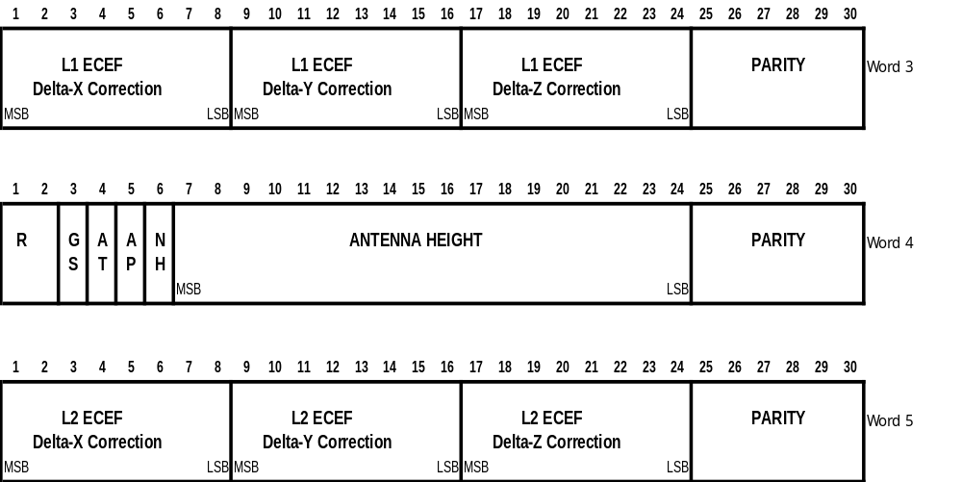
Figure 4-14. MESSAGE TYPE 22 - EXTENDED REFERENCE STATION PARAMETERS

4.3.24 Message Type 23 – Antenna Type Definition Record (Permanent)

Message Type 23 provides the information on the antenna type used on the reference station. Figure 4-15 and Table 4-32 show the contents of the Type 23 Message. The RTCM commission adopted the naming convention from the IGS equipment-naming table as supplied by the International GPS Service Central Bureau (IGS CB). The current table can be downloaded from the following URL: ftp://igscb.jpl.nasa.gov/igscb/station/general/rcvr_ant.tab. This table provides a unique antenna descriptor for antennas used for high-precision surveying type applications, which is utilized in the ANTENNA DESCRIPTOR (see below). IGS limits the number of character to 20 at this time, but the standard allows more characters for future extension.

The SETUP ID is a parameter for use by the service provider to indicate the particular reference station-antenna combination. "0" for this value means that the values of a standard model type calibration should be used. A non-zero value is used to specify a particular setup or calibration table for the specific antenna in use at the reference station. The number should be increased whenever a change occurs at the station that affects the antenna phase center variations. While the ANTENNA DESCRIPTOR and the ANTENNA SERIAL NUMBER give an indication of when the installed antenna has been changed, it is envisioned that other changes could occur. For instance the antenna might been repaired, or the surrounding of the antenna might have been changed and the provider of the service may want to make the user station aware of the change. Depending on the change of the phase center variations due to a setup change, a change in the SETUP ID would mean that the user should check with the service provider to see if the antenna phase center variation in use is still valid. Of course, the provider must make appropriate information available to the users.

The ANTENNA SERIAL NUMBER is the individual antenna serial number as issued by the manufacturer of the antenna. A possible duplication of the ANTENNA SERIAL NUMBER is not possible, because together with the ANTENNA DESCRIPTOR only one antenna with the particular number will be available. In order to avoid confusion the ANTENNA SERIAL NUMBER should be omitted when the record is used together with reverse reduction to model type calibration values, because it cannot be allocated to a real physical antenna.

FILL bytes have to be used to fill empty bytes when necessary. The fill bytes are only allowed at the end of the record. The number of FILL bytes can vary between 0 and the maximum of 2. In case of no ANTENNA SERIAL NUMBER, FILL bytes will follow the SETUP ID immediately, if required to fill the record. With ANTENNA SERIAL NUMBER available the first FILL byte in the record can be found after the ANTENNA SERIAL NUMBER, if required.

Note: Some of the record contents, namely the ANTENNA DESCRIPTOR and the ANTENNA SERIAL NUMBER, have variable length. The consequence will be that the location within the record of the information after the ANTENNA DESCRIPTOR will vary with different values.

Table 4-32. CONTENTS OF A TYPE 23 MESSAGE

PARAMETER | NUMBER OF BITS | SCALE FACTOR AND UNITS | RANGE
RESERVED | 1
AR = REFERENCE STATION ARP PARAMETER | 1 | -- | “0” = No “Reference Station Antenna Reference Point Parameter” record (type 24) will follow  “1” = “Reference Station Antenna Reference Point Parameter” record (type 24) will follow
SF = SERIAL FLAG | 1 | -- | “0” = No antenna serial number will follow  “1” = Antenna serial number will follow
NAD = NUMBER OF CHARACTERS FOR ANTENNA DECRIPTOR | 5 | 1 | 0 – 31
AD = ANTENNA DESCRIPTOR | 8 * NAD | Char | 8-bit ASCII characters
SETUP ID | 8 | 1 | “0” = No specified setup – use standard IGS model  1-255 = Specific setup number (see Note 1)
RESERVED | 3 | --
NAS = NUMBER OF CHARACTERS FOR ANTENNA SERIAL NUMBERS | 5 | 1 | 0 - 31
AS = ANTENNA SERIAL NUMBER | 8 * NAS | Char
FILL (each byte) | 8 | -- | “10101010”
Total | 32 + 8* (NAD+NAS)
PARITY | 6*N | (Note 2)

Note 1: User should consult the service provider for the meaning of non-zero Setup ID values.
Note 2: See GPS/SPS Signal Specification, available from U.S. Coast Guard Navigation Information Service, see Appendix E.
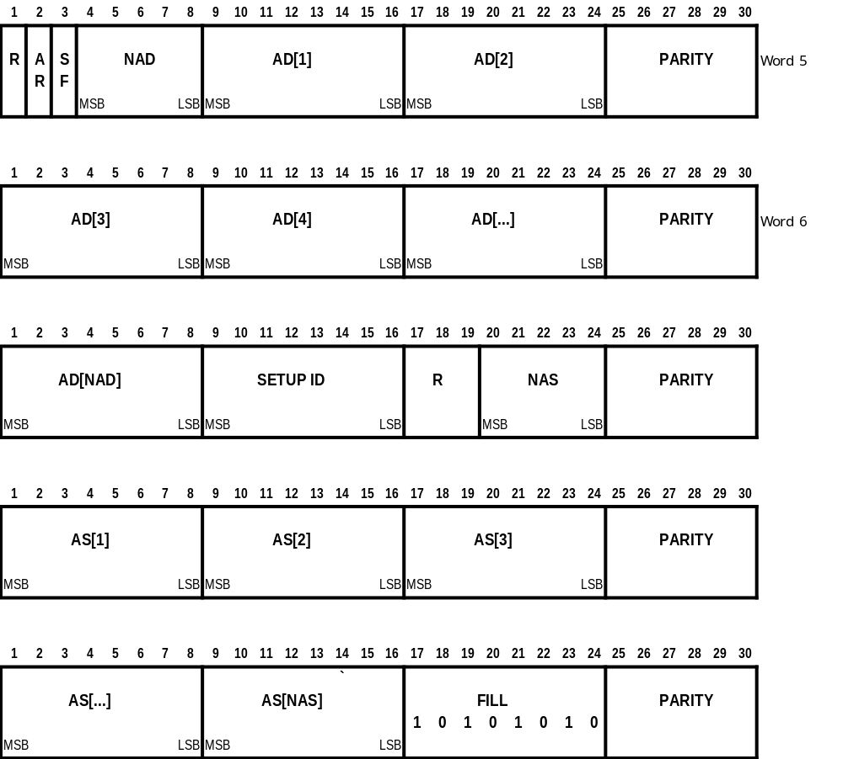

Figure 4-15. MESSAGE TYPE 23 – ANTENNA TYPE DEFINITION RECORD

    - Message Type 24 – Reference Station Antenna Reference Point (ARP) Parameter
(Permanent)

Message 24 has been introduced to replace messages 3 and 22 for RTK operation. Message Types 3 and 22 together enable the user receiver to reconstruct the coordinates of the reference station’s L1 phase center, instead of a mechanical marker on the antenna. Unfortunately, the L1 phase center is not a point in space that can be used as a standard reference. The location of L1 phase center is strongly dependent on the antenna calibration method used during the calibration process. Therefore, the location of the L1 phase center may vary between different calibration tables for the same antenna model. Message Type 24 solves the problem of referencing the L1 phase center by utilizing the Antenna Reference Point (ARP), which is used throughout the International GPS Service (IGS). The form and content of Message Type 24 is shown in Table 4-33 and Figure 4-16.

Message 24 contains the coordinates of the installed antenna’s ARP in the GNSS coordinate system Earth-Center-Earth-Fixed (ECEF) coordinates -- local datums are not supported. The coordinates always refer to a physical point on the antenna (typically the bottom of the antenna mounting surface).

A user receiver that utilizes Message Type 24 should ignore Message Types 3 and 22, because message 24 provides more precise information. If Message Type 24 is transmitted, a Message Type 23 must be transmitted as well in order to provide a complete set of information for proper operation. For proper mixed GPS/GLONASS operation a Message Type 24 containing GPS coordinates and a Message Type 24 containing GLONASS coordinates shall be transmitted separately.

RTK services based on Version 2.3 of the standard should utilize Message Type 24 (and 23) at a minimum. It is advisable, for reasons of backward compatibility, to also broadcast the redundant Message Types 22 and 3 until all receivers in the field have been upgraded to utilize the preferred Type 24.

Table 4-33. CONTENTS OF A TYPE 24 MESSAGE (Words 3 through 8)

PARAMETER | NUMBER OF BITS | SCALE FACTOR AND UNITS | RANGE
ECEF X-COORDINATE | 38 | 0.0001 m | ±13,743,895.3472 m (Note 1)
RESERVED | 2 | -- | “00” (Note 2)
ECEF Y-COORDINATE | 38 | 0.0001 m | ±13,743,895.3472 m (Note 1)
RESERVED | 2 | -- | “00” (Note 2)
ECEF Z-COORDINATE | 38 | 0.0001 m | ±13,743,895.3472 m (Note 1)
GS = GLOBAL NAVIGATION SATELLITE SYSTEM INDICATOR | 1 | -- | “0” = GPS  “1” = GLONASS
AH = ANTENNA HEIGHT | 1 | -- | “0” = No Antenna height information provided  “1” = Antenna height  information provided
ANTENNA HEIGHT (IF AH = 1) | 18 | 0.0001 m | 0 – 26.2144 m
RESERVED | 6 | -- | “000000” (Note 2)
Total | 120 (AH=0)  144 (AH=1)
PARITY | 6*6 (AH=0)  6*7 (AH=1) | (Note 3)

Note 1: 2’s complement
Note 2: Reserved bits must be set to 0 in order to allow a default setting assumption for later use
Note 3: See GPS/SPS Signal Specification, available from U.S. Coast Guard Navigation Information Service, see Appendix E.
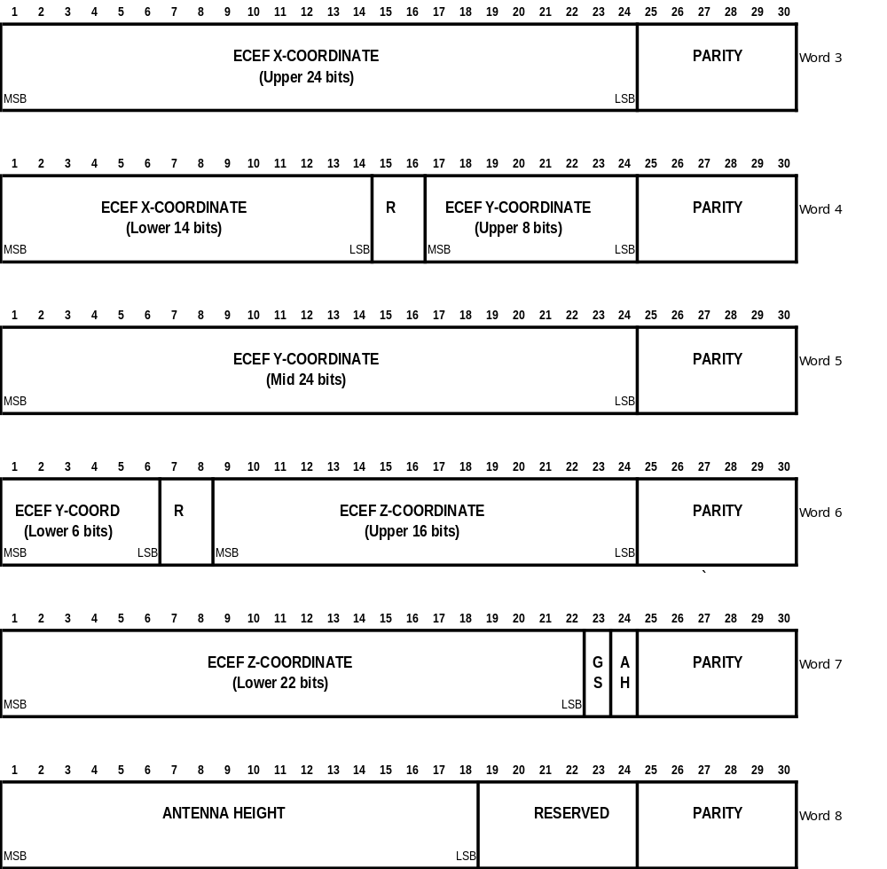

Figure 4-16. Antenna Reference Point (ARP) Record
    - Message Type 25-26 – (Undefined)

Message Types 25 and 26 are undefined at this time. They are available for future designation as new requirements are identified.

4.3.27 Message Type 27 – Extended DGNSS Radiobeacon Almanac (Permanent)

The Radiobeacon almanac provides the location, frequency, operational status, and station name for a network of marine radiobeacons, equipped to transmit differential GPS data. In contrast to Message Type 7, this message provides the ID’s of the reference stations. The information will provide a properly equipped GPS receiver the capability to update its database of existing (and future) radiobeacons and to automatically select the optimum differential data transmitter. The radiobeacon location data is coarse, (0.3 km in Latitude and 0.6 km in Longitude) but it provides sufficient accuracy for determining the next nearest station. It is the responsibility of the service provider to supply the operational status information. The frequency range covers both the marine and aircraft non-directional radiobeacon bands. This message has also been defined to allow extended reference station selection criteria by providing an integrity type indicator of the transmitter as well as flags indicating the satellite constellation included in the correction service.
The content of the message is given in Table 4-34 and Figure 4-17.

Provision has been made to indicate either an ITRF global reference frame or a local datum. The three major GNSS systems, i.e., GPS, GLONASS, and Galileo, have now been adjusted so that for the accuracies supported by differential services, the differences between them and ITRF is negligible. Similarly, the periodic corrections made to the global reference frames are likewise negligible.

The message has been designed to accommodate future definitions of Forward Error Correction and higher Broadcast Bit Rates.

Station Name has been limited to 9 characters and should conform to the Short Form of station name, published by the International Association of Marine Aids to Navigation and Lighthouse Authorities (IALA) on their web site, http://www.iala-aism.org. Manufacturers of reference stations and user receivers should design their equipment to download new station information from the website.

In order to implement Type 27 messages properly, the transmitting radiobeacon must have access to information about all the radiobeacons listed in the almanac message. The service provider must implement the network to make this possible. In addition, neighboring service providers may share information in order to facilitate transitions between different jurisdiction zones. In this manner a differential user will always be provided with current almanac data in traversing from one radiobeacon service area to the next.

The radiobeacon almanac update rate does not have to be very high. One message every 5 minutes should be adequate for marine service.

The message is designed to accommodate two reference stations, the second one being the backup in case the first goes out. This is the usual configuration. If only one reference station is utilized, the second identification field will repeat the first one.

The Integrity Mode field of message Type 27 is also used to help facilitate transitions between stations and zones, by providing another possible precedence selection criterion. This field provides an indication of the Integrity Monitoring style used at the broadcast station. Under the Post-Broadcast integrity monitoring mode, correction data that are to be monitored by an Integrity Monitor are obtained from the same medium as that from which the end user obtains its data: i.e., the end-user obtains the correction information before the Integrity Monitor has had time to monitor that data and report integrity to the Reference Station. Any detected errors in that broadcast data are indicated in some later broadcast. Under Pre-Broadcast Integrity Monitoring, the Reference Station provides the Integrity Monitor with correction data over a medium that is not available to the end-user. This allows the Integrity Monitor to validate the corrections and report associated integrity information to the Reference Station before those corrections are actually broadcast, thus allowing the Reference Station to incorporate any status in its broadcast. The Post-Broadcast Integrity Mode is often used at sites to validate the transmission data link (e.g., exciter/transmitter validation), thus those employing Pre-Broadcast Integrity will often employ the Post mode as well.

Table 4-34. CONTENTS OF A TYPE 27 MESSAGE – RADIOBEACON ALMANAC
PARAMETER | NUMBER OF BITS | SCALE FACTOR AND UNITS | RANGE
Latitude | 16 | 0.002747° | ±90° (Notes 1 and 2)
Longitude | 16 | 0.005493° | ±180° (Notes 1 and 2)
Reference Station #1 ID | 10 | 1 | 0 to 1023
Frequency | 12 | 100Hz | 190 (all 0’s) to 599.5 kHz (all 1’s)
OP = Operational Status | 2 | -- | “00” - Radiobeacon fully operational  “01” - Test mode  “10” - No information available  “11” - Not in operation (or planned station)
Reference Station #2 ID | 10 | 1 | 0 to 1023 (Note 3)
Broadcast bit rate | 3 | -- | “000” - 25 bits/s  “001” - 50 bits/s  “010” - 100 bits/s  “011” - 200 bits/s (Note 4)
dat = DatuM | 1 | -- | “0” – ITRF  “1” – Local
R = Reserved for Synchronization Type | 1 | -- | “0” - Default
BC = Broadcast coding | 1 | -- | “0” – No added coding  “1” – FEC coding
IM = INTEGRITY MODE | 2 | -- | “00” – Pre-Broadcast Integrity Mode Only.  “01” – Post-Broadcast Integrity Mode Only.  “10” – Pre- and Post-Broadcast Integrity Modes.  “11” – Reserved.
CONSTELLATION  FLAGS | 7 |  | Each bit represents a different satellite constellation. When a bit is set, it is used to indicate that the associated reference station(s) provides correction data/messages for that particular satellite constellation. Spare bits are used to enable inclusion of future constellations. The bits and their associated constellations follow.  The lowest bit number is left-most.  Bit Constellation  0 - GPS  1 - Galileo  2 - GLONASS  3-7 Spare
STATION NAME (9 CHARACTERS) | 63 |  | (Note 5)
Total | 144 x N_{b}
PARITY | 36 * N_{b} | (Note 6)

N_{b} = Number of radiobeacons in message
Note 1: 2’s complement
Note 2: Average Position of the Reference Station Antennas. “+” values indicate North Latitude or East Longitude.
Note 3: Same as ID as Reference Station #1 if there is only one reference station.
Note 4: 100, 101, 110, and 111 are reserved for future use.
Note 5: 7 bit ASCII (i.e., the 7 least-significant-bits of 8-bit ASCII characters). The name should conform to the IALA List, Short Form. Unused character fields should be filled with zeros.
Note 6: See GPS/SPS Signal Specification, available from U.S. Coast Guard Navigation Information Service, see Appendix F.
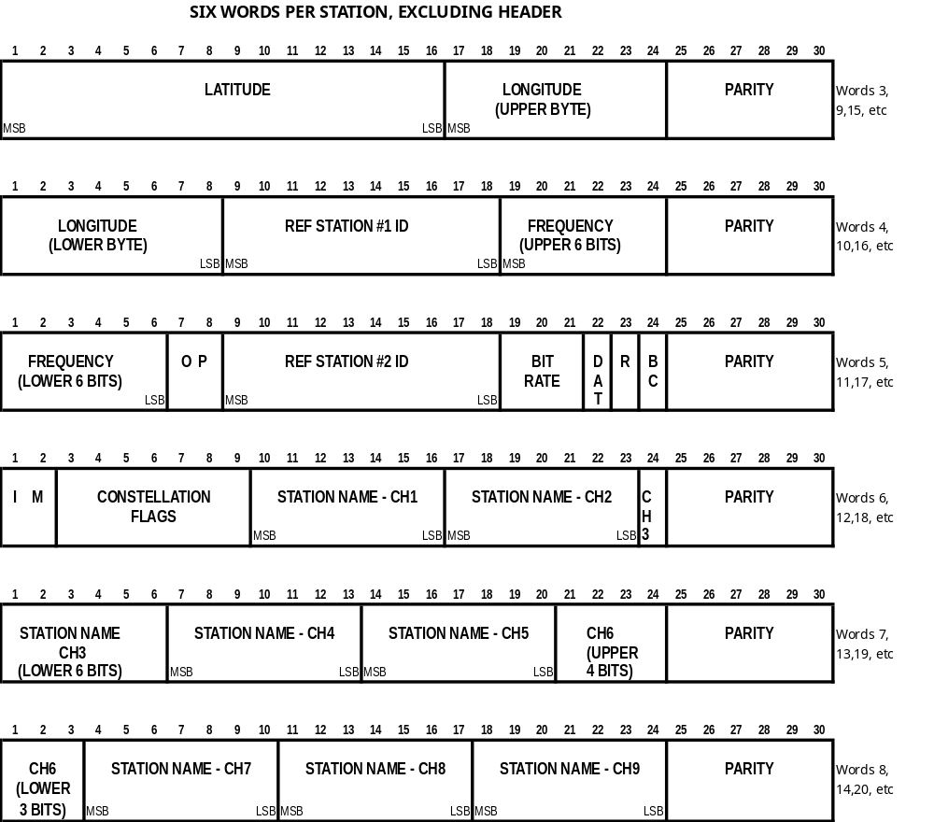

Figure 4-17. EXTENDED RADIOBEACON ALMANAC

4.3.28 Message Type 28-30 – (Undefined)

Message Types 28 -30 are undefined at this time. They are available for future designation as new requirements are identified.

4.3.29 Message Type 31 - Differential GLONASS Corrections (Tentative, to be Retired)

The Message Type 31 message is designed to handle signals from satellites launched prior to the modern GLONASS-M satellites, wherein it was observed that occasional changes in ephemeris would tke place without a corresponding change in the time index t_{b}. At this time there are no more non-GLONASS-M satellites transmitting, and this message type works with GLONASS-M signals. However, the new generic GNSS Message Type 41 is simpler and has more capability, so vendors and service providers should implement the new message as soon as practical, as the Message Type 31 will soon be retired.

Figure 4-18 and Table 4-35 present the content of Message Type 31, the differential GLONASS corrections. This is the primary message type which provides the pseudorange correction PRC(t) for any user receiver GLONASS measurement time "t":

PRC(t) = PRC(t₀) + RRC • [t-t₀]

where PRC(t₀) is the 16 bit pseudorange correction, RRC is the 8-bit rate of change of the pseudorange correction (range rate correction), and t_{b} is the 13-bit time indicator of the second word. These parameters are all associated with the satellite indicated by the 5-bit Satellite ID, which indicates its orbital slot number. The pseudorange measured by the user, PRM(t), is then corrected as follows:
PR(t) = PRM(t) + PRC(t)

Note that the correction is added to the measurement. PR(t) is the differentially corrected pseudorange measurement that should be processed by the user equipment navigation filter. Also provided is a l-bit Scale Factor (see Table 4-36) and 2-bit User Differential Range Error ("UDRE" - see Table 4-37). The UDRE is a one-sigma estimate of the uncertainty in the pseudorange correction as estimated by the reference station, and combines the estimated effects of multipath, signal-to-noise ratio, and other effects.

The Type 31 Message contains data for all satellites in view of the reference station (N_{s} ). Since 40 bits are required for the corrections from each satellite, there won't always be an exact integer number of words required. There will be messages that require 8 or 16 bits of fill to finish the frame. The fill will be alternating l's and 0's so as not to be confused with the "preamble" synchronization code. The format of the Type 31 Message is illustrated in Figure 4-19. Each word has one of five formats unless it is the last word in the message. If N_{s} is not a multiple of 3, the last word has one of two formats, containing either 8 or 16 fill bits.

The pseudorange correction PRC(t₀) will diverge from the proper value as it "grows old." Because of this characteristic, it will be updated and transmitted as often as possible. The user equipment should update the corrections accordingly.

The range rate correction RRC is designed to compensate for the predicted rate of change of the pseudorange correction. This is an attempt to "extend the life" of the pseudorange correction as it "grows old." The RRC can also be used to correct the user receiver's velocity. The user equipment should not use the RRC as a carrier phase correction -- it may degrade that type of measurement. Carrier phase measurements should be corrected only using Message Types 18 or 20. The reference station will not apply ionospheric and tropospheric delay models in deriving the differential corrections.

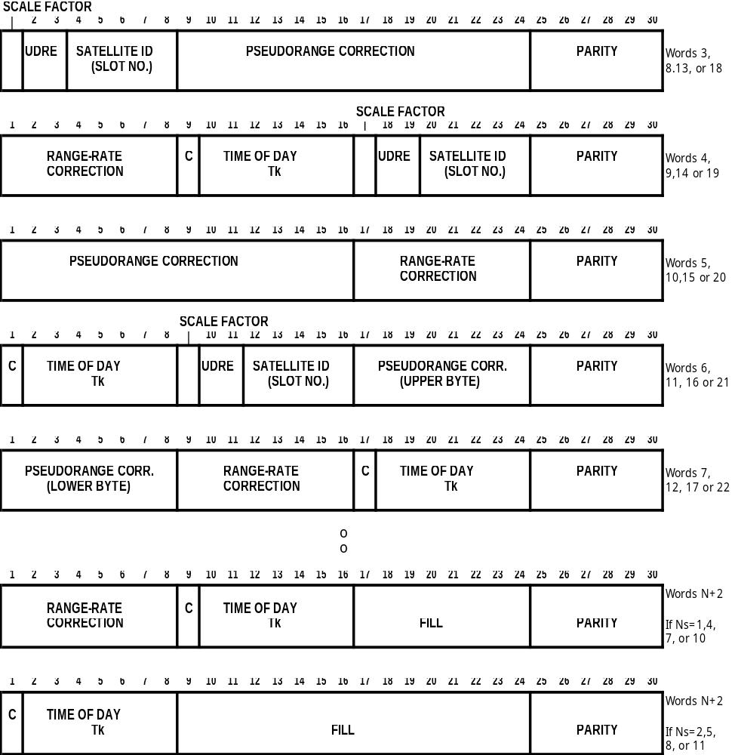

Figure 4-18. MESSAGE TYPE 31 - DIFFERENTIAL GLONASS CORRECTIONS
Table 4-35. CONTENTS OF A TYPE 31 MESSAGE

PARAMETER | NO. OF BITS | SCALE FACTOR AND UNITS | RANGE
SCALE FACTOR | l |  | (See Table 4-36)
UDRE | 2 |  | (See Table 4-37)
SATELLITE ID | 5 | l | l-32 (Note 1)
PRC(t₀) | 16 | 0.02 or 0.32 m | +655.34 or +10485.44 m  (Notes 2 & 3)
RRC | 8 | 0.002 or 0.032  m/s | +0.254 or +4.064 m/s (Notes 2 & 4)
CHANGE BIT | 1 | -- | Toggles between “0” and “1” (see accompanying text)
TIME OF DAY t_{k} | 7 | 30 sec | 0 – 3570 sec (Note 5)
Total | 40 x N_{s}
FILL | 8 x [N_{s} mod 3] | -- | [N_{s} mod 3] groups of “10101010”
PARITY | N x 6 | (Note 6)

N_{s} = Number of satellite corrections contained in message.
N = Number of words in message containing data. Frame length = N+2 words.
Note 1: Satellite number 32 is indicated with all zeros (00000).
Note 2: 2’s complement
Note 3: Binary 1000 0000 0000 0000 indicates a problem and the User Equipment should immediately stop using this satellite.
Note 4: Binary 1000 0000 indicates a problem and the User Equipment should immediately stop using this satellite.
Note 5: Indicates number of 30-second periods since the top of the hour, obtained from least 7 significant bits of t_{k} in GLONASS satellite data (from GLONASS ICD, see Appendix G)
Note 6: See GPS/SPS Signal Specification, available from U.S. Coast Guard Navigation Information Service, see Appendix F.

The effect of satellite clock and relativistic parameters will be determined using GLONASS ICD algorithms. The reference station clock offsets will be a common offset in all pseudorange corrections, which does not affect position calculations.

GLONASS does not utilize an IOD, so the 7 least significant bits of the Time of Day (t_{k}) are included in the reference station message so that the user equipment may compare it with the t_{k} of the GLONASS navigation data being used to determine if the user equipment calculations and reference station corrections are based on the same set of broadcast orbital and clock parameters. The GLONASS Time of Day in each satellite message includes 5 bits for the hours of the day (not transmitted by the reference station), 6 bits for the minutes since the top of the hour, and the least significant bit for first (“0”) or second (“1”) 30-second period within the minute. The reference station receiver should always base its corrections on the most recently measured pseudoranges. Except when the reference station receiver has just detected a change in ephemeris data, it should broadcast the t_{k} associated with the ephemerides in the most recently received satellite message. However, when the reference receiver detects that a change in ephemeris has occurred, it should continue to base the corrections on the previous ephemeris and to set the value of t_{k} to the last value associated with the previous ephemeris data, for a period of 96 seconds. The reason for this is to ensure that the user receiver has had sufficient time to decode that same ephemeris even if satellite data dropouts occur. Thus the user receiver should be designed to keep track of recent ephemerides and their associated t_{k}’s, and to store new satellite data in readiness for any change in ephemeris.
It has been noted that occasionally the GLONASS ephemeris data will change without a corresponding change in the Time of Data, t_{b}, sometimes more than once. To deal with this situation, it is recommended that the reference station and user receivers observe the following rules:
1. Upon detecting a change in ephemeris, the reference station should delay basing corrections on the new ephemeris for a period of 96 seconds, but should continue to issue corrections based on ephemerides that are 96 seconds old, along with their associated t_{k}. On the next Message Type 31 or 34 following the 96 second period, the reference station should base its corrections on the new ephemeris, change the value of the “C” bit, and set the time of day indicator to the t_{k} associated with the new ephemeris. Until the corrections are based on the new ephemeris, Type 33 messages should have the New Navigation Data bit set to “1”. The New Navigation Data bit should be changed back to “0” once the corrections are based on the new ephemeris.
2. Upon detecting a change in satellite ephemeris without a corresponding change in t_{b}, the corrections should continue to be based on the old ephemeris as in rule 1 until the 96-second period has been completed, and the t_{k} value should continue to be set to the last value associated with the previous ephemeris. At the end of the 96 second period, the reference station should base its corrections on the new ephemeris, change the value of the “C” bit, and set the time of day indicator to the t_{k} associated with the new ephemeris, as with rule 1. It should treat Type 33 messages as in rule 1.
- Upon detecting a second change in ephemeris without a change in t_{b}, the reference station should treat the “C” bit as with rule 2. The handling of corrections and t_{k}’s is the same as in rule 2.
- If one of the strings containing the ephemeris data does not pass parity, the reference station should base the corrections on the previous ephemeris, and should maintain the transmitted t_{k} at the value associated with the previous ephemeris. Once the reference receiver has stopped tracking a satellite, it should stop transmitting corrections for that satellite. It is recommended that the reference receiver limit the age of corrections by not transmitting corrections for satellites where continuous data outages have caused the ephemeris to be more than one minute old.
- The user receiver should decode every new ephemeris in the satellite messages to look for a change in ephemeris, and should receive two successive identical ephemeris messages before accepting and storing new ephemeris data. The new ephemeris information should not be used to compute the pseudorange until other conditions are met, as described below.
- Since the reference station holds off using the new ephemeris for 96 seconds, the user receiver should continue to use the previous ephemeris for computing pseudorange, and to apply the reference station corrections as long as the t_{k} in the correction message is associated with the previous ephemeris. When the reference station correction message changes its t_{k} to one that is associated with the new satellite ephemeris, the pseudorange calculation should use the new satellite ephemeris, and the new corrections should be applied; this is normal operation.
- If a change in satellite ephemeris is not accompanied by a change in t_{b}, then the user receiver should not use the new ephemeris for pseudorange computations until the reference station correction message received by the user has a t_{k} that is the same as the t_{k} in the satellite data with the new ephemeris. This applies for any number of such ephemeris changes.
- When the reference receiver misses a satellite ephemeris data message but still tracks the satellites, it will issue differential corrections based on the new measurements, but it will use the previous, successfully decoded ephemeris data, and will employ the t_{k} of that previous ephemeris. In this case the user receiver must use the ephemeris associated with the t_{k} issued by the reference station, but it can apply the new correction data.
- If the user receiver misses a satellite ephemeris message, it can apply the next reference station correction unless the C bit has changed from its previous value. If the C bit has changed, the user receiver should "coast" on the previous correction until it obtains a match between the satellite ephemeris t_{k} and the reference station t_{k}.
- A user receiver just coming on line should collect satellite ephemeris data and associated t_{k} before applying reference station corrections. It should then examine the value of t_{k} in the correction message. The user receiver should not apply corrections for that satellite until it has collected an ephemeris whose t_{k} matches one in the last few reference station messages.
If these rules are followed, full use of the satellite can be obtained even in the presence of missed or garbled data from the satellite or data transmission, and user receivers coming on line or initially acquiring the reference station broadcast will not experience any performance problems.

Under no circumstances should a "partial" differential solution be attempted by the user receiver, i.e., processing both differentially corrected and non-differentially-corrected pseudoranges in the same position calculation. The resulting position will usually be little better than a non-differential solution.

The rationale for the two-level scale factor is to maintain a high degree of precision most of the time, and allow the ability to increase the range of the corrections when it is needed.

Table 4-36. SCALE FACTOR

CODE | NUMBER | INDICATION
0 | 0 | Scale factor for pseudorange correction is 0.02 meter and for range rate correction is 0.002 meter/second
1 | 1 | Scale factor for pseudorange correction is 0.32 meter and for range rate correction is 0.032 meter/second (also refer to Table 4-37)

Table 4-37. USER DIFFERENTIAL RANGE ERROR (UDRE)

CODE | NUMBER | ONE-SIGMA DIFFERENTIAL ERROR
00 | 0 | ≤ l meter
01 | 1 | > 1 meter and ≤ 4 meters
10 | 2 | > 4 meters and ≤ 8 meters
11 | 3 | > 8 meters

Note that there is no GLONASS message corresponding to the GPS Message Type 2, “Delta Differential Corrections”. This is because GLONASS operation utilizes a 96-second “hold-off” period that ensures that all users have detected and decoded any change in ephemeris, obviating the need for such a message.

4.3.30 Message Type 32 - GLONASS Reference Station Parameters (Tentative, to be Retired)

The new generic GNSS Message Type 3 is simpler and has more capability, so vendors and service providers should implement the new message as soon as practical, as Message Type 32 will soon be retired.

The International Terrestrial Reference Frame (ITRF) is now the accepted standard for GNSS's. GPS and ITRF are the same at the 10-centimeter level. The most recent GLONASS datum, PZ-90.02, has been defined similarly. As a consequence, Message Type 32 provides no information that is not already in Message Type 3. Therefore, service providers and vendors that implement differential GLONASS should stop using Message Type 32 as soon as practicable.

Message Type 32 contains GLONASS reference station information. Figure 4-19 and Table 4-38 give the contents of the Type 32 Message. It consists of four data words (N=4) for a total frame length of six 30-bit words. It includes the GLONASS coordinates (Earth-Centered-Earth-Fixed (ECEF)) of the reference station antenna phase center to the nearest centimeter, using the GLONASS PZ-90.02 reference frame, which at the 10-centimeter level, is the same as the ITRF.

Table 4-38. CONTENTS OF A TYPE 32 MESSAGE
PARAMETER | NUMBER OF BITS | SCALE FACTOR AND UNITS | RANGE
ECEF X-COORDINATE | 32 | 0.01 meter | +21474836.47 meters (Note 1)
ECEF Y-COORDINATE | 32 | 0.01 meter | +21474836.47 meters (Note 1)
ECEF Z-COORDINATE | 32 | 0.01 meter | +21474836.47 meters (Note 1)
PARITY | 24 | (Note 2)

Note 1: 2’s complement
Note 2: See GPS/SPS Signal Specification, available from U.S. Coast Guard Navigation Information Service, see Appendix E

While a service provider may provide these coordinates referenced to a datum other than ITRF, it is not generally recommended, because of the possibility of confusion (see Appendix D). If a datum other than ITRF is used, Message Type 4 should be broadcast frequently to inform the users of the datum being used for the reference station coordinates. Since the user receiver will assume the coordinates are referenced to ITRF until a Type 4 message is received, significant errors could be experienced until then. It is generally recommended that a Type 4 message accompany each Type 32 message in order to eliminate any ambiguity on the datum in use.

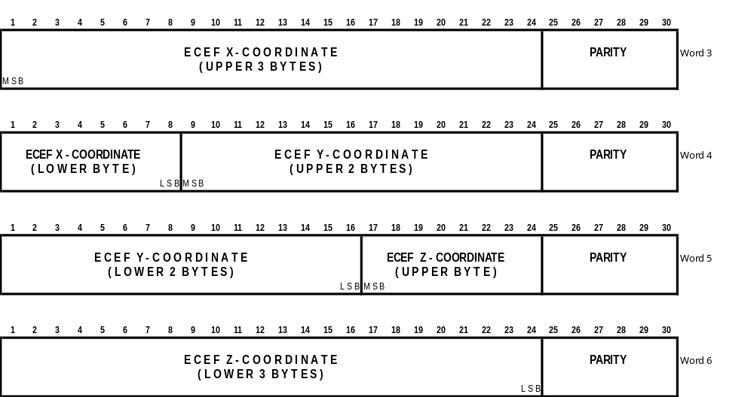
Figure 4-19. MESSAGE TYPE 32 - GLONASS REFERENCE STATION PARAMETERS

4.3.31 Message Type 33 - GLONASS Constellation Health (Tentative, to be Retired)

NOTE: the new generic GNSS Message Type 43 incorporates the essential information of Message Type 33, so vendors and service providers should implement the new message as soon as practical, as the Message Type 33 will soon be retired.

The Type 33 Message provides information that can assist in the operation of differential User Equipment. It is a mechanism through which the observations made at the reference station can be automatically used by the User Equipment to improve performance without operator intervention. It could also be used by non-differential users to obtain satellite constellation health information. This message may contain information for only one satellite. It will be transmitted periodically as determined necessary by the reference station. The content of a Type 33 Message is described in Table 4-39 and illustrated in Figure 4-20. The first bit is reserved for expansion of satellite ID's beyond 32 to accommodate non-GLONASS satellites. However, before this happens, a full-scale review of the applicability of the data content would be required.

It has been noted that on occasion the GLONASS ephemeris data will change without a corresponding change in the Time of Data, t_{b}, sometimes more than once. Section 4.3.30 describes how the reference station receiver and user receiver should handle Type 33 messages to deal with this situation.

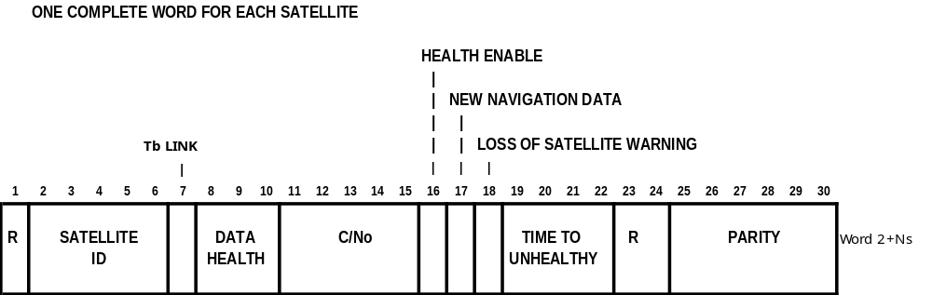

Figure 4-20. MESSAGE TYPE 33 - GLONASS CONSTELLATION HEALTH

Table 4-39. CONTENTS OF A TYPE 33 MESSAGE

PARAMETER | NUMBER OF BITS | EXPLANATION
RESERVED | 1 | A single bit reserved for possible future expansion of satellite numbers beyond 32
SATELLITE ID | 5 | Standard format, see Table 4-35
t_{b} LINK | 1 | Bit set to 0 normally; set to 1 if the Type 31/34 corrections are not based on the currently broadcast ephemeris and an ephemeris change has occurred without a corresponding change in t_{b}. Reset to 0 when corrections are based on the currently broadcast ephemeris.
DATA HEALTH | 1 | “0” = Healthy  “1” = The satellite is considered by the reference station to be unhealthy, even if the satellite navigation message indicates the satellite and data is healthy.
RESERVED | 2 | Default to “00”
C/N_{o} | 5 | Satellite signal to noise ratio as measured at reference station. Scale factor l dB-Hz. Range is 25 to 55 dB-Hz. Bit 15 is LSB. The value "00000" indicates that the satellite is not being tracked by the reference station. The value "00001" = 25 dB-Hz at the low end and the value "11111" = 55 dB-Hz at the high end.
HEALTH ENABLE | 1 | Bit set to l indicates that satellite can be considered healthy by DGLONASS User Equipment despite the fact that satellite navigation data indicates the satellite is unhealthy.
NEW NAVIGATION DATA | 1 | Bit set to l indicates that new satellite navigation data is being acquired by the reference station and being integrated into the pseudorange correction generation process.
LOSS OF SATELLITE WARNING | 1 | Bit set to 1 indicates that a change in the satellite's health to unhealthy" is scheduled. The "healthy" time remaining is estimated by the following 4 bits.
TIME TO UNHEALTHY | 4 | See bit 18 above. Scale factor is 5 minutes. Range is 0 to 75 minutes. Bit 22 is LSB. The value "0000" indicates that the satellite is about to go "unhealthy". The value "1111" indicates the satellite will go "unhealthy" in about 75 minutes.
RESERVED | 2 | Default to “00”
PARITY | 25-30 | See GPS/SPS Signal Specification, available from U.S. Coast Guard Navigation Information Service, see Appendix E

4.3.32 Message Type 34 -- GLONASS Partial Correction Set (N>1) (Tentative, to be Retired)

NOTE: the new generic GNSS Message Type 42 is simpler and has more capability, so vendors and service providers should implement the new message as soon as practical, as the Message Type 34 will soon be retired.

This message type was designed to repeat the fundamental differential correction format of Message Type 31, but to indicate a partial set of corrections. Therefore, as Message Type 31 is retired and replaced by Message Type 30, at the same time this usage of Message Type 34 should be changed to replicate Message Type 30.

The Type 34 Message has the same data fields and format, and serves the same purpose as the Type 31 Message, in that it contains the primary differential corrections. However, unlike Type 31's, Type 34 Messages do not require a complete satellite set. As a result, they require the use of a more stable clock than a station transmitting only Type 31's, because the satellite corrections have different time references. To prevent degradation of navigation accuracy due to un-modelable clock drift that can occur between Type 34 messages, a highly stable clock source is required. Type 34's are useful for providing additional updates for satellites whose rate correction variations are high. They are also useful for slow data links in the presence of impulse noise, such as that encountered in radiobeacon operation. During high noise periods, the higher rate of preambles supports a faster re-synchronization.

The average correction age is reduced by packing the corrections in groups of three in a Type 34 message, thereby improving performance. Grouping partial sets of satellite corrections, the age of the corrections can be reduced because the corrections can be applied immediately, instead of waiting until the entire Type 31 message is received. Also, if impulse noise results in a loss of data, only those satellites in the group are affected.

The content and the format of the Type 34 Message is identical to that of the Type 31 Message, except that N_{s}, the number of satellites, and N, the number of 30 bit words will be much less.

The reference station will delay basing corrections on the new t_{b} for 96 seconds, in order to ensure that all users have decoded the new t_{b} and associated ephemeris data. Thus the user receiver must be designed to store new satellite ephemeris data in readiness for the change in the t_{b} in the broadcast message.

Both the reference station and user receiver should handle ephemeris changes for type 34 messages precisely as described for type 31 messages.

4.3.33 Message Type 34 - GLONASS Null Frame (N≤1) (Tentative, to be Retired)

NOTE: the new generic GNSS Message Type 42 is simpler and has more capability, so vendors and service providers should implement the new message as soon as practical, as the Message Type 34 will soon be retired.

The Type 34 Message with N=0 or N=1 contains no parameters. It will be used as transmission fill, if required. Its purpose is to provide messages when the Reference Station has no other message ready to send, or to synchronize the beginning of a message to some unspecified epoch. There may never be a reason to send this message. It is only defined as a contingency. It could be used as message fill in the future if higher message rates are not required because of slow error growth. Since it is a short message, it provides the user with additional preambles. This should aid in establishing and maintaining frame synchronization. Moreover, this message type can be used to indicate the differential GLONASS reference station health.

The message contains the first two words as usual with N=0 or 1, depending whether or not an even or odd transmission fill is required. If N=1, then the 24 data bits in the extra word should be filled with alternating 1's and 0's. Parity should be tested as usual.

4.3.34 Message Type 35 -- GLONASS Radiobeacon Almanac (Tentative, to be Retired)

With the new generic radiobeacon almanac message, Message Type 27, there is no need for a separate GLONASS message. As a consequence, service providers and vendors are advised not to implement this message. If they have already implemented it in their equipment, they should implement Message Type 27 instead, and stop using it as soon as is practicable, because Message Type 35 will no longer be used or supported.

The radiobeacon almanac provides the location, frequency, service range, and health information for a network of marine radiobeacons equipped to transmit differential GLONASS data. It also provides the identification of the broadcast station. The information will provide a properly equipped GLONASS receiver the capability of automatically selecting the optimum differential data transmitter. The radiobeacon location data resolution is coarse (0.3 Km in Latitude and 0.6 Km in Longitude), but it provides sufficient accuracy for determining the next nearest station. The range information is based on the useful service range as determined by the service provider. The frequency range covers the marine non-directional radiobeacon bands. The beacon health data provides four indications; "Normal", "No Integrity Monitoring", "No Health Information Available", and "Don't Use". The content of this message is given in Table 4-40. The format is illustrated in Figure 4-21.

The message has been designed to accommodate either MSK or FSK modulation. It is left to the service provider to specify the modulation scheme used.

Provision has also been made to indicate both synchronous and asynchronous data synchronization. The preamble of each message type provides the "sync" character for MSK broadcasts. The "start" and "stop" bits provide character synchronization for asynchronous broadcasts. While all bits in a synchronous broadcast are "data" bits, only 6 or 8 bits of each character are "data" bits in an asynchronous broadcast and that convention needs to be established by the provider of the service.

The radiobeacon almanac update rate does not have to be very high. One message every 15 minutes should be adequate for marine service. A change in the health state of the radiobeacon should prompt it to issue a new message immediately.

In order to implement Type 35 messages properly, the transmitting radiobeacon must have access to information from all the radiobeacons listed in the almanac message. The service provider must implement the network to make this possible. In addition, neighboring service providers may share information in order to facilitate transitions between different jurisdiction zones. In this manner a differential user will always be provided with current almanac data in traversing from one radiobeacon service area to the next.

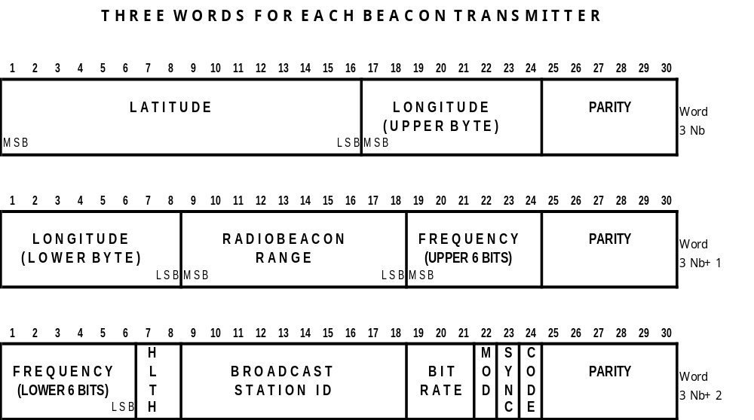

Figure 4-21. MESSAGE TYPE 35 - GLONASS BEACON ALMANAC
Table 4-40. TYPE 35 MESSAGE - GLONASS RADIOBEACON ALMANAC

PARAMETER | NUMBER OF BITS | SCALE FACTOR AND UNITS | RANGE
LATITUDE | 16 | 0.002747º | +90º (Notes 1 & 2)
LONGITUDE | 16 | 0.005493º | +180º (Notes 1 & 2)
RADIOBEACON RANGE | 10 | 1 km | 0 to 1023 km
FREQUENCY | 12 | 100Hz | 190 (all 0's) to 599.5 kHz (all 1's)
RADIOBEACON HEALTH | 2 | -- | “00” - Radiobeacon Operation Normal  “01” - No Integrity Monitor Operating  “10” - No information available  “11” - Don't Use this Radiobeacon
BROADCAST STATION ID | 10 | 1 | 0 to 1023
BROADCAST BIT RATE | 3 | -- | 8 states – (See Note 3)
MODULATION CODE | 1 | -- | "0" – MSK  "1" - FSK
SYNCHRONIZATION TYPE | 1 | -- | "0" – Asynchronous  "1" – Synchronous
BROADCAST CODING | 1 | -- | "0" - No added coding  "1" – FEC coding
Total | 72 x N_{b}
PARITY | N x 6 | (Note 4)

N_{b} = Number of radiobeacons in message
N = Number of words in message containing data
Note 1: “+” values indicate North Latitude or East Longitude
Note 2: 2's complement
Note 3: Broadcast Bit Rate: 000 (0) 25 bits/sec 100 (4) 150 bits/sec
001 (1) 50 bits/sec 101 (5) 200 bits/sec
010 (2) 100 bits/sec 110 (6) 250 bits/sec
011 (3) 110 bits/sec 111 (7) 300 bits/sec
Note 4: See GPS/SPS Signal Specification, available from U.S. Coast Guard Navigation Information Service, see Appendix E
4.3.35 Message Type 36 - GLONASS Special Message (Permanent)

Message Type 36 is a special ASCII message that can be displayed on a printer or CRT. Each Type 36 message can be up to 90 characters long. To be consistent with the other messages, the MSB is transmitted first, which means that the "data roll" described in section 5.3.2 applies to this message type as well. If for special purposes a commercial operation or agency elects to use IBM graphics characters, for example, they could be sent using the Type 36 message, except for the fill bits. Fill bits are zeros for this message, in order to avoid accidental misinterpretation of the alternating l's and 0's found as the fill pattern in other messages.

Figure 4-9 shows how the word "QUICK" would look as a Type 36 message.

Message Type 36 will be broadcast in English, using the 7-bit ASCII convention, and in Russian, using the 8-bit table in Appendix F. For example, the Russian word “ШТОРМ” would appear as shown in Figure 4-22.

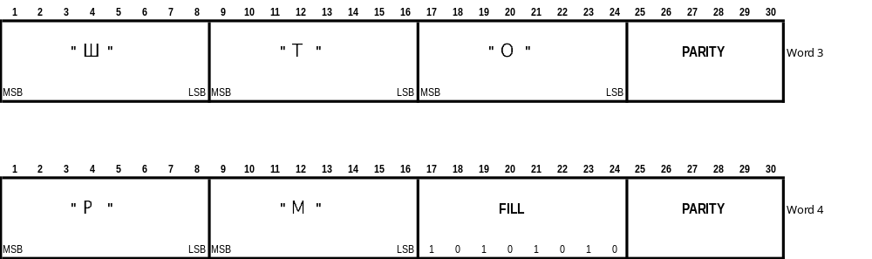
Figure 4-22. MESSAGE TYPE 36 - SPECIAL GLONASS MESSAGE

4.3.37 Message Type 36 - GNSS System Time Offset (Permanent)

Message Type 37 is used to relate the differential corrections from different GNSS's to each other. When differential corrections are calculated they are referenced to the reference station's calculation of time for that system. For example: DGPS corrections are calculated relative to GPS time as calculated by the reference station. This time calculation is sensitive to the actual satellites being tracked and the clock algorithms in the reference station. This value for system time is unique to the particular differential reference station. Consider a case with a DGNSS reference station tracking two separate systems, two separate time or clock calculations will be made. The corrections for each system will be referenced to the clock calculation for that particular system. In order to mix these corrections for best accuracy the user would need to know the offset between these two clock calculations with a high degree of precision. Rather than provide a time offset down to 2 cm with a 2 mm/sec rate term to be consistent with the accuracy of the corrections, the clock offset should be calculated and kept constant. To fill this function a separate message, Type 37, has been created to give the calculated offset between different satellite systems being mixed in differential mode. Therefore, by definition, Type 1 & 9 are referenced to GPS time as derived by the reference station and Type 31 & 34 are referenced to GLONASS time as derived by the reference station. For an integrated GPS/GLONASS reference station to work with the proposed Type 37 message, this time base offset must be held fixed between the two systems. Frequency of transmission will be driven by the rate of change between the two GNSS time references, the desired combined accuracy at the user equipment and any expected data loss in the broadcast. Note that new Type 37 messages must be transmitted before the affected system 2 corrections, that is, the second system's corrections are tied to the last received Type 37 message.

The parameters are to be combined by the mobile receiver in the following manner:

Time_sys1 = Time_sys2 + t_{diff}, where t_{diff} = t_{int} + t_{dec}

The parameter t_{diff} is computed by the DGNSS reference station and held at a one-nanosecond interval. This constant offset is maintained in the different sets of corrections until the reference station updates t_{diff} with a new value. The parameter t_{diff} is valid at the modified Z-count, and remains valid until another message is transmitted.

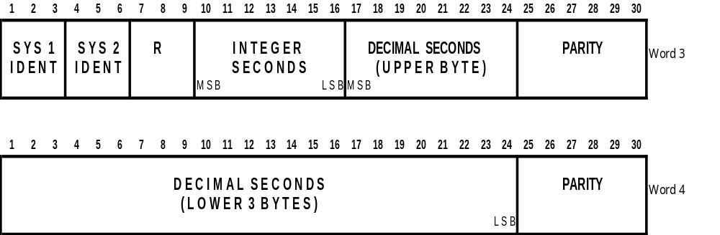
Figure 4-23. MESSAGE TYPE 37 - GNSS SYSTEM TIME OFFSET

Table 4-41. CONTENTS OF A TYPE 37 MESSAGE

PARAMETER | NUMBER OF BITS | SCALE FACTOR AND UNITS | RANGE
SYSTEM 1 IDENTIFIER | 3 | -- | "000" = GPS  "001" = GLONASS  "010" = Galileo  "011" = Reserved  "100" = Reserved  "101" = Reserved  "110" = Reserved  "111" = Reserved
SYSTEM 2 IDENTIFIER | 3 | -- | Same as for System 1 Identifier
RESERVED | 3 | -- | Default to “000”
DIFFERENCE - INTEGER SECONDS PART (t_{int}) | 7 | 1s | -64 s to +63 s (Note 1)
DIFFERENCE - DECIMAL SECONDS PART (t_{dec}) | 32 | 2⁻³² s | ±0.5 s (Note 1)
PARITY | 12 | (Note 2)

Note 1: 2's complement
Note 2: See GPS/SPS Signal Specification, available from U.S. Coast Guard Navigation Information Service, see Appendix E.

4.3.37 Message Types 38-40 (Undefined)

Message Types 38 through 40 are undefined at this time. They are available for future designation as new requirements are identified.

4.3.38 Message Type 41 - GNSS Differential Corrections (Tentative)
Message Types 41-46 are generic, i.e., they apply to all GNSS's, in support of conventional differential operation; they do not support real-time-kinematic (RTK) operation. In this document they apply to the GPS, GLONASS, and Galileo systems; they can be adapted to future systems as well. These generic message types use a one word header at the beginning of the message (see Table 4-42 and Figure 4-24), followed by a set of satellite-specific data (see Table 4-43). This header identifies the GNSS. This means that the differential corrections for different GNSS’s in a multi-system operation must use separate messages.
This message provides the pseudorange correction (PRC(t)) for any User Receiver at the GNSS Epoch measurement time "t":
PRC(t) = PRC(t₀)
where PRC(t₀) is the 16 bit pseudorange correction and t₀ is the epoch time of the GNSS broadcast message, measure in 0.6 second increments from the top of the hour. This is called the "Modified Z-Count", and is provided in Word 2 of the message (see Table 4-1). The correction parameters are all associated with the satellite indicated by the 6-bit GNSS SATELLITE ID, which indicates the SV number. The code-based pseudorange measured by the user, PRM(t), is then corrected as follows:

PR(t) = PRM(t) + PRC(t)

Note that the correction is added to the measurement. PR(t) is the differentially corrected pseudorange measurement that should be processed by the User Equipment navigation filter.

The header byte (Table 4-42) consists of the GNSS SYSTEM ID, and the GNSS SIGNAL ID. Table 4-43 shows the satellite-specific content of the message. A typical message thus consists of a header byte followed by a set of satellite-specific data words, one set for each satellite in view of the reference station (see Figure 4-24).

The GNSS SIGNAL ID (Table 4-44) enables the user to identify which of the different signal frequency and codes is being corrected. Note that the designations are specific to the GNSS. The different range signals will have different corrections (PRC) as well as UDREs.

The GNSS SATELLITE ID is defined differently for each GNSS (see Table 4-45). It applies to the SBAS's (WAAS, EGNOS) as well as the primary systems.

The Type 41 Message contains data for all satellites in view of the reference station (N_{s} ). Since 40 bits are required for the corrections from each satellite, there won't always be an exact integer number of words required. There will be messages that require 8 or 16 bits of fill to finish the frame. The fill will be alternating l's and 0's so as not to be confused with the "preamble" synchronization code. The format of the Type 41 Message is illustrated in Figure 4-25. If N_{s} is not a multiple of 3, the last word has one of two formats, containing either 8 or 16 fill bits.

The pseudorange correction PRC(t₀) will diverge from the proper value as it "grows old." Because of this characteristic, it will be updated and transmitted as often as possible. The user equipment should update the corrections accordingly.

Note that there is no range-rate correction. Carrier phase measurements should be corrected only using Message Type 18. The reference station will not apply ionospheric and tropospheric delay models in deriving the differential corrections.

The pseudorange correction PRC(t₀) is the difference between the computed geometric range and the adjusted pseudorange. The adjusted pseudorange is the raw pseudorange measurement adjusted for:
a. Receiver clock offset, scaled to meters.
b. Inter-frequency bias using the broadcast group delay (BGD) correction (see GALILEO OS SIS ICD)
c. Satellite clock offset, scaled to meters (see GALILEO OS SIS ICD)
d. Satellite relativistic correction, scaled to meters
The reference station shall apply neither ionospheric nor tropospheric delay models in deriving the differential corrections. The reference station clock offset will be a common offset in all pseudorange corrections, and thus will not affect position calculations. The reference station may also adjust the PRC(t₀) for multipath effects.

The GNSS UDRE (Table 4-46) is a one-sigma estimate of the uncertainty in the pseudorange correction as estimated by the reference station, and combines the estimated effects of multipath, signal-to-noise ratio, and other effects. Note: when Type 41 or 42 messages are broadcast, the Reference Station Health Status Indicator (Word 2 of the broadcast) must be set to "000".

The Issue of Data (IOD) (see Table 4-47) identifies the GNSS navigation data, in particular the satellite position, being used by the reference station to compute the differential corrections. These data typically change several times a day. It is included in the message so that the User Equipment may compare it with the IOD of the GNSS navigation data received from the satellite. The IOD is the key that ensures that the user equipment calculations and reference station corrections are based on the same set of broadcast orbital and clock parameters. If they don't agree, it is the responsibility of the differential user equipment to take the appropriate actions to acquire parameters that match the ones in use at the reference station. This can be done two ways: test the present IOD for a match to the IOD in a Type l or Type 2 message, or acquire another navigation data message from the appropriate satellite. In general, the reference station attempts to use the present navigation data being broadcast by a satellite. The user receiver should be designed to accommodate the possibility that the reference receiver may delay the broadcast of corrections based on a new satellite ephemeris for a period of up to 90 seconds.
The GPS IOD is defined in the GPS/SPS Signal Specification (see Appendix F). GLONASS does not utilize an IOD, but during normal operation changes in satellite ephemeris coincide with a change in the Time Index (t_{b}). Thus the 7 bits of the Time Index are included in the message so that the user equipment may compare it with the t_{b} of the GLONASS navigation data being used to determine if the user equipment calculations and reference station corrections are based on the same set of broadcast orbital and clock parameters. The Time Index comprises the 7 MSB's of the 8-bit IOD; the LSB is set to "0" and should be ignored. Note that for GLONASS-M satellites a change in ephemeris is always accompanied by a change in t_{b}, obviating the need for the complex procedure described in Message Type 31.

The Galileo IOD requires special attention, because the proposed IODnav consists of 10 bits, whereas only 8 bits are in the GNSS IOD field. Since the IODnav field is randomly selected, there is a finite possibility that the 8 LSB's of two successive IODnav fields could be the same. Thus the reference station shall check for this event and take special measures. Thus if the 7 LSB's of two successive IODnav fields are different (the usual case), the Galileo IOD in the message will consist of a "0", followed by the 7 LSB's of the Proposed 10-bit IODnav, defined in the Galileo OS SIS ICD. In the unlikely (but possible) event that the 7 LSB's of two successive IOD's are the same, the Galileo IOD will consist of "1", followed by the 7 MSB's of the 10-bit IODnav. The following IOD will always revert back to "0" and the 7 LSB's.

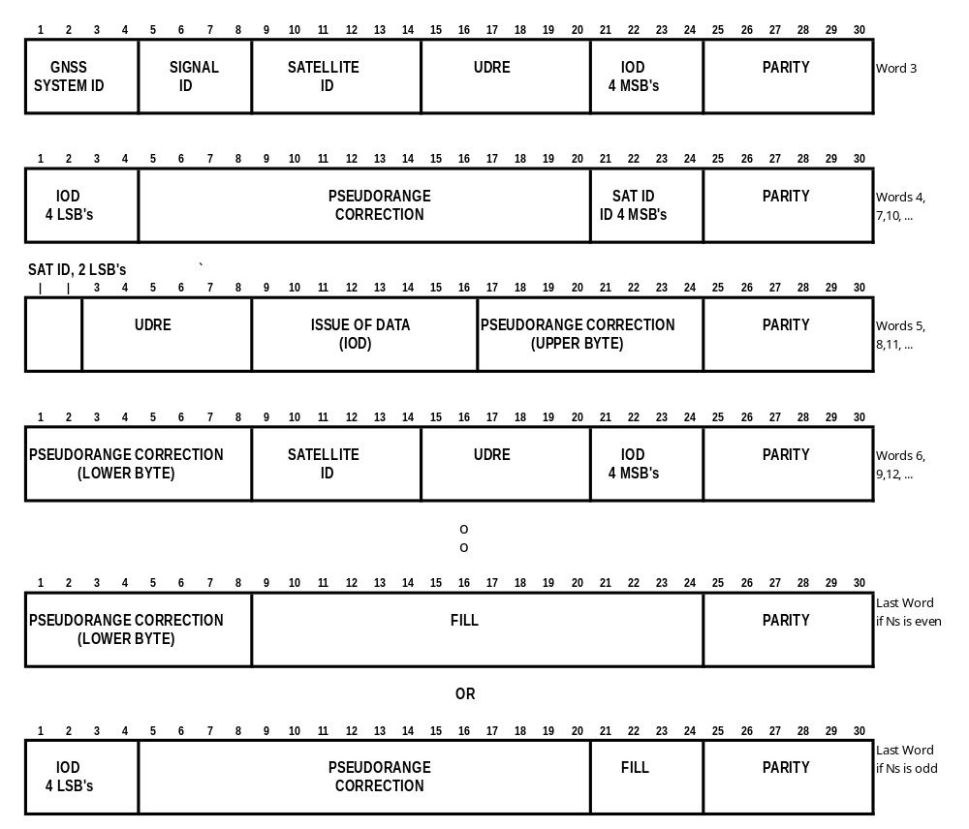
Figure 4-24. MESSAGE TYPE 41 – GNSS BASIC DIFFERENTIAL CORRECTION

Table 4-42. CONTENTS OF THE HEADER BYTE FOR TYPE 41 AND 42 MESSAGES

PARAMETER | NUMBER OF BITS | UNITS | RANGE
GNSS SYSTEM ID | 4 | 1 | 1 = GPS  2 = GLONASS  3 = Galileo  4 = SBAS  0, 5-15 are Reserved
GNSS SIGNAL ID | 4 | 1 | 0-15 (See Table 4-44)

Table 4-43. SATELLITE-SPECIFIC CONTENTS OF A TYPE 41 MESSAGE

PARAMETER | NUMBER OF BITS | SCALE FACTOR AND UNITS | RANGE
GNSS SATELLITE ID | 6 | 1 | 1 – 64  (See Table 4-45)
GNSS UDRE | 6 | 1 | 64 states  (See Table 4-46)
GNSS ISSUE OF DATA (IOD) | 8 | 1 | (See Table 4-47)
GNSS PRC(t₀) | 16 | 0.02 m | ± 655.34 (Note 1)
Total | 36 x Ns
Fill | 8x[Ns mod3] |  | 0, 8 or 16
Parity | N x 6
Ns = Number of satellite corrections
N = Number of words in message containing data. Frame length = N+2 words

Note 1: 2’s complement; binary 1000 0000 0000 0000 indicates a problem and the User Equipment should immediately stop using this satellite.

Table 4-44. GNSS SIGNAL ID

GNSS SYSTEM | SIGNAL ID | SIGNAL | CARRIER FREQUENCY (MHZ)
GPS | 0 |  | All signals
 | 1 | L1 C/A | 1575.420
 | 2 | L2 C/A | 1227.600
 | 3 | L2C | 1227.600
 | 4 | L5 | 1176.450
 | 5-15 | Reserved
GLONASS | 0 |  | All signals
 | 1 | G1 C/A | 1598.0625 - 1609.3125
 | 2 | G1 P | 1598.0625 - 1609.3125
 | 3 | G2 C/A | 1242.9375 - 1251.6875
 | 4 | G2 P | 1242.9375 - 1251.6875
 | 5-15 | Reserved
GALILEO | 0 |  | All signals
 | 1 | E5a | 1176.450
 | 2 | E5b | 1207.140
 | 3 | E5ab | 1191.795
 | 4 | E6-A | 1278.750
 | 5 | E6-BC | 1278.750
 | 6 | E1-A | 1575.420
 | 7 | E1-BC | 1575.420
 | 8-15 | Reserved
SBAS | 0 |  | All signals
 | 1 | GPS L1 | 1575.42
 | 2-15

Table 4-45. GNSS SATELLITE ID

GNSS System ID | GNSS NAME | Satellite ID
1 | GPS | A GPS Satellite ID number from 0 to 36 refers to the PRN code of the GPS satellite, although only PRN's 0-31 are normally used ("0" is used for PRN 32). Satellite ID’s 37-63 are reserved for future use.
2 | GLONASS | A GLONASS Satellite ID number from 0 to 31 refers to the slot number of the GLONASS satellite, where "000000" indicates slot number 32. A Satellite ID of zero indicates that the slot number is unknown. Satellite ID’s 32-63 are reserved for future use.
3 | Galileo | A Galileo Satellite ID number from 1 to 36 refers to the SV_{ID} code of the Galileo satellite. Satellite ID’s 37-63 are reserved for future use.  Galileo Satellite ID number 64 (all zeros) refers to all GNSS satellites
4 | SBAS | SBAS PRN codes cover the range 120-158. SBAS PRN codes are derived from the Satellite ID codes by adding 100.
5-15 | Reserved

Table 4-46. GNSS USER DIFFERENTIAL RANGE ERROR (UDRE)

Code Indicator  (i) | UDRE  Step | Minimum UDRE (m)  (Note 1) | Range of Indicated UDRE (m)
0-15 | 0.05 m | 0.05 ⋅ i | 0 < UDRE < 0.8
16-31 | 0.10 m | 0.1⋅ i - 0.8 | 0.8 ≤ UDRE < 2.4
32-47 | 0.29 m | 0.2⋅ i – 4.0 | 2.4 ≤ UDRE < 5.6
48-59 | 0.40 m | 0.4⋅ i - 13.6 | 5.6 ≤ UDRE < 10.4
60 |  |  | 10.4 ≤ UDRE < 15
61 |  |  | UDRE ≥ 15
62 |  |  | Not monitored
63 |  |  | Do not use
Note 1: for example, if i=1, 0.05m ≤ UDRE < 0.10m; if i=20, 1.20 m ≤ UDRE < 1.30m.
Table 4-47. Explanation of GNSS IOD
GNSS System ID | GNSS NAME | Issue of data (iod)
1 | GPS | For GPS, the Issue Of Data is the 8-bit IODE, which is defined in the GPS/SPS Signal Specification.
2 | GLONASS | GLONASS does not utilize an IOD, but during normal operation changes in satellite ephemeris coincide with a change in the Time Index (t_{b}). Thus the 7 bits of the Time Index are included in the message so that the user equipment may compare it with the t_{b} of the GLONASS navigation data being used to determine if the user equipment calculations and reference station corrections are based on the same set of broadcast orbital and clock parameters. The Time Index comprises the 7 MSB's of the 8-bit IOD; the MSB of the IOD is set to "0" and should be ignored. Note that for GLONASS-M satellites a change in ephemeris is always accompanied by a change in t_{b}, obviating the need for the complex procedure used in Version 2.2 and 2.3.
3 | Galileo | The Galileo IOD will normally consist of a "0", followed by the 7 LSB's of the Proposed 10-bit IODnav, defined in the Galileo OS SIS ICD. However, in the unlikely (but possible) event that the 7 LSB's of two successive IOD's are the same, the Galileo IOD will consist of a "1", followed by the 7 MSB's of the 10-bit IODnav (see text).
4 | SBAS | Referenced to GPS IOD
5-15 | Reserved

4.3.39 Message Type 42 - GNSS Partial Correction Sets (Tentative)
The Type 42 Message serves the same purpose as the Type 41 Message, in that it contains the primary differential GNSS correction. However, unlike Type 41, Type 42 does not require a complete satellite set. As a result, they require the use of a more stable clock than a station transmitting only Type 41, because the satellite corrections have different time references. To prevent degradation of navigation accuracy due to unmodelable clock drift that can occur between 42 messages, a highly stable clock source is required. These message types are useful for slow data links in the presence of impulse noise, such as that encountered in radio beacon operation. During high noise periods, the higher rate of preambles supports a faster re-synchronization.

The Type 42 Message can also be used to improve the performance of data links that are susceptible to interference from impulse noise, such as radio beacon data links. Grouping satellites in blocks of three significantly improves the data link performance in two ways. First, when Type 42 Messages contain the corrections for three satellites, their initially lower age of corrections more than compensates for their longer propagation time associated with the increased overhead. Second, the short length of the Type 42 Message provides increased noise immunity and allows a more rapid resynchronization, due to the fact that the preamble is transmitted at a much higher rate. Note that unlike the case for Type 41 Messages, corrections from partial correction messages can be applied as soon as they are received (see Section 5.3.5) thus further reducing the average PRC latency and lowering the susceptibility of the messages to channel noise.

4.3.40 Message Type 42 - GNSS Null Frame (N≤1) (Tentative)

The Type 42 Message with N=0 or N=1 contains no parameters. It will be used as transmission fill, if required. Its purpose is to provide messages when the Reference Station has no other message ready to send, or to synchronize the beginning of a message to some unspecified epoch. There may never be a reason to send this message. It is only defined as a contingency. It could be used as message fill if higher message rates are not required because of slow error growth. Since it is a short message, it provides the user with additional preambles. This should aid in establishing and maintaining frame synchronization. Moreover, this message type can be used to indicate the differential GNSS reference station health.

The message contains the first two words as usual with N=0 or 1, depending whether or not an even or odd transmission fill is required. If N=1, then the 24 data bits in the third word should be filled with alternating 1's and 0's. Parity should be tested as usual.

4.3.42 Message Type 43 - GNSS Navigation Data Validity and Signal Health Status (Tentative)
The Type 43 Message provides information that can assist in the operation of differential GNSS user equipment. It is a mechanism through which the observations made at the reference station can be automatically used by the user equipment to improve performance without operator intervention. This message can contain information for one or more satellites. The satellite may or may not be in view of the reference station. It will be transmitted periodically as determined necessary by the reference station. The content of a Type 43 Message is described in Tables 4-48 and 4-49, and illustrated in Figures 4-25 and 4-26.

Table 4-48. CONTENTS OF A TYPE 43 MESSAGE HEADER

PARAMETER | NUMBER OF BITS | UNITS | EXPLANATION
RESERVED | 1
SYSTEM ID | 4 | 1 | 1 = GPS  2 = GLONASS  3 = Galileo  4 = SBAS  0, 5-15 are Reserved
RESERVED | 19 |  | Alternating 1's and 0's
PARITY | 6

Table 4-49. CONTENTS OF A TYPE 43 MESSAGE, SATELLITE-SPECIFIC DATA

PARAMETER | NUMBER OF BITS | UNITS | EXPLANATION
SATELLITE ID | 6 | 1 | 1 - 64 (See Table 4-45)
SIGNAL ID | 4 | 1 | 0-15 (See Table 4-44)
GNSS DATA VALIDITY STATUS | 1 | 1 | Bit set to 0 indicates that Navigation Data are valid.  Bit set to 1 indicates that the Navigation Data are ‘working without guarantee’ (see GALILEO OS SIS ICD)
GNSS SIGNAL HEALTH STATUS | 2 | 1 | The signal status bits have the following values (see GALILEO OS SIS ICD):  0: Signal OK  1: Signal out of service  2: Signal will be out of service  3: Signal component currently in test
C/N₀ | 5 | 1 dB-Hz | Satellite signal to noise ratio as measured at reference station.  "00001" = 25 dB-Hz  "00010" = 26 dB-Hz  ...  "11111" = 55 dB-Hz
NEW NAVIGATION DATA | 1 | 1 | Bit set to 1 indicates that the new satellite navigation data is being acquired by the reference station and being integrated into the pseudorange correction generation process. There will soon be a new IOD indicated in the Type 41 or 42 Message.
SATELLITE HEALTH WARNING | 1 | 1 | Bit set to 1 indicates that a change in the satellite’s health to “unhealthy” is scheduled. The “healthy” time remaining is indicated by the following 4 bits.
TIME TO UNHEALTHY | 4 | 5 minutes | Range is 0 to 75 minutes, i.e.,  "0001" = 5 min  ...  "1111" = 75 min  The value “0000” indicates that the signal is about to go “unhealthy”, while the value “1111” indicates that the satellite will go “unhealthy” in about 75 minutes.
PARITY | 6

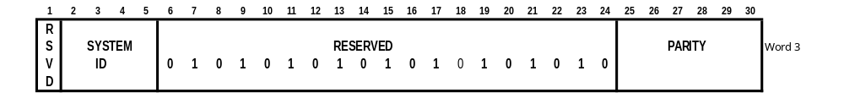
Figure 4-25. MESSAGE TYPE 43 – GNSS NAVIGATION DATA VALIDITY AND SIGNAL HEALTH STATUS - HEADER

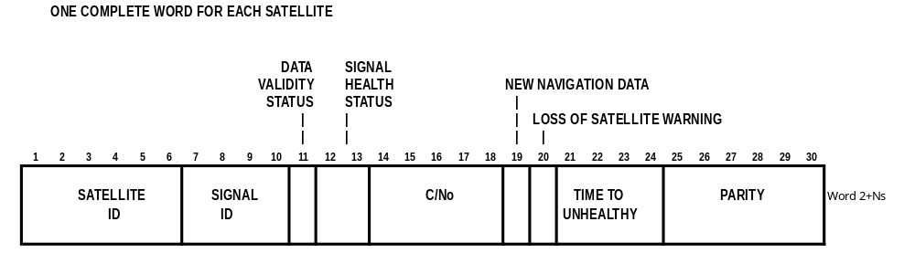
Figure 4-26. MESSAGE TYPE 43 – GNSS NAVIGATION DATA VALIDITY AND SIGNAL HEALTH STATUS - SATELLITE-SPECIFIC DATA

4.3.42 Message Type 44 - GNSS Ionospheric Delay (Tentative)
Message Type 44 is designed to provide ionospheric delay in a specific frequency band along the line-of-sight vector to different satellites, corresponding to Message Type 15 for GPS and GLONASS. It can be employed by multi-frequency users to ameliorate the ionospheric de-correlation that would otherwise be experienced by a user receiver distant from the reference station. The Type 44 Message does not include a rate of change term, therefore Type 43 Messages should be broadcast a rate corresponding to a service provider defined maximum change between two consecutive 44 Messages.

The Type 44 Message is designed to enable the user equipment to continuously remove the ionospheric component from the received pseudorange corrections, to form what are called "iono-free" corrections. The delay term is added exactly like Type 41 and Type 42 corrections to provide the total ionospheric delay at a given time, and the total ionospheric delay is then subtracted from the pseudorange corrections. The resulting corrections are thus "iono-free". The user equipment similarly subtracts off its own measurements (or estimates) of ionospheric delay from its own pseudorange measurement, and applies the iono-free corrections. Tables 4-50 and 4-51define the parameters of the Type 44 Message, and Figure 4-27 shows the manner in which the bits are distributed throughout the message. Note that the rate of change term has been omitted (compared to Message Type 15) and that each satellite requires only one word, or 24 bits, of data, exclusive of parity. Also note that a combined GPS/GNSS/GLONASS reference receiver should transmit the ionospheric information for each system in separate messages (using Message Type 15 for GPS and GLONASS).

Table 4-50. CONTENTS OF A TYPE 44 MESSAGE, HEADER WORD

PARAMETER | NUMBER OF BITS | SCALE FACTOR AND UNITS | RANGE
RESERVED | 1 |  | 1 – 64 (Note 1)
SYSTEM ID | 4 | 1 | 1 = GPS  2 = GLONASS  3 = Galileo  4 = SBAS  0, 5-15 Reserved
RESERVED | 3 | --
SIGNAL ID | 4 | 1 | 16 states (See Table 4-44)
RESERVED | 12
Total | 24
PARITY | 6

Table 4-51. CONTENTS OF A TYPE 44 MESSAGE, SATELLITE-SPECIFIC DATA

PARAMETER | NUMBER OF BITS | SCALE FACTOR AND UNITS | RANGE
SATELLITE ID | 6 |  | 1 – 64 (Note 1)
E1 IONOSPHERIC DELAY | 12 | 0.02 m | 0 - 81.92  (Notes 2 and 3)
E1 UDRE_{IONO} | 6 | -- | 64 states (See Table 4-52)
Total | 24 x Ns
PARITY | N x 6
Ns = Number of satellite corrections
N = Number of words in message containing data. Frame length = N+2 words
Note 1: See Note 1, Table 4-45
Note 2: 2’s complement
Note 3: Binary 1000 0000 0000 indicates a problem and the User Equipment should immediately stop using iono correction

Figure 4-27. MESSAGE TYPE 44 – GNSS E1 IONOSPHERIC DELAY

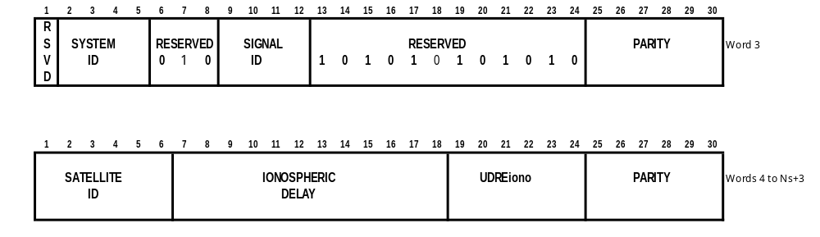

Table 4-52. GNSS E1 UDRE_{IONO}

Code Indicator (i) | UDRE_{IONO}  Step | Minimum UDRE_{IONO} (m) | Range of  Indicated UDRE_{IONO} (m)
0-15 | 0.05 m | i⋅ 0.05 | 0 < UDRE_{IONO} < 0.80
16-31 | 0.10 m | i⋅ 0.1 - 0.8 | 0.8 ≤ UDRE_{IONO} < 2.4
32-47 | 0.20 m | i⋅ 0.2 – 4.0 | 2.4 ≤ UDRE_{IONO} < 5.6
48-59 | 0.40 m | i⋅ 0.4 -13.6 | 5.6 ≤ UDRE_{IONO} < 10
60 |  |  | 10 ≤ UDRE_{IONO} < 15
61 |  |  | UDRE_{IONO} ≥ 15
62 |  |  | Not monitored
63 |  |  | Do not Use

4.3.43 Message Type 45 - GNSS Local Integrity Alert (Tentative)
Local DGNSS broadcasting stations can provide an independent source of integrity data to mitigate local signal conditions with respect to interference (unintentional or not) and shadowing. Notably, provision of local integrity data may enhance availability of integrity data for systems providing global or regional integrity (GNSS, SBAS) in areas of low satellite visibility (high latitudes, mountain areas, urban canyons, etc.).

At present, the RTCM SC-104 DGNSS Version 2 message repertoire, both permanent and tentative messages, handle integrity using special code indicators in the data fields for pseudorange and carrier phase corrections. However, Time to Alert (TTA) requirements for various Safety of Life applications may not be met for low capacity data links using this technique. As an example, the proposed IMO TTA requirement of 10 seconds requires that no message should take more than 5 seconds to transmit . At the nominal transmission rate of 100 bps for the IALA Maritime Radiobeacon DGNSS service, this limits the number of satellites to 8 for Version 2.3 Message Types 1 and 31, and 6 for Message Types 9-3 and 34-3.

Local integrity provision should not override global or regional integrity data, i.e. a satellite flagged ‘Not OK’ should not be flagged ‘OK’ by the local integrity monitor. However, a satellite flagged ‘OK’ by the GNSS operator may well be flagged ‘Not OK’ locally.

The GNSS Local Integrity Alert message provides both a supplement and an alternative to the way integrity alerts are handled for local integrity provision. The message is generic in the sense that local DGNSS broadcasting stations can incorporate all current and near-future GNSS systems using this message type.

Table 4-53 and Figure 4-28 describes the content of the GNSS Local Integrity Alert Message Type 46. .

Table 4-53. CONTENTS OF A TYPE 45 MESSAGE

DATA FIELD | NUMBER OF BITS | SCALE FACTOR AND UNITS | RANGE
Reserved | 1
GNSS SYSTEM ID | 4 | 1 | 1 = GPS  2 = GLONASS  3 = Galileo  4 = SBAS  0, 5-15 Reserved
GNSS SATELLITE ID | 6 | 1 | See Table 4-45
GNSS SIGNAL ID | 4 | 1 | See Table 4-44
GNSS LOCAL INTEGRITY FLAG | 2 | 1 | 00 = Use  01 = Do NOT use  10 = Not monitored (Note 1)  11 = Reserved
ALERT TIME INDICATOR | 5 | 1 | Time since start of alert,  see Table 4-54
RESERVED | 2
PARITY | 6
Note 1: For stations with Integrity Monitoring. This condition will be flagged until a new Message Type 27 (Radiobeacon Almanac) is broadcast.

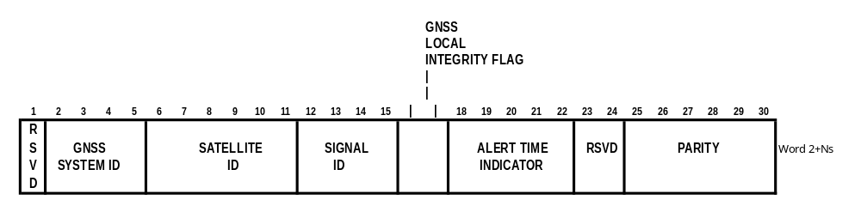
Figure 4-28. MESSAGE TYPE 45 – GNSS LOCAL INTEGRITY ALERT

Table 4-54. ALERT TIME INDICATOR

Indicator (i) | Step Size | Minimum Alert Time (s) | Range of Indicated Alert Times (s)
0-3 | 1 s |  | 0 < alert time < 4
4-7 | 2 s | i·2-4 | 4 ≤ alert time < 12
8-11 | 4 s | i·4-20 | 12 ≤ alert time < 28
12-15 | 16 s | i·16-164 | 28 ≤ alert time < 92
16-19 | 64 s | i·64-932 | 92 ≤ alert time < 348
20-23 | 256 s | i·256-4772 | 348 ≤ alert time < 1372
24-27 | 1024 s | i·1024-23204 | 1372 ≤ alert time < 5468
28-30 | 4096 s | i·4096-109220 | 5468 ≤ alert time < 13661
31 | --- | --- | alert time ≥ 13661 (3 hrs)

4.3.44 Message Type 46 - GNSS Integrity Table (Reserved)
The GNSS Integrity Table message may be broadcast in the event that the number of ‘connected’ satellites are considered sub-critical for navigation in areas with restrictions in the navigational ability and/or high traffic density. Also, regular transmission of the integrity table would benefit users with OS receivers.

4.3.45 Message Types 47-58 (Undefined)

Message Types 47 through 58 are undefined at this time. They are available for future designation as new requirements are identified.

4.3.45 Message Type 59 - Proprietary Message (Permanent)

Message Type 59 is reserved for private use by operators who wish to use their data links to communicate proprietary information to their users. It is anticipated that if such operators wish to send more than one type of message, it is their responsibility to design their format to allow for multiple sub-message types. The first eight bits in the third word (the word immediately following the header) shall serve as the identification code for the operator.

4.3.46 Message Types 60-63 - Multipurpose Usage (Reserved)

Message Types 60-63 are reserved, at least temporarily, for use in exploring the use of multi-purpose data links. Since the standards for broadcast have already been set up by this Committee, the SC-104 format can be used to transmit differential Loran-C, differential Chayka, differential Omega, weather messages, or other navigational information. Four message types have been reserved to explore such options.

The page intentionally left blank
5. GNSS RECEIVER TO DATA LINK EQUIPMENT INTERFACE

5.l INTRODUCTION

In Chapter 4 the various message types and their digital format were presented. However, a data link is required to move this information from the differential GNSS reference station to the mobile receiver. This section presents recommended standards on the operation of the data transmitter and data receiver that interface with the ground and mobile GNSS receivers. It is recognized that it is possible to integrate the GNSS receiver and data transmitter or receiver at either end of the link, in which case the interface requirements described here are not applicable.

Data link operation is described in Section 3.4. Figure 3-2 shows the reference station functions that are involved. The reference receiver processes the GNSS sensor data and develops corrections, which are then fed to the data transmitter at a speed higher than the link data rate. The data transmitter formats and buffers the incoming data, then modulates the data onto a transmitter carrier for broadcast to mobile user equipments. Figure 3-4 shows the corresponding functions for the user. In both cases it is necessary to provide standards for the interfaces between GNSS receivers and data transmitters and receivers in order to promote interoperability.

5.2 INTERFACE SPECIFICATION

The GNSS equipment shall be designed in such a way that the digital data link information enters and exits through an asynchronous full duplex serial input/output port. Good general purpose commercial practices are recommended, rather than military or avionics standards. The choice of the electrical connector is left to the GNSS user equipment manufacturer. The signal voltage levels should conform to either the EIA RS-232-C (1) or RS-422-A/RS-449 (2 and 3). A synopsis of these signals is contained in Table 5-1.

Table 5-1. SYNOPSIS OF SIGNAL VOLTAGE LEVELS

INTERCHANGE | SIGNAL VOLTAGE | BINARY STATE / SIGNAL CONDITION
 |  | 1 / MARKING | 0 / SPACING
RS-232-C | SIGNAL PIN TO GROUND | -25V TO –3V | +3V TO +25V
RS-422-A | DIFFERENTIAL,  SIGNAL PIN "A" TO "B" | -6V TO –2V | +2V TO +6V

The American National Standards Institute (ANSI) X3.16 (4) and X3.15 (5) standards for eight-bit character structure shall govern the rules for serial data transfers. Note that the use of all eight bits in the transfer of serial data precludes the use of 7 bit parity formats. The recommended protocol being 8 bits, no parity, 1 stop bit. The serial data rate should be selectable at least over the 300 to 9600 baud range (300, 600, l200, 2400, 4800, or 9600 baud). As a minimum the user equipment shall be designed to handle a continuous information rate of 30 eight bit bytes every second.

5.3 IMPORTANT INTERFACE RULES

Although the data is packaged in 8 bit bytes, the interpretation of what each of the 8 bits means is dictated by a combination of what was presented in Section 4 and rules that follow.

5.3.l Byte Format Rule

A standard 8-bit byte is described as the "8-Bit Environment" in ANSI X3.l6(4). This standard assigns the order of the start, stop, and eight data bits: the first data bit transmitted is designated "a_{l}" and the last is "a₈"; bit "a_{l}" is designated the least significant bit. This is a source of problems and is discussed in the next section (see 5.3.2).

All equipment shall support the use of the "6 of 8" format (data bits a_{l} through a₆) to transfer the information contained in Chapter 4. As an indication that bits a_{l} through a₆ are "message information", bit a₇ shall be set "marking" and a₈ shall be set "spacing". The appropriate mark and space signaling conditions are discussed in EIA RS-232-C(l) and EIA RS-422-A (2).

5.3.2 Most Significant Bit First Rule

The Data Link (see Section 3.4) binary information shall always be passed in the order it appears in Section 4. This is known as most significant bit first. This facilitates the introduction of pure synchronous data links between the reference station and user equipment. Unfortunately, the ANSI X3.l5-l976 standard states that the least significant bit is first. Almost all integrated circuits designed for serial communications follow this convention. The use of X3.l5 standard Universal Asynchronous Receivers and Transmitters (UARTs) introduces the need for a "byte roll" prior to leaving the reference station equipment and then again just after entering the GPS user equipment. The following is from ANSI standard X3.l5-l976 (5): "The bit sequence for an ASCII character shall be least significant bit first to most significant bit - in terms of the 7-bit ASCII nomenclature (6) b_{l} through b₇ in ascending (consecutive) order, or in terms of the 8-bit nomenclature (7) a_{l} through a₈ in ascending (consecutive) order".

The "roll" process is performed on each byte prior to transmission. Rolling means that bits a_{l} and a₆, a₂ and a₅, a₃ and a₄ are swapped. This same process is repeated after the user equipment accepts each byte.

5.3.3 Bit Slip Rule

In a typical installation the communications receiver or modem will assemble the received bits into 8-bit bytes. No specific (except bit synchronization) byte or "word" synchronization should be assumed. The user equipment shall be required to recover the message synchronization just as it is responsible for recovering the synchronization of the satellite navigation data. This simply means that the user equipment designer should not assume there will be any consistent relationship between the word boundaries of this standard's 30 bits words and the communications channel 8 bit bytes. Synchronization and decoding of this standard's data should be handled in a manner similar to that used by the GNSS receiver to decode satellite broadcast navigation data.

5.3.4 Terminal Equipment Rule

If the manufacturer uses the standard connectors suggested in the RS-232-C or RS-449 standards, the connector shall be wired as though the GNSS user equipment were a piece of DTE "terminal equipment".

5.3.5 Complete Message Decode Rule

The mobile equipment should generally avoid using message data until the message has been completely received. Otherwise the situation could arise where corrections for the first satellites received would be applied, but later words in the message would not pass parity. This would result in errors caused by drift in the reference station clock. Section 3.2.9 discusses this effect in more detail. For reference stations employing highly stable clocks, such as those transmitting Type 9's, this restriction does not apply.

5.4 EQUIPMENT OPTIONS

Reverse communications from the mobile receiver to the modem, communications equipment, or reference station are not required for differential operation but could be useful. Including features that control the flow of data to the user equipment, allow the operator to send commands from the mobile receiver to the communications equipment (such as dialing a telephone), and automatic functions to control the communications equipment, could enhance operation of the equipment and should be considered by manufacturers.

Some of the broadcast information (message Types 7 and l3) provides information about the broadcast system itself. The intent of some messages is to provide enough information so that automatic communications control can be done by the user equipment. For example, in the case where the communications receiver is a radio beacon receiver, a reception frequency is required. The user equipment may be able to perform automatic frequency and data rate selection. Other helpful information would include commands to shift bits (after frame synchronization has been established), do self test, and request status.

5.5 DATA LINK INTERFACING EXAMPLES

5.5.1 Methods of Data Link Interfacing

There are several methods to control the flow of data between the GNSS equipment and the data link. One method used is commonly referred to as a hardware handshake. This is often used on the reference station equipment to control the data link transmitter. As an example, consider a GNSS receiver configured as a DTE (Data Terminal Equipment) and a data link configured as a DCE (Data Communication Equipment).

In this scheme the GNSS receiver has data available to output and raises the RTS (Request To Send) signal on the serial I/O port. The data link responds by asserting a response signal CTS (Clear To Send), which indicates to the GNSS receiver that it is clear for data to be output. The GNSS receiver then outputs the data until it is finished or until the data link CTS signal is de-asserted, signifying that it can no longer accept data, at which time the GNSS receiver would suspend the data output until data link CTS is again asserted. The data link should not assert the CTS signal until the instant it is able to accept more data for transmission. Using this scheme ensures that the proper timing of the data between the GNSS reference equipment and the data link equipment is maintained.

Another method for flow control is referred to as a software handshake. In this method the GNSS receiver outputs data through the serial port to the data link and will continue to output data until it receives a "X Off" (ASCII control character DC3) from the data link. This indicates that no more data can be accepted by the data link and data output from the GNSS receiver is suspended. When the data link is again ready to accept more data, it sends a "X On" (ASCII control character DC1) at which time the GNSS receiver may resume its data transmission.

If no hardware or software flow control is used, often a rate setting is used whereby the GNSS reference equipment is configured to output data at a certain maximum rate that the data link is capable of handling. This is independent of the serial baud rate of the data itself.

It is important to note that the configuration as to DTE or DCE and the availability of these protocols varies greatly between GNSS equipment and data links. If no method for flow control is available, then the data link must be capable of handling the data at the rate it is output from the GNSS equipment.

5.5.2 Radiobeacon Minimum Shift Keying (MSK) Data Link

The transmission of DGNSS corrections using a marine radiobeacon is a popular method of accomplishing the differential data link. The MSK modulator generally receives data from the DGNSS reference station via an RS-232 link. The reference station takes the 30 bit RTCM words and divides them into five 6-bit bytes that are then sent to the modulator in a standard ASCII eight bit byte as the six least significant bits. The modulator strips the start, stop and the two most significant bits from this byte and only transmits the six RTCM SC-104 data bits over the air. At this point the data consists of just the RTCM SC-104 data protocol and the relationship between the start of a RTCM 30-bit word and an asynchronous ASCII byte has been lost. The MSK receiver demodulates the radiobeacon signal, puts six bits into an eight bit byte (byte format rule section 5.3.1) and sends the data along to a DGNSS receiver. The RTCM SC-104 decoding process in the DGNSS receiver must then reconstruct the original order of the bits (see 5.3.2) and synchronize with the message stream by recovering the RTCM SC-104 preamble and parity. This start of a RTCM 30 bit word will probably not (5 out of 6 times) fall on a ASCII byte boundary, thus the bit slip rule (see 5.3.3).

5.6 REFERENCES

l. Electronic Industries Association, "Interface Between Data Terminal Equipment and Data Communication Equipment Employing Serial Binary Data Interchange (EIA RS-232-C)", 200l Eye Street, N.W., Washington, D.C. 20006

2. Electronic Industries Association, "Electrical Characteristics of Balanced Voltage Digital Interface Circuits (EIA RS-422-A, December l978)", 200l Eye Street, N.W., Washington, D.C. 20006

3. Electronic Industries Association, "General Purpose 37-Position and 9-Position Interface for Data Terminal Equipment and Data Circuit-Terminating Equipment Employing Serial Binary Data Interchange (EIA RS-449, November l977)", 200l Eye Street, N.W., Washington, D.C. 20006

4. American National Standards Institute, "American National Standard Character Structure and Character Parity Sense for Serial-by-Bit Data Communication in the American National Standard Code for Information Interchange (ANSI X3.l6-l976 revision of X3.l6-l966)", l430 Broadway, New York, New York l00l8

5. American National Standards Institute, "American National Standard for Bit Sequencing of the American National Standard Code for Information Interchange in Serial-by-Bit Data Transmission (ANSI X3.l5-l976 revision of X3.l5-l966)", l430 Broadway, New York, New York l00l8

6. American National Standards Institute, "American National Standard Code for Information Interchange (ANSI X3.4-l977 revision of X3.4-l968)", l430 Broadway, New York, New York l00l8

7. American National Standards Institute, "American National Standard Character Code Extension Techniques for Use with the 7-Bit Coded Character Set of American National Standard Code for Information Interchange (ANSI X3.4l-l974)", l430 Broadway, New York, New York l00l8

This page intentionally left blank

6. recommended data message format for Loran-cOMM broadcasts

6.1 Message Structure for LORAN-COMM systems

6.1.1 Timing and Modulation

The basic Loran-C signal consists of a group of eight pulses having a 100 kHz carrier. These pulses are transmitted at the designated group repetition rate (GRI) of the chain in which a station is operating. The master station sets the timing reference for a chain by transmitting its group of eight pulses first. Then each secondary station (up to five secondary stations per chain) transmits its group of eight pulses with its own unique “emission delay” after the master pulse group.

Modulation is applied within each group of pulses to the last six of the eight transmitted pulses. The first two pulses are reserved for the Loran-C integrity signaling system called “blink”. Modulation may advance a pulse by 1.0 microseconds, retard it by 1.0 microseconds or allow it to remain at its unmodulated (prompt) timing. Hence there is tri-level (ternary) modulation: advanced (+), prompt (0) or retarded (-). A ternary data element is called a “trit”. Six trits represent the modulation pattern for a particular pulse group. With no limitations on the sequence of trits, there can be 3⁶ = 729 data states for these trits. However, the pattern of modulation within a pulse group is limited by the requirement that the sum of advanced pulses and retarded pulses is always zero. This is done to prevent biasing timing measurements in Loran-C navigation receivers. There are 141 possible data states for these trits with this limitation. The design is simplified by limiting use to 128 states (equivalent to exactly 7 binary bits of data) of these trits, plus the all zeros state which is reserved for the unmodulated signal. Table 6-1 shows the relationship between seven bit binary words and six trit ternary words.

Since only binary data is manipulated in logic hardware, binary representation of the ternary modulation is implemented in the RSIM to pass to the modulation circuits in the Loran-C timer. Two bits are needed to represent each trit. The bit pattern “01” represents “advance”, “00” represents “prompt” and “10” represents “retard”. The bit pattern “11” is not allowed. If it appears in the data, the entire pulse group is unmodulated.

The normal structure of binary devices calls for eight-bit words to be moved between equipment on serial data lines. To accommodate this, the modulator is designed to expect two eight-bit words with modulation information in the last six bits of each word. For example: hex = 53:

seven bit word: 1010011 = six trit word: – + 0 – 0 +
six trit word: – + 0 – 0 + = modulator input: 00|10|01|00 00|10|00|01

Note that since the arrangement of the table is arbitrary, fee-based DGNSS service is easily accommodated by rearranging Table 6-1. Each of the 128 valid modulation patterns should uniquely represent a 7-bit binary block of data as shown below.

Table 6-1. Translation Matrix, Hex ( 7-Bit Binary ) to ( 6 Trit ) Ternary, for Loran-Comm Modulation

Decimal Hexa- Pattern  decimal |  |  |  | Decimal Hexa- Pattern  decimal |  |  |  | Decimal Hexa- Pattern  decimal
0 | 0 | --00++ |  | 43 | 2B | 00-+-+ |  | 86 | 56 | ++-00-
1 | 1 | --0+0+ |  | 44 | 2C | 00-++- |  | 87 | 57 | ++0--0
2 | 2 | --0++0 |  | 45 | 2D | 00+--+ |  | 88 | 58 | ++0-0-
3 | 3 | --+00+ |  | 46 | 2E | 00+-+- |  | 89 | 59 | ++00--
4 | 4 | --+0+0 |  | 47 | 2F | 00++-- |  | 90 | 5A | -0000+
5 | 5 | --++00 |  | 48 | 30 | 0+--0+ |  | 91 | 5B | -000+0
6 | 6 | -0-0++ |  | 49 | 31 | 0+--+0 |  | 92 | 5C | -00+00
7 | 7 | -0-+0+ |  | 50 | 32 | 0+-0-+ |  | 93 | 5D | -0+000
8 | 8 | -0-++0 |  | 51 | 33 | 0+-0+- |  | 94 | 5E | -+0000
9 | 9 | -00-++ |  | 52 | 34 | 0+-+-0 |  | 95 | 5F | 0-000+
10 | A | -00+-+ |  | 53 | 35 | 0+-+0- |  | 96 | 60 | 0-00+0
11 | B | -00++- |  | 54 | 36 | 0+0--+ |  | 97 | 61 | 0-0+00
12 | C | -0+-0+ |  | 55 | 37 | 0+0-+- |  | 98 | 62 | 0-+000
13 | D | -0+-+0 |  | 56 | 38 | 0+0+-- |  | 99 | 63 | 00-00+
14 | E | -0+0-+ |  | 57 | 39 | 0++--0 |  | 100 | 64 | 00-0+0
15 | F | -0+0+- |  | 58 | 3A | 0++-0- |  | 101 | 65 | 00-+00
16 | 10 | -0++-0 |  | 59 | 3B | 0++0-- |  | 102 | 66 | 000-0+
17 | 11 | -0++0- |  | 60 | 3C | +--00+ |  | 103 | 67 | 000-+0
18 | 12 | -+-00+ |  | 61 | 3D | +--0+0 |  | 104 | 68 | 0000-+
19 | 13 | -+-0+0 |  | 62 | 3E | +--+00 |  | 105 | 69 | 0000+-
20 | 14 | -+-+00 |  | 63 | 3F | +-0-0+ |  | 106 | 6A | 000+-0
21 | 15 | -+0-0+ |  | 64 | 40 | +-0-+0 |  | 107 | 6B | 000+0-
22 | 16 | -+0-+0 |  | 65 | 41 | +-00-+ |  | 108 | 6C | 00+-00
23 | 17 | -+00-+ |  | 66 | 42 | +-00+- |  | 109 | 6D | 00+0-0
24 | 18 | -+00+- |  | 67 | 43 | +-0+-0 |  | 110 | 6E | 00+00-
25 | 19 | -+0+-0 |  | 68 | 44 | +-0+0- |  | 111 | 6F | 0+-000
26 | 1A | -+0+0- |  | 69 | 45 | +-+-00 |  | 112 | 70 | 0+0-00
27 | 1B | -++-00 |  | 70 | 46 | +-+0-0 |  | 113 | 71 | 0+00-0
28 | 1C | -++0-0 |  | 71 | 47 | +-+00- |  | 114 | 72 | 0+000-
29 | 1D | -++00- |  | 72 | 48 | +0--0+ |  | 115 | 73 | +-0000
30 | 1E | 0--0++ |  | 73 | 49 | +0--+0 |  | 116 | 74 | +0-000
31 | 1F | 0--+0+ |  | 74 | 4A | +0-0-+ |  | 117 | 75 | +00-00
32 | 20 | 0--++0 |  | 75 | 4B | +0-0+- |  | 118 | 76 | +000-0
33 | 21 | 0-0-++ |  | 76 | 4C | +0-+-0 |  | 119 | 77 | +-+-+-
34 | 22 | 0-0+-+ |  | 77 | 4D | +0-+0- |  | 120 | 78 | -+-+-+
35 | 23 | 0-0++- |  | 78 | 4E | +00--+ |  | 121 | 79 | +-+--+
36 | 24 | 0-+-0+ |  | 79 | 4F | +00-+- |  | 122 | 7A | -+-++-
37 | 25 | 0-+-+0 |  | 80 | 50 | +00+-- |  | 123 | 7B | +--+-+
38 | 26 | 0-+0-+ |  | 81 | 51 | +0+--0 |  | 124 | 7C | -++-+-
39 | 27 | 0-+0+- |  | 82 | 52 | +0+-0- |  | 125 | 7D | +--++-
40 | 28 | 0-++-0 |  | 83 | 53 | +0+0-- |  | 126 | 7E | -++--+
41 | 29 | 0-++0- |  | 84 | 54 | ++--00 |  | 127 | 7F | +0000-
42 | 2A | 00--++ |  | 85 | 55 | ++-0-0

    - Message Length

The required data content in order to recreate the conventional Message Type 9-1 differential correction message has been determined to be 52 bits. To this, the design team has added four message type bits and 14 bits for the cyclic redundancy code (CRC), for a total of 70 bits. The 70 bits are operated on by the Reed-Solomon algorithm to create a total message length of 210 bits. 210 bits equate to 30 seven-bit words and translate to 30 six-trit words for modulation. Since one six-trit word modulates one pulse group, the entire message requires exactly 30 pulse groups for transmission.

    - Cyclic Redundancy Check (CRC)

The cyclic redundancy check should be generated using the following polynomial:
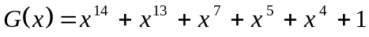.
The following steps should be used in the calculation of the cyclic redundancy check:
1) translation of the data, including the Message Type field to a polynomial following the convention defined in Table 6-2. The resulting polynomial will not contain higher orders of x than x⁵⁵,
2) multiplication of the polynomial obtained in step 1 with x¹⁴,
3) division of the polynomial obtained in step 2 by the generator polynomial,
4) translation of the remainder of the division in step 3 to a binary representation is the CRC.
Table 6-2. Relation between binary representation and
polynomial representation
Position | Bit number | Multiply with
LSB | I₁ | x⁰
 | I ₂ | x¹
 | … | …
 | … | …
MSB | I_{n} | x^{n-1}

    - Reed-Solomon Algorithm

The systematic Reed-Solomon (30,10) 2⁷-ary code should be applied to all messages. All messages should consist of 30 symbols, each symbol representing a 7-bit element. Of these symbols, 10 should be data and 20 should be Reed-Solomon parity.

6.1.4.1 Forward Error Primitive Polynomial

The symbols should be elements of the Galois field GF(128), constructed using the primitive polynomial:
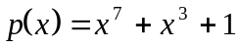.
The relationship between GF(128) elements and binary data should be to consider the value of the power of alpha as a 7-bit binary value converted to decimal. The symbol ‘0’ should correspond to a 7-bit value of 127.
6.1.4.2 Generator Polynomial

The FEC parity should be defined by the following generator polynomial:
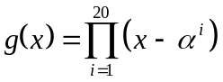.
The relation between a symbol representation and a polynomial is given in Table 6-3.
Table 6-3. Relation between symbol representation and
polynomial representation
Position | Symbol number | Multiply with
Least significant symbol | S₁ | x⁰
 | S₂ | x¹
 | … | …
 | … | …
Most significant symbol | S_{n} | x^{n-1}

The following steps should be used in the message encoding process:
1) translation of the binary data to a symbol representation, using the primitive polynomial,
2) translation of the symbol representation obtained in step 1 to a polynomial,
3) multiplication of the polynomial obtained in step 2 with x²⁰,
4) division of the polynomial obtained in step 3 by the generator polynomial,
5) summation of the polynomial obtained in step 3 with the remainder of the division in step 4,
- translation of the polynomial obtained in step 5 to a symbol or binary representation.

6.1.4.3 Order of Transmission

The first transmitted pattern of an FEC-encoded message should correspond to the least significant symbol of that message.

6.1.4.4 Continuity of Modulation

Messages should be transmitted consecutively without interleaving. The pattern transmitted in the first pulse group after the last pattern of a message shall be the first pattern of the next message.

    - Data Rate and Message Rate

The data rate of the Loran-Comm transmissions is dependent on the Loran-C pulse group rate. The pulse group rate is specified by its reciprocal, the Loran-C “Group Repetition Interval” (GRI). GRI is stated in terms of the tens of microseconds between the start of consecutive intervals and ranges from 4,000 to 10,000, which equates to 0.04 to 0.1 seconds. Thirty GRI are required to transmit a complete conventional Message Type 9-1, 56-bit message, or 1.2 to 3.0 seconds. The data rate will then be between 46.7 and 18.7 data bits per second. The baud rate, which includes the overhead bits, is 175 to 70 baud.

The consideration of a conventional Message Type 9-3 message was rejected by the design team because the condensed message content leaves little gain in the data rate, while it nearly trebles the age of the data received. Also, the longer message would delay the opportunity to transmit integrity data when the state of the satellite constellation changes.

6.2 Relation to the conventional dgnsS Standard

Loran-Comm messages are intended to provide for a subset of conventional messages and also provide unique functionality. The differential correction messages are formatted to provide data equivalent to that provided in the conventional Message Types 9-1 (GPS) and 34-1 (GLONASS) messages. A Loran-Comm message type is reserved for Galileo differential corrections. Satellite health messages are supported, equivalent to conventional Message Types 5 and 33, but not all data fields are currently supported. Up to four satellite constellation types may be identified, assuring health messages for Galileo as well.

The conventional Message Type 14, GPS time (week, second) is supported. The Loran-Comm time reference message may also be linked to the Loran-C or Chayka clock. This permits determination of the satellite system clock time to within nanoseconds, using only the Loran-Comm message.

The conventional Message Type 16 special message (text message) is also supported. The message format will support either eight 6-bit bytes or six 8-bit bytes per message. This will allow use of either 6 bit ASCII or eight bits for Cyrillic alphabet text or compressed decimal data.

A message type with no equivalent in the DGNSS standard is Type 6, the Loran-C Baseline Extension Time Difference message.

6.3 General LORAN-COMM Message Format

Paragraph 4.2 calls for a two-word header for every message for conventional DGNSS messages. This requirement is removed in the Loran-Comm messages for conservation of bits and because the nature of this data link eliminates some data requirements, such as variable message lengths and asynchronous messaging. The Message Type and Modified Z-Count information of the header is moved to within the differential data message, and station health information is in the UDRE bits.

The conventional DGNSS format calls for six parity bits for each message word. Loran-Comm uses a single 14-bit cyclic redundancy code (CRC) for each message. The CRC is used as an integrity check for the message. If the CRC does not validate the message, it is rejected in its entirety. This, combined with the Reed-Solomon error correction, provides a very high probability of detection of the correct message and a very low probability of validation of an erroneous message.

Table 6-4 summarizes the information contained in each message type. Note that only four message types are firm at this time. There are three tentative types, not fully defined, and nine message types are undefined. The following paragraphs explain the design of each message type. Figure 6-3 shows how Loran-Comm data are to be reformatted into conventional messages.

Table 6-4. Translation of Loran-C-Based UDRE to Conventional DGNSS Bits

Loran-Comm UDRE | Reference Station Health Status Indicator,  Word 2, Bits 22 - 24 | Ch. 4 UDRE  Word 4, Bits 18 & 19
00 | 000 | 00
01 | 000 | 01
10 | 000 | 10
11 | 110 | 11

6.3.1 Type 1, Differential GPS data (Permanent)

The message type is coded as binary “0001”. The data in this message type has a one-to-one correspondence with the same data items defined for the conventional Message Type 9. However, data on the pseudorange and pseudorange rate corrections for only a single satellite are contained in the Loran-Comm message. The most significant bit of the pseudorange data is not transmitted, as compared to the conventional Message Types 1, 2 and 31. This is satisfactory as determined by the observation that the PRC does not utilize this bit in normal operation with Selective Availability (SA) on. Therefore, with SA off, the bit (and probably several lesser bits) will not be required to transmit the PRC, even when using the high precision range. In the reconstituted standard message, the bit will be set to zero and inserted in the data by the Loran-Comm receiver.

The UDRE, UDRE scale and Reference Station health bit meanings are changed to best utilize the available bits and yet remain consistent with the Chapter 4 definitions. The information in the three data bits of the second word of the conventional DGNSS message header is limited as permitted in paragraph 4.2.1. The UDRE bits in this message type will only indicate the states shown in Table 3-1, below. The “Reference Station Not Working” state is indicated by the “System Health Message”, Type 3. The satellite “do-not-use” form of the PRC (PRC = 100000000000000) remains as a single satellite health message.

6.3.2 Type 2, Differential GLONASS data (Tentative)

The message type is coded as binary “0010”. The data in this message type has a one-to-one correspondence with the same data items defined for the conventional Message Type 34, and as noted above will utilize one less bit for in the PRC data. Data on the pseudorange and pseudorange rate corrections for only a single satellite are contained in the Loran-Comm message.

6.3.3 Type 3, Health Data (Tentative)

The message type is coded as binary “0011”. The data in this message are unique to Loran-Comm. The message reports the health of one of up to four constellations of navigation satellites, health of the stations in the Loran-C chain from which the message is received, and the health of the reference station at the station from which the message is received.

The health of each satellite, in a constellation of up to 32 satellites, is reported as a single bit, where “0” indicates “use” and “1” indicates “don’t use”. The health of any one of up to four constellations is reported using the two Constellation ID bits (00=GPS; 01=Glonass; 10=Galileo; 11=undefined).

The health of the Loran-C chain is reported using two bits per station and up to six stations in a chain. The 12 bits are assigned sequentially in pairs to the Master station and then the Victor, Whiskey, X-ray, Yankee and Zulu secondary stations. If a particular secondary designation is not used in a chain, the bits are set to 11.

Table 6-5. Meaning of Loran-C Station Health Bits

Bit Pattern | Meaning
00 | Station Operating Normally
01 | Timing Control by Bravo Monitor
10 | Timing Control by Local Monitor
11 | Timing Out-of-Tolerance, Blink, or Not Used

    - Type 4, Time Reference Message (Permanent)

The time relationship of the Loran-C chain time reference (CTR) to UTC is defined in the Loran-C system specification. The chain time reference occurs every other pulse group or “Phase Code Interval” (PCI) and is the reference point of the first pulse of the “A” interval of the master station antenna current. The specific CTR associated with the Time Reference Message is the CTR next occurring after the last pulse group associated with the message. See Figures 6-1 and 6-2 showing this relationship. The specific CTR offset from the UTC second is calculated as defined in Appendix G, “Loran-C UTC Synchronization”.
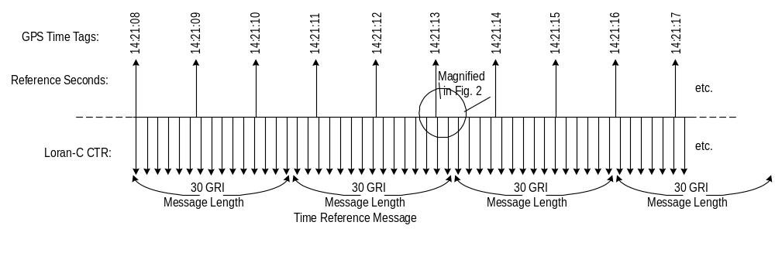

Figure 6-1. Typical Alignment of Reference Seconds and the Loran-C CounteR. GRI = 8970 in the Example

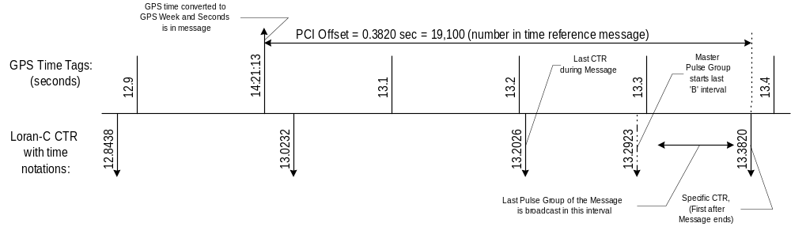
Figure 6-2. Enlarged Time Interval around the end of a Time Reference Message

    - Type 5, Text Message (Permanent)

The message type is coded as binary “0101”. There may be up to four text messages in a text sequence. Two bits are allocated to the sequence number. Additionally, one bit is allocated to indicating the last message in the sequence, to assure that the receiver is aware of sequences of text messages of less than four. Up to eight ASCII characters of six bits each are accommodated in each text message. Alternatively, six 8 bit Cyrillic characters or binary data bytes may be accommodated. The format bit is set to zero for ASCII or to one for eight bit Cyrillic.

    - Type 6, Loran-C Baseline Extension Time Difference (Tentative)

The tentative message type is coded as binary “0110”. This message is provided as a means to permit users to improve Loran-C coordinate conversion and time of arrival routines by transmitting baseline extension time differences (TD-BLE). These values will enable the user receiver to calculate precision secondary station timing offsets and mean baseline propagation velocities. These parameters can then be used to improve Loran-C geographic position accuracy. The TD-BLE between stations in different chains can also be used to resolve time reference differences between chains.

TD-BLE’s are transmitted with a resolution of one nanosecond and a maximum range of ±8 microseconds. Fourteen bits is utilized for each BLE-TD. The specific Baseline is identified by a three-bit ID code, which identifies the remote station for the BLE-TD.

    - Type 7 Message, Reserved

    - Type 8 Message, Reserved

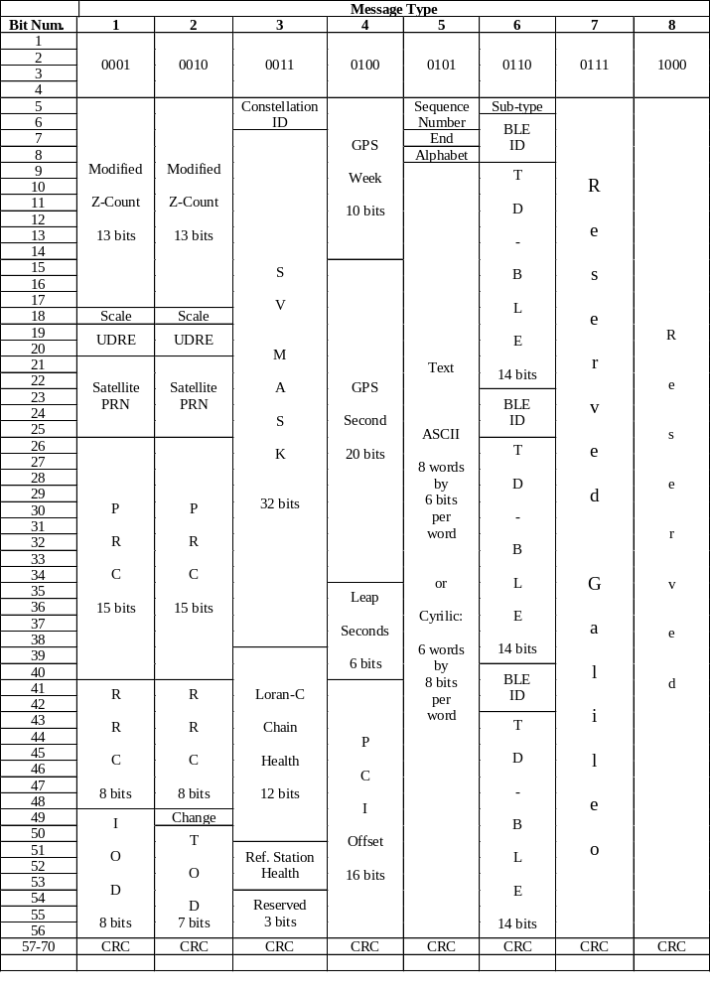

Figure 6-3. Message Bit Assignment Table

APPENDIX A

DATA QUALITY INDICATOR FOR CARRIER PHASE MEASUREMENTS

A.1 INTRODUCTION

This appendix provides background information for the Data Quality Indicator for the Carrier Phase Measurements. It includes the definition of the Reference Station receiver measurements used for the indicator, plus the conversion of those measurements to the 3-bit indicator for the messages. The definition is a suggestion. The measurements of data quality may be made using any method desired, as long as the net result provides the indication of quality specified in the message definition.

The definition described in this appendix only includes the effect of receiver tracking errors with respect to the observed phase of the composite received signal, which may include multipath signals and phase errors due to antenna phase variations, etc. Knowledge of those errors may indeed be included in the data quality indicator in a root-sum-squared sense, depending upon reference station design. If corrections of those errors are made, the data quality indicator should only include an indication of the "residual" error after correction.

A.2 REFERENCE STATION RECEIVER MEASUREMENTS

The measurements defined here are those which are sometimes used to determine phase lock status of a phase-lock-loop (PLL). They are not the phase lock indicator itself, but are the signed magnitude of the measurements used for lock indication, which is usually a hard decision based on the comparison of the signed magnitude against a predetermined threshold. This measurement is a good indication of carrier phase tracking quality, if computed correctly. It is important to note, however, that this measurement does not include computational or systematic errors introduced in the "single difference" or "double difference" computations.

The lock indicator normally used for the so-called Costas PLL involves the computation of I² - Q² using the in-phase (I) and quadriphase (Q) components of the signal. In steady state, these component quantities would be integrated (or summed) over a 20 millisecond bit period for GPS, 10 msec for GLONASS, while the lock indicator value would be averaged over a period of a half second or so. This value is proportional to the cosine of twice the carrier phase error, and also proportional to the signal-to-noise ratio in a 50 Hz bandwidth for GPS, or a 100 Hz bandwidth for GLONASS. The problem is that it is "proportional", where the scale factor is only as known by the receiver designer and a computed signal-to-noise ratio. However, this problem can be overcome by using a "normalized" indicator of the form

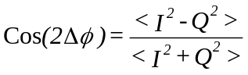 (Eq. A-1)
using an average value. This value is proportional to the cosine of twice the phase tracking error Δφ, but it can be mapped appropriately into a data quality indicator directly proportional to phase error in cycles as

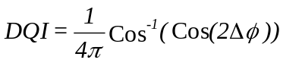 (Eq. A-2)

quantized appropriately into the 3 bits allotted for the quality indicator.

The expected value of the quantity in Equation A-1 is plotted in Figure A-1 for GPS for an averaging time of 1 second. Its one sigma value is plotted in Figure A-2 for GPS. They are both plotted against the carrier phase tracking error, assumed to be constant over that interval (such as a loop hang-off). They are also plotted for a range of carrier-to-noise density 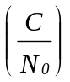values between 26 and 50 dB-Hz. The expected value is compared against the cosine of twice the phase error, a value that would be achieved at infinite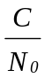.

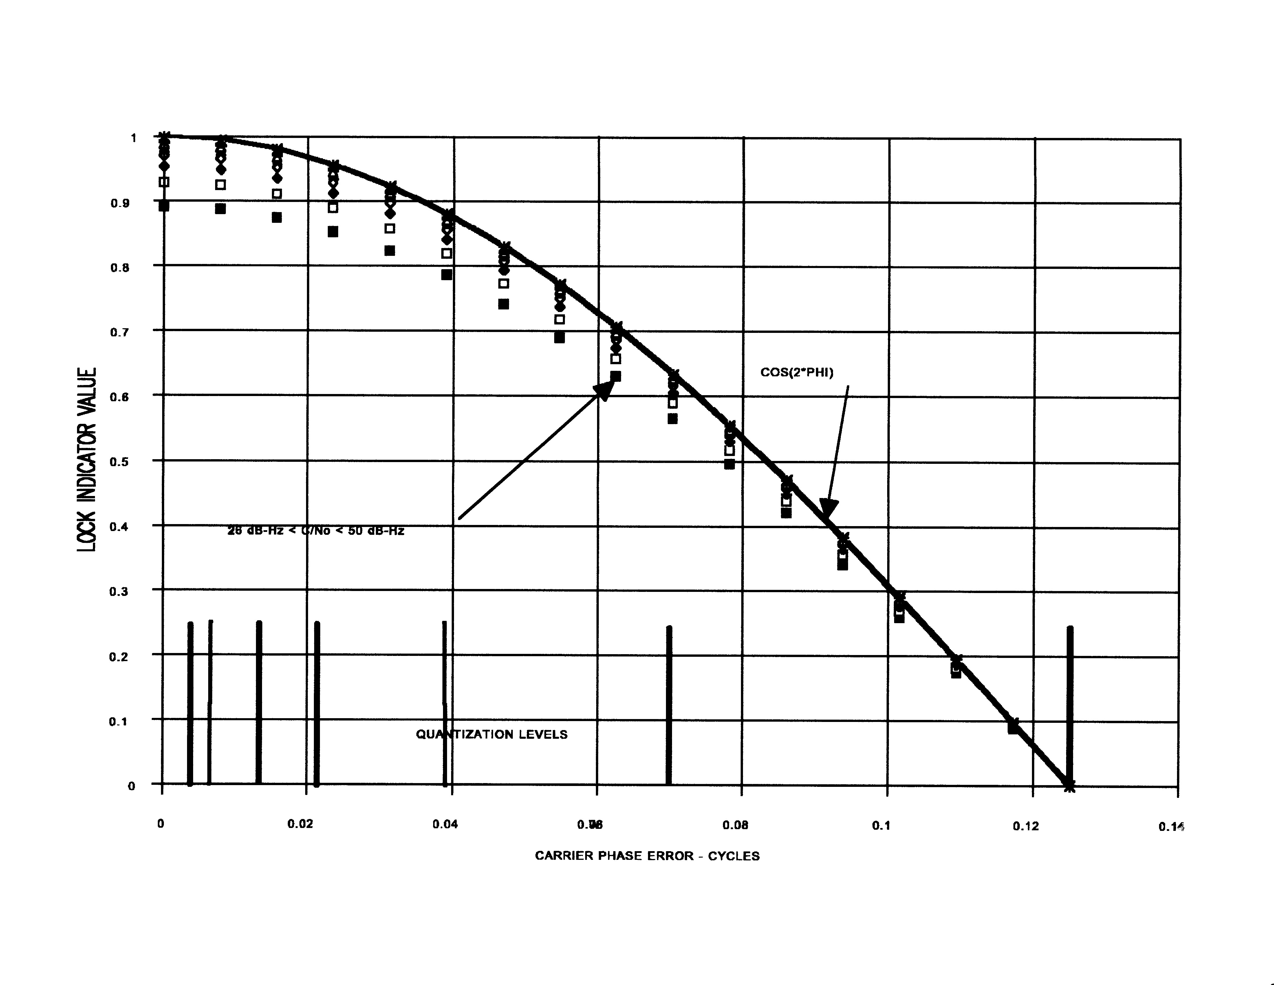
Figure A-1. EXPECTED VALUE OF PHASE LOCK DETECTOR

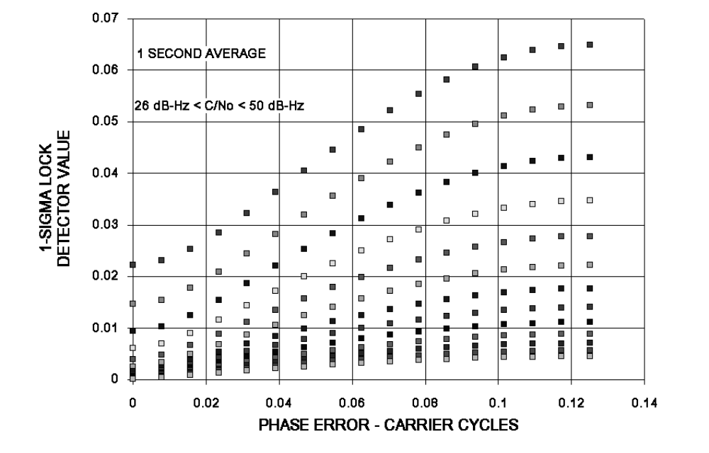
Figure A-2. PHASE LOCK DETECTOR 1-SIGMA VALUES

The question is, "What are the characteristics of the Data Quality Indicator given in Equation A-2?". Does it really reflect the phase error of the tracking loop? It certainly will indicate the "mean" phase error, but what about the one-sigma error due to thermal noise (or oscillator phase noise)? To evaluate that, the values plotted in Figure A-1 plus three times the values plotted in Figure A-2 were entered into Equation A-2 for the zero mean phase error conditions. Adding the three sigma value decreases the value of the data quality indicator because it increased the value of the cosine function. Thus, it indicates a minimum phase error. This evaluation is compared to the one-sigma PLL tracking error due to noise given as

where B_{L} is the loop bandwidth and T is 20 milliseconds for GPS or 10 milliseconds fo GLONASS. This quantity is plotted against the Data Quality Indicator for a 5 Hz bandwidth in Figure A-3 for a GPS receiver. Note that the minimum Data Quality Indicator always exceeds the one-sigma loop noise for all signal-to-noise densities. This is because of the noise suppression of the phase lock detector, which reduces its value. That noise suppression works in our favor.
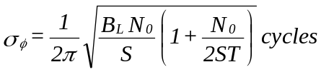

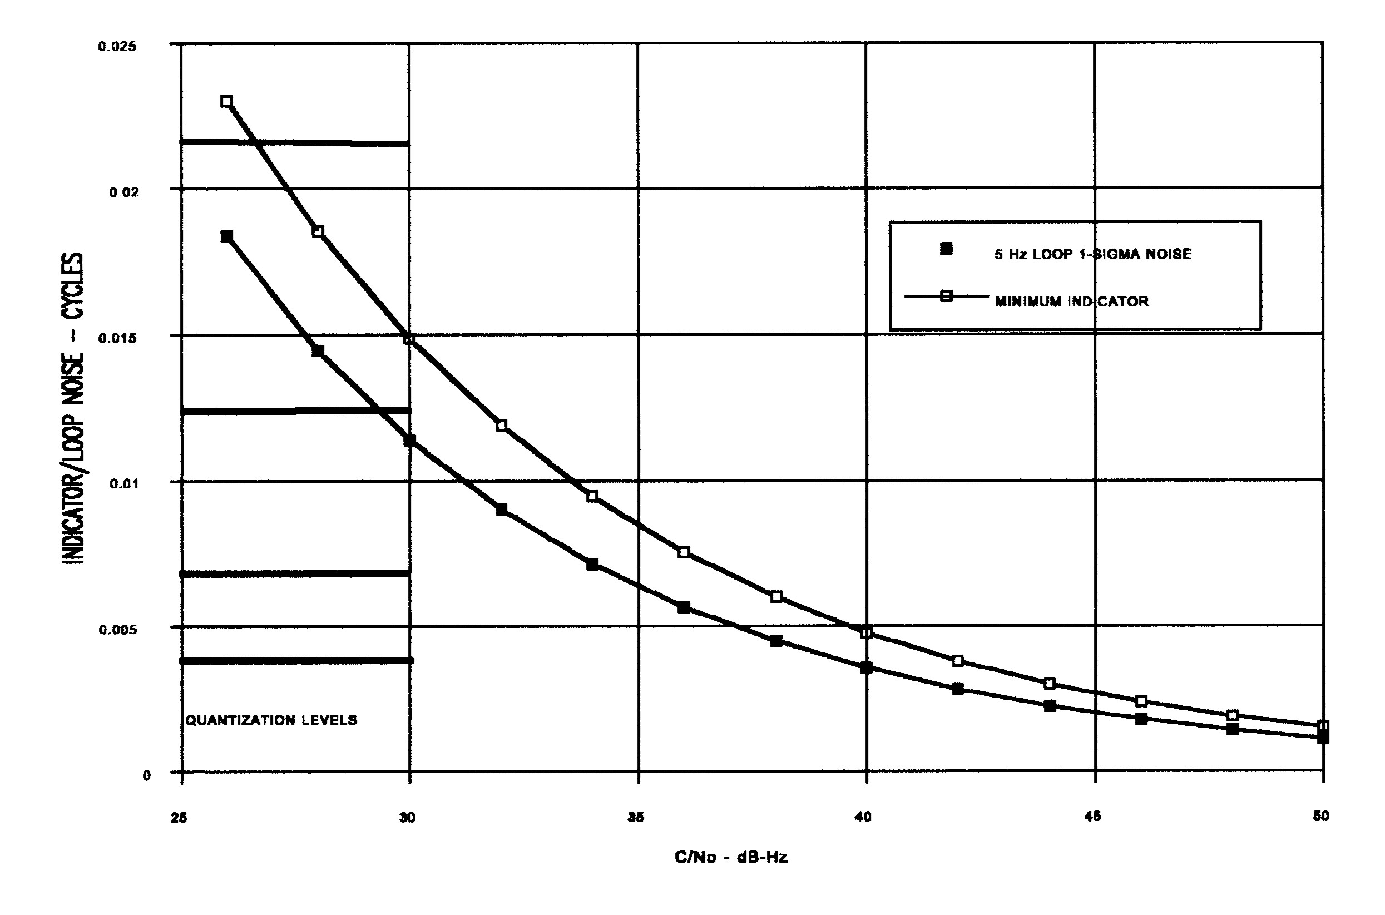
Figure A-3. DATA QUALITY INDICATOR PERFORMANCE FOR ZERO MEAN PHASE ERROR

A.3 DATA QUALITY INDICATOR QUANTIZATION

Figure A-3 also shows how the Data Quality Indicator should be quantized in to the 3-bit field. It is obvious that a linear quantization is not desirable because there would not be enough resolution to handle the smaller errors. A graduated scale for the quantization levels that are also indicated on Figures A-1 and A-3 is more desirable. Table A-1 is an interpretation of that exponential scale, which satisfies the equation

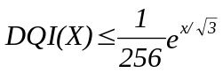 (Eq. A-3)
where X is the decimal equivalent of the 3-bit indication.

Table A-1. DATA QUALITY INDICATOR QUANTIZATION

Bit Indication (X) | Phase Error Interpretation
000 (0) | ≤ 0.00391 cycle
001 (1) | ≤ 0.00696 cycle
010 (2) | ≤ 0.01239 cycle
011 (3) | ≤ 0.02208 cycle
100 (4) | ≤ 0.03933 cycle
101 (5) | ≤ 0.07006 cycle
110 (6) | ≤ 0.12480 cycle
111 (7) | > 0.12480 cycle or CosΔφ < 0

This page intentionally left blank

APPENDIX B

DATA QUALITY AND MULTIPATH ERROR INDICATORS FOR
PSEUDORANGE MEASUREMENT MESSAGES

B.1 INTRODUCTION

This appendix provides background information for the Data Quality and Multipath Error Indicators for the Pseudorange Measurement Messages. It includes suggestions for the Reference Station receiver measurements used for those indicators, plus the conversion of those measurements to the 4-bit indicators for the messages. The measurements of data quality and multipath error may be made using any method desired, as long as the net result provides the indication of quality and multipath error specified in the message definitions.

B.2 DATA QUALITY INDICATOR

A suggested Pseudorange Data Quality Indicator is based on a short-term estimate of the one-sigma pseudorange error due to ambient noise, where, for a simultaneous early power minus late power discriminator,

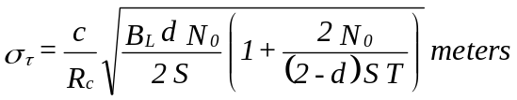 (Eq. B-1)
where

c = 3 x 10⁸ meters/second
R_{c} = the P or C/A code chipping rate in chips/second
S/N₀ = an estimated signal-to-noise density in ratio-Hz
T = 0.02 seconds for GPS, 0.01 seconds for GLONASS
d = early/late correlator spacing in chips
B_{L} = the equivalent single-sided noise bandwidth of the pseudorange smoothing process in chips

For a dot product discriminator,

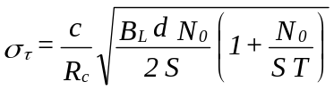 (Eq. B-2)
B_{L} is not necessarily the delay lock loop bandwidth. For example, if post measurement smoothing of the pseudorange against the carrier phase is performed, then

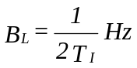 (Eq. B-3)
where T_{I} is the smoothing interval in seconds.

This Data Quality Indicator does not include time-correlated errors such as multipath and changes in the ionosphere, nor does it include quantization errors. If pseudorange quantization is significant, its effect should be root-sum-squared (RSS'd) with the quantity defined in Equation B-1. This can indeed be the case if the larger scale factor is used in conjunction with accurate pseudoranges in the Pseudorange Correction Message. Note that the only measured quantity that affects this indicator is the estimated signal-to-noise density.

Since the four bits allocated to the Data Quality Indicator are not enough to cover an entire range of implementations and smoothing intervals, an exponential function is applied to the indicator, providing more granularity to the indicator for smaller errors. This function is indicated in the definition of the Pseudorange Correction Message, Type 21.

B.3 MULTIPATH ERROR INDICATOR

The pseudorange corrections in this message may or may not be corrected for multipath errors. That would be a function of the Reference Station design. The indicator is defined to be only a one-sigma estimate of the residual multipath error in the corrected pseudorange. As the Data Quality Indicator, the four bits allocated to the Multipath Error Indicator are not enough to cover an entire range of implementations and multipath correction schemes. Thus, an exponential function is also applied to the Multipath Error Indicator, providing granularity to the indicator for smaller errors. This function is indicated in the definition of the Pseudorange Correction Message.

It is not the purpose of this appendix to define any multipath correction schemes or Multipath Error Indicator estimation algorithms. However, two possibilities are given here. The first is to smooth the pseudorange measurements against the carrier phase over some extended time interval - say, two or three minutes, in order to average out the effect of the multipath. This time must be short enough so that the ionospheric delay divergence between the code and carrier does not dominate the multipath effects. The pseudorange corrections are then based on the carrier phase itself, corrected with the newly smoothed pseudorange. If this multipath correction is not applied, the longer term (smoothed) residuals of the correction process will provide an indication of the multipath error. In either case, longer term means that the effect of ambient noise is basically removed by smoothing, but the effects of multipath (or multipath correction error) are not.

A second possible correction scheme is to use a post processed estimation of the multipath error from previous days to correct the current day errors, adjusted in time by three minutes and 56 seconds. The assumption here is that the object of multipath reflection is the same each day for the same geometry. However, depending upon circumstances, the reflection coefficient may change from day-to-day, or the reflecting object may have moved. The "best" approach in this case is to move the antenna or the object so that the multipath doesn't occur. If this type of correction scheme is used, the estimation of the residual error could be performed as described above for the smoothing process.

APPENDIX C

GPS SATELLITE POSITION COMPUTATION TEST FILES

C.1 INTRODUCTION

Whenever carrier phase or pseudorange corrections are broadcast from a Differential GPS Reference Station, that station computes the GPS satellite positions corresponding to the integrated carrier beginning and end times and the pseudorange measurement times in deriving those corrections. Thus, the accuracy of those computations directly affect the accuracy of the broadcast corrections. If the identical computations are performed at the remote user locations, any errors in those computations, if realistically small, will cancel in the differential positioning. This would be the case where the same software was used at the Reference Station and the remote user. However, if a different receiver manufacture produces the remote user equipment than that of the Reference Station, errors in general will not cancel. Thus, a standard for those computations is required. This appendix, along with a diskette containing test files, provides a mechanism for establishing that standard. Appendix C applies to GPS satellites only.

C.2 TEST CASE GENERATION

The satellite position computations convert the orbital and clock parameters received from the GPS satellites in Subframes 1, 2 and 3 of the GPS Navigation message to the Earth-Centered-Earth-Fixed (ECEF) XYZ coordinates of the subject satellite versus time. The clock parameters are converted to the clock offset Δt of the subject satellite, which also includes the general relativity correction that is based on the orbital parameters. The parameters received from the satellite are in the form of packed binary integers. The test cases developed for this standard converts these integer variables in decimal form first to floating point variables, and then to the XYZ and Δt versus time. They do not convert the packed binary integers to decimal form.

The generation of the test cases implemented the equations provided in ICD-GPS-200B without the use of any short cut approximations, except that Kepler's Equation

E_{k} = e sinE_{k} + M_{k} (Eq. C-1)

was solved iteratively for E_{k} at time t_{k} to an accuracy of 1 x 10⁻¹² radians.

C.2.1 Earth's Rotation Correction

Two sets of test cases were generated. The first set made a correction to the XYZ coordinates for the earth's rotation of the ECEF coordinate frame for a fixed signal transit time, while the second set did not. This is because there are two methods to account for this rotation. In one method, the satellites position at time of signal transmission is rotated to the user's coordinate frame at time of signal reception, while in the other method, a correction to the measured pseudorange is made to account for the coordinate frame rotation. In the first method, the longitude of the satellite is adjusted with the amount in radians

ΔΩ_{k} = - dΩ_{e}/dt * R/c (Eq. C-2)

where, dΩ_{e}/dt is the earth's rotation rate, R is the estimated range to the satellite and c is the speed of light. In the generated test cases, R is set to a constant of 24,000,000 meters. The effect of this correction is an adjustment in the east-west direction of a few meters in the satellites position, thus changing both the X and Y coordinates, but not the Z coordinate. Although a constant range is not realistic, it is appropriate for the test case since it can be set at this maximum value, and thus, not sensitive to a user's location.

In the second method, the correction is made to the pseudorange measurement, which is given as

ΔR = 1/c * dΩ_{e}/dt * (X_{s}Y_{u} - Y_{s}X_{u}) (Eq. C-3)

where X_{s} and Y_{s} are the coordinates of the satellite in the ECEF coordinate frame at the time of transmission, and X_{u} and Y_{u} are the estimated coordinates of the user in the ECEF coordinate frame at the time of reception. In this case, no earth's rotation correction is made to the satellite's coordinates, which is the same as making a correction with an estimated range of 0. In fact, this is the method used for that test case, and the quantity of Equation C.3 was not computed.

C.2.2 Test Case Details

The inputs to the test cases (six total for each earth rotation correction method) are the satellite's PRN number, the range used for the earth rotation correction and the integer clock and ephemeris parameters unpacked from GPS Navigation Message Subframes 1, 2 and 3 for six different satellite PRN numbers. These inputs were collected from live Block II satellites. The outputs of the test cases are the floating point versions of the integer parameters, some derived floating point parameters (in seconds, meters, radians and radians per second) and the XYZ ECEF coordinates (in meters) and(in seconds) evaluated at 10 minute intervals over the four hours of applicability of the parameters. A representative output is given in Table C.I for one satellite PRN number.

These test cases were evaluated against an independent source and were found to agree to within 0.2 to 0.3 millimeters.

prn range | 14 | 24000000
integer clock and ephemeris parameters
toc af0 af1 af2 | 31500 | 393441 | 3 | 0
crs deltan m0 cuc | 36 | 11925 | -607851560 | -60
e cus sqra toe | 39103504 | 6381 | -1593052047 | 31500
cic omega0 cis i0 | -1 | 504805826 | -58 | 656731450
omgdot idot omga crc | -22026 | 357 | 1972752536 | 4738
floating point clock and ephemeris parameters
toc af0 af1 af2 | 504000 | 1.832102425396e-04 | 3.410605100000e-13 | 0.000000000000
toe sqra deln m0 | 504000 | 5.153494356155e+03 | 4.259106000000e-09 | -8.892370366347e-01
e omega cus cuc | 4.552247002721e-03 | 2.885975350835e+00 | 1.188553900000e-05 | -1.117587100000e-07
crc crs cic cis | 1.480625000000e+02 | 1.125000000000e+00 | -1.862645100000e-09 | -1.080334200000e-07
i0 idot omg0 omgdot | 9.607443114283e-01 | 1.275053100000e-10 | 7.384895693748e-01 | -7.866756253000e-09
a n0 n | 2.655850407893e+07 | 1.458691678037e-04 | 1.458734269097e-04
t | x | y | z | deltatsv
496800 | -1.925132225385e+07 | 5.287213520833e+06 | 1.758197241879e+07 | 1.832174931499e-04
497400 | -1.852325341598e+07 | 4.111140955354e+06 | 1.863191927798e+07 | 1.832179922371e-04
498000 | -1.779609748114e+07 | 2.847861255577e+06 | 1.953977263714e+07 | 1.832184150563e-04
498600 | -1.708115246527e+07 | 1.505145628662e+06 | 2.029843978735e+07 | 1.832187598536e-04
499200 | -1.638891257552e+07 | 9.219638541095e+04 | 2.090194872206e+07 | 1.832190254656e-04
499800 | -1.572888937811e+07 | -1.380481227134e+06 | 2.134549869009e+07 | 1.832192113317e-04
500400 | -1.510945030926e+07 | -2.901230212362e+06 | 2.162550232157e+07 | 1.832193175004e-04
501000 | -1.453767741057e+07 | -4.457413637737e+06 | 2.173961885040e+07 | 1.832193446327e-04
Table C-1 - Format of Test Files

This page intentionally left blank

APPENDIX D

DATUM SELECTION FOR DIFFERENTIAL GPS REFERENCE STATIONS

This section discusses factors in the decision making process regarding the selection of datum for DGPS operations. While the discussion will focus on the use of local datums versus WGS 84, the datum used in GPS, the applications to GLONASS are evident. GPS operates in an Earth Centered Earth Fixed (ECEF) reference frame. This reference frame is described by the WGS 84 ellipsoid model of the earth. WGS 84 differs from traditional geoid-based geodetic datums in that it is global in scope and does not have an absolute reference point on the earth. To effectively use the relative accuracy of DGPS for many applications it needs to be related to the local datum. Traditional geodetic datums or "local" datums have a central reference point on which the rest of the datum is based. Many of these local datums were developed for the creation of nautical charts. In the past, traditional surveying methods have caused inconsistencies to build up in these datums until significant biases developed. The provider of a DGPS service is presented with a decision, whether to locate reference stations in WGS 84 or the local datum. If users of the service are using nautical charts based on the local datum there are two alternatives: 1) locate the DGPS reference station in WGS 84 and utilize algorithms in the DGPS user equipment to transform the coordinates from WGS 84 to the local datum, or 2) locate the DGPS reference station in the coordinates of the local datum, thereby using the DGPS corrections themselves to offset the users to their local datum. In general, Method 1 is preferred, but there are cases where Method 2 can be used with minimal disadvantages. Each method has its benefits and potential problems. The severity of the problems compared to the benefits in each case would serve to guide the service provider to the best decision.

For this discussion the situation in North America will be used as an example. The North American Datum of 1927 (NAD 27) has as its absolute reference point a monument in Meads Ranch, Kansas. During early GPS and DGPS work in New England, biases in NAD 27 relative to WGS 84 were observed to be on the order of 30 Meters. These biases had not been significant for local use of NAD 27, as the datum was internally consistent over the local area. It is important to remember that this type of datum is defined by the actual geodetic markers placed on the ground. When one asks how much error a particular marker has, the answer is none, by definition it is where it says it is. Another issue with traditional local datums is that they are horizontal control networks. Vertical coordinates or elevation were often described by a separate vertical control datum. Setting the DGPS reference stations to WGS 84 coordinates (method 1) was first considered as the method of choice for this early DGPS testing. It was soon discovered that the available algorithms to convert WGS 84 to NAD 27 exhibited errors on the order of 10 meters! This error became obvious because of the accuracy of the DGPS. At this point method 2 was pursued and the DGPS reference station NAD 27 horizontal and mean sea level (MSL) vertical coordinates were entered. When this was done the DGPS corrections themselves automatically adjusted the users position into the local NAD 27/MSL datum. The DGPS receiver was set to output WGS 84 positions since further adjustment was not necessary and would have introduced error. It was later discovered that the offset between NAD 27/MSL and WGS 84 varied by several meters over the broadcast area of a marine radio beacon. Since the fixed offset induced at the reference station by entering NAD 27/MSL coordinates would not correct for this variation, the users would see significant datum induced error as they moved away from the beacon. This situation would be less than desirable for a broadcast service intending to serve many users over a large area.

When considering the use of a local datum for DGPS, the effect of user and reference station line of sight to satellite differences must also be considered. In a typical GPS reference station, the reference station transforms the geodetic position into Earth Centered Earth Fixed (ECEF) coordinates using the WGS 84 parameters. The DGPS correction algorithms use the ECEF position. If the position entered into the reference station is in WGS 84 coordinates, theoretically the ECEF position calculated will be in WGS 84. User equipment applying corrections will then calculate a position fix in WGS 84.

However, If the reference station position input is changed to an alternate datum, the user equipment position shifts. Since the transformation within the reference station uses the WGS 84 parameters, the resulting ECEF position is translated from the WGS 84 position. The direction and magnitude of the translation will depend on the datum used and the location of the reference station on the earth. In the case of NAD 83, which replaced NAD 27 and was designed to be aligned with WGS 84 as much as possible, translations may be less than one meter, mostly in altitude. In the case of other local datums around the world, translations can be 200 meters or more, with a majority of the translation in the horizontal directions.

When a reference station is translated, the component of the translation perpendicular to the line of sight vector to a satellite will not be incorporated into the correction for that satellite. Upon receiving the correction, the user equipment applies the correction to its line of sight vector to the same satellite. Because the reference station and the user equipment are not coincident, their line of sight vectors are not equal. Therefore, the translation at the user equipment will not be the same as at the reference station. The magnitude of the position error caused by the line of sight differences will be dependent on the reference station position, the local datum selected (i.e. the datum difference at the reference station) and the user equipment distance from the reference station. Figure D-1 shows the expected User Horizontal Position 2drms errors versus Datum Difference at the Reference Station, in meters, and User Distance from the Reference Station, in kilometers, due to the line of sight differences. The data plotted was gathered from 56,000 Monte Carlo simulations for a reference station at sea level randomly placed over the entire earth. The user equipment was placed at a random azimuth at a given distance from the reference station. The user equipment antenna was assumed to be at sea level. A three dimensional solution was computed at the user equipment using the differential corrections from the reference station. It was assumed that there were no receiver errors at either the reference station or the user equipment. The error in computer latitude and longitude was then used to compute the Horizontal Error.
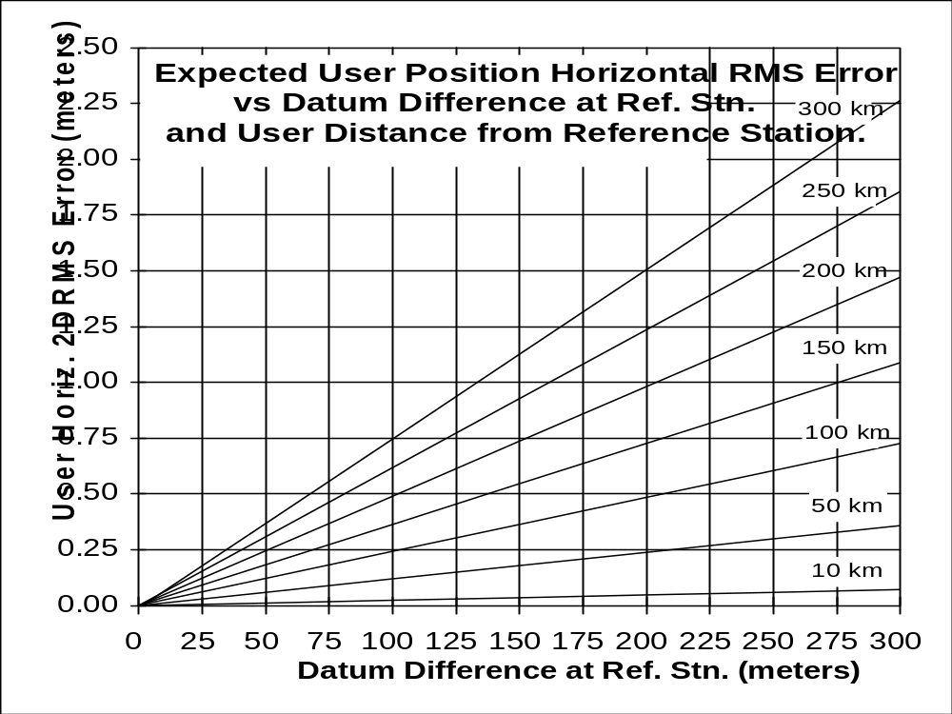

Figure D-1. EXPECTED USER POSITION 2DRMS ERRORS DUE TO REFERENCE RECEIVER TRANSLATION LINE OF SIGHT ERRORS

To summarize the alternatives for positioning a DGPS reference station:

1. Input reference station coordinates in WGS-84:
Advantages:
a. DGPS corrections only represent the observed errors in GPS.
b. DGPS user equipment contains algorithms to convert this to a variety of datums.
Disadvantages:
a. Uncertainties in absolute positioning in WGS 84 (0.75-1.0 meter 1σ), for example, those caused by continental drift.
b. Potential error in algorithms for converting from WGS 84 to local datums. Note that Message Type 4 can be used as an integrity check on the algorithms.

2. Input reference station coordinates in local datum:
Advantages:
a. Users are automatically referenced to the local datum with no further adjustments necessary (assuming mobile user equipment is set to output WGS 84), even in the presence of continental drift.

Disadvantages:
a. The local offset that adjusted the reference station may only be applicable to a limited area with respect to the applicability of the DGPS corrections.
b. Local offset not fully incorporated by user due to line of sight to satellite difference between user and reference station.
c. The mobile user may have difficulty knowing which datum should be used.

DGPS DATUM SELECTION IN THE UNITED STATES

One solution is to develop an earth-referenced local datum that does not exhibit the problems typically found with most traditional local datums. Fortunately, in the United States, the National Geodetic Survey (NGS), part of the National Oceanographic and Atmospheric Administration has developed a 3 dimensional datum, North American Datum of 1983 (NAD 83), that bridges the gap between space based mathematical models (WGS 84) and earth referenced datums suitable for local short baseline surveys. NAD-83 uses the Geodetic Reference System of 1980 (GRS 80) ellipsoid to model the earth. The GRS 80 is virtually identical to the WGS 84 ellipsoid. The flattening coefficient is slightly different, but this only creates millimeter differences in coordinates. Rather than remaining as a mathematical model of the earth with uncertainty over actual absolute positions on the earth, NGS tied NAD 83 to the earth in an absolute sense. NAD-83 was created through a network adjustment of all previous survey data. It included all recorded data through NAD 27, conventional surveys since then, Doppler points, VLBI baselines, and GPS baselines. This included over 250,000 measurements. NAD-83 contains a vertical component that is also the reference for the North American geiod offset models, used for translating ellipsoid height to mean sea level. NAD-83 is the datum that all construction and cartography are based. The users' relationship to NAD-83 will be the most important consideration, not their relationship to WGS-84. In North America, DGPS reference stations are now being located in NAD 83. For DGPS user operations, the user equipment is set to compute in WGS 84. The reference station adjusts all the pseudoranges to yield NAD-83 positions at the user with no further adjustment. When the user drops out of DGPS (back to WGS 84) this technique will not cause a perceptible offset. NAD-83 and WGS 84 coordinate offsets range from 0 - 2 meters, well within the expected accuracy of GPS-SPS.

APPENDIX E

SOURCES OF DGNSS INFORMATION

There are many sources of information on GPS, GLONASS, and Galileo, and more are coming on-line every year. Rather than provide a list which would quickly become obsolete, three primary sources of information are provided, one each on GPS, GLONASS, and Galileo.

E.1 GPS -- U.S. COAST GUARD NAVIGATION CENTER

The US Coast Guard Navigation Center provides information about GPS, Differential GPS, Nationwide DGPS, and LORAN-C. The information provided includes status and advisories for GPS, DGPS broadcast sites, reports from policy groups, and the standard operating procedure that the USCG used for installing GPS antennas at the broadcast sites. Also provided are documents such as the GPS/SPS Signal Specification developed by the Department of Defense for general distribution. This information is potentially helpful for organizations implementing services.

Mailing Address: US Coast Guard Navigation Center
NAVCEN MS 7310
7323 Telegraph Road
Alexandria, VA 20598-7310

Internet Home Page Address: http://www.navcen.uscg.gov

Voice recording: +1 (703) 313-5907

Voice: +1 (703) 313-5900

FAX: +1 (703) 313-5920 ????

E.2 GLONASS: Russian Space Agency's Information Analytical Centre

The Russian Space Agency's Information Analytical Centre provides information about GLONASS, as well as GPS and Galileo. The information provided includes status of the systems, GLONASS satellite visibility at prescribed locations, and related reports. Primarily intended for Russian-speaking CIS member-states, the service is also available in English to interested parties world-wide.

Mailing address: ??

Web Page Access (English): Information - Analytical Centre, Russian Space Agency
http://www.glonass-ianc.rsa.ru/pls/htmldb/f?p=202:1:13258549737136607007

E-Mail Address: glonass-ianc@mcc.rsa.ru

Voice: +7 (095) 926-28-83 ???

E.3 Galileo: European Space Agency Galileo Program

The European Space Agency's web page on Galileo provides information about the Galileo program, including technology developments, simulation facilities, and constellation. It is available in all the languages spoken in the European Union.

Web Page Access (English): ESA -- The Future -- Galileo
http://www.esa.int/esaNA/galileo.html

E-Mail Address: Navigation.Applications@esa.int

Voice: +33 1 5369 7155 (Paris, France)

This page intentionally left blank

APPENDIX F

8-BIT REPRESENTATION OF RUSSIAN ALPHABET

Type 36 messages provide for characters to be transmitted from a differential GLONASS reference station. To augment the ASCII standard, which is based on English alphabetic characters, the following table provides the standard to be employed when transmitting Cyrillic characters to provide Russian language messages. The code is in decimal. Codes from 0 to 127 correspond to standard ASCII codes.

Code Char. Code Char. Code Char. Code Char.

128 А 144 Р 160 а 176 р
129 Б 145 С 161 б 177 с
130 В 146 Т 162 в 178 т
131 Г 147 У 163 г 179 у
132 Д 148 Ф 164 д 180 ф
133 Е 149 Х 165 е 181 х
134 Ж 150 Ц 166 ж 182 ц
135 З 151 Ч 167 з 183 ч
136 И 152 Ш 168 и 184 ш
137 Й 153 Щ 169 й 185 щ
138 К 154 Ъ 170 к 186 ъ
139 Л 155 Ы 171 л 187 ы
140 М 156 Ь 172 м 188 ь
141 Н 157 Э 173 н 189 э
142 О 158 Ю 174 о 190 ю
143 П 159 Я 175 п 191 я

This page intentionally left blank

Appendix G

Loran-C UTC Synchronization

(Computation of Loran-C TOC and un-TOC Second Offsets)

G.1. Background and Definitions

In the use of Loran-C with precision timing applications and in navigation equipment which integrates Loran-C and the Global Positioning System (GPS), it is necessary know the time relationship of the signals of each system. Both systems are synchronized to UTC. GPS is synchronized to within 20 nsec and Loran-C soon will be within a few tens nanoseconds of UTC. The measurement and control of Loran-C synchronization to UTC, in the US, is not yet sufficient to permit Loran-C and GPS integration at the pseudorange level. In order to achieve and utilize Loran-C synchronization at this level, improved real-time control, as well as receivers, which utilize the unique Loran-C timing relationship to UTC, are needed. The Loran-C epoch is sub-synchronous with the UTC second (1PPS(UTC)), and so, the Loran-C epoch does not occur in the same relationship with every UTC one-second epoch, but will be coincident with the 1PPS(UTC) at regular intervals, called 'Times-of-Coincidence' (TOC). To predict the Loran-C relationship to 1PPS(UTC) at any second is a straightforward mathematical operation requiring an iterative process with variable processing times. While this may be acceptable in a multiprocessing computer environment, in a low-cost user equipment a more elegant and much less demanding process is required. The definition of TOC is clarified and methods for the computation of TOC and Loran-C un-TOC Second Offsets are proposed here. This information is intended to meet the design needs for low-cost user navigation equipment.

G.1.1 Synchronization

Synchronization is defined in terms of time offsets and rates. A statement that two clocks are synchronized implies that, at a specific time, the time offset and offset rate are known, whether or not an effort is made to reduce the time offset and offset rate to zero. That is, synchronization does not require that two clocks read exactly the same time, but rather that their relationship is known. For example, in the GPS each satellite has three clocks, each of which are allowed to run freely. It falls to the Ground Earth Segment of GPS to determine the time offset and offset rate of each of the clocks, and to ensure that accurate data on the operational clock is contained in the message from each satellite to the users. In this way, the satellite signals are synchronized. The mean time of all the clocks in the constellation constitutes the 'constellation clock', and the USNO publishes data on the synchronization of the constellation to the USNO master clock. In turn, the Bureau International Poids et Measures (BIPM) publishes data on the synchronization of all national master clocks to Coordinated Universal Time (UTC), albeit sixty days after the fact. It should be noted here that Loran-C synchronization is achieved by adjustment of the timing at transmitting stations, as there is no standard communications means to inform users of the real time offsets, and further, present-day user equipment is not designed to accommodate corrections for clock offset and rate.

G.1.2 Loran-C Timing

Loran-C pulses, as shown in Figure I-2, have a carrier frequency of 100 kHz and rise to a peak in about 65 µsec. The pulse time reference is the sixth zero crossing, which is used for real time control of the time of transmission. Pulses are transmitted in groups of eight pulses at a time, with the carrier phase shifted 1801 in selected pulses. The first pulse of the group always has 01 carrier phase. The pattern of the carrier phase shifts is called the 'phase code' and repeats in alternate pulse groups. The third positive-going zero crossing of the carrier of the first pulse of the 'A' interval of the phase code is the Loran-C pulse Group Time Reference (GTR). The pulse group time reference of the master station signal follows the chain time reference (CTR) by exactly 30.000 µsec.

Loran-C signals from various sets of stations (chains) are identified by their Group Repetition Intervals (GRI's). The GRI is a measure of the Loran-C clock time. Authorized GRI's are integers and range from 4000 to 9999. These numbers represent the time interval between pulse groups transmitted from each station of the chain. Specifically, GRI is the time interval between consecutive group time references from each station in the chain, expressed in 10's of microseconds. Two GRI's, which represent the complete phase code pattern, are called a Phase Code Interval (PCI). The PCI is 20 times the GRI and is expressed in microseconds. Note that because GRI is an integer, PCI is always an exact multiple of 20 microseconds.

Loran-C stations are grouped in 'chains' of three to six stations. All stations in a chain share the same GRI and PCI, but secondary stations' transmissions are delayed relative to the master station in a chain by their respective emission delays (see Figure I-1). Emission delays are chosen at the time a chain is established and assure that the signals from the stations in the chain do not overlap in time at any point in the coverage area.

For reference, the U. S. Coast Guard timing control specification uses the GTR, as observed at the 'System Area Monitor' station (SAM) to control the timing of the secondary station signal with respect to the master station signal. However, the timing control of the CTR by the US Naval Observatory is based on the master, as observed in the received signal at the USNO designated observation site. This means that all Loran-C time differences are based on the reference zero crossings of the pulses of the various stations, but the relationship of the CTR to UTC is based on the USNO definition. The time interval from the master GTR to each secondary GTR, as observed in the antenna current, is the emission delay for each respective secondary station. Further definition of the Loran-C signal states that the first epoch of the CTR of all Loran-C chains occurred at 00:00:00, 1 January 1958, UTC. The time of transmission of the master station in each chain is then defined in terms of UTC, and the difference between actual CTR and the defined time is the offset. It is the intent of this paper to provide an algorithm to determine at which UTC seconds the CTR is coincident with the UTC second (TOC); and for other seconds, to calculate the time interval between the UTC second and the next occurring CTR, called the un-TOC Second Offset, UNTOC.

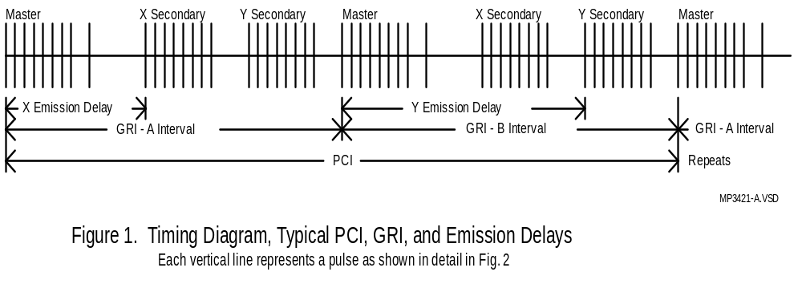

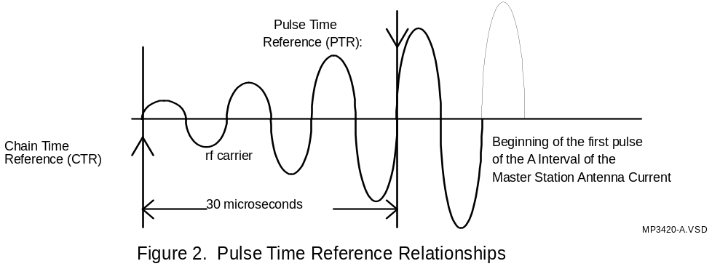

G.1.3 Coordinated Universal Time (UTC) and International Atomic Time (TAI)

TAI represents the fundamental definition of time interval. One second in TAI is equal to exactly 9,192,631,770 cycles of the hyperfine resonance of the cesium 133 atom in zero magnetic field. The significance of this definition is that the UTC second, as of 1972, is equal in duration to the TAI second. The relationship of the TAI clock and UTC, as well as the synchronization relationship of the real time implementations of UTC, are reported in the US by NIST and by USNO. In other nations, their respective standards organizations also report this. As noted above, USNO is charged with determining the synchronization relationship of GPS and Loran-C. NIST also reports the Loran-C synchronization.

G.1.4 UTC and Leap Seconds

In this discussion, the relationship between the naming of the one-second epochs for various clocks is defined. Note that the one-second epochs for each clock (TAI, UTC, GPS, and Loran-C) are nominally coincident; however, each epoch has a different name in the definition of the various clocks. The one-second naming convention is the procedure which names each one-second epoch according to the clock display: hh:mm:ss. The first second in a day is called 00:00:00, and so on through the day to the last second which is 23:59:59. From 1 January 1958 until 1 January 1972, the frequency of UTC was offset from the frequency of International Atomic Time (TAI) by varying offsets so as to maintain the 1PPS(UTC) epoch within 0.9 seconds of the second as reckoned by the rotation of the earth (DUT1). During this time, the UTC frequency and the Loran-C clock frequency were the same, and the UTC one-second naming convention was constant. In 1972, international agreement was reached to implement UTC differently. The UTC second and the TAI second were defined to be of the same duration (same frequency) and coincident. However, in order to keep UTC aligned with the earth's rotation, leap seconds would be inserted in the UTC clock definition. That is, a day containing a leap second would have the one-second naming convention changed to either insert an additional second (23:59:60) or to delete a second and end on 23:59:58. In 1972, UTC and the Loran-C clock were coincident and later than TAI by exactly 10 seconds, so the Loran-C clock defining Loran epochs is offset from TAI by ten seconds. Cumulative leap seconds since that date, which apply only to UTC, cause the Loran-C clock to be offset from UTC by 21 seconds as of 1 July 1997. This offset is added to the UTC time in order to determine the exact number of seconds of Loran-C clock time since the origin, as this determines when TOC's will occur. At 23:59:60 31 December 1998, an additional leap second will be inserted, bringing the total to 32 seconds.

Similarly, GPS time is reckoned from 6 January 1980, when UTC was offset from TAI by 19 seconds, due to both the 10 seconds accumulated when the UTC frequency was offset and the 9 leap seconds which were inserted between 1972 and 1980. Therefore, the Loran-C clock and GPS clock are offset 9 seconds and will remain with that offset. The relationship of the various clock times can be written:

Time(TAI) = Time(Loran)+10s = Time(GPS)+19s = Time(UTC)+LS,

where LS = 31 seconds on 1 July 1997, until the next LS (See Figure I-3).

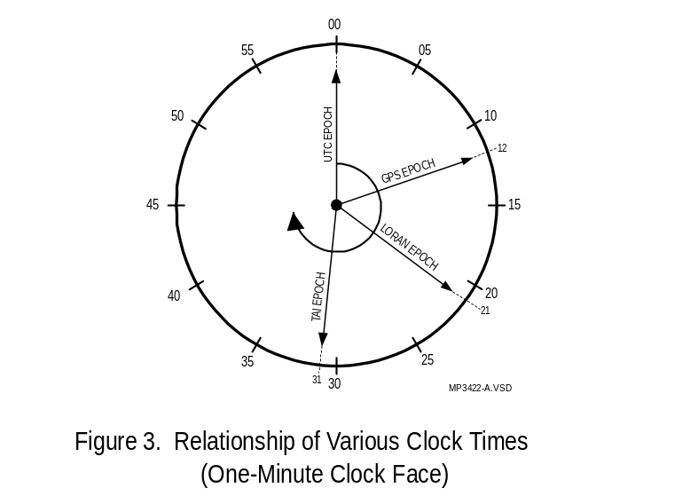

G.1.5 CTR Relationship to UTC

Because one second is not an integer multiple of the Loran-C PCI, the CTR does not coincide with every UTC one-second epoch, except occasionally. These occasions are called the times-of-coincidence (TOC's). On other seconds, the CTR is delayed a multiple of 20 microseconds after the UTC second. The delay is the un-TOC second offset (UNTOC). See Figure I-4. Note that because measurements are generally made by time interval counter starting on the UTC second and stopping on the Loran-C epoch, the stated UNTOC is the time to the next CTR after the second and is positive. It is important to note that the UNTOC is always a multiple of 20 microseconds. It should further be noted that actual observations of the UNTOC will be further increased by the Loran-C propagation path, transmitting antenna phase shifts, and receiver and cable delays. This paper does not address calibration of these delays.

G.2 General Description of the Algorithm
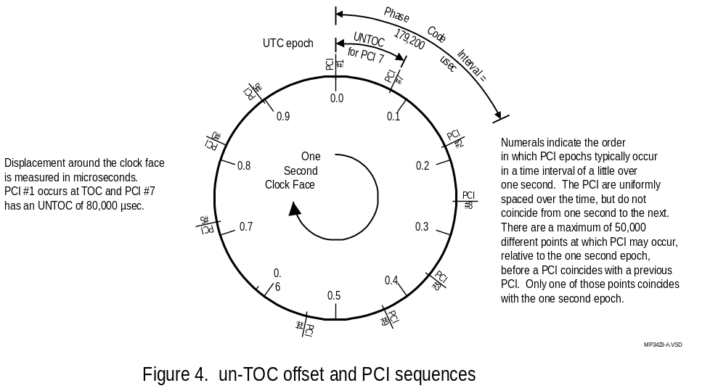

The process first determines the number of seconds and the number of PCI's between TOC's. This is the TOC Interval (TOCI). To do this, the least common multiple of PCI and one second is determined. To then determine the first TOC of the day, the number of seconds from the origin to the beginning of the day (in UTC seconds) is computed, divided by the TOCI in seconds, and the remainder determined. TOCI minus the remainder is the first TOC of the day. TOC's for other times of the day are determined by the same computation, or by simply adding multiples of the TOCI to the first TOC.

UNTOC is determined by first establishing the time at which UNTOC is desired, determining the number of seconds since the origin, dividing by the PCI in seconds, and determining the remainder. PCI minus the remainder is the UNTOC, generally expressed in microseconds. In all these computations care must be taken to assure that the units and clock times are properly accounted for.

G.2.1 TOC Interval Computation

TOC Interval (TOCI) is, of course, an integer multiple of seconds. It is also obviously an integer multiple number of PCI's:
(1)
where 'm' and 'n' are integers, and PCI µsec = 20 * GRI

The problem is to find the minimum value of 'm' and 'n' which satisfy the equation. This is a 'least common multiple' function. It is iterative and must test many values. The proposed technique limits the number of values tested and provides a direct computation of 'm' and 'n'. Note that PCI is 20 times GRI, and 4000#GRI#9999. Rewriting:
(2)
One solution, by inspection, to this equation is n = n_{o} = 50,000 (50,000 * 20 = 10^6). In which case m = m_{o} = GRI. This is the simplest solution. However, it is only the minimum value of m when GRI is a prime number. The equation can be rewritten to indicate the existence of common factors, such that:

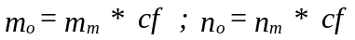

where m_{m} and n_{m} are the least common multiples of GRI and one second, respectively.

Factoring equation (2):
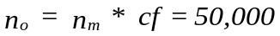Since
(3)

and n_{m} and cf are integers, cf is a factor of 50,000!

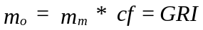and

The factors of 50,000 and therefore potentially factors of cf are:

If any of these factors (other than 1) are factors of GRI, then n is less than 50,000 and a least value of m is calculated by dividing m_{o} by the common factor. Note that there may be other factors of GRI which are not common and, therefore, are not significant. The algorithm: (where @MOD(x,y) calculates the remainder of x divided by y, and @if(r=0,cf,1) returns cf if the remainder is zero, or returns 1 if the remainder is non-zero) is:

@if(@mod(GRI,5)=0,5,1) = cf₁
@if(@mod(GRI,25)=0,5,1) = cf₂
@if(@mod(GRI,125)=0,5,1) = cf₃
@if(@mod(GRI,625)=0,5,1) = cf₄
@if(@mod(GRI,3125)=0,5,1) = cf₅
@if(@mod(GRI,2)=0,2,1) = cf₆
@if(@mod(GRI,4)=0,2,1) = cf₇
@if(@mod(GRI,8)=0,2,1) = cf₈
@if(@mod(GRI,16)=0,2,1) = cf₉

(4)

Examples:
(5)(6)
For GRI = 9960, find m_{m} and n_{m}: For GRI = 7001, find m_{m} and n_{m}:
cf = 5 * 1 * 1 * 1 * 1 * 2 * 2 * 2 * 1 = 40 cf = 1 * 1 * 1 * 1 * 1 * 1 * 1 * 1 * 1 = 1
m_{m} = GRI/cf = 9960/40 = 249 sec m_{m} = GRI/cf = 7001/1 = 7001 sec
n_{m} = 50,000/cf = 50,000/40 = 1250 PCI n_{m} = 50,000/cf = 50,000/1 = 50,000 PCI

G.2.2 TOC₀ Computation

Every TOC occurs at an integer multiple of TOCI after the original epoch. For any given date the first TOC after midnight (TOC_{o}) occurs at a time computed by:

Note: Use caution: the fractional part of division of the date interval by TOCI does not have units. The remainder is a whole number, having units of seconds. TOC_{o} is the whole number of seconds after midnight, when the first TOC occurs on 'given date'. Additional TOC's occur exactly every (t * TOCI) seconds after TOC_{o}, where 't' is an integer ranging from 1 to the largest value for which the product is less than 86,400. LS is the number of leap seconds difference between the Loran clock and UTC. LS = 21 seconds, as of 1 July 1997.

For simplicity, dates in equation (7) are in modified Julian date (MJD). The origin date (1 Jan 1958) is 36204 MJD. Spreadsheets do not use MJD, so the current dates are computed using spreadsheet date numbering schemes and the difference between the spreadsheet numbers and MJD. Note that different spreadsheets may use a different dates for the origin. The spreadsheet date offset should be computed for 1 January 1958 and applied to the current date. Note that TOC is in seconds and must be converted to hh:mm:ss if needed in this form for display.

Example:
Find TOC_{o} for GRI = 9960 on 5 January 1998:
5 January 1998 50,818.0000000000 days
1 January 1958 -36,204.0000000000 days
Days since Origin 14,614.0000000000 days
Seconds since Origin 1,262,649,600.0000000000 seconds
Leap Seconds Since 1/1/72 21.0000000000 seconds
Total Loran Seconds since Origin 1,262,649,621.0000000000 seconds
TOCI 249.0000000000 seconds
TOCI since Origin 5,070,882.0120481928 TOCI
Fractional TOCI 0.0120481928
Remainder in Seconds (TOCI*249) 3.0000000000 seconds
TOC_{o} = TOCI - Remainder 246.0000000000 seconds
TOC_{o} (Loran Time) 12:04:06 AM hh:mm:ss
TOC_{o} (UTC) 12:03:45 AM hh:mm:ss
TOC_{o} (GPS Time) 12:03:57 AM hh:mm:ss
TOC_{o} (TAI) 12:04:16 AM hh:mm:ss

G.2.3 TOC Before an Arbitrary Time

This computation is a generalization of the TOC_{o} computation. First determine the number of seconds since the origin, then find the number of whole TOCI preceding the arbitrary time. Calculate the number of seconds represented by these TOCI and convert to time of day.

Example:
Find the Last TOC before 14:32:27, 5 January 1998 on GRI = 9960:
5 January 1998 50,818.0000000000 days
1 January 1958 -36,204.0000000000 days
Days since Origin 14,614.0000000000 days
Seconds since Origin 1,262,649,600.0000000000 seconds
Leap Seconds 21.0000000000 seconds
Seconds to day beginning 1,262,649,621.0000000000 seconds
14 hours * 3,600 50,400.0000000000 seconds
32 min * 60 1,920.0000000000 seconds
27 sec 27.0000000000 seconds
Total seconds since Origin 1,262,701,968.0000000000 seconds
TOCI since Origin 5,071,092.2409600000 TOCI
Whole TOCI to last TOC 5,071,092. TOCI
Sec=s, Origin to last TOC 1,262,701,908. seconds
Seconds to day beginning 1,262,649,621. seconds
Sec=s day beg. to last TOC 52,287. seconds
Conversion to hh:mm:ss, UTC 14:31:27 hh:mm:ss
(60 seconds before the chosen arbitrary time.)
Next TOC, last TOC + TOCI 52,536 seconds
Conversion to hh:mm:ss 14:35:36 hh:mm:ss

G.2.4 Loran-C Offset at Any Second (UNTOC)

This computation is also done in units of seconds and is includes the computation of TOC before an arbitrary time. Since the offset will be computed to the nearest 20 µsec, not less than 10 digits to the left of the decimal and 7 digits to the right of the decimal point are required. The units of the selected time and date, PCI and Loran-C offset in the equation are 'days'. 'Days' are converted to seconds by multiplying by 86,400 and further converted to microseconds by multiplying by 10⁶.
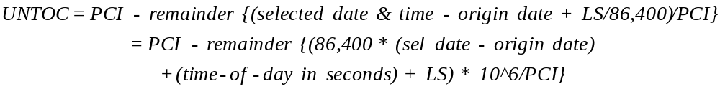 (8)

Example:
Find the UNTOC for GRI = 9960, @ 14:32:27, 5 January 1998:
5 January 1998 50,818.0000000000 days
1 January 1958 36,204.0000000000 days
Days since Origin 14614.0000000000 days
Seconds since Origin 1,262,649,600.0000000000 seconds
Leap Seconds 21.0000000000 seconds
Seconds to day beginning 1,262,649,621.0000000000 seconds
14 hours * 3,600 50,400.0000000000 seconds
32 min * 60 1920.0000000000 seconds
27 sec 27.0000000000 seconds
Total seconds since Origin 1,262,701,968.0000000000 seconds
PCI in seconds 0.1992000000 seconds
PCI since Origin: 6,338,865,301.2048192800 PCI
Remainder in Fractional PCI: 0.2048192800 PCI
Remainder * 199,200 µsec/PCI 40,799.9997787178 µsec
Rounded to nearest 20 µsec 40,800. µsec
UNTOC = PCI - Remainder: 158,400. µsec after arbitrary time

To avoid the 17 digit PCI since Origin (this requires only 12 digits max):
Seconds since Origin 1262,701,968.0000000000 seconds
TOCI since Origin 5,071,092.0000000000 TOCI
Sec's fm Origin to latest TOC 1,202,701,908.0000000000 seconds
Sec's since last TOC 60.0000000000 seconds
PCI since last TOC 301.2048193000 PCI
Remainder in PCI 0.2048193000 PCI
Remainder * 199,200 μ sec/PCI 40,799.9997787178 µsec
Rounded to nearest 20 μ sec 40,800. µsec
UTO = PIC - Remainder 158,400. µsec

Note: a programmer will note a number of ways to reduce the total number of digits to be manipulated so that double precision arithmetic may not required. Note also that the observation of UNTOC will be a measure of the time interval from the local representation of UTC, which may be offset from the defined UTC, to the Loran-C reference epoch which will also be offset due to measurement cable delays. The observed value must be reduced by 30 microseconds to account for the definition of the relationship of the Loran-C epoch to UTC.

Attachment G-A
TOCI Computation Using Euclid's Algorithm

Beginning from equation 2:
Rewriting:
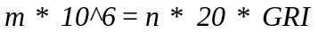 (2)
Euclid's algorithm finds the greatest common divisor of m and n using the following procedure:
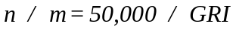 (2A)

1) Set the index, i = 0. Let n_{i} = n₀ = 50,000 and m_{i} = m₀ = GRI

2) Divide n_{i} by m_{i} and record the remainder, r_{i} .
Note that the remainder is a whole number, less than or equal to m_{i}
and not a fraction.
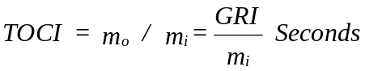
3) If the remainder, r_{i} = 0, then m_{i} is the greatest common divisor, and
4) If r_{i} … 0, set n_{i+1} = m_{i} , and m_{i+1} = r_{i} , and i = i + 1 and go to step 2).
Attachment G-B

Julian Day and Modified Julian Day

Edited from Robin O’Leary (http://pdc.ro.nu/mjd.html)

Astronomers and other people who need to deal with events separated by a large time span use the Julian Day to refer to time, rather than a date in a particular calendar. The Julian Day is a number that simply increases by 1 every mean solar day. Because there are no discontinuities in the count, the elapsed time between two events expressed as Julian Day numbers can be found by simple subtraction. Time within a day is expressed as a decimal fraction.

Julian Day numbering was invented in 1583 by the French scholar, Joseph Justus Scaliger. He constructed the Julian Period, an interval of 7980 years, based on three cycles of years: the 28-year solar cycle (the time taken before the days of the week next align with the Julian year), the 19-year lunar cycle (when the phase of the moon aligns with the days), and the 15-year Roman indiction cycles (used for taxation, census and other legal purposes which continued to be used into the Middle ages). Assuming all dates are reckoned in the Julian calendar, for which it was named, the Julian period began at 12 noon, 1st. January 4713 BC and will end at 12 noon, 1st. January 3268 AD, when all three cycles will once again coincide. Days are numbered consecutively from zero within the Julian Period, without any subdivisions into months or years.

Here are some Julian days for some interesting dates:

(In this table, midnight is considered the beginning of the day)

Gregorian Date | Julian Day | MJD
Noon 1752-09-14 | 2361222
Noon 1858-11-16 | 2400000
Midnight 1858-11-17 | 2400000.5 | 0
Noon 1858-11-17 | 2400001 | 0.5
Midnight 1900-01-01 | 2415020.5 | 15020
Noon 1996-09-03 | 2450330 | 50329.5
Midnight 2000-01-01 | 2451544.5 | 51544
Midnight 2100-01-02 | 2488069.5 | 88069
Midnight 2132-08-31 | 2499999.5 | 99999
Midnight 2132-09-01 | 2500000.5 | 100000

Although the Julian Day is very useful for astronomical purposes, it does have some drawbacks:

a) It begins at noon, rather than at midnight as is civil convention. This offset of 0.5 day makes it awkward to talk about calendar days as single Julian day numbers.

b) It is rather long, with all the dates in the current and next centuries beginning with the decimal digits``24".

To remedy these two inconveniences, the Modified Julian Day is defined as the Julian Day minus 2400000.5. Thus MJD 0 is at midnight between the 16 and 17 November 1858 AD Gregorian. For any date in the 20th and 21st centuries, the MJD will be at most five decimal digits long.

For all you ever want to know about calendars see:

http://www.pip.dknet.dk/~pip10160/cal/calendar20.pdf
Or just search the Internet for ‘Modified Julian Day’

APPENDIX H. CYCLIC REDUNDANCY CHECK (CRC) ALGORITHM

Message Type 30 uses the QualComm CRC-24Q algorithm. Twenty-four bits of CRC parity provide protection against burst as well as random errors with a probability of undetected error
≤ 2-24 = 5.96×10-8 for all channel bit error probabilities ≤ 0.5. The CRC operates on the ordered sequence of 208 bits in Table 4-36, beginning with the LSB of the first data element and ending with the MSB of the last data element, and using a seed of 0. The sequence of 24 bits (p₁,p₂,...,p₂₄) is generated from the sequence of information bits (m₁,m₂,...,m_{8N}), where N is the total number of bytes in the sequence consisting of the message plus preamble and Message Length Definition Parameter. This is accomplished by means of a code that is generated by the polynomial

where
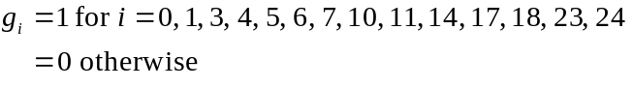

The generator polynomial of this code is in the following form (using binary polynomial algebra):
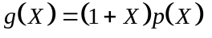
where p(X) is the primitive and irreducible polynomial
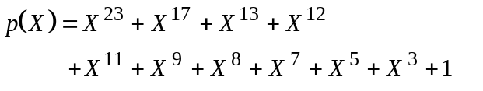
When, by the application of binary polynomial algebra, the above g(x) is divided into m(x)x²⁴, where the information sequence m(x) is expressed as

the result is a quotient and a remainder R(x) of degree < 24. The bit sequence formed by this remainder represents the parity check sequence. Parity bit p_{i}, for any i from 1 to 24, is the coefficient of x^{24-i} in R(x).

This code has the following characteristics:
1) It detects all single bit errors per code word.
2) It detects all double bit error combinations in a codeword because the generator polynomial g(X) has a factor of at least three terms.
3) It detects any odd number of errors because g(X) contains a factor 1+X.
4) It detects any burst error for which the length of the burst is ≤ 24 bits.
5) It detects most large error bursts with length greater than the parity length r = 24 bits. The fraction of error bursts of length b > 24 that are undetected is:
a) 2⁻²⁴ = 5.96 × 10⁻⁸, if b > 25 bits.
b) 2⁻²³ = 1.19 × 10⁻⁷, if b = 25 bits.

As noted earlier, the reference station should insert zero’s in all reserved fields, and for messages whose lengths that don’t line up with byte boundaries, zero’s should be used for undefined bits to fill out the last unfilled byte.

Galileo Open Service Signal in Space Interface Control Document (OS SIS ICD), ESA/GJU, GAL OS SIS ICD/D.0, 23/05/2006, http://www.galileoju.com/page2.cfm
IMO Res. A.915(22) on ‘Revised Maritime Policy and Requirements for a future Global Navigation Satellite System (GNSS)’, 22 January 2002
For the reader familiar with Euclid’s algorithm for the “greatest common divisor”, see attachment I-A for an alternate algorithm

