https://igs.bkg.bund.de/ntrip/
см Broadcast Ephemeris messages from globally distributed streams are also converted to RINEX Navigation files. These files are made available for download at https://igs.bkg.bund.de/root_ftp/NTRIP/BRDC/. Unlike daily concatenated files from reference stations, their 24h sliding window content is updated every 15 minutes.
https://igs.bkg.bund.de/root_ftp/NTRIP/BRDC/
https://igs.bkg.bund.de/root_ftp/NTRIP/BRDC/2020/002/
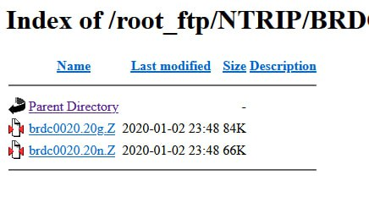
верхний файл - за полные сутки (2 января 2020 г) эфемериды GPS, нижний - ГЛОНАСС

