LAPORAN PRAKTIKUM
POSTTEST 1
ALGORITMA PEMROGRAMAN LANJUT



Disusun oleh:
REZA HAIKAL (2509106113)
INFORMATIKA C2‘25

PROGRAM STUDI INFORMATIKA
UNIVERSITAS MULAWARMAN
SAMARINDA
2025

1. Flowchart

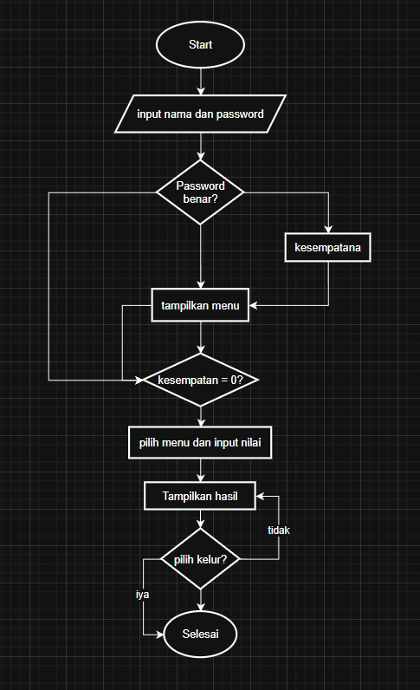

Gambar 1.1

2. codingan
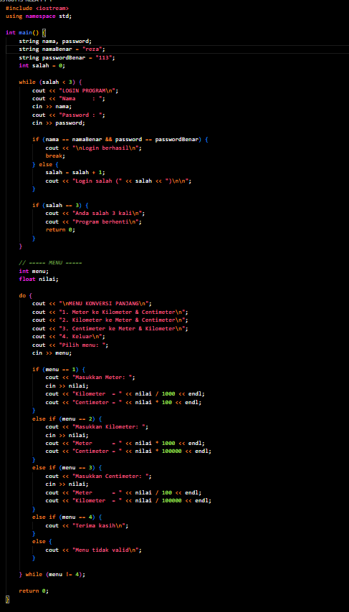

Gambar 1.2

3. Source Code

#include <iostream>
using namespace std;

int main() {
string nama, password;
string namaBenar = "reza";
string passwordBenar = "113";
int salah = 0;

while (salah < 3) {
cout << "LOGIN PROGRAM\n";
cout << "Nama : ";
cin >> nama;
cout << "Password : ";
cin >> password;

if (nama == namaBenar && password == passwordBenar) {
cout << "\nLogin berhasil\n";
break;
} else {
salah = salah + 1;
cout << "Login salah (" << salah << ")\n\n";
}

if (salah == 3) {
cout << "Anda salah 3 kali\n";
cout << "Program berhenti\n";
return 0;
}
}

// ===== MENU =====
int menu;
float nilai;

do {
cout << "\nMENU KONVERSI PANJANG\n";
cout << "1. Meter ke Kilometer & Centimeter\n";
cout << "2. Kilometer ke Meter & Centimeter\n";
cout << "3. Centimeter ke Meter & Kilometer\n";
cout << "4. Keluar\n";
cout << "Pilih menu: ";
cin >> menu;

if (menu == 1) {
cout << "Masukkan Meter: ";
cin >> nilai;
cout << "Kilometer = " << nilai / 1000 << endl;
cout << "Centimeter = " << nilai * 100 << endl;
}
else if (menu == 2) {
cout << "Masukkan Kilometer: ";
cin >> nilai;
cout << "Meter = " << nilai * 1000 << endl;
cout << "Centimeter = " << nilai * 100000 << endl;
}
else if (menu == 3) {
cout << "Masukkan Centimeter: ";
cin >> nilai;
cout << "Meter = " << nilai / 100 << endl;
cout << "Kilometer = " << nilai / 100000 << endl;
}
else if (menu == 4) {
cout << "Terima kasih\n";
}
else {
cout << "Menu tidak valid\n";
}

} while (menu != 4);

return 0;
}

4. Langkah-langkah GIT

4.1 GIT Init

4.2 GIT Add
jangan lupa pakai spasi dan dot (.) untuk mencakup semua file

4.3 GIT Commit
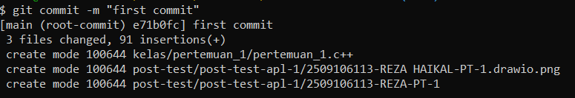

4.4 GIT Remote

4.5 GIT Push

