LAPORAN PRAKTIKUM
POSTTEST 5
ALGORITMA PEMROGRAMAN LANJUT



Disusun oleh:
REZA HAIKAL (2509106113)
INFORMATIKA C2‘25

PROGRAM STUDI INFORMATIKA
UNIVERSITAS MULAWARMAN
SAMARINDA
2025

1. Flowchart

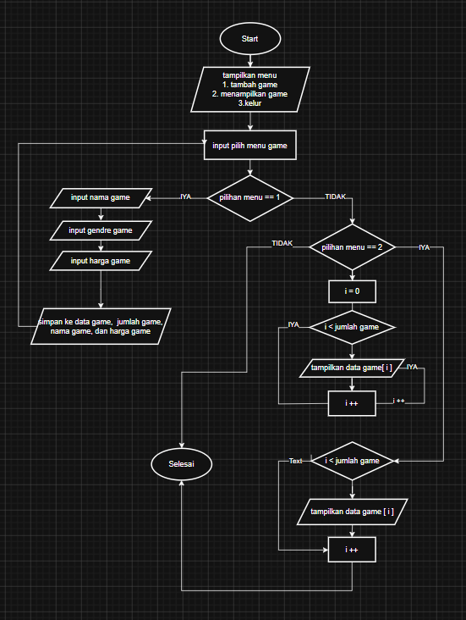

Gambar 1.1

2. codingan
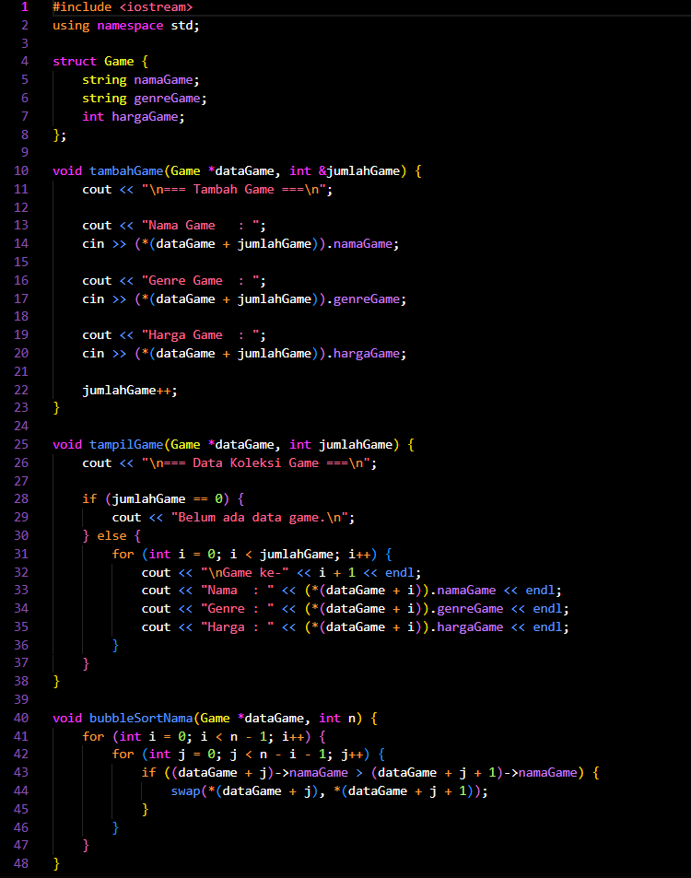
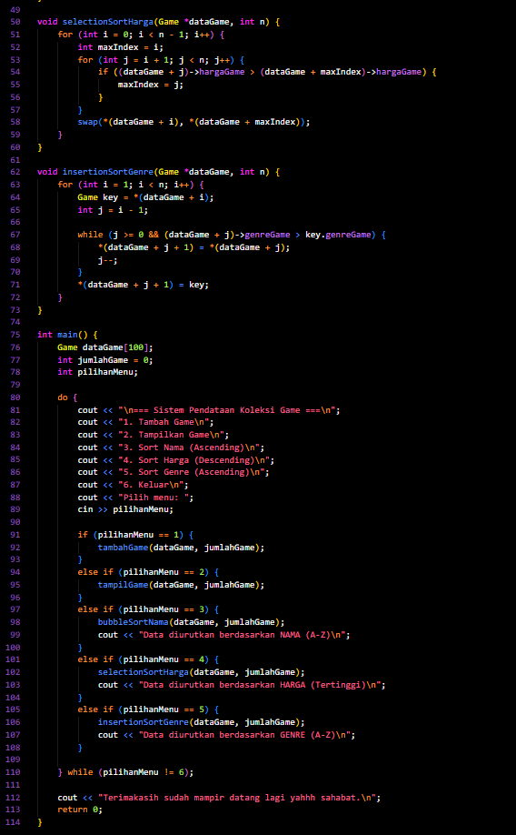

Gambar 1.2

3. Source Code

#include <iostream>
using namespace std;

struct Game {
string namaGame;
string genreGame;
int hargaGame;
};

void tambahGame(Game *dataGame, int &jumlahGame) {
cout << "\n=== Tambah Game ===\n";

cout << "Nama Game : ";
cin >> (*(dataGame + jumlahGame)).namaGame;

cout << "Genre Game : ";
cin >> (*(dataGame + jumlahGame)).genreGame;

cout << "Harga Game : ";
cin >> (*(dataGame + jumlahGame)).hargaGame;

jumlahGame++;
}

void tampilGame(Game *dataGame, int jumlahGame) {
cout << "\n=== Data Koleksi Game ===\n";

if (jumlahGame == 0) {
cout << "Belum ada data game.\n";
} else {
for (int i = 0; i < jumlahGame; i++) {
cout << "\nGame ke-" << i + 1 << endl;
cout << "Nama : " << (*(dataGame + i)).namaGame << endl;
cout << "Genre : " << (*(dataGame + i)).genreGame << endl;
cout << "Harga : " << (*(dataGame + i)).hargaGame << endl;
}
}
}

void bubbleSortNama(Game *dataGame, int n) {
for (int i = 0; i < n - 1; i++) {
for (int j = 0; j < n - i - 1; j++) {
if ((dataGame + j)->namaGame > (dataGame + j + 1)->namaGame) {
swap(*(dataGame + j), *(dataGame + j + 1));
}
}
}
}

void selectionSortHarga(Game *dataGame, int n) {
for (int i = 0; i < n - 1; i++) {
int maxIndex = i;
for (int j = i + 1; j < n; j++) {
if ((dataGame + j)->hargaGame > (dataGame + maxIndex)->hargaGame) {
maxIndex = j;
}
}
swap(*(dataGame + i), *(dataGame + maxIndex));
}
}

void insertionSortGenre(Game *dataGame, int n) {
for (int i = 1; i < n; i++) {
Game key = *(dataGame + i);
int j = i - 1;

while (j >= 0 && (dataGame + j)->genreGame > key.genreGame) {
*(dataGame + j + 1) = *(dataGame + j);
j--;
}
*(dataGame + j + 1) = key;
}
}

int main() {
Game dataGame[100];
int jumlahGame = 0;
int pilihanMenu;

do {
cout << "\n=== Sistem Pendataan Koleksi Game ===\n";
cout << "1. Tambah Game\n";
cout << "2. Tampilkan Game\n";
cout << "3. Sort Nama (Ascending)\n";
cout << "4. Sort Harga (Descending)\n";
cout << "5. Sort Genre (Ascending)\n";
cout << "6. Keluar\n";
cout << "Pilih menu: ";
cin >> pilihanMenu;

if (pilihanMenu == 1) {
tambahGame(dataGame, jumlahGame);
}
else if (pilihanMenu == 2) {
tampilGame(dataGame, jumlahGame);
}
else if (pilihanMenu == 3) {
bubbleSortNama(dataGame, jumlahGame);
cout << "Data diurutkan berdasarkan NAMA (A-Z)\n";
}
else if (pilihanMenu == 4) {
selectionSortHarga(dataGame, jumlahGame);
cout << "Data diurutkan berdasarkan HARGA (Tertinggi)\n";
}
else if (pilihanMenu == 5) {
insertionSortGenre(dataGame, jumlahGame);
cout << "Data diurutkan berdasarkan GENRE (A-Z)\n";
}

} while (pilihanMenu != 6);

cout << "Terimakasih sudah mampir datang lagi yahhh sahabat.\n";
return 0;
}

4. Langkah-langkah GIT

4.1 GIT Init

4.2 GIT Add
jangan lupa pakai spasi dan dot (.) untuk mencakup semua file

4.3 GIT Commit
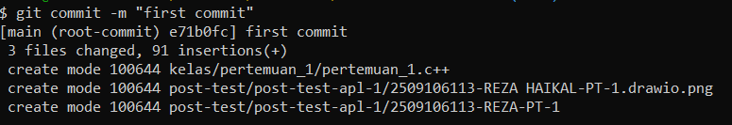

4.4 GIT Remote

4.5 GIT Push

