LAPORAN PRAKTIKUM
POSTTEST 2
ALGORITMA PEMROGRAMAN LANJUT



Disusun oleh:
REZA HAIKAL (2509106113)
INFORMATIKA C2‘25

PROGRAM STUDI INFORMATIKA
UNIVERSITAS MULAWARMAN
SAMARINDA
2025

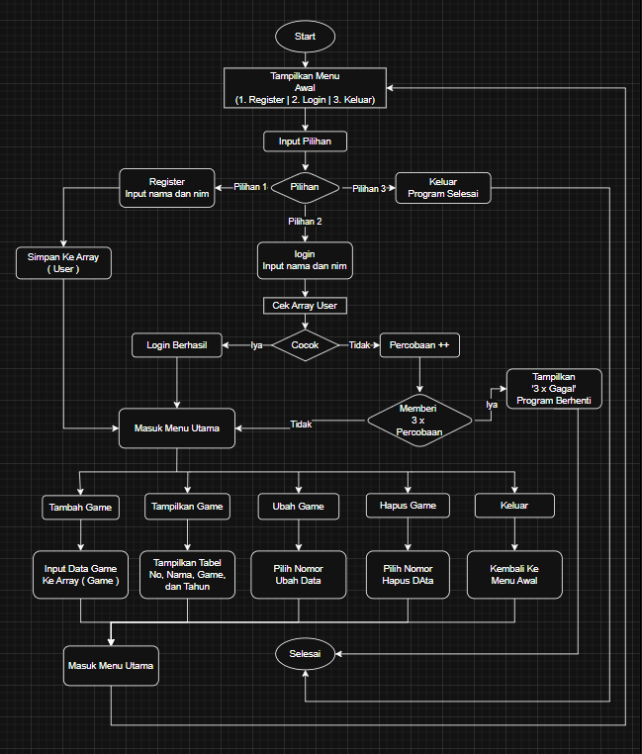
1. Flowchart

Gambar 1.1

2. codingan
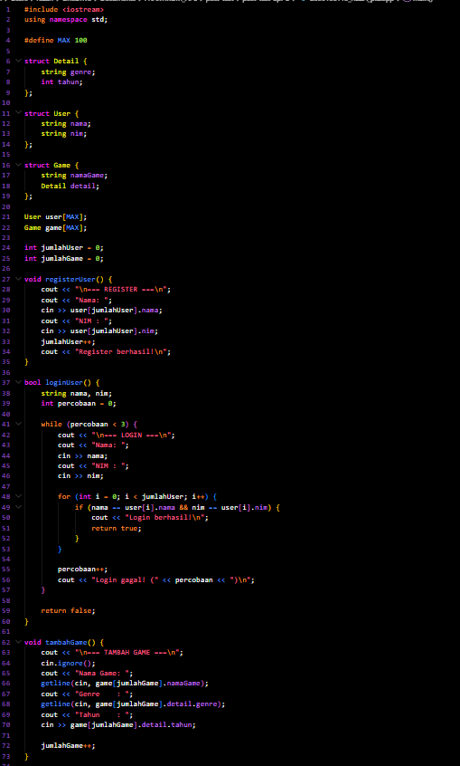
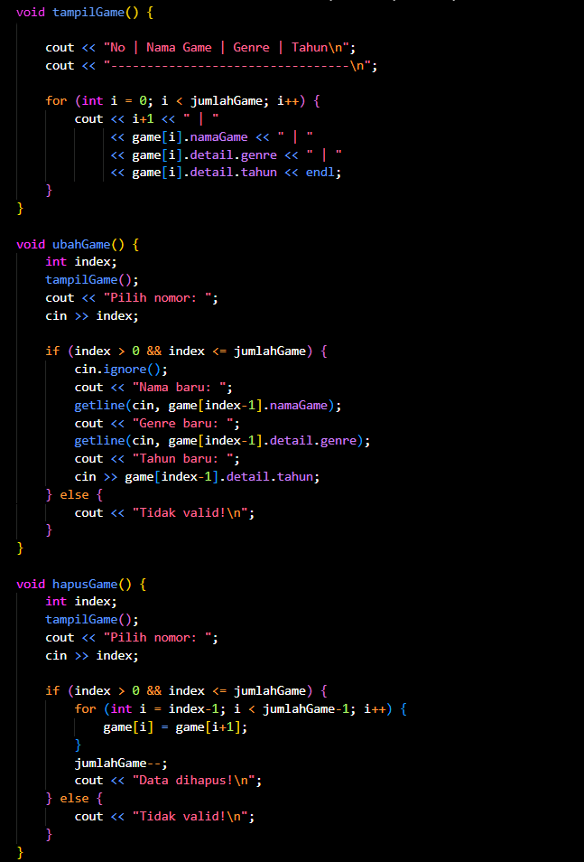
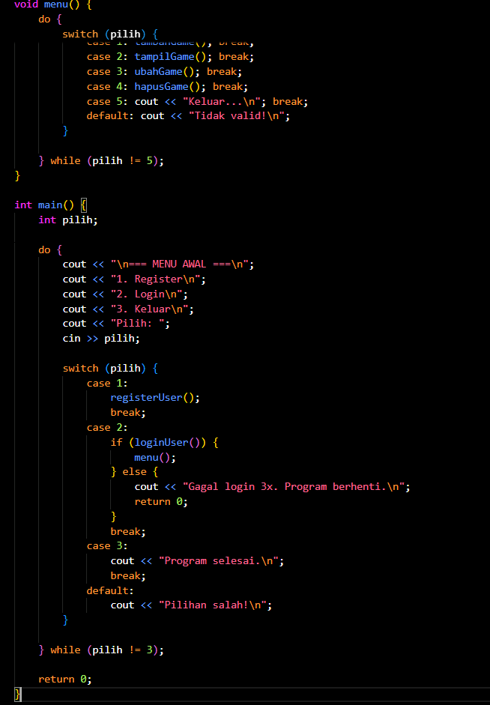

Gambar 1.2

3. Source Code

#include <iostream>
using namespace std;

#define MAX 100

struct Detail {
string genre;
int tahun;
};

struct User {
string nama;
string nim;
};

struct Game {
string namaGame;
Detail detail;
};

User user[MAX];
Game game[MAX];

int jumlahUser = 0;
int jumlahGame = 0;

void registerUser() {
cout << "\n=== REGISTER ===\n";
cout << "Nama: ";
cin >> user[jumlahUser].nama;
cout << "NIM : ";
cin >> user[jumlahUser].nim;
jumlahUser++;
cout << "Register berhasil!\n";
}

bool loginUser() {
string nama, nim;
int percobaan = 0;

while (percobaan < 3) {
cout << "\n=== LOGIN ===\n";
cout << "Nama: ";
cin >> nama;
cout << "NIM : ";
cin >> nim;

for (int i = 0; i < jumlahUser; i++) {
if (nama == user[i].nama && nim == user[i].nim) {
cout << "Login berhasil!\n";
return true;
}
}

percobaan++;
cout << "Login gagal! (" << percobaan << ")\n";
}

return false;
}

void tambahGame() {
cout << "\n=== TAMBAH GAME ===\n";
cin.ignore();
cout << "Nama Game: ";
getline(cin, game[jumlahGame].namaGame);
cout << "Genre : ";
getline(cin, game[jumlahGame].detail.genre);
cout << "Tahun : ";
cin >> game[jumlahGame].detail.tahun;

jumlahGame++;
}

void tampilGame() {
cout << "\n=== DATA GAME ===\n";

if (jumlahGame == 0) {
cout << "Belum ada data!\n";
return;
}

cout << "No | Nama Game | Genre | Tahun\n";
cout << "---------------------------------\n";

for (int i = 0; i < jumlahGame; i++) {
cout << i+1 << " | "
<< game[i].namaGame << " | "
<< game[i].detail.genre << " | "
<< game[i].detail.tahun << endl;
}
}

void ubahGame() {
int index;
tampilGame();
cout << "Pilih nomor: ";
cin >> index;

if (index > 0 && index <= jumlahGame) {
cin.ignore();
cout << "Nama baru: ";
getline(cin, game[index-1].namaGame);
cout << "Genre baru: ";
getline(cin, game[index-1].detail.genre);
cout << "Tahun baru: ";
cin >> game[index-1].detail.tahun;
} else {
cout << "Tidak valid!\n";
}
}

void hapusGame() {
int index;
tampilGame();
cout << "Pilih nomor: ";
cin >> index;

if (index > 0 && index <= jumlahGame) {
for (int i = index-1; i < jumlahGame-1; i++) {
game[i] = game[i+1];
}
jumlahGame--;
cout << "Data dihapus!\n";
} else {
cout << "Tidak valid!\n";
}
}

void menu() {
int pilih;
do {
cout << "\n=== MENU GAME ===\n";
cout << "1. Tambah Game\n";
cout << "2. Tampilkan Game\n";
cout << "3. Ubah Game\n";
cout << "4. Hapus Game\n";
cout << "5. Keluar\n";
cout << "Pilih: ";
cin >> pilih;

switch (pilih) {
case 1: tambahGame(); break;
case 2: tampilGame(); break;
case 3: ubahGame(); break;
case 4: hapusGame(); break;
case 5: cout << "Keluar...\n"; break;
default: cout << "Tidak valid!\n";
}

} while (pilih != 5);
}

int main() {
int pilih;

do {
cout << "\n=== MENU AWAL ===\n";
cout << "1. Register\n";
cout << "2. Login\n";
cout << "3. Keluar\n";
cout << "Pilih: ";
cin >> pilih;

switch (pilih) {
case 1:
registerUser();
break;
case 2:
if (loginUser()) {
menu();
} else {
cout << "Gagal login 3x. Program berhenti.\n";
return 0;
}
break;
case 3:
cout << "Program selesai.\n";
break;
default:
cout << "Pilihan salah!\n";
}

} while (pilih != 3);

return 0;
}

4. Langkah-langkah GIT

4.1 GIT Init

4.2 GIT Add
jangan lupa pakai spasi dan dot (.) untuk mencakup semua file

4.3 GIT Commit
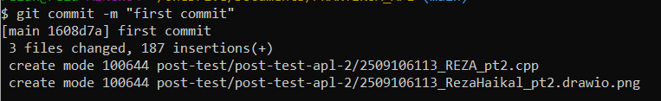

4.4 GIT Remote

4.5 GIT Push
