GARCH Analysis

**CUNY SPS MSDS**

**Professor Samuel Gralnick**

**Team Sugar Cane: Euclid Zhang, Jie Zou, Zhenni Xie**

**Fall 2022**

In this analysis, we will build a GARCH for one of the assets in our investment portfolio. We then use the model to predict the return and volatility for the next 10 days.

Our investment portfolio includes the following assets. In this analysis, we will focus on the equity assets.

| **Ticker** | **Type** | **Sector** | **Units** | **Amount** |
| --- | --- | --- | --- | --- |
| US30Y | U.S. 30 Year Treasury | NaN | 467317.00 | 42262981.19 |
| HSON | Common Stock | COMMERCIAL SERVICES | 36138.24 | 1263031.49 |
| GOGO | Common Stock | COMMUNICATIONS | 94822.19 | 1263031.57 |
| JAKK | Common Stock | CONSUMER DURABLES | 54044.99 | 1263031.42 |
| CALM | Common Stock | CONSUMER NON-DURABLES | 22216.91 | 1263031.33 |
| HRB | Common Stock | CONSUMER SERVICES | 28111.09 | 1263031.27 |
| HDSN | Common Stock | DISTRIBUTION SERVICES | 159071.98 | 1263031.52 |
| BELFA | Common Stock | ELECTRONIC TECHNOLOGY | 44285.81 | 1263031.30 |
| ARLP | Common Stock | ENERGY MINERALS | 52890.76 | 1263031.35 |
| CI | Common Stock | HEALTH SERVICES | 4350.03 | 1263031.21 |
| SRTS | Common Stock | HEALTH TECHNOLOGY | 85339.97 | 1263031.56 |
| LNG | Common Stock | INDUSTRIAL SERVICES | 7551.75 | 1263030.19 |
| BSM | Common Stock | MISCELLANEOUS | 80447.87 | 1263031.56 |
| HUDI | Common Stock | NON-ENERGY MINERALS | 42612.40 | 1263031.54 |
| CF | Common Stock | PROCESS INDUSTRIES | 12810.95 | 1263031.56 |
| CSL | Common Stock | PRODUCER MANUFACTURING | 4335.84 | 1263030.19 |
| MUSA | Common Stock | RETAIL TRADE | 4561.65 | 1263029.65 |
| AZPN | Common Stock | TECHNOLOGY SERVICES | 5579.50 | 1263031.42 |
| ASC | Common Stock | TRANSPORTATION | 126303.15 | 1263031.50 |
| ED | Common Stock | UTILITIES | 12966.13 | 1263030.72 |
| YCS | ETF | NaN | 25261.96 | 1599839.93 |
| UUP | ETF | NaN | 54416.32 | 1599839.81 |
| EUO | ETF | NaN | 47870.73 | 1599839.80 |
| EWV | ETF | NaN | 79832.33 | 1599839.89 |
| DIG | ETF | NaN | 44390.67 | 1599839.75 |
| TTT | ETF | NaN | 23645.28 | 1599839.64 |
| ERX | ETF | NaN | 29349.47 | 1599839.61 |
| TMV | ETF | NaN | 13430.49 | 1599839.97 |
| TBT | ETF | NaN | 54509.02 | 1599839.74 |
| TYO | ETF | NaN | 127782.74 | 1599839.90 |

We will demonstrate the GARCH process using one of our assets, 'HSON', as an example. We use the *rugarch* package in R to construct our model. It is a powerful tool for building GARCH models with supportive output summaries.

First, let's build a model with ar = 5, ma = 5, alpha = 5, beta = 5. The following are the estimated parameters.

|  |  |  |  |  |
| --- | --- | --- | --- | --- |
|  | Estimate | Std. Error | t value | Pr(>|t|) |
| mu | 0.002282 | 0.001975 | 1.155528 | 0.247874 |
| ar1 | -0.390539 | 0.276836 | -1.410719 | 0.158327 |
| ar2 | 0.299202 | 0.239189 | 1.250903 | 0.210970 |
| ar3 | -0.307978 | 0.343824 | -0.895743 | 0.370390 |
| ar4 | 0.257204 | 0.111308 | 2.310752 | 0.020847 |
| ar5 | 0.527938 | 0.174548 | 3.024611 | 0.002490 |
| ma1 | 0.323521 | 0.287829 | 1.124006 | 0.261010 |
| ma2 | -0.362023 | 0.250290 | -1.446413 | 0.148061 |
| ma3 | 0.243253 | 0.382543 | 0.635883 | 0.524853 |
| ma4 | -0.245103 | 0.119780 | -2.046284 | 0.040728 |
| ma5 | -0.394276 | 0.206220 | -1.911918 | 0.055887 |
| omega | 0.000000 | 0.000017 | 0.000000 | 1.000000 |
| alpha1 | 0.164288 | 0.048520 | 3.386009 | 0.000709 |
| alpha2 | 0.000025 | 0.067529 | 0.000373 | 0.999703 |
| alpha3 | 0.000018 | 0.070694 | 0.000250 | 0.999800 |

The P-values of the Optimal Parameters indicate that some of the parameters are statistically insignificant. We will use Backward Elimination to reduce the model complexity by removing the last term of each parameter with P-value greater than 0.05.

The Parameters of our final model are ar = 4, ma = 1, alpha = 1, beta = 3. The following are the estimated parameters.

|  |  |  |  |  |
| --- | --- | --- | --- | --- |
|  | Estimate | Std. Error | t value | Pr(>|t|) |
| mu | 0.00175 | 0.00081 | 2.16057 | 0.03073 |
| ar1 | 0.92580 | 0.05038 | 18.37713 | 0.00000 |
| ar2 | 0.05210 | 0.06993 | 0.74508 | 0.45622 |
| ar3 | -0.11876 | 0.08412 | -1.41183 | 0.15800 |
| ar4 | 0.11840 | 0.05754 | 2.05765 | 0.03962 |
| ma1 | -1.00000 | 0.00049 | -2046.17665 | 0.00000 |
| omega | 0.00000 | 0.00002 | 0.00000 | 1.00000 |
| alpha1 | 0.19490 | 0.06213 | 3.13683 | 0.00171 |
| beta1 | 0.09747 | 0.05463 | 1.78425 | 0.07438 |
| beta2 | 0.00000 | 0.15547 | 0.00000 | 1.00000 |
| beta3 | 0.69636 | 0.03324 | 20.94814 | 0.00000 |

The P-values of the last alpha and beta terms are less than 0.01, which indicates that our time series exhibits heteroskedasticity.

The followings are the results of the Weighted Ljung-Box Tests and the Adjusted Pearson Goodness-of-Fit Test:

Weighted Ljung-Box Test on Standardized Residuals

|  |  |  |
| --- | --- | --- |
|  | statistic | p-value |
| Lag[1] | 0.03059 | 0.86120 |
| Lag[2*(p+q)+(p+q)-1][14] | 5.27336 | 1.00000 |
| Lag[4*(p+q)+(p+q)-1][24] | 13.53741 | 0.32580 |

d.o.f=5

Weighted Ljung-Box Test on Standardized Squared Residuals

|  |  |  |
| --- | --- | --- |
|  | statistic | p-value |
| Lag[1] | 0.01741 | 0.89500 |
| Lag[2*(p+q)+(p+q)-1][11] | 4.69891 | 0.62660 |
| Lag[4*(p+q)+(p+q)-1][19] | 7.25944 | 0.75650 |

d.o.f=4

Adjusted Pearson Goodness-of-Fit Test:

|  |  |  |
| --- | --- | --- |
| group | statistic | p-value(g-1) |
| 20 | 23.81 | 0.2037 |
| 30 | 30.43 | 0.3928 |
| 40 | 42.42 | 0.3258 |
| 50 | 48.00 | 0.5135 |

The Weighted Ljung-Box Tests and the Adjusted Pearson Goodness-of-Fit Test all fail to reject that the residuals are dependent, which implies that our model is valid.

The following plot shows the returns and the modeled volatility. We confirm that there is heteroskedasticity in the time series.

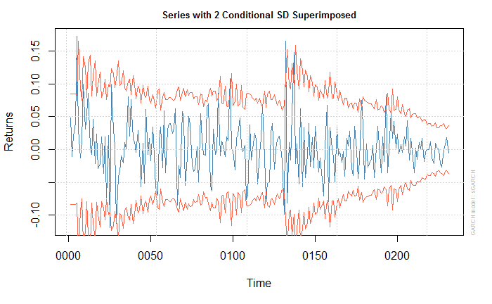

Since the volatility is not constant, our previous risk assessment of calculating the VaR using constant volatility may not be reliable. Calculating the potential loss using the estimated volatility from a GARCH model would a more appropriate method.

Finally, let's predict the returns and standard deviation for the next 10 days.

|  |  |  |
| --- | --- | --- |
|  | Series | Sigma |
| T+1 | 0.0024769 | 0.01518 |
| T+2 | 0.0007862 | 0.01560 |
| T+3 | 0.0036509 | 0.01731 |
| T+4 | 0.0025338 | 0.01575 |
| T+5 | 0.0027751 | 0.01555 |
| T+6 | 0.0023999 | 0.01671 |
| T+7 | 0.0025370 | 0.01595 |
| T+8 | 0.0024835 | 0.01558 |
| T+9 | 0.0025141 | 0.01630 |
| T+10 | 0.0024791 | 0.01596 |