**Watson Cloud APIs**

ITCR Workshop

**Horario:**

Agosto: Lunes 6, Lunes 13, Lunes 20 - 1:30PM-4:30PM

Setiembre: Lunes 3, Lunes 10, - 1:30PM-4:30PM

**Objetivo general:**

Demostrar el uso de los APIs cognitivos de Watson disponibles en IBM Cloud y la utilizacion de los lenguajes de programacion Java (principalmente), Javascript (NodeJS) y otras herramientas para crear applicaciones estos APIs.

**Objetivos especificos:**

* Demostrar el funcionamiento del API: Watson Assistant
* Demostrar el funcionamiento del API: Discovery
* Demostrar el funcionamiento del API: Visual Recognition
* Demostrar el funcionamiento del API: Natural Language Understanding
* Demostrar el funcionamiento del API: Speech to Text
* Demostrar el funcionamiento del API: Text to Speech
* Demostrar el funcionamiento del API: Natural Language Classifier
* Demostrar el funcionamiento del API: Personality Insights
* Demostrar el funcionamiento del API: Tone Analyzer
* Demostrar el funcionamiento del API: Language Translator
* Demostrar el funcionamiento del API: Machine Learning
* Crear applicacion combinando los servicios Watson Assistant
* Crear applicacion combinando los servicios Watson Assistant + Tone Analyzer
* Crear applicacion combinando los servicios Visual Recognition
* Crear applicacion combinando los servicios Natural Language Understanding
* Crear applicacion combinando los servicios Watson Assistant + Discovery

**Propuesta de agenda**

* Workshop Pt1:

Day 1:

1 hr - Introduction to Cognitive Computing and Watson

0.5 hr - Review of IBM Cloud

0.5 hr - API: Watson Assistant

1 hr - Develop app – Flower shop

Day 2:

0.5 hr - Speech to Text

0.5 hr - Text to Speech

0.5 hr - Language Translator

0.5 hr - Personality Insights

0.5 hr - Tone Analyzer

Day 3:

1.0 hr - Develop app (Empathetic chatbot)

0.5 hr - Visual Recognition

1.0 hr – Develop app (TBD)

* Workshop Pt2:

Day 1:

0.5 hr - Natural Language Classifier

0.5 hr - Natural Language Understanding

1.0 hr – Develop app (TBD)

1.0 hr - Discovery

Day 2:

0.5 hr – Develop app (Chatbot with recommendations from WEB)

1.0 hr – Machine Learning

0.5 hr Questions and feedback.

**Requisitos:**

* Eclipse IDE instalado
* Cuenta de IBM Cloud

**Recursos generales:**

* Acceso a IBM Cloud para estudiantes :

(IBM Academy Initiative) <https://onthehub.com/ibm/>

* Watson Java SDK:

https://github.com/watson-developer-cloud/java-sdk

* IBM redbooks:

http://www.redbooks.ibm.com/redbooks.nsf/pages/cognitiveapps?Open

**1. Watson Assistant (formerly Conversation)**

* Documentation: [https://console.bluemix.net/docs/services/conversation/getting-started.html#gettingstarted](https://console.bluemix.net/docs/services/conversation/getting-started.html" \l "gettingstarted)
* API Reference: <https://www.ibm.com/watson/developercloud/assistant/api/v1/java.html?java>
* Demo: <https://watson-conversation-duo-dev.ng.bluemix.net/>
* Redbook: <http://www.redbooks.ibm.com/redbooks.nsf/redbookabstracts/sg248394.html?Open>

The IBM Watson™ Assistant service combines machine learning, natural language understanding, and integrated dialog tools to create conversation flows between your apps and your users.

How to use the service:

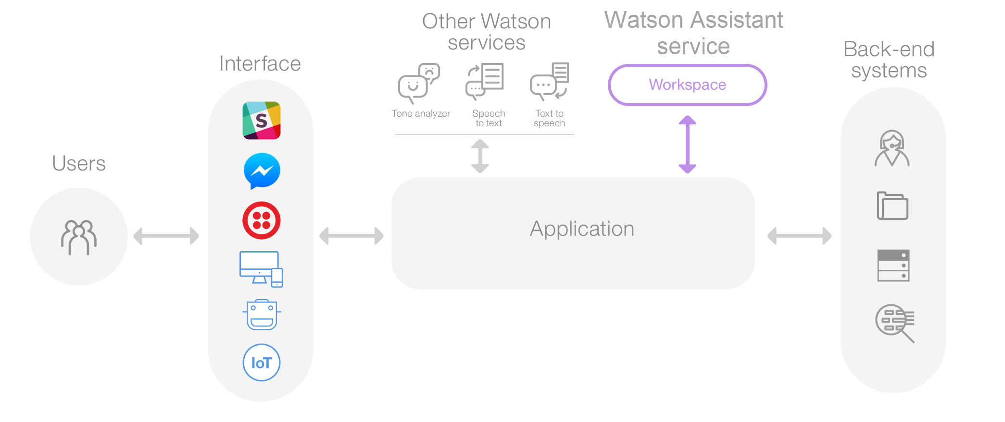

**2. Discovery**

* Documentation: [https://console.bluemix.net/docs/services/discovery/getting-started.html#getting-started-with-the-api](https://console.bluemix.net/docs/services/discovery/getting-started.html" \l "getting-started-with-the-api)
* API Reference: <https://www.ibm.com/watson/developercloud/discovery/api/v1/java.html?java>
* Demo: <https://discovery-news-demo.ng.bluemix.net/?cm_mc_uid=22565909282615302790198&cm_mc_sid_50200000=15890121530536433028&cm_mc_sid_52640000=55219051530307399788>
* Redbook: -

The IBM Watson™ Discovery Service is a cognitive search and content analytics engine that you can add to applications to identify patterns, trends and actionable insights to drive better decision-making. Securely unify structured and unstructured data with pre-enriched content, and use a simplified query language to eliminate the need for manual filtering of results.

How to use the service:

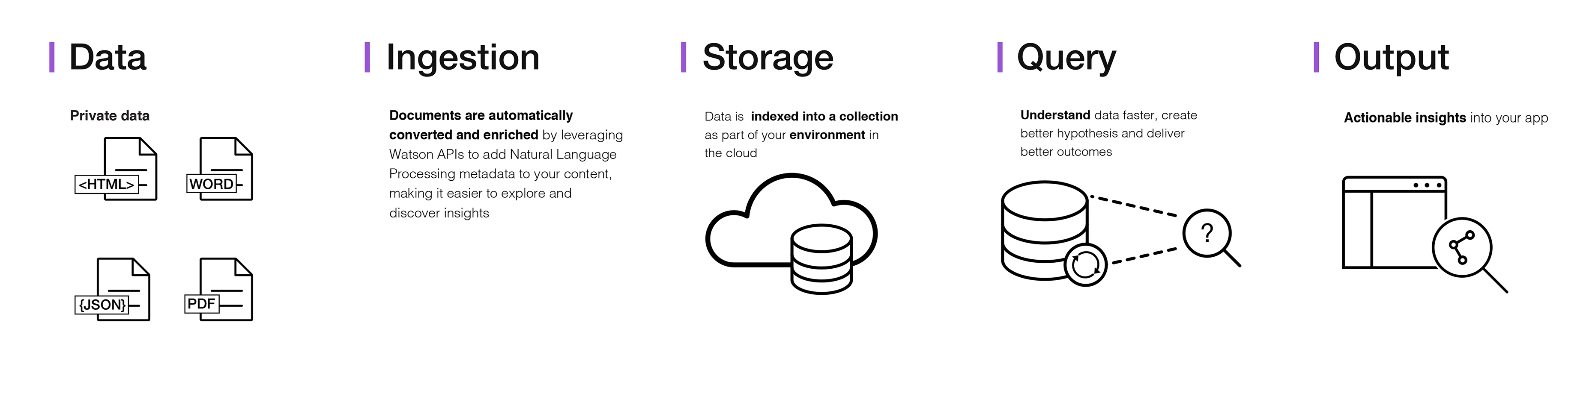

**3. Visual Recognition**

* Documentation: [https://console.bluemix.net/docs/services/visual-recognition/getting-started.html#getting-started-tutorial](https://console.bluemix.net/docs/services/visual-recognition/getting-started.html" \l "getting-started-tutorial)
* API Reference: <https://www.ibm.com/watson/developercloud/visual-recognition/api/v3/java.html?java>
* Demo: <https://watson-visual-recognition-duo-dev.ng.bluemix.net/>
* Redbook: <http://www.redbooks.ibm.com/redbooks.nsf/redbookabstracts/sg248393.html?Open>

How to use the API

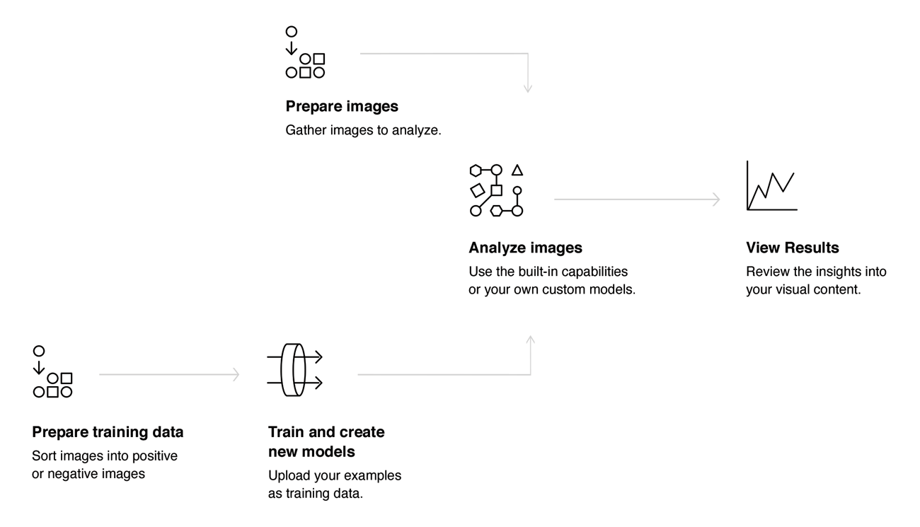

**4. Natural Language Understanding**

* Documentation: [https://console.bluemix.net/docs/services/natural-language-understanding/getting-started.html#getting-started-tutorial](https://console.bluemix.net/docs/services/natural-language-understanding/getting-started.html" \l "getting-started-tutorial)
* API Reference: [https://www.ibm.com/watson/developercloud/natural-language-understanding/api/v1/?java#](https://www.ibm.com/watson/developercloud/natural-language-understanding/api/v1/?java)
* Demo: <https://natural-language-understanding-demo.ng.bluemix.net/>
* Redbook: <http://www.redbooks.ibm.com/redbooks.nsf/redbookabstracts/sg248398.html?Open>

**5. Speech to Text**

* Documentation: [https://console.bluemix.net/docs/services/speech-to-text/getting-started.html#gettingStarted](https://console.bluemix.net/docs/services/speech-to-text/getting-started.html" \l "gettingStarted)
* API Reference: <https://www.ibm.com/watson/developercloud/speech-to-text/api/v1/java.html?java>
* Demo: <https://speech-to-text-demo.ng.bluemix.net/>
* Redbook: <http://www.redbooks.ibm.com/redbooks.nsf/redbookabstracts/sg248388.html?Open>

The IBM® Speech to Text service provides an API that uses IBM's speech-recognition capabilities to produce transcripts of spoken audio. The service can transcribe speech from various languages and audio formats. It addition to basic transcription, the service can produce detailed information about many aspects of the audio. For most languages, the service supports two sampling rates, broadband and narrowband. It returns all JSON response content in the UTF-8 character set.

**6. Text to Speech**

* Documentation: [https://console.bluemix.net/docs/services/text-to-speech/getting-started.html#gettingStarted](https://console.bluemix.net/docs/services/text-to-speech/getting-started.html" \l "gettingStarted)
* API Reference: <https://www.ibm.com/watson/developercloud/text-to-speech/api/v1/java.html?java>
* Demo: <https://text-to-speech-demo.ng.bluemix.net/>
* Redbook: <http://www.redbooks.ibm.com/redbooks.nsf/redbookabstracts/sg248388.html?Open>

**7. Natural Language Classifier**

* Documentation: [https://console.bluemix.net/docs/services/natural-language-classifier/getting-started.html#natural-language-classifier](https://console.bluemix.net/docs/services/natural-language-classifier/getting-started.html" \l "natural-language-classifier)
* API Reference: <https://www.ibm.com/watson/developercloud/natural-language-classifier/api/v1/java.html?java>
* Demo: <https://natural-language-classifier-demo.ng.bluemix.net/>
* Redbook: <http://www.redbooks.ibm.com/redbooks.nsf/redbookabstracts/sg248391.html?Open>

How to use the Service

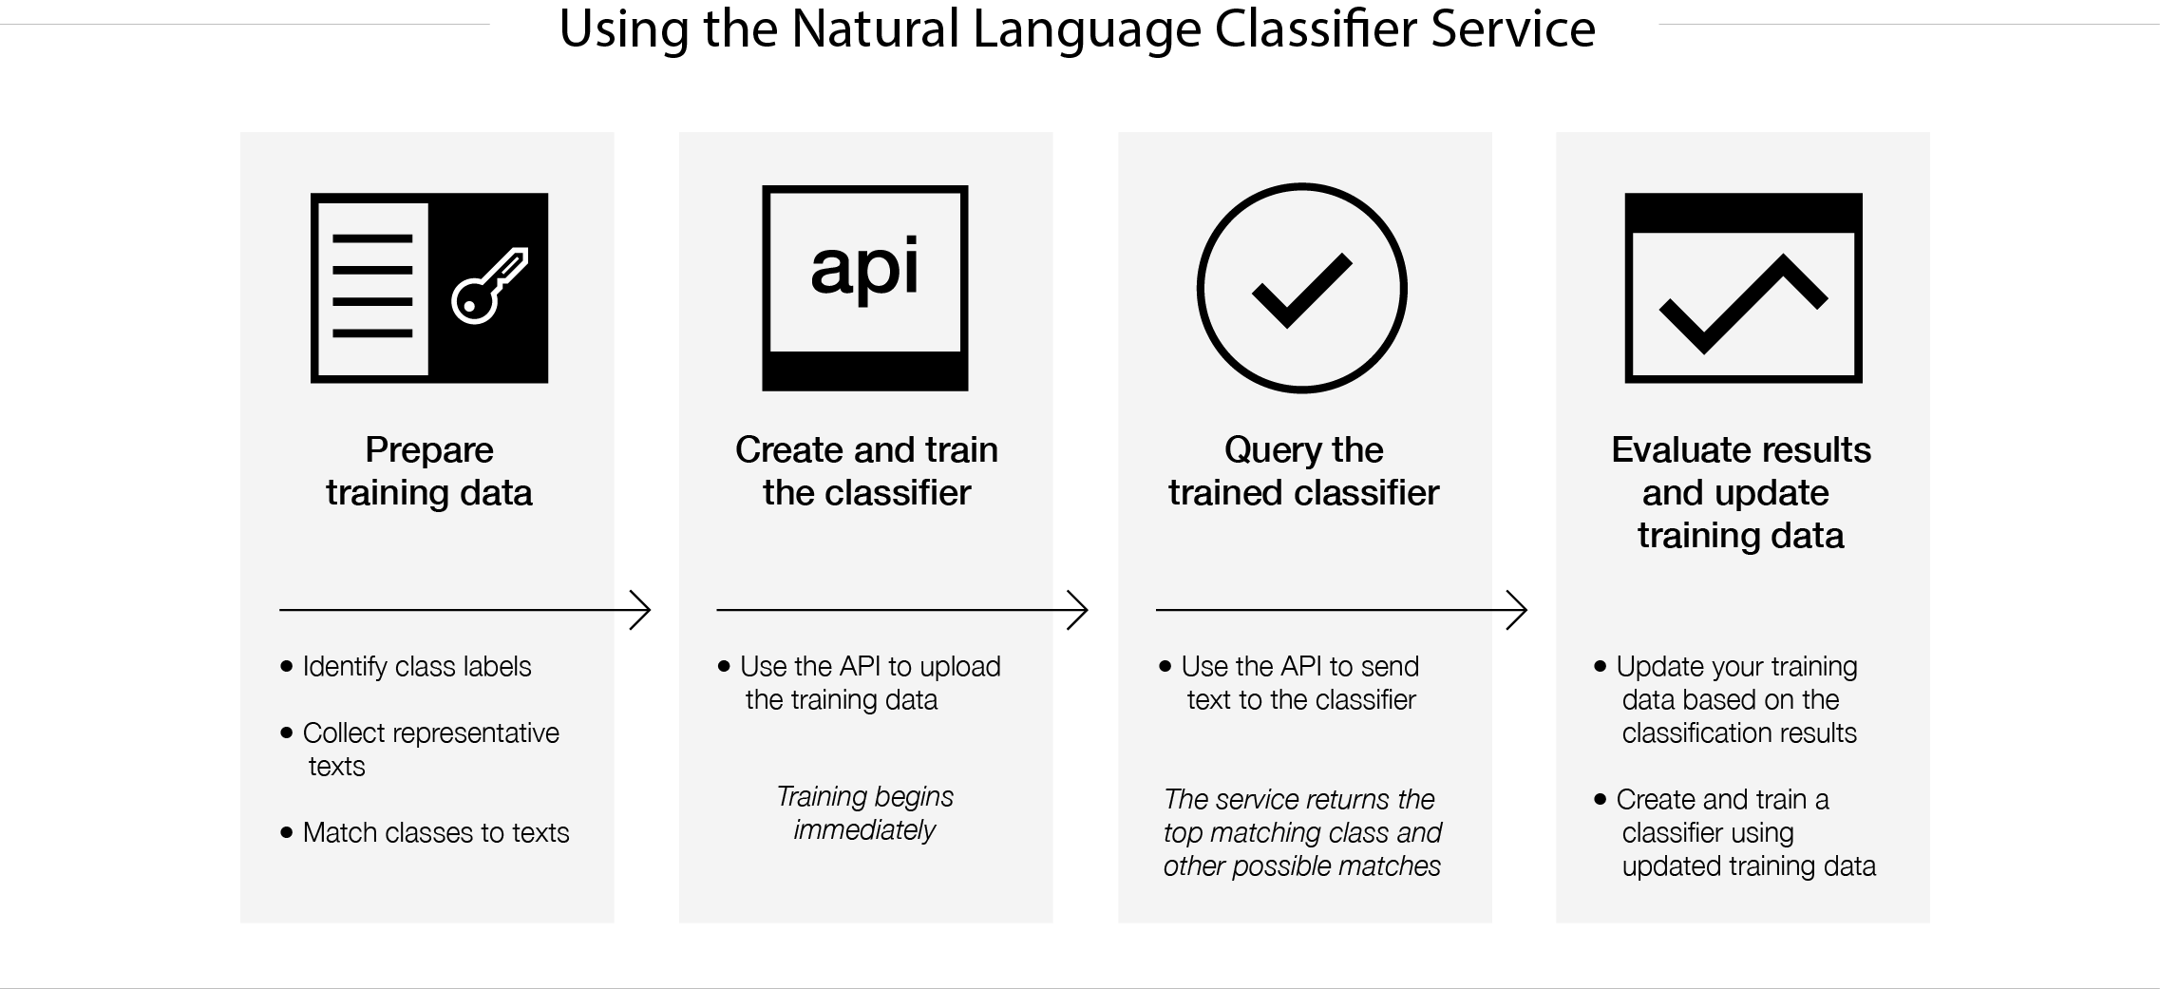

**8. Personality Insights**

* Documentation: [https://console.bluemix.](https://console.bluemix.net/docs/services/personality-insights/getting-started.html" \l "getting-started-tutorial)net/docs/services/personality-insights/getting-started.html#getting-started-tutorial
* API Reference: <https://www.ibm.com/watson/developercloud/personality-insights/api/v3/java.html?java>
* Demo: <https://personality-insights-demo.ng.bluemix.net/>
* Redbook: -

**9. Tone Analyzer**

* Documentation: [https://console.bluemix.net/docs/services/tone-analyzer/getting-started.html#getting-started-tutorial](https://console.bluemix.net/docs/services/tone-analyzer/getting-started.html" \l "getting-started-tutorial)
* API Reference: <https://www.ibm.com/watson/developercloud/tone-analyzer/api/v3/java.html?java>
* Demo: <https://tone-analyzer-demo.ng.bluemix.net/>
* Demo: <https://customer-engagement-demo.ng.bluemix.net/>
* Redbook: -

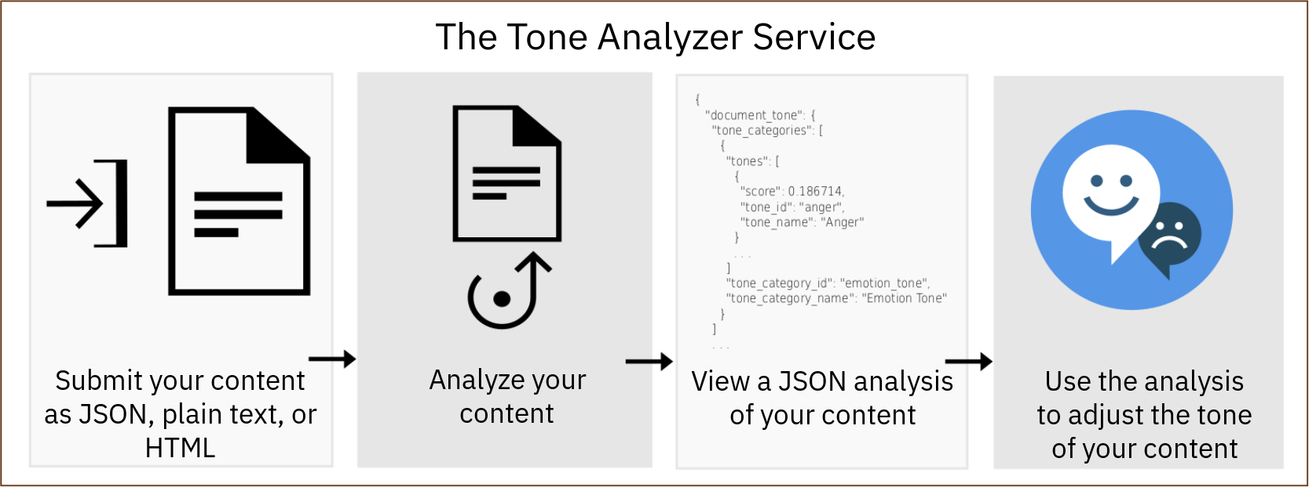

**10. Language Translator**

* Documentation: [https://console.bluemix.net/docs/services/language-translator/getting-started.html#gettingstarted](https://console.bluemix.net/docs/services/language-translator/getting-started.html" \l "gettingstarted)
* API Reference: <https://www.ibm.com/watson/developercloud/language-translator/api/v3/java.html?java>
* Demo: <https://language-translator-demo.ng.bluemix.net/>
* Redbook: <http://www.redbooks.ibm.com/redbooks.nsf/redbookabstracts/sg248392.html?Open>

**11. Machine Learning**

* Documentation: https://console.bluemix.net/docs/services/PredictiveModeling/index.html#WMLgettingstarted
* API Reference: https://dataplatform.ibm.com/docs/content/analyze-data/pm_service_api_spark.html
* Demo: -
* Redbook: -