IBM Cloud account:
1. Create and IBM Cloud account: https://onthehub.com/ibm/

Install tools for local development:
2. Get Eclipse (With IBM Cloud plug-ins) from http://eclipse.bluemix.net/packages/epp.bmt/?cm_mc_uid=22565909282615302790198&cm_mc_sid_50200000=53683491550266207784&cm_mc_sid_52640000=40488661550266207791
3. Install the plug-in "IBM Websphere Liberty Tools 18.0.0.4" into Eclipe. Then create an IBM Websphere Liberty Server (I'm using the WebProfile 8, The video below uses the WebProfile 7)
Reference material
- https://www.youtube.com/watch?v=DOZ61smBeA0
- https://developer.ibm.com/wasdev/downloads/liberty-profile-using-eclipse/

Create the application: The REST services with jersey
Example material
- https://crunchify.com/how-to-build-restful-service-with-java-using-jax-rs-and-jersey/
4. Create a Dynamic Web Project (See images for values to enter/select)
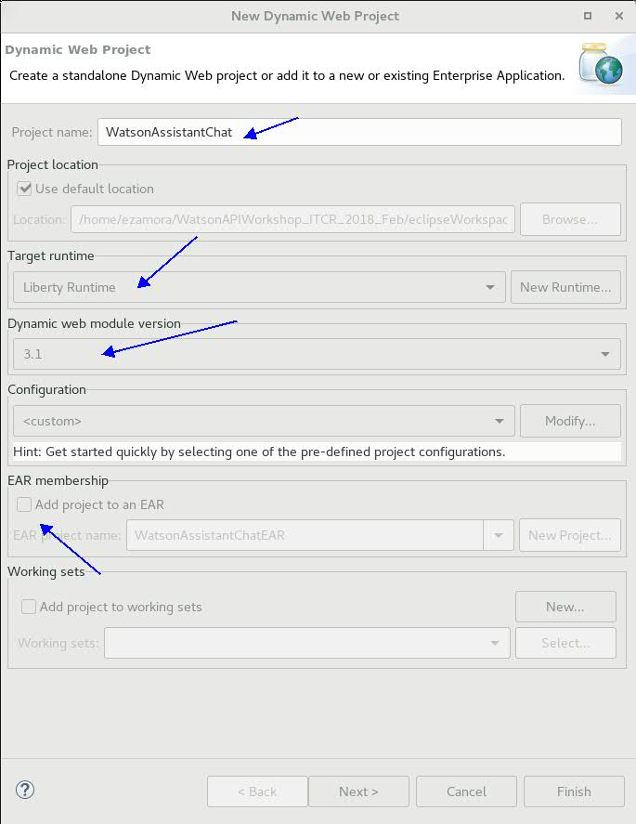
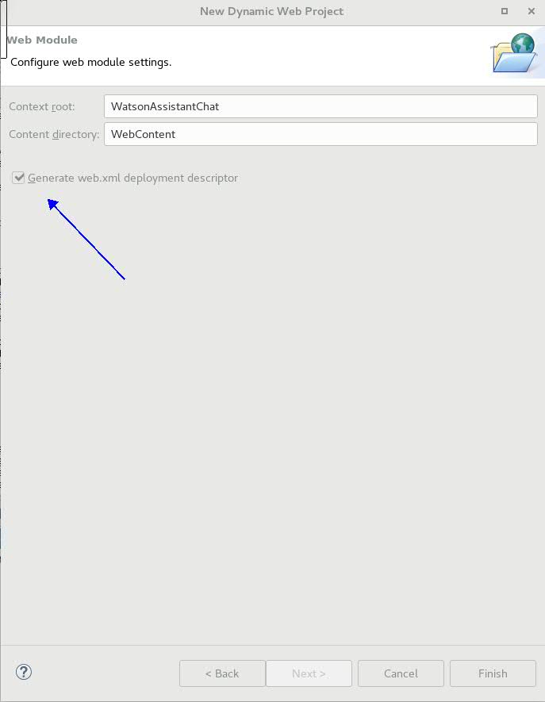

5. Convert to maven project
Right click on the project, Then Configure>Convert to Maven Project

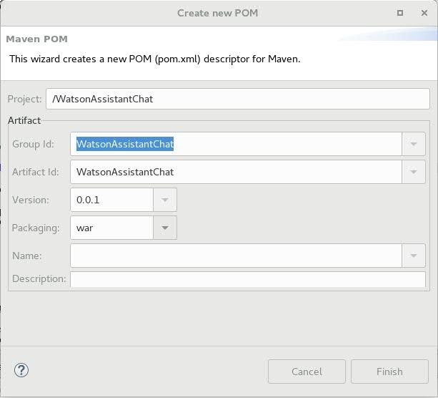

6. On the new pom.xml file, remove this dependency
<dependency>
<groupId>net.wasdev.maven.tools.targets</groupId>
<artifactId>liberty-target</artifactId>
<version>19.0.0.1</version>
<type>pom</type>
<scope>provided</scope>
</dependency>

And add these ones:
<dependency>
<groupId>asm</groupId>
<artifactId>asm</artifactId>
<version>3.3.1</version>
</dependency>
<dependency>
<groupId>com.sun.jersey</groupId>
<artifactId>jersey-bundle</artifactId>
<version>1.19.4</version>
</dependency>
<dependency>
<groupId>org.json</groupId>
<artifactId>json</artifactId>
<version>20170516</version>
</dependency>
<dependency>
<groupId>com.sun.jersey</groupId>
<artifactId>jersey-server</artifactId>
<version>1.19.4</version>
</dependency>
<dependency>
<groupId>com.sun.jersey</groupId>
<artifactId>jersey-core</artifactId>
<version>1.19.4</version>
</dependency>

7. Add these configurations to the web.xml

<servlet>
<servlet-name>Jersey Web Application</servlet-name>
<servlet-class>com.sun.jersey.spi.container.servlet.ServletContainer</servlet-class>
<load-on-startup>1</load-on-startup>
</servlet>
<servlet-mapping>
<servlet-name>Jersey Web Application</servlet-name>
<url-pattern>/chatbot/*</url-pattern>
</servlet-mapping>

8. Create service class

package worshop.chat;

import javax.ws.rs.GET;
import javax.ws.rs.Path;
import javax.ws.rs.QueryParam;
import javax.ws.rs.Produces;

@Path("/chatservice")
public class ChatService {

@GET
@Produces("application/json")
public String getResponse(@QueryParam("conversationMsg") String conversationMsg, @QueryParam("conversationCtx") String conversationCtx) {
return "{\"response\":\"Hi!!!\", \"context\":{\"msg\": " + conversationMsg +", \"ctx\": " + conversationCtx +"}}";
}

}

9. Build with maven
Project -> Clean
Project -> Right click -> Maven -> Update Project
Project -> Right click -> Run As.. -> Maven Build -> Add "clean install" goals -> Run

10. Add project to the server and start the server

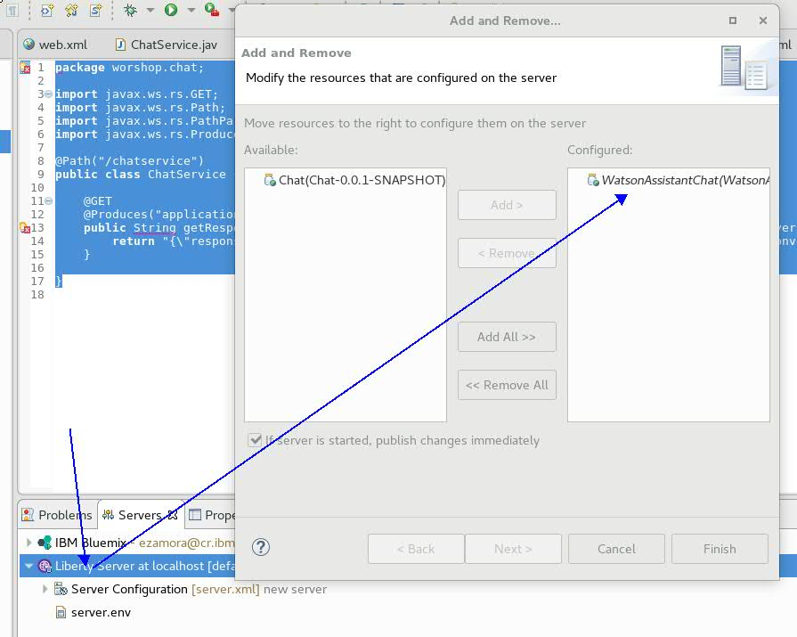

11 In a browser type: http://localhost:9080/WatsonAssistantChat/chatbot/chatservice/?conversationMsg=Hola&conversationCtx={%22msg%22:%22Hola%22}

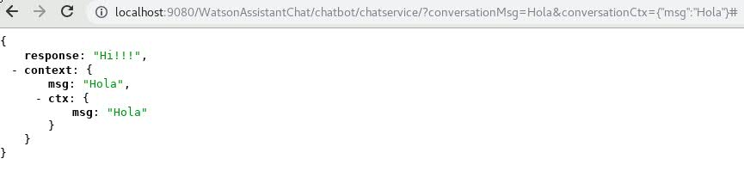

Deploying application to IBM Cloud
Check this video again, if you haven’t: - https://www.youtube.com/watch?v=DOZ61smBeA0

12. Add the manifest.yml to the root of your project (Change “Ezamora” in the texts for something that makes your url unique, e.g. a serial, your initials)
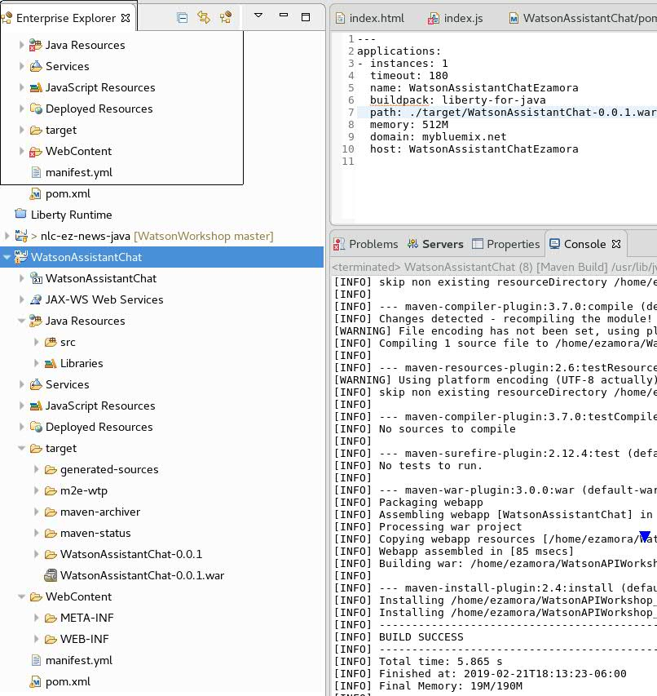
Project -> Clean
Project -> Right click -> Maven -> Update Project
Project -> Right click -> Run As.. -> Maven Build -> Add "clean install" goals -> Run

13. Create Bluemix Server
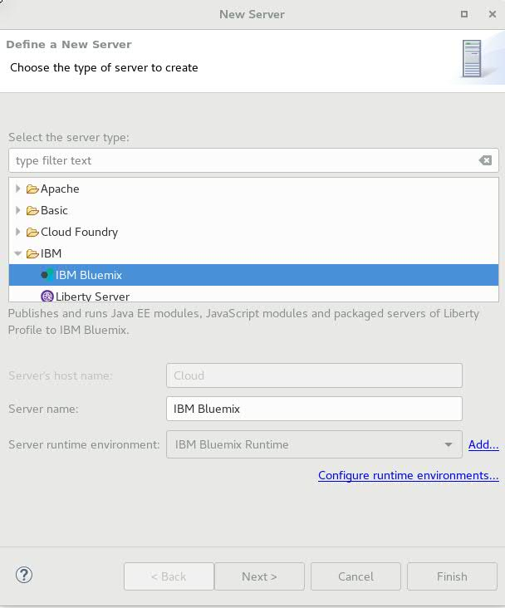

Click next> Add your IBM cloud user and password
Click Next> Select the organization and space
Click Next> Add your application
Click Next> Keep the values of the manifest and don’t add services

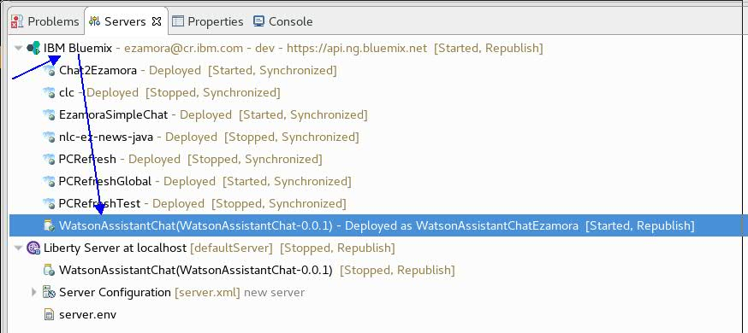

14. Go to the browser and enter (Remember to change “Ezamora” for your suffix of step 12)

https://watsonassistantchatezamora.mybluemix.net/chatbot/chatservice/?conversationMsg=Hola&conversationCtx={%22msg%22:%22Hola%22}

Create the application: The web UI (ReactJS, without server side)
Example material
https://www.youtube.com/watch?v=A800BaLBB2k
https://medium.freecodecamp.org/how-to-build-a-react-js-chat-app-in-10-minutes-c9233794642b
https://blog.hellojs.org/fetching-api-data-with-react-js-460fe8bbf8f2

15 Create the next files/folder in the eclipse project, under WebContent folder

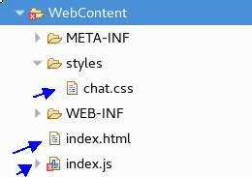

index.html

<!DOCTYPE html>
<html>
<head>
<meta charset="UTF-8">
<title>Simple chat application</title>
<link rel="stylesheet" href="styles/chat.css">
</head>
<body>
<div id="root"></div>
<script src="https://unpkg.com/react@16/umd/react.development.js"></script>
<script src="https://unpkg.com/react-dom@16/umd/react-dom.development.js"></script>
<script src="index.js" type="text/babel"></script>
</body>
</html>

index.js

class App extends React.Component {
constructor() {
super()
this.state = {
messages: []
}
this.sendMessage = this.sendMessage.bind(this)
}

// componentDidMount() {
// }

sendMessage(text) {
fetch('http://localhost:9080/WatsonAssistantChat/chatbot/chatservice/?conversationMsg=' + text + '&conversationCtx={"usr":"ezamora"}#')
.then((response) => {
return response.json()
})
.then((myJsonResponse) => {
this.setState({
messages: [...this.state.messages, myJsonResponse]
})
})
}

render() {
return (
<div className="app">
<Title />
<MessageList
messages={this.state.messages} />
<SendMessageForm
sendMessage={this.sendMessage} />
</div>
);
}
}

class MessageList extends React.Component {
render() {
return (
<ul className="message-list">
{this.props.messages.map((message, index) => {
return (
<li key={message.response} className="message">
<div>{message.context.ctx.usr}</div>
<div>{message.context.msg}</div>
</li>
)
})}
</ul>
)
}
}

class SendMessageForm extends React.Component {
constructor() {
super()
this.state = {
message: ''
}
this.handleChange = this.handleChange.bind(this)
this.handleSubmit = this.handleSubmit.bind(this)
}

handleChange(e) {
this.setState({
message: e.target.value
})
}

handleSubmit(e) {
e.preventDefault()
this.props.sendMessage(this.state.message)
this.setState({
message: ''
})
}

render() {
return (
<form
onSubmit={this.handleSubmit}
className="send-message-form">
<input
onChange={this.handleChange}
value={this.state.message}
placeholder="Type your message and hit ENTER"
type="text" />
</form>
)
}
}

function Title() {
return <p className="title">Simple chat app (For IBM cloud deploy)</p>
}

ReactDOM.render(<App />, document.getElementById('root'));

16. Build with maven
Project -> Clean
Project -> Right click -> Maven -> Update Project
Project -> Right click -> Run As.. -> Maven Build -> Add "clean install" goals -> Run

17. Add project to the Liberty server and start the server

18. In a browser type: http://localhost:9080/WatsonAssistantChat and test the UI

Deploying application to IBM Cloud (With UI)
19. Update the service url in the index.js

sendMessage(text) {
//fetch('http://localhost:9080/WatsonAssistantChat/chatbot/chatservice/?conversationMsg=' + text + '&conversationCtx={"usr":"ezamora"}#')
fetch('https://watsonassistantchatezamora.mybluemix.net/chatbot/chatservice/?conversationMsg=' + text + '&conversationCtx={"usr":"ezamora"}#')
.then((response) => {
return response.json()
})
.then((myJsonResponse) => {
this.setState({
messages: [...this.state.messages, myJsonResponse]
})
})
}

20. Build with maven
Project -> Clean
Project -> Right click -> Maven -> Update Project
Project -> Right click -> Run As.. -> Maven Build -> Add "clean install" goals -> Run

21. Click right on Project in the Bluemix Server
select push

22. Test application at https://watsonassistantchatezamora.mybluemix.net/

