Paper Title* (use style: paper title)
*Note: Sub-titles are not captured in Xplore and should not be used

Erin Zaroukian
Computational and Information Sciences Directorate
U.S. Army Research Laboratory
Aberdeen Proving Ground, USA
erin.g.zaroukian.civ@mail.mil
Justine Caylor
line 2: dept. name of organization (of Affiliation)
line 3: name of organization (of Affiliation)
line 4: City, Country
line 5: email address or ORCID
Michelle Vanni
line 2: dept. name of organization (of Affiliation)
line 3: name of organization (of Affiliation)
line 4: City, Country
line 5: email address or ORCID
Sue Kase
line 2: dept. name of organization (of Affiliation)
line 3: name of organization (of Affiliation)
line 4: City, Country
line 5: email address or ORCID

Abstract— Information extraction (IE) pipelines aim to point human decision makers toward relevant information, but beyond the accuracy of the pipeline itself, designing the presentation of the output of the pipeline for optimal human understanding should be a goal. This paper establishes a framework for testing comprehension of text documents with and without markup from an IE pipeline and reports the results of a behavioral experiment where an information extraction pipeline, instead of helping, seems to hurt both objective and subjective measures of performance. These results suggest further steps that can be taken toward developing more human-usable IE pipeline outputs.
Keywords—component, formatting, style, styling, insert (key words)

Introduction (Heading 1)
Information extraction (IE) pipelines have been developed as a way to pull relevant information from large document sets. When a decision maker such as a military intelligence analyst has mountains of documents to synthesize in a limited amount of time, a reliable IE pipeline may be an invaluable aid for making selections of relevant documents or portions of documents for further summarization to facilitate decision making.
While the output of an IE pipeline can take many forms, it often provides markup for input texts, identifying, for example, relevant entities and events. Research on these pipelines typically focuses on precision and recall of the computational outputs, and while these are important measures, the end (human) user is often overlooked. What work that has focused on human users typically looks at user experience with highly specific or low-level features such as font size and serifs, e.g., [1-3]. Little research on markup and its effect on reading comprehension is available, and in particular there is a paucity of work comparing text with markup to text without markup to assess what value markup adds. In response, this paper aims to establish a framework for assessing markup by presenting an experiment comparing comprehension of text documents with and without markup from an IE pipeline. Results of such experiments can then lead us toward developing more human-useable IE pipeline outputs.
Starting with simple text documents and the output of an existing IE pipeline, this paper asks: Does markup improve human comprehension of text documents? Comprehension in this experiment is measured objectively as the accuracy and speed with which participants answer questions about the text, and it is measured subjectively through ratings of workload (self-reported mental task demands) and preference (preferred document representation with or without markup). Here, marked-up text surprisingly leads to worse comprehension (lower accuracy, slower response times, higher workload ratings, and lower preference ratings) than comparable text without markup. Further work is proposed to gain a clearer understanding of why this pattern emerged and what it means for creating useful markup.

Previous Work/Experiment
A previous experiment was conducted… cite… identical to the experiment presented below with the following exceptions:
1. The first experiment treated with/without markup as a within-subjects manipulation with 100 participants. The second experiment treats with/without markup as a between-subjects manipulation with 100 participants per condition. [add explanation for change]
2. The version of the NASA-TLX survey used in the first experiment was modified to directly compare both version of the task (with/without markup). The second experiment used the NASA-TLX as written. [because between subjects]
3. The first experiment did not include a trust in automation survey. The second experiment does.
4. The markup in the first experiment was generated using an IE pipeline developed at Rensselaer Polytechnic Institute [4][5] which highlights a variety of entities (e.g., person, vehicle, geo-political entity), and where mouse-over reveals additional information (e.g., a relation’s arguments, the class an entity belongs to). See Fig. 1 for an example of text marked up through this IE pipeline. The markup in the second experiment was created by hand to be as accurate and relevant as possible.
5. The first experiment drew from four separate scenarios. In the second experiment, only two separate scenarios were used. [hand markup ease]
For more detail, see below or ICCRTS paper.
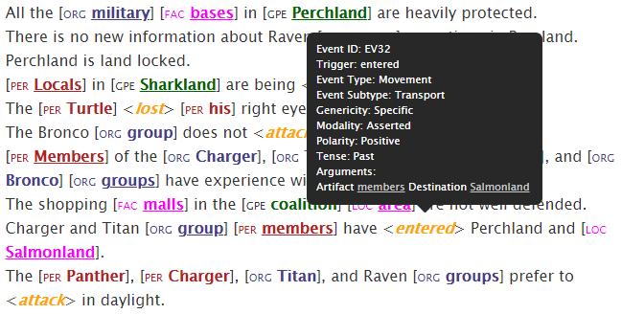Excerpt from an ELICIT scenario showing markup with mouse-over information for “entered”.
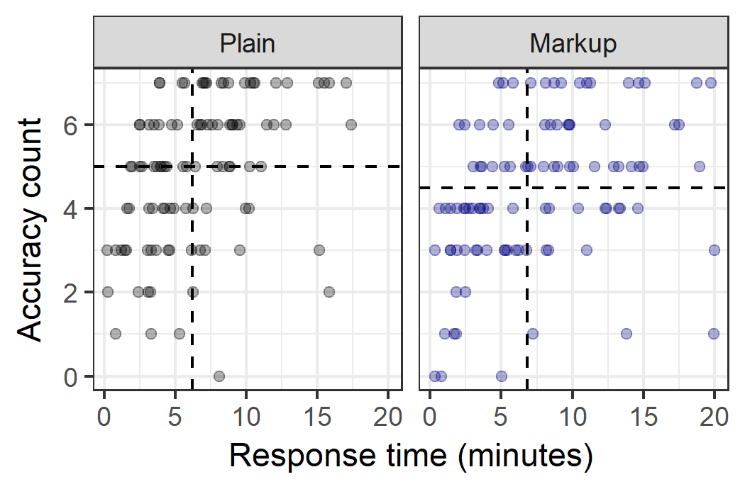
Accuracy count (number of correctly answered questions) versus response time in minutes for each participant in each condition. Medians are shown as dotted lines.
In this first experiment, a Wilcoxon signed-rank test determined that participants answered significantly more questions corrrectly in the plain condition (median = 5) than in the markup condition (median = 4.5, p=0.04). Among the 77 participants that showed an asymmetry in their accuracy counts across conditions, 46 (60%) scored higher in the plain condition.
An additional Wilcoxon signed-rank test determined that participants answered significantly faster in the plain condition (median = 6.19 minutes) than in the markup condition (median = 6.83 minutes, p=0.02). Fifty-eight of the 100 participants (58%) responded faster in the plain condition.
In addition to responding more accurately and quicky on markup trials, participants overall associated higher workload with the markup trials and showed a preference for plain trials. Participant scores on these 21-point scales were binned (1-10, 12-21) into those indicating the plain version of the task and those indicating the markup version of the task (the side of the scale associated with each of these versions was randomized, scores of 11 were dropped from analysis). For each question, Pearson’s Chi-squared tests show significantly more favorable scores for the plain version, shown in Table… [add something about multiple comparisons?]
Question | Percent of participants that chose this version of the task
Question | Plain | Markup
Which version of the task felt more mentally demanding? | 29 | 64
Which version of the task felt more mentally demanding? | χ²(1, N=93)=13.17, p<0.001
Which version of the task felt more physically demanding? | 22 | 45
Which version of the task felt more physically demanding? | χ²(1, N=67)=7.90, p=.005
Which version of the task felt more hurried or rushed? | 21 | 49
Which version of the task felt more hurried or rushed? | χ²(1, N=70)=11.2, p<0.001
On which version of the task do you think you performed better? | 57 | 34
 | χ²(1, N=91)=5.81, p=.016
On which version of the task did you feel you had to work harder? | 25 | 64
 | χ²(1, N=89)=17.09, p<0.001
Which version of the task lead you to feel more insecure, discouraged, irritated, stressed, or annoyed? | 26 | 62
 | χ²(1, N=88)=14.73, p<0.001
Overall, which version of the task you do you prefer? | 66 | 30
Overall, which version of the task you do you prefer? | χ²(1, N=96)=13.5, p<0.001

The poorer scores, both objective and subjective, seen on markup trials in this experiment suggest that markup is detrimental to performance. The markup used here, however, is far from perfect and should by no means signal an indightment of all markup. To better understand how markup might be of use, the markup in the next experiment was designed to be optimna, i.e., as accurate and as relevant (define or something...) as possible. If participants perform better with such markup than without, further testing can be conducted to estimate thresholds in accuracy and relevance required for markup to be considered a helpful addition. If participants do not perform better with this markup than without, more serious thought should be given to the use of such markup.

Current Experiment
The current experiment tests whether participants show improvments in objective and subjective measures of performance using maximally-accurate and maximally-relevant text markup over non-marked-up text in uncovered a hypothetical adversarial attack.

Participants
Two hundred participants were recruited through Amazon Mechanical Turk to take part in this experiment. Each participant was compensated $2.00.

Materials and Equipment
Identify applicable funding agency here. If none, delete this text box.
The experiment was prepared using the Ibex tool for running behavioral psycholinguistic experiments (https://code.google.com/archive/p/webspr/) and run online through Amazon Mechanical Turk.The markup used in this experiment was generated by hand by the first auther (regenerated by other authors and compared, resolved). .... See Fig. 1 for an example of text marked up through this IE pipeline.
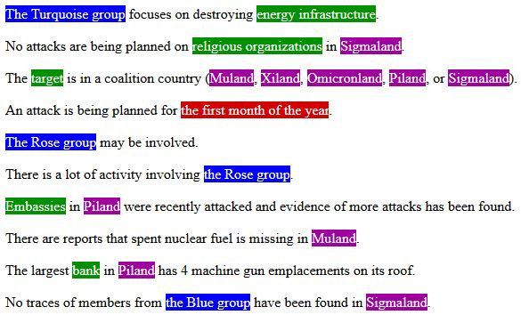
The text used in this experiment was drawn from ELICIT, the Experimental Laboratory for the Investigation of Collaboration, Information Sharing, and Trust [6]. ELICIT is a type of hidden profile task, which requires deductive reasoning to solve a problem given different pieces of information. Specifically, ELICIT is a simulated intelligence task containing a number of hypothetical adversary attack scenarios, each in the form of a list of 68 simple sentences that together allow a reader to deduce the Who, What, When, and Where of an anticipated adversary attack. These questions are answered in this experiment through seven dropdown menus (When is broken down into separate menus for month, date, time of day, and am/pm). See Fig. 1 above for example sentences from an ELICIT scenario.
This experiment included three questionnaires: a demographic questionnaire, a trust in automation questionnaire [maybe Justine can add citation and details (or no details since we’re tight on space here, save it for another paper], and the NASA Task Load Index (NASA-TLX) [8]. The NASA-TLX asked participants to rate the task on a variety of workload measures, and a question was included asking participants, were they to do the task again, whether they would prefer to do the task with or without markup. These questions can be seen in Table I... Participants responded to each question by choosing a point on a 21-point scale where the ends of the scale represent a strong preference for each of the versions.

Procedure
At the beginning of the experiment, participants completed a demographic questionnaire and read a page of instructions explaining the experiment. Participants then completed an abbreviated practice scenario in each condition in order to familiarize them with the scenario presentation and the method for answering questions, as well as to ensure that each participant had some exposure to the markup (importand for the trust in automation survey). Participants then completed a trust in automation survey to gauge their baseline trust. At the end of the experiment, participants again complete the trust in automation surver, as well as the workload and preference questionnaire.
Each participant completed two test scenarios, both either with markup (markup condition) or without (plain condition), determined randomly. Accuracy and response time were collected for each test scenario.

Results
After concerns about quality in the previous experiment, the following/several filtering criteria were established. Unfortunately, this lead to a loss of nearly half of all participants. In the results presented below, only the speed criteria was maintained, as it was the least subjective. This caused 50 participants to be dropped. One additional participant was dropped due to a technical failure, leaving 80 participants in the plain condition and 69 participants in the markup condition. All participants’ accuracy and responses times are shown in Fig. X. All other measures include only the filtered 149 participants.
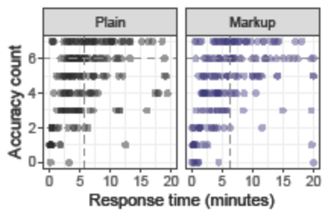Accuracy count (number of correctly answered questions) versus response time in minutes for all participants, separated by each condition. Medians (with filering criterion applied) are shown as dotted lines.

A Wilcoxon rank sum test found no significant difference in the number of correctly answered questions betwen conditions (plain median = 6, markup median = 6, W = 10976, p=0.93, r=.005).
An additional Wilcoxon rank sum test found no significant difference in response time betwen conditions (plain median = 5.73, markup median = 6.38, W=12005, p =0.19, r=.08). However, while the effect size here is quite small, it suggests that with more power significantly faster response times may emerge for plain trials.
Responses to the TLX questions were binned (1-7, 8-14, 15-21) and compared across conditions using Pearson’s Chi-quared test. Only the fourth question about perceived success emerged as differing significantly across conditions, with responses skewing higher in the markup condition (χ²(2, N=149)=7.95 , p=0.02) (plain: 35/31/14 vs. markup: 25/18/26).
Question | Median response
Question | Plain | Markup
How mentally demanding was the task? | 18 | 18
How physically demanding was the task? | 2 | 2
How hurried or rushed was the pace of the task? | 11 | 11
How successful were you in accomplishing what you were asked to do? | 9 | 11
How hard did you have to work to accomplish your level of performance? | 18 | 17
How insecure, discouraged, irritated, stressed, and annoyed were you? | 9 | 8

s

The question on preference, “If given the choice, which version of the task would you prefer to work with?”, directly compared both versions of the task and so was binned as in the first experiment (1-10, 12-21), where 1-10 = plain preference and 12-21 = markup preference. Responses were pooled across both conditions, and a Pearson’s Chi-squared test showed a significant preference for markup (χ²(1, N=124)=23.52, p<0.001), (35 vs 89).
While there are no clear differences among objective measures of performance, the subjective measures hint at higher perceived success with markup and an overall preference for markup.

Discussion
The experiment presented here attepmted to create a best-case scenario for markup… This resulted minimally in no clear preference for the plain condition, unlike in the first experiment. However, only participants subjective measures show any advantage for markup over plain.
Where to go from here – look deeper into data, try to get more power, consider that this markup might not be that optimal, look at trust in automation...

Figures and Tables

Positioning Figures and Tables: Place figures and tables at the top and bottom of columns. Avoid placing them in the middle of columns. Large figures and tables may span across both columns. Figure captions should be below the figures; table heads should appear above the tables. Insert figures and tables after they are cited in the text. Use the abbreviation “Fig. 1”, even at the beginning of a sentence.
- Table Type Styles
Table Head | Table Column Head
Table Head | Table column subhead | Subhead | Subhead
copy | More table copyª
- Sample of a Table footnote. (Table footnote)
- Example of a figure caption. (figure caption)
Figure Labels: Use 8 point Times New Roman for Figure labels. Use words rather than symbols or abbreviations when writing Figure axis labels to avoid confusing the reader. As an example, write the quantity “Magnetization”, or “Magnetization, M”, not just “M”. If including units in the label, present them within parentheses. Do not label axes only with units. In the example, write “Magnetization (A/m)” or “Magnetization {A[m(1)]}”, not just “A/m”. Do not label axes with a ratio of quantities and units. For example, write “Temperature (K)”, not “Temperature/K”.

Acknowledgment (Heading 5)
The preferred spelling of the word “acknowledgment” in America is without an “e” after the “g”. Avoid the stilted expression “one of us (R. B. G.) thanks ...”. Instead, try “R. B. G. thanks...”. Put sponsor acknowledgments in the unnumbered footnote on the first page.

References
The template will number citations consecutively within brackets [1]. The sentence punctuation follows the bracket [2]. Refer simply to the reference number, as in [3]—do not use “Ref. [3]” or “reference [3]” except at the beginning of a sentence: “Reference [3] was the first ...”
Number footnotes separately in superscripts. Place the actual footnote at the bottom of the column in which it was cited. Do not put footnotes in the abstract or reference list. Use letters for table footnotes.
Unless there are six authors or more give all authors’ names; do not use “et al.”. Papers that have not been published, even if they have been submitted for publication, should be cited as “unpublished” [4]. Papers that have been accepted for publication should be cited as “in press” [5]. Capitalize only the first word in a paper title, except for proper nouns and element symbols.
For papers published in translation journals, please give the English citation first, followed by the original foreign-language citation [6].

- G. Eason, B. Noble, and I. N. Sneddon, “On certain integrals of Lipschitz-Hankel type involving products of Bessel functions,” Phil. Trans. Roy. Soc. London, vol. A247, pp. 529–551, April 1955. (references)
We suggest that you use a text box to insert a graphic (which is ideally a 300 dpi TIFF or EPS file, with all fonts embedded) because, in an MSW document, this method is somewhat more stable than directly inserting a picture.
To have non-visible rules on your frame, use the MSWord “Format” pull-down menu, select Text Box > Colors and Lines to choose No Fill and No Line.
- J. Clerk Maxwell, A Treatise on Electricity and Magnetism, 3rd ed., vol. 2. Oxford: Clarendon, 1892, pp.68–73.
- I. S. Jacobs and C. P. Bean, “Fine particles, thin films and exchange anisotropy,” in Magnetism, vol. III, G. T. Rado and H. Suhl, Eds. New York: Academic, 1963, pp. 271–350.
- K. Elissa, “Title of paper if known,” unpublished.
- R. Nicole, “Title of paper with only first word capitalized,” J. Name Stand. Abbrev., in press.
- Y. Yorozu, M. Hirano, K. Oka, and Y. Tagawa, “Electron spectroscopy studies on magneto-optical media and plastic substrate interface,” IEEE Transl. J. Magn. Japan, vol. 2, pp. 740–741, August 1987 [Digests 9th Annual Conf. Magnetics Japan, p. 301, 1982].
- M. Young, The Technical Writer’s Handbook. Mill Valley, CA: University Science, 1989.
- J. Nielsen, Designing web usability: The practice of simplicity, Indianapolis, IN: New Riders Publishing, 1999.
- L. Rello, M. Pielot, M. Marcos, “Make it big!: The effect of font size and line spacing on online readability,” Proceedings of the 2016 CHI Conference on Human Factors in Computing Systems, 2016, pp. 3637-3648.
- L. Akhmadeeva, I. Tukhvatullin, and B. Veytsman, “Do serifs help in comprehension of printed text? An experiment with Cyrillic readers,” Vision Research, vol 65, 2012, pp. 21-24.
- Q. Li and H. Ji, “Incremental Joint Extraction of Entity Mentions and Relations,” Proceedings of the 52nd Annual Meeting of the Association for Computational Linguistics, June 2014, pp. 402–412.
- Q. Li, H. Ji, and L. Huang, “Joint Event Extraction via Structured Prediction with Global Features,” Proceedings of the 51st Annual Meeting of the Association for Computational Linguistics, August 2013, pp. 73–82.
- M. Ruddy, “ELICIT – The Experimental Laboratory for the Investigation of Collaboration, Information Sharing, and Trust,” Proceedings of the 12th ICCRTS, Newport, RI, June 2007.
- A. Krausman, “Understanding audio communication delay in distributed team interaction: Impact on trust, shared understanding, and workload,” Proceedings of the IEEE Conference on Cognitive and Computational Aspects of Situation Management (CogSIMA), Savannah, GA, pp. 1-3.
- NASA: NASA Task Load Index (TLX), v. 1.0 Manual, 1986.
- E. C. Poulton and P. R. Freeman, “Unwanted asymmetrical transfer effects with balanced experimental designs,” in Psychological Bulletin, 1966, pp. 1-8.
- E. T. Davis and J. Palmer, “Visual search and attention: An overview,” Spatial Vision, vol 17 (4-5), 2004, pp. 249-255.
- J. C. Jan, C. M. Chen, and P. H. Huang, “Enhancement of digital reading performance by using a novel web-based collaborative reading annotation system with two quality annotation filtering mechanisms,” International Journal of Human-Computer Studies, vol 86, 2016, pp. 81-93.
- A. Neigel, J. Caylor, S. Kase, M. Vanni, J. Hoye, “The Role of Trust and Automation in an Intelligence Analyst Decisional Guidance Paradigm,” Journal of Cognitive Engineering and Decision Making, vol. 12, no. 4, 2018, pp. 239–247.
- E. Zaroukian, “Information extraction for optimized human understanding and decision making,” Proceeding
IEEE conference templates contain guidance text for composing and formatting conference papers. Please ensure that all template text is removed from your conference paper prior to submission to the conference. Failure to remove template text from your paper may result in your paper not being published.

