TECHNICAL PORTFOLIO / VALIDATION REPORT

Outage Shield
Version 1 — Test Evidence
ServiceNow Personal Developer Instance | GitHub + Cloudflare integrations | Evidence captured 03 November 2026

Executive summary
Outage Shield is a scoped ServiceNow application that monitors SaaS vendor status APIs, correlates vendor incidents to internal Service Offerings, assesses potential business risk and recommends or executes native Incident Management actions according to configured rules. It also prepares subscriber communications when potential Service Offering impact starts, changes or clears.
This report explains six groups of screenshots collected during Version 1 testing. The evidence demonstrates mapping and risk context, real native Incident escalation, Major Incident proposal, fail-safe decision handling, recurring API polling and outbound email generation.

Evidence register
Reference | Evidence | Outcome
01 | Component-to-Service Offering mappings | Four active operational mappings shown
02 | Incident creation and escalation | INC0010007: P3 to P2 on the same record
03 | Native Major Incident proposal | INC0010008: Proposed; not declared
04 | Failure safeguards | 4 / 4 test cases passed
05 | Recurring vendor polling | GitHub and Cloudflare success logs
06 | Outbound notifications | Initial and cleared emails queued for two recipients
Test method: controlled incident payloads and native ITSM tests were used for decision paths; live Cloudflare polling was used to test the full REST → mapping → advisory link → event → outbound email path. Native ITSM writes remained disabled during the live integrated polling exercise.

CONFIGURATION EVIDENCE

01 Component and service mapping
Purpose. Demonstrate that externally reported vendor components can be connected to internal ServiceNow Service Offerings, providing business context for outage assessment.
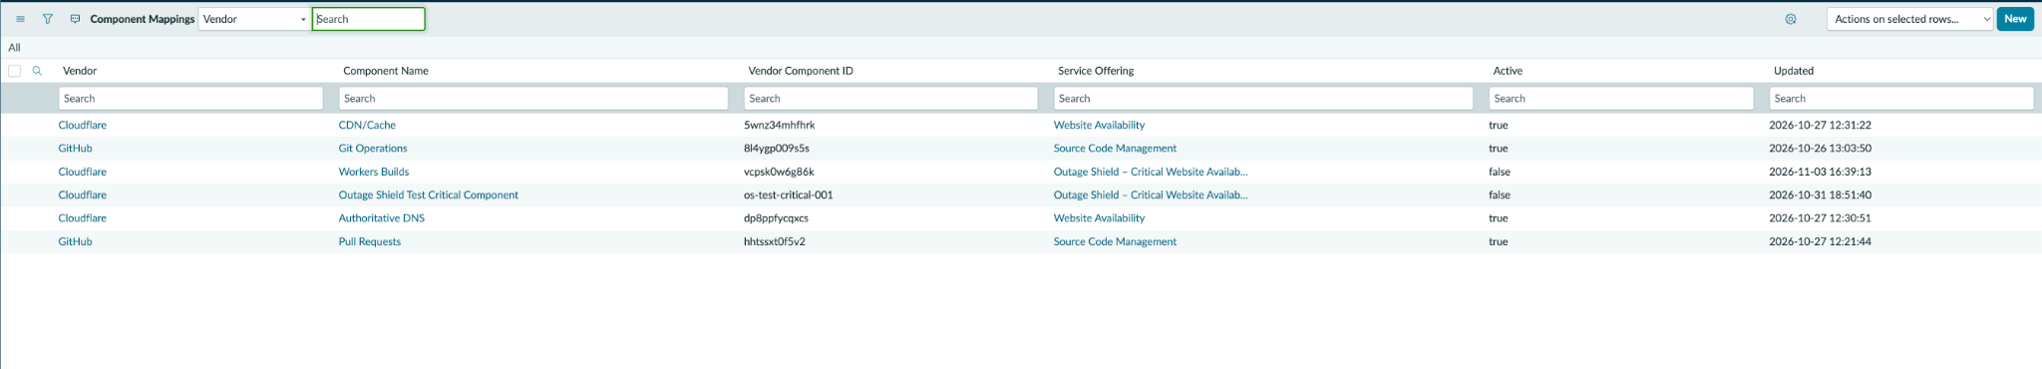
Figure 1. Component Mappings list; four operational mappings active and two test mappings inactive.
Observed. The screenshot shows GitHub Git Operations and Pull Requests mapped to Source Code Management; Cloudflare CDN/Cache and Authoritative DNS mapped to Website Availability. Workers Builds and the synthetic critical-component mapping are inactive at the time of capture.
Interpretation. The mapping table supports translating a vendor-reported component ID into the internal offering affected. Business risk then depends on the offering’s criticality and the vendor’s incident severity, not vendor severity alone.
Evidence limitation. The mapping list proves configuration is present. Actual usage of a mapping in the poller is corroborated by the live Cloudflare integration logs described later in this report.

INCIDENT MANAGEMENT EVIDENCE — PART A

02 Native Incident creation and escalation
Purpose. Verify that a Medium preliminary business risk produces a native investigative Incident with target P3, and that increased risk escalates the existing Incident to P2 instead of opening another primary Incident.
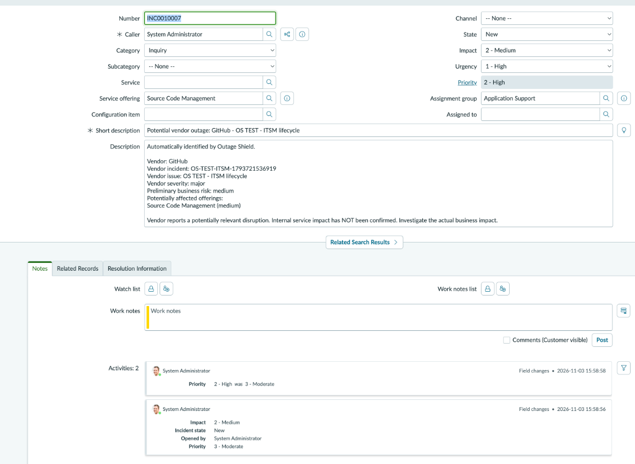
Figure 2a. INC0010007 after escalation: Source Code Management offering, Impact 2, Urgency 1, Priority 2.
Observed. Incident INC0010007 is linked to Source Code Management, assigned to Application Support and displays Priority 2 – High. Its description identifies GitHub and states that internal business impact remains unconfirmed and requires investigation.

INCIDENT MANAGEMENT EVIDENCE — PART B

02 Native Incident creation and escalation
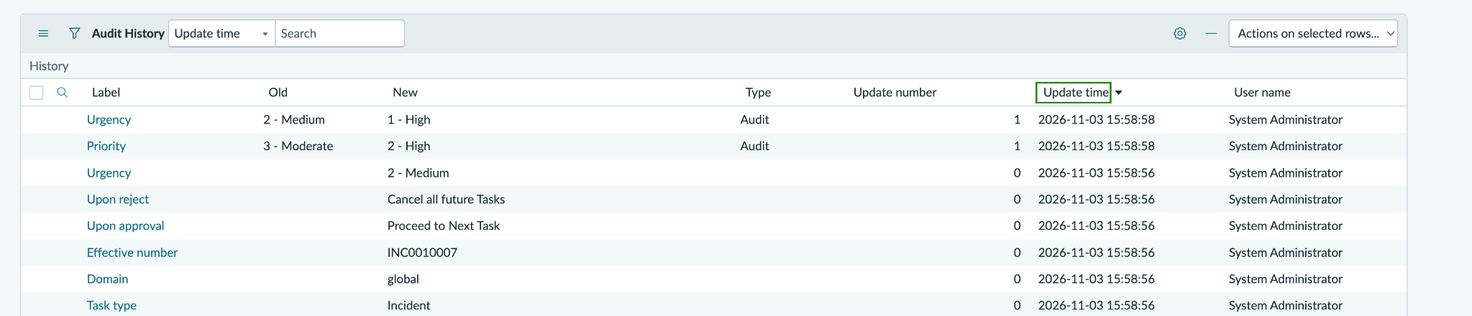
Figure 2b. Audit History showing the P3 → P2 change and associated urgency increase.
Timestamp | Audit evidence | Meaning
15:58:56 | Incident created with Priority 3 – Moderate | Initial investigative Incident at P3
15:58:58 | Urgency changed from 2 – Medium to 1 – High | Updated Impact/Urgency inputs
15:58:58 | Priority changed from 3 – Moderate to 2 – High | Escalation on INC0010007
Outcome. The audit trail confirms a change from P3 to P2 within INC0010007. Controlled test output also confirmed reuse of the primary Incident for a repeated outage report; this screenshot specifically documents the in-place escalation.
Why it matters. Avoiding duplicate Incidents is important during widespread SaaS outages, where many status updates or affected components may refer to one underlying vendor event.

NATIVE ITSM GOVERNANCE EVIDENCE

03 Major Incident candidate proposal
Purpose. Validate the Very High preliminary risk policy: create a standard investigative P2 Incident and submit a native Major Incident proposal for human assessment, without automatically declaring a Major Incident.
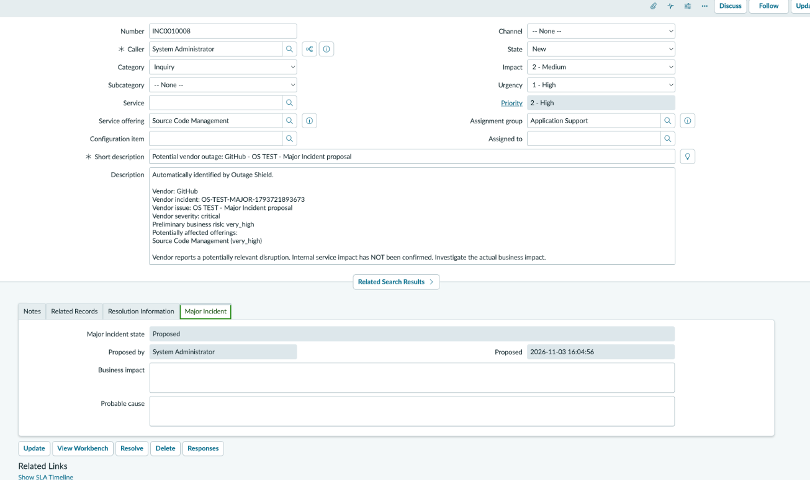
Figure 3. INC0010008 with Major Incident State = Proposed and Priority 2 – High.
Observed. INC0010008 has Service Offering Source Code Management, Impact 2 – Medium, Urgency 1 – High and Priority 2 – High. Its description records a critical GitHub vendor incident and preliminary business risk of Very High. The Major Incident tab shows State = Proposed, with a recorded proposal time of 16:04:56.
Outcome. The native proposal path worked in the controlled test. No automatic Major Incident acceptance or declaration is claimed. Human evaluation remains part of the intended process.

CONTROLLED NEGATIVE-PATH TESTING

04 Failure safeguards
Purpose. Verify that insufficient, inconsistent or malformed vendor evidence does not generate a confident impact classification or automatic escalation decision.
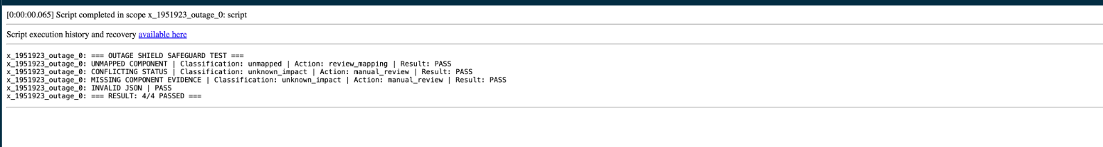
Figure 4. Scripts - Background result showing 4 / 4 safeguards passed.
Scenario | Observed classification / action | Result
Unmapped degraded component | unmapped → review_mapping | PASS
Conflicting component status | unknown_impact → manual_review | PASS
Missing component evidence | unknown_impact → manual_review | PASS
Invalid JSON payload | Rejected by parser | PASS
Outcome. All four cases passed in a repeated read-only test using the actual VendorOutageProcessor methods. These safeguards favour human review when the component evidence is ambiguous or cannot be tied to an internal offering.
Evidence limitation. This test does not simulate an HTTP timeout, server unavailability or retry/failure recovery at the transport layer.

OPERATIONAL INTEGRATION EVIDENCE

05 Scheduled vendor polling
Purpose. Verify repeatable background execution and successful processing of both configured vendor APIs.
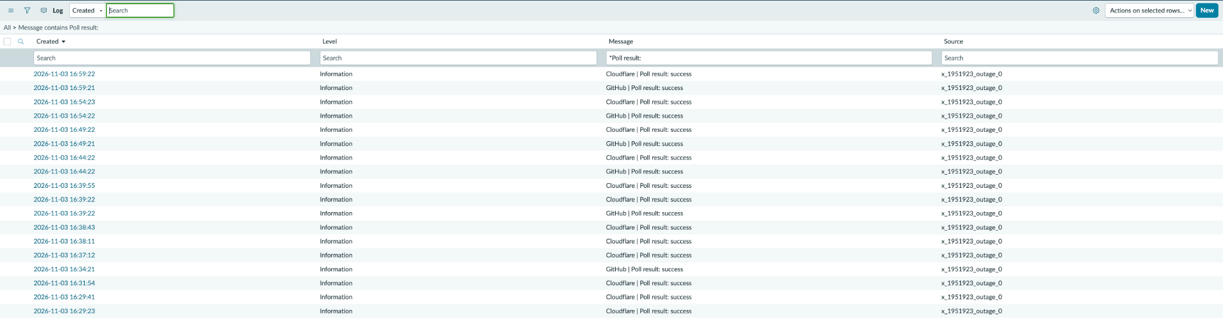
Figure 5. System Logs filtered for “Poll result:”, showing repeated success for GitHub and Cloudflare.
Observed. The logs show successful GitHub and Cloudflare polls in repeated cycles, including entries around 16:44, 16:49, 16:54 and 16:59 on 03 November 2026. The paired vendor results are consistent with the five-minute scheduled configuration.
Outcome. The application repeatedly fetched and processed the vendor status information without visible polling failures in these log entries. The scheduled-job exercise was also observed separately during testing.
Evidence limitation. System Log entries alone do not identify whether every individual execution was started by the scheduler or run manually; the schedule configuration and execution context provide that distinction.

EVENT AND EMAIL GENERATION EVIDENCE

06 Outbound subscriber notifications
Purpose. Verify that a genuine poller-driven Service Offering impact transition produces subscriber email notifications, while an unchanged poll does not cause repeated notifications.
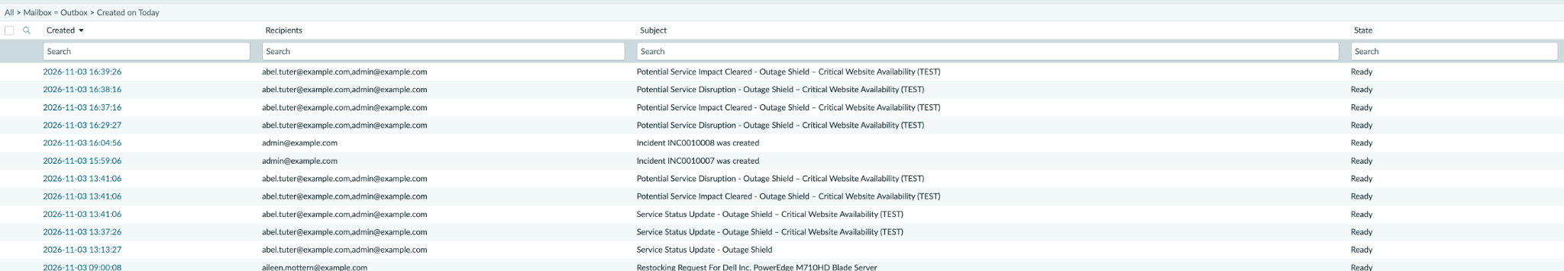
Figure 6. Outbox entries for initial disruption and potential-impact clearance, each addressed to two test recipients.
Time | Email subject / event | State
16:29:27 | Potential Service Disruption (initial) | Ready
16:37:16 | Potential Service Impact Cleared | Ready
16:38:16 | Potential Service Disruption (initial) | Ready
16:39:26 | Potential Service Impact Cleared | Ready
Observed. The initial and cleared messages were produced during deliberate activation and deactivation of a temporary Cloudflare Workers Builds mapping to a TEST Service Offering. The events targeted two eligible subscribers. A repeated poll with unchanged conditions generated zero new event batches.
Important qualification. Outbox State = Ready means the message was generated and queued. It does not prove external transmission, receipt or inbox delivery; the recipient addresses shown are test example.com addresses.

PROJECT EVIDENCE INTERPRETATION

07 Overall result, boundaries and next steps

Validated in Version 1
- Live vendor REST polling and parsing of GitHub / Cloudflare status data.
- Active vendor-component to internal Service Offering mapping and business risk assessment.
- Controlled native Incident creation, P3 to P2 escalation and primary-Incident reuse.
- Native Major Incident candidate proposal without automatic declaration.
- Fail-closed review paths for unmapped, conflicting, missing and invalid component data.
- Periodic polling and subscriber event generation for initial / cleared conditions with duplicate suppression.
- Outbound email record generation for subscribed test users.

Not demonstrated by these screenshots
- Actual external delivery of notification emails (only Ready/queued state shown).
- Unattended native ITSM writes enabled during the live poller end-to-end test (execution was disabled by system property).
- HTTP/API transport failure handling, retry strategy or recovery after upstream outages.
- Production deployment, live business-user acceptance, or a declared Major Incident.

Portfolio takeaway
Outage Shield Version 1 has a documented, repeatable test trail demonstrating the central design: vendor alerts are interpreted using internal service context; uncertain evidence triggers review; native Incident Management actions follow risk and governance rules; and subscribers are notified when potential impact changes. The report distinguishes verified PDI behaviour from capabilities that would need additional production-like validation.

Screenshot file index
01 - Component Mappings.png | 02a - Incident P2.png | 02b - P3 to P2 Escalation.png | 03a - Major Incident Details.png | 03b - Major Incident Proposed.png | 04 - Failure Safeguards.png | 05 - Scheduled Polling.png | 06 - Outbound Notifications.png

