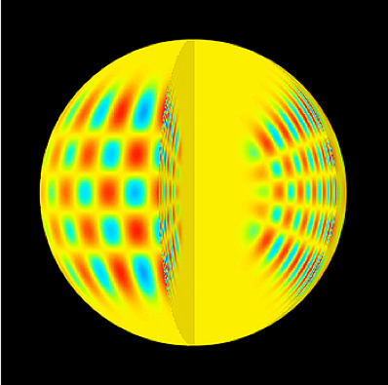
Acoustic waves in a star.

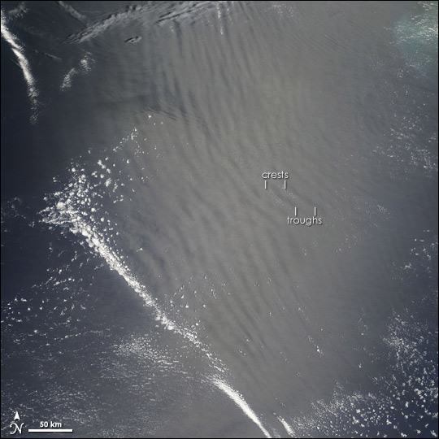
Gravity waves in ocean caused by an oscillation due to the restoring force of gravity on a perturbation of the surface.

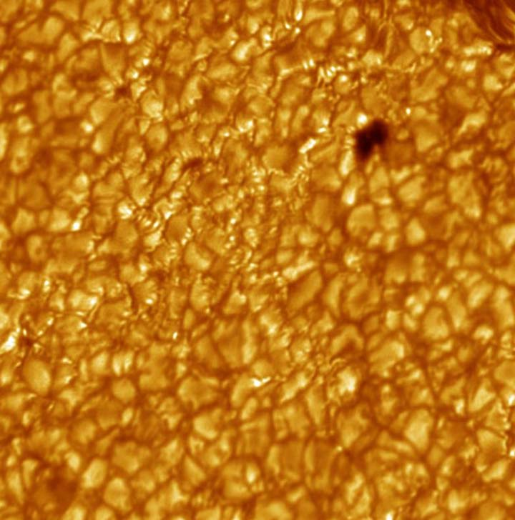
Solar granules caused by convective instabilities

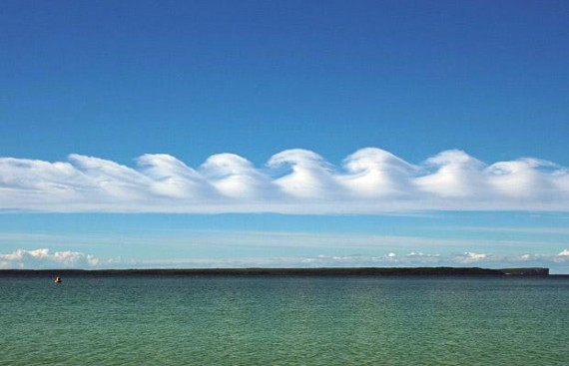
Kelvin-Helmholtz instability in the atmosphere

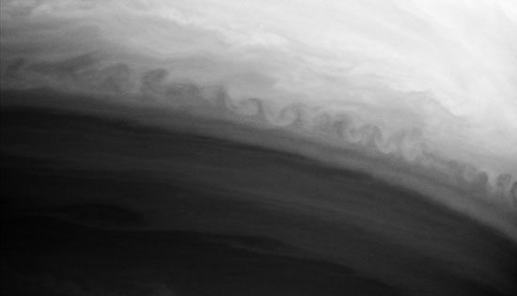
Kelvin-Helmholtz instability in Jupiter's atmosphere. The instabilities are caused by different densities in two moving layers in the atmosphere.

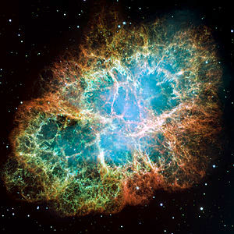

Rayleigh-Taylor instability, the expanding diffuse gas from the core is accelerated into the denser ISM

