Credit Card Default Analysis

# Predicting the Accuracy of Credit Card Default

Credit cards are a way of life in the US. In fact, data from the Federal Reserve shows that total revolving debt in the US is near $1 trillion. For households that carry an unpaid balance each month, the average debt was just over $8,000. [Credit Card Data](https://www.cnbc.com/2017/05/17/how-much-the-average-us-family-has-in-credit-card-debt.html)

One of the biggest challenges facing credit card issuers is identifying which borrowers might default on their debt. At the end of 2016, the average credit card write-off rate was 3.32% for the top 100 US banks ranked by assets. [Wrie off Data](https://fred.stlouisfed.org/series/CORCCT100S)

Our goal in this analysis is to help financial institutions reduce their credit card loan write-off rate by identifying the traits of borrowers most and least likely to default.

## The Data

While not focused on the US market, the data set for this project looked at one response variable, default or payment of credit card debt for 30,000 Taiwanese credit card holders in October 2005.

* Client action (0 = no default, 1 = default)

The following 23 independent variables were also included.

* Credit limit available to the borrower (ranging from $10,000 to $1,000,000)
* Gender (1 = male; 2 = female)
* Education level (1 = graduate school; 2 = university; 3 = high school; 0, 4, 5, 6 = other)
* Marriage status (1 = married; 2 = single; 3 = divorce; 0 = other)
* Age in years (ranging from 21 to 79)
* History of past payment (six columns, April to September of 2005) The payment scale:
  + -2 = No consumption (card holder has nothing due and didn't access line of credit)
  + -1 = Paid in full (previous balance has been paid off)
  + 0 = Revolving credit (previous balance not fully paid off)
  + 1 = Payment delay for 1 month; 2 = payment delay for 2 months;...; 9 = payment delay for 9 months and above
* Monthly balance for past six months (April - September of 2005)
* Amount of previous monthly payment for past six months (April - September of 2005)

Data is available at the following link: [Data set](http://archive.ics.uci.edu/ml/datasets/default+of+credit+card+clients)

### Data Limitations

Two variables not included in the data set are the credit score and annual income of the borrower. Both of these variables are considered important data points for financial institutions that issue credit cards. Any conclusions from this study should take into account that these two variables were not included.

Another limitation is the study's narrow focus on the Taiwanese credit card market. The health of the Taiwanese economy, domestic interest rates at the time of the study, and local political or cultural factors may have had an effect on the default rate that may be less relevant in other populations.

Additionally, interest assessed on outstanding debt is not included in the data set. While this study attempts to assign probabilities of default to different types of loans, a more complete analysis would combine the likelihood of default with potential return. This would give card issuers the ability to offer different terms based on the target market.

Finally, 2005 was a period where many Taiwanese financial institutions greatly expanded credit card issuance with little to no regard for the ability of borrowers to repay. In addition, card holders accumulated higher than average balances during this period. This resulted in abnormally high default rates in the Taiwanese market. Credit card lending in Taiwan during this period was similar in some ways to the mortgage loan market in the US leading up to the 2008 housing crisis. Any conclusions about who fits the profile of a risky cardholder must take into account the lax lending practices of issuers during the period of this study.

### Data Wrangling

Data import and all libraries used in the analysis are below.

library(readr)  
library(plyr)  
library(tidyr)  
library(dplyr)  
library(varhandle)  
library(ggplot2)  
library(caTools)  
library(rpart)  
library(rpart.plot)  
library(randomForest)  
dcc <- read_csv("~/dcc.csv")

A quick look at the structure of the data reveals that data is in the form of a table. All variables are classified as the character type.

# Look at structure of dcc  
str(dcc)

Column headings use the terms X1, X2, X3 etc. These were renamed to the appropriate titles (Gender, Education etc). In addition, duplicate rows and the ID column were removed.

# Change column names from X1, X2 etc to the value in row 2  
colnames(dcc) <- dcc[1,]  
  
# Delete row 2 to remove duplicate titles  
dcc = dcc[-1,]  
  
# Remove ID column (column #1)  
dcc <- dcc[-1]  
  
# Clean up column names  
names(dcc) <- c("LimitAmt", "Gender", "Education", "Marriage", "Age", "StatusSep05", "StatusAug05"  
 , "StatusJul05", "StatusJun05", "StatusMay05", "StatusApr05", "BalSep05", "BalAug05",  
 "BalJul05", "BalJun05", "BalMay05", "BalApr05", "PayAmtSep05", "PayAmtAug05",  
 "PayAmtJul05", "PayAmtJun05", "PayAmtMay05", "PayAmtApr05", "DefaultOct05")

The data set needed to be transformed to a data frame.

# Transform data set to data frame  
dcc <- as.data.frame(dcc)

Each column type is character, and should be converted to numeric.

# Convert each column from character to numeric  
dcc[] <- lapply(dcc, function(x) as.numeric(x))

The Education column had multiple values representing the same field. In order to remove duplicate values we merged all the duplicates together.

# Convert values 4,5, and 6 in Education column to 0 as they all represent "Other"  
dcc$Education[dcc$Education == 4] <- 0  
dcc$Education[dcc$Education == 5] <- 0  
dcc$Education[dcc$Education == 6] <- 0

Since some of the independent variables need to have a numeric type for certain analysis and a character type for others, we created duplicate columns for certain variables so we don't have to convert each back and forth. For example, the Gender variable has a numeric type and the Gender1 variable has a factor type.

# Add duplicate columns with different character types  
dcc$Gender1 <- paste(dcc$Gender)  
dcc$Education1 <- paste(dcc$Education)  
dcc$Marriage1 <- paste(dcc$Marriage)  
dcc$Status1Sep05 <- paste(dcc$StatusSep05)  
dcc$Status1Aug05 <- paste(dcc$StatusAug05)  
dcc$Status1Jul05 <- paste(dcc$StatusJul05)  
dcc$Status1Jun05 <- paste(dcc$StatusJun05)  
dcc$Status1May05 <- paste(dcc$StatusMay05)  
dcc$Status1Apr05 <- paste(dcc$StatusApr05)  
dcc$Default1Oct05 <- paste(dcc$DefaultOct05)

We also changed the values for certain variables to the corresponding category that value represents. For example, 1 and 2 were changed to male and female for the Gender variable.

# Change values from integer to categorical for Sex, Education, Marriage, Default columns  
  
dcc$Gender1 <- factor(dcc$Gender1)   
levels(dcc$Gender1) <- c("Male", "Female")  
  
dcc$Education1 <- factor(dcc$Education1)  
levels(dcc$Education1) <- c("Other", "GradSch", "Bachelors", "HS")  
  
dcc$Marriage1 <- factor(dcc$Marriage1)  
levels(dcc$Marriage1) <- c("Div", "Mar", "Single", "Div")  
  
dcc$Default1Oct05 <- factor(dcc$Default1Oct05) #NDef and Def stand for No Default and Default  
levels(dcc$Default1Oct05) <- c("NDef", "Def")  
  
# Change values from integer to categorical for payment status columns from Apr05 to May05  
  
dcc$Status1Sep05 <- factor(dcc$Status1Sep05)  
dcc$Status1Aug05 <- factor(dcc$Status1Aug05)  
dcc$Status1Jul05 <- factor(dcc$Status1Jul05)  
dcc$Status1Jun05 <- factor(dcc$Status1Jun05)  
dcc$Status1May05 <- factor(dcc$Status1May05)  
dcc$Status1Apr05 <- factor(dcc$Status1Apr05)  
  
# Change values from -2, -1, etc to character strings  
  
levels(dcc$Status1Sep05)<- c("SepPaid", "SepNoCons", "SepRev", "Sep1MoD", "Sep2MoD", "Sep3MoD", "Sep4MoD", "Sep5MoD", "Sep6MoD", "Sep7MoD", "Sep8MoD")  
levels(dcc$Status1Aug05)<- c("AugPaid", "AugNoCons", "AugRev", "Aug1MoD", "Aug2MoD", "Aug3MoD", "Aug4MoD", "Aug5MoD", "Aug6MoD", "Aug7MoD", "Aug8MoD")  
levels(dcc$Status1Jul05)<- c("JulPaid", "JulNoCons", "JulRev", "Jul1MoD", "Jul2MoD", "Jul3MoD", "Jul4MoD", "Jul5MoD", "Jul6MoD", "Jul7MoD", "Jul8MoD")  
levels(dcc$Status1Jun05)<- c("JunPaid", "JunNoCons", "JunRev", "Jun1MoD", "Jun2MoD", "Jun3MoD", "Jun4MoD", "Jun5MoD", "Jun6MoD", "Jun7MoD", "Jun8MoD")  
levels(dcc$Status1May05)<- c("MayPaid", "MayNoCons", "MayRev", "May2MoD", "May3MoD", "May4MoD", "May5MoD", "May6MoD", "May7MoD", "May8MoD")  
levels(dcc$Status1Apr05)<- c("AprPaid", "AprNoCons", "AprRev", "Apr2MoD", "Apr3MoD", "Apr4MoD", "Apr5MoD", "Apr6MoD", "Apr7MoD", "Apr8MoD")

The credit limit and age of borrowers was segmented into bins in order to study how each segment effects the default rate differently. The distribution of data points with the highest concentration was split into smaller bin sizes, while those with fewer data points had wider bin sizes. For example, there were far more borrowers with lower credit limits and than those with higher credit limits. As a result, there were more bins representing cardholders with lower limits.

# Create bins for credit limit and age so we can group borrowers into different categories  
# The LAmtCut and AgeCut variables represent where the cutoff for each bin is  
  
dcc$LimitAmtBin <- paste(dcc$LimitAmt)  
dcc$LimitAmtBin <- as.numeric(as.character(dcc$LimitAmtBin))  
sapply(dcc$LimitAmtBin, class)  
LAmtCut <- cut(dcc$LimitAmtBin, breaks = c(0, 10000, 25000, 50000, 100000, 250000, 500000, 1000000),  
 labels = c("10KLimit", "25KLimit", "50KLimit", "100KLimit", "250KLimit", "500KLimit", "1MilLimit"))  
dcc$LimitAmtBin <- LAmtCut  
  
dcc$AgeBin <- paste(dcc$Age)  
dcc$AgeBin <- as.numeric(as.character(dcc$AgeBin))  
sapply(dcc$AgeBin, class)  
AgeCut <- cut(dcc$AgeBin, breaks = c(20, 25, 30, 35, 40, 50, 60, 80),  
 labels = c("25Y", "30Y", "35Y", "40Y", "50Y", "60Y", "80Y"))  
dcc$AgeBin <- AgeCut

Finally, bins were created for the six monthly balance amounts and six monthly payment amounts. The code is identical to the code used to create the credit limit and age bins. Much like the age and credit limit bins, the bins sizes reflect the concentration of borrowers at each level.

## Preliminary Exploration

The goal of preliminary exploration was to identify independent varibles that appear to have some predictive power of default. Our baseline for comparison is simply the average default rate across the data set.

table(dcc$DefaultOct05)/length(dcc$DefaultOct05)

##   
## 0 1   
## 0.7788 0.2212

Across 30,000 loans, 22.12% default.

Below are the graphs for those variables that appear to have a strong influence on default.

##### Credit Limit

summary = dcc %>% group_by(LimitAmtBin, Default1Oct05) %>% tally %>% group_by(LimitAmtBin) %>%   
 mutate(pct = n/sum(n), n.pos = cumsum(n) - 0.5*n)  
ggplot(summary, aes(x=LimitAmtBin, y=n, fill=Default1Oct05)) + geom_bar(stat="identity", position = position_dodge()) +  
 geom_text(aes(label=paste0(sprintf("%1.1f", pct*100),"%"), y=n.pos), colour="black") +  
 theme(axis.text.x = element_text(angle = 60, hjust=1))

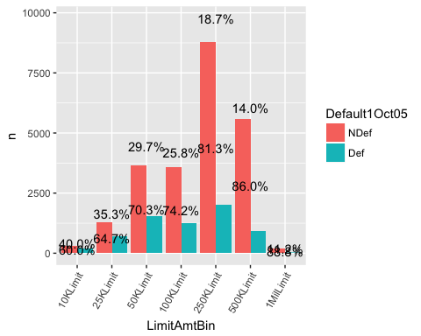

Those with the lowest credit limits have the highest default rates, and those with the highest credit limits have the lowest default rates. Default rates are near 40.0% for the 10K bucket, and decline with each increasing limit bin. The largest credit limit sees a default rate of just over 11.0%.

##### Age

summary = dcc %>% group_by(AgeBin, Default1Oct05) %>% tally %>% group_by(AgeBin) %>%   
 mutate(pct = n/sum(n), n.pos = cumsum(n) - 0.5*n)  
ggplot(summary, aes(x=factor(AgeBin), y=n, fill=Default1Oct05)) + geom_bar(stat="identity", position = position_dodge()) +   
 geom_text(aes(label=paste0(sprintf("%1.1f", pct*100),"%")), colour="black")

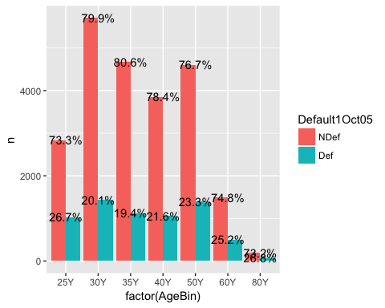

The age breakdown shows a different trend. The youngest and oldest borrowers (25 and below and those between 61 to 80) have the highest default rates, both approaching 27.0%. However, middle-age borrowers (31-35) have the lowest default rate of 19.42%. Default rates based on age have a V shape. At the extremes, loans appear to be riskier. Loans to the middle age crowd appear to be safer.

##### Education

summary = dcc %>% group_by(Education1, Default1Oct05) %>% tally %>% group_by(Education1) %>%   
 mutate(pct = n/sum(n), n.pos = cumsum(n) - 0.5*n)  
ggplot(summary, aes(x=Education1, y=n, fill=Default1Oct05)) + geom_bar(stat="identity", position = position_dodge()) +   
 geom_text(aes(label=paste0(sprintf("%1.1f", pct*100),"%")), colour="black")

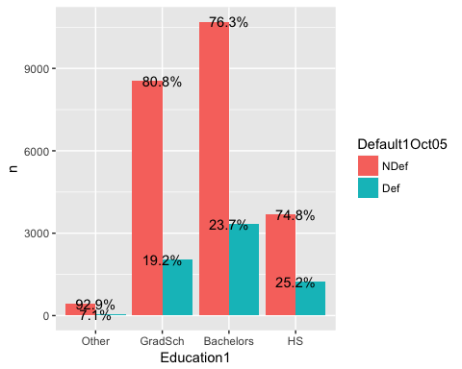

Education shows an interesting trend that intuitively makes sense. The higher the level of education, the lower the default rate. For example, those with only a high school education default over 25% of the time, while those with only a bachelors degree have a default rate of 23.73%, which is higher than our baseline, but still an improvement over high school. Finally, those with a graduate degree have the lowest default rate of 19.23%.

##### Gender

summary = dcc %>% group_by(Gender1, Default1Oct05) %>% tally %>% group_by(Gender1) %>%  
 mutate(pct = n/sum(n), n.pos = cumsum(n) - 0.5*n)  
ggplot(summary, aes(x=Gender1, y=n, fill=Default1Oct05)) + geom_bar(stat="identity", position = position_dodge()) +  
 geom_text(aes(label=paste0(sprintf("%1.1f", pct*100),"%")), colour="black")

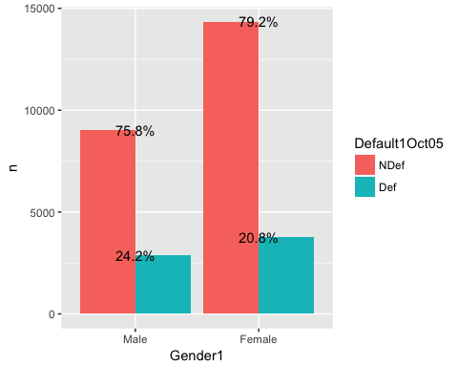

Males have a 24.24% default rate while females have a 20.73% default rate. There is a wide disparity between the two groups, with males well above the baseline default rate and females well below.

##### Marriage Status

summary = dcc %>% group_by(Marriage1, Default1Oct05) %>% tally %>% group_by(Marriage1) %>%   
 mutate(pct = n/sum(n), n.pos = cumsum(n) - 0.5*n)  
ggplot(summary, aes(x=Marriage1, y=n, fill=Default1Oct05)) + geom_bar(stat="identity", position = position_dodge()) +   
 geom_text(aes(label=paste0(sprintf("%1.1f", pct*100),"%")), colour="black")

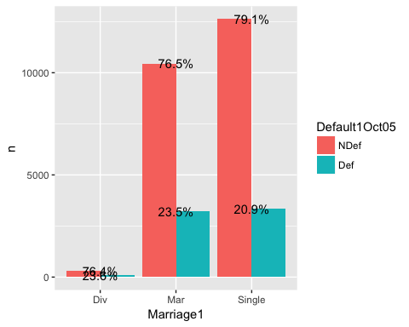

Marriage status provides a mixed picture. Both married and divorced borrowers default around 23.5% of the time while single borrowers who haven't been married default 20.92% of the time.

##### Monthly Payment Status

summary = dcc %>% group_by(Status1Sep05, Default1Oct05) %>% tally %>% group_by(Status1Sep05) %>%   
 mutate(pct = n/sum(n), n.pos = cumsum(n) - 0.5*n)  
ggplot(summary, aes(x=Status1Sep05, y=n, fill=Default1Oct05)) + geom_bar(stat="identity", position = position_dodge()) +  
 geom_text(aes(label=paste0(sprintf("%1.1f", pct*100),"%"), y=n.pos), colour="black") +  
 theme(axis.text.x = element_text(angle = 60, hjust=1))

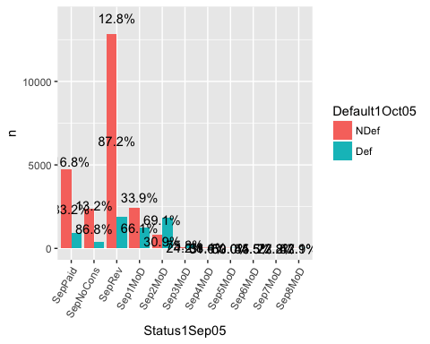

Only September is shown since all six months have very similar default rates for each payment status. Regardless of month, the payment status shows a much lower default rate than the baseline for those that fall into the No Consumption, Paid in full or Revolving bins. Loans that are two or more months behind see default rates that are 50% or higher regardless of what month they are behind. We see that there isn't much middle ground when it comes to payment status. If a cardholder is behind they are much more likely to default compared to the baseline. If they are on time, they are much less likely to default compared to the baseline.

##### Monthly Payment Amount

summary = dcc %>% group_by(PayAmtBinSep05, Default1Oct05) %>% tally %>% group_by(PayAmtBinSep05) %>%   
 mutate(pct = n/sum(n), n.pos = cumsum(n) - 0.5*n)  
ggplot(summary, aes(x=PayAmtBinSep05, y=n, fill=Default1Oct05)) + geom_bar(stat="identity", position = position_dodge()) +   
 geom_text(aes(label=paste0(sprintf("%1.1f", pct*100),"%"), y=n.pos), colour="black") +  
 theme(axis.text.x = element_text(angle = 60, hjust=1))

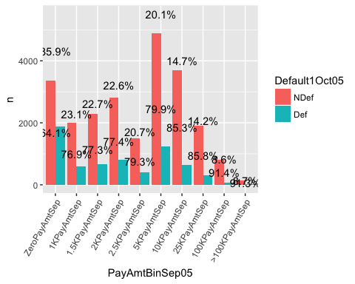

Only September is shown since all six months have very similar default rates for each payment amount. We see a very clear trend with the payment amount variables. The lower the payment, the higher the default rate. This is true across all six months. As payment amounts reached the 100K and >100K amounts, default rates hovered around 8%, well below the baseline. Clearly the higher the monthly payment amount, the lower the default rate.

## Machine Learning

In this section we will use machine learning methods to build three different models that will predict the probability of either a default or no default across the loans in the data set. We will build a logistic regression model, a classification and regression tree (CART), and a random forest model.

We saw earlier that the default rate across all loans is 22.12%, which means that 77.88% of loans are not defaulting. Our goal is to improve upon the baseline with each model.

### Logistic Regression

We first split the data into a training data set and testing data set. We will use the training set to discover potentially predictive relationships and use the testing set to assess the performance of these relationships.

Our training set uses 75% of the observations, and our testing set uses 25%. The set.seed variable is used to make sure the dependent variable (default) is well balanced in both the training and testing sets.

# Split data into training and testing set with a 75/25 ratio  
set.seed(64)  
split = sample.split(dcc$DefaultOct05, SplitRatio = 0.75)  
dccTrain = subset(dcc, split == TRUE)  
dccTest = subset(dcc, split == FALSE)

# Check rows for both the training and testing set  
nrow(dccTrain)

## [1] 22500

nrow(dccTest)

## [1] 7500

We see there are 22,500 rows in the training data set and 7,500 in the testing data set which is consistent with a 75/25 split.

We will now build our model using the training data set. We start with a large universe of variables and continue to refine our model by removing those with no significance.

##### Model1

# Model 1 starts with almost all the independent variables  
dccLog1 = glm(DefaultOct05 ~ LimitAmt + Gender + Education + Marriage + Age +  
 StatusSep05 + StatusAug05 + StatusJul05 + StatusJun05 + StatusMay05 +  
 StatusApr05 + PayAmtSep05 + PayAmtAug05 + PayAmtMay05 + PayAmtApr05 +  
 BalSep05 + BalAug05 + BalJul05 + BalJun05 + BalMay05 + BalApr05,   
 data=dccTrain, family=binomial)  
  
summary(dccLog1)

##   
## Call:  
## glm(formula = DefaultOct05 ~ LimitAmt + Gender + Education +   
## Marriage + Age + StatusSep05 + StatusAug05 + StatusJul05 +   
## StatusJun05 + StatusMay05 + StatusApr05 + PayAmtSep05 + PayAmtAug05 +   
## PayAmtMay05 + PayAmtApr05 + BalSep05 + BalAug05 + BalJul05 +   
## BalJun05 + BalMay05 + BalApr05, family = binomial, data = dccTrain)  
##   
## Deviance Residuals:   
## Min 1Q Median 3Q Max   
## -3.1067 -0.6993 -0.5482 -0.2893 3.5383   
##   
## Coefficients:  
## Estimate Std. Error z value Pr(>|z|)   
## (Intercept) -8.687e-01 1.370e-01 -6.342 2.27e-10 ***  
## LimitAmt -6.821e-07 1.804e-07 -3.781 0.000156 ***  
## Gender -1.108e-01 3.540e-02 -3.129 0.001752 **   
## Education -1.647e-02 2.566e-02 -0.642 0.520960   
## Marriage -1.446e-01 3.644e-02 -3.969 7.22e-05 ***  
## Age 6.969e-03 2.048e-03 3.403 0.000666 ***  
## StatusSep05 5.740e-01 2.044e-02 28.078 < 2e-16 ***  
## StatusAug05 9.571e-02 2.331e-02 4.105 4.04e-05 ***  
## StatusJul05 7.012e-02 2.611e-02 2.686 0.007235 **   
## StatusJun05 1.385e-02 2.885e-02 0.480 0.631193   
## StatusMay05 3.701e-02 3.095e-02 1.196 0.231738   
## StatusApr05 1.471e-02 2.561e-02 0.574 0.565730   
## PayAmtSep05 -1.811e-05 2.971e-06 -6.096 1.09e-09 ***  
## PayAmtAug05 -7.498e-06 2.249e-06 -3.335 0.000854 ***  
## PayAmtMay05 -7.128e-06 2.216e-06 -3.216 0.001299 **   
## PayAmtApr05 -2.125e-06 1.505e-06 -1.413 0.157788   
## BalSep05 -6.055e-06 1.304e-06 -4.642 3.45e-06 ***  
## BalAug05 4.127e-06 1.703e-06 2.423 0.015387 *   
## BalJul05 7.717e-07 1.353e-06 0.570 0.568505   
## BalJun05 8.548e-07 1.214e-06 0.704 0.481495   
## BalMay05 -2.965e-06 1.644e-06 -1.803 0.071374 .   
## BalApr05 2.420e-06 1.441e-06 1.679 0.093164 .   
## ---  
## Signif. codes: 0 '***' 0.001 '**' 0.01 '*' 0.05 '.' 0.1 ' ' 1  
##   
## (Dispersion parameter for binomial family taken to be 1)  
##   
## Null deviance: 23779 on 22499 degrees of freedom  
## Residual deviance: 20891 on 22478 degrees of freedom  
## AIC: 20935  
##   
## Number of Fisher Scoring iterations: 6

We see that 7 variables are not significant. We will remove the variables with no significance and rerun the model.

##### Model2

# Model 2 removes insignificant variables  
dccLog2 = glm(DefaultOct05 ~ LimitAmt + Gender + Marriage + Age +  
 StatusSep05 + StatusAug05 + StatusJul05 + PayAmtSep05 + PayAmtAug05 +   
 PayAmtMay05 + BalSep05 + BalAug05 + BalMay05 + BalApr05,   
 data=dccTrain, family=binomial)  
  
summary(dccLog2)

##   
## Call:  
## glm(formula = DefaultOct05 ~ LimitAmt + Gender + Marriage + Age +   
## StatusSep05 + StatusAug05 + StatusJul05 + PayAmtSep05 + PayAmtAug05 +   
## PayAmtMay05 + BalSep05 + BalAug05 + BalMay05 + BalApr05,   
## family = binomial, data = dccTrain)  
##   
## Deviance Residuals:   
## Min 1Q Median 3Q Max   
## -3.1097 -0.6972 -0.5480 -0.2919 3.5601   
##   
## Coefficients:  
## Estimate Std. Error z value Pr(>|z|)   
## (Intercept) -9.028e-01 1.298e-01 -6.954 3.54e-12 ***  
## LimitAmt -7.490e-07 1.725e-07 -4.343 1.40e-05 ***  
## Gender -1.116e-01 3.535e-02 -3.156 0.001598 **   
## Marriage -1.426e-01 3.622e-02 -3.936 8.30e-05 ***  
## Age 6.731e-03 2.012e-03 3.344 0.000825 ***  
## StatusSep05 5.799e-01 2.029e-02 28.577 < 2e-16 ***  
## StatusAug05 1.015e-01 2.305e-02 4.405 1.06e-05 ***  
## StatusJul05 1.021e-01 2.154e-02 4.743 2.11e-06 ***  
## PayAmtSep05 -1.867e-05 2.970e-06 -6.287 3.24e-10 ***  
## PayAmtAug05 -6.270e-06 1.989e-06 -3.152 0.001621 **   
## PayAmtMay05 -7.891e-06 2.196e-06 -3.594 0.000326 ***  
## BalSep05 -6.296e-06 1.301e-06 -4.839 1.30e-06 ***  
## BalAug05 4.934e-06 1.441e-06 3.425 0.000614 ***  
## BalMay05 -2.397e-06 1.467e-06 -1.634 0.102188   
## BalApr05 3.054e-06 1.403e-06 2.176 0.029539 *   
## ---  
## Signif. codes: 0 '***' 0.001 '**' 0.01 '*' 0.05 '.' 0.1 ' ' 1  
##   
## (Dispersion parameter for binomial family taken to be 1)  
##   
## Null deviance: 23779 on 22499 degrees of freedom  
## Residual deviance: 20903 on 22485 degrees of freedom  
## AIC: 20933  
##   
## Number of Fisher Scoring iterations: 6

We see an improvement in the AIC score from 20935 to 20933, but one of the remaining variables is not significant. Once again, we will remove this variable and rerun the model.

##### Model3

# Model 3 removes one more that is insignificant  
dccLog3 = glm(DefaultOct05 ~ LimitAmt + Gender + Marriage + Age +  
 StatusSep05 + StatusAug05 + StatusJul05 + PayAmtSep05 + PayAmtAug05 +   
 PayAmtMay05 + BalSep05 + BalAug05 + BalApr05,   
 data=dccTrain, family=binomial)  
  
summary(dccLog3)

##   
## Call:  
## glm(formula = DefaultOct05 ~ LimitAmt + Gender + Marriage + Age +   
## StatusSep05 + StatusAug05 + StatusJul05 + PayAmtSep05 + PayAmtAug05 +   
## PayAmtMay05 + BalSep05 + BalAug05 + BalApr05, family = binomial,   
## data = dccTrain)  
##   
## Deviance Residuals:   
## Min 1Q Median 3Q Max   
## -3.1082 -0.6969 -0.5477 -0.2931 3.6157   
##   
## Coefficients:  
## Estimate Std. Error z value Pr(>|z|)   
## (Intercept) -9.031e-01 1.298e-01 -6.957 3.47e-12 ***  
## LimitAmt -7.727e-07 1.719e-07 -4.495 6.97e-06 ***  
## Gender -1.119e-01 3.534e-02 -3.165 0.001549 **   
## Marriage -1.426e-01 3.623e-02 -3.936 8.30e-05 ***  
## Age 6.772e-03 2.012e-03 3.365 0.000764 ***  
## StatusSep05 5.798e-01 2.029e-02 28.571 < 2e-16 ***  
## StatusAug05 1.012e-01 2.305e-02 4.392 1.12e-05 ***  
## StatusJul05 1.017e-01 2.153e-02 4.723 2.33e-06 ***  
## PayAmtSep05 -1.888e-05 2.974e-06 -6.348 2.18e-10 ***  
## PayAmtAug05 -6.723e-06 1.973e-06 -3.406 0.000658 ***  
## PayAmtMay05 -6.319e-06 1.970e-06 -3.207 0.001340 **   
## BalSep05 -6.385e-06 1.303e-06 -4.900 9.57e-07 ***  
## BalAug05 4.659e-06 1.434e-06 3.249 0.001156 **   
## BalApr05 1.036e-06 6.431e-07 1.610 0.107379   
## ---  
## Signif. codes: 0 '***' 0.001 '**' 0.01 '*' 0.05 '.' 0.1 ' ' 1  
##   
## (Dispersion parameter for binomial family taken to be 1)  
##   
## Null deviance: 23779 on 22499 degrees of freedom  
## Residual deviance: 20906 on 22486 degrees of freedom  
## AIC: 20934  
##   
## Number of Fisher Scoring iterations: 6

The April Balance amount is insignificant. After removing this variable we run our model once more, however the AIC score is slightly higher (moving from 20933 to 20934)

##### Model4

# Model 4 shows all remaining variables with significance  
dccLog4 = glm(DefaultOct05 ~ LimitAmt + Gender + Marriage + Age +  
 StatusSep05 + StatusAug05 + StatusJul05 + PayAmtSep05 + PayAmtAug05 +   
 PayAmtMay05 + BalSep05 + BalAug05,   
 data=dccTrain, family=binomial)  
  
summary(dccLog4)

##   
## Call:  
## glm(formula = DefaultOct05 ~ LimitAmt + Gender + Marriage + Age +   
## StatusSep05 + StatusAug05 + StatusJul05 + PayAmtSep05 + PayAmtAug05 +   
## PayAmtMay05 + BalSep05 + BalAug05, family = binomial, data = dccTrain)  
##   
## Deviance Residuals:   
## Min 1Q Median 3Q Max   
## -3.1156 -0.6971 -0.5483 -0.2933 3.6443   
##   
## Coefficients:  
## Estimate Std. Error z value Pr(>|z|)   
## (Intercept) -9.058e-01 1.298e-01 -6.979 2.97e-12 ***  
## LimitAmt -7.458e-07 1.709e-07 -4.364 1.28e-05 ***  
## Gender -1.102e-01 3.533e-02 -3.120 0.001811 **   
## Marriage -1.431e-01 3.622e-02 -3.952 7.75e-05 ***  
## Age 6.754e-03 2.012e-03 3.357 0.000788 ***  
## StatusSep05 5.813e-01 2.027e-02 28.673 < 2e-16 ***  
## StatusAug05 1.014e-01 2.304e-02 4.400 1.08e-05 ***  
## StatusJul05 1.042e-01 2.148e-02 4.850 1.23e-06 ***  
## PayAmtSep05 -1.926e-05 2.966e-06 -6.494 8.34e-11 ***  
## PayAmtAug05 -6.315e-06 1.950e-06 -3.238 0.001202 **   
## PayAmtMay05 -5.568e-06 1.901e-06 -2.930 0.003394 **   
## BalSep05 -6.420e-06 1.297e-06 -4.949 7.46e-07 ***  
## BalAug05 5.395e-06 1.352e-06 3.991 6.57e-05 ***  
## ---  
## Signif. codes: 0 '***' 0.001 '**' 0.01 '*' 0.05 '.' 0.1 ' ' 1  
##   
## (Dispersion parameter for binomial family taken to be 1)  
##   
## Null deviance: 23779 on 22499 degrees of freedom  
## Residual deviance: 20908 on 22487 degrees of freedom  
## AIC: 20934  
##   
## Number of Fisher Scoring iterations: 6

Model 4 appears to be the best mix of independent variables as it delivers an AIC score of 20934, and shows significance of between 0 and 0.001 or between 0.001 and 0.01 for all independent variables. The coefficients for Age, payment status, and the August balance variable are positive, which indicates that higher values are indicative of a higher chance of default.

#### Predict the data

By using a threshold value, we can convert our probabilities to predictions. If the probability of default is greater than the threshold, then we predict default. If its below, then we predict no default. The threshold we start with is based on what type of error we are more comfortable with. A high threshold will lead to fewer innacurately predicted defaults but more innacurate predictions of a loan non defaulting. A low threshold will lead to the opposite. If there is no preference between the two errors we can choose a threshold of 0.5 since it is in between our two outcomes (0 or 1).

Using a threshold of 0.5, lets look at how our model works with the test data set.

# Prediction on Test data  
predictdccTest = predict(dccLog4, type="response", newdata = dccTest)  
table(dccTest$DefaultOct05, predictdccTest > 0.5)

##   
## FALSE TRUE  
## 0 5682 159  
## 1 1251 408

The matrix above shows the breakdown of of all defaults. The rows are the acutal result (0 = no default, 1 = default), the columns are the predictions. We see that out of 7,500 occurrences, we have 6090 correct predictions (5682 loans predicted to be paid off, 408 predicted to default).

However, 1251 loans did default that were predicted to be paid off. We also see that of the loans predicted to default, 159 were actually paid off.

Our overall accuracy measures the number of correct predictions divided by the total number of loans.

# Check for accuracy of model  
TestAccuracy = (5682 + 408)/(5682 + 408 + 1251 + 159)  
TestAccuracy

## [1] 0.812

The accuracy of the model is 81.2%.

This tells us that our model is a better predictor of default compared to a random guess, or our baseline (77.88%).

### Classification Tree

While logistic regression shows how an independent variable may be predictive for a specific outcome, it's difficult to understand which factors are most important, and to evaluate what the prediction is for a new case.

The classification tree also predicts the probability of a specific outcome. By following a split in the tree, we can predict the most frequent outcome in the training set that followed the same path.

We use the same training and testing as with our logistic regression model.

# Split data and create train/test sets  
set.seed(64)  
split = sample.split(dcc$DefaultOct05, SplitRatio = 0.75)  
dccTrain = subset(dcc, split == TRUE)  
dccTest = subset(dcc, split == FALSE)

We then build the model, and examine the tree. and its accuracy.

# Build classification tree model with all variables  
dccTree = rpart(DefaultOct05 ~ LimitAmtBin + Gender1 + Education1 + Marriage1 + AgeBin + StatusSep05 +   
 StatusAug05 + StatusJul05 + StatusJun05 + StatusMay05 + StatusApr05 +  
 PayAmtSep05 + PayAmtAug05 + PayAmtJul05 + PayAmtJun05 + PayAmtMay05 +   
 PayAmtApr05 + BalSep05 + BalAug05 + BalJul05 + BalJun05 + BalMay05 + BalApr05,   
 data = dccTrain, method = "class", control = rpart.control(minbucket = 25))  
  
# Look at tree  
prp(dccTree)

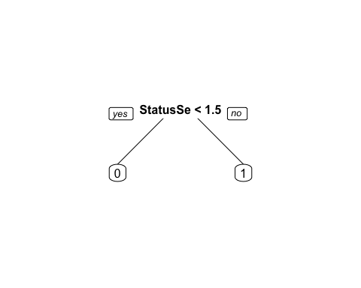

The tree shows the payment status for September variable as its only node. If a loan is less than 1.5 months behind, then it is less likely to default. If a loan is more than 1.5 months behind its more likely to default.

Only one node appears in the tree which may be confusing since our model includes all 23 independent variables. This tells us that the September payment status is the most important factor in predicting default. Other variables are not as important.

An important note is that the September payment status variable precedes our dependent variable by one month. This may give extra weight to September in the model. In practice, a financial institution would not be limited to the previous six months of data, and there may not be an ending date for every loan since credit card debt is revolving. This may explain why there is only one node for this specific study.

Finally, we apply the model to our test set.

# Apply on test set and look at accuracy of model  
PredictCARTdcc = predict(dccTree, newdata = dccTest, type = "class")  
table(dccTest$DefaultOct05, PredictCARTdcc)

## PredictCARTdcc  
## 0 1  
## 0 5615 226  
## 1 1113 546

The confusion matrix shows the accuracy of our model.

# Examine accuracy  
CAccuracy = (5615 + 546)/(5615 + 546 + 1113 + 226)  
CAccuracy

## [1] 0.8214667

The classification tree has an accuracy of 82.15%, which is a slight improvement over the logistic regression model

### Random Forest

Our final approach is the random forest model. This was designed to improve the accuracy of CART by building a large number of CART trees. Random forest selects data randomly with replacement.

As with the previous models, we use the same split for the training and testing data sets. We then try the model on the testing data set.

# Split data, build model, apply to test set  
set.seed(64)  
split = sample.split(dcc$DefaultOct05, SplitRatio = 0.75)  
dccTrain = subset(dcc, split == TRUE)  
dccTest = subset(dcc, split == FALSE)  
  
dccTrain$Default1Oct05 = as.factor(dccTrain$Default1Oct05)  
dccTest$Default1Oct05 = as.factor(dccTest$Default1Oct05)  
  
dccForest = randomForest(Default1Oct05 ~ LimitAmtBin + Gender + Education + AgeBin + StatusSep05 +   
 StatusAug05 + StatusJul05 + StatusJun05 + StatusMay05 + StatusApr05 +  
 PayAmtSep05 + PayAmtAug05 + PayAmtJul05 + PayAmtJun05 + PayAmtMay05 +  
 PayAmtApr05 +BalSep05 + BalAug05 + BalJul05 + BalJun05 + BalMay05 +   
 BalApr05, data = dccTrain, nodesize = 25, ntree = 200)  
  
PredictdccForest = predict(dccForest, newdata = dccTest)  
table(dccTest$DefaultOct05, PredictdccForest)

## PredictdccForest  
## NDef Def  
## 0 5540 301  
## 1 1064 595

# Examine accuracy  
RAccuracy = (5548 + 598)/(5548 + 598 + 1061 + 293)  
RAccuracy

## [1] 0.8194667

The accuracy of the random forrest model is 81.8%.

### Conclusions

1. Our three models improved upon the probability of a random loan being paid off (77.88%). Our logistic regression model had an accuracy of 81.2%. The CART model improved upon that number slightly with an accuracy of 82.1%, while the random forest model had an accuracy of 81.95%.
2. While we've been able to imrpove upon our baseline depending on the model, this is a modest improvement and may not be enough for the credit card issuer to replace any existing loan screening mechanism.
3. Payment status in the month immediately preceding the final month of the study appears to have a high level of significance. Due to the defined time periods of the study, and the revolving nature of credit card debt, this conclusion may not be accurate.

### Recommendations

1. When assessing the risk of a loan, an important feature for analysis is the potential return, not just the likelihood of default. While this data set did not include the interest rate for each loan, it's important to factor this data point into the analysis. With both the likelihood of default and potential return, a credit card issuer will be able to identify which loans are most and least profitable which is ultimately more important than simply measuring the likelihood of default.
2. Include both the borrower's credit rating and income in future analyis. These are both considered important data points for most loans, credit card or otherwise.
3. Further examine the payment status in the month preceding the final month of the study. It's important to see if the CART model conclusion is simply a result of the start and end date of the study, or if the specific payment status month is statistically significant.