**REPUBLIC OF RWANDA**

**KIGALI INDEPENDENT UNIVERSITY ULK**

**P.O Box 2280**

Website://www.ulk.ac.rw

Email: [info@ulk.ac.rw](mailto:info@ulk.ac.rw)

PROJECT: **IBM Online Training Management Information System**

Student Roll Number : **201710226**

**201710259**

**201810058**

**201710117**

Course: **Human and Computer Iteration**

Lecture: **Dr. Pius**

ACADEMIC YEAR : 2019 - 2020

**Introduction**

**IBM Online Training Management Information System** is a web application developed in Java [**JSP**] for IBM Company Department of Training Online in order to facilitate their management of activities such as management of Administrators, Mentors, Training Modules (Courses), Training Program, Participants enrolled for the Training, and Setting to assume the security of their accounts. We realize that as many Organizations of Training as IBM included still use Papers, files, calculators, books to manage their activities, which makes very hard their operations, no follow up, clarity, transparency in their operations, … **IBM Online Training Management Information System** will allow the main admin to manage each and every operations(register, update, delete and view the list of Administrators, Mentors, Training Modules (Courses), Training Program, Participants enrolled and new Participant) once logged in.

Download the Software in Github : [**https://github.com/ezechiel1/ibmjsp**](https://github.com/ezechiel1/mmms) (The Database Is in database folder, called ibm_db). Default Credentials to login: email: [ez](mailto:ezpk@gmail.com)echielkalengya@gmail.com & password: ezechiel

Note: For the codes,and the MVC Structure, Db.jsp structure, Please just visit the link ([**https://github.com/ezechiel1/ibmjsp**](https://github.com/ezechiel1/mmms)) to see the codes. We prefere to do not put the codes in this current file cause they are too many.

**1. Sign In Page:**

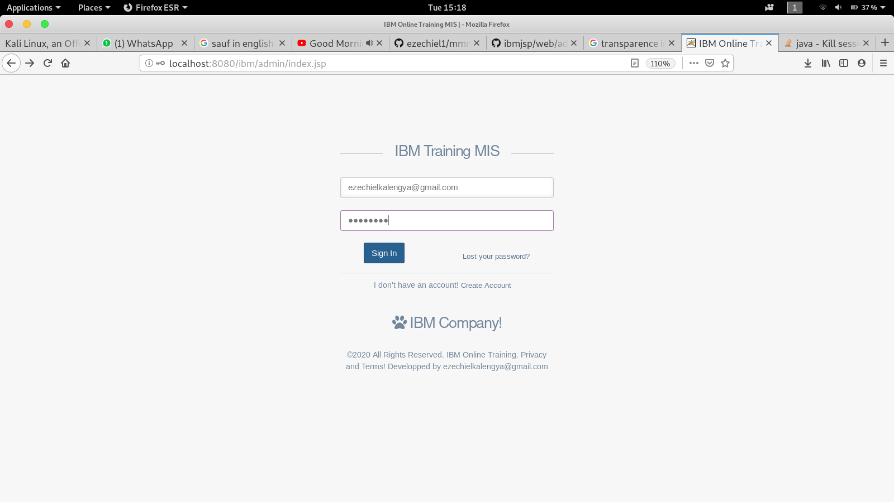

**2. Dashboard Page:**

**3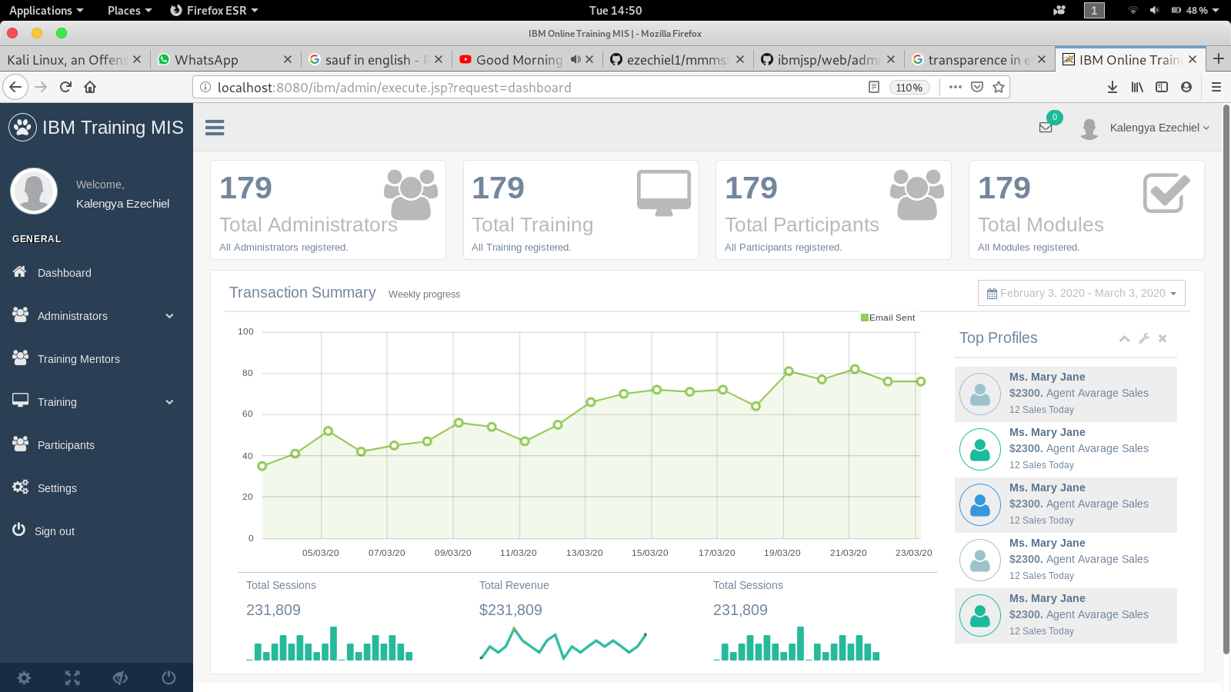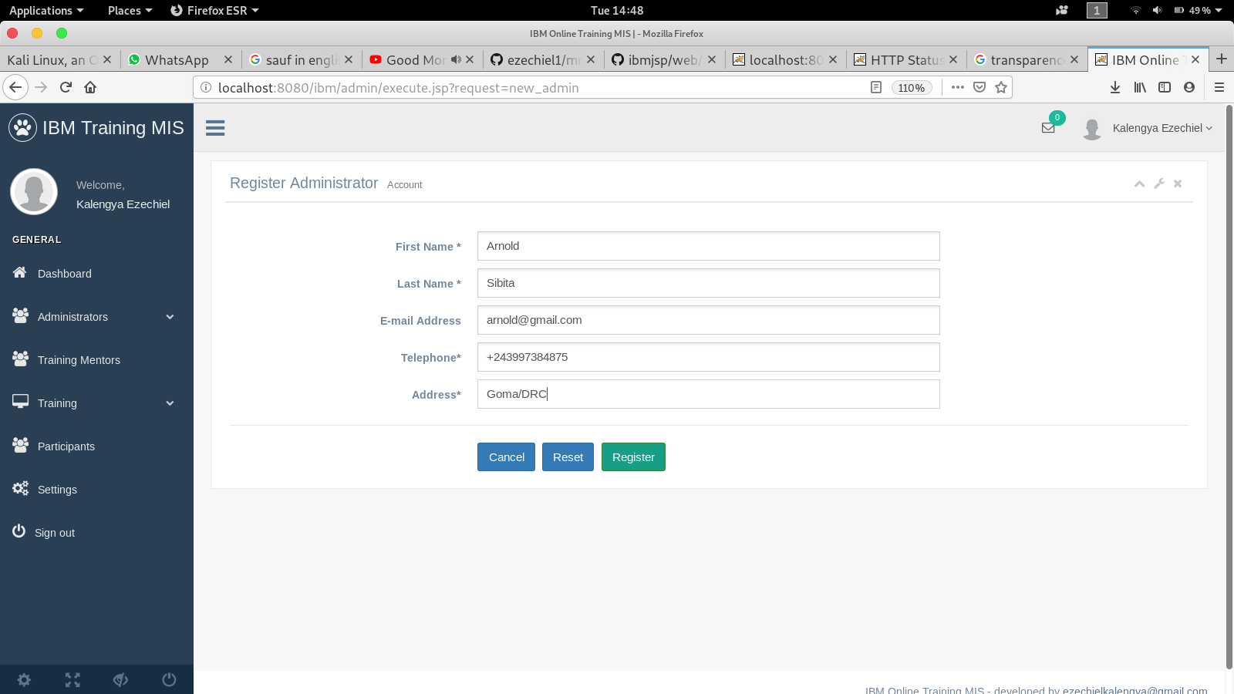. Administrator Registration:**

**5. List of Administrators:**

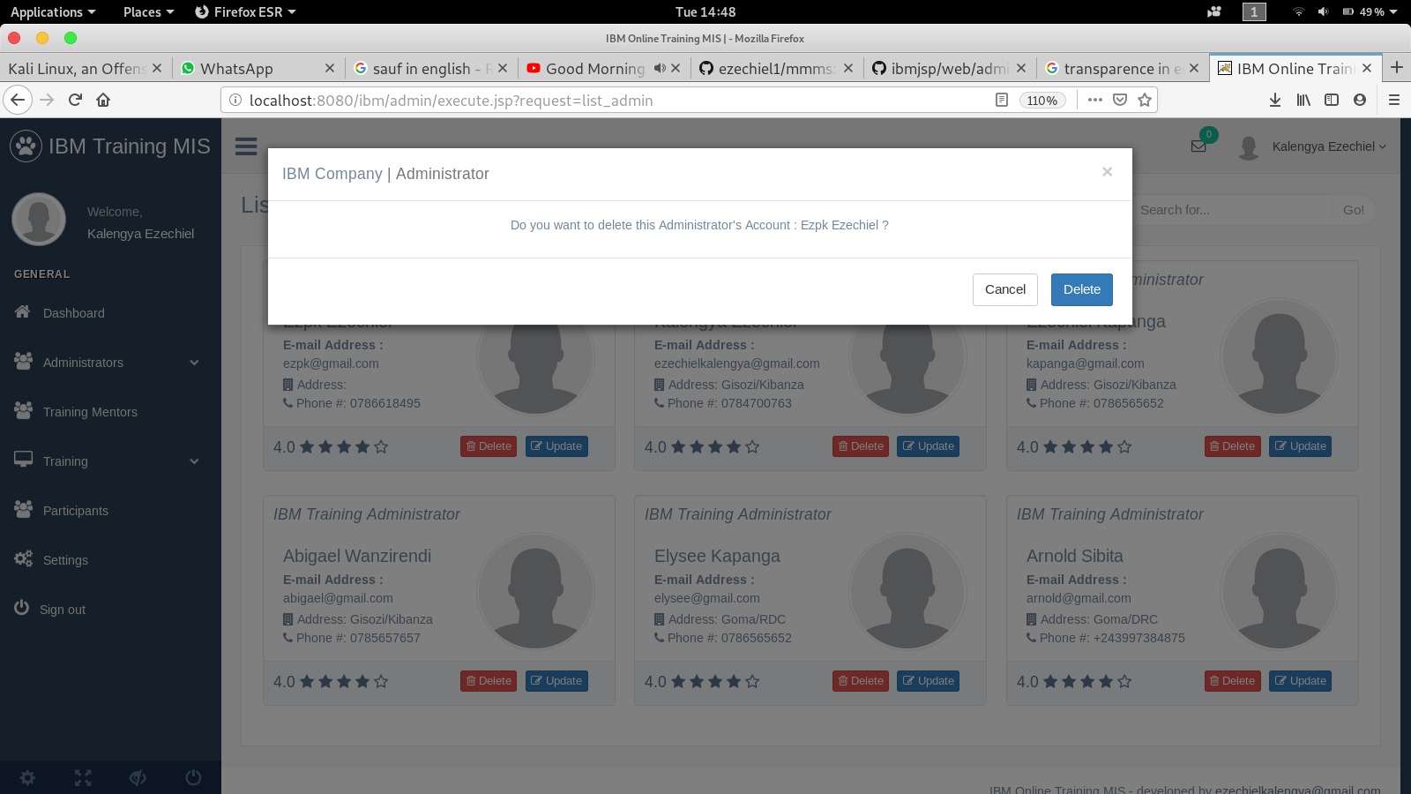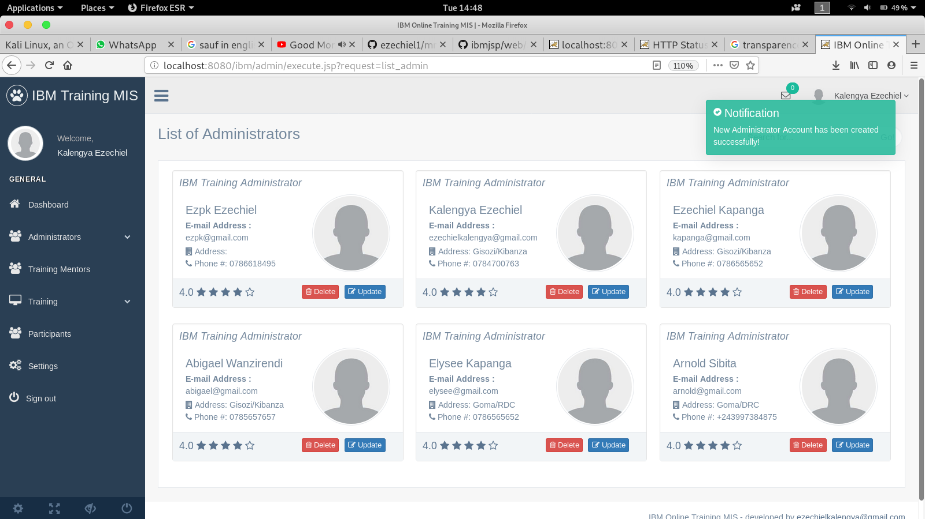

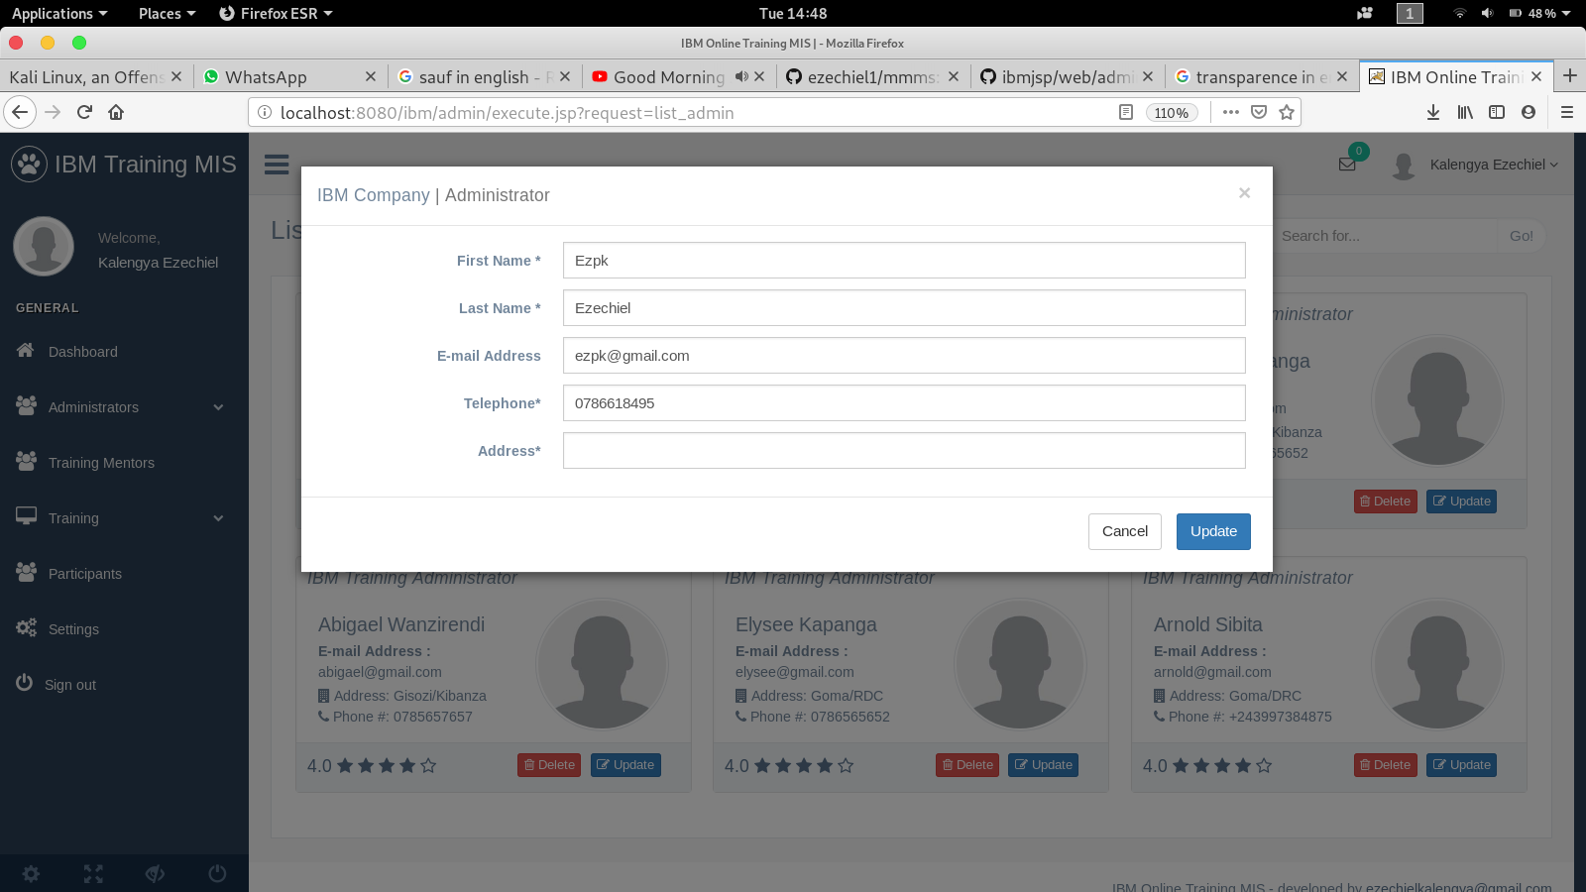

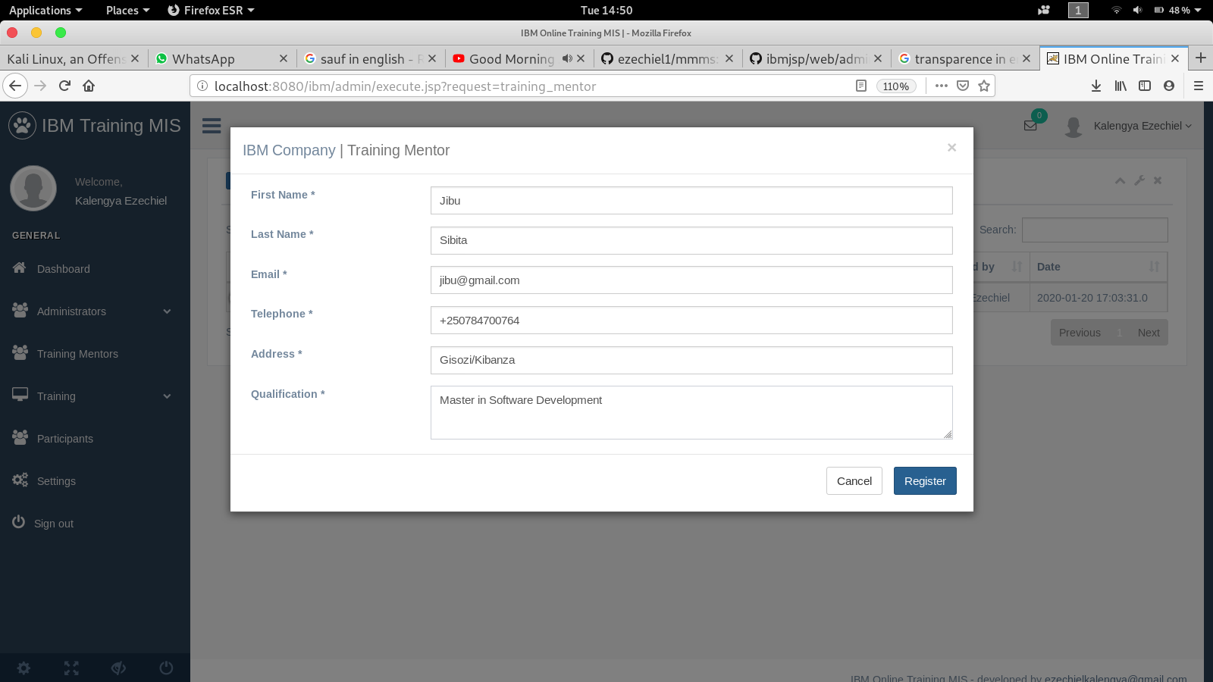**6. Training Mentors:**

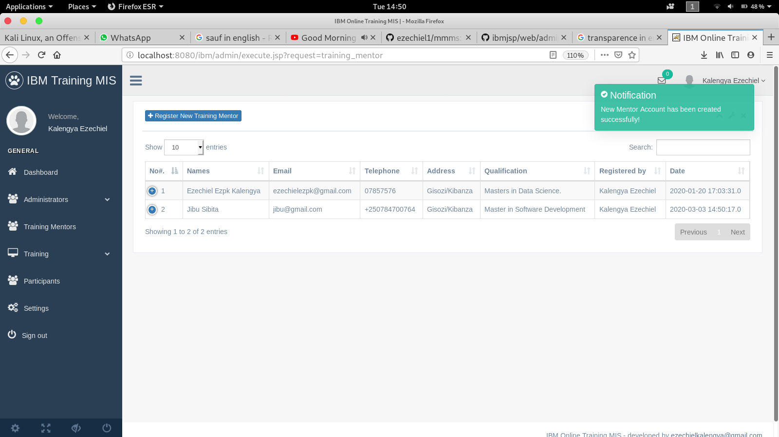

**7. Training Course [Module]:**

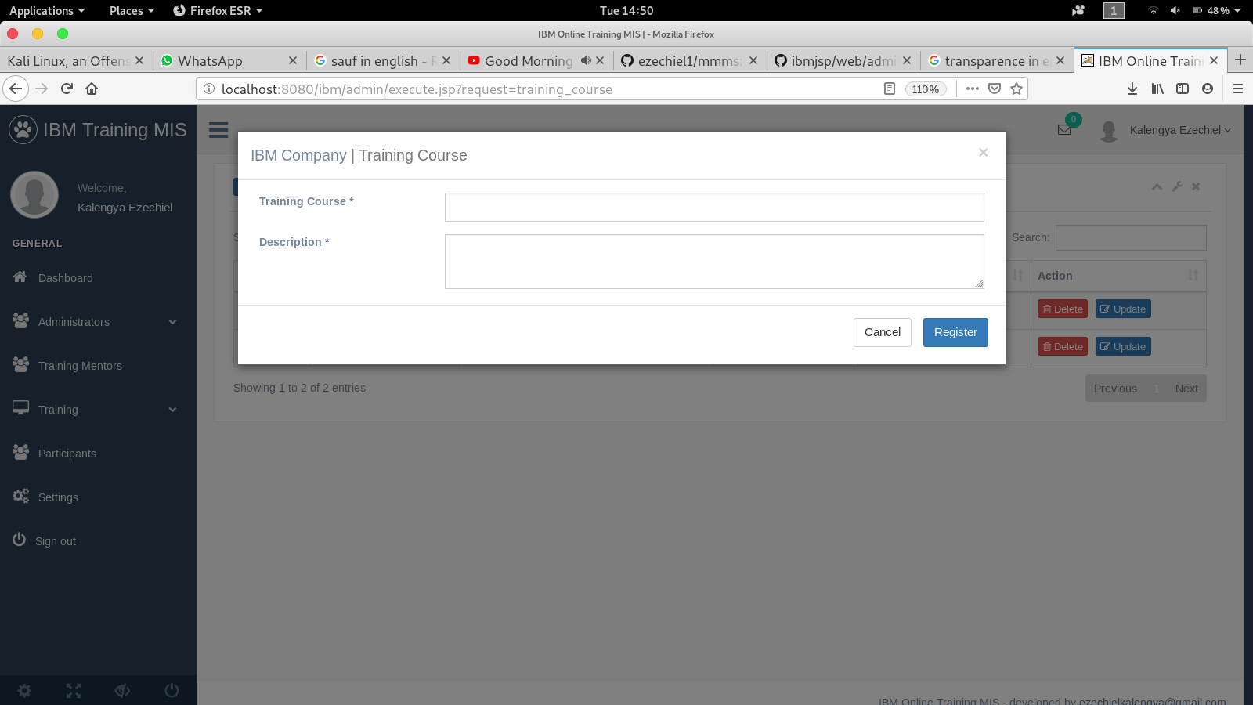

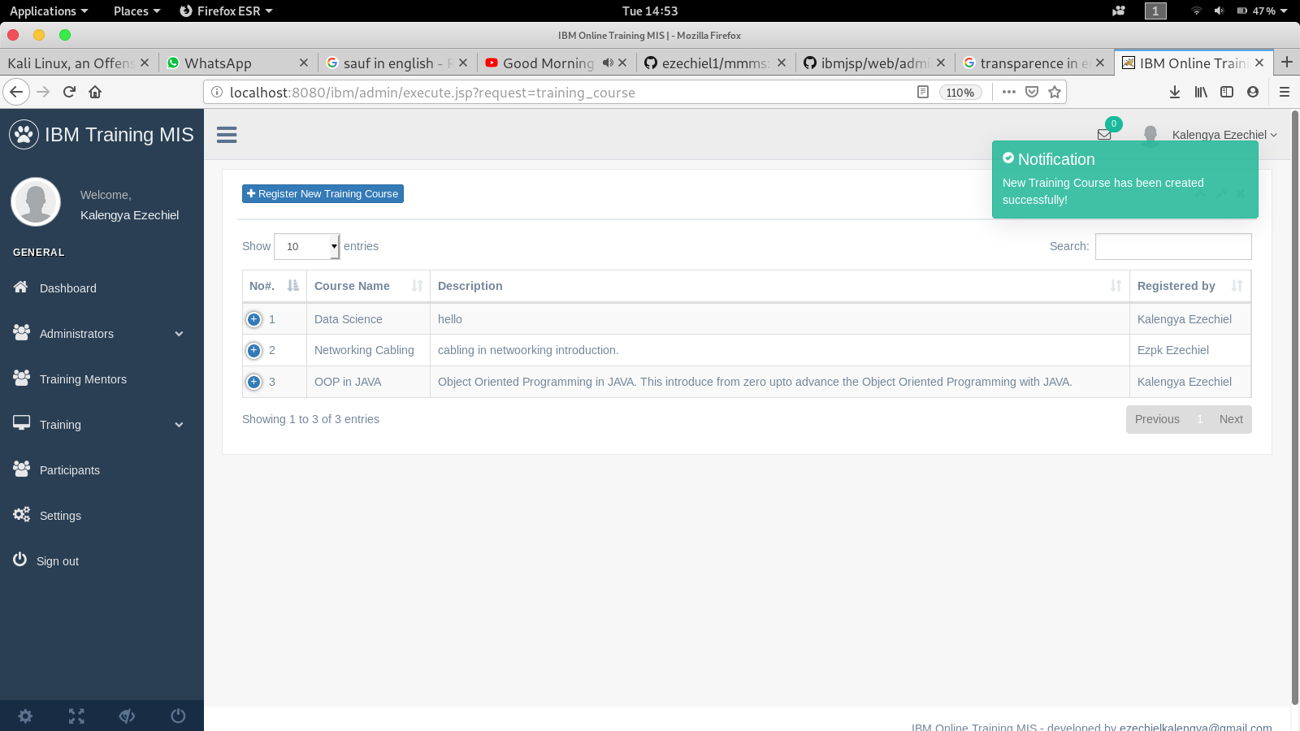

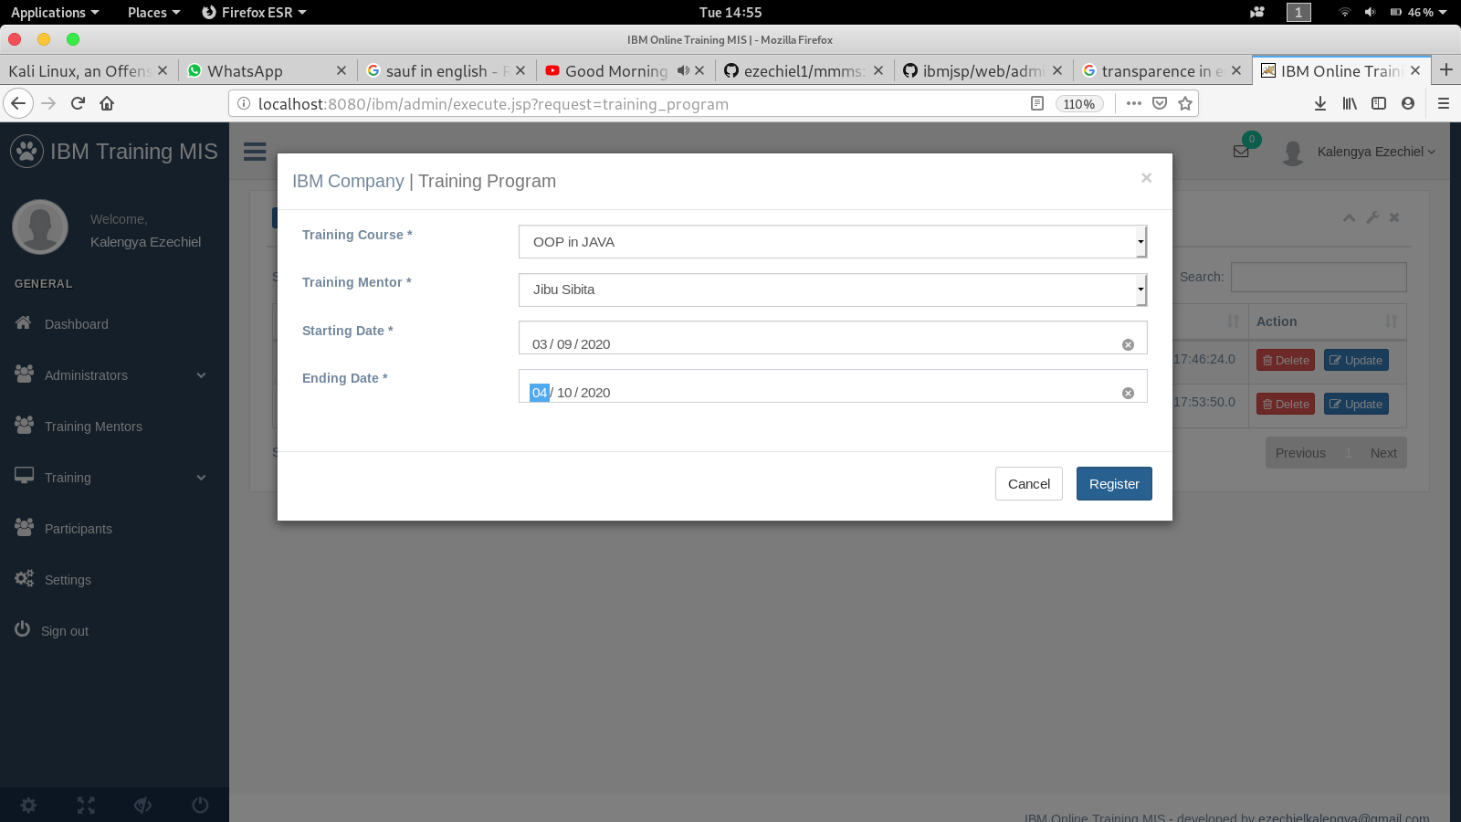**8. Training Program:**

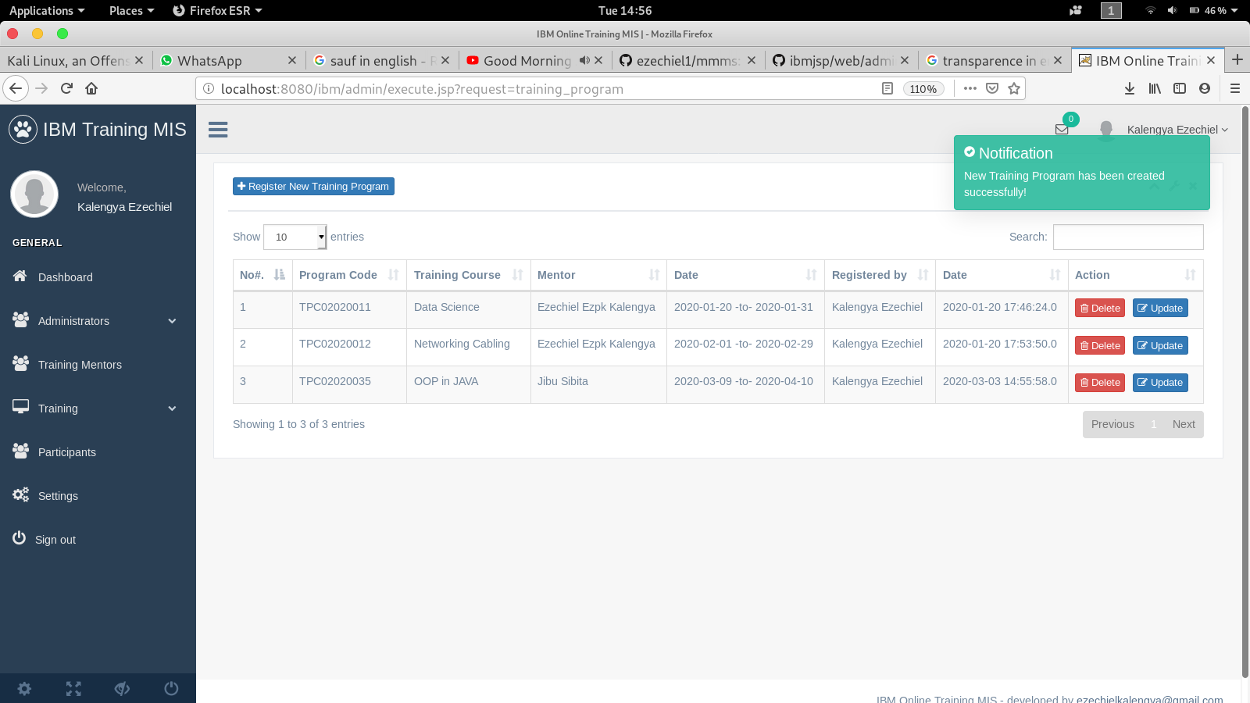

**9. Participants**

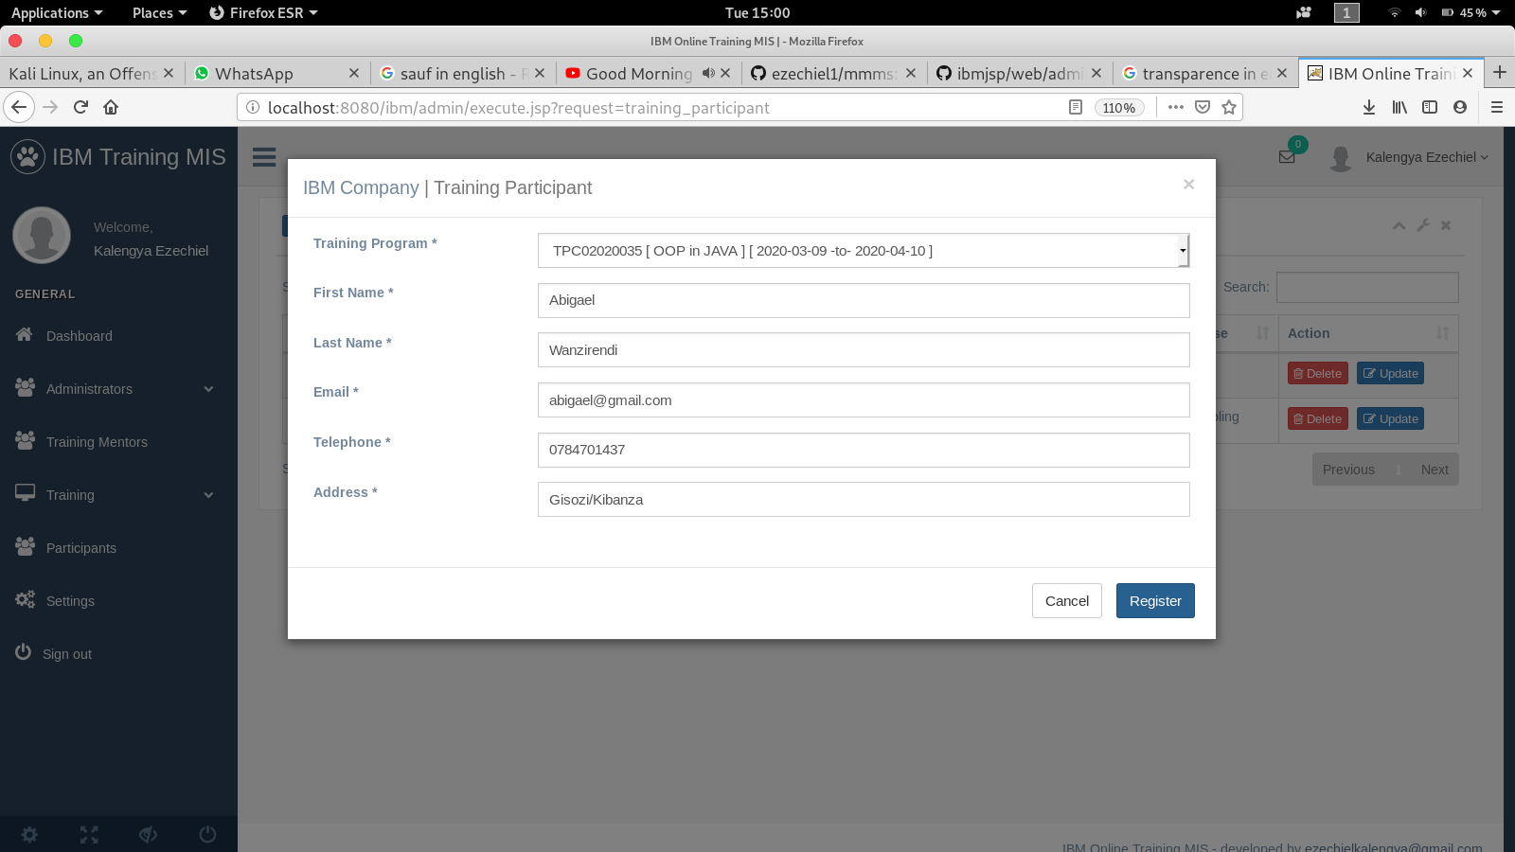

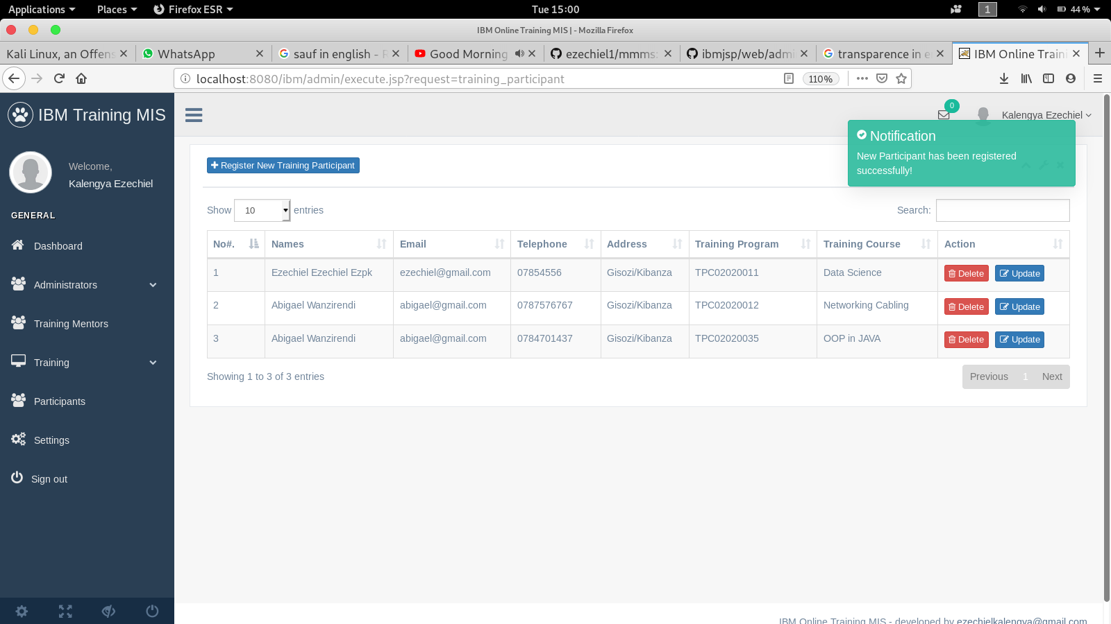

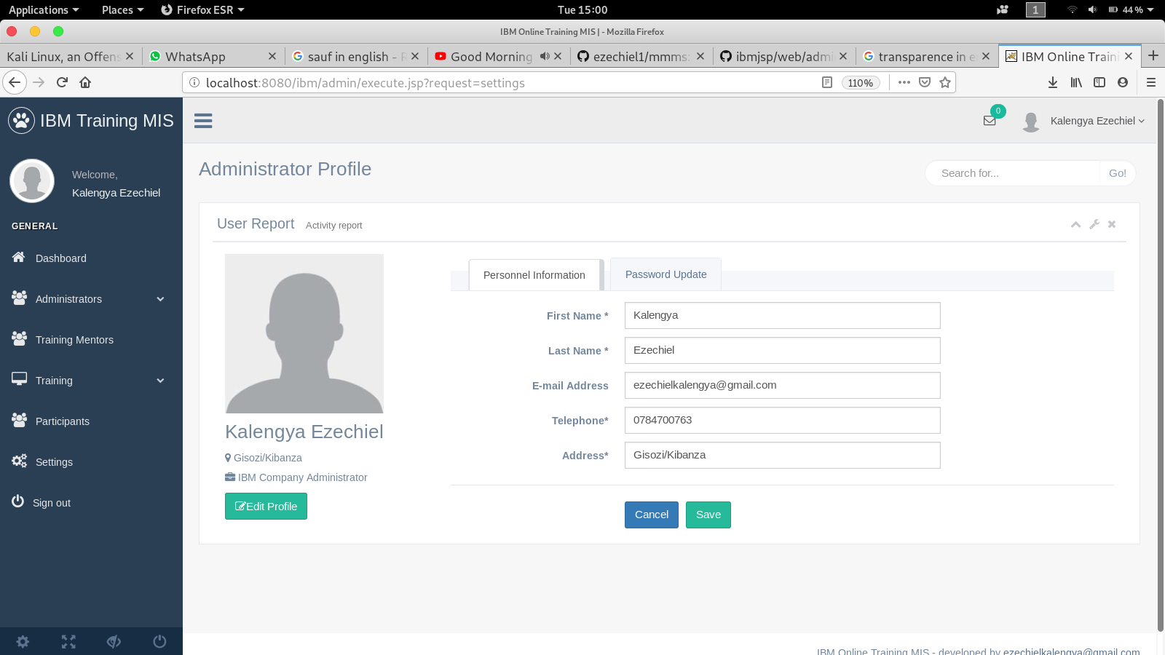**10. Settings:**

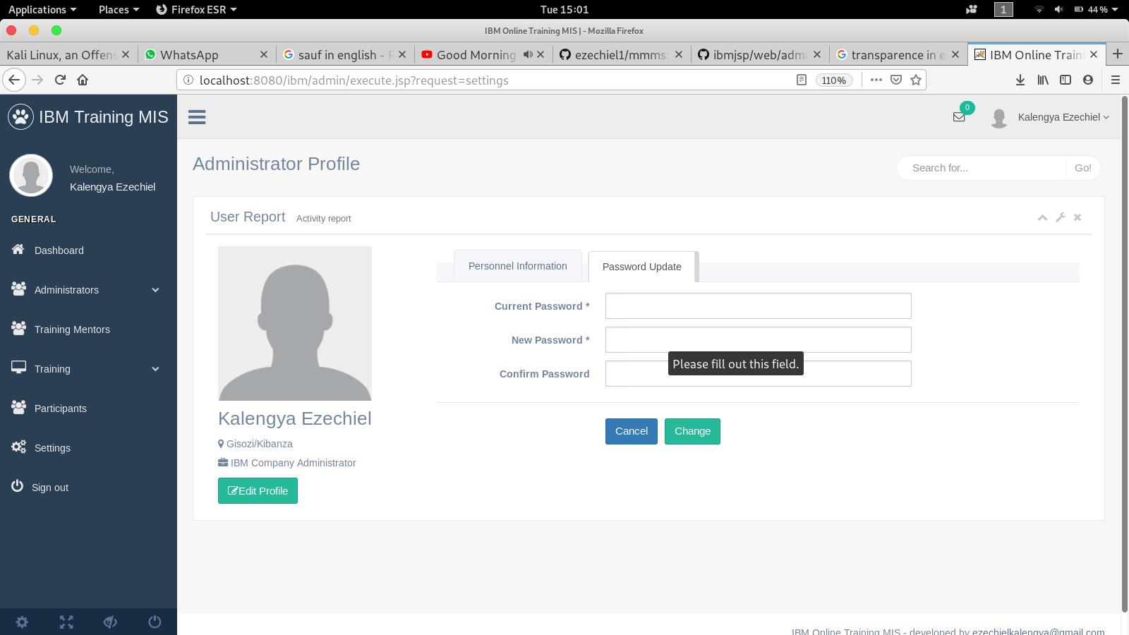

**Thanks!!!**