**REPUBLIC OF RWANDA**

**KIGALI INDEPENDENT UNIVERSITY ULK**

**P.O Box 2280**

Website://www.ulk.ac.rw

Email: [info@ulk.ac.rw](mailto:info@ulk.ac.rw)

PROJECT: project MMS

Student Roll Number : **201710226**

**201710259**

**201810954**

**201711468**

Course: **Internet& Web Technologies**

Lecture:

ACADEMIC YEAR : 2019 - 2020

**Introduction**

Solglobal Money Mutuality Management System (MMMS) is a web application developed for Money Mutuality Organisation in order to facilitate their activities for the management of Money. We realize that many Money Mutuality Organisations still use Papers, files, calculators, books to manage their business activities, which makes very hard their operations, no follow up, clarity in operations, … MMMS will allow the main admin to manage each and every Members(Register, Edit, Delete, Activate) by creatining account for them, will help to mannage the contributions, money loan, and money back of members. MMMS will help each member once logged in to follow up his activities, operations (Contribution, Money Loan, Money Back).

Download the Software in Github : [**https://github.com/ezechiel1/mmms**](https://github.com/ezechiel1/mmms) (The Database Is in core, called mmms_db). Default Credentials to login: email: [ezpk@gmail.com](mailto:ezpk@gmail.com) & password: ezpk

Note : For the codes, Please just visit the link ([**https://github.com/ezechiel1/mmms**](https://github.com/ezechiel1/mmms)) to see the codes. We prefere to do not put the codes in this current file cause they are too many.

**1. Sign In Page:**

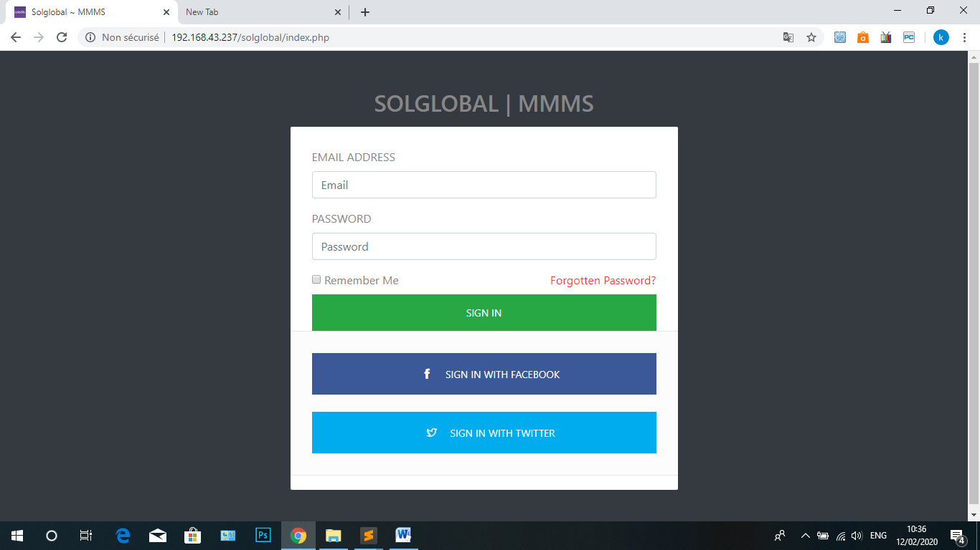

**2. Dashboard Page:**

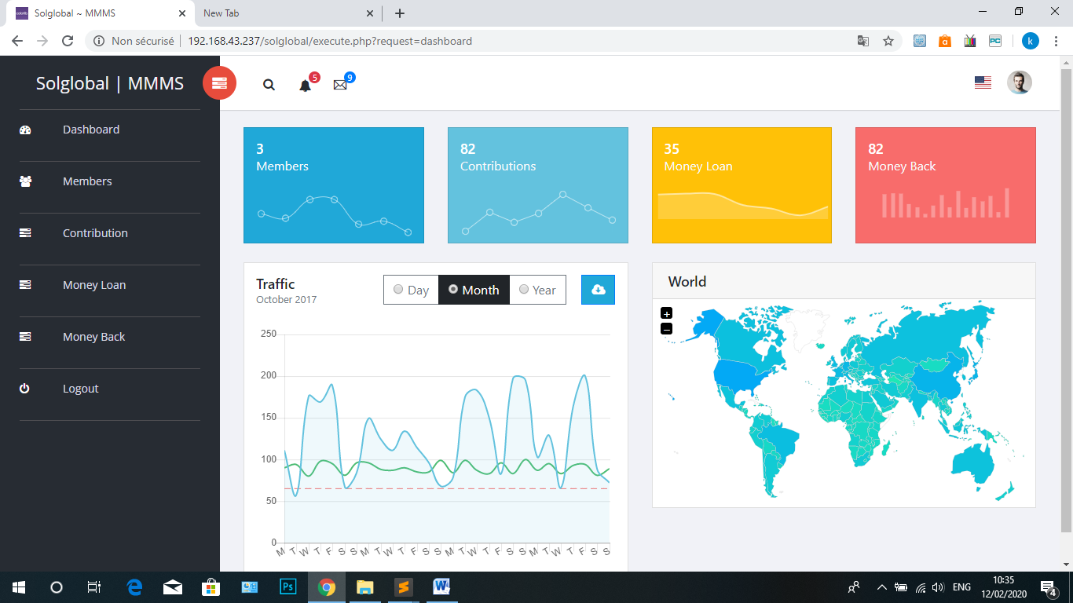

**3. Administrators Page:**

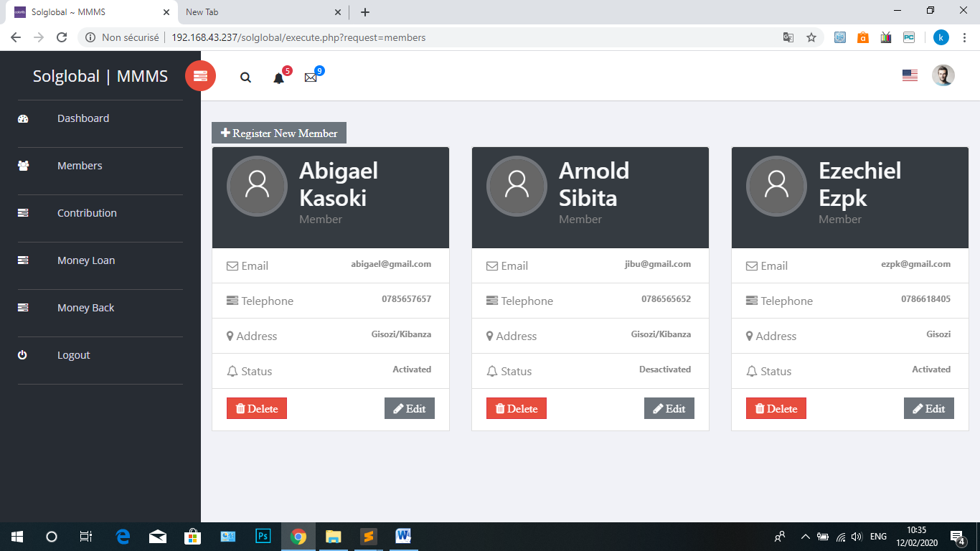

**4. Members Contributions:**

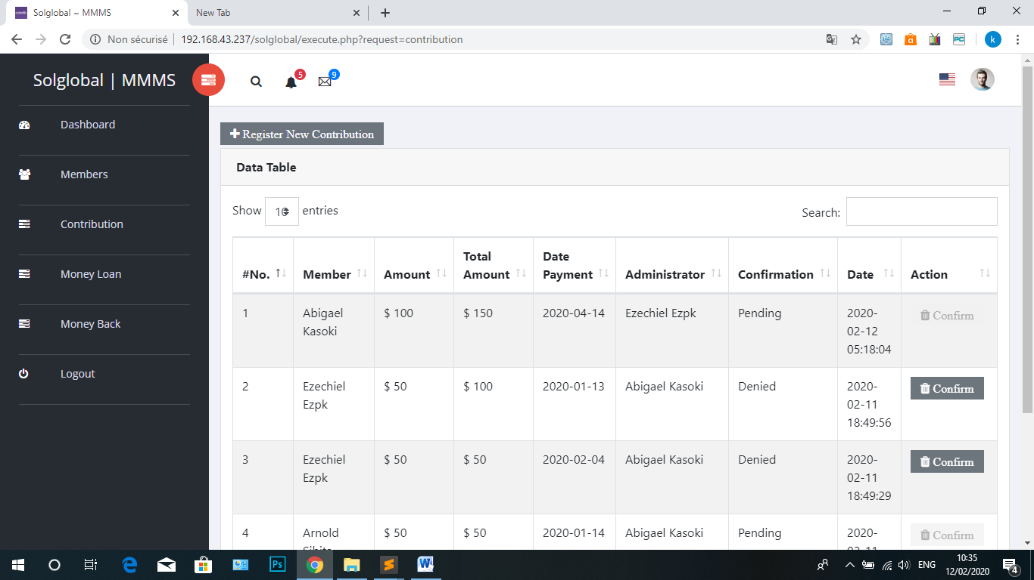

**5. Money Loan:**

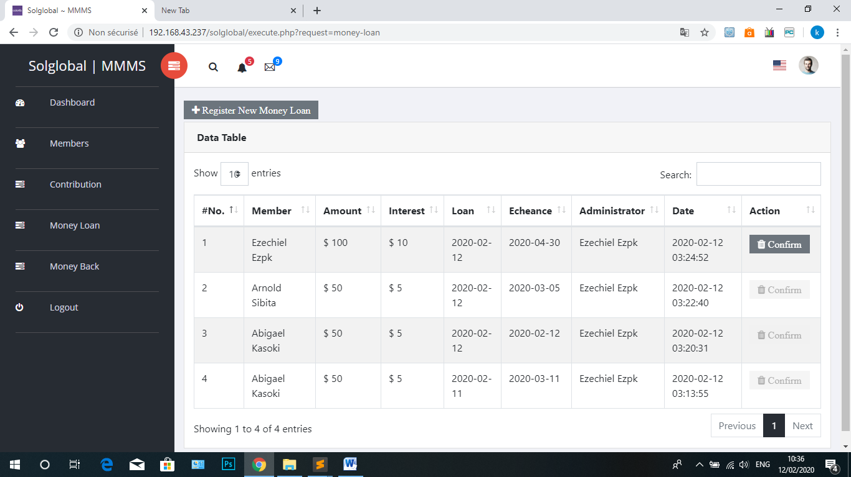

**6. Money Back (Payment of Loan):**

