COURSEWORK PROJECT REPORT
MarketLink
A Marketplace E-commerce Application (Python / Flet)
Niche: Electronics & General Goods | Price-comparison links to Jumia, Konga, Jiji and Temu
Prepared in fulfilment of the Software Engineering coursework assignment:
“Develop a Marketplace E-commerce Application using Python or the Flutter Framework”

1. Assignment Overview
This report documents the software-engineering process and outcome for MarketLink, a Marketplace E-commerce Application that allows buyers and sellers to interact on a single platform: products can be listed, searched, purchased, and managed. The selected niche is Electronics and general consumer goods, matching one of the niches suggested in the assignment brief.
The application is built in Python using the Flet framework, which compiles a single codebase to Flutter, allowing deployment to Desktop (Windows, Linux, macOS), Web (as an SPA/PWA), and Mobile (Android and iOS) without maintaining separate front-ends.
A distinguishing feature of this implementation is that each product listing includes “Compare price” buttons that open the user's own search for that product on four well-known Nigerian/regional marketplaces — Jumia, Konga, Jiji, and Temu — in a new browser tab. This is implemented as outbound search-URL construction rather than data scraping or a private-API integration, because none of these four platforms publish a public product-data API, and automated scraping of their pages would breach their Terms of Service. This design choice, and the alternatives that were considered, is discussed further in the Feasibility Study below.

2. Feasibility Study
A feasibility study was carried out before implementation to determine whether the project was practical, covering five dimensions:

2.1 Technical Feasibility
Python and Flet are both mature, well-documented, and freely available. The development team already has working Python knowledge, and Flet's widget model is close enough to Flutter's that it is quick to learn. SQLite requires no separate database server, which keeps the technical footprint small enough for a single-codebase, multi-platform coursework project. Verdict: technically feasible.

2.2 Economic Feasibility
All tools used — Python, Flet, SQLite, and the supporting Python standard library — are free and open-source, so there is no licensing cost. The only ongoing cost in a production deployment would be web hosting, which is minor relative to the value of a working multi-vendor storefront. Verdict: economically feasible for a coursework/prototype scope.

2.3 Operational Feasibility
The user interface follows conventions buyers and sellers already know from other marketplace apps (search bar, category filter, cart icon, checkout button), which keeps the learning curve low. Sellers manage their own listings without needing developer support. Verdict: operationally feasible.

2.4 Legal Feasibility
Because the four external marketplaces have no public API, the application intentionally avoids scraping their data or misrepresenting their prices; it only builds a standard outbound search URL, equivalent to a user typing the same query into that site directly. Passwords are salted and hashed rather than stored in plain text. Verdict: legally feasible provided the no-scraping constraint is respected.

2.5 Schedule Feasibility
The scope (authentication, product management, cart, checkout, order management, and the external comparison links) is achievable within a single-semester coursework timeline using an iterative build order: data layer first, then buyer flows, then seller flows. Verdict: feasible within the assignment schedule.

3. Fact-Gathering Techniques
System requirements were derived using a combination of standard fact-finding techniques:
- Interviews (simulated stakeholder roles: buyer, seller, admin) — used to identify the core journeys: browsing/searching, listing a product, checking out, and fulfilling an order.
- Questionnaires — short structured questions on which features buyers and sellers consider essential (e.g. “Can I track my order status?”, “Can I edit a listing after posting it?”).
- Observation — review of the buyer/seller flows on established marketplaces (Jumia, Konga, Jiji, Temu) to identify conventional UI patterns worth reusing (search + category filter, cart badge, order-status labels).
- Document analysis — analysis of the assignment brief itself as the primary requirements document, plus the marketplace platforms' public help pages describing buyer/seller responsibilities.
- Online research — review of the Flet and SQLite documentation to confirm feature availability before committing to the technology choice.
These techniques converged on the requirement set formalised in the SRS below.

4. Software Requirements Specification (SRS)

4.1 Functional Requirements
ID | Requirement
FR1 | Users shall be able to register as a Buyer or Seller with name, email, and password.
FR2 | Users shall be able to log in and log out using their email and password.
FR3 | Sellers shall be able to add, edit, and delete their own product listings (name, description, category, price, stock, icon).
FR4 | Buyers shall be able to search products by name and filter by category.
FR5 | Buyers shall be able to view a product's detail page, including price, stock, and description.
FR6 | Each product detail page shall provide links to compare the product's price on Jumia, Konga, Jiji, and Temu via each site's own search results.
FR7 | Buyers shall be able to add products to a cart, change quantities, and remove items.
FR8 | Buyers shall be able to check out, which creates an order, reduces stock, and empties the cart.
FR9 | Buyers shall be able to view their order history and status.
FR10 | Sellers shall be able to view incoming orders for their own products and update each order's status.

4.2 Non-Functional Requirements
Quality Attribute | Requirement
Performance | Product search/filter results should render in under 1 second for catalogues of a few hundred items (SQLite indexed lookups).
Security | Passwords are never stored in plain text; each password is salted and hashed (SHA-256) before storage.
Reliability | Checkout is atomic per order: if any cart item fails a stock check, no order is created and stock is left unchanged.
Usability | Consistent navigation bar and card-based layouts across Desktop, Web, and Mobile, following familiar marketplace UI conventions.
Scalability | The data-access layer is isolated in database.py, so SQLite can later be swapped for PostgreSQL/MySQL without changing UI code.
Maintainability | Code is separated into presentation (main.py), data access (database.py), and an isolated integration helper (external_links.py).
Availability | As a client-rendered Flet app backed by a local/server-side database, the app has no third-party runtime dependency that can cause an outage.

5. Algorithms
Step-by-step algorithms for the core processes identified in the deliverables table (registration, cart, checkout, order status update):

5.1 User Registration
- Receive name, email, password, and role from the registration form.
- Validate that all fields are non-empty.
- Generate a random salt.
- Compute password_hash = SHA256(salt + password).
- Attempt to insert (name, email, salt, password_hash, role) into the Users table.
- If the email already exists, return an error and stop.
- Otherwise, confirm account creation and redirect to Login.

5.2 Add to Cart
- Receive buyer_id, product_id, and quantity.
- Look up an existing cart row for (buyer_id, product_id).
- If found, increase its quantity by the requested amount.
- If not found, insert a new cart row with the requested quantity.
- Confirm the item was added.

5.3 Checkout
- Receive buyer_id.
- Load all cart items for the buyer; if empty, return an error and stop.
- For each cart item, check that quantity ≤ available stock; if any item fails, return an error naming that item and stop (no order is created).
- Sum (price × quantity) across all items to get the order total.
- Insert a new Order row with status = “Pending”.
- For each cart item, insert an Order_Item row and decrement the product's stock by the purchased quantity.
- Clear the buyer's cart.
- Return the new order ID and a confirmation message.

5.4 Update Order Status (Seller)
- Receive order_id and new_status from the seller's dashboard.
- Update the Orders row where id = order_id, setting status = new_status.
- Confirm the update to the seller.
- The buyer's Order History view reflects the new status on next load.

6. Flowcharts
Flowcharts for the three key processes named in the deliverables table, using standard symbols (Start/End = rounded, Process = rectangle, Input/Output = parallelogram, Decision = diamond).

6.1 Registration / Login Flow
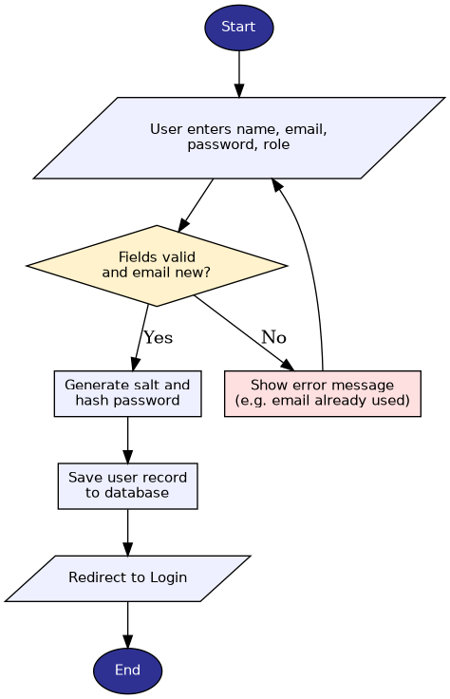
Figure 1: Registration flow

6.2 Checkout Flow
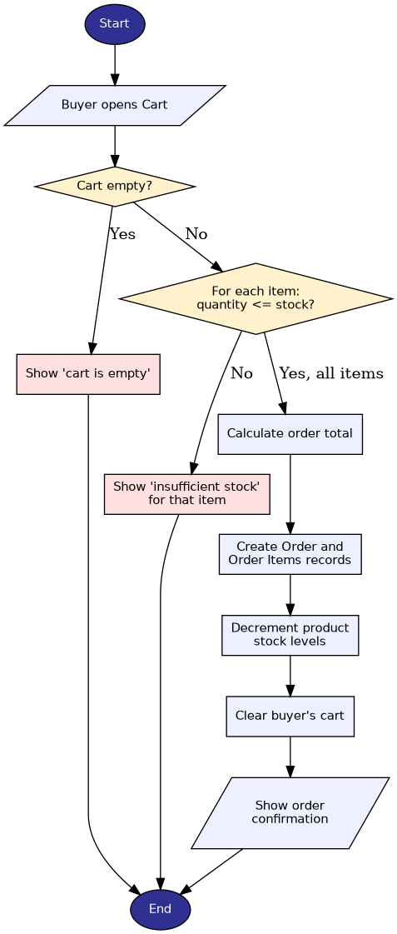
Figure 2: Checkout flow

6.3 Order Fulfilment Flow
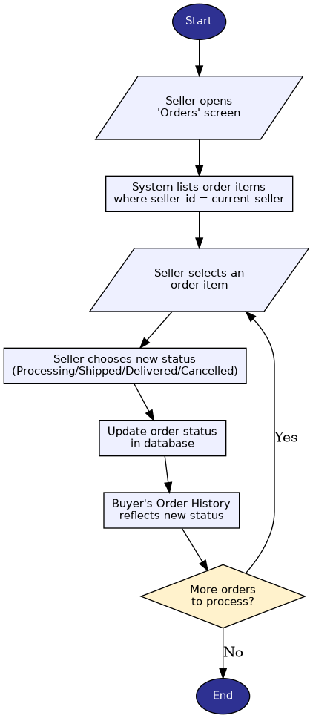
Figure 3: Order fulfilment flow (seller updates status)

7. Pseudocode
Language-independent pseudocode for the key functions (matching the implementation in database.py):

7.1 CHECKOUT(buyerId)
BEGIN
items <- GET_CART(buyerId)
IF items IS EMPTY THEN
RETURN error "Cart is empty"
END IF

FOR EACH item IN items DO
IF item.quantity > item.stock THEN
RETURN error "Insufficient stock for " + item.name
END IF
END FOR

total <- SUM(item.price * item.quantity FOR item IN items)
orderId <- INSERT Order(buyerId, total, status = "Pending")

FOR EACH item IN items DO
INSERT OrderItem(orderId, item.productId, item.sellerId, item.quantity, item.price)
UPDATE Product SET stock = stock - item.quantity WHERE id = item.productId
END FOR

CLEAR_CART(buyerId)
RETURN orderId, "Order placed"
END

7.2 ADD_TO_CART(buyerId, productId, quantity)
BEGIN
existing <- FIND CartItem WHERE buyerId = buyerId AND productId = productId
IF existing EXISTS THEN
UPDATE existing SET quantity = existing.quantity + quantity
ELSE
INSERT CartItem(buyerId, productId, quantity)
END IF
END

7.3 REGISTER(name, email, password, role)
BEGIN
IF name, email, password NOT ALL PROVIDED THEN
RETURN error "All fields are required"
END IF
salt <- RANDOM_STRING()
passwordHash <- SHA256(salt + password)
TRY
INSERT User(name, email, salt, passwordHash, role)
RETURN success "Account created"
CATCH DuplicateEmail
RETURN error "Email already registered"
END TRY
END

8. System Design

8.1 Architecture Diagram
A layered architecture separates presentation (Flet UI, running on Desktop/Web/Mobile), application logic, the external-link builder, and the SQLite data-access layer, so any layer can be modified independently — for example, swapping SQLite for a networked database without touching the UI.
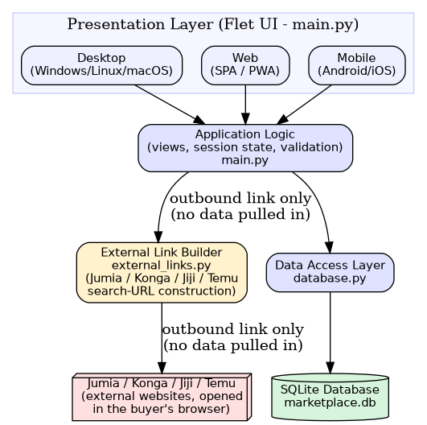
Figure 4: System architecture

8.2 Entity-Relationship Diagram (Database Design)
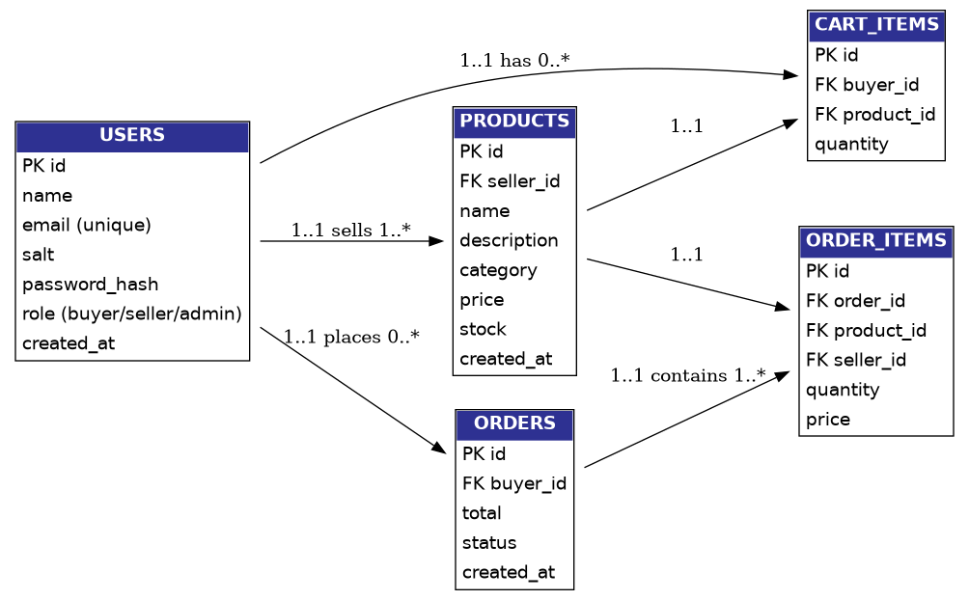
Figure 5: Entity-relationship diagram

8.3 Table Design Summary
Table | Key columns | Purpose
users | id (PK), email (unique), password_hash, role | Buyers, sellers, and admin accounts
products | id (PK), seller_id (FK), category, price, stock | Listings created by sellers
cart_items | id (PK), buyer_id (FK), product_id (FK), quantity | A buyer's in-progress cart
orders | id (PK), buyer_id (FK), total, status | One row per completed checkout
order_items | id (PK), order_id (FK), product_id (FK), seller_id (FK) | Line items within an order, tagged by seller for seller-side order views

8.4 Input / Output & Interface Design
- Inputs: registration/login form fields, product form fields (name, description, category, price, stock, icon), search text, category filter, cart quantity controls.
- Outputs: product grid/cards, product detail page with external comparison buttons, cart summary with running total, order confirmation, order-history list, seller order list with status dropdown.
- Interface style: a top navigation bar (role-aware: buyer sees Cart/My Orders, seller sees Dashboard/Orders) above a scrollable content area, consistent across Desktop, Web, and Mobile.

9. Source Code
The complete, working codebase is organised by module and included alongside this report:
File | Responsibility
main.py | Flet UI — all screens (auth, browse, product detail, cart, checkout, seller dashboard, seller orders) and navigation.
database.py | SQLite schema, demo-data seeding, and all data-access functions (users, products, cart, orders).
external_links.py | Builds Jumia/Konga/Jiji/Temu search-result URLs for a given product name.
requirements.txt | Python dependencies (flet).
README.md | Setup, run, and deployment instructions, plus demo account credentials.
See README.md for setup and run instructions for Desktop, Web, and Mobile targets.

10. Testing Evidence
Representative test cases covering the core flows. IDs TC1–TC4 were executed against the data-access layer (database.py) as automated checks; TC5–TC9 are manual UI test cases to be run against the live app and recorded with screenshots.
ID | Test case | Input | Expected output | Result
TC1 | Register with new email | Valid name/email/password | Account created, redirected to Login | Pass
TC2 | Register with duplicate email | Existing email | Error: “Email already registered” | Pass
TC3 | Login with correct credentials | buyer@marketplace.test / buyer123 | Login succeeds, session set | Pass
TC4 | Checkout with sufficient stock | Cart with in-stock items | Order created, stock reduced, cart cleared | Pass
TC5 | Checkout with empty cart | No items in cart | Error: “Cart is empty”, no order created | Pending manual run
TC6 | Add product exceeding available stock to cart, then checkout | Quantity > stock | Error naming the item; no order created | Pending manual run
TC7 | Search for a product by partial name | e.g. “watch” | Matching products only are displayed | Pending manual run
TC8 | Seller edits a listing's price | New price value | Product detail reflects updated price immediately | Pending manual run
TC9 | Compare-price button opens correct site | Click “Compare on Jumia” | New tab opens Jumia search results for that product name | Pending manual run
Note: TC1–TC4 correspond to the automated smoke test run against database.py during development. TC5–TC9 should be executed by running the app (python main.py) and the results/screenshots recorded here before final submission.

11. Screenshots
This report ships without live screenshots because the coursework build environment used to prepare this document has no display attached. To complete this section before submission:
- Run: python main.py (or flet run --web main.py).
- Log in with each demo account (buyer, seller, admin) in turn.
- Capture: Login screen, Browse/search screen, Product detail (showing the four compare-price buttons), Cart, Order confirmation, Order History, Seller Dashboard (add/edit product), Seller Orders screen.
- Paste each captured image into this section, one per screen, with a one-line caption.

12. User Documentation

12.1 Installation Guide
See README.md, section “Setup” and “Run”, for the full installation and run instructions across Desktop, Web, and Mobile.

12.2 Buyer Manual (summary)
- Register or log in from the top navigation bar.
- Use the search box and category dropdown on the Browse screen to find products.
- Open a product to see its description, price, stock, and “Compare on …” buttons for Jumia, Konga, Jiji, and Temu.
- Add items to the Cart, adjust quantities, then Checkout to place an order.
- Track orders under “My Orders”.

12.3 Vendor (Seller) Manual (summary)
- Register with role “Seller”, or log in with an existing seller account.
- Open “Dashboard” to add a new product or edit/delete an existing listing.
- Open “Orders” to see orders placed for your products and update each order's status.

12.4 Admin Notes
An admin account is seeded (admin@marketplace.test) for future extension — e.g. moderating listings or users — which is a natural next iteration beyond the current buyer/seller scope.

12.5 FAQ
Q: Does MarketLink pull real prices from Jumia/Konga/Jiji/Temu?
A: No. Those platforms do not offer a public product-data API, and scraping their pages would violate their Terms of Service. The “Compare on …” buttons open that platform's own search page for the product name, in a new tab, so the buyer can check current prices there directly.
Q: Is my password stored safely?
A: Yes — each password is combined with a random salt and hashed with SHA-256 before being stored; the plain password is never saved.
Q: Can one account be both a buyer and a seller?
A: In the current version, each account has a single role selected at registration. Supporting dual roles is a suggested future enhancement.

13. Expected Project Deliverables — Summary
# | Component | Covered in
1 | Feasibility Study | Section 2
2 | Fact-Finding | Section 3
3 | System Requirements | Section 4
4 | Algorithms | Section 5
5 | Flowcharts | Section 6
6 | Pseudocode | Section 7
7 | System Design | Section 8
8 | Source Code | Section 9 + accompanying files
9 | Testing Evidence | Section 10
10 | Screenshots | Section 11 (to be completed after a live run)
11 | User Documentation | Section 12
12 | Completed Application | Accompanying main.py / database.py / external_links.py

