> #######################################
> ####### OST-CONST-04_Analyses1 ########
> #######################################
>
> # Load packages
> library(ggplot2)
> library(magrittr)
> library("ggpubr")
> library(Matrix)
> library(languageR)
> library(dplyr)
> library(lsr)
> library(tidyr)
> library(reshape)
> library(lme4)
> library(emmeans)
> library(lmerTest)
> library(lsmeans)
> library(rcompanion)
>
>
> # How many participants are in each condition? (get overview using e.g. table())
>
>
> ################## Plots Master_ost:
> ################## mood, ios, excluded, ignored, NT1-4, perception of other player/group
> ### mood
> # Test
> # t-test if only comparing two groups (e.g. exclusion vs. inclusion)
> stats::t.test(master_ost$mood[master_ost$cyberball == 1],
+ master_ost$mood[master_ost$cyberball == 2])

Welch Two Sample t-test

data: master_ost$mood[master_ost$cyberball == 1] and master_ost$mood[master_ost$cyberball == 2]
t = 9.3133, df = 128.57, p-value = 4.411e-16
alternative hypothesis: true difference in means is not equal to 0
95 percent confidence interval:
2.497099 3.844319
sample estimates:
mean of x mean of y
6.358209 3.187500

> # Anova to compare all four groups (e.g. main effect cyberball, main effect focus, interaction Cyberbal*focus)
> summary(stats::aov(mood ~ self_other_condition * ostracism_condition, data = master_ost))
Df Sum Sq Mean Sq F value Pr(>F)
self_other_condition 1 17.9 17.9 4.759 0.031 *
ostracism_condition 1 320.1 320.1 85.036 8.08e-16 ***
self_other_condition:ostracism_condition 1 2.2 2.2 0.596 0.441
Residuals 127 478.0 3.8
---
Signif. codes: 0 ‘***’ 0.001 ‘**’ 0.01 ‘*’ 0.05 ‘.’ 0.1 ‘ ’ 1
>
> # Effect size (Cohen's d): z.B. cohensD(mood ~ ostracism_condition, data = master_ost)
> lsr::cohensD(mood ~ ostracism_condition, data = master_ost)
[1] 1.628279
>
> # Display mean & sd of groups (this function is very helpful for documenting results afterwards)
> dplyr::group_by(master_ost, cyberball, focus) %>%
+ dplyr::summarise(count = dplyr::n(),
+ mean = mean(mood, na.rm = TRUE),
+ sd = stats::sd(mood, na.rm = TRUE))
`summarise()` regrouping output by 'cyberball' (override with `.groups` argument)
# A tibble: 4 x 5
# Groups: cyberball [2]
cyberball focus count mean sd
<int> <int> <int> <dbl> <dbl>
1 1 1 35 6.49 1.72
2 1 2 32 6.22 2.17
3 2 1 29 3.62 2.21
4 2 2 35 2.83 1.67
>
> # Plot mood
> # Important info:
> # This plot cannot deal with NAs (need to be removed before, here not necessary)
>
> # Grouping variables (e.g. cyberball & focus) should not be numeric but factor
> # Is focus a factor variable?
> utils::str(master_ost$focus)
int [1:131] 2 1 2 1 1 1 2 1 1 2 ...
> # Is self_other_condition a factor variable?
> utils::str(master_ost$self_other_condition)
chr [1:131] "green" "yellow" "green" "yellow" "yellow" "yellow" "green" "yellow" "yellow" "green" "green" "green" "green" "yellow" "yellow" "green" ...
> # Try to exchange focus with self_other_condition and see how the plot changes
> # You can also change self_other_condition to a factor variable and see how the plot changes
>
> Sum_mood <- rcompanion::groupwiseMean(mood ~ ostracism_condition + self_other_condition,
+ data = master_ost,
+ conf = 0.95,
+ digits = 3,
+ traditional = FALSE,
+ percentile = TRUE)
> pd = ggplot2::position_dodge(.2)
> ggplot2::ggplot(Sum_mood, ggplot2::aes(x = ostracism_condition,
+ y = Mean,
+ color = self_other_condition)) +
+ ggplot2::geom_errorbar(ggplot2::aes(ymin=Percentile.lower,
+ ymax=Percentile.upper),
+ width=.2, size=0.7, position=pd) +
+ ggplot2::geom_point(shape=15, size=4, position=pd) +
+ ggplot2::theme(axis.title = ggplot2::element_text(face = "bold")) +
+ ggplot2::geom_point(shape=15, size=4, position=pd) + ggplot2::ylim(1, 9) +
+ ggplot2::ylab("Mood value (1 = bad; 9 = good)") +
+ ggplot2::theme_bw() +
+ ggplot2::theme(axis.title = ggplot2::element_text(face = "bold"))
>
> ### ios1 (Relationship towards person group Green OR person group Yellow)
> # Test
> stats::t.test(master_ost$ios_outcome[master_ost$ios_condition == "group_yellow_own"],
+ master_ost$ios_outcome[master_ost$ios_condition == "group_green_other"])

Welch Two Sample t-test

data: master_ost$ios_outcome[master_ost$ios_condition == "group_yellow_own"] and master_ost$ios_outcome[master_ost$ios_condition == "group_green_other"]
t = -3.1073, df = 128.16, p-value = 0.002326
alternative hypothesis: true difference in means is not equal to 0
95 percent confidence interval:
-1.5222592 -0.3378154
sample estimates:
mean of x mean of y
3.562500 4.492537

>
> # ANOVA
> summary(stats::aov(ios_outcome ~ self_other_condition * ostracism_condition, data = master_ost))
Df Sum Sq Mean Sq F value Pr(>F)
self_other_condition 1 28.3 28.313 10.781 0.001325 **
ostracism_condition 1 30.4 30.361 11.560 0.000901 ***
self_other_condition:ostracism_condition 1 16.6 16.600 6.321 0.013183 *
Residuals 127 333.5 2.626
---
Signif. codes: 0 ‘***’ 0.001 ‘**’ 0.01 ‘*’ 0.05 ‘.’ 0.1 ‘ ’ 1
>
> # Display mean & sd of groups
> dplyr::group_by(master_ost, ios_condition) %>%
+ dplyr::summarise(count = dplyr::n(),
+ mean = mean(ios_outcome, na.rm = TRUE),
+ sd = stats::sd(ios_outcome, na.rm = TRUE))
`summarise()` ungrouping output (override with `.groups` argument)
# A tibble: 2 x 4
ios_condition count mean sd
<chr> <int> <dbl> <dbl>
1 group_green_other 67 4.49 1.82
2 group_yellow_own 64 3.56 1.60
>
> # Plot ios1
> Sum_ios_outcome <- rcompanion::groupwiseMean(ios_outcome ~ ostracism_condition + self_other_condition,
+ data = master_ost,
+ conf = 0.95,
+ digits = 3,
+ traditional = FALSE,
+ percentile = TRUE)
> pd = ggplot2::position_dodge(.2)
> ggplot2::ggplot(Sum_ios_outcome, ggplot2::aes(x = ostracism_condition,
+ y = Mean,
+ color = self_other_condition)) +
+ ggplot2::geom_errorbar(ggplot2::aes(ymin=Percentile.lower,
+ ymax=Percentile.upper),
+ width=.2, size=0.7, position=pd) +
+ ggplot2::geom_point(shape=15, size=4, position=pd) +
+ ggplot2::theme(axis.title = ggplot2::element_text(face = "bold")) +
+ ggplot2::geom_point(shape=15, size=4, position=pd) + ggplot2::ylim(1, 9) +
+ ggplot2::ylab("IOS_outcome value (1 = close; 7 = distant)") +
+ ggplot2::theme_bw() +
+ ggplot2::theme(axis.title = ggplot2::element_text(face = "bold"))
>
>
> ### ios2 (Relationship self and own group)
> # Test
> stats::t.test(master_ost$ios_group_ident[master_ost$ios_condition == "group_yellow_own"],
+ master_ost$ios_group_ident[master_ost$ios_condition == "group_green_other"])

Welch Two Sample t-test

data: master_ost$ios_group_ident[master_ost$ios_condition == "group_yellow_own"] and master_ost$ios_group_ident[master_ost$ios_condition == "group_green_other"]
t = 1.9321, df = 125.93, p-value = 0.0556
alternative hypothesis: true difference in means is not equal to 0
95 percent confidence interval:
-0.01486357 1.23921059
sample estimates:
mean of x mean of y
4.671875 4.059701

>
> # ANOVA
> summary(stats::aov(ios_group_ident ~ self_other_condition * ostracism_condition, data = master_ost))
Df Sum Sq Mean Sq F value Pr(>F)
self_other_condition 1 12.3 12.267 3.782 0.0540 .
ostracism_condition 1 0.4 0.392 0.121 0.7286
self_other_condition:ostracism_condition 1 15.6 15.567 4.800 0.0303 *
Residuals 127 411.9 3.243
---
Signif. codes: 0 ‘***’ 0.001 ‘**’ 0.01 ‘*’ 0.05 ‘.’ 0.1 ‘ ’ 1
>
> # Display mean & sd of groups
> dplyr::group_by(master_ost, ios_condition) %>%
+ dplyr::summarise(count = dplyr::n(),
+ mean = mean(ios_group_ident, na.rm = TRUE),
+ sd = stats::sd(ios_group_ident, na.rm = TRUE))
`summarise()` ungrouping output (override with `.groups` argument)
# A tibble: 2 x 4
ios_condition count mean sd
<chr> <int> <dbl> <dbl>
1 group_green_other 67 4.06 1.99
2 group_yellow_own 64 4.67 1.62
>
> # Plot ios2
> Sum_ios_group_ident <- rcompanion::groupwiseMean(ios_group_ident ~ ostracism_condition + self_other_condition,
+ data = master_ost,
+ conf = 0.95,
+ digits = 3,
+ traditional = FALSE,
+ percentile = TRUE)
> pd = ggplot2::position_dodge(.2)
> ggplot2::ggplot(Sum_ios_group_ident, ggplot2::aes(x = ostracism_condition,
+ y = Mean,
+ color = self_other_condition)) +
+ ggplot2::geom_errorbar(ggplot2::aes(ymin=Percentile.lower,
+ ymax=Percentile.upper),
+ width=.2, size=0.7, position=pd) +
+ ggplot2::geom_point(shape=15, size=4, position=pd) +
+ ggplot2::theme(axis.title = ggplot2::element_text(face = "bold")) +
+ ggplot2::geom_point(shape=15, size=4, position=pd) + ggplot2::ylim(1, 7) +
+ ggplot2::ylab("IOS_group_ident value (1 = close; 7 = distant)") +
+ ggplot2::theme_bw() +
+ ggplot2::theme(axis.title = ggplot2::element_text(face = "bold"))
>
>
> ### How much do participants identify with their own group (positive experience and like being part)
> ## Positive experience
> # Test
> stats::t.test(master_ost$group_ident_experience[master_ost$ios_condition == "group_yellow_own"],
+ master_ost$group_ident_experience[master_ost$ios_condition == "group_green_other"])

Welch Two Sample t-test

data: master_ost$group_ident_experience[master_ost$ios_condition == "group_yellow_own"] and master_ost$group_ident_experience[master_ost$ios_condition == "group_green_other"]
t = 0.32939, df = 127.55, p-value = 0.7424
alternative hypothesis: true difference in means is not equal to 0
95 percent confidence interval:
-0.4741021 0.6634677
sample estimates:
mean of x mean of y
5.781250 5.686567

>
> # ANOVA
> summary(stats::aov(group_ident_experience ~ self_other_condition * ostracism_condition, data = master_ost))
Df Sum Sq Mean Sq F value Pr(>F)
self_other_condition 1 0.3 0.293 0.109 0.7413
ostracism_condition 1 8.5 8.547 3.189 0.0765 .
self_other_condition:ostracism_condition 1 2.5 2.452 0.915 0.3406
Residuals 127 340.4 2.680
---
Signif. codes: 0 ‘***’ 0.001 ‘**’ 0.01 ‘*’ 0.05 ‘.’ 0.1 ‘ ’ 1
>
> # Display mean & sd of groups
> dplyr::group_by(master_ost, ios_condition) %>%
+ dplyr::summarise(count = dplyr::n(),
+ mean = mean(group_ident_experience, na.rm = TRUE),
+ sd = stats::sd(group_ident_experience, na.rm = TRUE))
`summarise()` ungrouping output (override with `.groups` argument)
# A tibble: 2 x 4
ios_condition count mean sd
<chr> <int> <dbl> <dbl>
1 group_green_other 67 5.69 1.77
2 group_yellow_own 64 5.78 1.52
>
> # Plot positive experience
> Sum_group_ident_experience <- rcompanion::groupwiseMean(group_ident_experience ~ ostracism_condition + self_other_condition,
+ data = master_ost,
+ conf = 0.95,
+ digits = 3,
+ traditional = FALSE,
+ percentile = TRUE)
> pd = ggplot2::position_dodge(.2)
> ggplot2::ggplot(Sum_group_ident_experience, ggplot2::aes(x = ostracism_condition,
+ y = Mean,
+ color = self_other_condition)) +
+ ggplot2::geom_errorbar(ggplot2::aes(ymin=Percentile.lower,
+ ymax=Percentile.upper),
+ width=.2, size=0.7, position=pd) +
+ ggplot2::geom_point(shape=15, size=4, position=pd) +
+ ggplot2::theme(axis.title = ggplot2::element_text(face = "bold")) +
+ ggplot2::geom_point(shape=15, size=4, position=pd) + ggplot2::ylim(1, 9) +
+ ggplot2::ylab("Positive_experience value (1 = disagree; 9 = agree)") +
+ ggplot2::theme_bw() +
+ ggplot2::theme(axis.title = ggplot2::element_text(face = "bold"))
>
>
> ## Like being a member of Group Yellow
> # Test
> stats::t.test(master_ost$group_ident_like[master_ost$ios_condition == "group_yellow_own"],
+ master_ost$group_ident_like[master_ost$ios_condition == "group_green_other"])

Welch Two Sample t-test

data: master_ost$group_ident_like[master_ost$ios_condition == "group_yellow_own"] and master_ost$group_ident_like[master_ost$ios_condition == "group_green_other"]
t = 0.12489, df = 124.83, p-value = 0.9008
alternative hypothesis: true difference in means is not equal to 0
95 percent confidence interval:
-0.5505563 0.6247168
sample estimates:
mean of x mean of y
5.828125 5.791045

>
> # ANOVA
> summary(stats::aov(group_ident_like ~ self_other_condition * ostracism_condition, data = master_ost))
Df Sum Sq Mean Sq F value Pr(>F)
self_other_condition 1 0.0 0.045 0.015 0.901
ostracism_condition 1 1.4 1.379 0.473 0.493
self_other_condition:ostracism_condition 1 4.8 4.796 1.646 0.202
Residuals 127 370.0 2.913
>
> # Display mean & sd of groups
> dplyr::group_by(master_ost, ios_condition) %>%
+ dplyr::summarise(count = dplyr::n(),
+ mean = mean(group_ident_like, na.rm = TRUE),
+ sd = stats::sd(group_ident_like, na.rm = TRUE))
`summarise()` ungrouping output (override with `.groups` argument)
# A tibble: 2 x 4
ios_condition count mean sd
<chr> <int> <dbl> <dbl>
1 group_green_other 67 5.79 1.89
2 group_yellow_own 64 5.83 1.50
>
> # Plot liking
> Sum_group_ident_like <- rcompanion::groupwiseMean(group_ident_like ~ ostracism_condition + self_other_condition,
+ data = master_ost,
+ conf = 0.95,
+ digits = 3,
+ traditional = FALSE,
+ percentile = TRUE)
> pd = ggplot2::position_dodge(.2)
> ggplot2::ggplot(Sum_group_ident_like, ggplot2::aes(x = ostracism_condition,
+ y = Mean,
+ color = self_other_condition)) +
+ ggplot2::geom_errorbar(ggplot2::aes(ymin=Percentile.lower,
+ ymax=Percentile.upper),
+ width=.2, size=0.7, position=pd) +
+ ggplot2::geom_point(shape=15, size=4, position=pd) +
+ ggplot2::theme(axis.title = ggplot2::element_text(face = "bold")) +
+ ggplot2::geom_point(shape=15, size=4, position=pd) + ggplot2::ylim(1, 9) +
+ ggplot2::ylab("Like_beeing_member value (1 = disagree; 9 = agree)") +
+ ggplot2::theme_bw() +
+ ggplot2::theme(axis.title = ggplot2::element_text(face = "bold"))
>
>
> ### Feeling excluded
> # Test
> stats::t.test(master_ost$excluded[master_ost$cyberball == 1],
+ master_ost$excluded[master_ost$cyberball == 2])

Welch Two Sample t-test

data: master_ost$excluded[master_ost$cyberball == 1] and master_ost$excluded[master_ost$cyberball == 2]
t = -17.057, df = 128.63, p-value < 2.2e-16
alternative hypothesis: true difference in means is not equal to 0
95 percent confidence interval:
-5.718184 -4.529484
sample estimates:
mean of x mean of y
2.641791 7.765625

>
> # Display mean & sd of groups
> dplyr::group_by(master_ost, cyberball) %>%
+ dplyr::summarise(count = dplyr::n(),
+ mean = mean(excluded, na.rm = TRUE),
+ sd = stats::sd(excluded, na.rm = TRUE))
`summarise()` ungrouping output (override with `.groups` argument)
# A tibble: 2 x 4
cyberball count mean sd
<int> <int> <dbl> <dbl>
1 1 67 2.64 1.71
2 2 64 7.77 1.73
>
> # Plot excluded
> Sum_excluded <- rcompanion::groupwiseMean(excluded ~ cyberball,
+ data = master_ost,
+ conf = 0.95,
+ digits = 3,
+ traditional = FALSE,
+ percentile = TRUE)
> pd = ggplot2::position_dodge(.2)
> ggplot2::ggplot(Sum_excluded, ggplot2::aes(x = cyberball,
+ y = Mean)) +
+ ggplot2::geom_errorbar(ggplot2::aes(ymin=Percentile.lower,
+ ymax=Percentile.upper),
+ width=.2, size=0.7, position=pd) +
+ ggplot2::geom_point(shape=15, size=4, position=pd) +
+ ggplot2::theme(axis.title = ggplot2::element_text(face = "bold")) +
+ ggplot2::geom_point(shape=15, size=4, position=pd) + ggplot2::ylim(1, 9) +
+ ggplot2::ylab("Exclusion value (1 = disagree; 9 = agree)") +
+ ggplot2::theme_bw() +
+ ggplot2::theme(axis.title = ggplot2::element_text(face = "bold"))
>
>
> ### Feeling ignored
> # Test
> stats::t.test(master_ost$ignored[master_ost$cyberball == 1],
+ master_ost$ignored[master_ost$cyberball == 2])

Welch Two Sample t-test

data: master_ost$ignored[master_ost$cyberball == 1] and master_ost$ignored[master_ost$cyberball == 2]
t = -17.234, df = 123.5, p-value < 2.2e-16
alternative hypothesis: true difference in means is not equal to 0
95 percent confidence interval:
-5.672803 -4.503969
sample estimates:
mean of x mean of y
2.552239 7.640625

>
> # Display mean & sd of groups
> dplyr::group_by(master_ost, cyberball) %>%
+ dplyr::summarise(count = dplyr::n(),
+ mean = mean(ignored, na.rm = TRUE),
+ sd = stats::sd(ignored, na.rm = TRUE))
`summarise()` ungrouping output (override with `.groups` argument)
# A tibble: 2 x 4
cyberball count mean sd
<int> <int> <dbl> <dbl>
1 1 67 2.55 1.54
2 2 64 7.64 1.82
>
> # Plot excluded
> Sum_ignored <- rcompanion::groupwiseMean(ignored ~ cyberball,
+ data = master_ost,
+ conf = 0.95,
+ digits = 3,
+ traditional = FALSE,
+ percentile = TRUE)
> pd = ggplot2::position_dodge(.2)
> ggplot2::ggplot(Sum_ignored, ggplot2::aes(x = cyberball,
+ y = Mean)) +
+ ggplot2::geom_errorbar(ggplot2::aes(ymin=Percentile.lower,
+ ymax=Percentile.upper),
+ width=.2, size=0.7, position=pd) +
+ ggplot2::geom_point(shape=15, size=4, position=pd) +
+ ggplot2::theme(axis.title = ggplot2::element_text(face = "bold")) +
+ ggplot2::geom_point(shape=15, size=4, position=pd) + ggplot2::ylim(1, 9) +
+ ggplot2::ylab("Ignoration value (1 = disagree; 9 = agree)") +
+ ggplot2::theme_bw() +
+ ggplot2::theme(axis.title = ggplot2::element_text(face = "bold"))
>
> ### Received tosses
> # Test
> stats::t.test(master_ost$received_tosses[master_ost$cyberball == 1],
+ master_ost$received_tosses[master_ost$cyberball == 2])

Welch Two Sample t-test

data: master_ost$received_tosses[master_ost$cyberball == 1] and master_ost$received_tosses[master_ost$cyberball == 2]
t = 23.044, df = 87.003, p-value < 2.2e-16
alternative hypothesis: true difference in means is not equal to 0
95 percent confidence interval:
22.90333 27.22727
sample estimates:
mean of x mean of y
31.9403 6.8750

>
> # ANOVA
> summary(stats::aov(received_tosses ~ self_other_condition * ostracism_condition, data = master_ost))
Df Sum Sq Mean Sq F value Pr(>F)
self_other_condition 1 144 144 3.552 0.0618 .
ostracism_condition 1 20426 20426 505.528 <2e-16 ***
self_other_condition:ostracism_condition 1 31 31 0.771 0.3816
Residuals 127 5131 40
---
Signif. codes: 0 ‘***’ 0.001 ‘**’ 0.01 ‘*’ 0.05 ‘.’ 0.1 ‘ ’ 1
>
> # Display mean & sd of groups
> dplyr::group_by(master_ost, cyberball) %>%
+ dplyr::summarise(count = dplyr::n(),
+ mean = mean(received_tosses, na.rm = TRUE),
+ sd = stats::sd(received_tosses, na.rm = TRUE))
`summarise()` ungrouping output (override with `.groups` argument)
# A tibble: 2 x 4
cyberball count mean sd
<int> <int> <dbl> <dbl>
1 1 67 31.9 8.25
2 2 64 6.88 3.27
>
> # Plot received tosses
> Sum_received_tosses <- rcompanion::groupwiseMean(received_tosses ~ cyberball,
+ data = master_ost,
+ conf = 0.95,
+ digits = 3,
+ traditional = FALSE,
+ percentile = TRUE)
> pd = ggplot2::position_dodge(.2)
> ggplot2::ggplot(Sum_received_tosses, ggplot2::aes(x = cyberball,
+ y = Mean)) +
+ ggplot2::geom_errorbar(ggplot2::aes(ymin=Percentile.lower,
+ ymax=Percentile.upper),
+ width=.2, size=0.7, position=pd) +
+ ggplot2::geom_point(shape=15, size=4, position=pd) +
+ ggplot2::theme(axis.title = ggplot2::element_text(face = "bold")) +
+ ggplot2::geom_point(shape=15, size=4, position=pd) + ggplot2::ylim(1, 60) +
+ ggplot2::ylab("Received_tosses value (1 = few; 60 = many)") +
+ ggplot2::theme_bw() +
+ ggplot2::theme(axis.title = ggplot2::element_text(face = "bold"))
>
> ### Need threat 1-4
> ## NT1
> # Test
> stats::t.test(master_ost$nt1_accepted[master_ost$cyberball == 1],
+ master_ost$nt1_accepted[master_ost$cyberball == 2])

Welch Two Sample t-test

data: master_ost$nt1_accepted[master_ost$cyberball == 1] and master_ost$nt1_accepted[master_ost$cyberball == 2]
t = 18.405, df = 126.41, p-value < 2.2e-16
alternative hypothesis: true difference in means is not equal to 0
95 percent confidence interval:
4.104837 5.093857
sample estimates:
mean of x mean of y
6.880597 2.281250

>
> # Display mean & sd of groups
> dplyr::group_by(master_ost, cyberball) %>%
+ dplyr::summarise(count = dplyr::n(),
+ mean = mean(nt1_accepted, na.rm = TRUE),
+ sd = stats::sd(nt1_accepted, na.rm = TRUE))
`summarise()` ungrouping output (override with `.groups` argument)
# A tibble: 2 x 4
cyberball count mean sd
<int> <int> <dbl> <dbl>
1 1 67 6.88 1.56
2 2 64 2.28 1.29
>
> # Plot NT1
> Sum_nt1_accepted <- rcompanion::groupwiseMean(nt1_accepted ~ cyberball,
+ data = master_ost,
+ conf = 0.95,
+ digits = 3,
+ traditional = FALSE,
+ percentile = TRUE)
> pd = ggplot2::position_dodge(.2)
> ggplot2::ggplot(Sum_nt1_accepted, ggplot2::aes(x = cyberball,
+ y = Mean)) +
+ ggplot2::geom_errorbar(ggplot2::aes(ymin=Percentile.lower,
+ ymax=Percentile.upper),
+ width=.2, size=0.7, position=pd) +
+ ggplot2::geom_point(shape=15, size=4, position=pd) +
+ ggplot2::theme(axis.title = ggplot2::element_text(face = "bold")) +
+ ggplot2::geom_point(shape=15, size=4, position=pd) + ggplot2::ylim(1, 9) +
+ ggplot2::ylab("NT1 value (1 = low; 9 = high)") +
+ ggplot2::theme_bw() +
+ ggplot2::theme(axis.title = ggplot2::element_text(face = "bold"))
>
>
> ## NT2
> # Test
> stats::t.test(master_ost$nt2_valued[master_ost$cyberball == 1],
+ master_ost$nt2_valued[master_ost$cyberball == 2])

Welch Two Sample t-test

data: master_ost$nt2_valued[master_ost$cyberball == 1] and master_ost$nt2_valued[master_ost$cyberball == 2]
t = 13.493, df = 126.83, p-value < 2.2e-16
alternative hypothesis: true difference in means is not equal to 0
95 percent confidence interval:
3.285207 4.414420
sample estimates:
mean of x mean of y
6.537313 2.687500

>
> # Display mean & sd of groups
> dplyr::group_by(master_ost, cyberball) %>%
+ dplyr::summarise(count = dplyr::n(),
+ mean = mean(nt2_valued, na.rm = TRUE),
+ sd = stats::sd(nt2_valued, na.rm = TRUE))
`summarise()` ungrouping output (override with `.groups` argument)
# A tibble: 2 x 4
cyberball count mean sd
<int> <int> <dbl> <dbl>
1 1 67 6.54 1.56
2 2 64 2.69 1.70
>
> # Plot NT2
> Sum_nt2_valued <- rcompanion::groupwiseMean(nt2_valued ~ cyberball,
+ data = master_ost,
+ conf = 0.95,
+ digits = 3,
+ traditional = FALSE,
+ percentile = TRUE)
> pd = ggplot2::position_dodge(.2)
> ggplot2::ggplot(Sum_nt2_valued, ggplot2::aes(x = cyberball,
+ y = Mean)) +
+ ggplot2::geom_errorbar(ggplot2::aes(ymin=Percentile.lower,
+ ymax=Percentile.upper),
+ width=.2, size=0.7, position=pd) +
+ ggplot2::geom_point(shape=15, size=4, position=pd) +
+ ggplot2::theme(axis.title = ggplot2::element_text(face = "bold")) +
+ ggplot2::geom_point(shape=15, size=4, position=pd) + ggplot2::ylim(1, 9) +
+ ggplot2::ylab("NT2 value (1 = low; 9 = high)") +
+ ggplot2::theme_bw() +
+ ggplot2::theme(axis.title = ggplot2::element_text(face = "bold"))
>
>
> ## NT3
> # Test
> stats::t.test(master_ost$nt3_powerfull[master_ost$cyberball == 1],
+ master_ost$nt3_powerfull[master_ost$cyberball == 2])

Welch Two Sample t-test

data: master_ost$nt3_powerfull[master_ost$cyberball == 1] and master_ost$nt3_powerfull[master_ost$cyberball == 2]
t = 11.109, df = 128.4, p-value < 2.2e-16
alternative hypothesis: true difference in means is not equal to 0
95 percent confidence interval:
2.695492 3.863744
sample estimates:
mean of x mean of y
5.701493 2.421875

>
> # Display mean & sd of groups
> dplyr::group_by(master_ost, cyberball) %>%
+ dplyr::summarise(count = dplyr::n(),
+ mean = mean(nt3_powerfull, na.rm = TRUE),
+ sd = stats::sd(nt3_powerfull, na.rm = TRUE))
`summarise()` ungrouping output (override with `.groups` argument)
# A tibble: 2 x 4
cyberball count mean sd
<int> <int> <dbl> <dbl>
1 1 67 5.70 1.67
2 2 64 2.42 1.71
>
> # Plot NT3
> Sum_nt3_powerfull <- rcompanion::groupwiseMean(nt3_powerfull ~ cyberball,
+ data = master_ost,
+ conf = 0.95,
+ digits = 3,
+ traditional = FALSE,
+ percentile = TRUE)
> pd = ggplot2::position_dodge(.2)
> ggplot2::ggplot(Sum_nt3_powerfull, ggplot2::aes(x = cyberball,
+ y = Mean)) +
+ ggplot2::geom_errorbar(ggplot2::aes(ymin=Percentile.lower,
+ ymax=Percentile.upper),
+ width=.2, size=0.7, position=pd) +
+ ggplot2::geom_point(shape=15, size=4, position=pd) +
+ ggplot2::theme(axis.title = ggplot2::element_text(face = "bold")) +
+ ggplot2::geom_point(shape=15, size=4, position=pd) + ggplot2::ylim(1, 9) +
+ ggplot2::ylab("NT3 value (1 = low; 9 = high)") +
+ ggplot2::theme_bw() +
+ ggplot2::theme(axis.title = ggplot2::element_text(face = "bold"))
>
> ## N4
> # Test
> stats::t.test(master_ost$nt4_recognized[master_ost$cyberball == 1],
+ master_ost$nt4_recognized[master_ost$cyberball == 2])

Welch Two Sample t-test

data: master_ost$nt4_recognized[master_ost$cyberball == 1] and master_ost$nt4_recognized[master_ost$cyberball == 2]
t = 13.141, df = 123.46, p-value < 2.2e-16
alternative hypothesis: true difference in means is not equal to 0
95 percent confidence interval:
3.415138 4.626373
sample estimates:
mean of x mean of y
6.223881 2.203125

>
> # Display mean & sd of groups
> dplyr::group_by(master_ost, cyberball) %>%
+ dplyr::summarise(count = dplyr::n(),
+ mean = mean(nt4_recognized, na.rm = TRUE),
+ sd = stats::sd(nt4_recognized, na.rm = TRUE))
`summarise()` ungrouping output (override with `.groups` argument)
# A tibble: 2 x 4
cyberball count mean sd
<int> <int> <dbl> <dbl>
1 1 67 6.22 1.97
2 2 64 2.20 1.51
>
> # Plot NT4
> Sum_nt4_recognized <- rcompanion::groupwiseMean(nt4_recognized ~ cyberball,
+ data = master_ost,
+ conf = 0.95,
+ digits = 3,
+ traditional = FALSE,
+ percentile = TRUE)
> pd = ggplot2::position_dodge(.2)
> ggplot2::ggplot(Sum_nt4_recognized, ggplot2::aes(x = cyberball,
+ y = Mean)) +
+ ggplot2::geom_errorbar(ggplot2::aes(ymin=Percentile.lower,
+ ymax=Percentile.upper),
+ width=.2, size=0.7, position=pd) +
+ ggplot2::geom_point(shape=15, size=4, position=pd) +
+ ggplot2::theme(axis.title = ggplot2::element_text(face = "bold")) +
+ ggplot2::geom_point(shape=15, size=4, position=pd) + ggplot2::ylim(1, 9) +
+ ggplot2::ylab("NT4 value (1 = low; 9 = high)") +
+ ggplot2::theme_bw() +
+ ggplot2::theme(axis.title = ggplot2::element_text(face = "bold"))
>
>
>
> ### How is Player 3 from Group Green perceived?
> ## Gender P3
> # Test
> stats::t.test(master_ost$gender_green[master_ost$cyberball == 1],
+ master_ost$gender_green[master_ost$cyberball == 2])

Welch Two Sample t-test

data: master_ost$gender_green[master_ost$cyberball == 1] and master_ost$gender_green[master_ost$cyberball == 2]
t = -0.66663, df = 120.44, p-value = 0.5063
alternative hypothesis: true difference in means is not equal to 0
95 percent confidence interval:
-0.303671 0.150686
sample estimates:
mean of x mean of y
1.298507 1.375000

>
> # Display mean & sd of groups
> dplyr::group_by(master_ost, cyberball) %>%
+ dplyr::summarise(count = dplyr::n(),
+ mean = mean(gender_green, na.rm = TRUE),
+ sd = stats::sd(gender_green, na.rm = TRUE))
`summarise()` ungrouping output (override with `.groups` argument)
# A tibble: 2 x 4
cyberball count mean sd
<int> <int> <dbl> <dbl>
1 1 67 1.30 0.578
2 2 64 1.38 0.724
>
> # Plot gender P3
> Sum_gender_green <- rcompanion::groupwiseMean(gender_green ~ cyberball,
+ data = master_ost,
+ conf = 0.95,
+ digits = 3,
+ traditional = FALSE,
+ percentile = TRUE)
> pd = ggplot2::position_dodge(.2)
> ggplot2::ggplot(Sum_gender_green, ggplot2::aes(x = cyberball,
+ y = Mean)) +
+ ggplot2::geom_errorbar(ggplot2::aes(ymin=Percentile.lower,
+ ymax=Percentile.upper),
+ width=.2, size=0.7, position=pd) +
+ ggplot2::geom_point(shape=15, size=4, position=pd) +
+ ggplot2::theme(axis.title = ggplot2::element_text(face = "bold")) +
+ ggplot2::geom_point(shape=15, size=4, position=pd) + ggplot2::ylim(1, 3) +
+ ggplot2::ylab("Gender_green value (1 = male; 2 = female)") +
+ ggplot2::theme_bw() +
+ ggplot2::theme(axis.title = ggplot2::element_text(face = "bold"))
>
> ## Age P3
> # Test
> stats::t.test(master_ost$age_green[master_ost$cyberball == 1],
+ master_ost$age_green[master_ost$cyberball == 2])

Welch Two Sample t-test

data: master_ost$age_green[master_ost$cyberball == 1] and master_ost$age_green[master_ost$cyberball == 2]
t = 2.6526, df = 128.77, p-value = 0.008993
alternative hypothesis: true difference in means is not equal to 0
95 percent confidence interval:
0.1127095 0.7744174
sample estimates:
mean of x mean of y
2.537313 2.093750

>
> # Display mean & sd of groups
> dplyr::group_by(master_ost, cyberball) %>%
+ dplyr::summarise(count = dplyr::n(),
+ mean = mean(age_green, na.rm = TRUE),
+ sd = stats::sd(age_green, na.rm = TRUE))
`summarise()` ungrouping output (override with `.groups` argument)
# A tibble: 2 x 4
cyberball count mean sd
<int> <int> <dbl> <dbl>
1 1 67 2.54 0.959
2 2 64 2.09 0.955
>
> # Plot age P3
> Sum_age_green <- rcompanion::groupwiseMean(age_green ~ cyberball,
+ data = master_ost,
+ conf = 0.95,
+ digits = 3,
+ traditional = FALSE,
+ percentile = TRUE)
> pd = ggplot2::position_dodge(.2)
> ggplot2::ggplot(Sum_age_green, ggplot2::aes(x = cyberball,
+ y = Mean)) +
+ ggplot2::geom_errorbar(ggplot2::aes(ymin=Percentile.lower,
+ ymax=Percentile.upper),
+ width=.2, size=0.7, position=pd) +
+ ggplot2::geom_point(shape=15, size=4, position=pd) +
+ ggplot2::theme(axis.title = ggplot2::element_text(face = "bold")) +
+ ggplot2::geom_point(shape=15, size=4, position=pd) + ggplot2::ylim(1, 7) +
+ ggplot2::ylab("Age_green value (1 = <18; 7 = >65)") +
+ ggplot2::theme_bw() +
+ ggplot2::theme(axis.title = ggplot2::element_text(face = "bold"))
>
>
> ## P3 Similarity to others from Group Green
> # Test
> stats::t.test(master_ost$similar_green[master_ost$cyberball == 1],
+ master_ost$similar_green[master_ost$cyberball == 2])

Welch Two Sample t-test

data: master_ost$similar_green[master_ost$cyberball == 1] and master_ost$similar_green[master_ost$cyberball == 2]
t = -0.040834, df = 128.58, p-value = 0.9675
alternative hypothesis: true difference in means is not equal to 0
95 percent confidence interval:
-0.634328 0.608675
sample estimates:
mean of x mean of y
5.940299 5.953125

>
> # Display mean & sd of groups
> dplyr::group_by(master_ost, cyberball) %>%
+ dplyr::summarise(count = dplyr::n(),
+ mean = mean(similar_green, na.rm = TRUE),
+ sd = stats::sd(similar_green, na.rm = TRUE))
`summarise()` ungrouping output (override with `.groups` argument)
# A tibble: 2 x 4
cyberball count mean sd
<int> <int> <dbl> <dbl>
1 1 67 5.94 1.89
2 2 64 5.95 1.70
>
> # Plot similarity
> Sum_similar_green <- rcompanion::groupwiseMean(similar_green ~ cyberball,
+ data = master_ost,
+ conf = 0.95,
+ digits = 3,
+ traditional = FALSE,
+ percentile = TRUE)
> pd = ggplot2::position_dodge(.2)
> ggplot2::ggplot(Sum_similar_green, ggplot2::aes(x = cyberball,
+ y = Mean)) +
+ ggplot2::geom_errorbar(ggplot2::aes(ymin=Percentile.lower,
+ ymax=Percentile.upper),
+ width=.2, size=0.7, position=pd) +
+ ggplot2::geom_point(shape=15, size=4, position=pd) +
+ ggplot2::theme(axis.title = ggplot2::element_text(face = "bold")) +
+ ggplot2::geom_point(shape=15, size=4, position=pd) + ggplot2::ylim(1, 9) +
+ ggplot2::ylab("Similarity value (1 = low; 9 = high)") +
+ ggplot2::theme_bw() +
+ ggplot2::theme(axis.title = ggplot2::element_text(face = "bold"))

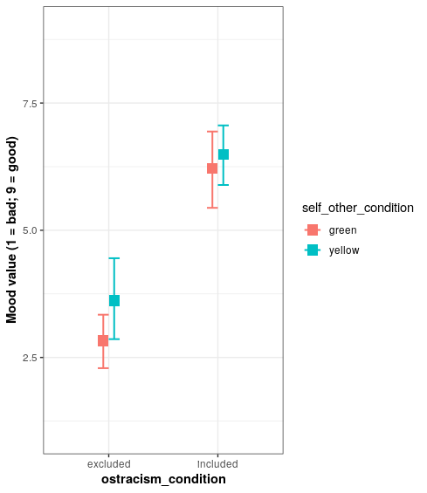
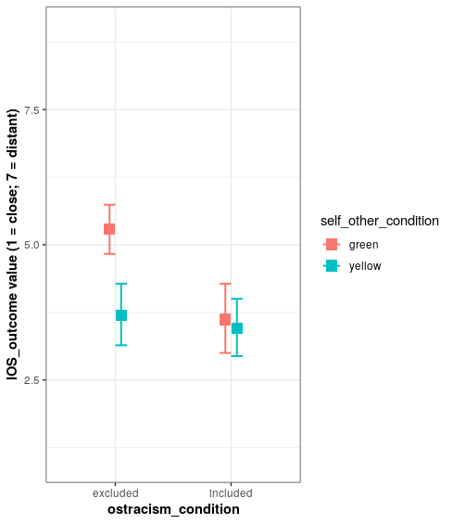
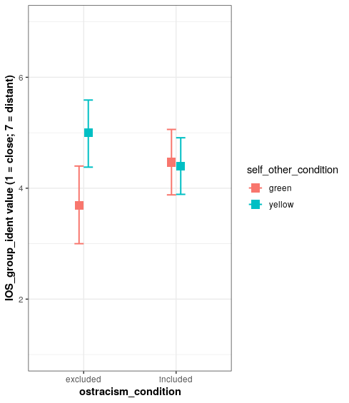
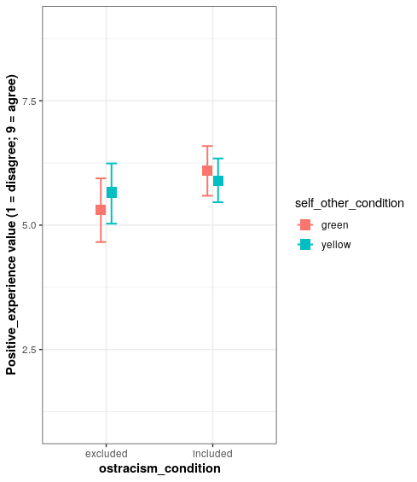
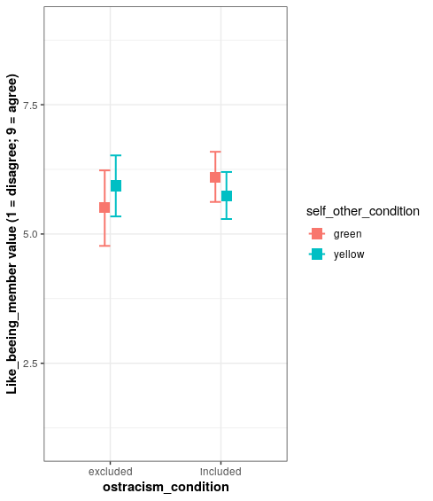
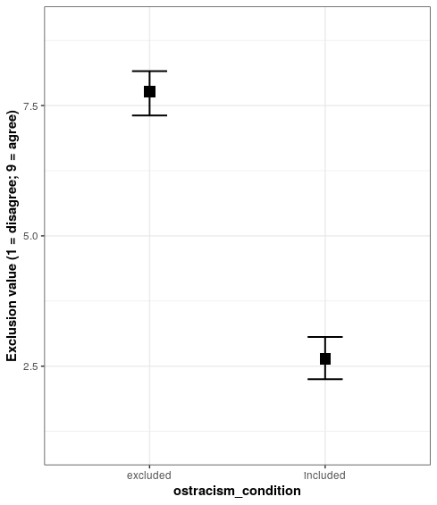
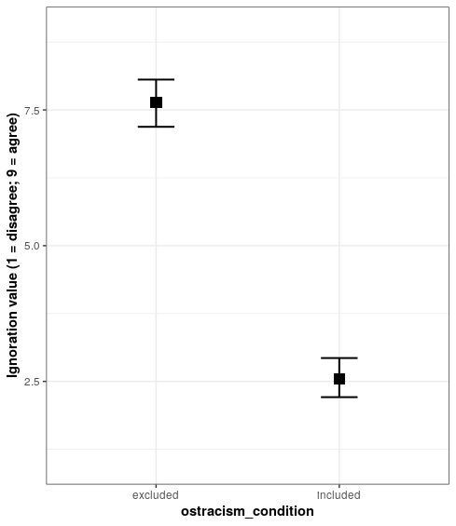
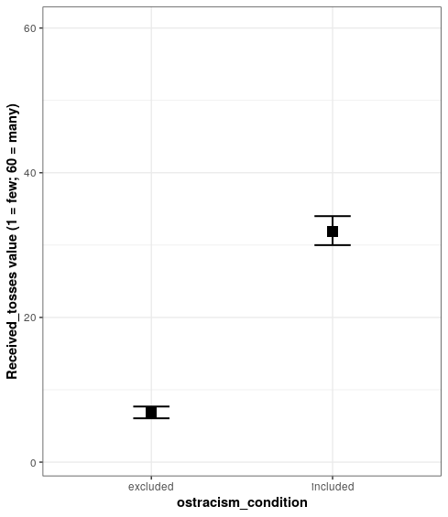
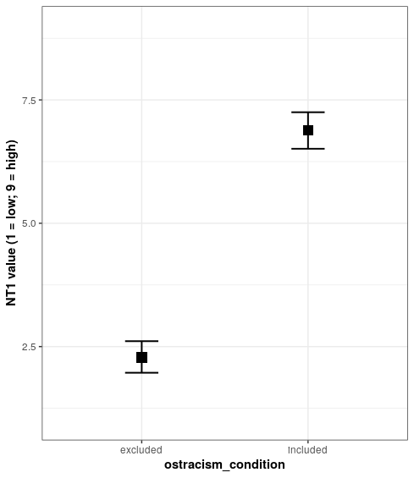
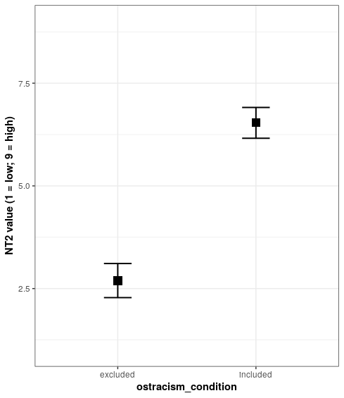
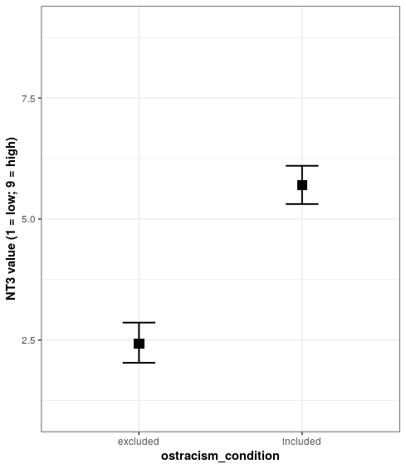
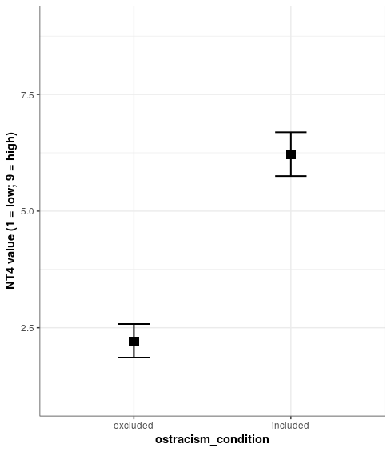
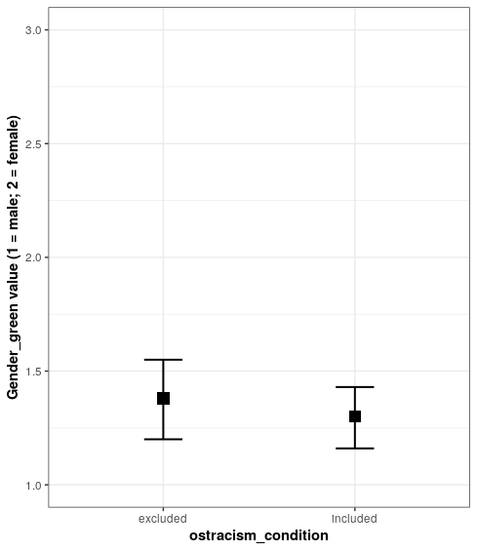
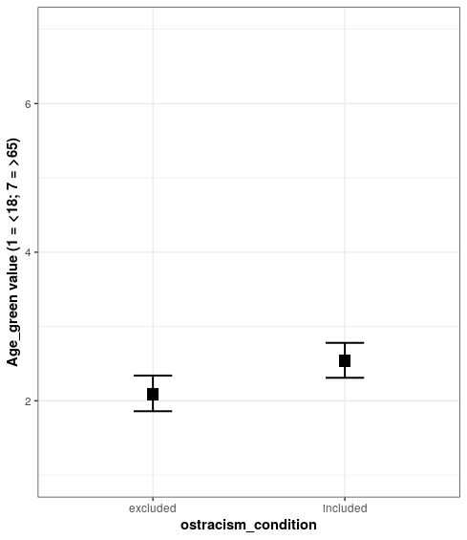
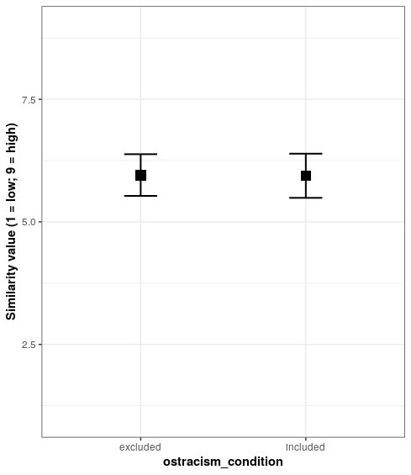
> #######################################
> ####### OST-CONST-04_Analyses2 ########
> #######################################
>
> # Load packages
> library(ggplot2)
> library(magrittr)
> library("ggpubr")
> library(Matrix)
> library(languageR)
> library(dplyr)
> library(lsr)
> library(tidyr)
> library(reshape)
> library(lme4)
> library(emmeans)
> library(lmerTest)
> library(lsmeans)
> library(rcompanion)
> library(car)
Lade nötiges Paket: carData

Attache Paket: ‘car’

The following object is masked from ‘package:dplyr’:

recode

> library(rstatix)

Attache Paket: ‘rstatix’

The following object is masked from ‘package:stats’:

filter

>
>
> #### Mixed Models Analysis
> # Conditions need to be centered to -0.5 and 0.5 (instead of 1 and 2)
> long_data_clean %<>%
+ dplyr::mutate(ostracism_condition_c = dplyr::if_else(condition = ostracism_condition == "included",
+ true = -0.5,
+ false = 0.5)) %>%
+ dplyr::mutate(self_other_condition_c = dplyr::if_else(condition = self_other_condition == "yellow",
+ true = -0.5,
+ false = 0.5))
>
> # We only look at negative outcomes (as stated in our preregistration)
> long_neg <-
+ long_data_clean %>%
+ dplyr::filter(outcome %in% c(1:5))
>
> # Check if the centering is done correclty
> table(long_neg$ostracism_condition, long_neg$ostracism_condition_c)

-0.5 0.5
excluded 0 285
included 315 0
> table(long_neg$self_other_condition, long_neg$self_other_condition_c)

-0.5 0.5
green 0 315
yellow 285 0
>
> # How many people are in the study?
> length(unique(long_neg$id))
[1] 130
>
> # Stability analyses
> # First overall overview
> dplyr::group_by(long_neg, ostracism_condition, self_other_condition) %>%
+ dplyr::summarise(count = dplyr::n(),
+ mean = mean(stability_value, na.rm = TRUE),
+ sd = stats::sd(stability_value, na.rm = TRUE))
`summarise()` regrouping output by 'ostracism_condition' (override with `.groups` argument)
# A tibble: 4 x 5
# Groups: ostracism_condition [2]
ostracism_condition self_other_condition count mean sd
<chr> <chr> <int> <dbl> <dbl>
1 excluded green 159 3.26 1.12
2 excluded yellow 126 3.67 0.986
3 included green 156 3.51 1.01
4 included yellow 159 3.64 0.895
>
> # Plot stability
> Sum_stability <- rcompanion::groupwiseMean(stability_value ~ ostracism_condition + self_other_condition,
+ data = long_neg,
+ conf = 0.95,
+ digits = 3,
+ traditional = FALSE,
+ percentile = TRUE)
> pd = ggplot2::position_dodge(.2)
> ggplot2::ggplot(Sum_stability, ggplot2::aes(x = ostracism_condition,
+ y = Mean,
+ color = self_other_condition)) +
+ ggplot2::geom_errorbar(ggplot2::aes(ymin=Percentile.lower,
+ ymax=Percentile.upper),
+ width=.2, size=0.7, position=pd) +
+ ggplot2::geom_point(shape=15, size=4, position=pd) +
+ ggplot2::theme(axis.title = ggplot2::element_text(face = "bold")) +
+ ggplot2::geom_point(shape=15, size=4, position=pd) + ggplot2::ylim(1, 5) +
+ ggplot2::ylab("Mean stability value (1 = stable; 5 = variable)") +
+ ggplot2::theme_bw() +
+ ggplot2::theme(axis.title = ggplot2::element_text(face = "bold"))
>
> # Is self_other_condition a good predictor for Stability?
> fit_stab_1 <- lme4::lmer (stability_value ~ 1 + (1 | id) + (1 | outcome), data = long_neg)
> fit_stab_2 <- lme4::lmer (stability_value ~ self_other_condition_c + (1 | id) + (1 | outcome), data = long_neg)
> stats::anova(fit_stab_1, fit_stab_2) # Fit2 better
refitting model(s) with ML (instead of REML)
Data: long_neg
Models:
fit_stab_1: stability_value ~ 1 + (1 | id) + (1 | outcome)
fit_stab_2: stability_value ~ self_other_condition_c + (1 | id) + (1 | outcome)
npar AIC BIC logLik deviance Chisq Df Pr(>Chisq)
fit_stab_1 4 1668.8 1686.4 -830.40 1660.8
fit_stab_2 5 1665.1 1687.1 -827.57 1655.1 5.6612 1 0.01734 *
---
Signif. codes: 0 ‘***’ 0.001 ‘**’ 0.01 ‘*’ 0.05 ‘.’ 0.1 ‘ ’ 1
>
> # Haupteffekt self_other_condition auf Stability
> summary(fit_stab_2)
Linear mixed model fit by REML ['lmerMod']
Formula: stability_value ~ self_other_condition_c + (1 | id) + (1 | outcome)
Data: long_neg

REML criterion at convergence: 1660.6

Scaled residuals:
Min 1Q Median 3Q Max
-3.8554 -0.5309 0.0228 0.6251 2.5416

Random effects:
Groups Name Variance Std.Dev.
id (Intercept) 0.23266 0.4823
outcome (Intercept) 0.03262 0.1806
Residual 0.75573 0.8693
Number of obs: 600, groups: id, 130; outcome, 5

Fixed effects:
Estimate Std. Error t value
(Intercept) 3.51927 0.09803 35.901
self_other_condition_c -0.26597 0.11108 -2.394

Correlation of Fixed Effects:
(Intr)
slf_thr_cn_ -0.024
>
> dplyr::group_by(long_neg, self_other_condition) %>%
+ dplyr::summarise(count = dplyr::n(),
+ mean = mean(stability_value, na.rm = TRUE),
+ sd = stats::sd(stability_value, na.rm = TRUE))
`summarise()` ungrouping output (override with `.groups` argument)
# A tibble: 2 x 4
self_other_condition count mean sd
<chr> <int> <dbl> <dbl>
1 green 315 3.38 1.07
2 yellow 285 3.65 0.935
> # Mean difference Group Yellow - Group Green
> # 0.27
>
> # Is Ostracism a good predictor for Stability?
> fit_stab_1 <- lme4::lmer (stability_value ~ 1 + (1 | id) + (1 | outcome), data = long_neg)
> fit_stab_3 <- lme4::lmer (stability_value ~ ostracism_condition_c + (1 | id) + (1 | outcome), data = long_neg)
> stats::anova (fit_stab_1, fit_stab_3)
refitting model(s) with ML (instead of REML)
Data: long_neg
Models:
fit_stab_1: stability_value ~ 1 + (1 | id) + (1 | outcome)
fit_stab_3: stability_value ~ ostracism_condition_c + (1 | id) + (1 | outcome)
npar AIC BIC logLik deviance Chisq Df Pr(>Chisq)
fit_stab_1 4 1668.8 1686.4 -830.40 1660.8
fit_stab_3 5 1669.3 1691.3 -829.66 1659.3 1.4737 1 0.2248
>
> # Haupteffekt ostracism_condition auf Stability
> summary(fit_stab_3)
Linear mixed model fit by REML ['lmerMod']
Formula: stability_value ~ ostracism_condition_c + (1 | id) + (1 | outcome)
Data: long_neg

REML criterion at convergence: 1664.7

Scaled residuals:
Min 1Q Median 3Q Max
-3.9434 -0.5385 0.0456 0.6364 2.5341

Random effects:
Groups Name Variance Std.Dev.
id (Intercept) 0.24575 0.4957
outcome (Intercept) 0.03255 0.1804
Residual 0.75578 0.8694
Number of obs: 600, groups: id, 130; outcome, 5

Fixed effects:
Estimate Std. Error t value
(Intercept) 3.51079 0.09848 35.650
ostracism_condition_c -0.13676 0.11292 -1.211

Correlation of Fixed Effects:
(Intr)
ostrcsm_cn_ 0.024
>
> dplyr::group_by(long_neg, ostracism_condition) %>%
+ dplyr::summarise(count = dplyr::n(),
+ mean = mean(stability_value, na.rm = TRUE),
+ sd = stats::sd(stability_value, na.rm = TRUE))
`summarise()` ungrouping output (override with `.groups` argument)
# A tibble: 2 x 4
ostracism_condition count mean sd
<chr> <int> <dbl> <dbl>
1 excluded 285 3.44 1.08
2 included 315 3.58 0.953
> # Mean difference Group Excluded - Group Included
> # 0.14
>
> # Interaction model
> fit_stability <- lme4::lmer (stability_value ~ self_other_condition_c * ostracism_condition_c + (1 |id) + (1 | outcome), data = long_neg)
> summary(fit_stability)
Linear mixed model fit by REML ['lmerMod']
Formula: stability_value ~ self_other_condition_c * ostracism_condition_c + (1 | id) + (1 | outcome)
Data: long_neg

REML criterion at convergence: 1661.7

Scaled residuals:
Min 1Q Median 3Q Max
-3.9129 -0.5332 0.0336 0.6435 2.5935

Random effects:
Groups Name Variance Std.Dev.
id (Intercept) 0.23039 0.4800
outcome (Intercept) 0.03267 0.1807
Residual 0.75587 0.8694
Number of obs: 600, groups: id, 130; outcome, 5

Fixed effects:
Estimate Std. Error t value
(Intercept) 3.52161 0.09811 35.894
self_other_condition_c -0.26422 0.11119 -2.376
ostracism_condition_c -0.11192 0.11120 -1.006
self_other_condition_c:ostracism_condition_c -0.27175 0.22238 -1.222

Correlation of Fixed Effects:
(Intr) slf___ ostr__
slf_thr_cn_ -0.027
ostrcsm_cn_ 0.028 -0.074
slf_th__:__ -0.042 0.049 -0.048
>
> dplyr::group_by(long_neg, ostracism_condition, self_other_condition) %>%
+ dplyr::summarise(count = dplyr::n(),
+ mean = mean(stability_value, na.rm = TRUE),
+ sd = stats::sd(stability_value, na.rm = TRUE))
`summarise()` regrouping output by 'ostracism_condition' (override with `.groups` argument)
# A tibble: 4 x 5
# Groups: ostracism_condition [2]
ostracism_condition self_other_condition count mean sd
<chr> <chr> <int> <dbl> <dbl>
1 excluded green 159 3.26 1.12
2 excluded yellow 126 3.67 0.986
3 included green 156 3.51 1.01
4 included yellow 159 3.64 0.895
>
> # Mean difference Interaction Stability
> # (Excluded-Yellow - Excluded-Green) - ((Included-Yellow - Included-Green))
> # (3.67 - 3.26) - (3.64 - 3.51) = 0.28
>
> ### Try to also calculate the effect sizes fore mixed models
> ## For effect sizes, use https://jakewestfall.shinyapps.io/crossedpower/
> # Participants within condition
> # Unstandardized
> # 0 for all residuals we did not include in our model
> # Power = X
>
> # effect size self_other_condition: 0.647
> # effect size ostracism_condition: 0.22
> # effect size interaktion: 0.692
>
> # Hypothese 1 verworfen!
> # H1. While in both conditions (exclusion and inclusion) the participants attribute the behavior of an out-group-member more to stable causes
> # than the behavior of an ingroup member, this difference is greater in the exclusion condition.
>
> ### Locus Analyses
> # First overall overview
> dplyr::group_by(long_neg, ostracism_condition, self_other_condition) %>%
+ dplyr::summarise(count = dplyr::n(),
+ mean = mean(locus_value, na.rm = TRUE),
+ sd = stats::sd(locus_value, na.rm = TRUE))
`summarise()` regrouping output by 'ostracism_condition' (override with `.groups` argument)
# A tibble: 4 x 5
# Groups: ostracism_condition [2]
ostracism_condition self_other_condition count mean sd
<chr> <chr> <int> <dbl> <dbl>
1 excluded green 159 2.60 1.25
2 excluded yellow 126 2.80 1.23
3 included green 156 2.89 1.13
4 included yellow 159 3.03 1.22
>
> # Plot locus
> Sum_locus <- rcompanion::groupwiseMean(locus_value ~ ostracism_condition + self_other_condition,
+ data = long_neg,
+ conf = 0.95,
+ digits = 3,
+ traditional = FALSE,
+ percentile = TRUE)
> pd = ggplot2::position_dodge(.2)
> ggplot2::ggplot(Sum_locus, ggplot2::aes(x = ostracism_condition,
+ y = Mean,
+ color = self_other_condition)) +
+ ggplot2::geom_errorbar(ggplot2::aes(ymin=Percentile.lower,
+ ymax=Percentile.upper),
+ width=.2, size=0.7, position=pd) +
+ ggplot2::geom_point(shape=15, size=4, position=pd) +
+ ggplot2::theme(axis.title = ggplot2::element_text(face = "bold")) +
+ ggplot2::geom_point(shape=15, size=4, position=pd) + ggplot2::ylim(1, 5) +
+ ggplot2::ylab("Mean locus value (1 = stable; 5 = variable)") +
+ ggplot2::theme_bw() +
+ ggplot2::theme(axis.title = ggplot2::element_text(face = "bold"))
>
> # Is self_other_condition a good predictor for Locus?
> fit_locus_1 <- lme4::lmer (locus_value ~ 1 + (1 | id) + (1 | outcome), data = long_neg)
> fit_locus_2 <- lme4::lmer (locus_value ~ self_other_condition_c + (1 | id) + (1 | outcome), data = long_neg)
> stats::anova (fit_locus_1, fit_locus_2)
refitting model(s) with ML (instead of REML)
Data: long_neg
Models:
fit_locus_1: locus_value ~ 1 + (1 | id) + (1 | outcome)
fit_locus_2: locus_value ~ self_other_condition_c + (1 | id) + (1 | outcome)
npar AIC BIC logLik deviance Chisq Df Pr(>Chisq)
fit_locus_1 4 1903.2 1920.8 -947.61 1895.2
fit_locus_2 5 1903.3 1925.2 -946.63 1893.3 1.9554 1 0.162
>
> # Haupteffekt self_other_condition auf Locus
> summary(fit_locus_2)
Linear mixed model fit by REML ['lmerMod']
Formula: locus_value ~ self_other_condition_c + (1 | id) + (1 | outcome)
Data: long_neg

REML criterion at convergence: 1898.1

Scaled residuals:
Min 1Q Median 3Q Max
-2.39013 -0.67137 -0.06569 0.67495 2.44957

Random effects:
Groups Name Variance Std.Dev.
id (Intercept) 0.2602 0.5101
outcome (Intercept) 0.0518 0.2276
Residual 1.1668 1.0802
Number of obs: 600, groups: id, 130; outcome, 5

Fixed effects:
Estimate Std. Error t value
(Intercept) 2.8423 0.1198 23.725
self_other_condition_c -0.1764 0.1264 -1.396

Correlation of Fixed Effects:
(Intr)
slf_thr_cn_ -0.023
>
> dplyr::group_by(long_neg, self_other_condition) %>%
+ dplyr::summarise(count = dplyr::n(),
+ mean = mean(locus_value, na.rm = TRUE),
+ sd = stats::sd(locus_value, na.rm = TRUE))
`summarise()` ungrouping output (override with `.groups` argument)
# A tibble: 2 x 4
self_other_condition count mean sd
<chr> <int> <dbl> <dbl>
1 green 315 2.74 1.20
2 yellow 285 2.93 1.23
> # Mean difference Group Yellow - Group Green
> # 0.19
>
> # Is Ostracism a good predictor for Locus?
> fit_locus_1 <- lme4::lmer (locus_value ~ 1 + (1 | id) + (1 | outcome), data = long_neg)
> fit_locus_3 <- lme4::lmer (locus_value ~ ostracism_condition_c + (1 | id) + (1 | outcome), data = long_neg)
> stats::anova(fit_locus_1, fit_locus_3)
refitting model(s) with ML (instead of REML)
Data: long_neg
Models:
fit_locus_1: locus_value ~ 1 + (1 | id) + (1 | outcome)
fit_locus_3: locus_value ~ ostracism_condition_c + (1 | id) + (1 | outcome)
npar AIC BIC logLik deviance Chisq Df Pr(>Chisq)
fit_locus_1 4 1903.2 1920.8 -947.61 1895.2
fit_locus_3 5 1900.5 1922.5 -945.27 1890.5 4.6816 1 0.03049 *
---
Signif. codes: 0 ‘***’ 0.001 ‘**’ 0.01 ‘*’ 0.05 ‘.’ 0.1 ‘ ’ 1
>
> # Haupteffekt ostracism_condition auf Locus
> summary(fit_locus_3)
Linear mixed model fit by REML ['lmerMod']
Formula: locus_value ~ ostracism_condition_c + (1 | id) + (1 | outcome)
Data: long_neg

REML criterion at convergence: 1895.4

Scaled residuals:
Min 1Q Median 3Q Max
-2.39881 -0.70248 -0.06395 0.68038 2.47165

Random effects:
Groups Name Variance Std.Dev.
id (Intercept) 0.25173 0.5017
outcome (Intercept) 0.05104 0.2259
Residual 1.16564 1.0797
Number of obs: 600, groups: id, 130; outcome, 5

Fixed effects:
Estimate Std. Error t value
(Intercept) 2.8325 0.1189 23.825
ostracism_condition_c -0.2716 0.1253 -2.167

Correlation of Fixed Effects:
(Intr)
ostrcsm_cn_ 0.023
>
> dplyr::group_by(long_neg, ostracism_condition) %>%
+ dplyr::summarise(count = dplyr::n(),
+ mean = mean(locus_value, na.rm = TRUE),
+ sd = stats::sd(locus_value, na.rm = TRUE))
`summarise()` ungrouping output (override with `.groups` argument)
# A tibble: 2 x 4
ostracism_condition count mean sd
<chr> <int> <dbl> <dbl>
1 excluded 285 2.69 1.24
2 included 315 2.96 1.18
> # Mean difference Group Excluded - Group Included
> # 0.27
>
> # Interaction model
> fit_locus <- lme4::lmer (locus_value ~ self_other_condition_c * ostracism_condition_c + (1 |id) + (1 | outcome), data = long_neg)
> summary(fit_locus)
Linear mixed model fit by REML ['lmerMod']
Formula: locus_value ~ self_other_condition_c * ostracism_condition_c + (1 | id) + (1 | outcome)
Data: long_neg

REML criterion at convergence: 1897

Scaled residuals:
Min 1Q Median 3Q Max
-2.42907 -0.67271 -0.04669 0.65225 2.50532

Random effects:
Groups Name Variance Std.Dev.
id (Intercept) 0.25236 0.5024
outcome (Intercept) 0.05101 0.2258
Residual 1.16619 1.0799
Number of obs: 600, groups: id, 130; outcome, 5

Fixed effects:
Estimate Std. Error t value
(Intercept) 2.8367 0.1190 23.836
self_other_condition_c -0.1590 0.1258 -1.263
ostracism_condition_c -0.2598 0.1259 -2.064
self_other_condition_c:ostracism_condition_c -0.0275 0.2517 -0.109

Correlation of Fixed Effects:
(Intr) slf___ ostr__
slf_thr_cn_ -0.026
ostrcsm_cn_ 0.027 -0.072
slf_th__:__ -0.039 0.051 -0.050
>
> dplyr::group_by(long_neg, ostracism_condition, self_other_condition) %>%
+ dplyr::summarise(count = dplyr::n(),
+ mean = mean(locus_value, na.rm = TRUE),
+ sd = stats::sd(locus_value, na.rm = TRUE))
`summarise()` regrouping output by 'ostracism_condition' (override with `.groups` argument)
# A tibble: 4 x 5
# Groups: ostracism_condition [2]
ostracism_condition self_other_condition count mean sd
<chr> <chr> <int> <dbl> <dbl>
1 excluded green 159 2.60 1.25
2 excluded yellow 126 2.80 1.23
3 included green 156 2.89 1.13
4 included yellow 159 3.03 1.22
>
> # Mean difference Interaction Locus
> # (Excluded-Yellow - Excluded-Green) - ((Included-Yellow - Included-Green))
> # (2.80 − 2.6) − (3.03 − 2.89) = 0.06
>
> ### Try to also calculate the effect sizes fore mixed models
> ## For effect sizes, use https://jakewestfall.shinyapps.io/crossedpower/
> # Participants within condition
> # Unstandardized
> # 0 for all residuals we did not include in our model
> # Power = X
>
> # effect size self_other_condition: 0.269
> # effect size ostracism_condition: 0.548
> # effect size interaktion: 0.075
>
> # Hypothese 2 verworfen!
> # H2. While in both conditions (exclusion and inclusion) the participants attribute the behavior of an out-group-member more to internal causes
> # than the behavior of an in-group-member, this difference is greater in the exclusion condition.

