1. Introduction
This project began with the goal of forecasting daily taxi demand in New York City. After loading the June 2024 Yellow Taxi dataset, I realized the data is split into monthly files, giving only about thirty days per month. With so few points, a daily forecasting model would not be trustworthy, since it would mostly learn noise.
Because of this, I shifted the project toward understanding the dataset itself: how rides are distributed by hour, how consistent fares are, and how simple models perform using basic engineered features.

2. Data Preparation
The dataset contains about three million June 2024 Yellow Taxi trips. I engineered:
- hour, weekday, pickup_date
- trip_time_min
- pickup and dropoff borough categories
- binary multi_passenger
These features drive the figures and models that follow.

3. Exploratory Analysis

3.1 Trip Frequency by Hour
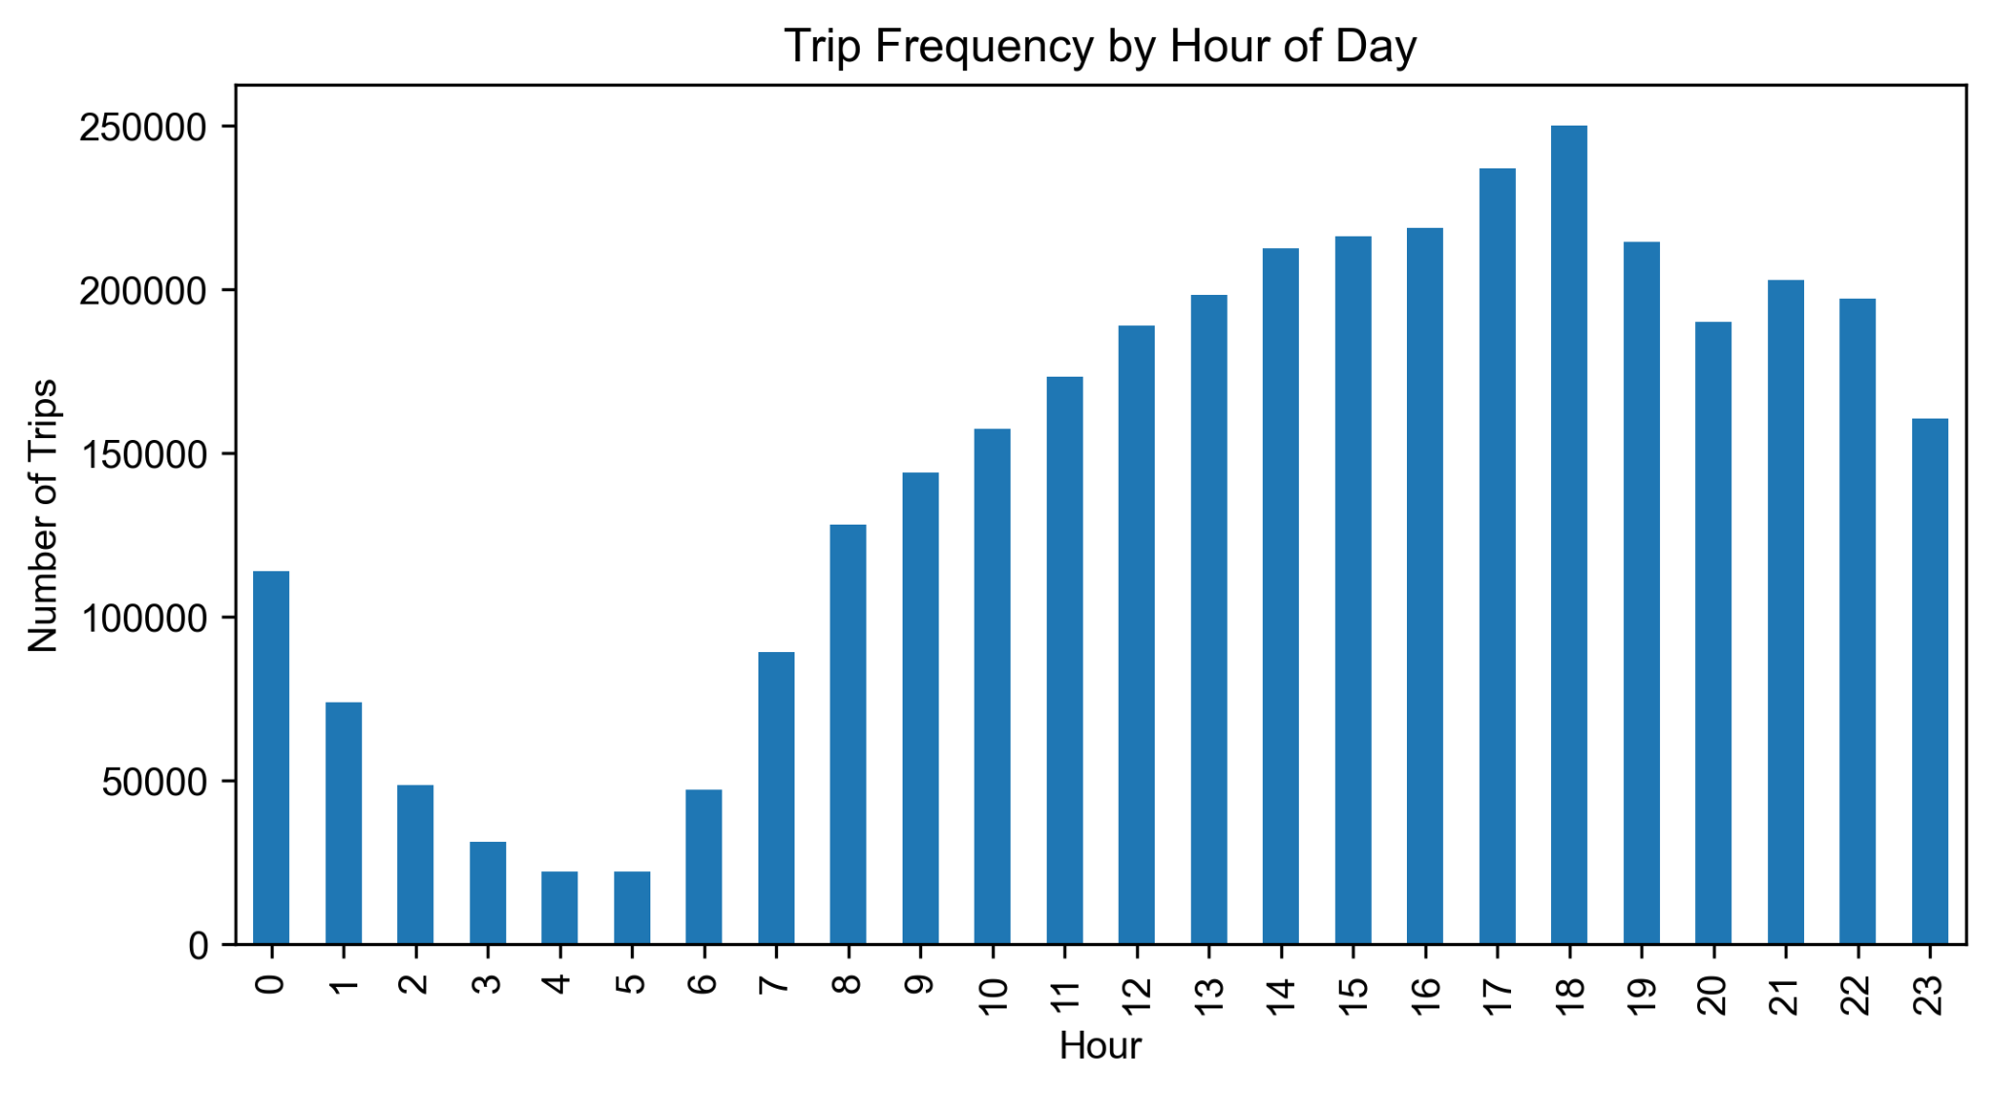
Here, I expected a bimodal pattern based on general commuting behavior, but the data showed a different trend. The strongest peak happens late at night, with a deep low around 4–5 AM. This reflects New York’s nightlife rather than a strict workday cycle.

3.2 Fare Consistency Check
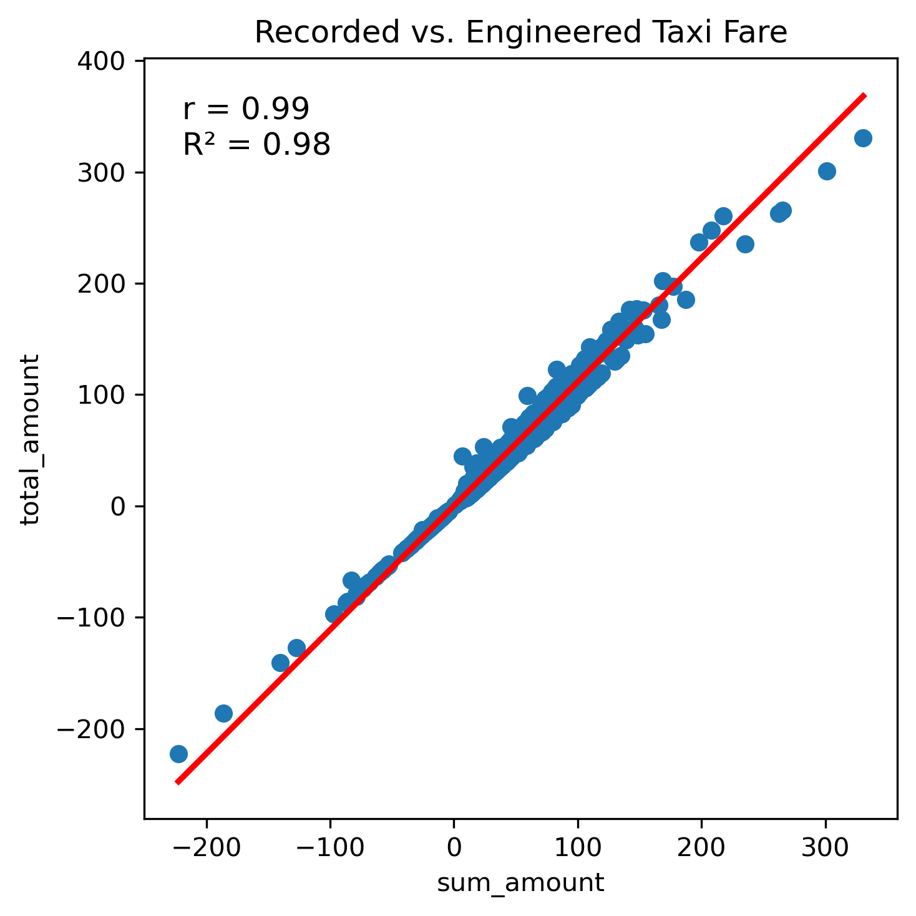
This figure compares the recorded total_amount with the engineered sum of fare components. Most points fall near a diagonal line, showing consistency. But the outliers reveal that some individual fare entries are incomplete or inflated. This matters because unreliable fare components weaken any price-related model. This was also part of the reason forecasting daily totals or revenue was not viable.

4. Modeling
I ran three independent models, each using the engineered features.

4.1 Linear Regression – Trip Duration
Purpose: test if simple variables can explain variation in trip duration.
Outcome: moderate predictive power, as expected—duration depends heavily on traffic patterns and routing, which are not included.

4.2 Linear Regression – Total Amount
Purpose: check how well fares can be predicted from the same engineered features.
Outcome: performance was modest, regardless of slight irregularities shown in the fare anomaly plot.

4.3 Logistic Regression – Multi-Passenger
Purpose: classify whether a ride has more than one passenger.
Process: one-hot encoding for categorical features, scaling numeric features.
Outcome: AUC = 0.59, indicating weak predictive strength. Group travel depends on social factors not captured in the dataset.

5. Performance Summary

Target variable | Method | Score
Trip Duration (min) | Linear Regression | MAE = 4.28  RMSE = 6.75
Total Fare ($) | Linear regression | MAE = 3.43  RMSE = 6.28
> 1 Passenger Likelihood | Logistic Regression | AUC = .59

This table summarizes the results of all three models, in the same form as shown on the poster. It provides a clear comparison of how each model performed given the limited feature set.

6. Limitations
- Only one month of data produces too few daily observations for forecasting.
- Missing contextual variables (weather, events, tourism, traffic) limit all models.
- Fare component irregularities reduce reliability of fare predictions.
- Basic engineered features cannot capture behavior like group travel or driver routing.
- Without multi-month continuity, no seasonal or temporal patterns can be established.

7. Conclusion
This project evolved from a forecasting attempt into a focused analysis of what June 2024 taxi data can reliably show. The hourly trip plot reveals New York’s late-night activity cycle. The fare consistency check shows where the data breaks down. The three independent models—two linear regressions and one logistic regression—demonstrate the predictive power using limited features, with the multi-passenger classifier reaching an AUC of 0.59.
The results are most useful for understanding short-term behavior, identifying data quality issues, and clarifying what information is missing before larger modeling goals such as forecasting can be attempted.

