In paper 1:

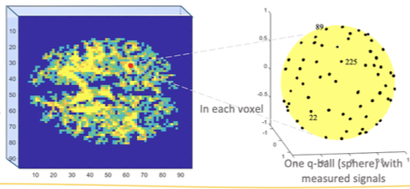

Step 1: They estimated the signal at blue locations using the Radial Basis Functions interpolation.
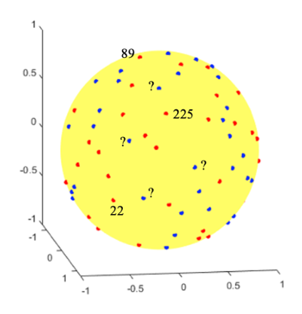

Step 2: Then created ODFs were created at each voxel using Spherical harmonic interpolation.
f₆₄: assuming all the signals are measured at red and blue locations. This is the ground truth.
f_{cm}: using the measured signal at red locations and the estimated signal at blue locations to

Repeatedly created ODFs for all brain locations on a given slice and for all slices.

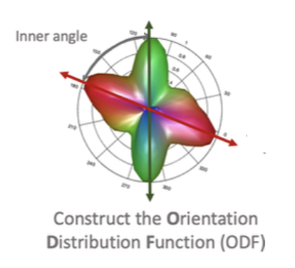
Step 3: Used DSI Studio software to generate fiber tracts.
Again, using f₆₄ and f_{cm.}
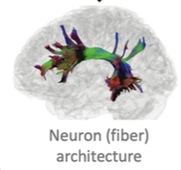

In Section 3.3, Experimental Validation onwards, they discuss why their method is effective—essentially justifying why it works, which is something you'll also need to do when publishing a paper.

We did Homework 17, where I prompted you to read these and start forming an initial idea, so today’s discussion would make more sense.

Now let’s take a look at the quantitative and qualitative methods they used. In visual-based work like this, it’s common to include both.

The goal is to recognize what others have done in the literature so that if you're proposing a new method—say, to estimate a signal or construct an ODF—you'll know how to justify it based on what’s accepted in the field. Reading papers also helps you develop the skill of identifying how authors present and support their methods.

- Quantitative

Relative L² error with results shown in table 1 and 2

Percentage of voxels at the crossing fibers in both original and generated directions

Angular deviation of the fiber structures in the ODF

Ratio of inner angles second fiber direction to major fibers (Table 3)

- Qualitative

Reconstruction of SDF by relative errors across all voxels in figure 4

