Gabriel Eze
Dr. Pallage
MAT 425
20 March 2025
Human Brain MRI Analysis Report
This report will dive into the preliminary process of collating and analyzing human brain data. Our brain imaging data is pooled from public sources and one of the chief providers for this kind of dataset is the Advanced Biomedical MRI Lab located in the National Taiwan University Hospital (NTU). Given the sensitivity of an MRI experimental research, there are some restrictions amended by the NTU Lab to protect copyright infringement. This assignment is designed to produce a similar experiment similar to the ones done by NTU Lab and other organizations, so utmost discretion is vital when sharing and discussing results with others.
For any experiment, extracting relevant data is needed for analysis. The data1.m file is a script that will load the dataset and extract signal values measured with the MRI machine. To do this, we need to initialize two matrices—gdirt and rho4000; the first for storing displacement in cartesian coordinates of hydrogen molecules in the brain cells and the latter saves the corresponding signal values at that location. The B-values quantifies the sensitivity of the DWI to the movement of hydrogen molecules while the signal values render the MR signal strength.
For the next step in our analysis, we select only a subset of directions from gdirt matrix to ensure that our results align with the experimental accuracy achieved by the NTU Lab in Northern Taiwan. Since there’s no single correct answer to this approach, I used a simple range function to evenly select directions in two groups. This decision is crucial in maintaining the study’s constraints, preventing prolonged MRI exposure, which poses health risks to the patient.
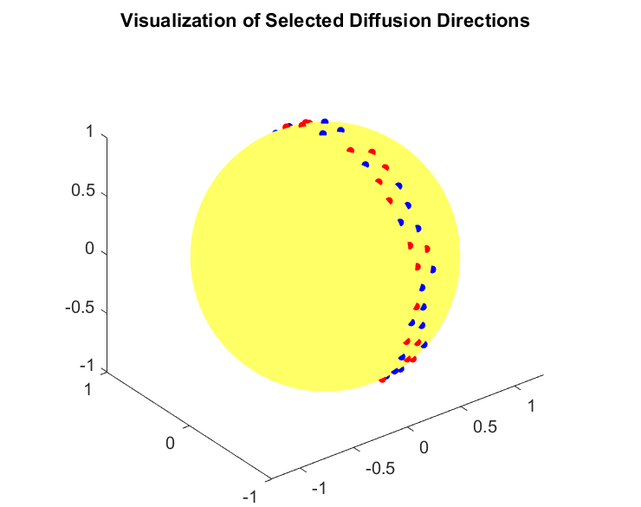
Now, we can dive deeper and begin to inspect some of the brain slices. It is safer to select a slice that is at the center of the picture series. This slice will have a lower chance of having too much noise around the neurons and especially along the cranium. Hence, I will choose to inspect the 20th slice in the 9th DG direction. This slice below is a depiction of brain network with porous density and precision because we did not utilize the entirety of our dataset.
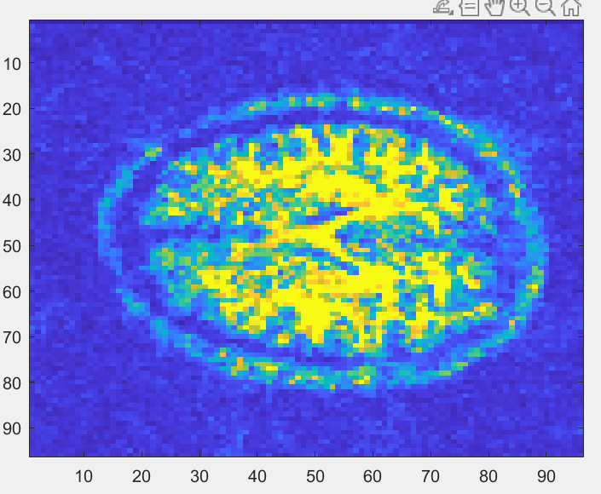
The final step before constructing the orientation distribution function (ODF) for spherical harmonic interpolation would be to remove the redundant parts of the MRI image. Observing the slice above, we see that the yellow spots are the more likely paths for dense neuron crossings while the green and blue colored spots represent the noise from the machine. To preprocess our data neatly, we can introduce a threshold value to filter out non-brain tissues. Next, we initialize a binary mask which will determine the pixels that would be ignored as non- background noise. A threshold value of 80 is sufficient because it reliably distinguishes between signal intensities of brain and non-brain tissues. This is the result of the cleaning process: 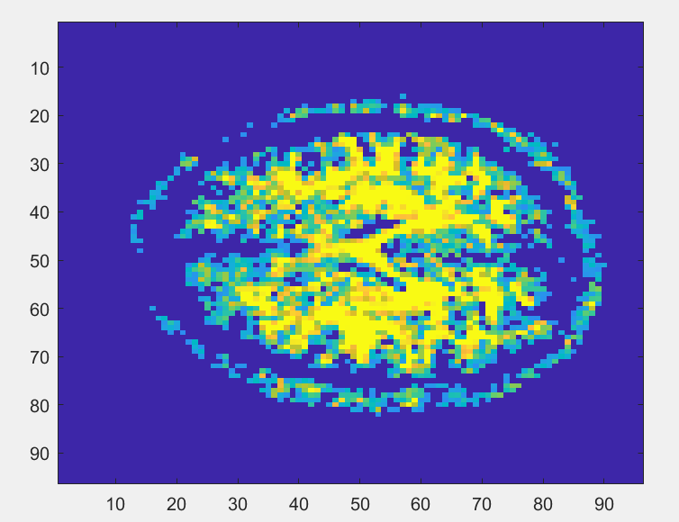
The skull region is still visibly present, but the overall resolution is improved, and this is a more accurate representation of brain signal activities. Using more DG directions would correspond to an increase to noise levels in the dataset since the time elapsed for the patient in the MRI machine would remain constant throughout the experiment. Hence, more advanced procedure would be recommended. However, given that this reports replicates work originally done by NTU Lab, this slice is sufficient for any interpolation methods required.

clear; close all;clc;

addpath Data
addpath Functions

%% create images and save

% load('20081006_M025Y_1Shell.mat')
%
% bsize = size(b_table);
% for i=1:bsize(2)
% eval(strcat('images(:,:,:,i) = reshape(image',int2str(i-1),',dimension);'));
% end
%
%
% fprintf('size of the data \n');
% size(images)
% gdirt=b_table(2:4, 11:250)';
% rho4000=images(:,:,:, 11:250); % signal data corresponding to 96, 96, 40
% clear

%% step2: load data

load gdirt
load rho4000

%% step 3: preparing data

num_directions=size(gdirt,1); % Total number of signal directions

vgdirt = gdirt(1:2:63, :);
ugdirt = gdirt(2:2:64, :)

% produce 32 indices array for ugdirt and vgdirt

% extend total directions for complete ball
etgdirt = [vgdirt; -vgdirt; ugdirt; -ugdirt];
% Red and blue directions

set(gcf, 'color', 'white');
figure(1);plotSphNodes2(vgdirt,[],ugdirt,[],[],[]);
title('Visualization of Selected Diffusion Directions')
figure(2)
image(rho4000(:, :, 20, 9))

%% step 4: analyzing slices

% signal value corresponding 96x96 20th slice and 9th DG direction
vS=rho4000(:,:,20, 9);

for nsl=1:22
figure(nsl)
image(rho4000(:, :, nsl, 9))
end

%% step 5: preprocession - removing non-brain regions
selected_slice = rho4000(:, :, 20, 9);
threshold = 80; %adjust as necessary
mask = selected_slice < threshold;
selected_slice(mask) = 0;
figure(3)
image(selected_slice)

%%
vS = rho4000(:, :, 20, 9)

