Course Name | ITD 2343 – Object Oriented Programming with C#
Instructor | Mark L. Pranger
Student Name | <Ezequiel Barrientos>
Due date | <10/31/25>
Grade | <grade earned here>
Grading Comments | <instructor comments here>

Test 1: 2021 Dividend and 13 Divisor
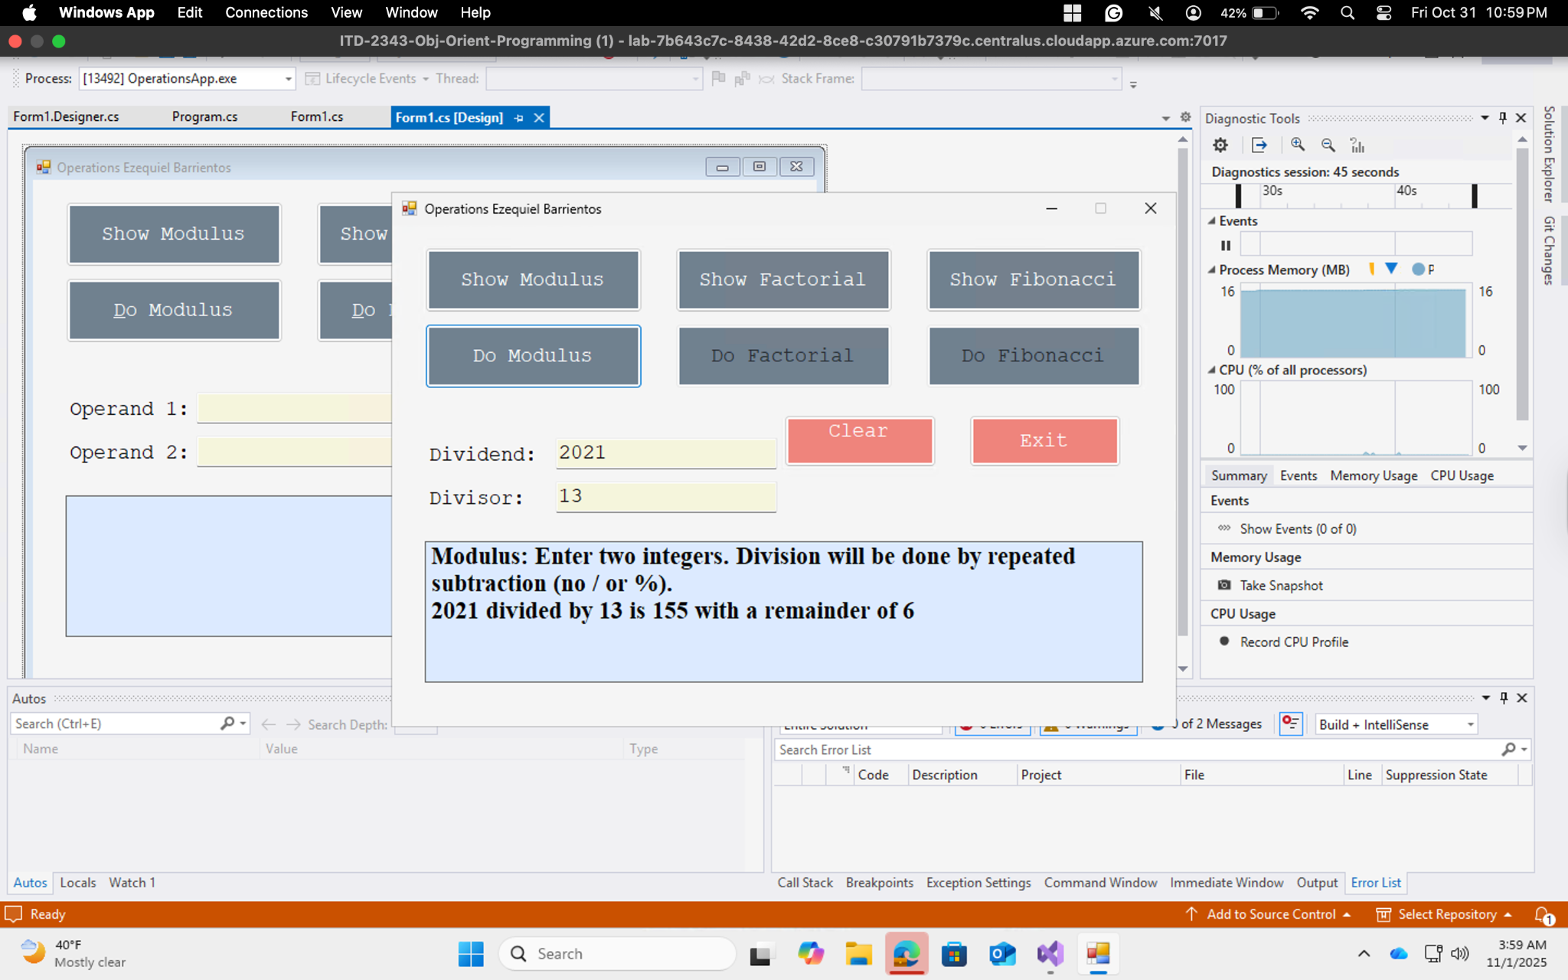
Test 2: 100256 Dividend and 256 Divisor
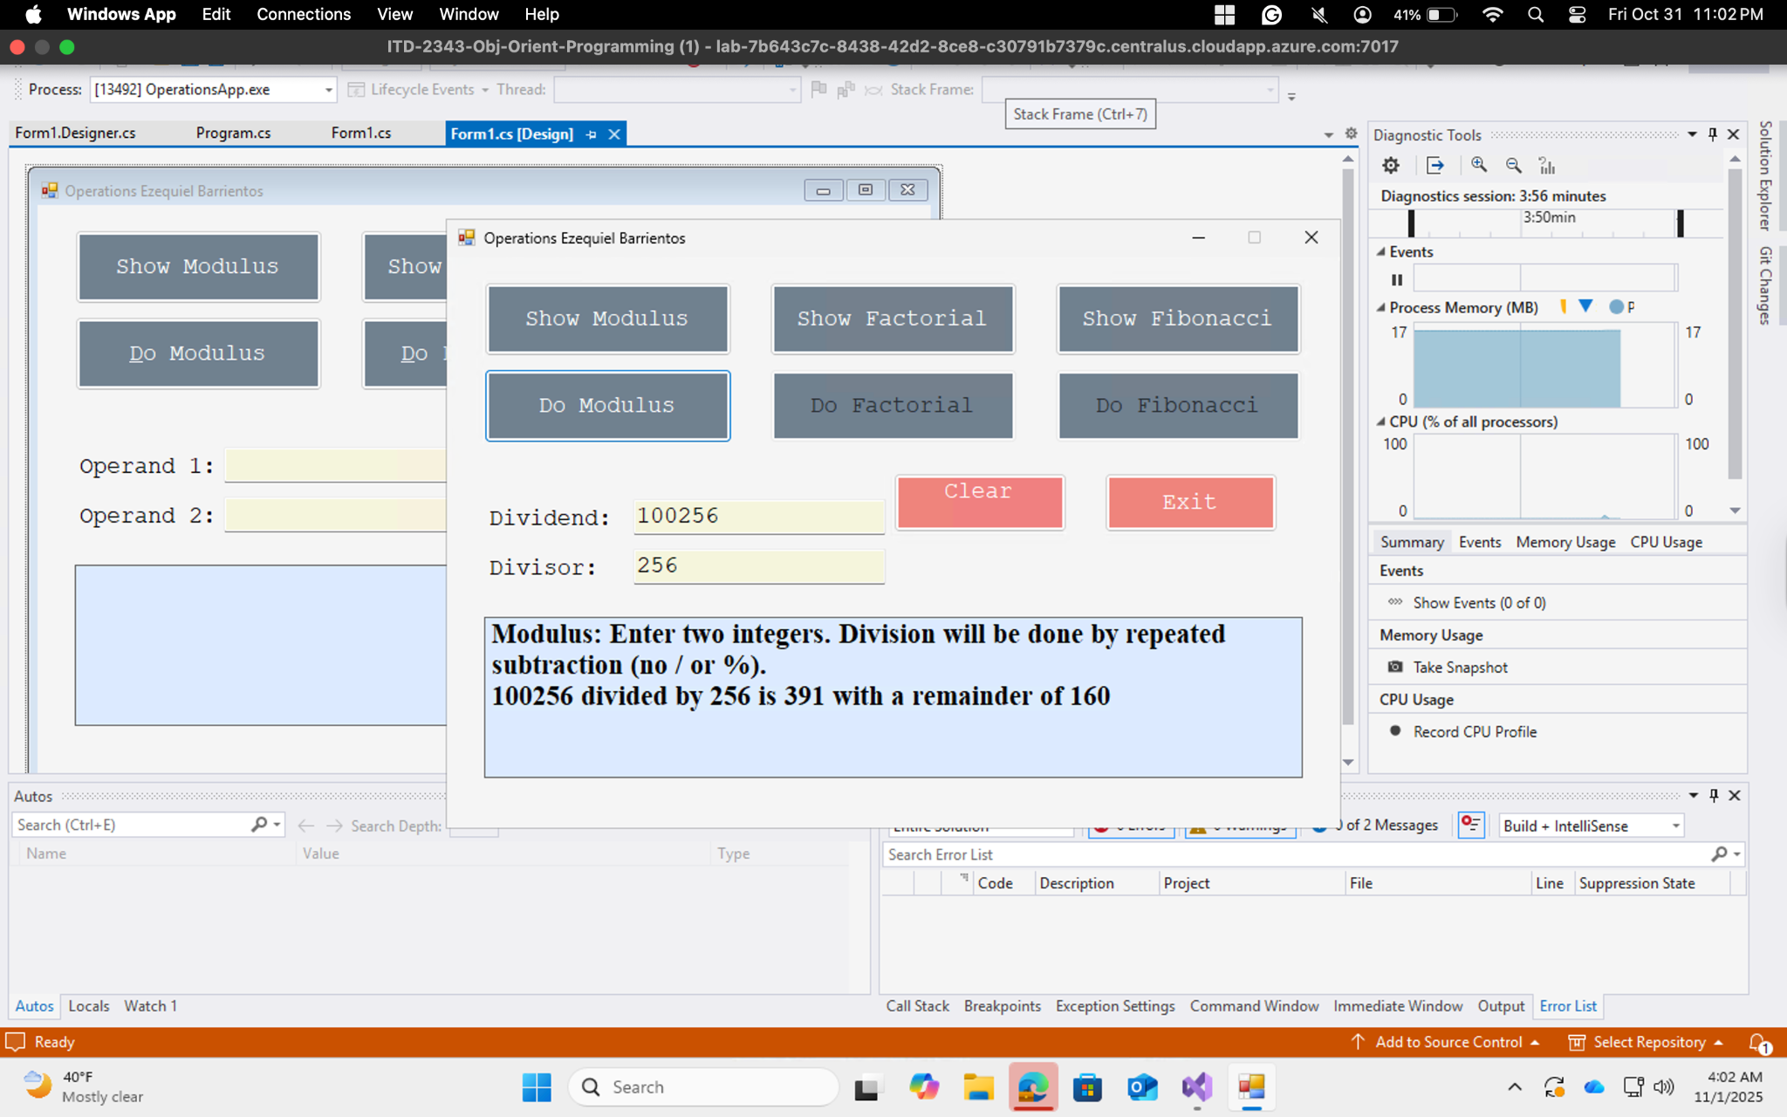
Test 3: Show Factorial number 13
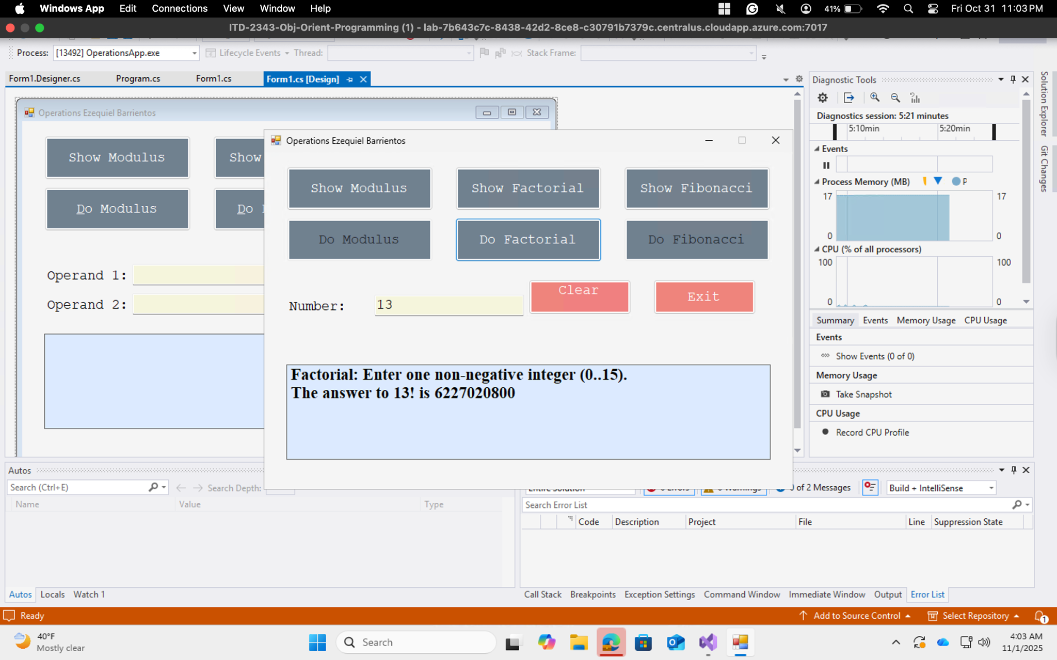
Test 4: Fibonacci number 75
