Discovering knowledge in Discussion Forums

ABSTRACT

INTRODUCTION
Distance Education and eLearning is a growing field for growth for educational institutions. While initially tied to a format similar to face to face meetings with a small student to teacher ratio, the advent of Massive Open Online Courses (MOOCs) is adding new challenges. One such challenge is how to reach all students taking the class. This amount of assistance also needs to take account a high turnover ratio. Discussion forums have been found to be the common source of knowledge for students when completing homework tasks [14], and for interaction with instructors and peers [9][10].

Graduating Undergraduate students with a Science, Technology, Engineering and Mathematics (STEM) degree face challenges for which they might not be prepared once they enter the workforce. The challenges include open ended and ill-defined problems not typically addressed during a normal course of education. A skill that is helpful with addressing these problems is research exploration commonly acquired during graduate education. One way undergraduate students can acquire these skills is by performing independent research tasks such as semester long Capstone projects[4]. However, the mentoring time required from the instructors compounded with the number of students prevents most students from taking advantage of these projects. One approach to address this is by breaking up large research projects into bite-sized projects requiring from a few hours to several days to complete. This approach enables instructors to incorporate the research tasks as part of the course curriculum and it helps the students to acquire the skills needed. However, there is still a problem with scaling the mentoring to a large number of students. One method to address this is by encouraging peer learning and knowledge sharing among students so they can learn to collaborate among each other by using Online Question and Answering systems. This approach serves three main purposes; first, it eases the fear of tackling unknown problems for which students can get discouraged. Second, it provides them with collaboration and knowledge creation skills that are highly beneficial in their post educational careers. Third, it lowers the dependency on the instructor’s time to provide feedback to all students.
The increased use of the Web as a knowledge repository and social medium has led to the proliferation of Online Question and Answer systems also known as Knowledge Sharing Communities. These communities rely on its members to create the knowledge by following a question and answer format. The knowledge created becomes available to all members of the community. Following a Question and Answer format becomes more intuitive to users. When users have a need to know something about a topic, it is easier to represent their inquiries in the form of a question and ask them to a trusted source rather than using a search engine and filtering on the results.
The power of social collaboration enables users to contribute knowledge for the greater good of the community. When somebody needs help or has a question, they expect to go to a trusted source to obtain an answer or advice [6]. The growth of the internet and the usage of search crawlers gave users the tool to search for content themselves. By doing this, users had the content but there was no easy way to trust the source of the content. Additionally, when users had a question, they now needed to decompose the question into searchable keywords that can be submitted to a query engine and then review the different results returned and try to find their answer by basically learning about the entire context of the search result [1]. For example, to find out who was the first president, a user first needs to decompose the question into keywords that identify the question. After performing the search, the user needs to determine which search result is relevant. Then, the user has to possibly read about the entire history of the country as well as who were the other presidents. While this approach has worked well for now, it comes with an increase in the mental load a user needs to acquire before finding the answer to the question. For this reason, web users have been turning to online Knowledge Sharing Communities such as Yahoo! Answers[17], WikiAnswers, and AskVille[18], to obtain answers to questions in diverse topics [1]. Knowledge Sharing Communities aim to become repositories of knowledge with a familiar Question and Answer format. They exploit the power of human knowledge to satisfy a broad range of users’ information needs by handling factual as well as complex questions that could be very difficult, if not impossible, to answer using conventional web search engines [12].
Educational Knowledge Sharing Communities are a subset that targets primarily an educational audience. The main difference relies in the fact that its members have the common property of belonging to the same class or workgroup. In addition, this common bond is finite as it is tied to either a semester or project end, after which time, the bond disappears.
During a pilot study performed in two courses at the Department of Computer Sciences of the University of Pittsburgh, a few unexpected observations were noted. In the study, a Q&A site with gamification mechanisms was deployed and user feedback was collected. The first observation noted was the difficulty with getting users engaged in particular during a short period of time. The second observation was the reluctance of participants to feel as if they were competing against other students when the gaming elements were considered, in particular, the use of a leaderboard.
For an Educational Knowledge Sharing Community to be effective and thrive, it needs to ensure that its members are constant participants. Without participation, either active or passive, the value of Education Knowledge Sharing Communities decrease [2]. Therefore, it is important to be able to address the motivational aspect to ensure the proper use of Knowledge Sharing Communities in an education setting. This proposal aims to address the issue of motivating student participation in Educational Knowledge Sharing Communities.

RELATED WORK

Distance Learning

MOOCs

Design Patterns

Forum Visualization
Peer Instruction is an active pedagogical technique that engages students in construction their own understanding of a concept with the help of peer discussions [13][7]. In [16], authors present an overview of the discussions threads and order threads sequentially based on different layout order parameters.
Discovering of information thru visualization is not only limited to finding relevance between posts, but also about finding structure. [15]

MICROBROWSER
MicroBrowser is an application implemented on Java 6 using Java Swing and the Prefuse [8] visualization libraries. It provides users with a layered visualization for browsing discussion threads created in Question and Answer[3][11] (Q&A) systems such as StackOverflow[19]. In addition, it provides information about related Design Patterns[5]. The design goals of MicroBrowser are to: a) Identify, create and reuse design patterns for answering questions in discussions and b) Make it easier to visualize discussion similarities and associated patterns.
The user interface of MicroBrowser consists of two main parts: A visualization area and a search results area. The visualization area allows users to browse the discussion and view their relationships. The discussions are grouped using Multi-Dimensional Scaling (MDS). Hovering over a node will display the relationship links. These links can be either to other discussion threads or to design patterns.
Shape: A discussion thread that has been answered is displayed as a circle while one without an accepted answer is displayed as a diamond. A discussion thread can received multiple answers, to represent this; the intensity of the color denotes the number of answers provided.

METHODOLOGY
The evaluation design consisted of a Within-Subject study. A total of 4 subjects were recruited for a 1-hour session. Subjects were randomly assigned to start with either the MicroBrowser or the MicroProbe application. Before starting the tasks, subjects completed a brief tutorial on the use of the respective application. A total of 12 tasks were given. The tasks were organized into 4 sets of 3 tasks each. The sets consisted of Topic Search, Time Search, Pattern Knowledge Discovery and Pattern Quality Improvement. Upon completion of each task, the subjects were asked to rate the perceived difficulty at completing the task with a scale of 1 to 5, with 5 being the easiest. Once subjects completed with all the tasks with one application, they were asked to repeat a similar set using the other application. At the end of the experiment; subjects were compensated with a $15 gift card valid at Amazon.com

A total of 4 subjects were recruited for the Pilot study. The mean average and standard deviation of age and
The aim of the study is to find answers to the following Hypothesis:
H1a: When using MicroProbe, time to complete tasks that perform keyword and time based searches will be faster compared to MicroBrowser.
H1b: When using MicroBrowser, time to complete tasks that use patterns for knowledge discovery and quality improvement will be faster compared to MicroProbe.
H2: When using MicroBrowser, perceive tasks are easier to complete compared to MicroProbe.
H3: Explore the benefit of using design patterns for knowledge discovery and contribution by the use MicroBrowser.

Qualitative Results
Following the completion of the experiments, we captured a questionnaire to validate the ease of use of the application as well as to gather feedback on failed futures and potential improvements to the application. Figure 1 presents the age distribution of the participants and Figure 2 presents the distribution of years of experience of the participants. As noted by Figure 2, the majority of the subjects have more than 8 years of experience which indicates their level of education for the most part is above the Bachelor’s degree level.
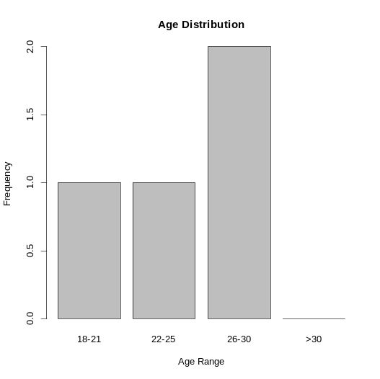  Figure 1 - Age distribution | 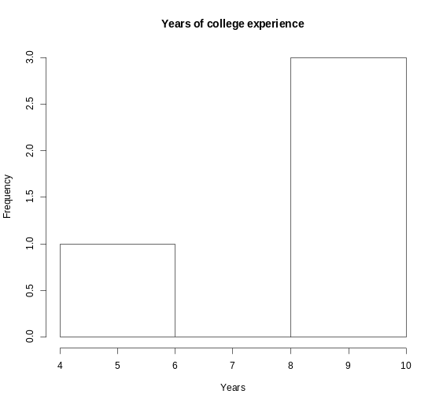  Figure 2 - Years of College Experience

Figure 3 shows the gender distribution where we can see 75% of subjects are Male and 25% are female.
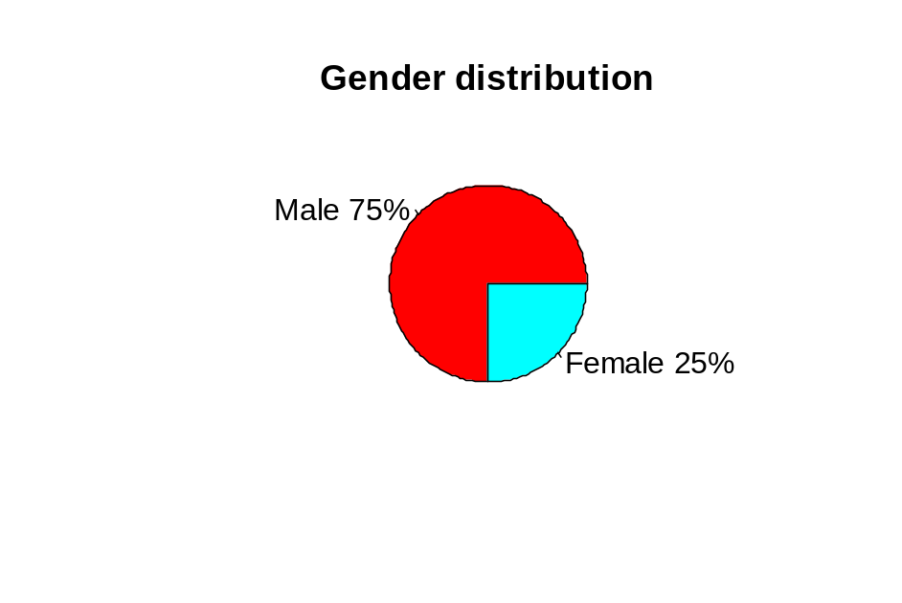
Figure 3 - Gender distribution
Quantitative Results

- H1a: When using MicroProbe, time to complete tasks that perform keyword and time based searches will be faster compared to MicroBrowser.
- For Hypothesis 1a, paired t-test or Wilcoxon signed rank test will be used to determine mean differences in total time to perform keyword and time based searches tasks.
- H1b: When using MicroBrowser, time to complete tasks that use patterns for knowledge discovery and quality improvement will be faster compared to MicroProbe.
- For Hypothesis 1b, paired t-test or Wilcoxon signed rank test will be used to determine mean differences in total time to complete tasks that use patterns for knowledge discovery and quality improvement.
- H2: When using MicroBrowser, perceive tasks are easier to complete compared to MicroProbe.
- For Hypothesis 2, Wilcoxon signed rank test will be used to determine differences in perception of difficulty.
- H3: Explore the benefit of using design patterns for knowledge discovery and contribution by the use MicroBrowser.
- For Hypothesis 3, we will describe the user experience obtained from the questionnaire responses and comments. Tests for apriori hypothesis will be two-tailed and α=0.05.

Descriptive statistics, such as frequencies and percentages, and median and interquartile range were computed for categorical and continuous data, respectively.

For Hypothesis H1a, Wilcoxon signed rank test was used to determine differences in time distributions to complete tasks that perform keyword and time based searches between MicroProbe and MicroBrowser. Table 1 shows the results of the experiments. From the results we can see that we were not able to find statistically significant results. However, looking at the information for Topic Searches , we see that in two of the three tasks, the MicroProbe application required less time to complete the tasks.

 | MicroProbe (n=4) |  | MicroBrowser (n=4)
 | Median | S.D. | Median | S.D. | p-value | V
Topic Search
Task 1 | 8.50 | 3.00 | 10.00 | 95.49 | 0.714 | 3.5
Task 2 | 74.50 | 35.19 | 33.50 | 21.28 | 0.125 | 10
Task 3 | 57.00 | 96.75 | 75.50 | 63.49 | 0.875 | 6
Time Search
Task 4 | 38.50 | 12.03 | 52.00 | 30.58 | 0.713 | 3.5
Task 5 | 16.00 | 11.09 | 26.50 | 39.45 | 0.875 | 4
Task 6 | 14.00 | 10.15 | 87.50 | 76.53 | 0.125 | 0
Table 1 - Topic and time based searches

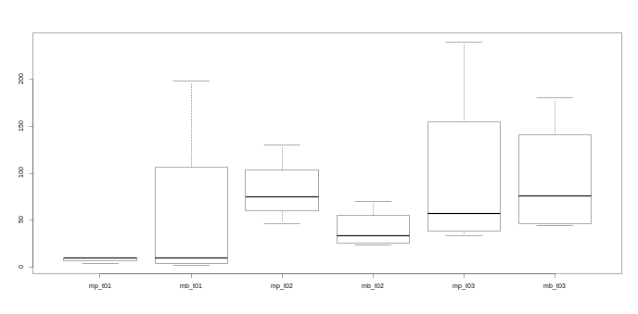
Figure 4- Topic based searches

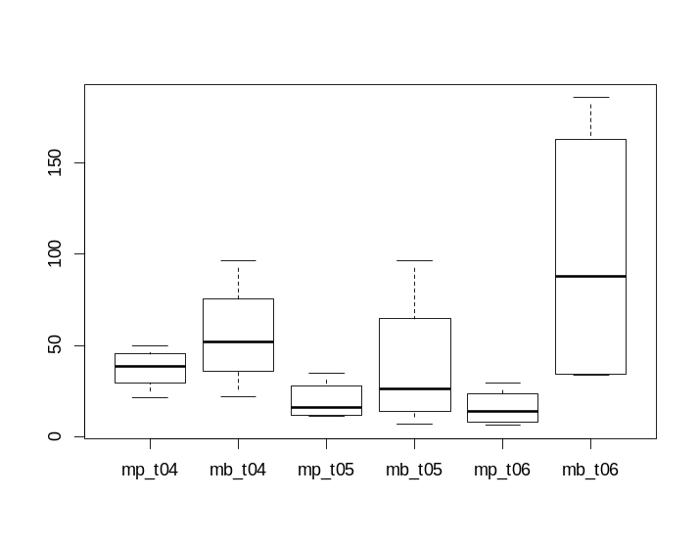

For Hypothesis H2a, Wilcoxon signed rank test was used to determine differences in time distributions to complete tasks that use patterns for knowledge discovery and quality improvement between MicroProbe and MicroBrowser. None of the data is statistically significant as shown in Table 2. However, from the available median data, we can observe that for those tasks that performed pattern discovery, the MicroProbe application took less time to complete than the MicroBrowser application. This result was unexpected and it leads us to believe that a failure in execution caused the pattern information to be overlooked by subjects.

 | MicroProbe (n=4) |  | MicroBrowser (n=4)
 | Median | S.D. | Median | S.D. | p-value | V
Pattern Knowledge Discovery
Task 7 | 14.00 | 7.13 | 46.00 | 101.10 | 0.625 | 3
Task 8 | 27.00 | 48.84 | 89.50 | 80.78 | 0.375 | 2
Task 9 | 22.50 | 9.21 | 40.00 | 26.06 | 0.125 | 0
Pattern Quality Improvement
Task 10 | 39.50 | 95.52 | 53.50 | 59.95 | 1.000 | 5
Task 11 | 73.00 | 28.92 | 111.50 | 77.64 | 0.125 | 0
Task 12 | 62.00 | 88.63 | 162.50 | 40.08 | 0.25 | 1
Table 2 – Pattern based tasks

For Hypothesis H2, we look at the perceived difficulty for completing the tasks using both applications. We used Wilcoxon signed rank test to determine differences in Likert scale distribution between MicroBroweser and MicroProbe.

Qualitative Results
H3: Explore the benefit of using design patterns for knowledge discovery and contribution by the use MicroBrowser.
For addressing Hypothesis 3, we looked at the information captured from the Questionnaire. To the questions of q18: “Using design patterns made finding related discussions easier when using the MicroBrowser application”, had a median of 3.5 (s.d. 0.95) which barely agrees with the statement. For q22: “Having pattern information can help me to learn how to answer questions”, it had a median of

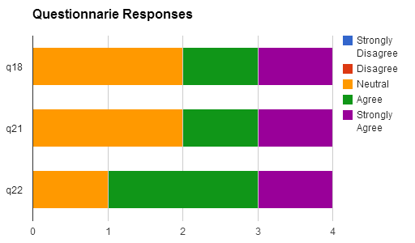

As reported on Table 2, the median perception for Topic Search using MicroBrowser and MicroProbe are the same. This can be attributed to the fact that users are accustomed to performing searches and both applications have support for keyword searches. We see the same perception for Pattern Knowledge Discovery. This result was surprising as we were expecting to have a difference between the two. However, it could be explained by a failure in execution where users were still relaying on topic searches rather than using the Patterns to find information. We see a bigger difference for Time Based searches. This is a feature subjects had a very favorable opinion towards. The ability to specify a particular time range for performing queries helped users to narrow the search scope. This feature is very important for educational settings as subjects might want to concentrate in particular time slots rather than searching for information for the majority of the semester. For tasks around Pattern Quality Improvement, we can see a smaller difference between the two systems.

DISCUSSION

CONCLUSION

BIBLIOGRAPHY
1. Agichtein, E. Finding the Right Facts in the Crowd : Factoid Question Answering over Social Media Categories and Subject Descriptors. Search, (2008), 467–476.
2. Ardichvili, A., Page, V., and Wentling, T. Motivation and barriers to participation in virtual knowledge-sharing communities of practice. Journal of Knowledge Management 7, 1 (2003), 64–77.
3. Dror, G., Koren, Y., Maarek, Y., and Szpektor, I. I Want to Answer , Who Has a Question ? Yahoo ! Answers Recommender System. Work, (2011), 1109–1117.
4. Dutson, A.J., Todd, R.H., Magleby, S.P., and Sorensen, C.D. A review of literature on teaching engineering design through project-oriented capstone courses. Journal of Engineering Education 86, January (1997), 17–28.
5. Gamma, E., Helm, R., Johnson, R., and Vlissides, J. Design Patterns: Elements of Reusable Object-Oriented Software. 1994.
6. Girgensohn, A. and Lee, A. Making web sites be places for social interaction. Proceedings of the 2002 ACM conference on Computer supported cooperative work, ACM (2002), 136–145.
7. Gnagey, W.J. Peer leadership of small research teams in two introductory psychology classes. Teaching of Psychology 6, 2 (1979), 80–82.
8. Heer, J., Card, S., and Landay, J. Prefuse: a toolkit for interactive information visualization. Proceedings of the SIGCHI conference on …, (2005).
9. Huang, J., Dasgupta, A., Ghosh, A., Manning, J., and Sanders, M. Superposter behavior in MOOC forums. Proceedings of the first ACM conference on Learning @ scale conference - L@S ’14, (2014), 117–126.
10. Luo, L., Wang, F., Zhou, M.X., Xin, Y., and Hang, P. Who Have Got Answers ? Growing the Pool of Answerers in a Smart Enterprise Social QA System. (2014), 7–16.
11. Matejka, J., Grossman, T., and Fitzmaurice, G. IP-QAT : In-Product Questions , Answers & Tips. Human Factors, (2011), 175–184.
12. Pera, M.S. A Community Question-Answering Refinement System. Strategy, (2011), 251–260.
13. Porter, L., Lee, C.B., Simon, B., and Zingaro, D. Peer Instruction : Do Students Really Learn from Peer Discussion in Computing ? (2011), 45–52.
14. Seaton, D.T., Bergner, Y., Chuang, I., Mitros, P., and Pritchard, D.E. Who does what in a massive open online course? Communications of the ACM 57, 2014, 58–65. http://www.researchgate.net/publication/236973386_Who_Does_What_in_a_Massive_Open_Online_Course/file/3deec51f9478f239cd.pdf.
15. Seo, J., Croft, W.B., and Smith, D. a. Online community search using thread structure. Proceeding of the 18th ACM conference on Information and knowledge management - CIKM ’09, (2009), 1907.
16. Wanner, F., Ramm, T., and Keim, D. ForAVis: explorative user forum analysis. WIMS ’11: Proceedings of the International Conference on Web Intelligence, Mining and Semantics, (2011).
17. Yahoo! Answers. http://answers.yahoo.com/.
18. AskVille. http://askville.amazon.com.
19. Stackoverflow. http://www.stackoverflow.com.

APPENDIX

Experiment Variables and Outcomes
Indicators – How to measure the outcome
Analyses – How to use the data from indicators to answer research question

Research question | Goal | Outcome | Analyses | Expected insights | MicroBrowser | Q&A
The MicroBrowser application promotes knowledge sharing | Knowledge sharing | Number of questions asked | Descriptive statistics  McNemar’s test | Find out whether users are able to complete the task of creating new questions. | X | X
The MicroBrowser application promotes knowledge sharing | Knowledge sharing | Number of patterns created | Descriptive statistics | Find out whether users are able to complete the task of creating new patterns. | X
The MicroBrowser application promotes knowledge sharing | Knowledge sharing | Number of relationships created between patterns and discussion threads | Descriptive statistics | Find out whether users understand the concept of associating design patterns to discussion threads. | X
The MicroBrowser application promotes knowledge sharing | Knowledge sharing | Numbers of relationships created between patterns | Descriptive statistics | Find out whether users understand the concept that design patterns can be associated with each other. | X
The MicroBrowser application promotes knowledge sharing | Knowledge sharing | Number of relationships created between discussion threads | Descriptive statistics Paired-t test (Mann Whitney Test) or alt. non-parametric test | Find out whether users are able to associate discussion threads. | X | X
The MicroBrowser application promotes knowledge sharing | Knowledge sharing | Time taken to answer a question. | Descriptive statistics Paired-t test (Mann Whitney Test) or alt. non-parametric test | Find out if there are differences between systems in the time taken to answer questions. | X | X
The MicroBrowser application promotes knowledge sharing | Knowledge sharing | Number of question answered | Descriptive statistics Paired-t test (Mann Whitney Test) or alt. non-parametric test |  | X | X
The MicroBrowser application promotes knowledge sharing | Knowledge dissemination | Number of pages visited while finding related discussion threads | Descriptive statistics Paired-t test (Mann Whitney Test) or alt. non-parametric test | Find out whether using one system requires the user to visit more pages to find the same information. | X | X
The MicroBrowser application promotes knowledge sharing | Knowledge dissemination | Time to find related discussion threads | Descriptive statistics Paired-t test (Mann Whitney Test) or alt. non-parametric test | Find out what is the time it takes to find related discussion threads to determine which system is more efficient. | X | X
The MicroBrowser application promotes knowledge sharing | Knowledge dissemination | Number of design pattern pages views | Descriptive statistics | Find out if users are actually visiting the design pattern pages. | X
The MicroBrowser application promotes knowledge sharing | Knowledge dissemination | Time taken to find an unanswered question | Descriptive statistics Paired-t test (Mann Whitney Test) or alt. non-parametric test | Find out if there are differences for locating questions with no answers | X | X
Is the system easy to use? | Utility | Easiness to ask questions | Descriptive statistics  1-5 point Likert scale | Asking questions is one of the two fundamental capabilities of any Q&A system. It is expected that users should have no problems asking questions. | X | X
Is the system easy to use? | Utility | Easiness to answer questions | Descriptive statistics  1-5 point Likert scale | Answering questions is one of the two fundamental capabilities of any Q&A system. It is expected that users should have no problems answering questions. | X | X
Is the system easy to use? | Utility | Design patterns help to answer questions | Descriptive statistics  1-5 point Likert scale |  | X
Is the system easy to use? | Utility | Design patterns help to find related discussion threads | Descriptive statistics  1-5 point Likert scale |  | X
Is the system easy to use? | Efficiency | Easiness to find related discussion threads | Descriptive statistics  1-5 point Likert scale |  | X | X
Is the system easy to use? | Efficiency | Perceived time to find related discussion threads | Descriptive statistics  1-5 point Likert scale |  | X | X
Is the system easy to use? | Efficiency | Perceived time to create new design patterns | Descriptive statistics  1-5 point Likert scale |  | X
Is the system easy to use? | Efficiency | Perceived time to associate design patterns to answers | Descriptive statistics  1-5 point Likert scale |  | X

