AIRA
AI-Native Enterprise Platform

Architecture Fitness Function Catalog
Executable Architecture Controls | SOLID Enforcement | AVCI Evidence
Version 1.0 | April 2026 | INTERNAL CONFIDENTIAL

Property | Value
Document ID | AIRA-DOC-023
Document Title | AIRA Architecture Fitness Function Catalog
Version | v1.0 - Initial Implementation Baseline
Classification | INTERNAL CONFIDENTIAL
Status | FOR ARCHITECTURE REVIEW BOARD / ENGINEERING ADOPTION
Owner | Solutions Architecture Office / AI-Native Platform Architecture
Effective Date | On CAB / Architecture Review Board approval
Review Cadence | Quarterly; unscheduled on material architecture, tooling, security, AI, or regulatory change
Audience | Solutions Architect / IT Head, Enterprise Architects, Software Development Leads, Developers, DevSecOps, QA/SDET, Security, DBA, SRE, Internal Audit
Companion Documents | 01A Enterprise Design Principles and SOLID Enforcement Layer; 01 AVCI v3.0; 02 Engineering Blueprint v5.0; 03 Developer Guide v4.0; 08 Unit Testing v3.0; 20 CI/CD Pipeline and Evidence Pack; 22 Prompt/Guardrail/Model Registry
Purpose | Define the executable architecture fitness functions used to continuously validate SOLID, Clean Architecture, DDD boundaries, security, testability, reversibility, observability, and AVCI evidence across AIRA.

Mandatory Practice Statement
No AIRA code, configuration, prompt, guardrail, model route, database migration, MicroFunction, contract, infrastructure change, or AI-assisted remediation is production-ready unless the mandatory architecture fitness functions pass or a formal, time-bound waiver is approved. Fitness functions are executable governance controls, not optional review suggestions.

Table of Contents
1. Executive Summary
2. Purpose, Scope, and Authority
3. Fitness Function Operating Model
4. Enforcement Levels and Toolchain
5. Architecture Fitness Function Catalog
6. SOLID and Clean Architecture Fitness Functions
7. DDD, Ports-and-Adapters, and Boundary Fitness Functions
8. Security, AI, and Policy Fitness Functions
9. Data, API, Workflow, and MicroFunction Fitness Functions
10. Testing, Determinism, Idempotency, and Resilience Fitness Functions
11. Observability, Reversibility, and AVCI Evidence Fitness Functions
12. Auto-Heal, Auto-Learn, and Auto-Improve Fitness Gates
13. CI/CD Integration and Evidence Manifest
14. Waivers, Exceptions, and Non-Conformance
15. RACI and Operating Responsibilities
16. Implementation Roadmap and Acceptance Criteria
Appendix A. Copy-Ready ArchUnit Examples
Appendix B. Copy-Ready Semgrep Rules
Appendix C. Copy-Ready OPA/Rego Policies
Appendix D. Mermaid Diagram References
Appendix E. AVCI Compliance Summary

1. Executive Summary
AIRA is a regulated AI-native platform where architecture quality must be measurable, repeatable, and enforceable. This catalog defines the architecture fitness functions that transform the Enterprise Design Principles and SOLID Enforcement Layer into automated and reviewable controls.
Fitness functions are tests, policies, scans, inspections, and evidence gates that continuously verify whether a system remains aligned with its intended architecture. They protect AIRA from silent erosion: misplaced business logic, cross-context data access, direct model provider calls, missing idempotency, unobservable changes, insecure shortcuts, unreviewed AI improvements, and unrecoverable production changes.
The catalog is designed for daily engineering use. Developers run a subset locally through pre-commit and IDE checks. CI/CD runs the full mandatory set. Architecture, Security, QA, and DevSecOps review evidence before protected merges, promotions, and production-impacting changes.
Strategic Outcome | How This Catalog Delivers It
Architecture drift prevention | Detects boundary violations, dependency direction errors, cross-context writes, direct provider SDK use, and unsupported shortcuts before merge.
Executable SOLID enforcement | Converts SOLID, Clean Architecture, DDD, and ports-and-adapters into checks that can be tested, reviewed, and evidenced.
AI-safe remediation | Prevents Auto-Heal, Auto-Learn, and Auto-Improve from weakening architecture boundaries, security posture, tests, observability, rollbackability, or AVCI.
Audit-ready evidence | Produces a fitness evidence pack linked to ticket, commit, PR/MR, pipeline, policy version, reviewer, and waiver status.
Continuous improvement | Turns repeated fitness failures into backlog items, ADR/TDL updates, training needs, and updated repository rules.

2. Purpose, Scope, and Authority

2.1 Purpose
This catalog defines the mandatory and recommended architecture fitness functions for AIRA. It identifies what each function checks, when it runs, who owns it, which tools enforce it, what causes rejection, and what evidence must be retained.

2.2 In Scope
- Java, TypeScript, Python, SQL, YAML, Dockerfile, Helm, Kubernetes, GitHub/GitLab workflow, prompt, guardrail, model-alias, MicroFunction, and documentation changes that influence AIRA system behaviour.
- Fitness functions executed locally, in CI/CD, during architecture review, in pre-release validation, and during Auto-Heal / Auto-Improve review.
- Architecture, security, testability, resilience, observability, data, API, workflow, AI, and AVCI evidence controls.

2.3 Out of Scope
- Business feature prioritization, except where a feature attempts to bypass architecture rules.
- Manual UAT sign-off, except where UAT evidence feeds release readiness.
- Physical data center controls, except where infrastructure fitness evidence is required for platform readiness.

2.4 Authority and Conflict Resolution
Level | Authority | Role
L0 | Architecture Board / approved Blueprint | Defines intended architecture and boundary decisions.
L1 | 01A Enterprise Design Principles and SOLID Enforcement Layer | Defines the mandatory principles this catalog enforces.
L2 | This Fitness Function Catalog | Defines executable checks and acceptance criteria.
L3 | Repository CLAUDE.md, CI pipelines, OPA policies, ArchUnit/Semgrep rules | Implements the functions in code and automation.
L4 | Waiver / exception records | May temporarily accept risk but cannot silently weaken the standard.

3. Fitness Function Operating Model
A fitness function is an executable or reviewable assertion about the architecture. AIRA uses six control layers: repository rules, static analysis, policy-as-code, test evidence, runtime evidence, and knowledge feedback.
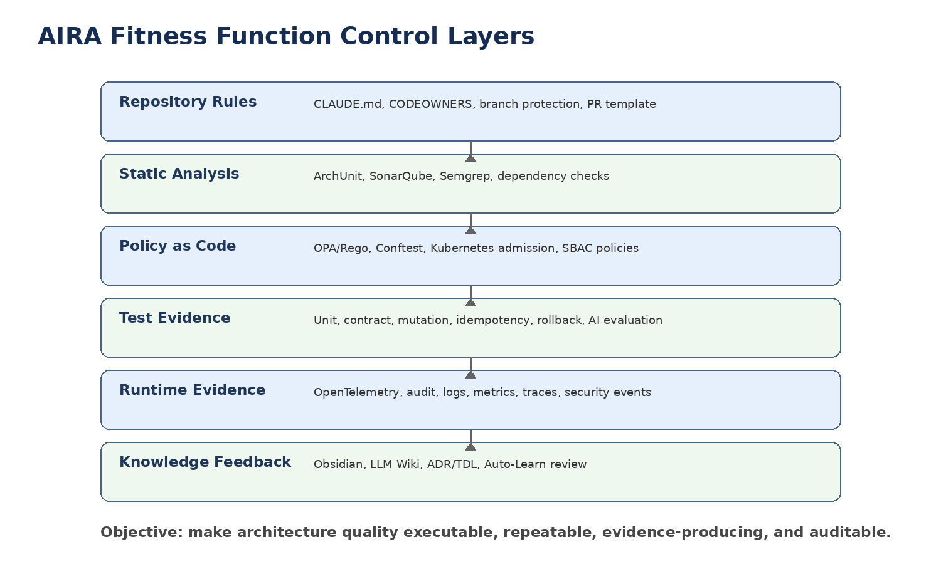
Figure 1. AIRA Fitness Function Control Layers

3.1 Fitness Function Types
Type | Purpose | Example Tools
Static structure | Checks dependencies, packages, imports, annotations, direct SDK usage, folder boundaries, naming, and forbidden APIs. | ArchUnit, Semgrep, SonarQube, dependency graph
Policy-as-code | Checks authorization, admission, IaC, environment, model routing, and action permission rules. | OPA/Rego, Conftest, Gatekeeper, Harness policy
Behavioral tests | Checks idempotency, determinism, error paths, compensation, retry, fallback, and rollback behaviour. | JUnit, Vitest, Playwright, Testcontainers, mutation testing
Contract tests | Checks APIs, events, schemas, error contracts, backward compatibility, and consumer expectations. | OpenAPI/AsyncAPI linters, Pact, Spring Cloud Contract
Evidence checks | Checks that evidence exists, is linked, complete, classified, retained, and reviewable. | CI evidence manifest, PR template validation, audit store
Runtime fitness | Checks production signals, SLOs, policy decisions, logs, traces, audit, and drift indicators. | OpenTelemetry, Prometheus, Loki, Tempo, Sentry, Grafana

3.2 Mandatory Rejection Rule
A critical or high-severity fitness failure blocks merge or promotion. The only exception is a formal waiver that states owner, reason, risk, expiry date, compensating control, remediation ticket, and approval authority. Waivers must be visible in the PR/MR evidence pack and must not permit direct production bypass of identity, guardrail, audit, or policy controls.

4. Enforcement Levels and Toolchain
Level | Meaning | Required Action
Advisory | Reports issue but does not block. Used for early adoption and low-risk maintainability signals. | Backlog item or refactor recommendation.
Warning | Allows merge only with reviewer acknowledgement. Used for medium-risk drift where compensating evidence exists. | Reviewer records disposition in PR/MR.
Blocking | Fails pre-commit or CI. Used for architecture, security, data, AI, tests, and evidence violations. | Fix required before merge or formal waiver.
Quarantine | Stops deployment or disables artifact from promotion. Used for secrets, direct provider calls, Restricted data leaks, policy bypass, or broken guardrails. | Security/Architecture escalation required.

4.1 Recommended Toolchain
Tool / Control | Primary Fitness Role
ArchUnit | Java architecture boundaries, dependency direction, annotation rules, package rules.
SonarQube / SonarCloud | Maintainability, duplication, complexity, security hotspots, quality gate.
Semgrep | Forbidden imports, direct SDK calls, unsafe patterns, logging leaks, framework bypass.
OPA / Conftest | Policy-as-code checks for IaC, model routing, SBAC, waivers, deployment rules.
OpenAPI / AsyncAPI Linters | Contract completeness, versioning, error shape, security schemes, compatibility.
JUnit / Vitest / Playwright | Unit, component, frontend, workflow, idempotency, rollback, and regression tests.
Mutation Testing | Verifies that tests actually detect behavioural changes.
OpenTelemetry / Observability Checks | Verifies trace, metric, log, audit, and correlation requirements.
Trivy / Gitleaks / Syft / Cosign | Container, secret, dependency, SBOM, and provenance fitness.
Custom AIRA Evidence Validator | Validates PR/MR AVCI summary, evidence manifest, fitness function results, and waiver records.

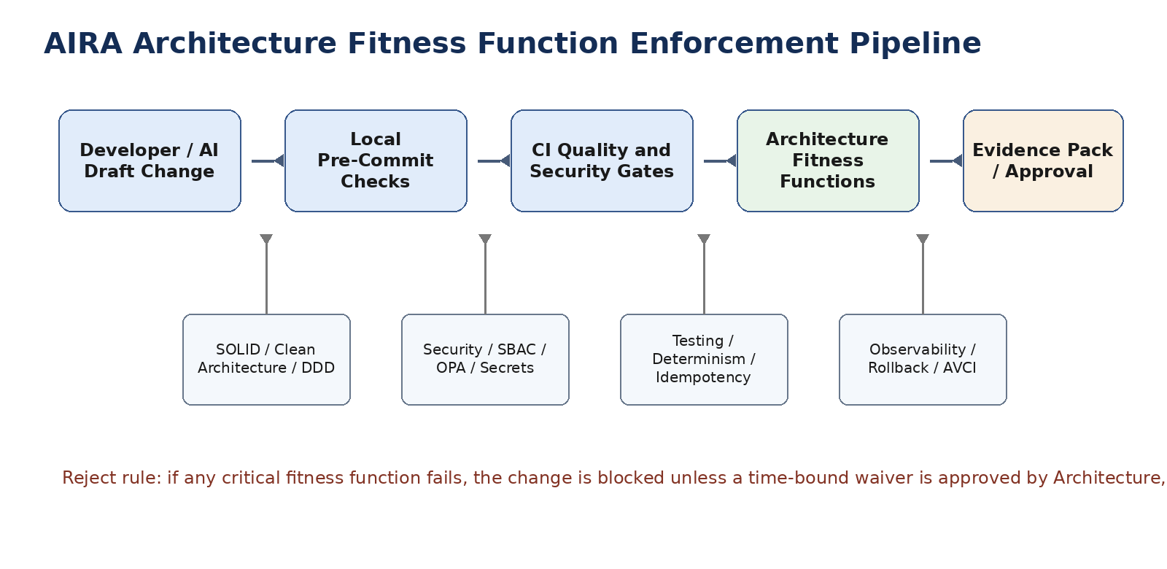
Figure 2. Architecture Fitness Function Enforcement Pipeline

5. Architecture Fitness Function Catalog
The catalog below defines the initial AIRA baseline. Project teams may add stricter service-specific fitness functions, but they may not remove or weaken mandatory functions without formal approval.
ID | Fitness Function | Primary Principle | Tool / Evidence | Trigger | Reject Condition
AFF-001 | Single Responsibility enforcement for services, MicroFunctions, adapters, policies, and prompts. | SOLID / SRP | ArchUnit, code review, Sonar complexity | Every PR/MR | Class mixes controller, domain, persistence, workflow, or AI routing concerns.
AFF-002 | Open/Closed and extension-by-configuration for MicroFunctions and policies. | SOLID / OCP | Catalog validator, tests | MicroFunction/config change | Change hardcodes process sequence instead of approved config/rule extension.
AFF-003 | Liskov-safe contracts and DTO compatibility. | SOLID / LSP | Contract tests, schema compatibility | API/event change | Subtype/implementation breaks declared contract or consumer expectations.
AFF-004 | Interface segregation for ports, adapters, and clients. | SOLID / ISP | ArchUnit, code review | Service/client change | Large generic interface forces unrelated dependencies or permissions.
AFF-005 | Dependency inversion: domain cannot depend on infrastructure frameworks. | SOLID / DIP | ArchUnit | Every backend PR | Domain package imports Spring Web, JPA repository, Kafka, Vault, LiteLLM, OpenKM, or provider SDK.
AFF-006 | Clean Architecture ring direction enforcement. | Clean Architecture | ArchUnit, dependency graph | Every backend PR | Outer layer is referenced by inner layer or business logic leaks to controller/adapters.
AFF-007 | Bounded context ownership and no cross-context writes. | DDD / Bounded Contexts | DB policy, API contract, ArchUnit | DB/API PR | Service writes another context schema or bypasses API/event boundary.
AFF-008 | Ports-and-adapters boundary for external systems. | Ports and Adapters | ArchUnit, Semgrep | Integration change | External HTTP, DB, OpenKM, model, Kafka, Vault call appears inside domain logic.
AFF-009 | DRY/KISS/YAGNI complexity and duplication gate. | DRY/KISS/YAGNI | SonarQube, review | Every PR/MR | Duplicate standard concern, speculative abstraction, or unnecessary framework added.
AFF-010 | Idempotency for mutations, workflows, consumers, and external calls. | Idempotency by Design | Tests, DB constraints, outbox evidence | Mutation path | No idempotency key, processed-event registry, natural key, or compensation path.
AFF-011 | Deterministic build, test, migration, and AI evaluation. | Determinism/Reproducibility | CI logs, pinned versions, test controls | Every pipeline | Unpinned dependency, real clock/random/network in unit tests, non-repeatable eval.
AFF-012 | Fail-safe not fail-open for critical dependencies. | Fail-Safe | Resilience tests, OPA checks | Security/AI path | OPA, Vault, LiteLLM, Guardrails, Harness, identity, or audit failure allows protected action.
AFF-013 | Human-in-the-loop for high-risk or low-confidence actions. | Human-in-the-Loop | Flowable evidence, Harness log | AI/tool action | High-risk change proceeds without named human approval.
AFF-014 | Least privilege and SBAC action eligibility. | Least Privilege / SBAC | OPA, SBAC registry, audit | Tool/action PR | Role, service, or agent can perform action beyond approved skill/scope.
AFF-015 | Separation of duties through CODEOWNERS and review gates. | Separation of Duties | CODEOWNERS, branch protection | Protected path change | Maker self-approves or required owner/security/DBA/QA review missing.
AFF-016 | Observability by design for every controlled path. | Observability | OTel checks, log schema tests | Service/workflow change | No trace_id, span, metric, audit event, error code, or SLO signal.
AFF-017 | Policy-as-code over hidden decision logic. | Policy as Code | OPA/Rego tests, review | Authorization/policy change | Business/security policy hardcoded where OPA/DMN/rule table is required.
AFF-018 | Testability by design and changed-line coverage. | Testability | Unit/contract/mutation coverage | Every PR/MR | Untestable design, no tests for changed behavior, or missing negative/error paths.
AFF-019 | Secure-by-design and no sensitive leakage. | Secure by Design | Semgrep, Gitleaks, SAST | Every PR/MR | Secret/PII in code, logs, tests, prompts, examples, cache keys, or telemetry.
AFF-020 | Resilience pattern coverage for external dependencies. | Resilience Patterns | Resilience4j tests, chaos subset | External call change | No timeout, retry, circuit breaker, fallback, bulkhead, or DLQ policy.
AFF-021 | Architecture fitness function evidence exists. | Architectural Fitness Functions | Evidence manifest validator | Every PR/MR | Required AFF results absent, stale, not linked, or unauditable.
AFF-022 | Progressive autonomy gate for agents. | Progressive Autonomy | Trust score, Harness audit | AI action change | Agent authority exceeds trust, skill, risk tier, or human-approval threshold.
AFF-023 | Rollbackability or forward-fix plan. | Reversibility/Rollbackability | Deployment plan, migration test | Release/promotion | No rollback, compensation, forward-fix, or recovery evidence.
AFF-024 | AVCI completeness for every material artifact. | AVCI | PR template, evidence schema | Every PR/MR | Owner, evidence, classification, or improvement path missing.
AFF-025 | No direct LLM provider SDK or uncontrolled model call. | AI governance | Semgrep, dependency scan | AI/code PR | Application imports provider SDK or bypasses LiteLLM/guardrails.
AFF-026 | Guardrails four-checkpoint enforcement. | AI safety | Guardrail tests, config validator | AI prompt/model change | Input, Retrieval, Execution, or Output checkpoint missing or bypassable.
AFF-027 | Contract-first API and event governance. | API discipline | OpenAPI/AsyncAPI linters | API/event PR | Endpoint/topic/schema added without approved contract and tests.
AFF-028 | Database migration governance and expand/contract safety. | Database discipline | Flyway validation, migration tests | DB PR | Manual DDL, destructive migration, no rollback/forward-fix, no owner/classification.
AFF-029 | MicroFunction mandatory standard-step validation. | MicroFunction | Publish validator, tests | Process config change | Sequence omits receive, correlate, session, security, validation, audit, error path, or response.
AFF-030 | Knowledge and retrieval provenance validation. | Knowledge governance | LLM Wiki metadata, retrieval tests | Knowledge/AI change | Output or curated knowledge lacks source, version, classification, citation, or review state.

6. SOLID and Clean Architecture Fitness Functions
SOLID enforcement in AIRA is not a style preference. It is a maintainability and safety gate. Business logic must remain small, cohesive, testable, and isolated from infrastructure concerns. Clean Architecture dependency direction must be enforced automatically wherever possible.
Control Area | Requirement
Mandatory Checks | Run blocking checks for critical architecture, security, data, AI, and evidence violations.
Recommended Checks | Run warning/advisory checks for maintainability, duplication, complexity, and drift trends.
Evidence Required | Store result status, tool version, ruleset version, commit, PR/MR, owner, reviewer, timestamp, and waiver reference if any.

7. DDD, Ports-and-Adapters, and Boundary Fitness Functions
A bounded context owns its language, data model, schema, APIs, events, and invariants. Cross-context access happens through approved contracts and events. Ports-and-adapters isolates external systems so domain rules are not coupled to transport, persistence, AI providers, or vendor APIs.
Control Area | Requirement
Mandatory Checks | Run blocking checks for critical architecture, security, data, AI, and evidence violations.
Recommended Checks | Run warning/advisory checks for maintainability, duplication, complexity, and drift trends.
Evidence Required | Store result status, tool version, ruleset version, commit, PR/MR, owner, reviewer, timestamp, and waiver reference if any.

8. Security, AI, and Policy Fitness Functions
AI-native capability increases the need for strict boundaries. Fitness functions must detect direct provider SDK usage, guardrail bypass, missing SBAC, excessive agent authority, secrets leakage, direct production tooling, and policy-as-code gaps.
Control Area | Requirement
Mandatory Checks | Run blocking checks for critical architecture, security, data, AI, and evidence violations.
Recommended Checks | Run warning/advisory checks for maintainability, duplication, complexity, and drift trends.
Evidence Required | Store result status, tool version, ruleset version, commit, PR/MR, owner, reviewer, timestamp, and waiver reference if any.

9. Data, API, Workflow, and MicroFunction Fitness Functions
Data, contract, workflow, and MicroFunction checks protect enterprise consistency. Mutations require idempotency, events require contracts, database changes require Flyway evidence, Temporal handles machine durability, Flowable handles human approvals, and MicroFunctions must use the standard execution envelope.
Control Area | Requirement
Mandatory Checks | Run blocking checks for critical architecture, security, data, AI, and evidence violations.
Recommended Checks | Run warning/advisory checks for maintainability, duplication, complexity, and drift trends.
Evidence Required | Store result status, tool version, ruleset version, commit, PR/MR, owner, reviewer, timestamp, and waiver reference if any.

10. Testing, Determinism, Idempotency, and Resilience Fitness Functions
AIRA tests must be deterministic and evidence-producing. Fitness functions reject uncontrolled clocks, random values, real network calls in unit tests, incomplete error paths, missing retry/fallback tests, and insufficient changed-line coverage for high-risk changes.
Control Area | Requirement
Mandatory Checks | Run blocking checks for critical architecture, security, data, AI, and evidence violations.
Recommended Checks | Run warning/advisory checks for maintainability, duplication, complexity, and drift trends.
Evidence Required | Store result status, tool version, ruleset version, commit, PR/MR, owner, reviewer, timestamp, and waiver reference if any.

11. Observability, Reversibility, and AVCI Evidence Fitness Functions
Every material change must be observable, recoverable, and evidentiary. The absence of trace IDs, audit records, error codes, rollback plans, compensation paths, or AVCI evidence is a production-readiness defect.
Control Area | Requirement
Mandatory Checks | Run blocking checks for critical architecture, security, data, AI, and evidence violations.
Recommended Checks | Run warning/advisory checks for maintainability, duplication, complexity, and drift trends.
Evidence Required | Store result status, tool version, ruleset version, commit, PR/MR, owner, reviewer, timestamp, and waiver reference if any.

12. Auto-Heal, Auto-Learn, and Auto-Improve Fitness Gates
Auto-Heal, Auto-Learn, and Auto-Improve must preserve or improve SOLID compliance, architecture boundaries, testability, security posture, observability, reversibility, and AVCI evidence. AIRA rejects improvements that make the system harder to understand, test, audit, secure, or roll back.
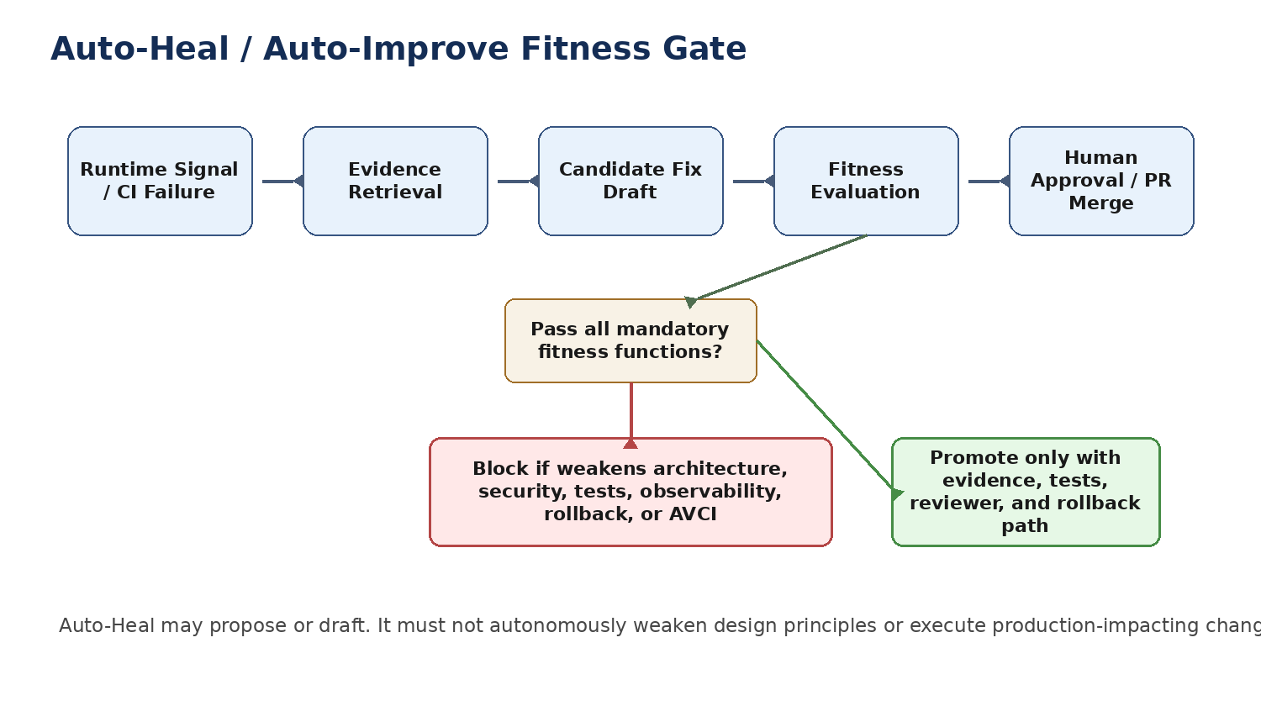
Figure 3. Auto-Heal / Auto-Improve Fitness Gate
Capability | Required Fitness Proof | Reject If
Auto-Heal | Fix must be minimal, evidence-based, tested, idempotent, secure, observable, reversible, and reviewed. | Block if it hides root cause, bypasses policy, weakens tests, or changes production without approved path.
Auto-Learn | Learning output must be sourced, cited, classified, reviewed, non-conflicting, and linked to an approved knowledge artifact. | Block if it promotes stale, unverified, unclassified, or contradictory knowledge.
Auto-Improve | Improvement must reduce measurable risk, defect rate, complexity, latency, cost, or maintainability debt without weakening controls. | Block if it adds speculative abstraction, expands privilege, reduces observability, or lacks rollback evidence.

13. CI/CD Integration and Evidence Manifest
The CI/CD pipeline must publish a fitness evidence manifest for every protected merge and promotion. The manifest is stored with the build evidence pack and referenced by the PR/MR AVCI Compliance Summary.
fitness_evidence:
artifact_id: AFF-EVID-2026-0001
repository: aira-platform
commit_sha: <sha>
pull_request: <url-or-id>
pipeline_run: <run-id>
ruleset_version: aira-aff-v1.0
classification: INTERNAL
required_functions:
- id: AFF-001
status: PASS
tool: archunit
evidence_ref: evidence/archunit-results.xml
- id: AFF-025
status: PASS
tool: semgrep
evidence_ref: evidence/semgrep.json
waivers: []
reviewer:
architecture: <name>
security: <name-if-required>
qa: <name>
decision: APPROVED_FOR_MERGE

Pipeline Stage | Fitness Evidence Requirement
Pre-commit | Run fast checks: formatting, forbidden patterns, secrets, direct provider SDK imports, basic evidence template.
Pull Request | Run full static, policy, test, contract, and architecture fitness set. Require CODEOWNERS approval.
Merge to main | Generate signed evidence manifest, SBOM, provenance, and immutable audit reference.
Release candidate | Run promotion checks, rollback readiness, environment policy, migration compatibility, and smoke tests.
Production promotion | Require CAB/approval evidence, deployment plan, observability readiness, and post-deploy verification.

14. Waivers, Exceptions, and Non-Conformance
Waivers are controlled exceptions, not informal permissions. A waiver must never permit direct production bypass of identity, guardrails, audit, secrets, policy, or classification controls. Waivers expire and must carry remediation evidence.
Required Field | Meaning
Waiver ID | Unique ID linked to ticket/ADR/TDL and PR/MR.
Affected Fitness Function | AFF ID, description, severity, and reason for temporary exception.
Risk Acceptance | Named risk owner, business justification, compensating controls, and expiry date.
Approvals | Architecture plus Security/QA/DBA/CAB depending on domain.
Remediation Plan | Concrete task, owner, target date, and evidence required to close waiver.

15. RACI and Operating Responsibilities
Role | RACI | Responsibility
Solutions Architect / IT Head | A | Owns architecture fitness baseline, exception decisions, and cross-document alignment.
Enterprise Architect | R/A | Defines and reviews architecture fitness functions, boundary rules, and ADR linkage.
Software Development Lead | R | Ensures developers follow gates and remediate fitness failures.
Software Developer | R | Runs local checks, writes tests, fixes violations, and records AVCI evidence.
DevSecOps Lead | R/A | Implements CI/CD checks, evidence manifest, pre-commit hooks, and policy integration.
Security Administrator | R/A | Owns security, SBAC, OPA, secrets, classification, and AI action gates.
QA/SDET | R | Owns test fitness, deterministic tests, mutation gates, contract tests, and evidence review.
DBA / Data Architect | R | Owns DB migration, bounded-context schema, RLS, outbox, pgvector, and data lineage checks.
Internal Audit / Compliance | C | Reviews evidence completeness, control mapping, and non-conformance handling.
CAB / Architecture Review Board | A | Approves major changes, waivers, production promotions, and standard updates.

16. Implementation Roadmap and Acceptance Criteria
Phase | Name | Activity | Acceptance Criteria
R1 | Define baseline ruleset | Approve AFF-001 to AFF-030 and publish in repository templates. | Ruleset reviewed and versioned.
R2 | Local enforcement | Install pre-commit hooks, Semgrep rules, Gitleaks, formatting, and fast evidence checks. | Developers can run checks before commit.
R3 | CI enforcement | Implement ArchUnit, SonarQube, OPA, contract tests, unit tests, mutation subset, and evidence manifest. | Protected branches block critical violations.
R4 | Service-specific hardening | Add stricter rules for orchestrator, harness, retrieval, workflow, database, AI, and MicroFunction paths. | Directory CLAUDE.md and CODEOWNERS enforce ownership.
R5 | Auto-Heal integration | Require AI-generated remediation PRs to include fitness evidence and human approval. | Auto-Heal cannot bypass fitness gates.
R6 | Continuous improvement | Track repeated failures, tune rules, add ADR/TDL updates, and train developers. | Quarterly review shows reduced drift and stable gates.

Appendix A. Copy-Ready ArchUnit Examples
@AnalyzeClasses(packages = "com.aira")
class AiraArchitectureFitnessTest {

@ArchTest
static final ArchRule domain_must_not_depend_on_infrastructure =
noClasses().that().resideInAPackage("..domain..")
.should().dependOnClassesThat().resideInAnyPackage(
"..adapter..", "..infrastructure..", "org.springframework.web..",
"org.springframework.data..", "org.apache.kafka..");

@ArchTest
static final ArchRule controllers_must_not_call_repositories =
noClasses().that().resideInAPackage("..controller..")
.should().dependOnClassesThat().resideInAPackage("..repository..");

@ArchTest
static final ArchRule provider_sdks_are_not_allowed =
noClasses().should().dependOnClassesThat().resideInAnyPackage(
"com.openai..", "com.anthropic..", "com.google.genai..", "software.amazon.awssdk.bedrockruntime..");
}

Appendix B. Copy-Ready Semgrep Rules
rules:
- id: aira-no-direct-llm-provider-sdk
message: "Direct LLM provider SDK use is prohibited. Route through LiteLLM and governed orchestration."
severity: ERROR
languages: [java, typescript, python]
patterns:
- pattern-either:
- pattern: import com.openai.$X
- pattern: import com.anthropic.$X
- pattern: import google.generativeai
- pattern: from openai import $X

- id: aira-no-secrets-in-source
message: "Potential secret or token in source. Use Vault or approved secret reference."
severity: ERROR
languages: [generic]
regex: '(api[_-]?key|secret|password|token)\s*[:=]\s*["'][A-Za-z0-9_\-]{16,}'

Appendix C. Copy-Ready OPA/Rego Policies
package aira.fitness

default allow = false

critical_failures := {f | f := input.fitness_results[_]; f.severity == "CRITICAL"; f.status != "PASS"}
high_failures := {f | f := input.fitness_results[_]; f.severity == "HIGH"; f.status != "PASS"}

allow {
count(critical_failures) == 0
count(high_failures) == 0
input.avci.owner != ""
input.avci.classification != ""
input.evidence_manifest.present == true
}

deny[msg] {
f := critical_failures[_]
msg := sprintf("Critical architecture fitness failure: %s", [f.id])
}

Appendix D. Mermaid Diagram References

D.1 Fitness Function Enforcement Pipeline
flowchart LR
DEV[Developer or AI Draft Change] --> PRE[Local Pre-Commit Checks]
PRE --> CI[CI Quality and Security Gates]
CI --> AFF[Architecture Fitness Functions]
AFF --> EVID[Evidence Pack and Approval]
AFF --> SOLID[SOLID / Clean Architecture / DDD]
AFF --> SEC[Security / SBAC / OPA / Secrets]
AFF --> TEST[Testing / Determinism / Idempotency]
AFF --> AVCI[Observability / Rollback / AVCI]
AFF -->|Critical failure| BLOCK[Reject or Waiver Required]

D.2 Auto-Heal Fitness Gate
flowchart TD
SIGNAL[Runtime Signal or CI Failure] --> RETRIEVE[Retrieve Evidence]
RETRIEVE --> DRAFT[AI Drafts Candidate Fix]
DRAFT --> FITNESS[Run Fitness Functions]
FITNESS --> DECISION{All Mandatory Gates Pass?}
DECISION -->|No| BLOCK[Block / Escalate / Create Remediation Ticket]
DECISION -->|Yes| HUMAN[Human Review and Approval]
HUMAN --> MERGE[Merge / Deploy Through Governed Pipeline]

Appendix E. AVCI Compliance Summary
AVCI Property | Compliance Evidence
Attributable | Document owned by Solutions Architecture Office; updates require Architecture Board or delegated approval.
Verifiable | Fitness functions are mapped to tools, triggers, rejection criteria, evidence manifests, and review gates.
Classifiable | Document classification is INTERNAL CONFIDENTIAL; fitness evidence inherits repository and artifact classification.
Improvable | Quarterly review, repeated-failure analysis, ADR/TDL updates, new rules, waiver closure, and lessons learned feed continuous improvement.

