AIRA
AI-Native Enterprise Platform

Security, Identity, Secrets, and Access Control Standard
Zero Trust · Keycloak / AD · Vault · SPIFFE/SVID · SBAC + RBAC + ABAC + OPA · SOLID/AVCI-Governed
Version 2.0 · April 2026
Mandatory Security Principle
Security is not an optional review stage. Every AIRA identity, service, MicroFunction, prompt, model route, secret, policy, tool action, workflow, data store, and operational process must be least-privilege, policy-governed, fail-closed, observable, reversible where applicable, and AVCI-evidenced by construction.

Property | Value
Document ID | AIRA-DOC-017
Document Title | AIRA Security, Identity, Secrets, and Access Control Standard
Version | v2.0 - Enterprise Design Principles and SOLID Enforcement Revision
Supersedes | 17-AIRA_Security_Identity_Secrets_and_Access_Control_Standard_v1.0
Status | FOR ARCHITECTURE REVIEW BOARD / ENGINEERING ADOPTION
Classification | CONFIDENTIAL - Internal Use Only
Owner | Solutions Architecture Office / Security Architecture
Co-Owners | Security Administrator · System Administrator · DevSecOps Lead · Software Development Lead · DBA · QA Lead · AI Governance Lead
Audience | Solutions Architect, Software Developers, Security Administrator, System Administrator, DBA, DevSecOps, Internal Audit, Compliance, AI Engineers
Effective Date | On CAB / Architecture Review Board approval
Review Cadence | Quarterly; unscheduled on material identity, secrets, AI, threat, regulatory, or technology-stack change
Primary Decision Inputs | ADR-AIRA-2026-001; AIRA Cross-Document Revision Control Matrix v1.0; 01A Enterprise Design Principles and SOLID Enforcement Layer v1.0
Companion Documents | 01 AVCI Engineering Standard v3.0; 01A Enterprise Design Principles v1.0; 02 Engineering Blueprint v5.0; 03 Developer Guide v4.0; 04 Technology Stack v8.0; 05 Information Nervous System v4.0; 06 CLAUDE.md Reference v3.0; 07 Skills Framework v3.0; 08 Unit Testing Standard v3.0; 09 Greenfield Environment Standard v3.0; 10/10A/10B/10C/10D MicroFunction documents; 11 DevSecOps Standard v3.0; 12 Rollout Pack v3.0; 13 Knowledge Governance v2.0; 14 ADR/TDL v2.0; 15 API Contract v2.0; 16 Database Standard v2.0
Compliance Scope | ISO/IEC 27001:2022 · CIS Controls v8.1 · NIST SP 800-207 · NIST CSF 2.0 · NIST SSDF · NIST AI RMF · OWASP ASVS 5.0.0 · SOC 2 · BSP IT Risk · SLSA Build Level 3
Purpose | Define mandatory security, identity, secrets, workload identity, access-control, AI agent execution, policy-as-code, audit, break-glass, and evidence controls used by AIRA applications and infrastructure.

Table of Contents
1. Executive Summary
2. Purpose, Scope, and Authority
3. Non-Negotiable Security Principles
4. Reference Security Architecture
5. Enterprise Design Principles and SOLID Enforcement for Security
6. Identity and Authentication Standard
7. Authorization Standard: RBAC, ABAC, SBAC, and OPA
8. Secrets, Keys, Certificates, and Vault Governance
9. Workload Identity, mTLS, and Service-to-Service Trust
10. Classification, Data Handling, Logging, and Model Routing
11. Application, API, MicroFunction, and Database Security Patterns
12. AI Agent Execution Security and Harness Boundary
13. DevSecOps Security Gates and Architecture Fitness Functions
14. Observability, Audit Evidence, Incident Response, and Break-Glass
15. Auto-Heal, Auto-Learn, and Auto-Improve Security Governance
16. Roles, RACI, and Operating Procedures
17. Implementation Roadmap and Acceptance Criteria
18. AVCI Compliance Summary
Appendix A. Access Request Checklist
Appendix B. OPA Policy Skeleton
Appendix C. Security PR/MR Compliance Summary
Word TOC Note
This document uses a static table of contents for deterministic rendering. A dynamic Word TOC may be inserted before final publication if required.

1. Executive Summary
AIRA is a regulated, AI-native enterprise platform. Security must be embedded into identity, authorization, secrets, workload identity, service-to-service trust, AI agent execution, logging, evidence, incident response, and operational recovery from the first line of code.
Version 2.0 upgrades the security baseline by incorporating the Enterprise Design Principles and SOLID Enforcement Layer. Security controls must preserve Clean Architecture boundaries, DDD ownership, ports-and-adapters separation, least privilege, separation of duties, fail-closed behavior, testability, observability, reversibility, and AVCI evidence.
Security Area | AIRA v2.0 Standard Position
Identity Provider | Keycloak federated to corporate Active Directory / enterprise IdP. No local application passwords except controlled break-glass accounts.
Authentication | OIDC/OAuth 2.x patterns with MFA, PKCE where applicable, short-lived tokens, token audience validation, and session evidence.
Authorization | RBAC for coarse roles, ABAC for contextual conditions, SBAC for human/AI skills, and OPA for policy-as-code decisions.
Secrets | Vault or approved enterprise secrets manager controls dynamic/leased secrets, PKI, encryption material, and secret access evidence.
Workload Identity | SPIFFE IDs and SVIDs for service identity; mTLS for service-to-service communication; static shared credentials rejected.
AI Agent Execution | Hermes may reason; Harness executes; OPA decides; SBAC and trust score gate actions; humans approve high-impact actions.
Audit Evidence | Every access decision records actor, subject, resource, action, decision, policy version, classification, and trace_id.

Security Architecture Rule
AI may recommend, draft, analyze, or classify security work. It must not approve access, bypass policy, expose secrets, execute production-impacting actions, suppress evidence, or weaken security posture.

2. Purpose, Scope, and Authority
This document gives developers, administrators, security engineers, and AI governance owners a single security design standard for implementing AIRA applications and infrastructure. It translates policy into concrete engineering patterns: identity propagation, token validation, authorization checks, secret retrieval, audit records, service trust, MicroFunction execution control, and AI agent action governance.
In Scope | Out of Scope
All AIRA applications, services, MicroFunctions, APIs, workflows, integrations, prompt repositories, model-routing configuration, and AI orchestration components. | Physical facilities security except where referenced by compliance evidence.
Human users, administrators, developers, approvers, auditors, service accounts, workload identities, CI identities, and AI agents. | Detailed firewall rule implementation, which belongs to infrastructure/security operations runbooks.
Authentication, authorization, secrets, service identity, mTLS, policy-as-code, break-glass, audit evidence, and classification-aware routing. | Business-specific role design, which must be owned by the business domain and implemented under this standard.
Development, test, UAT, staging, production, incident response, and maintenance workflows. | General HR policy except where access approval, onboarding, and offboarding evidence is required.

Authority Level | Document / Control | Security Concern
L0 | AIRA Consolidated Architecture Blueprint / Architecture Board decisions | End-to-end platform security posture, trust boundaries, and architecture exceptions.
L1 | Engineering Blueprint v5.0 and DevSecOps Standard v3.0 | Service boundaries, secure lifecycle, promotion gates, evidence regime.
L2 | AVCI v3.0 and 01A Enterprise Design Principles | Universal quality, SOLID, security posture, testability, reversibility, evidence.
L2 | This Security Standard | Identity, secrets, access control, workload trust, AI execution security, break-glass.
L3 | CLAUDE.md, OPA, CI/CD, CODEOWNERS, Harness, Vault policies | Executable controls and repository-specific enforcement.

3. Non-Negotiable Security Principles
ID | Principle | Engineering Meaning
SEC-01 | Zero Trust by Default | No user, service, agent, device, network segment, or environment is trusted implicitly. Every request is authenticated, authorized, classified, logged, and trace-correlated.
SEC-02 | Named Accountability | Human access is tied to one named person. Shared accounts are prohibited except approved break-glass with dual approval and post-use review.
SEC-03 | Least Privilege and Just-in-Time | Users, services, agents, and pipelines receive only the authority required, for the shortest viable time, with revocation evidence.
SEC-04 | Policy as Code | Authorization rules, admission controls, access decisions, model-routing rules, and guardrail approvals are reviewed policy artifacts.
SEC-05 | No Secret Exposure | Secrets never appear in Git, prompts, wiki pages, logs, traces, errors, screenshots, test fixtures, or documents.
SEC-06 | Workload Identity over Static Credentials | Service identity uses SPIFFE/SVID or approved short-lived workload credentials. Static credentials require waiver and rotation evidence.
SEC-07 | Classification Drives Controls | Public, Internal, Confidential, and Restricted classifications determine routing, encryption, logging, retention, approval, and AI use.
SEC-08 | AI Actions Are Mediated | AI agents cannot directly execute tools. Harness mediates identity, skill, trust, policy, scope, approval, and audit.
SEC-09 | Fail Closed | If OPA, Vault, Keycloak, Harness, NeMo Guardrails, LiteLLM, or audit evidence pipeline is unavailable, protected actions are blocked.
SEC-10 | AVCI Evidence on Every Control | Every access decision and security control must be attributable, verifiable, classifiable, and improvable.

4. Reference Security Architecture
AIRA uses layered enforcement. Gateway controls do not replace service controls; service controls do not replace data controls; AI guardrails do not replace OPA; and OPA decisions do not replace human accountability for high-impact actions.
Layer | Primary Controls | Mandatory Evidence
Identity Layer | Keycloak, corporate AD/IdP, MFA, group/role mapping, device posture where available. | User ID, realm, groups, MFA status, token issuer, login event, revocation event.
Gateway Layer | TLS, JWT validation, audience validation, rate limiting, WAF/API policies, trace_id injection. | Request ID, actor, tenant, route, decision, rate-limit result, security headers.
Service Layer | Spring Security, resource authorization, OPA client, MicroFunction envelope, method security. | Subject, action, resource, policy version, classification, decision, trace_id.
Data Layer | RLS, schema ownership, encryption, audit columns, least-privilege DB roles. | Tenant_id, actor_id, transaction_id, mutation history, migration version.
Secrets Layer | Vault dynamic secrets, leases, rotation, PKI, transit encryption, sealed secret workflow. | Secret path, lease ID, TTL, accessor, rotation event, revocation event.
Workload Layer | SPIFFE IDs, SVIDs, mTLS, service mesh/network policy, short-lived certificates. | SPIFFE ID, certificate serial, trust domain, workload attestation event.
AI Execution Layer | Harness, SBAC, OPA, trust scoring, NeMo Guardrails, LiteLLM routing. | Agent ID, skill, trust score, model alias, guardrail result, approval, action result.

5. Enterprise Design Principles and SOLID Enforcement for Security
Security implementation must preserve the 20 Enterprise Design Principles. Security features are not exempt from SOLID or Clean Architecture; they must be modular, testable, observable, and reversible like any other production capability.
Principle Group | Security Enforcement Meaning
SOLID | Security services, authorization evaluators, secret adapters, token validators, and audit writers must have single responsibility, stable contracts, substitutable implementations, segregated interfaces, and dependency inversion.
Clean Architecture | Domain logic must not depend directly on Keycloak, Vault, OPA, Kafka, database drivers, or model providers. Security dependencies enter through ports/adapters.
DDD / Bounded Contexts | Business roles, permissions, data classification, and ownership are defined within bounded contexts; cross-context privilege expansion requires ADR or approved policy.
Ports and Adapters | Identity, policy, secrets, workload identity, audit, and notification integrations are adapters behind ports; provider-specific code does not leak into domain services.
DRY, KISS, YAGNI | No duplicated custom authorization logic, secret-loading logic, or error-mapping logic in each service. Use framework controls unless justified.
Idempotency / Determinism | Access grants, secret rotations, policy bundles, and remediation actions must be retry-safe and produce reproducible evidence.
Fail-Safe / Human-in-the-Loop | High-impact and low-confidence actions require human approval. Protected operations block when controls are unavailable.
Least Privilege / SBAC / Separation of Duties | Authority is scoped by role, context, skill, trust, and task; requester, approver, executor, and reviewer duties are separated.
Observability / Policy as Code / Testability | Security decisions are logged, metrics-ready, policy-tested, CI-gated, and verifiable through architecture fitness functions.
Secure by Design / Resilience / Reversibility / AVCI | Security is embedded in design, resilient to dependency failure, reversible through revocation and rollback where possible, and evidenced under AVCI.

Security SOLID Rule
No security feature may be accepted if it introduces hidden coupling, duplicated privilege logic, direct provider dependency in domain code, untestable policy behavior, unobservable access decisions, or irreversible privilege expansion.

6. Identity and Authentication Standard
Control Area | Mandatory Rule | Evidence
Human Identity | Use named accounts federated through Keycloak and corporate AD/IdP. Shared accounts are prohibited except break-glass. | User lifecycle record, group mapping, MFA status, access approval.
MFA | MFA is mandatory for privileged roles, administrators, developers, repository access, CI/CD, cloud/AI workspaces, and security tools. | MFA enrollment report, exception register.
Session Control | Sessions use short-lived tokens, refresh policies, inactivity timeout, revocation support, and device/context checks where available. | Token policy, revocation evidence, session audit.
Application Authentication | OIDC/OAuth resource server pattern; validate issuer, audience, signature, expiry, and required claims. | Security tests, OPA decision evidence, API contract section.
Service Accounts | Service accounts are named, purpose-bound, owner-assigned, scoped, rotated, and reviewed quarterly. | Owner record, access review, last rotation, policy link.
AI Tool Accounts | ChatGPT, Codex, Claude Code, and other approved AI tooling use named seats only, with classification and workspace controls. | Seat assignment, onboarding acknowledgement, PR/MR AI declaration.

7. Authorization Standard: RBAC, ABAC, SBAC, and OPA
AIRA uses layered authorization. RBAC grants coarse role membership, ABAC evaluates contextual attributes, SBAC gates skill-based actions for humans and agents, and OPA provides policy-as-code decisions. Application code must not embed scattered hardcoded authorization decisions.
Authorization Layer | Use | Reject Pattern
RBAC | Coarse human and service roles such as Developer, Approver, DBA, Security Admin, AI Agent Owner. | Role explosion, shared admin role, direct production role by default.
ABAC | Tenant, branch, classification, environment, data domain, time, device posture, risk score, and workflow status. | Authorization based only on UI hiding or frontend checks.
SBAC | Skill-gated actions for humans and AI agents: code review, remediation, security triage, data migration, model route change. | AI agent with unrestricted tool scope or unverified skill.
OPA | Central policy decisions for APIs, tools, CI gates, Kubernetes admission, Harness actions, secrets, and model routing. | Hardcoded if/else policy logic in business code.
Human Approval | Required for high-risk, Confidential/Restricted, destructive, production-impacting, or low-confidence actions. | Auto-approve production changes or self-approval.

package aira.authz
default allow := false
allow {
input.actor.status == "ACTIVE"
input.actor.mfa == true
input.action in input.actor.allowed_actions
input.resource.classification <= input.actor.classification_ceiling
input.sbac.skill_status == "ACTIVE"
input.trust_score >= input.required_trust
not input.guardrail.blocked
not input.break_glass_without_approval
}

8. Secrets, Keys, Certificates, and Vault Governance
Control | Standard | Evidence / Gate
Secrets Source | Vault or approved enterprise secrets manager is authoritative. Git, CI variables, prompts, and documentation are not secret stores. | Vault path ownership, lease record, rotation evidence.
Dynamic Secrets | Use leased/dynamic database and service credentials where supported. Static secrets require exception. | Lease TTL, revocation test, rotation schedule.
Secret Injection | Secrets are mounted or injected at runtime through approved mechanisms; never baked into images or committed to repositories. | Image scan, secret scan, deployment manifest review.
Encryption Keys | Keys are owner-assigned, versioned, rotated, access-controlled, and separated by environment and classification. | Key inventory, rotation record, access review.
PKI and Certificates | Short-lived internal certificates use Vault PKI, SPIFFE/SVID, step-ca, or enterprise CA. Manual cert sprawl is prohibited. | Certificate inventory, expiry alert, issuance audit.
Emergency Access | Emergency secret disclosure requires dual approval, time-boxed access, ticket, post-use rotation, and RCA. | Break-glass ticket, approvers, rotation proof.

No Secret Exposure Rule
Any secret detected in Git, prompt, log, trace, screenshot, test fixture, wiki page, or document is a security incident and must trigger revocation, rotation, evidence preservation, and post-incident improvement.

9. Workload Identity, mTLS, and Service-to-Service Trust
Services must authenticate to each other using workload identity, not static shared secrets. SPIFFE IDs and SVIDs are the preferred pattern for service identity and mTLS trust.
Area | Mandatory Requirement
SPIFFE ID Naming | Each service receives a stable SPIFFE ID tied to environment, namespace, service name, and trust domain.
mTLS | Service-to-service communication must use mTLS where feasible. Plain internal HTTP is not acceptable for protected data paths.
Service Authorization | A valid certificate authenticates the workload; OPA/service policy still authorizes the action.
Certificate Rotation | Certificates are short-lived and rotated automatically. Expiry alerts must be observable.
Network Policy | Kubernetes network policies and ingress/egress rules restrict communication to approved paths.
Evidence | Workload attestation, certificate serial, policy decision, and trace_id are retained for audit.

10. Classification, Data Handling, Logging, and Model Routing
Classification | Security Handling | AI / Model Routing
Public | Standard integrity checks, normal logging without secrets, approved public examples. | Approved cloud routes permitted if source and output are non-sensitive.
Internal | Authenticated access, normal enterprise retention, redacted logs. | Approved workspace/cloud route may be permitted subject to policy.
Confidential | Least privilege, masking/redaction, stronger audit, restricted retrieval, explicit sharing control. | Private or approved enterprise route only; no uncontrolled prompt upload.
Restricted | Strongest access control, no raw exposure in logs/prompts/tests, human approval for high-impact use. | On-prem/private model route required unless formal waiver is approved.

Prohibited Data Handling Pattern | Reason
Raw PII or account data in logs, prompts, test fixtures, cache keys, traces, or screenshots. | Creates privacy, leakage, and uncontrolled retrieval risk.
Secrets in examples, documentation, or wiki articles. | Documentation can be indexed and retrieved by AI tools.
Classification omitted from API, event, data, prompt, or audit artifacts. | Routing, retention, logging, and access decisions cannot be enforced.
Direct model-provider call using provider SDK or hardcoded model name. | Bypasses LiteLLM, guardrails, routing, budgets, audit, and classification policy.

11. Application, API, MicroFunction, and Database Security Patterns
Component | Mandatory Security Pattern
Gateway | JWT validation, request correlation, rate limiting, TLS, security headers, edge policy, safe error mapping.
API / Service | Method/resource authorization, OPA decision, input validation, output redaction, audit event, no secrets in logs.
MicroFunction | Security, classification, session, SBAC/OPA, idempotency, audit, and error handling are standard steps before business logic.
Database | Least-privilege DB roles, RLS where applicable, classification columns, audit fields, Flyway-only schema change.
Kafka/Eventing | Schema-managed events, classification metadata, trace_id, no PII unless approved, consumer idempotency.
Temporal/Flowable | Workflow identity, human approval records, task assignment controls, compensation and escalation evidence.
Frontend | No secrets, no authorization-only-in-UI, CSP/security headers, secure session handling, synthetic test data.
AI Orchestrator | LiteLLM-only model traffic, NeMo guardrails, retrieval ACL filtering, durable audit intent before high-impact response.

12. AI Agent Execution Security and Harness Boundary
AI agent execution is a security-controlled workflow. An agent may reason and propose; it cannot directly execute Git, CI/CD, infrastructure, database, document store, model-routing, production API, or secrets actions.
Step | Required Control
1. Task Intake | Human/system request is classified, scoped, and trace-correlated.
2. Evidence Assembly | Agent retrieves only classification-eligible, approved, current sources.
3. Guardrail Evaluation | Input, Retrieval, Execution, and Output guardrails are applied as appropriate.
4. SBAC Check | Agent/human must hold active skill at required level with valid dependencies.
5. Trust Score Check | Trust score must meet action risk threshold and decay rules.
6. OPA Decision | Policy permits, denies, or requires human approval.
7. Harness Execution | Approved tool action is executed only through Harness using mediated credentials.
8. Evidence Capture | Action result, policy decision, approval, artifacts, and trace_id are written to audit.
9. Human Review | Production, destructive, Confidential/Restricted, or low-confidence changes require named human approval.

Explicitly Rejected AI Patterns
Direct agent credentials, provider SDK bypass, guardrail bypass flags, autonomous production execution, direct database edits, direct kubectl writes, unreviewed prompt/guardrail updates, and AI-approved access grants are rejected security patterns.

13. DevSecOps Security Gates and Architecture Fitness Functions
Gate / Fitness Function | Purpose | Minimum Evidence
Secret Scan | Detect secrets in code, tests, docs, configs, prompts, examples. | Gitleaks/TruffleHog report; zero unresolved findings.
SAST / Secure Code | Detect insecure coding patterns, injection, auth bypass, crypto misuse. | SonarQube/Semgrep report, reviewed exceptions.
SCA / Dependency Risk | Detect vulnerable/outdated dependencies and license risks. | Dependency scan, remediation or waiver.
Container/IaC Scan | Detect image, Kubernetes, Terraform, Helm, policy misconfigurations. | Trivy/Checkov/Conftest evidence.
OPA Policy Tests | Validate access, model routing, admission, and Harness decisions. | Policy unit tests and bundle version.
Architecture Boundary Test | Prevent domain code importing security provider adapters or provider SDKs directly. | ArchUnit/import-lint result.
SBAC/SoD Test | Verify high-risk actions require skill, trust, policy, and independent approval. | Component tests and approval workflow evidence.
Fail-Closed Test | Verify protected actions block when OPA, Vault, guardrails, LiteLLM, Harness, identity, or audit is unavailable. | Negative tests and chaos/fault-injection evidence.
Rollback / Revocation Test | Verify access grants, secrets, policies, and certificates can be revoked or rolled forward safely. | Revocation runbook and test result.

14. Observability, Audit Evidence, Incident Response, and Break-Glass
Evidence Type | Required Fields
Access Decision | actor_id, subject_id, resource, action, decision, policy_version, classification, reason, trace_id, timestamp.
Secret Access | secret_path, accessor, lease_id, TTL, operation, approval_ref if privileged, trace_id, timestamp.
Agent Action | agent_id, human_requester, skill, trust_score, tool, action, guardrail_result, OPA decision, approval, result.
Break-Glass | requester, approvers, scope, reason, start/end time, actions performed, evidence, revocation, post-use review.
Incident Record | trigger, classification, affected asset, severity, timeline, containment, eradication, recovery, RCA, improvement actions.

Break-glass access is exceptional, time-boxed, named, dual-approved, audited, and reviewed. It does not authorize uncontrolled production mutation, guardrail bypass, secret disclosure without rotation, or evidence suppression.

15. Auto-Heal, Auto-Learn, and Auto-Improve Security Governance
Capability | Allowed | Must Not Do | Acceptance Evidence
Auto-Heal | Detect security control failure, quarantine risky action, draft remediation PR, rotate non-production secret, propose policy fix. | Silently reduce security, bypass OPA, change production privileges, expose secret, or self-approve. | Incident link, RCA, PR, tests, security scan, rollback/revocation plan, human approval.
Auto-Learn | Convert reviewed incidents, blocked attacks, and approved remediations into knowledge, tests, policies, and runbooks. | Promote unreviewed model output, stale advice, real PII, secrets, or conflicting guidance. | Source citation, reviewer, classification, regression test, LLM Wiki/Obsidian approval.
Auto-Improve | Propose least-privilege tightening, policy simplification, authentication hardening, observability improvement, or fitness function enhancement. | Remove controls for convenience, weaken SoD, reduce logging, relax classification routing, or add irreversible privilege. | Impact analysis, principle assessment, test evidence, CAB/security approval.

Security Improvement Constraint
Auto-Heal, Auto-Learn, and Auto-Improve must preserve or improve SOLID compliance, architecture boundaries, testability, security posture, observability, reversibility, and AVCI evidence. A change that fixes one issue by weakening another control is rejected.

16. Roles, RACI, and Operating Procedures
Activity | Solutions Architect | Security Admin | SysAdmin / DevOps | Dev Lead | DBA | QA | Internal Audit
Approve security architecture standard | A | R/C | C | C | C | C | C
Identity and role model | A/C | R | C | C | C | I | C
OPA/SBAC policy changes | A/C | R | C | C | C | C | I
Vault/secrets lifecycle | C | A/R | R | I | C | I | C
Workload identity and mTLS | C | A/C | R | C | C | I | I
Security testing gates | C | A/R | R | R | C | R | I
AI agent action governance | A | R | C | C | I | C | I
Break-glass approval and review | A | R | R | I | I | I | C
Audit evidence review | C | R | C | C | C | C | A/C

17. Implementation Roadmap and Acceptance Criteria
Phase | Focus | Exit Criteria
S0 - Security Baseline | Approve v2.0 standard, update CLAUDE.md, confirm identity/secrets/control owners. | Security standard approved; owner matrix complete; exceptions logged.
S1 - Identity and Policy | Keycloak/AD mapping, RBAC/ABAC/SBAC model, OPA baseline policies. | Policy tests pass; access request and review workflow active.
S2 - Secrets and Workload Trust | Vault paths, dynamic secrets, PKI, SPIFFE/SVID, mTLS, rotation. | No unresolved secrets in Git; rotation/revocation tests passed.
S3 - Pipeline Enforcement | Secret scan, SAST, SCA, IaC, OPA, architecture boundary, fail-closed tests. | CI blocks violations; evidence stored with MR.
S4 - AI Agent Security | Harness action vocabulary, SBAC/trust gates, model-routing classification, guardrail tests. | No direct agent credentials; tool actions mediated and audited.
S5 - Operational Readiness | Incident response, break-glass, audit dashboards, access reviews, drift detection. | Drill completed; evidence reviewed; remediation backlog created.

18. AVCI Compliance Summary
AVCI Property | Security Evidence Requirement
Attributable | Every identity, policy, secret, role, certificate, agent, control, exception, and access decision has owner, source, version, approver, timestamp, and trace_id.
Verifiable | Security controls are proven by tests, scans, policy evaluations, audit events, access reviews, rotation tests, DR drills, and incident evidence.
Classifiable | Users, services, secrets, resources, logs, prompts, model routes, data, and outputs carry classification and handling rules.
Improvable | Findings, incidents, access reviews, test failures, and production signals feed controlled remediation, knowledge updates, policy improvements, and architecture reviews.

Appendix A. Access Request Checklist
Checklist Item | Required Before Approval
Named owner | Requester, approver, resource owner, and expiry are identified.
Business purpose | Ticket, project, or operational reason is linked.
Scope | Role/action/resource/environment/classification are explicit.
Least privilege | Requested access is minimum viable authority.
Separation of duties | Requester is not self-approving high-risk authority.
Duration | Access is time-bounded with review or expiry.
Evidence | Approval, policy decision, and audit record are retained.

Appendix B. OPA Policy Skeleton
# Required policy inputs
input.actor.id
input.actor.roles
input.actor.skills
input.actor.trust_score
input.actor.mfa
input.resource.id
input.resource.classification
input.action
input.environment
input.request.trace_id
input.guardrail.result
input.approval.status
# Required policy outputs
allow: boolean
reason: string
risk_tier: string
requires_human_approval: boolean
evidence_fields: object

Appendix C. Security PR/MR Compliance Summary
Security / AVCI Compliance Summary
- Security impact: None / Low / Medium / High / Critical
- Identity impact: roles, claims, scopes, sessions, MFA, service account changes
- Authorization impact: RBAC / ABAC / SBAC / OPA policy references
- Secrets impact: Vault path, rotation evidence, secret scan result
- Classification impact: Public / Internal / Confidential / Restricted
- SOLID / architecture boundary impact: preserved / improved / exception requested
- Test evidence: security tests, OPA tests, fail-closed tests, boundary tests
- Observability evidence: audit event, metric, log redaction, trace_id propagation
- Reversibility: rollback, revocation, rotation, forward-fix plan
- Human approval: approver, ticket, risk acceptance if applicable

Appendix D. Rendered Security Sequence Diagrams and Mermaid Reference
This appendix supplements the security standard with visual sequence diagrams and copy-ready Mermaid code. Software developers should use these diagrams as implementation references when building identity, authorization, secrets, workload identity, AI execution, model routing, break-glass, and security remediation flows.
Developer Usage Rule
The rendered diagram is the visual implementation reference. The Mermaid code is the copy-ready source for repository documentation, Obsidian notes, engineering walkthroughs, and future diagram regeneration. If the diagram and code ever differ, the Mermaid source must be corrected and regenerated through review.

SEC-SEQ-01 - Human Login, Session, and API Access Flow
Purpose: Shows how a human user authenticates through Keycloak/AD, receives claims, accesses an AIRA API, and receives an OPA-authorized response with audit evidence.
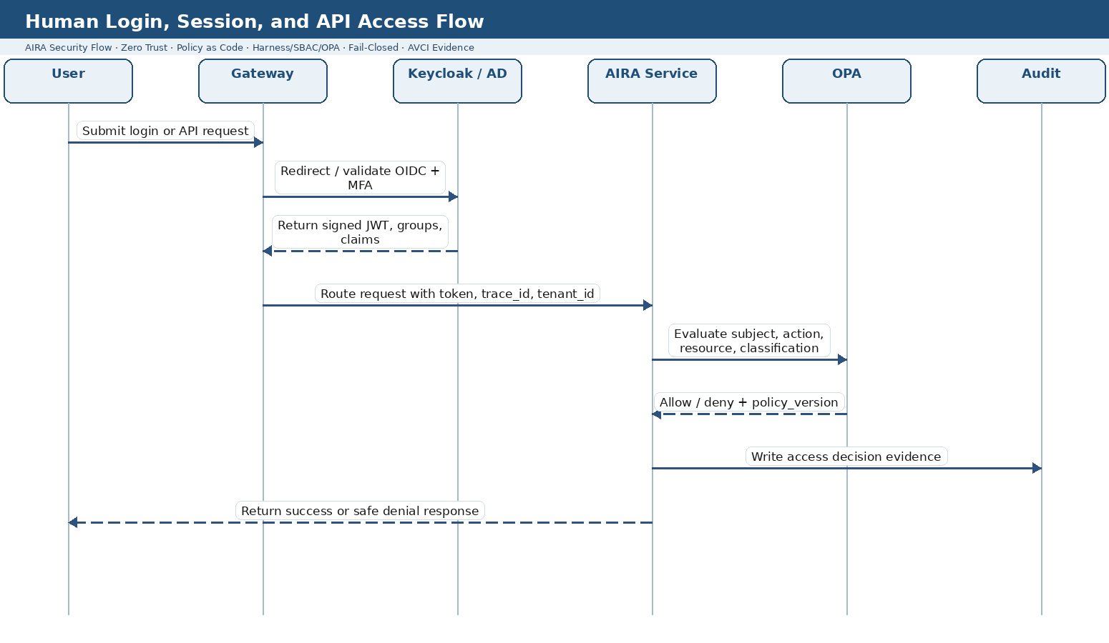
Figure 1. Human Login, Session, and API Access Flow

Copy-ready Mermaid code
sequenceDiagram
autonumber
actor U as User
participant GW as Spring Cloud Gateway
participant KC as Keycloak / Active Directory
participant SVC as AIRA Service
participant OPA as OPA Policy Decision Point
participant AUD as Audit Evidence Store
U->>GW: Submit login or API request
GW->>KC: Validate OIDC session / MFA / token
KC-->>GW: Signed JWT + claims + groups
GW->>SVC: Route request with trace_id, tenant_id, JWT
SVC->>OPA: Evaluate subject, action, resource, classification
OPA-->>SVC: Allow / deny + policy_version
SVC->>AUD: Write access decision evidence
SVC-->>U: Return success or safe denial response

SEC-SEQ-02 - Service-to-Service Workload Identity and mTLS Flow
Purpose: Shows how service identity, SVID issuance, mTLS, OPA authorization, and audit work together for internal service calls.
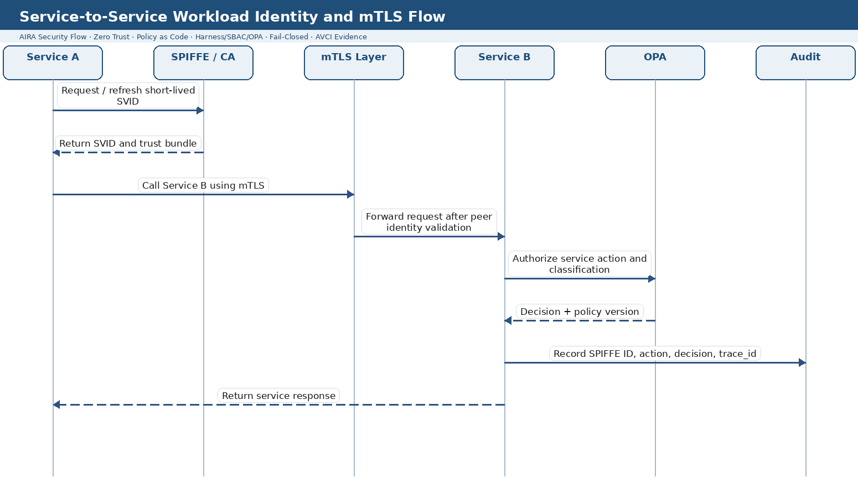
Figure 2. Service-to-Service Workload Identity and mTLS Flow

Copy-ready Mermaid code
sequenceDiagram
autonumber
participant A as Service A
participant SPIFFE as SPIFFE / SVID Authority
participant MTLS as mTLS / Service Mesh
participant B as Service B
participant OPA as OPA
participant AUD as Audit
A->>SPIFFE: Request or refresh short-lived SVID
SPIFFE-->>A: SVID + trust bundle
A->>MTLS: Call Service B using mTLS
MTLS->>B: Forward request after peer identity validation
B->>OPA: Authorize service action and classification
OPA-->>B: Decision + policy version
B->>AUD: Record SPIFFE ID, action, decision, trace_id
B-->>A: Return service response

SEC-SEQ-03 - Vault Dynamic Secret Retrieval and Rotation Flow
Purpose: Shows how applications obtain leased credentials from Vault, use them safely, and how expiry/revocation is evidenced.
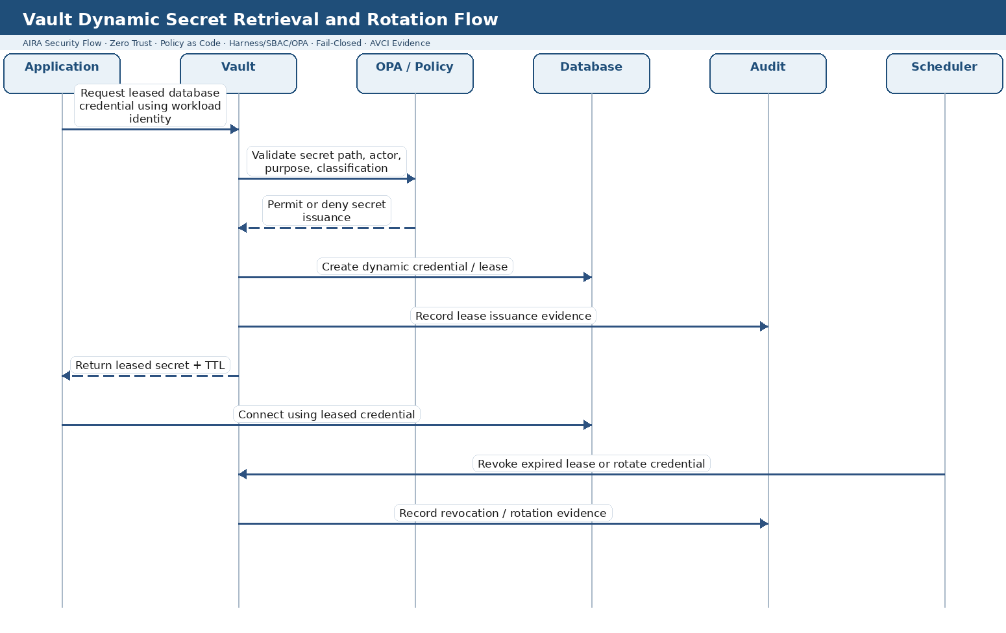
Figure 3. Vault Dynamic Secret Retrieval and Rotation Flow

Copy-ready Mermaid code
sequenceDiagram
autonumber
participant APP as Application
participant VAULT as Vault / Secrets Manager
participant OPA as OPA / Policy
participant DB as Database
participant AUD as Audit
participant SCH as Rotation Scheduler
APP->>VAULT: Request leased DB credential using workload identity
VAULT->>OPA: Validate secret path, actor, purpose, classification
OPA-->>VAULT: Permit or deny issuance
VAULT->>DB: Create dynamic credential / lease
VAULT->>AUD: Record lease issuance evidence
VAULT-->>APP: Return leased secret + TTL
APP->>DB: Connect using leased credential
SCH->>VAULT: Revoke expired lease or rotate credential
VAULT->>AUD: Record revocation / rotation evidence

SEC-SEQ-04 - RBAC, ABAC, SBAC, OPA, and Human Approval Flow
Purpose: Shows layered authorization for high-risk actions where role, context, skill, trust, policy, and approval all matter.
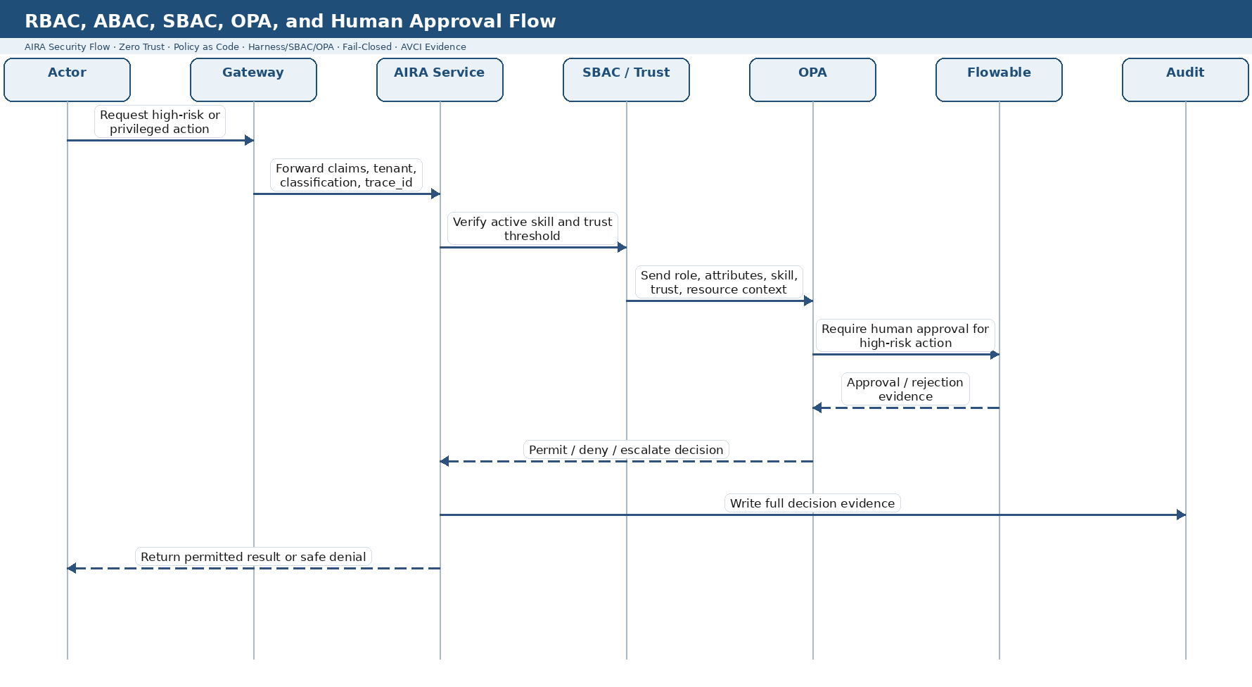
Figure 4. RBAC, ABAC, SBAC, OPA, and Human Approval Flow

Copy-ready Mermaid code
sequenceDiagram
autonumber
actor ACT as Actor
participant GW as Gateway
participant SVC as AIRA Service
participant SBAC as SBAC / Trust Score
participant OPA as OPA
participant BPM as Flowable Approval
participant AUD as Audit
ACT->>GW: Request high-risk or privileged action
GW->>SVC: Forward claims, tenant, classification, trace_id
SVC->>SBAC: Verify active skill and trust threshold
SBAC->>OPA: Send role, attributes, skill, trust, resource context
OPA->>BPM: Require human approval where risk demands it
BPM-->>OPA: Approval / rejection evidence
OPA-->>SVC: Permit / deny / escalate decision
SVC->>AUD: Write full decision evidence
SVC-->>ACT: Return permitted result or safe denial

SEC-SEQ-05 - AI Agent Tool Action Through Harness Flow
Purpose: Shows that Hermes or another agent may reason, but all tool execution is mediated by Guardrails, Harness, SBAC, OPA, and audit.
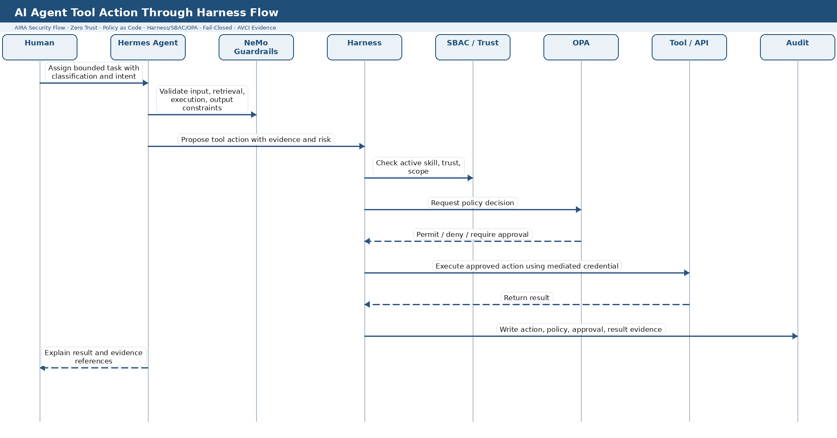
Figure 5. AI Agent Tool Action Through Harness Flow

Copy-ready Mermaid code
sequenceDiagram
autonumber
actor H as Human
participant AGT as Hermes Agent
participant GRD as NeMo Guardrails
participant HAR as Harness Control Plane
participant SBAC as SBAC / Trust
participant OPA as OPA
participant TOOL as Approved Tool / API
participant AUD as Audit
H->>AGT: Assign bounded task with classification and intent
AGT->>GRD: Validate input, retrieval, execution, output constraints
AGT->>HAR: Propose tool action with evidence and risk
HAR->>SBAC: Check active skill, trust, scope
HAR->>OPA: Request policy decision
OPA-->>HAR: Permit / deny / require approval
HAR->>TOOL: Execute approved action using mediated credential
TOOL-->>HAR: Return result
HAR->>AUD: Write action, policy, approval, result evidence
AGT-->>H: Explain result and evidence references

SEC-SEQ-06 - Classification-Aware Retrieval and Model Routing Flow
Purpose: Shows how data classification controls retrieval eligibility, guardrails, LiteLLM route selection, and final response evidence.
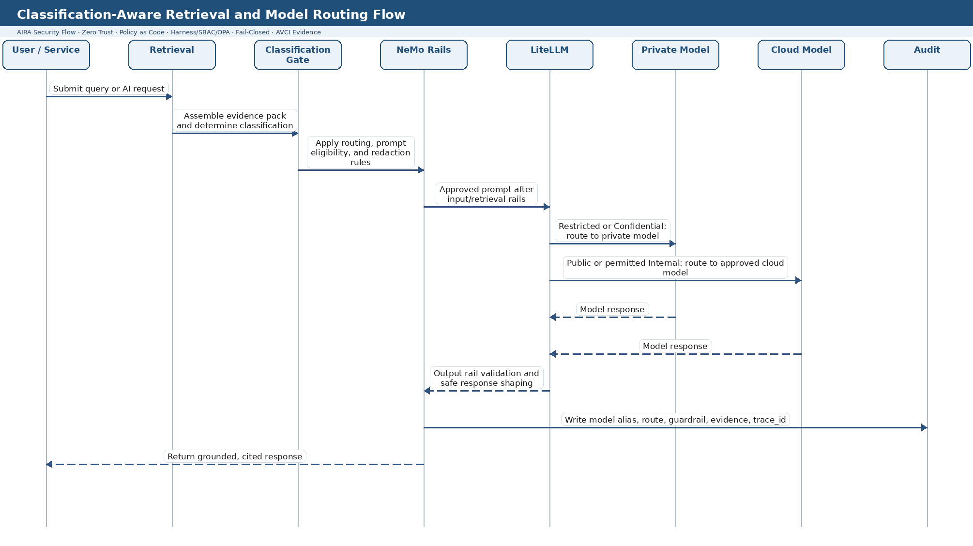
Figure 6. Classification-Aware Retrieval and Model Routing Flow

Copy-ready Mermaid code
sequenceDiagram
autonumber
actor U as User / Service
participant RET as Retrieval Service
participant CLS as Classification Gate
participant GRD as NeMo Guardrails
participant LLM as LiteLLM Gateway
participant PRIV as Private / On-Prem Model
participant CLOUD as Approved Cloud Model
participant AUD as Audit
U->>RET: Submit query or AI request
RET->>CLS: Assemble evidence pack and determine classification
CLS->>GRD: Apply routing, prompt eligibility, and redaction rules
GRD->>LLM: Approved prompt after input/retrieval rails
LLM->>PRIV: Restricted/Confidential route when required
LLM->>CLOUD: Public/Internal route when permitted
PRIV-->>LLM: Model response
CLOUD-->>LLM: Model response
LLM-->>GRD: Response for output rail validation
GRD->>AUD: Write model alias, route, guardrail, evidence, trace_id
GRD-->>U: Return grounded, cited response

SEC-SEQ-07 - Break-Glass Access Flow
Purpose: Shows controlled emergency access with dual approval, time-boxed privilege, audit capture, revocation, rotation, and post-use review.
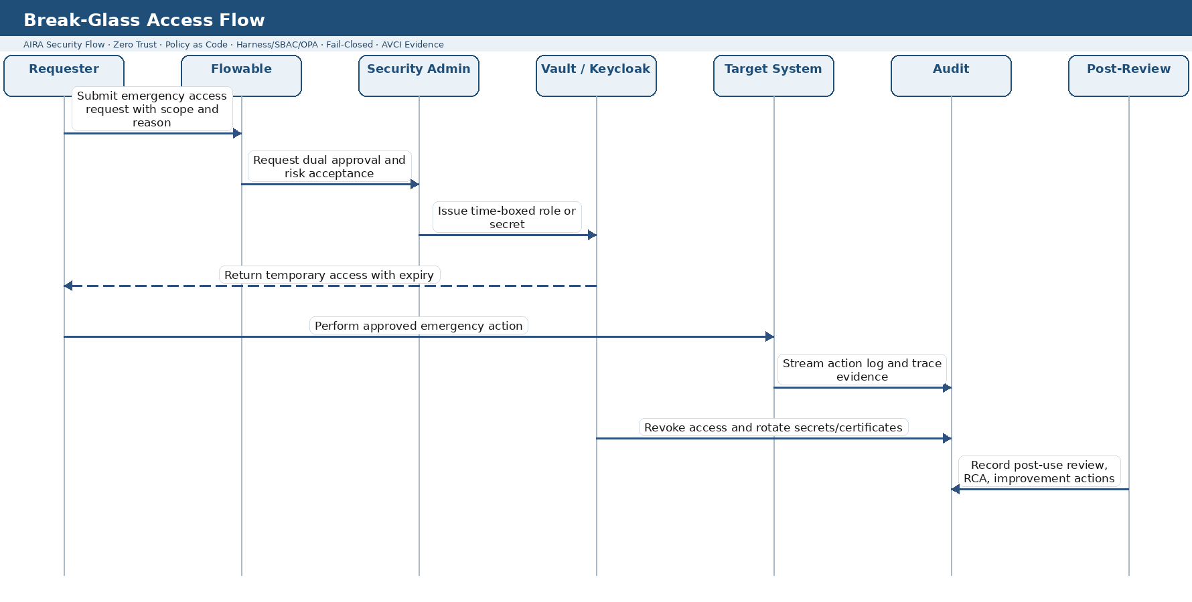
Figure 7. Break-Glass Access Flow

Copy-ready Mermaid code
sequenceDiagram
autonumber
actor REQ as Requester
participant BPM as Flowable Approval
participant SEC as Security Admin
participant IDSEC as Vault / Keycloak
participant SYS as Target System
participant AUD as Audit
participant PIR as Post-Use Review
REQ->>BPM: Submit emergency access request with scope and reason
BPM->>SEC: Request dual approval and risk acceptance
SEC->>IDSEC: Issue time-boxed role or secret
IDSEC-->>REQ: Return temporary access with expiry
REQ->>SYS: Perform approved emergency action
SYS->>AUD: Stream action log and trace evidence
IDSEC->>AUD: Revoke access and rotate secrets/certificates
PIR->>AUD: Record post-use review, RCA, improvement actions

SEC-SEQ-08 - Auto-Heal Security Remediation Flow
Purpose: Shows how a security signal becomes a governed remediation proposal, not an autonomous production change.
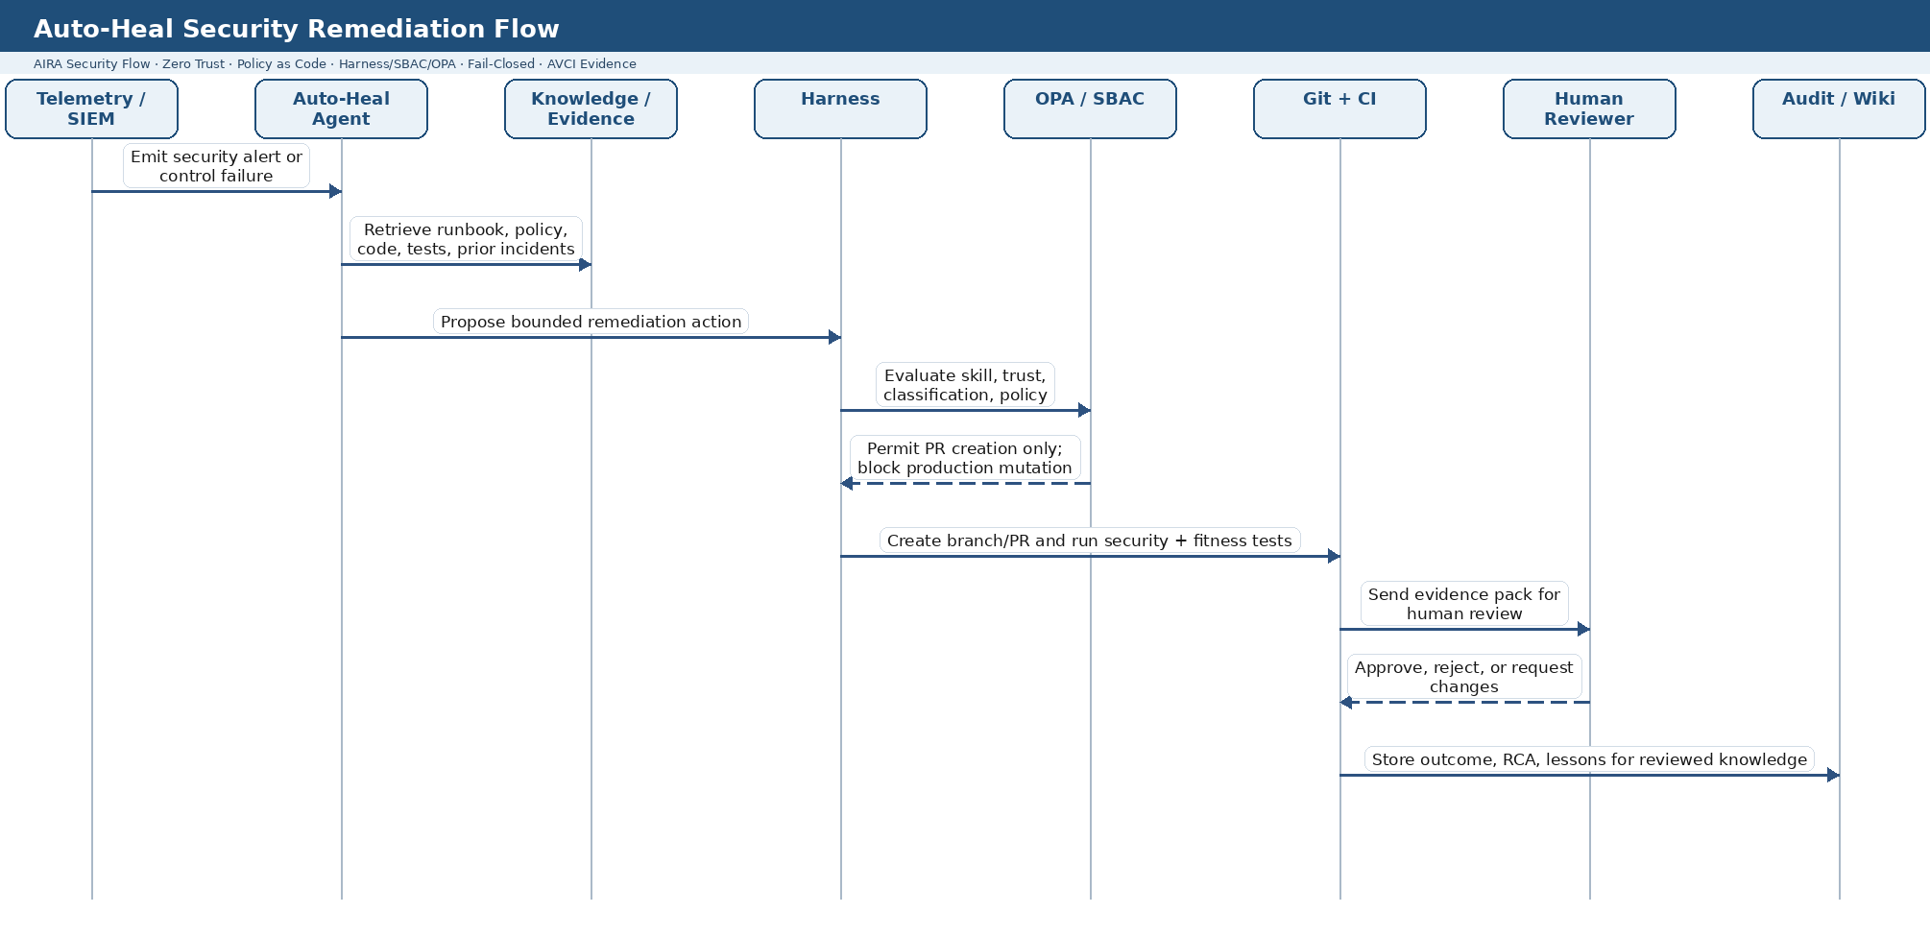
Figure 8. Auto-Heal Security Remediation Flow

Copy-ready Mermaid code
sequenceDiagram
autonumber
participant TEL as Telemetry / SIEM
participant AGT as Auto-Heal Agent
participant KNOW as Knowledge / Evidence
participant HAR as Harness
participant OPA as OPA / SBAC
participant GIT as Git + CI
participant HUM as Human Reviewer
participant AUD as Audit / LLM Wiki Candidate
TEL->>AGT: Emit security alert or control failure
AGT->>KNOW: Retrieve runbook, policy, code, tests, prior incidents
AGT->>HAR: Propose bounded remediation action
HAR->>OPA: Evaluate skill, trust, classification, policy
OPA-->>HAR: Permit PR creation only; block production mutation
HAR->>GIT: Create branch/PR and run security + fitness tests
GIT->>HUM: Send evidence pack for human review
HUM-->>GIT: Approve, reject, or request changes
GIT->>AUD: Store outcome, RCA, lessons for reviewed knowledge

