AIRA
AI-Native Enterprise Platform
Business Continuity, Disaster Recovery, Backup, and Restore Validation Standard
RTO/RPO Governance · Backup Discipline · Restore Proof · Failover/Failback · AVCI Evidence
Version 1.0 · April 2026 · CONFIDENTIAL - Internal Use Only

Mandatory Practice Statement
No AIRA service, data store, workflow, AI artifact, evidence repository, knowledge source, security platform, or operational tool may be considered production-ready unless its continuity tier, RTO, RPO, backup method, restore procedure, failover pattern, validation evidence, owner, and improvement path are defined, tested, and registered. A backup is not a control until it has been restored and verified.

Property | Value
Document ID | AIRA-DOC-035
Document Title | AIRA Business Continuity, Disaster Recovery, Backup, and Restore Validation Standard
Version | v1.0 - Initial Production Readiness Baseline
Classification | CONFIDENTIAL - Internal Use Only
Status | FOR ARCHITECTURE REVIEW BOARD / CAB APPROVAL
Owner | Solutions Architecture Office / IT Head
Co-Owners | Infrastructure Lead; DevSecOps Lead; Security Administrator; DBA; SRE / Operations Lead; Business Continuity Coordinator
Audience | Executive Sponsors, Solutions Architects, Software Development Leads, DevSecOps, SRE, System Administrator, Security Administrator, DBA, QA, Compliance, Internal Audit, Business Process Owners
Companion Documents | 01 AVCI; 02 Engineering Blueprint; 04 Technology Stack; 05 Information Nervous System; 11 DevSecOps; 16 Database Standard; 17 Security Standard; 24 Operations/Incident/Auto-Heal Runbook Pack; 26 Data Classification/Retention/Evidence Register; 30 Release/Change/CAB Standard; 31 Production Operations/SRE/Service Management Standard
Evidence Path | OpenKM Tier-0 / AIRA / Evidence / BCP-DR / v1.0 /
Review Cadence | Quarterly; unscheduled on material infrastructure, security, data-classification, recovery-tier, compliance, threat-landscape, production topology, or business-process change

Table of Contents
1. Executive Summary
2. Purpose, Scope, and Authority
3. BCP/DR Governance Principles
4. Criticality, RTO/RPO, and Service Tiering
5. Business Impact Analysis and Dependency Register
6. Backup Architecture and Control Requirements
7. Restore Validation Standard
8. Disaster Recovery Architecture and Patterns
9. Failover, Failback, and Controlled Recovery Procedures
10. Platform and Component Recovery Standards
11. Observability, SIEM/SOAR, APM, and ITSM Integration
12. Data Protection, Retention, and Evidence Governance
13. AI-Native Auto-Heal, Auto-Learn, and Auto-Improve Controls
14. DR Exercises, Audit Testing, and Metrics
15. RACI and Operating Responsibilities
16. Implementation Roadmap
17. Acceptance Criteria
Appendices

1. Executive Summary
AIRA is a mission-critical, AI-native enterprise platform. Its ability to operate safely is not proven only by successful deployment; it is proven by the ability to continue, recover, restore, reconcile, and explain the system after infrastructure failure, data corruption, cyber incident, configuration error, application defect, model-routing failure, human error, or business disruption.
This standard defines the mandatory Business Continuity, Disaster Recovery, Backup, and Restore Validation discipline for AIRA. It converts continuity from a general IT intention into an evidence-producing engineering control covering RTO/RPO ownership, backup design, restore tests, failover, failback, dependency mapping, immutable evidence, Zammad ticketing, Wazuh SIEM, TheHive/Cortex case handling, SigNoz/APM traces, and AVCI-aligned improvement.
Core Rule
AIRA does not accept “backup completed” as sufficient evidence. The required proof is “restore completed, integrity verified, application validated, business owner accepted, evidence retained, and improvement actions tracked.”

Strategic Outcome | Required Result
Business continuity readiness | Critical business processes have defined continuity tiers, alternate procedures, recovery owners, and communication paths.
Recoverability by design | Services, databases, documents, knowledge stores, AI registries, observability data, tickets, and security evidence have tested restore patterns.
Audit defensibility | Every recovery control produces evidence: backup job, restore job, integrity check, security check, business validation, approver, timestamp, and remediation record.
Controlled AI-native operations | Auto-Heal may assist in diagnosis and safe non-production remediation, but continuity and recovery decisions remain human-approved and policy-gated.
Reduced recovery uncertainty | Dependency maps, runbooks, automation scripts, and rehearsal results are maintained as governed AIRA artifacts.

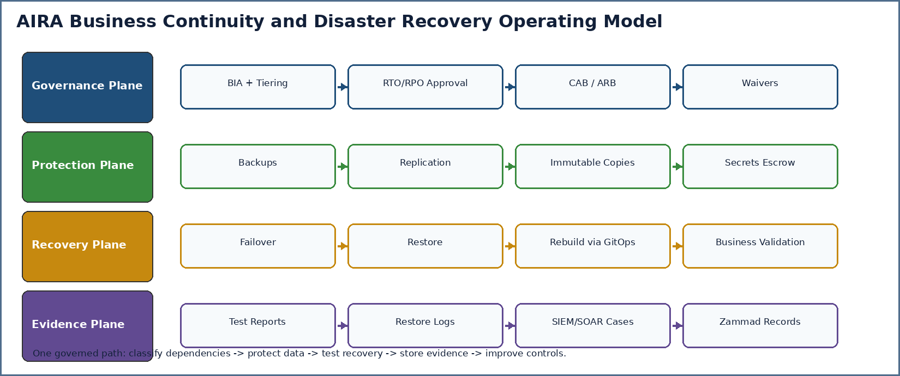
Figure 1. AIRA BCP/DR operating model across governance, protection, recovery, and evidence planes.

1.1 What This Standard Establishes
- AIRA continuity-tier model with mandatory RTO/RPO ownership and approval.
- Backup, retention, immutability, encryption, access, monitoring, and chain-of-custody requirements.
- Restore validation procedure for databases, document stores, Kubernetes workloads, GitOps state, secrets, AI registries, observability, ITSM, and security platforms.
- Failover and failback governance with go/no-go gates, rollback path, stakeholder communication, and post-recovery review.
- Evidence templates for backup jobs, restore tests, DR drills, BIA records, dependency maps, and recovery exceptions.
- Controls for Wazuh, TheHive, Cortex, SigNoz, Zammad, OpenTelemetry, Prometheus, Loki, Tempo, Grafana, and AIRA audit evidence.
- AVCI-aligned improvement loop so every failed test, drill gap, or incident finding updates the runbook, architecture, backlog, or ADR/TDL.

1.2 What This Standard Is Not
- It is not a generic corporate BCP policy. It is the AIRA engineering and operational recovery standard.
- It is not a substitute for business-owner continuity procedures. It defines the technology recovery control baseline that business continuity depends on.
- It is not an authorization to perform production failover without approval. Emergency actions remain governed by CAB, incident command, and security policy.
- It is not limited to infrastructure backups. It covers documents, data, metadata, prompts, model aliases, guardrails, evidence, tickets, observability, and security cases.

2. Purpose, Scope, and Authority

2.1 Purpose
The purpose of this standard is to ensure that AIRA can sustain or restore mission-critical operations within approved business tolerances and prove that capability through tested evidence. The standard establishes minimum requirements for business impact analysis, dependency registration, backup configuration, restore validation, DR drill execution, failover/failback governance, evidence retention, and continuous improvement.

2.2 In Scope
- AIRA application services, APIs, MicroFunction runtime, workflows, schedulers, workers, and integration services.
- Infrastructure and platform layers: Linux, Proxmox, Kubernetes, container registry, GitOps, network/service mesh, ingress, and storage.
- Data platforms: PostgreSQL/Patroni, pgvector, PgBouncer, OpenKM, object storage, Redis/Valkey, Kafka, Temporal, Flowable, Keycloak, Vault/OpenBao, and related metadata stores.
- AI-native artifacts: prompt templates, guardrails, model aliases, evaluation datasets, embeddings, retrieval indexes, LightRAG graphs, LLM Wiki, Obsidian canonical notes, AI evidence, and model-routing configuration.
- Operational platforms: Zammad, Wazuh, TheHive, Cortex, SigNoz, Prometheus, Thanos, Loki, Tempo, Grafana Alloy, Grafana, Sentry, OpenTelemetry collectors, and alerting rules.
- Recovery evidence, DR exercises, BIA records, dependency maps, recovery exceptions, waivers, and post-incident/post-drill improvement records.

2.3 Out of Scope
- Corporate-wide crisis management unrelated to AIRA platform recovery.
- Physical building, safety, and facilities continuity, except where these affect AIRA infrastructure availability.
- Business-user manual workarounds in detail; these are owned by business process continuity plans and referenced by this standard.
- Vendor contractual SLA negotiation, except where SLA terms affect AIRA recovery assumptions and must be recorded.

2.4 Authority and Conflict Rule
Authority Level | Source / Control | BCP/DR Effect
L0 | Executive Risk Decision / Legal / Regulatory Hold | Controls mandatory retention, legal hold, recovery priority, and risk acceptance.
L1 | AIRA Engineering Blueprint and Architecture Board | Controls service boundaries, DR topology, dependency architecture, and deployment/recovery patterns.
L1 | AIRA Security Standard and Data Classification Register | Controls access, secrets, encryption, evidence protection, retention, and classification-aware restore handling.
L2 | This Standard | Controls continuity tiering, backup, restore validation, DR drills, and recovery evidence.
L3 | Runbooks, tickets, ADRs/TDLs, platform procedures | Implement this standard for specific systems, environments, and recovery scenarios.

Conflict Rule
When recovery speed conflicts with security, legal hold, data integrity, or AVCI evidence, the issue must be escalated to incident command, Security, Compliance, and CAB. AIRA must fail safe, not fail open.

3. BCP/DR Governance Principles
ID | Principle | Operational Meaning
BCP-01 | Continuity is business-owned and technology-enabled | Business process owners define criticality and acceptable downtime; IT designs and proves recovery capability.
BCP-02 | RTO/RPO must be explicit | Every critical service, data store, evidence repository, and operational tool has an approved RTO and RPO.
BCP-03 | Restore is the control, backup is the input | A backup is incomplete until restored, integrity-checked, security-checked, and accepted.
BCP-04 | No untested recovery path | Runbooks, scripts, replicas, snapshots, and backups require scheduled exercise evidence.
BCP-05 | GitOps rebuild over manual reconstruction | Runtime state is rebuilt from approved source where possible; manual reconstruction is a controlled exception.
BCP-06 | Data integrity before availability | AIRA must not restore corrupted, stale, unauthorized, or misclassified data simply to meet uptime pressure.
BCP-07 | Classified recovery handling | Confidential and Restricted artifacts require controlled access, redaction, audit, and approved restore targets.
BCP-08 | Immutable recovery evidence | DR drill logs, restore reports, approvals, and exceptions are retained under the evidence register.
BCP-09 | No shadow backup path | Unmanaged exports, personal copies, desktop archives, screenshots, and private cloud folders are prohibited as recovery sources.
BCP-10 | AVCI always | Every continuity artifact must be attributable, verifiable, classifiable, and improvable.

4. Criticality, RTO/RPO, and Service Tiering
Continuity requirements must be agreed with business owners, Security, Compliance, Operations, and Architecture. The values below are planning baselines. Actual targets must be approved per business process, environment, and production release.
Tier | Typical Scope | Planning RTO | Planning RPO | Mandatory Controls
Tier 0 - Mission Critical | Core transaction processing, identity, secrets, PostgreSQL system of record, OpenKM core records, workflow history, audit evidence. | <= 2 hours or approved business target | <= 15 minutes or approved business target | HA design, PITR/WAL or equivalent, tested failover, encrypted immutable backup, quarterly restore test, annual full DR exercise.
Tier 1 - High Criticality | Gateway, workflow services, Kafka integration, Zammad, Wazuh/TheHive, CI/CD release evidence, model-routing registry. | <= 4 hours | <= 1 hour | Automated backup, documented rebuild path, restore test at least semi-annual, failover or rebuild runbook.
Tier 2 - Important | Reporting, non-critical admin services, curated knowledge projections, dashboards, non-production support services. | <= 1 business day | <= 4 hours | Scheduled backup or GitOps rebuild, annual restore test, documented owner.
Tier 3 - Rebuildable / Derivative | Redis/Valkey cache, derived indexes, pgvector ANN index, LightRAG graph projections, temporary runtime state. | Rebuild within agreed window | Source-derived; no independent RPO | Must be rebuildable from Tier-0 source; cache loss must not affect correctness.

RTO/RPO Approval Rule
No production go-live is allowed if Tier 0 or Tier 1 services lack approved RTO/RPO targets, tested restore evidence, assigned recovery owners, and documented fallback or manual business-continuity procedure.

5. Business Impact Analysis and Dependency Register
Every production release must maintain a Business Impact Analysis (BIA) and dependency register. The BIA identifies business processes, supporting services, dependency chains, data stores, recovery tiers, recovery owners, manual workaround feasibility, and evidence paths.
BIA Field | Required Description | Owner
business_process_id | Unique business process identifier, linked to process catalog and MVP backlog item. | Business Process Owner
service_dependency | Application service, workflow, database, integration, AI component, ticketing, or security dependency. | Solutions Architect / SRE
criticality_tier | Tier 0 to Tier 3 recovery category. | Business Owner + IT Head
rto / rpo | Approved recovery targets and measurement method. | Business Owner + Operations
manual_workaround | Whether manual operations can temporarily continue and under what restrictions. | Business SME
data_classification | Highest classification handled by the process or dependency. | Data Governance / Security
recovery_owner | Named role accountable for recovery coordination. | IT Head / Operations Lead
validation_owner | Named business or technical reviewer who confirms restored service correctness. | Business Owner / QA
evidence_path | OpenKM/Zammad/TheHive/Git evidence reference location. | Evidence Owner

Dependency Type | Examples | Continuity Requirement
Identity and Access | Keycloak, AD, MFA, service accounts, SPIFFE/SVID. | Recovery must not bypass MFA, RBAC/SBAC, OPA, mTLS, or audit.
Secrets and Certificates | Vault/OpenBao, PKI, dynamic database credentials, service certificates. | Recovery keys and unseal/recovery procedures must be escrowed and tested by authorized custodians.
Data and Documents | PostgreSQL, OpenKM, object storage, pgvector lineage. | Restore must preserve lineage, classification, ACLs, hashes, and audit references.
Workflow and Eventing | Temporal, Flowable, Kafka, outbox/DLQ. | Recovery must prove workflow state, task state, event ordering strategy, and duplicate safety.
AI and Knowledge | LiteLLM, NeMo Guardrails, prompts, model aliases, LLM Wiki, LightRAG, Obsidian. | Restore must enforce classification-aware routing and prevent stale or unapproved knowledge from becoming authoritative.
Operations and Evidence | Zammad, Wazuh, TheHive, Cortex, SigNoz, Grafana, Loki, Tempo. | Recovery must preserve incident records, traceability, alerts, cases, and audit evidence.

6. Backup Architecture and Control Requirements
AIRA backup architecture must protect three classes of assets: authoritative state, operational evidence, and rebuild sources. Derivative assets such as cache entries and indexes may be rebuilt from authoritative sources, but the rebuild process and triggers must be tested.
Control Area | Mandatory Requirement
Backup ownership | Every backup job has owner, scope, schedule, retention, classification, encryption method, restore target, and evidence path.
Encryption | Backups must be encrypted in transit and at rest. Key management must use Vault/OpenBao or approved enterprise key management.
Access control | Backup repositories use least privilege, separation of duties, MFA, and monitored administrative access.
Immutability | Tier 0 and Tier 1 backup sets require immutable or write-once protection where technically feasible.
Air-gap / isolation | At least one recovery copy for critical data must be isolated from normal production credentials and ransomware blast radius.
Integrity | Backup jobs must record checksum, manifest, source version, backup ID, timestamp, and completion status.
Restore rehearsal | Backups must be restored to an isolated target on a defined cadence and after major changes.
Classification handling | Backup media and restore targets inherit the highest classification of the protected data.
Legal hold | Legal hold suspends purge and must be checked before backup deletion or evidence disposal.
Monitoring | Backup failures must generate alert, Zammad ticket, severity classification, owner assignment, and closure evidence.

Backup Type | Use Case | AIRA Position
Snapshot | Rapid recovery from short-term operational issues. | Useful but not sufficient alone. Snapshots must not replace independent backups.
Full backup | Baseline recovery point. | Required for Tier 0/Tier 1 systems on approved cadence.
Incremental / differential | Efficient recovery between full backups. | Allowed when restore sequence is tested and documented.
Continuous archive / WAL / PITR | Database point-in-time recovery. | Required for Tier 0 PostgreSQL where business RPO requires it.
GitOps source rebuild | Recreate desired platform state. | Preferred for Kubernetes manifests, policies, prompts, guardrails, and configuration.
Export / logical backup | Schema/config portability and audit review. | Allowed as supplemental backup, not the only recovery path for critical systems.

7. Restore Validation Standard
Restore validation is the core control. Restore validation must prove that data can be recovered, applications can read and write safely, security policies remain intact, evidence is retained, and business users can confirm process correctness.
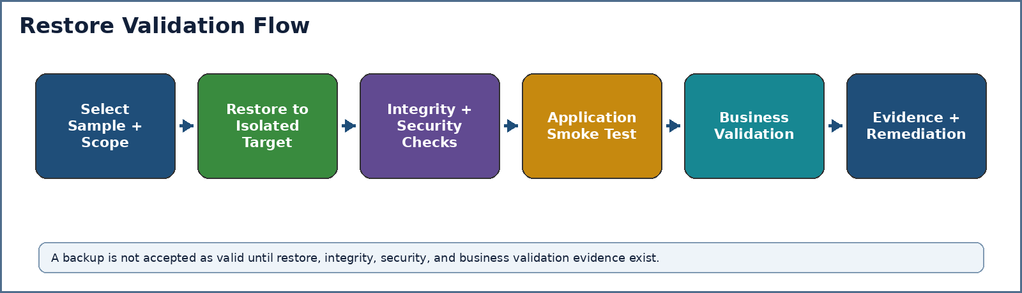
Figure 2. Restore validation flow.
Validation Stage | Required Test | Evidence Required
Scope selection | Select backup set, system, environment, data class, and recovery objective. | Restore test plan, owner, backup ID, system scope.
Isolated restore | Restore to isolated non-production or DR target without weakening access controls. | Restore job log, target environment ID, access approvals.
Integrity check | Verify checksum, counts, schema version, object/document hashes, and metadata consistency. | Integrity report, variance log, DBA/SRE sign-off.
Security check | Confirm ACLs, RLS, secrets references, encryption, classification, and audit logging. | Security validation checklist, policy test output.
Application check | Run smoke tests, API health checks, representative workflows, and error-path checks. | Test report, traces, logs, CI/manual validation evidence.
Business validation | Business owner validates sample transactions, documents, reports, or workflow states. | Business sign-off, exceptions, accepted limitations.
Evidence closure | Store evidence and open remediation tickets for gaps. | OpenKM path, Zammad ticket, ADR/TDL or backlog refs.

Restore Evidence Rule
Restore test evidence must include backup ID, restore target, actor, approver, timestamps, command/job references, integrity result, security result, application result, business result, exceptions, and improvement actions.

8. Disaster Recovery Architecture and Patterns
AIRA DR architecture must be designed around recoverable authority, not uncontrolled replication. The system should favour deterministic rebuild from GitOps and source-of-truth data restore, while using replication and HA only where business RTO/RPO requires it.
Pattern | Use When | AIRA Governance Rule
High Availability | Short outages are unacceptable and active node failure must be absorbed quickly. | HA does not replace backup. Failover must be monitored and tested.
Warm standby | Tier 0/Tier 1 systems need faster recovery than rebuild-only allows. | Standby must be patched, tested, secured, and evidence-producing.
Cold standby / rebuild | Tier 2 systems can tolerate longer recovery. | Runbooks and source artifacts must be sufficient to rebuild within RTO.
Point-in-time restore | Database corruption or bad release requires recovery to a known-good point. | Requires WAL/archive evidence, restoration rehearsal, and business reconciliation.
Blue/green or canary rollback | Application release defects can be isolated without data rollback. | Use only when database compatibility and forward-fix strategy are confirmed.
Manual business continuity | Temporary business processing can continue outside system during outage. | Manual workarounds must be reconciled into AIRA with audit evidence after recovery.

9. Failover, Failback, and Controlled Recovery Procedures
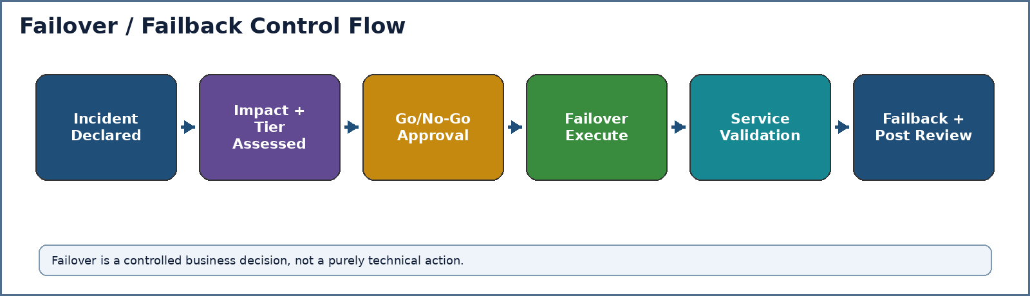
Figure 3. Failover and failback control flow.
Phase | Required Activities | Decision Owner
Detect and declare | Alert triage, incident classification, affected services, business impact, security suspicion, evidence preservation. | Incident Commander / Operations Lead
Assess recovery option | Choose restart, rollback, restore, failover, degraded operation, manual workaround, or security containment. | Solutions Architect + SRE + Security
Authorize | Obtain go/no-go approval based on severity, data risk, customer impact, and regulatory implications. | IT Head / CAB / Executive as needed
Execute failover or restore | Follow runbook, record commands/jobs, preserve evidence, avoid uncontrolled manual mutation. | Recovery Owner
Validate service | Run technical, security, and business validation; confirm RTO/RPO outcome. | QA / SRE / Business Owner
Failback | Plan return to primary site or steady state; reconcile data; confirm no split-brain or duplicate effects. | Operations Lead + DBA + Business Owner
Post-review | Document lessons learned, update runbooks, create backlog items, capture audit evidence. | Incident Commander + Internal Audit

Failback Rule
Failback is a separate controlled change. Do not automatically fail back simply because the primary environment is available. Confirm data integrity, traffic routing, workflow state, event lag, secrets validity, and business owner approval first.

10. Platform and Component Recovery Standards
The following component standards define minimum recovery expectations. Specific tools may be finalized through ADR/TDL, but the control outcome is mandatory.
Component | Recovery Requirement | Validation Evidence
Proxmox / VM estate | Use approved backup platform, VM inventory, host configuration backup, cluster configuration evidence, and isolated restore test. Snapshots are not sufficient alone. | VM restore log, boot test, network validation, security hardening check.
Kubernetes | Desired state rebuilt from GitOps. Protect cluster bootstrap config, secrets references, ingress, network policies, CRDs, and persistent volumes where needed. | Cluster rebuild or namespace restore evidence, Argo CD sync status, admission policy result.
Git / repository platform | Repository, branch protections, CODEOWNERS, tags, release evidence, and protected configuration must be backed up/exported or mirrored. | Repository restore/mirror test, branch protection verification.
Container/Artifact registry | Images, Helm charts, SBOMs, signatures, provenance, and retention rules must be protected. | Digest verification, image pull test, signature verification.
PostgreSQL / Patroni | Base backup plus WAL/PITR for critical databases. Restore must test schema version, counts, RLS, extensions, and application read/write. | PITR report, integrity report, application smoke test, DBA sign-off.
OpenKM / document store | Protect document binaries, metadata, versions, ACLs, indexes, and repository configuration. | Document hash validation, metadata validation, access test, sample retrieval.
Object storage | Protect bucket policies, objects, lifecycle rules, versioning, and immutability settings. | Object manifest, sample object restore, policy check.
Redis / Valkey | Treat as ephemeral unless explicitly approved otherwise. Recovery focuses on restart and rebuild from authoritative sources. | Cache rebuild test, correctness preserved after cache flush.
Kafka | Protect topic definitions, ACLs, schemas, connectors, offsets where appropriate, and DLQ retention. Do not use Kafka as the only workflow state. | Topic/schema restore, consumer replay test, duplicate safety test.
Temporal | Protect workflow histories and visibility store according to recovery tier. Validate workflow replay and compensation handling. | Workflow query/replay test, sample compensation validation.
Flowable | Protect BPMN/DMN definitions, runtime tasks, approvals, and history tables. | Task state restore, approval history check, DMN version validation.
Vault / OpenBao | Protect encrypted storage backend, recovery keys, policies, PKI, audit devices, and unseal/recovery procedure. | Recovery-key ceremony evidence, policy validation, test secret lease.
Keycloak / AD integration | Protect realms, clients, groups, role mappings, service accounts, and configuration exports. | Login test, token claim validation, group/role mapping check.
LiteLLM / AI registry | Protect model aliases, budgets, routing policies, virtual key metadata, evaluation status, and audit records. | Route policy restore, prohibited route test, usage audit check.
NeMo Guardrails | Protect rail definitions, prompt policies, test suites, and versioned approvals. | Guardrail regression test, fail-closed validation.
LLM Wiki / Obsidian / LightRAG / pgvector derivatives | Restore or rebuild from Tier-0 sources with lineage, source hash, classification, and freshness validation. | Re-index job evidence, retrieval quality sample, stale content exclusion test.
Zammad | Protect tickets, attachments, workflows, queues, SLA definitions, users, and audit trails. | Ticket restore, attachment check, SLA/workflow test.
Wazuh / TheHive / Cortex | Protect SIEM rules, agents, cases, observables, analyzer configuration, and incident evidence. | Case restore, alert ingestion test, analyzer test.
SigNoz / OTel / Prometheus / Loki / Tempo / Grafana | Protect observability configuration, dashboards, alert rules, long-term metrics, traces/logs required for evidence. | Dashboard restore, alert test, trace/log query sample.

11. Observability, SIEM/SOAR, APM, and ITSM Integration
BCP/DR controls are operationally useful only when failures are detected, triaged, ticketed, investigated, and improved. AIRA therefore integrates monitoring, SIEM/SOAR, APM, tracing, and ticketing into the continuity evidence loop.
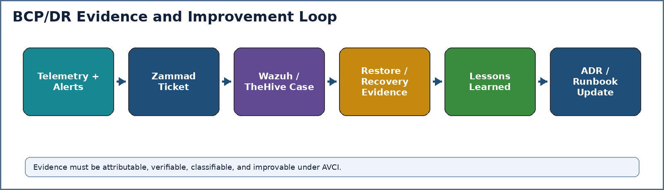
Figure 4. BCP/DR evidence and improvement loop.
Platform | BCP/DR Role | Required Evidence
Zammad | System of record for backup failures, restore tests, DR drill tasks, incident coordination, approvals, and remediation tickets. | Ticket ID, priority, SLA, owner, timeline, approval, closure note, evidence links.
Wazuh | Detect security events, backup tampering indicators, agent health, host compromise, policy violations, and suspicious recovery activity. | Alert ID, rule, agent, timestamp, severity, linked incident/case.
TheHive | Case management for cyber incidents that may trigger continuity, containment, restore, or forensic recovery. | Case ID, observables, tasks, decisions, chain-of-custody.
Cortex | Analyzer and responder support for enrichment and safe response actions. | Analyzer result, responder action, approval and scope.
SigNoz / APM | Application performance, traces, errors, and service dependency visibility during outage and recovery. | Trace IDs, error rates, latency before/after recovery, service map.
OpenTelemetry | Correlation layer for logs, metrics, traces, audit, and recovery evidence. | trace_id, service.name, environment, release, span evidence.
Prometheus / Thanos / Grafana | Metrics, alerting, long-term SLO trends, dashboards, and DR drill observation. | Alert firing/resolution, SLO burn rate, dashboard snapshot.
Loki / Tempo / Sentry | Log, trace, and error evidence for root-cause analysis and recovery validation. | Query links, trace samples, error event IDs.

12. Data Protection, Retention, and Evidence Governance
Evidence Artifact | Required Retention Logic | Handling Rule
Backup job evidence | Retain according to release/evidence class and audit requirement; minimum quarterly review. | Store in OpenKM evidence path with backup ID and classification.
Restore test evidence | Retain for audit period and until superseded by newer successful tests. | Include integrity, security, technical, and business validation results.
DR exercise evidence | Retain with annual audit and management review records. | Include participants, scenario, decisions, timing, gaps, and action plan.
Incident recovery evidence | Inherit incident/security retention; legal hold may extend retention. | Link Zammad, TheHive, Wazuh, traces, logs, and approvals.
Backup media metadata | Retain while backup set exists plus required evidence period. | Include classification, encryption status, location, custody, and purge record.
Disposal evidence | Retain according to evidence register and legal-hold state. | Disposal must be approved, logged, and derivative invalidation recorded.

Classification and Backup Rule
Backups inherit the highest classification of the source data. Restricted production data must not be restored into lower-classified environments unless explicitly masked, approved, and evidenced.

13. AI-Native Auto-Heal, Auto-Learn, and Auto-Improve Controls
AIRA may use AI-assisted analysis to accelerate continuity operations, but AI must not become an uncontrolled recovery actor. The same SOLID enforcement, security, evidence, reversibility, and human-in-the-loop principles apply during DR as during normal development.
Capability | Allowed Use | Prohibited Use
Auto-Heal | Detect likely cause, collect evidence, propose runbook step, open Zammad ticket, draft remediation PR, run non-production checks. | Autonomous production failover, database restore, backup purge, secret rotation, or policy override without approval.
Auto-Learn | Convert validated recovery lessons into candidate runbook updates, guardrail tests, knowledge entries, and training material. | Promote unreviewed incident content or Restricted data into LLM Wiki or prompt examples.
Auto-Improve | Recommend improved backup schedules, monitoring rules, tests, RTO/RPO adjustments, or architecture changes through ADR/TDL. | Self-modify recovery automation, weaken controls, bypass CAB, or reduce evidence retention.
AutoResearch | Compare recovery patterns, vendor advisories, security alerts, and technology options under controlled research workflow. | Use unverified external advice directly in production recovery.

SOLID / Enterprise Design Principle Rule
Auto-Heal, Auto-Learn, and Auto-Improve must preserve or improve SOLID compliance, architecture boundaries, testability, security posture, observability, reversibility, rollbackability, and AVCI evidence. Any candidate that weakens these must be rejected or escalated as a waiver.

14. DR Exercises, Audit Testing, and Metrics
Exercise Type | Minimum Cadence | Scope | Evidence
Backup job review | Weekly for Tier 0/Tier 1; monthly for others | Verify successful jobs, failures, capacity, retention, immutability, alerts. | Zammad review ticket, backup dashboard, exception list.
Sample restore test | Monthly or quarterly depending on tier | Restore selected backup to isolated target and validate. | Restore report, integrity/security/business validation.
Tabletop exercise | Semi-annual | Walk through outage, cyber incident, data corruption, and supplier failure scenarios. | Scenario, decisions, participants, gaps, action plan.
Technical DR drill | Annual minimum for Tier 0/Tier 1 | Failover/failback or rebuild of critical path components. | Timing results, RTO/RPO result, recovery evidence.
Cyber recovery drill | Annual or after major threat change | Ransomware, credential compromise, backup tampering, SIEM/SOAR coordination. | TheHive case, Wazuh alerts, containment and restore evidence.
Post-release recovery check | After major release or architecture change | Confirm backups, rollback/forward-fix, schema compatibility, runbooks. | Release evidence pack and CAB closure.

Metric | Definition | Target / Review Rule
Backup success rate | Successful backups divided by scheduled backups by tier. | Tier 0/Tier 1 failures generate immediate ticket and management visibility.
Restore success rate | Successful restore validations divided by planned restore tests. | Failures create remediation ticket and retest requirement.
Actual RTO | Elapsed time from incident declaration or restore start to validated service readiness. | Compare to approved RTO; variance requires root-cause review.
Actual RPO | Maximum accepted data loss or replay gap after recovery. | Compare to approved RPO; variance requires business and data-governance approval.
Evidence completeness | Percentage of recovery events with complete AVCI evidence fields. | Must improve quarter over quarter; gaps are audit findings.
Runbook freshness | Number of runbooks reviewed within cadence. | Expired runbooks block production readiness for the affected component.

15. RACI and Operating Responsibilities
Activity | IT Head / SA | BCP Coord. | SRE / Ops | DBA | Security | DevSecOps | Business Owner | Internal Audit
Approve BCP/DR standard | A | R | C | C | C | C | C | C
Define business criticality | C | R | C | C | C | I | A/R | C
Approve RTO/RPO | A | R | C | C | C | C | A/R | C
Design backup architecture | A | C | R | R | C | R | C | I
Operate backup jobs | I | I | A/R | R | C | R | I | I
Perform restore test | I | C | R | R | C | C | C | I
Validate business recovery | I | C | C | C | C | I | A/R | I
Manage cyber recovery case | C | C | C | C | A/R | C | I | C
Maintain recovery evidence | A | R | R | R | R | R | C | C
Audit control effectiveness | I | C | C | C | C | C | C | A/R

R = Responsible, A = Accountable, C = Consulted, I = Informed.

16. Implementation Roadmap
Phase | Activities | Exit Criteria
Phase 1 - Baseline and Ownership | Approve standard, assign BCP/DR owners, identify Tier 0/Tier 1 services, create evidence folders and Zammad categories. | Approved standard, owner register, initial criticality tier list.
Phase 2 - BIA and Dependency Mapping | Complete BIA, dependency register, RTO/RPO approval, manual workaround mapping. | Signed BIA and dependency register for MVP scope.
Phase 3 - Backup Implementation | Configure backup jobs, encryption, retention, monitoring, immutable copies, access controls. | Successful backup evidence and alerting in place.
Phase 4 - Restore Validation | Perform initial restore tests for PostgreSQL, OpenKM, Git/registry, Vault, Keycloak, Zammad, Wazuh/TheHive, and observability. | Restore evidence accepted; gaps converted into remediation tickets.
Phase 5 - DR Drill | Run tabletop and technical DR drill covering primary failure scenario and cyber recovery scenario. | DR drill report, RTO/RPO measurements, action plan.
Phase 6 - Continuous Improvement | Quarterly review of metrics, runbooks, drill findings, architecture gaps, and risk waivers. | Updated runbooks, ADR/TDL, backlog, and evidence register.

17. Acceptance Criteria
- All Tier 0 and Tier 1 services have approved RTO/RPO, recovery owner, validation owner, backup method, restore method, and evidence path.
- Initial BIA and dependency register exist for MVP and foundation services.
- PostgreSQL recovery strategy includes tested backup, WAL/PITR or approved equivalent, and DBA sign-off.
- OpenKM document recovery is tested for binary, metadata, version, ACL, and hash integrity.
- Vault/OpenBao, Keycloak, Git, container registry, Zammad, Wazuh/TheHive/Cortex, and SigNoz/observability recovery procedures are documented and tested at least once before production go-live.
- Kubernetes/GitOps rebuild path is tested for at least one representative service and one environment.
- DR alerts create Zammad tickets and security-relevant incidents can be linked to Wazuh/TheHive/Cortex evidence.
- Backup and restore evidence is stored in the approved OpenKM evidence path with AVCI metadata.
- A tabletop exercise and initial technical restore drill are completed before production acceptance.
- All gaps have Zammad tickets, owners, severity, target dates, and management visibility.

Appendix A. Backup and Restore Register Template
backup_restore_register:
system_id: ""
system_name: ""
business_process_ids: []
criticality_tier: "Tier-0 | Tier-1 | Tier-2 | Tier-3"
owner: ""
recovery_owner: ""
validation_owner: ""
classification: "Public | Internal | Confidential | Restricted"
rto_target: ""
rpo_target: ""
backup_method: "snapshot | full | incremental | wal_pitr | gitops_rebuild | export | other"
backup_schedule: ""
retention_rule_id: ""
encryption_method: ""
immutable_copy: "yes | no | exception"
offsite_or_isolated_copy: "yes | no | exception"
restore_runbook_ref: ""
last_backup_status: "success | failed | warning | not_configured"
last_restore_test_date: "YYYY-MM-DD"
last_restore_result: "pass | conditional | fail"
evidence_path: "OpenKM Tier-0 / AIRA / Evidence / BCP-DR / ..."
open_risks: []
next_review_due: "YYYY-MM-DD"

Appendix B. Restore Test Evidence Template
restore_test_evidence:
evidence_id: "RTE-2026-000001"
test_date: "YYYY-MM-DD"
system_id: ""
backup_id: ""
source_environment: "PROD | UAT | STG | DEV"
restore_target: "isolated-target-id"
requested_by: ""
approved_by: ""
executed_by: ""
backup_timestamp: "YYYY-MM-DDTHH:MM:SSZ"
restore_start: "YYYY-MM-DDTHH:MM:SSZ"
restore_end: "YYYY-MM-DDTHH:MM:SSZ"
integrity_checks:
checksum_result: "pass | fail"
row_count_result: "pass | fail | not_applicable"
object_hash_result: "pass | fail | not_applicable"
security_checks:
acl_result: "pass | fail"
rls_result: "pass | fail | not_applicable"
secret_exposure_check: "pass | fail"
application_checks:
smoke_test_result: "pass | fail"
api_test_result: "pass | fail | not_applicable"
workflow_test_result: "pass | fail | not_applicable"
business_validation:
validator: ""
result: "accepted | accepted_with_exception | rejected"
comments: ""
rto_result: ""
rpo_result: ""
exceptions: []
linked_zammad_ticket: ""
evidence_storage_path: ""

Appendix C. DR Drill Scenario Template
Field | Description
Scenario ID | Unique DR drill identifier.
Scenario Type | Infrastructure failure, database corruption, ransomware, identity outage, network failure, release defect, supplier failure.
Business Process Affected | Process IDs and business owners involved.
Systems In Scope | Services, data stores, security tools, observability tools, integrations.
Success Criteria | RTO/RPO achievement, service validation, business validation, security preservation, evidence completeness.
Exercise Team | Incident commander, recovery owners, DBAs, security, business validators, observers.
Timeline | Start time, declaration time, recovery start, validation completion, closeout.
Findings | Gaps, defects, unclear steps, missing access, failed restore, excessive time, missing evidence.
Action Plan | Owner, target date, severity, linked ticket, verification method.

Appendix D. Copy-Ready Mermaid References

D.1 Restore Validation Flow
flowchart LR
A[Select Backup Scope] --> B[Restore to Isolated Target]
B --> C[Integrity Check]
C --> D[Security and ACL Check]
D --> E[Application Smoke Test]
E --> F[Business Validation]
F --> G[Evidence Storage and Remediation]

D.2 Failover and Failback Flow
flowchart LR
A[Incident Declared] --> B[Assess Tier and Impact]
B --> C[Go / No-Go Approval]
C --> D[Execute Failover or Restore]
D --> E[Technical and Business Validation]
E --> F[Controlled Failback]
F --> G[Post Review and Improvement]

D.3 BCP/DR Evidence Loop
flowchart TD
A[Alert / Incident / Drill] --> B[Zammad Ticket]
A --> C[Wazuh / TheHive / Cortex Case]
B --> D[Recovery Action]
C --> D
D --> E[Restore / Failover Evidence]
E --> F[Business Validation]
F --> G[Lessons Learned]
G --> H[Runbook / ADR / Backlog Update]

Appendix E. AVCI Compliance Summary
AVCI Property | Compliance Statement
Attributable | Every BCP/DR artifact has an owner, recovery owner, validation owner, source system, backup ID, restore test ID, ticket/case reference, and approval path.
Verifiable | Backups, restores, failovers, failbacks, and DR drills are verified through logs, checksums, smoke tests, security checks, business validation, metrics, and evidence records.
Classifiable | Recovery artifacts inherit source classification and are governed by access, retention, legal hold, model-routing, and storage controls.
Improvable | Failed backups, failed restores, missed RTO/RPO, control gaps, incidents, and drill findings create tracked improvement actions through Zammad, ADR/TDL, backlog, or runbook update.

