AIRA
AI-Native Enterprise Platform
Developer Onboarding and Training Workbook
Ready-to-Code Curriculum · Hands-On Labs · Assessment Evidence · Developer Sign-Off
Version 1.0 · Reviewed and Format-Improved Edition · April 2026
INTERNAL CONFIDENTIAL
Workbook Operating Rule
A developer is not Ready-to-Code for AIRA until identity, environment, standards, repository rules, security controls, MicroFunction patterns, CI/CD evidence, and AI governance have been demonstrated through hands-on exercises and signed approval.

Prepared for the Solutions Architecture Office / IT Head, Software Development, DevSecOps, QA, Security, DBA, System Administration, AI Engineering, and Internal Audit teams

Document Control
Document ID | AIRA-DOC-027
Document Title | AIRA Developer Onboarding and Training Workbook
Version | v1.0 - Reviewed and Format-Improved Edition
Classification | INTERNAL CONFIDENTIAL
Status | FOR DEVELOPMENT TEAM ADOPTION / TRAINING BASELINE
Owner | Solutions Architecture Office / IT Head
Co-Owners | Software Development Lead; DevSecOps Lead; Security Administrator; QA Lead; System Administrator
Effective Date | Upon approval by Architecture Review Board / Change Advisory Board
Review Cadence | Quarterly; unscheduled on material stack, security, AI tooling, repository, onboarding-process, or control-change event
Audience | Software Developers, QA/SDET, DevSecOps, System Administrator, Security Administrator, Database Administrator, AI Engineers, Technical Leads
Purpose | Provide a structured, evidence-producing onboarding and training workbook that certifies developers for controlled AIRA foundation and business-feature development.
Companion Documents | 01 AVCI v3.0; 01A Enterprise Design Principles and SOLID Enforcement Layer; 02 Engineering Blueprint v5.0; 03 Developer Guide v4.0; 04 Technology Stack v8.0; 06 CLAUDE.md Reference v3.0; 08 Unit Testing v3.0; 10-10D MicroFunction documents; 11 DevSecOps v3.0; 18 Repository Bootstrap; 20 CI/CD Evidence Guide; 23 Architecture Fitness Function Catalog.
Evidence Path | OpenKM Tier-0 / AIRA / Training / Developer-Onboarding / v1.0 /
Mandatory Practice Statement
Ready-to-Code is a controlled engineering gate, not an attendance certificate. AIRA developers may pair, train, and practice before certification, but independent mergeable work requires named approval, evidence, and scope of authority.

Review Findings and Improvements Applied
Review Area | Finding | Improvement Applied
Document structure | Original workbook had strong content but needed a more polished, controlled-document layout. | Added formal title page, document control, static TOC, section numbering, headers/footers, and consistent tables.
Governance clarity | Ready-to-Code model was present but certification scope and remediation handling needed more explicit controls. | Added certification scope levels, remediation workflow, renewal rules, and role-based approval expectations.
Training evidence | Evidence expectations were defined but needed stronger register alignment. | Expanded evidence-pack fields and added a developer readiness record with approval scope, restrictions, and review dates.
Assessment quality | Quiz and capstone requirements were present but needed a scoring rubric for consistent panel decisions. | Added assessment scoring model, pass/conditional/fail thresholds, and capstone evaluation criteria.
Visual format | Mermaid code existed but was not sufficient for non-technical readers. | Added rendered process diagrams while preserving copy-ready Mermaid references in the appendix.
Enterprise design enforcement | SOLID and design-principle references needed to be consistently reinforced through labs and PR gates. | Integrated 01A, SOLID, Clean Architecture, DDD, TDD, security, observability, reversibility, and AVCI into gate criteria and lab evidence.

Table of Contents
1. Executive Summary
2. Purpose, Scope, and Authority
3. Onboarding Journey and Certification Model
4. Required Reading and Role-Based Learning Path
5. Training Curriculum
6. Hands-On Labs and Exercises
7. Developer Assessment and Ready-to-Code Gate
8. AI-Assisted Development Rules
9. Capstone Project and Review Defense
10. Evidence Pack and Records
11. Remediation, Renewal, and Access Revocation
12. RACI and Operating Responsibilities
13. Implementation Roadmap
Appendix A. Developer Acknowledgement Template
Appendix B. Quiz Blueprint
Appendix C. Developer Readiness Record
Appendix D. Capstone Scoring Rubric
Appendix E. Copy-Ready Mermaid References
Appendix F. AVCI Compliance Summary

1. Executive Summary
This workbook turns the AIRA standards into practical onboarding, training, and certification activities for developers and technical delivery roles. It ensures that every team member understands not only the technology stack, but also the operating discipline required for an AI-native, mission-critical, compliance-ready platform.
The workbook is intentionally evidence-producing. Completion is not based on attendance alone. Each developer must demonstrate environment readiness, repository discipline, MicroFunction development practice, TDD, security hygiene, AI usage controls, CI/CD evidence, architecture-fitness compliance, and a capstone defense before receiving Ready-to-Code approval.
Management Intent
Training is not a formality. It is a control. AIRA developers must be able to build, explain, test, secure, evidence, and improve their work under AVCI and the Enterprise Design Principles & SOLID Enforcement Layer.

Strategic Outcome | How This Workbook Delivers It
Controlled onboarding | Defines a consistent O1-O9 onboarding path with named owners, evidence, and approval.
Reduced rework | Developers learn the AIRA architecture, MicroFunction model, repository rules, and CI/CD gates before coding.
Safe AI acceleration | Developers practice AI-assisted work within classification, CLAUDE.md, LiteLLM, guardrails, Harness, and human accountability.
Audit readiness | Every training activity produces evidence linked to the developer, role, date, environment, repository, and reviewer.
Long-term maintainability | SOLID, Clean Architecture, DDD, ports-and-adapters, TDD, idempotency, observability, and reversibility are trained as daily habits.
Scoped authority | Ready-to-Code approval is granted by scope: foundation, MicroFunction, business module, QA/SDET, DevSecOps, DBA/Security, or restricted supervised work.

1.1 v1.0 Baseline Scope
Area | Workbook Baseline
Readiness model | Defines the practical O1-O9 onboarding workflow and Ready-to-Code gate.
Training curriculum | Converts the AIRA standards into role-based learning modules and hands-on labs.
Developer evidence | Defines required evidence: environment proof, quiz results, lab outputs, PR/MR evidence, CI results, security checks, and capstone review.
AI governance | Trains developers to use ChatGPT/Codex/approved assistants under classification, CLAUDE.md, Harness, SBAC, OPA, LiteLLM, and guardrail controls.
SOLID and 01A enforcement | Requires developers to demonstrate SOLID, Clean Architecture, DDD, ports-and-adapters, TDD, security, observability, reversibility, and AVCI evidence.
Certification decision | Defines named human approval before a developer may independently work on mergeable AIRA code.

2. Purpose, Scope, and Authority

2.1 Purpose
The purpose of this workbook is to provide a controlled onboarding path for AIRA developers and related delivery roles. It translates the formal AIRA standards into a structured training sequence, hands-on labs, assessment questions, evidence requirements, and a final Ready-to-Code decision.

2.2 In Scope
- AIRA standards orientation and role-based reading.
- Greenfield workstation and development environment readiness.
- Repository, CLAUDE.md, pre-commit, CODEOWNERS, and branch protection usage.
- MicroFunction configuration-first development training.
- TDD, unit testing, architecture fitness functions, and CI/CD evidence.
- Security, identity, secrets, classification, SBAC, OPA, and Harness awareness.
- AI-assisted development usage for ChatGPT, Codex, Claude Code, or approved equivalents.
- Capstone exercise, formal defense, and Ready-to-Code sign-off.

2.3 Out of Scope
- General HR onboarding unrelated to AIRA engineering.
- Business-user UAT training, which belongs to the MVP and UAT readiness pack.
- Production operations certification beyond developer-level awareness.
- Formal vendor certification for third-party tools.

2.4 Authority and Conflict Resolution
Authority Level | Document / Control | Training Impact
L0 | Architecture Board / Engineering Blueprint | Controls target architecture, service boundaries, and integration direction.
L1 | AVCI v3.0 and 01A SOLID Enforcement Layer | Controls production-readiness, evidence, and design-principle expectations.
L2 | Developer Guide, Unit Testing, DevSecOps, Technology Stack | Controls daily developer behaviour, tools, tests, and lifecycle gates.
L3 | This Workbook | Controls onboarding, training, assessment, and Ready-to-Code certification.
L4 | Lab outputs, quiz records, PR/MR evidence | Training evidence and readiness proof.

3. Onboarding Journey and Certification Model
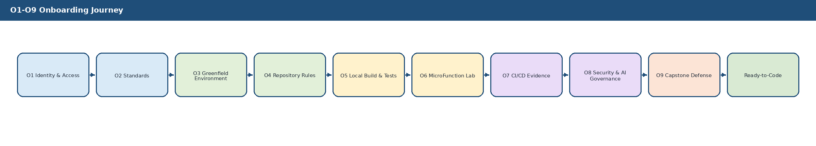
Figure 1. O1-O9 onboarding journey and Ready-to-Code approval path.
Stage | Objective | Required Evidence | Approval Owner
O1 Identity and Access | Confirm named identity, MFA, workspace access, data-handling acknowledgement. | Access checklist, signed acknowledgement, account inventory. | Security Administrator
O2 Standards Orientation | Read mandatory AIRA documents at role-appropriate depth. | Reading log, quiz result, Q&A notes. | Software Development Lead
O3 Greenfield Environment | Provision clean workstation/devcontainer from Golden Source. | Baseline hash, installed tool inventory, drift scan. | System Administrator
O4 Repository Rules | Understand CLAUDE.md hierarchy, branch protection, CODEOWNERS, and PR/MR template. | Local hook output, repository access proof. | DevSecOps Lead
O5 Local Build and Test | Run starter build, tests, lint, and architecture checks locally. | Terminal log, test report, screenshot or evidence reference. | QA Lead / Tech Lead
O6 MicroFunction Lab | Configure and execute a sample transaction using standard functions. | Config rows/YAML, test result, diagram explanation. | Tech Lead
O7 CI/CD Evidence Drill | Open a training PR/MR and pass required pipeline gates. | PR/MR link, CI run ID, evidence manifest. | DevSecOps Lead
O8 Security and AI Governance | Demonstrate safe prompt, classification, SBAC/OPA/Harness, secret hygiene. | Prompt log, classification worksheet, policy test output. | Security Administrator
O9 Capstone Review | Build, test, explain, and defend a sample feature. | Capstone package, panel decision, readiness record. | Solutions Architect / IT Head

3.1 Certification Scope Levels
Certification Scope | Permitted Work | Restrictions / Renewal Trigger
Foundation only | Repository bootstrap, local environment, starter tests, documentation updates, supervised platform tasks. | No independent business module work until MicroFunction or business certification is granted.
MicroFunction implementer | Implement or configure approved STP-BUS-* functions, standard step tests, transaction definitions, and error paths. | New framework concerns require Tech Lead and Architecture approval.
Business module developer | Implement approved business stories under bounded context, contract, data classification, and acceptance criteria. | No direct schema, workflow, or security-control deviation without ADR/TDL.
QA/SDET | Design tests, fixtures, evidence manifests, quality gates, and capstone verification. | Cannot lower quality gate or approve own test coverage gaps.
DevSecOps | Maintain CI/CD, pre-commit, evidence packs, repository controls, and runtime readiness scripts. | No production-impacting bypass; all changes through MR and policy checks.
Restricted / supervised | Pairing, training branches, or low-risk documentation/tasks only. | Requires remediation and re-assessment before independent mergeable work.

4. Required Reading and Role-Based Learning Path
Reading Depth Rule
Developers should not be asked to memorize all documents. They must know where the authoritative rule is, how to apply it during coding, and how to produce evidence that the rule was followed.

4.1 Role-Based Reading Matrix
Document | All Developers | Tech Lead | QA/SDET | DevSecOps | Security/DBA | Required Outcome
01 AVCI v3.0 | Read | Read | Read | Read | Read | Can explain AVCI evidence and PR/MR summary.
01A SOLID Enforcement Layer | Read | Read | Read | Read | Read | Can explain the 20 principles and impact on Auto-Heal/Improve.
02 Engineering Blueprint v5.0 | Core sections | Full | Core sections | Core sections | Security/data sections | Can explain service boundaries and architecture invariants.
03 Developer Guide v4.0 | Full | Full | Testing sections | CI/repo sections | Security/data sections | Can follow daily coding and repository rules.
04 Technology Stack v8.0 | Core tiers | Full | Test tools | Full | Security/data tools | Can identify approved vs conditional tools.
06 CLAUDE.md Reference v3.0 | Full | Full | Full | Full | Full | Can apply repository AI/human rules.
08 Unit Testing v3.0 | Full | Full | Full | CI integration | Security tests | Can perform TDD and evidence-based testing.
10-10D MicroFunction documents | Full | Full | Scenario tests | Pipeline impact | Security/data impact | Can design and implement configuration-first transactions.
17 Security Standard v2.0 | Awareness | Core | Core | Core | Full | Can avoid secrets/PII leakage and apply least privilege.
18-23 Execution Packs | Awareness | Full | Relevant | Full | Relevant | Can execute repository, CI/CD, platform, and fitness gates.

5. Training Curriculum
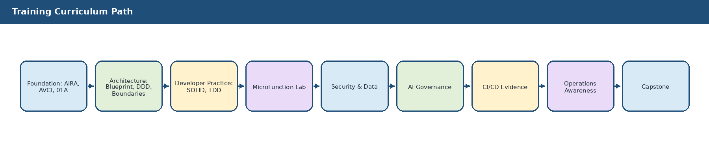
Figure 2. Training curriculum path from AIRA foundation to capstone defense.
Module | Topic | Learning Objectives | Exercise | Pass Criteria
M1 | AIRA Mission and AVCI | Understand why AIRA requires evidence-by-construction. | Map a sample artifact to AVCI. | All four AVCI properties correctly identified.
M2 | 01A Design Principles | Apply SOLID, Clean Architecture, DDD, ports/adapters, reversibility, observability. | Refactor a bad design into compliant boundaries. | Principle impact table accepted by reviewer.
M3 | Architecture Blueprint | Explain service boundaries, AI governance, workflow partition, data/knowledge responsibilities. | Trace a request through the architecture. | No boundary shortcuts or direct model calls proposed.
M4 | Repository Discipline | Use CLAUDE.md, hooks, branch protection, PR templates, CODEOWNERS. | Create a training branch and PR. | Hooks and CI pass; PR evidence complete.
M5 | TDD and Quality | Practice red-green-refactor, deterministic tests, mutation/security awareness. | Write tests before implementing a small MicroFunction. | Red-green-refactor evidence captured.
M6 | MicroFunction Framework | Configure standard steps and isolate STP-BUS-* logic. | Create sample transaction definition and tests. | Mandatory steps, error path, idempotency, audit included.
M7 | Security and Data | Use classification, secrets, least privilege, SBAC/OPA, RLS concepts. | Classify sample payload and select allowed model route. | No PII/secrets exposure; correct routing.
M8 | AI-Assisted Development | Use ChatGPT/Codex safely with prompts, citations, and human accountability. | Generate test suggestions and review them. | AI output declared and independently verified.
M9 | Operations Awareness | Understand incident, rollback, DLQ, Auto-Heal, Auto-Learn, Auto-Improve constraints. | Walk through a failed event replay scenario. | Safe recovery path and evidence identified.
M10 | Capstone | Deliver a small end-to-end sample with evidence and defense. | Build and defend sample function/transaction. | Panel approves Ready-to-Code.

6. Hands-On Labs and Exercises
Lab | Scenario | Required Output | Evidence
LAB-01 | Environment verification | Run devcontainer, Java/Node checks, Git hooks, local test command. | Tool versions, command output, drift scan result.
LAB-02 | AVCI artifact review | Review a sample PR and identify missing owner, tests, classification, improvement path. | Completed AVCI checklist.
LAB-03 | SOLID refactoring | Refactor a sample service that violates SRP/DIP and ports/adapters. | Before/after explanation, tests, architecture check.
LAB-04 | MicroFunction configuration | Assemble a sample transaction using standard steps and one STP-BUS-* function. | Config artifact, sequence diagram, unit tests.
LAB-05 | Error handling and compensation | Configure retry, timeout, safe response, DLQ, and compensation for a failing step. | Failure-path test output and audit evidence.
LAB-06 | API contract first | Create or update an OpenAPI path and generated contract test. | Contract file, compatibility check, test report.
LAB-07 | Database migration | Create Flyway migration with rollback/forward-fix notes and RLS/classification metadata. | Migration file, verification SQL output, evidence record.
LAB-08 | AI prompt safety | Classify a prompt, choose model route, apply guardrail expectations, and record usage. | Prompt registry sample and evaluation result.
LAB-09 | CI/CD evidence drill | Submit training PR/MR with complete AVCI and 01A summary. | Pipeline link, evidence manifest, reviewer notes.
LAB-10 | Incident walkthrough | Resolve simulated DLQ or failed deployment using runbook. | Incident worksheet, recovery evidence, lesson learned.

6.1 Developer Workstation to Repository Flow
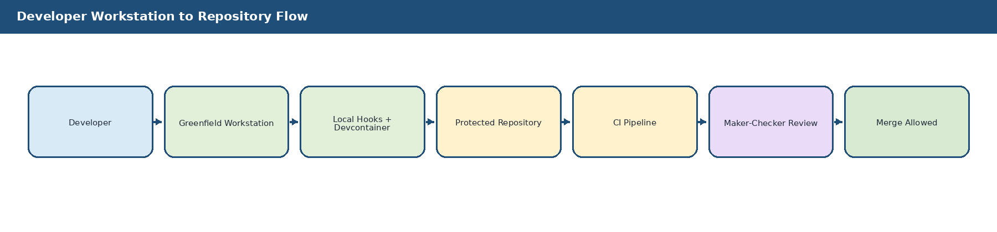
Figure 3. Developer workstation to repository flow with fail-fast local and CI feedback loops.

7. Developer Assessment and Ready-to-Code Gate
Ready-to-Code Rule
No developer may independently submit production-bound AIRA code until the Ready-to-Code gate is passed and recorded. Pairing, training branches, and supervised exercises may occur before approval.

Gate | Requirement | Minimum Passing Criteria | Evidence Owner
G1 Identity and Access | Named account, MFA, no shared credentials. | All required accounts active and mapped to role. | Security Admin
G2 Environment | Greenfield workstation/devcontainer operational. | Local build, test, and hooks execute successfully. | System Admin / DevSecOps
G3 Standards Knowledge | Role-based reading and quiz. | >= 85% quiz score or corrected oral defense. | Training Lead
G4 Architecture Understanding | Explain AIRA flow and boundaries. | No direct DB/model/provider/bypass patterns proposed. | Solutions Architect
G5 TDD and Testing | Demonstrate red-green-refactor and deterministic tests. | Tests pass, failure path covered, evidence retained. | QA Lead
G6 MicroFunction Practice | Create/configure sample transaction. | Mandatory steps, idempotency, audit, error path present. | Tech Lead
G7 Security and Data | Classify sample data and apply least privilege/model route. | Correct classification and no secret/PII exposure. | Security Admin
G8 CI/CD Evidence | Training PR/MR passes pipeline and review. | Evidence manifest complete and reviewer accepted. | DevSecOps Lead
G9 Capstone Defense | Deliver and explain sample feature. | Panel approves or assigns remediation. | IT Head / Solutions Architect

7.1 PR/MR Evidence Gate
This flow shows how a developer PR/MR is evaluated against AVCI, 01A principles, tests, security, classification, and review evidence before merge.
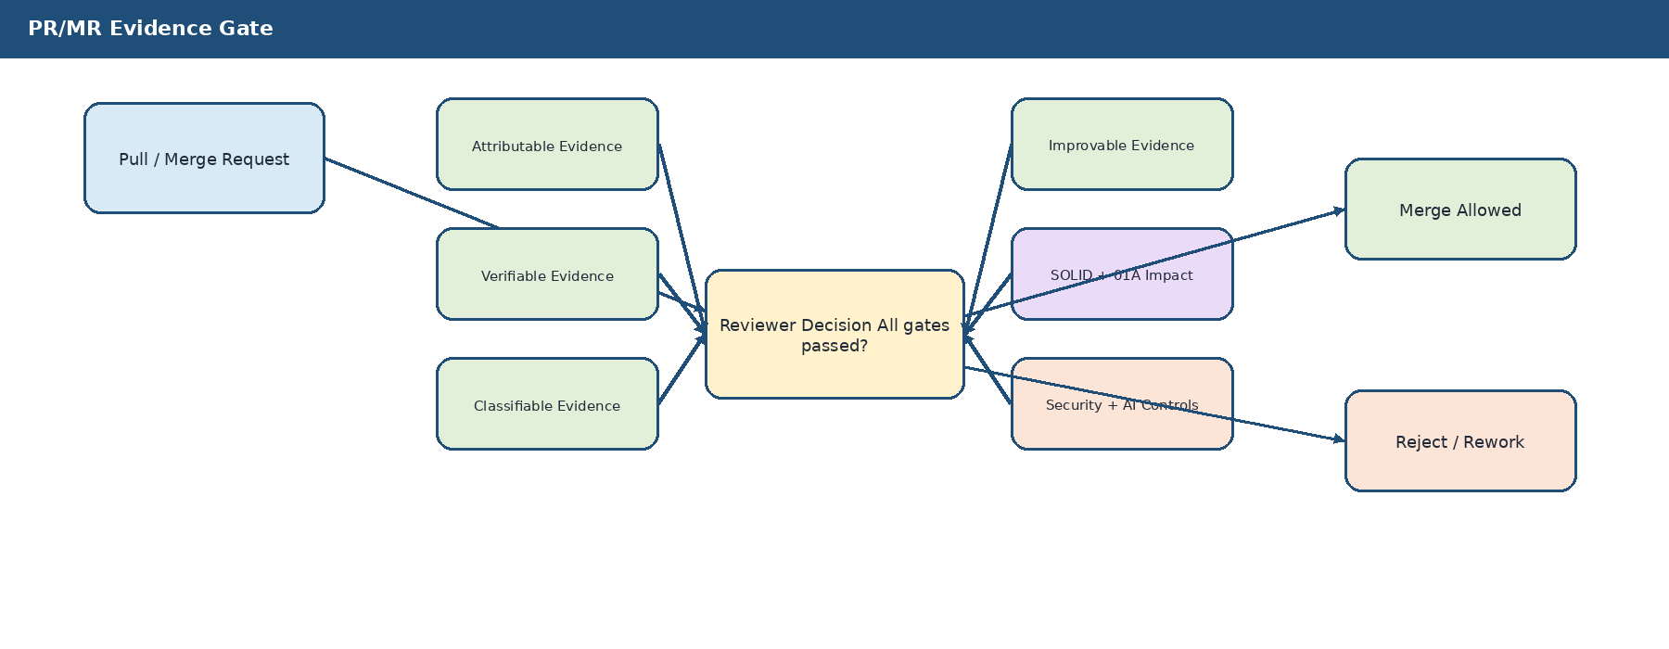
Figure 4. PR/MR evidence gate for Ready-to-Code and future development work.

7.2 Assessment Scoring Model
Assessment Area | Weight | Minimum Standard | Automatic Fail Condition
Standards knowledge and rule lookup | 15% | Can locate and apply relevant AIRA standards. | Cannot explain AVCI or ignores CLAUDE.md hierarchy.
Architecture and design boundaries | 20% | Correctly respects service boundaries, DDD, ports/adapters, and no direct model calls. | Proposes direct provider SDK, direct DB shortcut, or bypass of workflow/security boundary.
TDD, testing, and evidence | 20% | Shows red-green-refactor, deterministic tests, failure path coverage, CI evidence. | Code-first/test-later without justification or missing critical failure path.
MicroFunction and configuration-first design | 15% | Uses standard steps and isolates STP-BUS-* logic. | Hardcodes transaction flow or duplicates standard framework concerns.
Security, data, and AI governance | 20% | Correct classification, no PII/secrets, safe model route, OPA/SBAC/Harness awareness. | Pastes secrets/PII or proposes guardrail/policy bypass.
Communication and defense | 10% | Can explain decisions, limitations, risks, and rework path. | Cannot explain own code or evidence trail.
Decision | Score / Condition | Outcome
PASS | 85% or higher, no automatic-fail condition. | Ready-to-Code approval may be granted within defined scope.
CONDITIONAL | 75%-84% or minor evidence gaps with safe remediation. | Scoped/supervised work only until remediation is verified.
FAIL | Below 75% or any automatic-fail condition. | No independent mergeable work; repeat labs/capstone required.

8. AI-Assisted Development Rules
Rule | Developer Requirement | Evidence
Named accountability | AI output is advisory. The developer remains accountable for correctness, tests, security, and evidence. | PR/MR declaration identifies tool/model and human checker.
Classification before prompt | Classify content before sharing with ChatGPT/Codex or any approved AI tool. | Prompt classification worksheet or registry entry.
No secrets or real PII | Do not paste credentials, customer data, production logs with PII, tokens, raw documents, or restricted data. | Reviewer confirms synthetic/masked inputs.
CLAUDE.md compliance | AI-generated changes must follow root and directory-specific rules. | Hook/CI output and CODEOWNERS review.
No direct model/provider use | Application code may not call model providers directly; use governed gateway patterns. | Import lint/fingerprint checks.
Guardrails and Harness | Tool actions and high-impact AI recommendations require appropriate rails and Harness/OPA/SBAC path. | Policy decision and audit reference.
Independent verification | AI-generated tests and code must be reviewed and executed. | Test report, reviewer notes, changed-line coverage.
Bounded remediation | Auto-Heal/AI remediation is capped and escalates when repeated attempts fail. | Attempt count, escalation record.
AI Governance Red Line
A developer cannot use an AI tool to bypass classification, security review, test evidence, architecture boundaries, or human accountability. Any such attempt is treated as a governance non-conformance, not a productivity shortcut.

9. Capstone Project and Review Defense
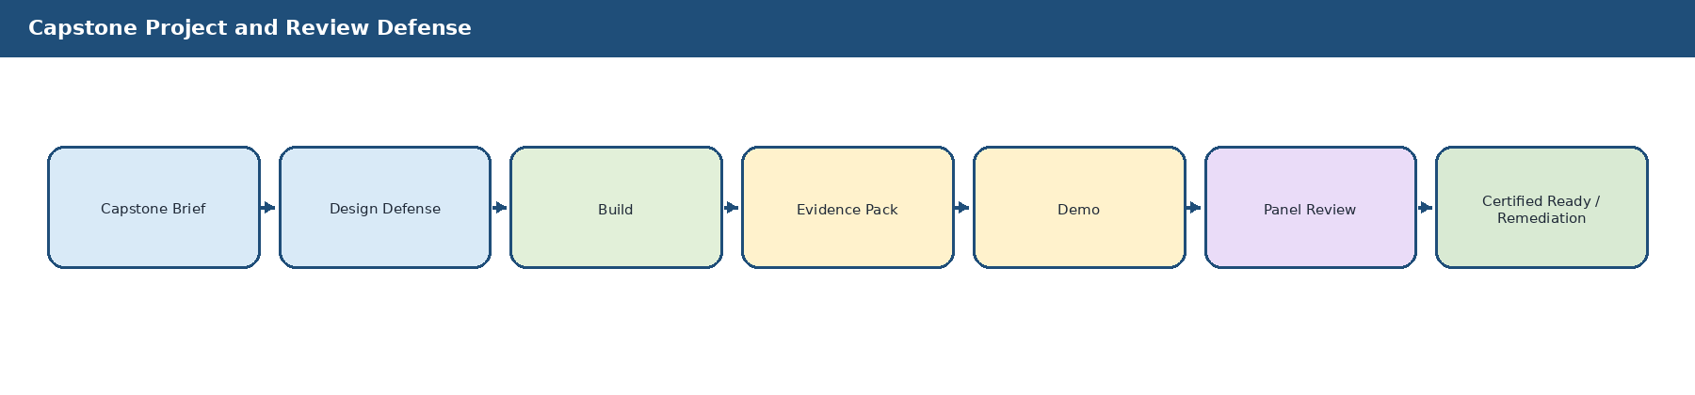
Figure 5. Capstone workflow from brief to certification or remediation.
Capstone Component | Expected Work Product | Evaluation Criteria
Scenario selection | Assigned sample transaction such as document intake stub, loan eligibility placeholder, or approval route sample. | Scope is small, bounded, and suitable for training.
Design explanation | Short design note explaining bounded context, API/event contract, data classification, and MicroFunction sequence. | Consistent with Blueprint, Developer Guide, API, Database, and MicroFunction standards.
Implementation | Minimal working code/configuration with tests and no bypass patterns. | SOLID, Clean Architecture, DDD, ports/adapters, idempotency, security, observability.
Testing | Unit, component, error-path, security, and architecture fitness checks. | Required gates pass and failure path is demonstrated.
CI/CD evidence | Training PR/MR evidence manifest, SBOM/scan if applicable, reviewer approval. | Evidence is complete and traceable.
Demo and defense | Live walkthrough of success path, failure path, and recovery/evidence path. | Developer can explain decisions and limitations.

10. Evidence Pack and Records
Evidence Artifact | Required Fields | Storage / Reference
Developer onboarding record | Name, role, manager, start date, assigned mentor, onboarding status. | OpenKM / AIRA / Training / Developer Records /
Reading log | Document, version, completion date, role relevance, questions raised. | Training workbook evidence package.
Quiz result | Module, score, incorrect answers, remediation if any. | Training evidence register.
Environment evidence | Workstation ID, devcontainer version, tool versions, drift scan, account map. | Greenfield environment evidence path.
Lab evidence | Lab ID, branch/commit, command output, tests, reviewer comments. | Repository training branch and evidence manifest.
AI usage evidence | Tool/model, prompt intent, classification, output use, human checker. | PR/MR AVCI summary and AI registry if applicable.
Capstone record | Scenario, design, implementation, CI result, panel decision, conditions. | Developer readiness register.
Ready-to-Code approval | Approver, date, scope of approval, restrictions, renewal date. | Signed onboarding acknowledgement.

10.1 Evidence Completeness Checklist
Checklist Item | Required Before Approval
Identity and access evidence | Named account, MFA, workspace, repository, and role mapping evidence captured.
Environment proof | Clean devcontainer/workstation baseline, tool inventory, local checks, and drift result captured.
Standards evidence | Reading log, quiz or oral defense, and unresolved questions recorded.
Lab evidence | Each assigned lab has output, reviewer, evidence reference, and pass/conditional/fail status.
PR/MR evidence | Training branch, PR/MR link, CI run ID, evidence manifest, and CODEOWNERS review available.
AI evidence | Any AI assistance declared with classification, prompt intent, tool/model, and human checker.
Capstone evidence | Design note, implementation, tests, demo, review decision, and remediation if any.
Approval evidence | Ready-to-Code record signed with approval scope and next review date.

11. Remediation, Renewal, and Access Revocation
Ready-to-Code approval is not permanent when the underlying standards, technology stack, AI tooling, or developer behavior materially changes. AIRA treats onboarding certification as a living control tied to evidence and continued compliance.
Trigger | Required Action | Owner
Conditional capstone result | Create remediation plan, assign mentor, repeat failed lab or defense item. | Software Development Lead / QA Lead
Automatic-fail condition | Suspend independent mergeable work; repeat security/AI/governance modules and capstone. | Solutions Architect / Security Administrator
Major stack or standard update | Run delta training and evidence refresh for affected roles. | Training Lead / DevSecOps Lead
Security or data-handling violation | Revoke affected access pending review; complete corrective training and approval. | Security Administrator
Repeated PR evidence gaps | Restrict to supervised work until evidence discipline is restored. | Dev Lead / QA Lead
Quarterly review cycle | Confirm active developers remain aligned with current standards and role scope. | Solutions Architect / IT Head

12. RACI and Operating Responsibilities
Activity | Solutions Architect / IT Head | Software Dev Lead | DevSecOps Lead | Security Admin | QA Lead | System Admin | Developer
Approve workbook baseline | A | R | C | C | C | C | I
Assign onboarding cohort | A | R | C | C | C | C | I
Provision identity/access | I | C | C | R/A | I | C | I
Provision workstation/devcontainer | I | C | R | C | C | R/A | I
Conduct standards orientation | A | R | C | C | C | I | R
Conduct MicroFunction lab | C | R/A | C | C | C | I | R
Conduct testing and CI lab | C | C | R | C | R/A | C | R
Conduct security/AI governance lab | C | C | C | R/A | C | C | R
Review capstone | A | R | C | C | R | C | R
Grant Ready-to-Code approval | A | R | C | C | C | I | I
Maintain evidence records | A | R | R | R | R | C | R
Legend: A = Accountable, R = Responsible, C = Consulted, I = Informed.

13. Implementation Roadmap
Phase | Timing | Activities | Exit Criteria
Phase 1 - Workbook adoption | Week 0 | Approve workbook, assign training owners, create evidence folders and readiness register. | Training package approved and published.
Phase 2 - Cohort onboarding | Week 1 | Run O1-O5 identity, standards, environment, repository, local build modules. | All developers can run local build and hooks.
Phase 3 - Engineering labs | Week 2 | Run MicroFunction, testing, CI/CD, security, and AI governance labs. | Training PR/MR evidence passes review.
Phase 4 - Capstone defense | Week 3 | Develop and defend sample transaction or assigned foundation component. | Capstone panel approves or issues remediation.
Phase 5 - Ready-to-Code activation | Week 4 | Grant scoped repository work permissions and assign first Sprint-0 tasks. | Readiness register updated and signed.

Appendix A. Developer Acknowledgement Template
Acknowledgement Item | Developer Initials | Reviewer Initials
I have read the assigned AIRA standards and understand where to find authoritative rules.
I understand AVCI and the Enterprise Design Principles & SOLID Enforcement Layer.
I will not use personal accounts, unmanaged AI tools, secrets, production data, or real PII in prompts/tests/examples.
I will follow CLAUDE.md, branch protection, CODEOWNERS, and PR/MR evidence rules.
I will write deterministic tests and follow TDD where feasible.
I understand that AI output is advisory and human accountability remains non-delegable.
I understand that mergeable AIRA work requires complete evidence and human review.

Appendix B. Quiz Blueprint
Topic | Sample Question | Expected Answer Theme
AVCI | What makes an artifact production-ready under AVCI? | It must be attributable, verifiable, classifiable, and improvable with evidence.
SOLID | Why must a MicroFunction remain single-responsibility? | To keep testing, reuse, replacement, and evidence clean.
Architecture | Which service may directly call a model provider? | None; model traffic goes through governed LiteLLM route.
Security | What happens when OPA, guardrails, Harness, Vault, or audit is unavailable? | Protected actions fail closed.
Data | May Redis or pgvector become authoritative source of truth? | No; they are derivative/acceleration layers unless explicitly approved.
AI Governance | Can Codex or an agent approve its own PR or execute production actions? | No; humans approve and Harness mediates actions.
Testing | What is required for a mutation or side-effecting transaction? | Idempotency, tests, error path, compensation/retry as applicable, audit evidence.

Appendix C. Developer Readiness Record
developer_readiness_record:
developer_id: ""
full_name: ""
role: "Software Developer | QA/SDET | DevSecOps | DBA | Security | AI Engineer"
mentor: ""
onboarding_start_date: "YYYY-MM-DD"
assigned_workstation_id: ""
repository_access_scope: []
completed_modules: []
completed_labs: []
quiz_score_summary: ""
capstone_result: "PASS | CONDITIONAL | FAIL"
ready_to_code_status: "APPROVED | RESTRICTED | NOT APPROVED"
approval_scope: "Foundation only | MicroFunction | Business module | Admin/config only"
approver: ""
approval_date: "YYYY-MM-DD"
next_review_date: "YYYY-MM-DD"
restrictions: []
remediation_items: []
evidence_refs: []

Appendix D. Capstone Scoring Rubric
Criteria | Excellent | Acceptable | Needs Remediation
Design boundary | Clear bounded context, ports/adapters, no shortcut. | Minor gaps but no boundary violation. | Direct DB/provider/workflow/security bypass.
MicroFunction use | Standard steps reused and business logic isolated. | Configuration mostly correct with minor reviewer fixes. | Hardcoded flow or duplicated framework concern.
Tests and evidence | Red-green-refactor, success/failure/security tests, CI evidence complete. | Core tests pass but evidence needs minor cleanup. | Missing failure path, non-deterministic tests, or no CI proof.
Security and AI controls | Correct classification, no PII/secrets, safe model route. | Minor documentation gap corrected during review. | Secret/PII exposure or policy/guardrail bypass.
Explanation | Can explain decisions, trade-offs, limitations, and rework path. | Can explain most choices with coaching. | Cannot explain own implementation or evidence trail.

Appendix E. Copy-Ready Mermaid References

E.1 Onboarding Journey
flowchart LR
O1[O1 Identity, NDA, Data Handling] --> O2[O2 AIRA Standards]
O2 --> O3[O3 Greenfield Workstation]
O3 --> O4[O4 Repository + CLAUDE.md]
O4 --> O5[O5 Devcontainer + Local Tests]
O5 --> O6[O6 MicroFunction Training Lab]
O6 --> O7[O7 CI/CD Evidence PR Drill]
O7 --> O8[O8 Security and AI Governance]
O8 --> O9[O9 Capstone Review Defense]
O9 --> READY[Ready-to-Code Approval]

E.2 Training Curriculum
flowchart TD
A[Foundation: AIRA, AVCI, 01A] --> B[Architecture: Blueprint, DDD, Boundaries]
B --> C[Developer Practice: SOLID, Clean Architecture, TDD]
C --> D[MicroFunction Lab]
D --> E[Security and Data]
E --> F[AI Governance]
F --> G[CI/CD Evidence]
G --> H[Operations and Auto-Heal]
H --> I[Capstone]

E.3 Developer Workstation to Repository Flow
flowchart LR
A[Developer] --> B[Greenfield Workstation]
B --> C[Local Hooks and Devcontainer]
C --> D[Protected Repository]
D --> E[CI Pipeline]
E --> F[Maker-Checker Review]
F --> G[Merge Allowed]
E -. fail fast .-> C
F -. rework .-> D

E.4 PR/MR Evidence Gate
flowchart TD
PR[Pull / Merge Request] --> A[Attributable Evidence]
PR --> V[Verifiable Evidence]
PR --> C[Classifiable Evidence]
PR --> I[Improvable Evidence]
PR --> S[SOLID and 01A Impact]
A --> D{Reviewer Decision}
V --> D
C --> D
I --> D
S --> D
D -->|All passed| M[Merge]
D -->|Gap found| R[Reject / Rework]

Appendix F. AVCI Compliance Summary
AVCI Property | Compliance Statement
Attributable | This workbook is owned by the Solutions Architecture Office / IT Head with co-ownership across Software Development, DevSecOps, Security, QA, and System Administration.
Verifiable | Completion is verified through reading logs, quizzes, lab evidence, PR/MR evidence, CI runs, capstone defense, and signed Ready-to-Code records.
Classifiable | The workbook is Internal Confidential; training evidence inherits classification based on role, system access, AI usage, and lab content.
Improvable | Quarterly reviews, developer feedback, audit findings, defect patterns, capstone outcomes, and standards changes feed updates to the workbook and training program.
Final Control Statement
The AIRA Developer Onboarding and Training Workbook certifies that a developer can build under discipline, not just run tools. A developer becomes Ready-to-Code only after the evidence shows they can follow AVCI, SOLID, Clean Architecture, TDD, security, AI governance, CI/CD evidence, and human accountability.

