AIRA
MicroFunction Sequence Diagrams and Mermaid Reference
Version 2.0 - Rendered Diagrams + Copy-Ready Mermaid Code
Core Design Rule
Every sequence diagram in this reference is a governed implementation pattern. Auto-Heal, Auto-Learn, and Auto-Improve must preserve or improve SOLID compliance, Clean Architecture boundaries, DDD bounded contexts, testability, security posture, observability, reversibility, and AVCI evidence.

Property | Value
Document Title | AIRA MicroFunction Sequence Diagrams and Mermaid Reference
Document ID | AIRA-DOC-10C
Version | v2.0 - Rendered Diagram and Mermaid Source Edition
Supersedes | 10C-AIRA MicroFunction Sequence Diagrams and Mermaid Reference v1.3
Classification | Internal Confidential
Status | Developer Reference / Architecture Review Ready
Owner | Solutions Architecture Office / Software Development Lead
Companion Documents | 01A Enterprise Design Principles and SOLID Enforcement Layer v1.0; 01 AVCI v3.0; 02 Engineering Blueprint v5.0; 03 Developer Guide v4.0; 08 Unit Testing v3.0; 10 MicroFunction Framework v3.0; 10A v2.0; 10B v2.0; 10D v2.0
Primary Audience | Solutions Architects, Software Developers, QA/SDET, DevSecOps, DBAs, System Administrators, Security Administrators
Purpose | Provide complete rendered sequence diagrams and copy-ready Mermaid code for AIRA MicroFunction implementation, including standard steps, error paths, AI-governed flows, architecture fitness gates, and operational support patterns.
Table of Contents Note: Use Microsoft Word > References > Table of Contents > Automatic Table, then Update Field before final publication.

1. Executive Summary
This v2.0 reference upgrades the MicroFunction sequence diagram set to align with the AIRA Enterprise Design Principles and SOLID Enforcement Layer. This edition includes both rendered sequence diagrams and the exact Mermaid source code so software developers can visualize the target flow immediately and still copy the source into repositories, Obsidian, GitHub/GitLab, or approved documentation tooling.
The rendered diagrams make implementation order, component boundaries, AI governance gates, error paths, and evidence responsibilities visible. The Mermaid code remains the source of truth for future diagram edits and must be updated whenever the visual diagram changes.
Mandatory Use Rule
Developers must not bypass the mandatory framework steps shown in these diagrams. A transaction or MicroFunction that removes identity, classification, authorization, validation, idempotency, error handling, audit, observability, or principle evidence is not production-ready.

1.1 v2.0 Change Summary
Change Area | v2.0 Improvement
Rendered diagrams | Adds visual sequence diagrams for every Mermaid flow so developers can understand the flow without rendering Mermaid separately.
Mermaid source retained | Keeps copy-ready Mermaid code after every diagram as the authoritative source for updates.
Enterprise principles | Adds 01A Enterprise Design Principles and SOLID Enforcement Layer as a controlling reference.
SOLID enforcement | Adds explicit single-responsibility, interface-driven, and dependency-inverted MicroFunction expectations.
Architecture boundaries | Adds Clean Architecture, DDD, and ports/adapters review points to coding and runtime flows.
Auto-Heal / Auto-Learn / Auto-Improve | Clarifies that AI loops create candidates, drafts, or reviewed knowledge only; they do not self-modify production.
Architecture fitness functions | Adds CI gate and principle impact assessment diagrams.
Error and rollback | Strengthens retry, compensation, DLQ, safe-response, human escalation, and reversibility evidence.

2. Developer Usage Guidance
This document is intended to be copied into the engineering repository and Obsidian vault. Each section contains a rendered diagram followed by the exact Mermaid sequence diagram code. Developers may use the image for walkthroughs and the Mermaid code for Markdown, Obsidian, GitHub/GitLab documentation, or approved diagram tooling.
The intended development model remains configuration-first: add, remove, reorder, and parameterize existing standard steps whenever possible. Code should only be written for a genuinely new reusable business MicroFunction or framework capability after no-code and low-code options are determined insufficient.
Rule | Required Behavior
Source of truth | The Mermaid source is authoritative for diagram changes. Rendered images are derivative and must be regenerated after source changes.
Visual reference | The rendered diagram is included for developer understanding, design walkthroughs, and onboarding discussions.
No uncontrolled edits | Do not hand-edit rendered diagrams without updating Mermaid source and evidence.
Review path | Diagram changes follow MR review with AVCI summary, owner, version, classification, and affected companion documents.
AI use | AI may draft or improve diagrams, but a named human validates correctness, architecture alignment, and evidence.
Conflicts | If a diagram conflicts with 01A, 01 AVCI, 02 Blueprint, 10 Framework, or 10B Implementation Standard, the higher-authority standard governs and the diagram must be corrected.

3. Enterprise Design Principles Applied to Diagrams
The following principles must be visible in design reviews, sequence walkthroughs, implementation tasks, and PR/MR evidence when the diagrams are used as development references.
Principle | Diagram Enforcement Meaning
SOLID | MicroFunctions must be single-purpose, replaceable through configuration, interface-driven, and dependency-inverted.
Clean Architecture | Domain logic must not depend on controllers, persistence, messaging, AI providers, or infrastructure details.
DDD / Bounded Contexts | A MicroFunction must respect its owning context and must not write across another context boundary.
Ports and Adapters | External systems, persistence, AI, Kafka, OpenKM, Flowable, and Temporal access must be behind ports/adapters.
DRY, KISS, YAGNI | Reusable framework concerns are implemented once; speculative or duplicated business plumbing is rejected.
Idempotency by Design | Mutating functions and event consumers must be retry-safe and deduplicated.
Determinism and Reproducibility | Runtime assembly, tests, workflows, and migration effects must be repeatable from versioned source.
Fail-Safe, Not Fail-Open | If policy, guardrails, identity, audit, or route validation is unavailable, protected actions stop.
Human-in-the-Loop | High-risk, low-confidence, Restricted, waiver, production-impacting, and destructive actions require named human approval.
Least Privilege / SBAC | Actors, agents, services, and tools receive only the skill and authority required for the scoped action.
Separation of Duties | Maker, checker, approver, and production promoter roles must remain separable and auditable.
Observability by Design | Every step must emit trace, metric, log, and audit evidence without leaking secrets or PII.
Policy as Code | Governance and authorization decisions must be expressed in reviewed policy artifacts, not hidden code paths.
Testability by Design | Every MicroFunction and configuration must be unit, contract, boundary, and regression testable.
Secure by Design | Input validation, classification, secret safety, safe errors, tenant isolation, and redaction are mandatory.
Resilience Patterns | Timeouts, retries, circuit breakers, bulkheads, DLQ, compensation, and fallback behavior are explicit.
Architectural Fitness Functions | CI must automatically verify boundary, dependency, policy, test, security, and evidence rules.
Progressive Autonomy | Automation moves from recommendation to execution only after evidence, trust, policy, and review thresholds are met.
Reversibility / Rollbackability | State-changing actions must define compensation, forward-fix, rollback, or safe stop behavior.
AVCI | Every diagram, code path, configuration, test, and improvement must be attributable, verifiable, classifiable, and improvable.

4. Standard Step Sequence
The standard synchronous sequence remains the default baseline. Some templates may omit steps that are not applicable, but no mutating, sensitive, AI-governed, or integration-facing flow may omit mandatory safety, security, evidence, or error-handling controls without waiver.
Order | Standard Step | Prefix | Purpose
1 | Receive | STP-RCV | Accept approved REST, Kafka, webhook, batch, file, or scheduled trigger.
2 | Correlate | STP-COR | Create or propagate trace_id, request_id, correlation_id, causation_id.
3 | Resolve Session / Actor / Tenant | STP-SES | Resolve human, service, agent, tenant, roles, skills, branch/unit, and channel.
4 | Rate Limit / Quota Check | STP-RATE | Apply API, tenant, user, workflow, and AI budget throttles.
5 | Authorize and Classify | STP-SEC / STP-CLS | Authenticate, authorize, classify, evaluate RBAC/ABAC/SBAC/OPA, and enforce prompt/model eligibility.
6 | Parse Payload | STP-PRS | Parse JSON, XML, CSV, Avro, CloudEvents, multipart, or file metadata.
7 | Normalize / Sanitize Input | STP-NRM | Canonicalize, sanitize, trim, encode/decode, and perform injection pre-checks.
8 | Validate Schema | STP-VAL | Validate schema, required fields, controlled values, and structural contract.
9 | Validate Business Rules / DMN / Policy | STP-VAL / STP-RUL | Run rule tables, DMN, OPA policy checks, duplicate checks, and domain invariants.
10 | Idempotency Check and Reserve | STP-IDP | Check, reserve, replay, complete, or expire idempotency state.
11 | Concurrency Guard | STP-CON | Apply optimistic lock, pessimistic lock, Redis/Redisson lock, or version check.
12 | Resolve Runtime Configuration / Feature Flags | STP-CFG | Resolve active version, feature flags, policy versions, and parameter sets.
13 | Optional Cache Lookup | STP-CAC | Use Caffeine/Redis only as derivative acceleration; never as authority.
14 | Execute Business Function or Rule | STP-BUS / STP-RUL | Execute isolated business MicroFunction, rule table, or DMN decision.
15 | Persist State / Append History | STP-DB / STP-HIS | Persist through approved repository/port and append business history.
16 | Write Audit Evidence | STP-AUD | Write immutable technical and business evidence with trace, actor, policy, and classification.
17 | Write Transactional Outbox | STP-EVT | Persist event publication intent atomically with business mutation.
18 | Publish Event / Notification | STP-EVT / STP-NOT | Publish CloudEvents and approved notifications through governed channels.
19 | Build Safe Success Response | STP-RSP | Return safe, classified, trace-correlated, user-appropriate response.
20 | Error Path | STP-ERR / STP-CMP | Classify, retry, compensate, DLQ, escalate, and build safe failure response.
21 | Principle / Fitness Gate | STP-GOV / CI | Validate SOLID, architecture boundaries, security, observability, reversibility, and AVCI evidence.

5. Diagram Index
No. | Diagram | Primary Use
1 | Standard Synchronous Transaction Template | Default configurable sequence for REST or UI-driven business transactions. Business logic is isolated in STP-BUS-* or rule/DMN steps; all other concerns are standard framework functions.
2 | Error Handling, Retry, Compensation, and Escalation | Shows the enterprise error path after a MicroFunction fails. The framework classifies the error, applies retry policy, compensates if needed, escalates to Flowable if required, and builds a safe response.
3 | Configuration Publish and Activation Flow | Shows how a new or changed transaction definition becomes active without changing Java code, while preserving architecture boundary, AVCI evidence, and principle compliance.
4 | Runtime Assembly and Cache Resolution | Shows L1 Caffeine, L2 Redis, and PostgreSQL Tier-0 source of truth. Cache accelerates processing but never becomes authoritative.
5 | Standard Step Execution Envelope | Shows the reusable envelope around every MicroFunction: security, idempotency, locking, telemetry, audit, error routing, and compensation.
6 | Kafka Async Event with DLQ | Shows CloudEvents plus idempotent consumer plus transactional execution plus DLQ for failed async events.
7 | Temporal Machine-Durable Workflow with Compensation | Shows long-running, retryable, machine-driven workflows with deterministic version pinning and compensating actions.
8 | Flowable Human Approval and Exception Review | Shows human-in-the-loop review for approval, exception handling, CAB gates, and high-risk failures.
9 | AI/RAG and Harness-Controlled Tool Action | Shows retrieval, four NeMo Guardrails checkpoints, LiteLLM-only model routing, and Harness/OPA/SBAC for tool execution.
10 | Document Intake, Malware Scan, OCR, and Indexing | Shows a configurable document workflow using OpenKM, malware scan, checksum, OCR, normalization, embedding, LightRAG, and LLM Wiki candidate creation.
11 | Runtime Customization Without Code Change | Shows how a transaction is changed by adding/removing/reordering existing standard steps or changing parameters.
12 | Business MicroFunction Extension Pattern | Shows the only normal coding path: create an isolated reusable STP-BUS-* function when existing standard functions and rules are insufficient.
13 | Reconciliation, Replay, and Reprocess Operations | Shows controlled operations for event replay, stuck workflow repair, cache rebuild, index rebuild, and state reconciliation.
14 | Auto-Heal Candidate Flow | Shows how production signals become a governed remediation candidate, not an autonomous production change.
15 | Auto-Learn and Auto-Improve Feedback Loop | Shows how production outcomes and human-reviewed lessons become approved LLM Wiki knowledge, prompts, guardrails, or MicroFunction configuration updates.
16 | Configuration Change and Cache Invalidation | Shows how a config.changed event invalidates L1/L2 cache and ensures new transactions use the active version.
17 | Retention, Archive, Supersede, and Purge Flow | Shows controlled lifecycle processing for documents, chunks, indexes, wiki artifacts, and audit-retained evidence.
18 | Observability, Audit, and Evidence Flow | Shows how every step produces trace, metric, log, and audit evidence for AVCI, troubleshooting, and compliance.
19 | Architecture Fitness Function CI Gate | Shows how CI verifies SOLID, Clean Architecture, DDD, ports/adapters, testability, security, observability, and rollbackability before merge.
20 | SOLID and Enterprise Principle Impact Assessment | Shows the standard review path for any AI-generated or human-authored change that affects MicroFunctions, configuration, workflows, prompts, policies, or adapters.

6. Rendered Sequence Diagrams and Copy-Ready Mermaid Code

6.1 Standard Synchronous Transaction Template
Purpose: Default configurable sequence for REST or UI-driven business transactions. Business logic is isolated in STP-BUS-* or rule/DMN steps; all other concerns are standard framework functions.
Enterprise principle check: Before implementing or modifying this flow, validate affected SOLID duties, architecture boundaries, idempotency, fail-safe behavior, observability, testability, security, reversibility, and AVCI evidence.
Rendered sequence diagram:
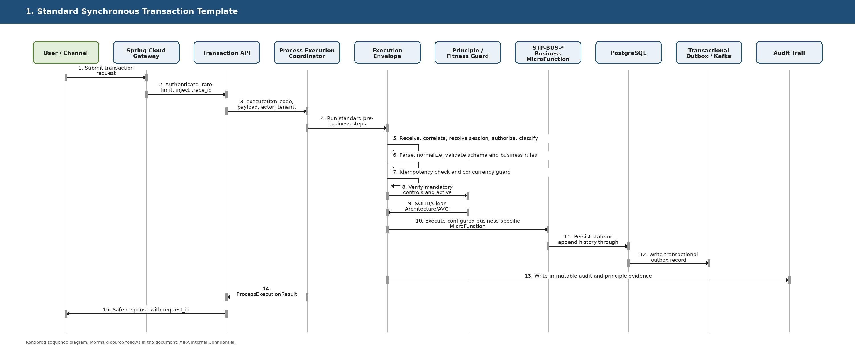
Figure 10C-1. Standard Synchronous Transaction Template
Copy-ready Mermaid source:
sequenceDiagram
autonumber
actor USER as User / Channel
participant GW as Spring Cloud Gateway
participant API as Transaction API
participant COORD as Process Execution Coordinator
participant ENV as Execution Envelope
participant FIT as Principle / Fitness Guard
participant BUS as STP-BUS-* Business MicroFunction
participant DB as PostgreSQL
participant OUT as Transactional Outbox / Kafka
participant AUD as Audit Trail
USER->>GW: Submit transaction request
GW->>API: Authenticate, rate-limit, inject trace_id
API->>COORD: execute(txn_code, payload, actor, tenant, idempotency_key)
COORD->>ENV: Run standard pre-business steps
ENV->>ENV: Receive, correlate, resolve session, authorize, classify
ENV->>ENV: Parse, normalize, validate schema and business rules
ENV->>ENV: Idempotency check and concurrency guard
ENV->>FIT: Verify mandatory controls and active definition version
FIT-->>ENV: SOLID/Clean Architecture/AVCI boundary is preserved
ENV->>BUS: Execute configured business-specific MicroFunction
BUS->>DB: Persist state or append history through approved port/adapter
DB->>OUT: Write transactional outbox record
ENV->>AUD: Write immutable audit and principle evidence
COORD-->>API: ProcessExecutionResult
API-->>USER: Safe response with request_id

6.2 Error Handling, Retry, Compensation, and Escalation
Purpose: Shows the enterprise error path after a MicroFunction fails. The framework classifies the error, applies retry policy, compensates if needed, escalates to Flowable if required, and builds a safe response.
Enterprise principle check: Before implementing or modifying this flow, validate affected SOLID duties, architecture boundaries, idempotency, fail-safe behavior, observability, testability, security, reversibility, and AVCI evidence.
Rendered sequence diagram:
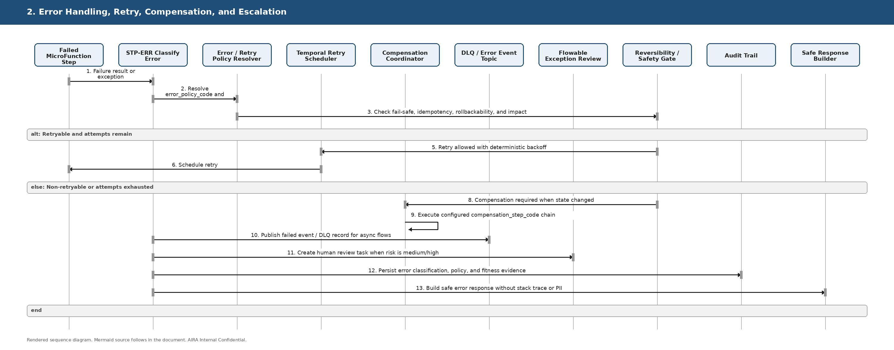
Figure 10C-2. Error Handling, Retry, Compensation, and Escalation
Copy-ready Mermaid source:
sequenceDiagram
autonumber
participant STEP as Failed MicroFunction Step
participant ERR as STP-ERR Classify Error
participant POL as Error / Retry Policy Resolver
participant TEMP as Temporal Retry Scheduler
participant COMP as Compensation Coordinator
participant DLQ as DLQ / Error Event Topic
participant FLOW as Flowable Exception Review
participant FIT as Reversibility / Safety Gate
participant AUD as Audit Trail
participant RSP as Safe Response Builder
STEP->>ERR: Failure result or exception
ERR->>POL: Resolve error_policy_code and retry_policy_code
POL->>FIT: Check fail-safe, idempotency, rollbackability, and impact
alt Retryable and attempts remain
FIT-->>TEMP: Retry allowed with deterministic backoff
TEMP->>STEP: Schedule retry
else Non-retryable or attempts exhausted
FIT-->>COMP: Compensation required when state changed
COMP->>COMP: Execute configured compensation_step_code chain
ERR->>DLQ: Publish failed event / DLQ record for async flows
ERR->>FLOW: Create human review task when risk is medium/high
ERR->>AUD: Persist error classification, policy, and fitness evidence
ERR->>RSP: Build safe error response without stack trace or PII
end

6.3 Configuration Publish and Activation Flow
Purpose: Shows how a new or changed transaction definition becomes active without changing Java code, while preserving architecture boundary, AVCI evidence, and principle compliance.
Enterprise principle check: Before implementing or modifying this flow, validate affected SOLID duties, architecture boundaries, idempotency, fail-safe behavior, observability, testability, security, reversibility, and AVCI evidence.
Rendered sequence diagram:
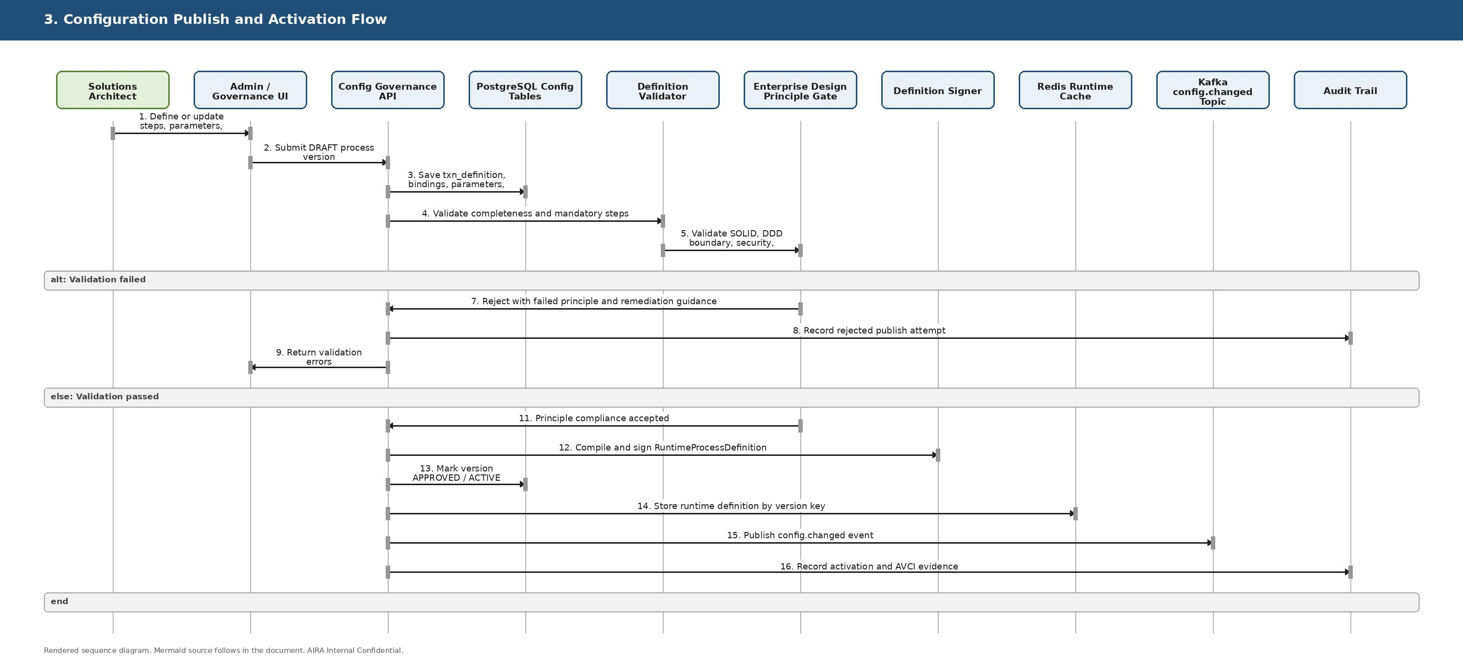
Figure 10C-3. Configuration Publish and Activation Flow
Copy-ready Mermaid source:
sequenceDiagram
autonumber
actor SA as Solutions Architect
participant UI as Admin / Governance UI
participant API as Config Governance API
participant DB as PostgreSQL Config Tables
participant VAL as Definition Validator
participant FIT as Enterprise Design Principle Gate
participant SIGN as Definition Signer
participant REDIS as Redis Runtime Cache
participant KAFKA as Kafka config.changed Topic
participant AUD as Audit Trail
SA->>UI: Define or update steps, parameters, retry, error, compensation
UI->>API: Submit DRAFT process version
API->>DB: Save txn_definition, bindings, parameters, policies
API->>VAL: Validate completeness and mandatory steps
VAL->>FIT: Validate SOLID, DDD boundary, security, testability, reversibility
alt Validation failed
FIT-->>API: Reject with failed principle and remediation guidance
API->>AUD: Record rejected publish attempt
API-->>UI: Return validation errors
else Validation passed
FIT-->>API: Principle compliance accepted
API->>SIGN: Compile and sign RuntimeProcessDefinition
API->>DB: Mark version APPROVED / ACTIVE
API->>REDIS: Store runtime definition by version key
API->>KAFKA: Publish config.changed event
API->>AUD: Record activation and AVCI evidence
end

6.4 Runtime Assembly and Cache Resolution
Purpose: Shows L1 Caffeine, L2 Redis, and PostgreSQL Tier-0 source of truth. Cache accelerates processing but never becomes authoritative.
Enterprise principle check: Before implementing or modifying this flow, validate affected SOLID duties, architecture boundaries, idempotency, fail-safe behavior, observability, testability, security, reversibility, and AVCI evidence.
Rendered sequence diagram:
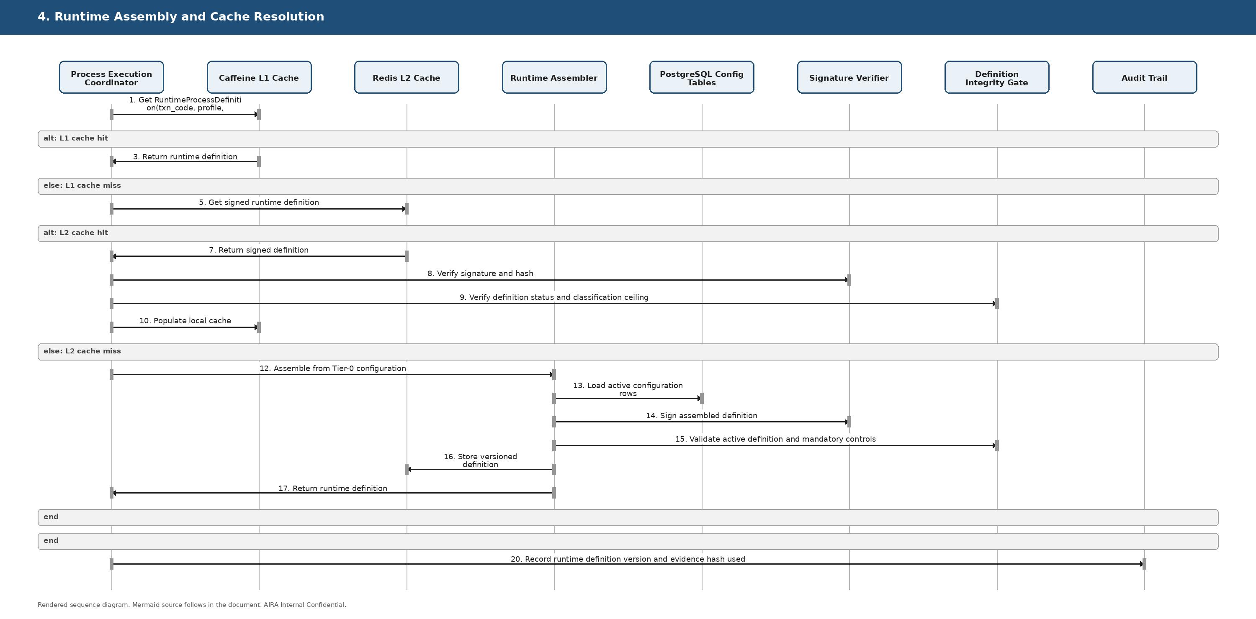
Figure 10C-4. Runtime Assembly and Cache Resolution
Copy-ready Mermaid source:
sequenceDiagram
autonumber
participant COORD as Process Execution Coordinator
participant L1 as Caffeine L1 Cache
participant L2 as Redis L2 Cache
participant ASM as Runtime Assembler
participant DB as PostgreSQL Config Tables
participant SIG as Signature Verifier
participant FIT as Definition Integrity Gate
participant AUD as Audit Trail
COORD->>L1: Get RuntimeProcessDefinition(txn_code, profile, version)
alt L1 cache hit
L1-->>COORD: Return runtime definition
else L1 cache miss
COORD->>L2: Get signed runtime definition
alt L2 cache hit
L2-->>COORD: Return signed definition
COORD->>SIG: Verify signature and hash
COORD->>FIT: Verify definition status and classification ceiling
COORD->>L1: Populate local cache
else L2 cache miss
COORD->>ASM: Assemble from Tier-0 configuration
ASM->>DB: Load active configuration rows
ASM->>SIG: Sign assembled definition
ASM->>FIT: Validate active definition and mandatory controls
ASM->>L2: Store versioned definition
ASM-->>COORD: Return runtime definition
end
end
COORD->>AUD: Record runtime definition version and evidence hash used

6.5 Standard Step Execution Envelope
Purpose: Shows the reusable envelope around every MicroFunction: security, idempotency, locking, telemetry, audit, error routing, and compensation.
Enterprise principle check: Before implementing or modifying this flow, validate affected SOLID duties, architecture boundaries, idempotency, fail-safe behavior, observability, testability, security, reversibility, and AVCI evidence.
Rendered sequence diagram:
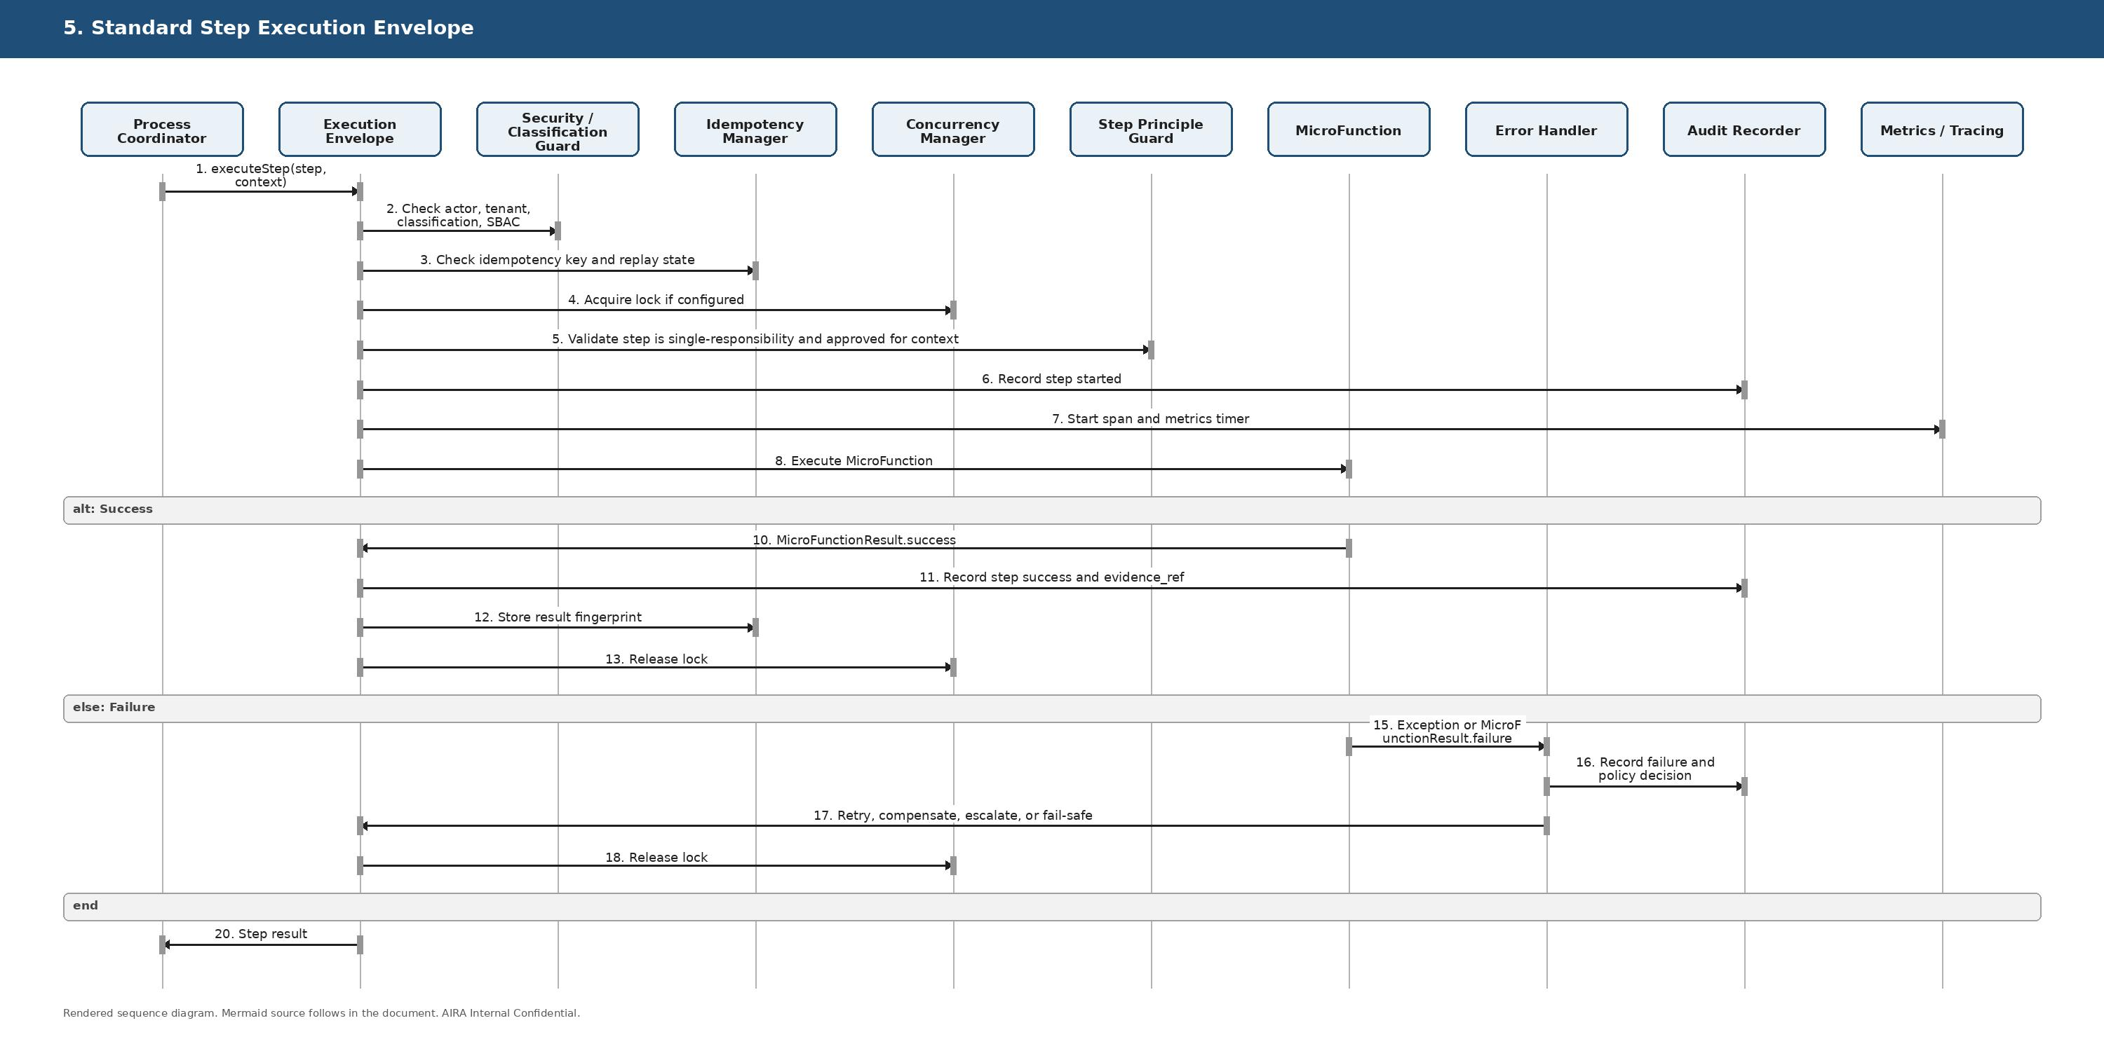
Figure 10C-5. Standard Step Execution Envelope
Copy-ready Mermaid source:
sequenceDiagram
autonumber
participant COORD as Process Coordinator
participant ENV as Execution Envelope
participant SEC as Security / Classification Guard
participant IDP as Idempotency Manager
participant LOCK as Concurrency Manager
participant FIT as Step Principle Guard
participant FUNC as MicroFunction
participant ERR as Error Handler
participant AUD as Audit Recorder
participant MET as Metrics / Tracing
COORD->>ENV: executeStep(step, context)
ENV->>SEC: Check actor, tenant, classification, SBAC
ENV->>IDP: Check idempotency key and replay state
ENV->>LOCK: Acquire lock if configured
ENV->>FIT: Validate step is single-responsibility and approved for context
ENV->>AUD: Record step started
ENV->>MET: Start span and metrics timer
ENV->>FUNC: Execute MicroFunction
alt Success
FUNC-->>ENV: MicroFunctionResult.success
ENV->>AUD: Record step success and evidence_ref
ENV->>IDP: Store result fingerprint
ENV->>LOCK: Release lock
else Failure
FUNC-->>ERR: Exception or MicroFunctionResult.failure
ERR->>AUD: Record failure and policy decision
ERR-->>ENV: Retry, compensate, escalate, or fail-safe
ENV->>LOCK: Release lock
end
ENV-->>COORD: Step result

6.6 Kafka Async Event with DLQ
Purpose: Shows CloudEvents plus idempotent consumer plus transactional execution plus DLQ for failed async events.
Enterprise principle check: Before implementing or modifying this flow, validate affected SOLID duties, architecture boundaries, idempotency, fail-safe behavior, observability, testability, security, reversibility, and AVCI evidence.
Rendered sequence diagram:
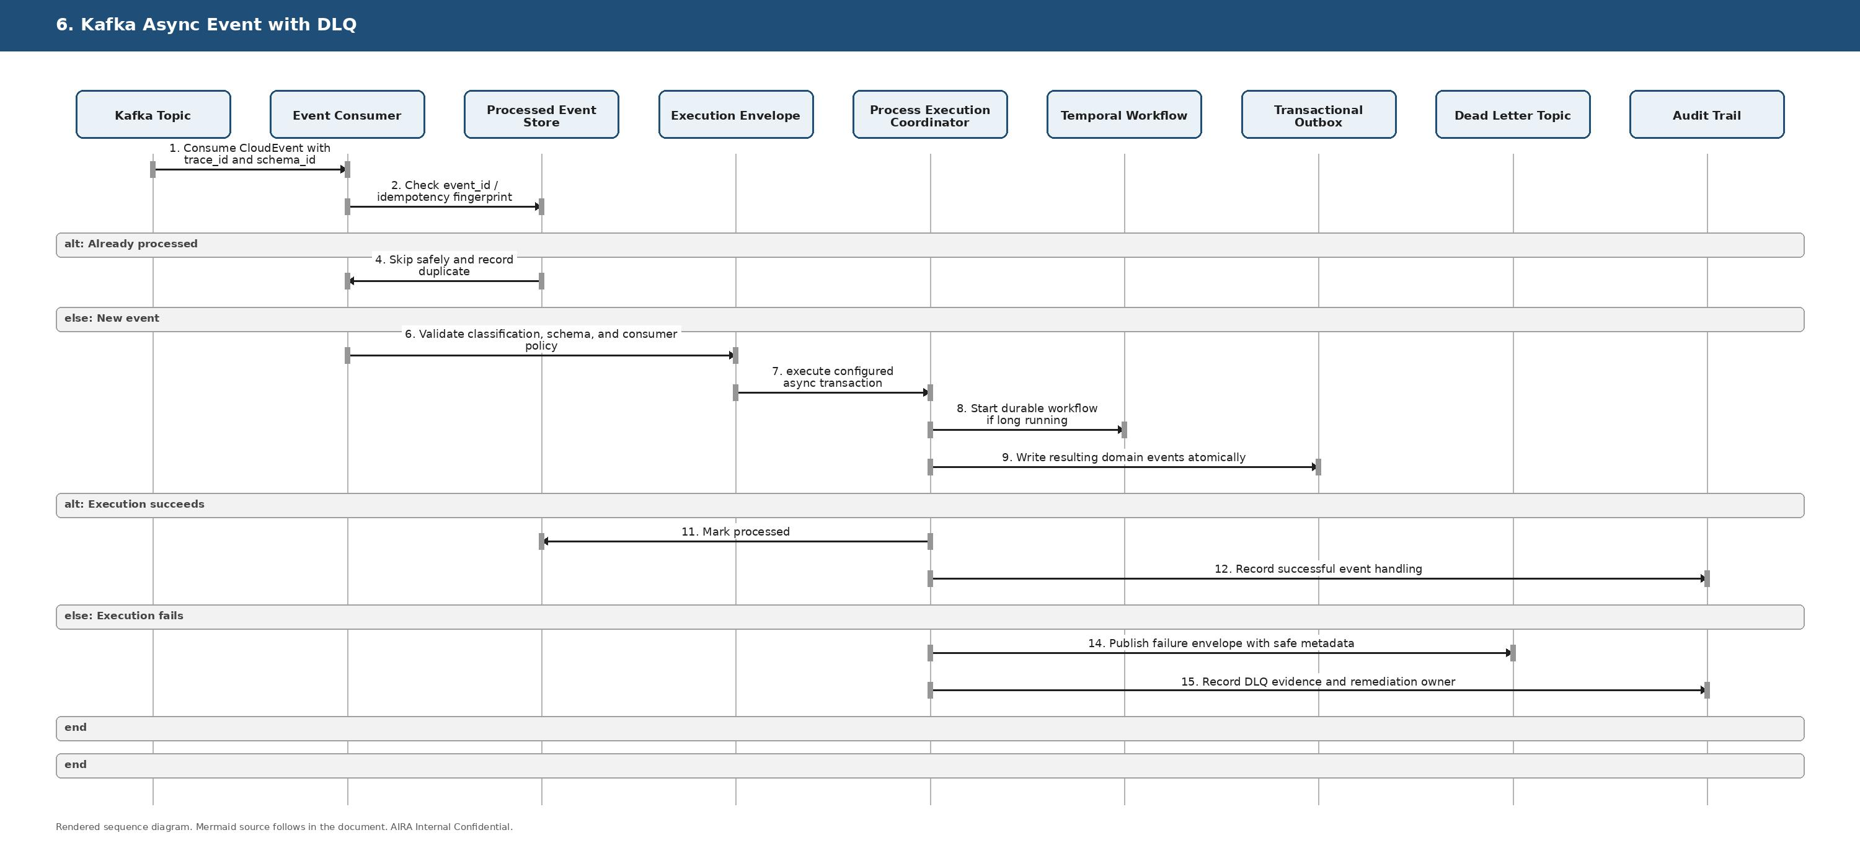
Figure 10C-6. Kafka Async Event with DLQ
Copy-ready Mermaid source:
sequenceDiagram
autonumber
participant KAFKA as Kafka Topic
participant CON as Event Consumer
participant IDP as Processed Event Store
participant ENV as Execution Envelope
participant COORD as Process Execution Coordinator
participant TEMP as Temporal Workflow
participant OUT as Transactional Outbox
participant DLQ as Dead Letter Topic
participant AUD as Audit Trail
KAFKA->>CON: Consume CloudEvent with trace_id and schema_id
CON->>IDP: Check event_id / idempotency fingerprint
alt Already processed
IDP-->>CON: Skip safely and record duplicate
else New event
CON->>ENV: Validate classification, schema, and consumer policy
ENV->>COORD: execute configured async transaction
COORD->>TEMP: Start durable workflow if long running
COORD->>OUT: Write resulting domain events atomically
alt Execution succeeds
COORD->>IDP: Mark processed
COORD->>AUD: Record successful event handling
else Execution fails
COORD->>DLQ: Publish failure envelope with safe metadata
COORD->>AUD: Record DLQ evidence and remediation owner
end
end

6.7 Temporal Machine-Durable Workflow with Compensation
Purpose: Shows long-running, retryable, machine-driven workflows with deterministic version pinning and compensating actions.
Enterprise principle check: Before implementing or modifying this flow, validate affected SOLID duties, architecture boundaries, idempotency, fail-safe behavior, observability, testability, security, reversibility, and AVCI evidence.
Rendered sequence diagram:
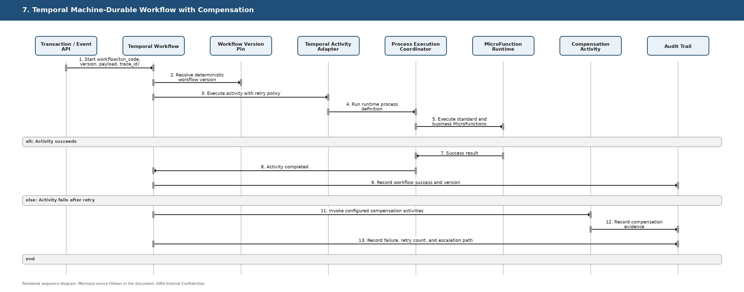
Figure 10C-7. Temporal Machine-Durable Workflow with Compensation
Copy-ready Mermaid source:
sequenceDiagram
autonumber
participant API as Transaction / Event API
participant TEMP as Temporal Workflow
participant VER as Workflow Version Pin
participant ACT as Temporal Activity Adapter
participant COORD as Process Execution Coordinator
participant FUNC as MicroFunction Runtime
participant COMP as Compensation Activity
participant AUD as Audit Trail
API->>TEMP: Start workflow(txn_code, version, payload, trace_id)
TEMP->>VER: Resolve deterministic workflow version
TEMP->>ACT: Execute activity with retry policy
ACT->>COORD: Run runtime process definition
COORD->>FUNC: Execute standard and business MicroFunctions
alt Activity succeeds
FUNC-->>COORD: Success result
COORD-->>TEMP: Activity completed
TEMP->>AUD: Record workflow success and version
else Activity fails after retry
TEMP->>COMP: Invoke configured compensation activities
COMP->>AUD: Record compensation evidence
TEMP->>AUD: Record failure, retry count, and escalation path
end

6.8 Flowable Human Approval and Exception Review
Purpose: Shows human-in-the-loop review for approval, exception handling, CAB gates, and high-risk failures.
Enterprise principle check: Before implementing or modifying this flow, validate affected SOLID duties, architecture boundaries, idempotency, fail-safe behavior, observability, testability, security, reversibility, and AVCI evidence.
Rendered sequence diagram:
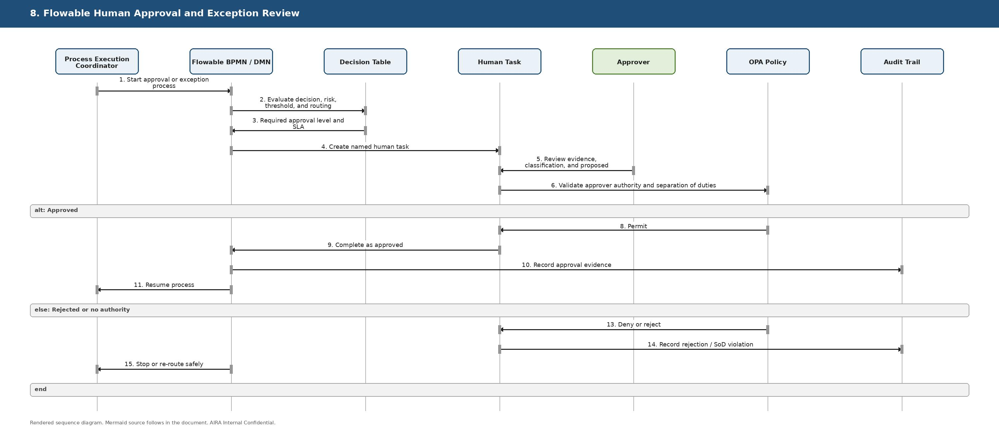
Figure 10C-8. Flowable Human Approval and Exception Review
Copy-ready Mermaid source:
sequenceDiagram
autonumber
participant COORD as Process Execution Coordinator
participant FLOW as Flowable BPMN / DMN
participant DMN as Decision Table
participant TASK as Human Task
actor APR as Approver
participant OPA as OPA Policy
participant AUD as Audit Trail
COORD->>FLOW: Start approval or exception process
FLOW->>DMN: Evaluate decision, risk, threshold, and routing
DMN-->>FLOW: Required approval level and SLA
FLOW->>TASK: Create named human task
APR->>TASK: Review evidence, classification, and proposed action
TASK->>OPA: Validate approver authority and separation of duties
alt Approved
OPA-->>TASK: Permit
TASK->>FLOW: Complete as approved
FLOW->>AUD: Record approval evidence
FLOW-->>COORD: Resume process
else Rejected or no authority
OPA-->>TASK: Deny or reject
TASK->>AUD: Record rejection / SoD violation
FLOW-->>COORD: Stop or re-route safely
end

6.9 AI/RAG and Harness-Controlled Tool Action
Purpose: Shows retrieval, four NeMo Guardrails checkpoints, LiteLLM-only model routing, and Harness/OPA/SBAC for tool execution.
Enterprise principle check: Before implementing or modifying this flow, validate affected SOLID duties, architecture boundaries, idempotency, fail-safe behavior, observability, testability, security, reversibility, and AVCI evidence.
Rendered sequence diagram:
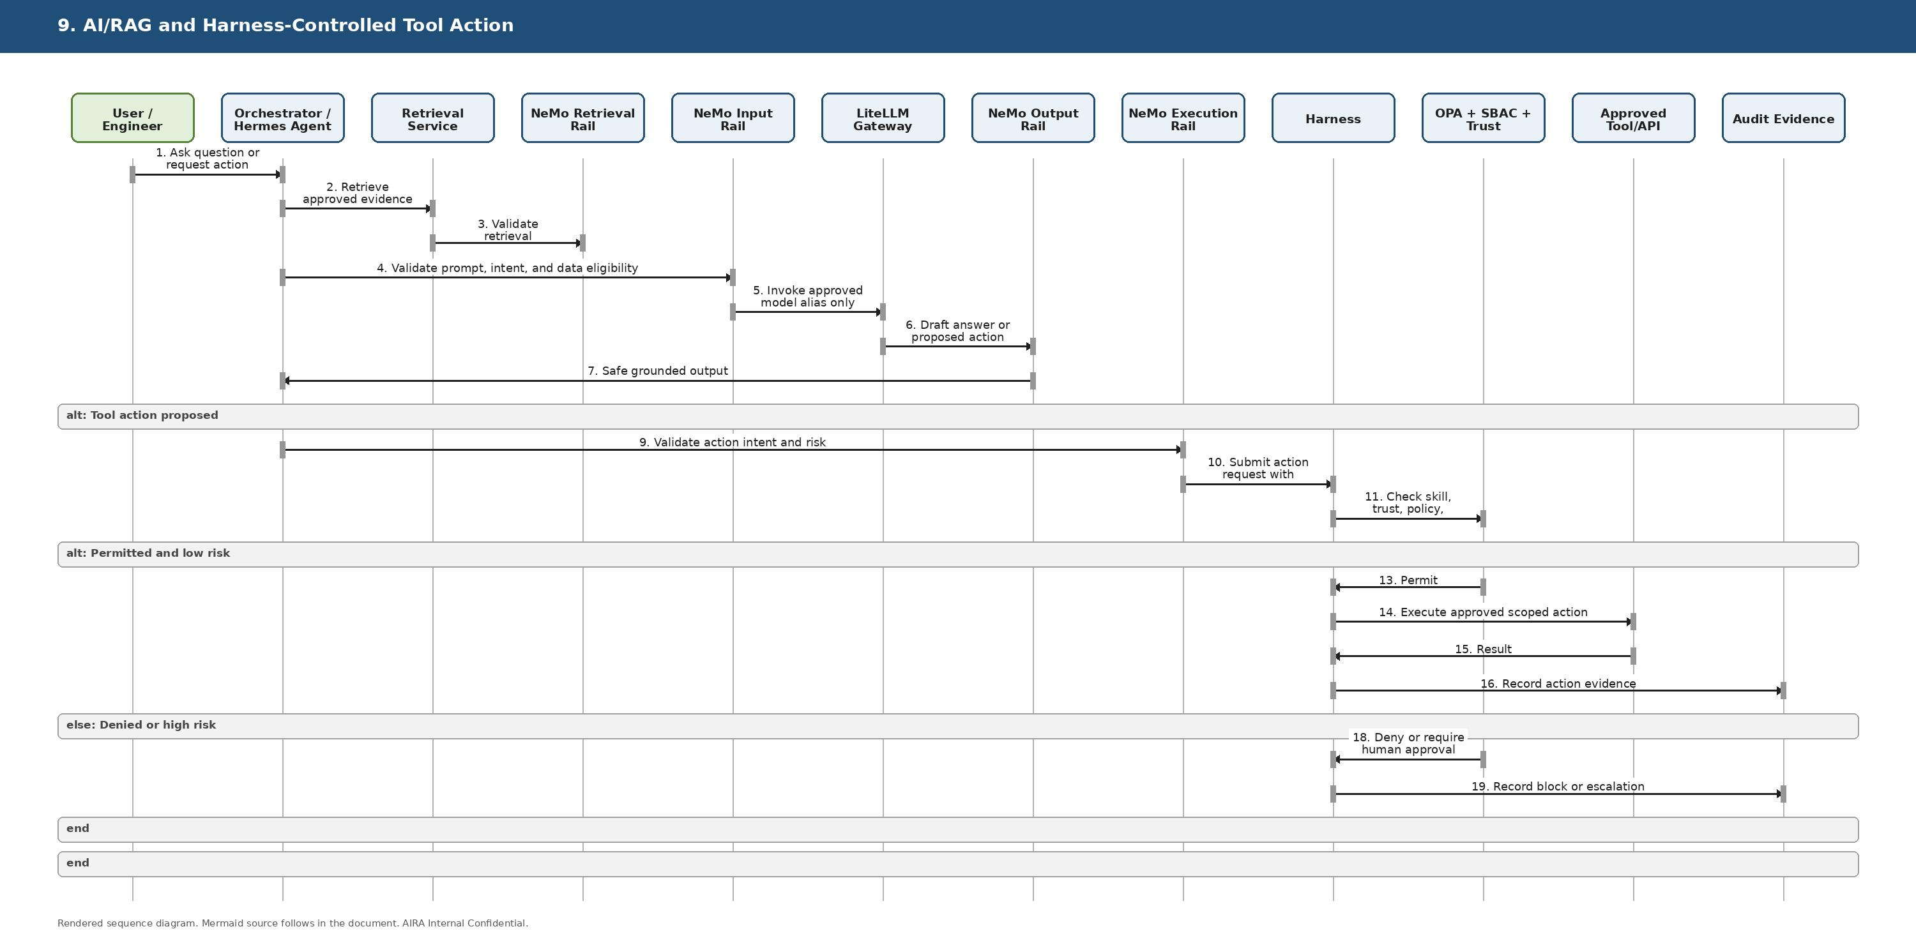
Figure 10C-9. AI/RAG and Harness-Controlled Tool Action
Copy-ready Mermaid source:
sequenceDiagram
autonumber
actor USER as User / Engineer
participant ORCH as Orchestrator / Hermes Agent
participant RET as Retrieval Service
participant GRR as NeMo Retrieval Rail
participant GRI as NeMo Input Rail
participant LLM as LiteLLM Gateway
participant GRO as NeMo Output Rail
participant GRE as NeMo Execution Rail
participant HAR as Harness
participant OPA as OPA + SBAC + Trust
participant TOOL as Approved Tool/API
participant AUD as Audit Evidence
USER->>ORCH: Ask question or request action
ORCH->>RET: Retrieve approved evidence pack
RET->>GRR: Validate retrieval relevance, classification, citation quality
ORCH->>GRI: Validate prompt, intent, and data eligibility
GRI->>LLM: Invoke approved model alias only
LLM-->>GRO: Draft answer or proposed action
GRO->>ORCH: Safe grounded output
alt Tool action proposed
ORCH->>GRE: Validate action intent and risk
GRE->>HAR: Submit action request with evidence
HAR->>OPA: Check skill, trust, policy, classification, SoD
alt Permitted and low risk
OPA-->>HAR: Permit
HAR->>TOOL: Execute approved scoped action
TOOL-->>HAR: Result
HAR->>AUD: Record action evidence
else Denied or high risk
OPA-->>HAR: Deny or require human approval
HAR->>AUD: Record block or escalation
end
end

6.10 Document Intake, Malware Scan, OCR, and Indexing
Purpose: Shows a configurable document workflow using OpenKM, malware scan, checksum, OCR, normalization, embedding, LightRAG, and LLM Wiki candidate creation.
Enterprise principle check: Before implementing or modifying this flow, validate affected SOLID duties, architecture boundaries, idempotency, fail-safe behavior, observability, testability, security, reversibility, and AVCI evidence.
Rendered sequence diagram:
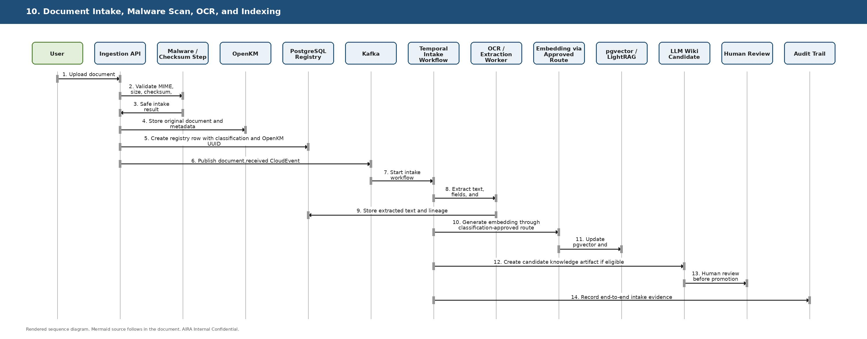
Figure 10C-10. Document Intake, Malware Scan, OCR, and Indexing
Copy-ready Mermaid source:
sequenceDiagram
autonumber
actor USER as User
participant API as Ingestion API
participant SCAN as Malware / Checksum Step
participant OKM as OpenKM
participant DB as PostgreSQL Registry
participant KAFKA as Kafka
participant TEMP as Temporal Intake Workflow
participant OCR as OCR / Extraction Worker
participant EMB as Embedding via Approved Route
participant IDX as pgvector / LightRAG
participant WIKI as LLM Wiki Candidate
participant FLOW as Human Review
participant AUD as Audit Trail
USER->>API: Upload document
API->>SCAN: Validate MIME, size, checksum, malware status
SCAN-->>API: Safe intake result
API->>OKM: Store original document and metadata
API->>DB: Create registry row with classification and OpenKM UUID
API->>KAFKA: Publish document.received CloudEvent
KAFKA->>TEMP: Start intake workflow
TEMP->>OCR: Extract text, fields, and confidence
OCR->>DB: Store extracted text and lineage
TEMP->>EMB: Generate embedding through classification-approved route
EMB->>IDX: Update pgvector and LightRAG derivative indexes
TEMP->>WIKI: Create candidate knowledge artifact if eligible
WIKI->>FLOW: Human review before promotion
TEMP->>AUD: Record end-to-end intake evidence

6.11 Runtime Customization Without Code Change
Purpose: Shows how a transaction is changed by adding/removing/reordering existing standard steps or changing parameters.
Enterprise principle check: Before implementing or modifying this flow, validate affected SOLID duties, architecture boundaries, idempotency, fail-safe behavior, observability, testability, security, reversibility, and AVCI evidence.
Rendered sequence diagram:
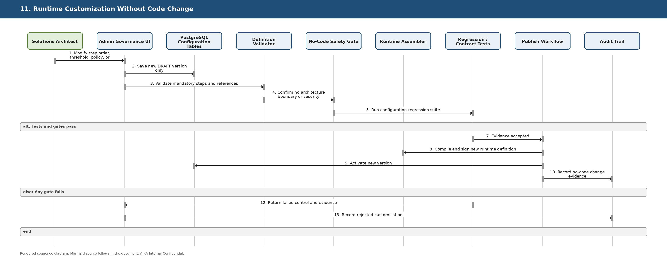
Figure 10C-11. Runtime Customization Without Code Change
Copy-ready Mermaid source:
sequenceDiagram
autonumber
actor SA as Solutions Architect
participant UI as Admin Governance UI
participant CFG as PostgreSQL Configuration Tables
participant VAL as Definition Validator
participant FIT as No-Code Safety Gate
participant ASM as Runtime Assembler
participant TEST as Regression / Contract Tests
participant PUB as Publish Workflow
participant AUD as Audit Trail
SA->>UI: Modify step order, threshold, policy, or parameter
UI->>CFG: Save new DRAFT version only
UI->>VAL: Validate mandatory steps and references
VAL->>FIT: Confirm no architecture boundary or security weakening
FIT->>TEST: Run configuration regression suite
alt Tests and gates pass
TEST-->>PUB: Evidence accepted
PUB->>ASM: Compile and sign new runtime definition
PUB->>CFG: Activate new version
PUB->>AUD: Record no-code change evidence
else Any gate fails
TEST-->>UI: Return failed control and evidence
UI->>AUD: Record rejected customization
end

6.12 Business MicroFunction Extension Pattern
Purpose: Shows the only normal coding path: create an isolated reusable STP-BUS-* function when existing standard functions and rules are insufficient.
Enterprise principle check: Before implementing or modifying this flow, validate affected SOLID duties, architecture boundaries, idempotency, fail-safe behavior, observability, testability, security, reversibility, and AVCI evidence.
Rendered sequence diagram:
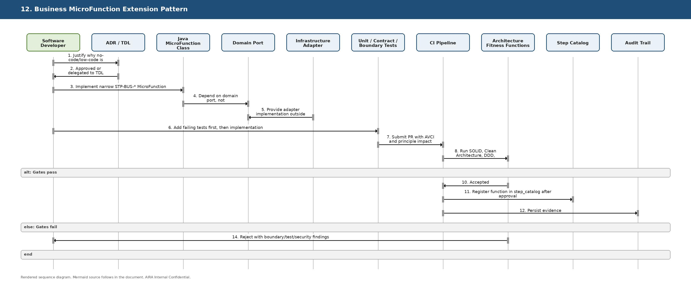
Figure 10C-12. Business MicroFunction Extension Pattern
Copy-ready Mermaid source:
sequenceDiagram
autonumber
actor DEV as Software Developer
participant ADR as ADR / TDL
participant CODE as Java MicroFunction Class
participant PORT as Domain Port
participant ADAPT as Infrastructure Adapter
participant TEST as Unit / Contract / Boundary Tests
participant CI as CI Pipeline
participant FIT as Architecture Fitness Functions
participant CAT as Step Catalog
participant AUD as Audit Trail
DEV->>ADR: Justify why no-code/low-code is insufficient
ADR-->>DEV: Approved or delegated to TDL
DEV->>CODE: Implement narrow STP-BUS-* MicroFunction
CODE->>PORT: Depend on domain port, not infrastructure detail
ADAPT-->>PORT: Provide adapter implementation outside domain core
DEV->>TEST: Add failing tests first, then implementation
TEST->>CI: Submit PR with AVCI and principle impact
CI->>FIT: Run SOLID, Clean Architecture, DDD, security, mutation gates
alt Gates pass
FIT-->>CI: Accepted
CI->>CAT: Register function in step_catalog after approval
CI->>AUD: Persist evidence
else Gates fail
FIT-->>DEV: Reject with boundary/test/security findings
end

6.13 Reconciliation, Replay, and Reprocess Operations
Purpose: Shows controlled operations for event replay, stuck workflow repair, cache rebuild, index rebuild, and state reconciliation.
Enterprise principle check: Before implementing or modifying this flow, validate affected SOLID duties, architecture boundaries, idempotency, fail-safe behavior, observability, testability, security, reversibility, and AVCI evidence.
Rendered sequence diagram:
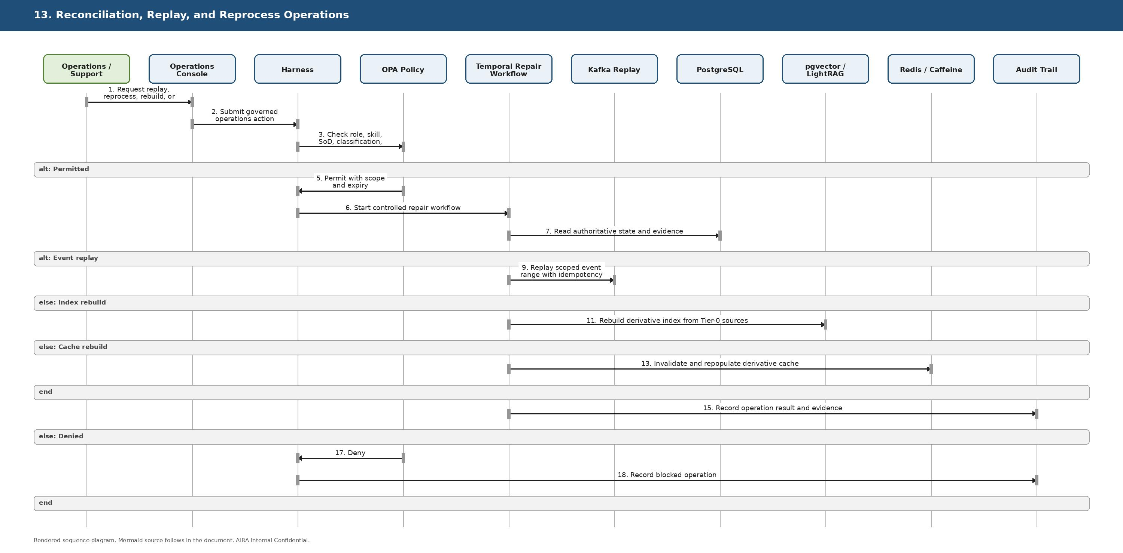
Figure 10C-13. Reconciliation, Replay, and Reprocess Operations
Copy-ready Mermaid source:
sequenceDiagram
autonumber
actor OPS as Operations / Support
participant UI as Operations Console
participant HAR as Harness
participant OPA as OPA Policy
participant TEMP as Temporal Repair Workflow
participant KAFKA as Kafka Replay
participant DB as PostgreSQL
participant IDX as pgvector / LightRAG
participant CACHE as Redis / Caffeine
participant AUD as Audit Trail
OPS->>UI: Request replay, reprocess, rebuild, or reconcile
UI->>HAR: Submit governed operations action
HAR->>OPA: Check role, skill, SoD, classification, risk
alt Permitted
OPA-->>HAR: Permit with scope and expiry
HAR->>TEMP: Start controlled repair workflow
TEMP->>DB: Read authoritative state and evidence
alt Event replay
TEMP->>KAFKA: Replay scoped event range with idempotency
else Index rebuild
TEMP->>IDX: Rebuild derivative index from Tier-0 sources
else Cache rebuild
TEMP->>CACHE: Invalidate and repopulate derivative cache
end
TEMP->>AUD: Record operation result and evidence
else Denied
OPA-->>HAR: Deny
HAR->>AUD: Record blocked operation
end

6.14 Auto-Heal Candidate Flow
Purpose: Shows how production signals become a governed remediation candidate, not an autonomous production change.
Enterprise principle check: Before implementing or modifying this flow, validate affected SOLID duties, architecture boundaries, idempotency, fail-safe behavior, observability, testability, security, reversibility, and AVCI evidence.
Rendered sequence diagram:
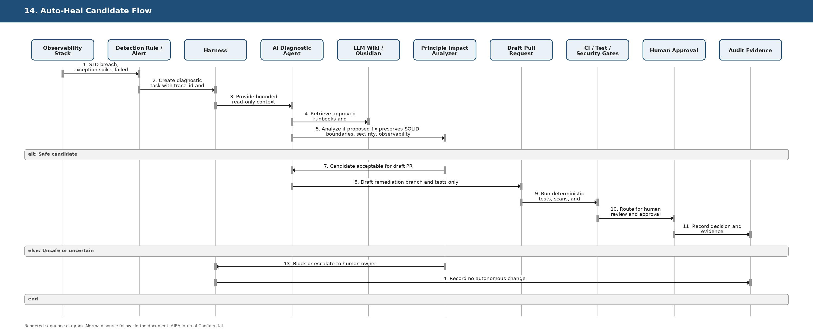
Figure 10C-14. Auto-Heal Candidate Flow
Copy-ready Mermaid source:
sequenceDiagram
autonumber
participant OBS as Observability Stack
participant ALERT as Detection Rule / Alert
participant HAR as Harness
participant AGT as AI Diagnostic Agent
participant WIKI as LLM Wiki / Obsidian
participant FIT as Principle Impact Analyzer
participant PR as Draft Pull Request
participant CI as CI / Test / Security Gates
participant FLOW as Human Approval
participant AUD as Audit Evidence
OBS->>ALERT: SLO breach, exception spike, failed job, or security signal
ALERT->>HAR: Create diagnostic task with trace_id and evidence
HAR->>AGT: Provide bounded read-only context
AGT->>WIKI: Retrieve approved runbooks and architecture rules
AGT->>FIT: Analyze if proposed fix preserves SOLID, boundaries, security, observability
alt Safe candidate
FIT-->>AGT: Candidate acceptable for draft PR
AGT->>PR: Draft remediation branch and tests only
PR->>CI: Run deterministic tests, scans, and fitness functions
CI->>FLOW: Route for human review and approval
FLOW->>AUD: Record decision and evidence
else Unsafe or uncertain
FIT-->>HAR: Block or escalate to human owner
HAR->>AUD: Record no autonomous change
end

6.15 Auto-Learn and Auto-Improve Feedback Loop
Purpose: Shows how production outcomes and human-reviewed lessons become approved LLM Wiki knowledge, prompts, guardrails, or MicroFunction configuration updates.
Enterprise principle check: Before implementing or modifying this flow, validate affected SOLID duties, architecture boundaries, idempotency, fail-safe behavior, observability, testability, security, reversibility, and AVCI evidence.
Rendered sequence diagram:
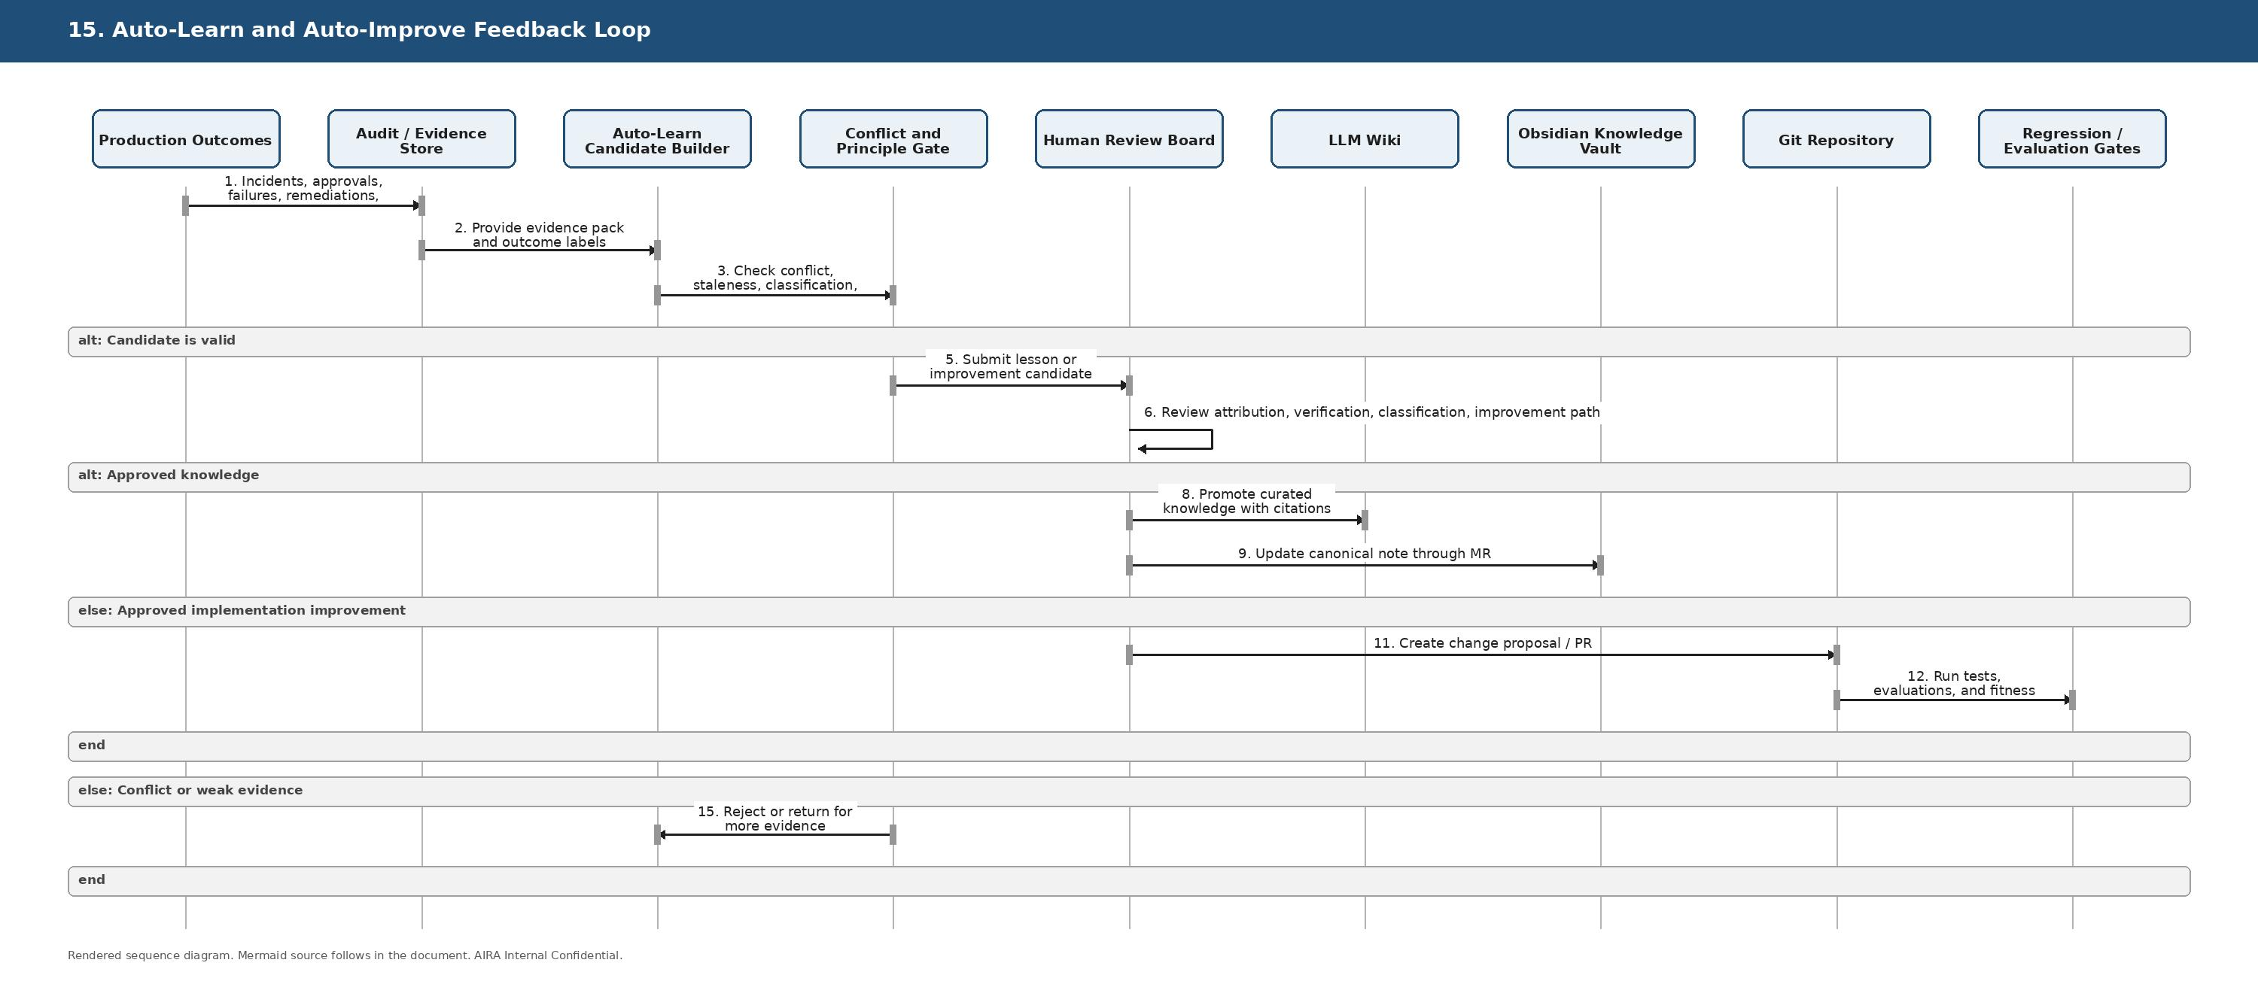
Figure 10C-15. Auto-Learn and Auto-Improve Feedback Loop
Copy-ready Mermaid source:
sequenceDiagram
autonumber
participant PROD as Production Outcomes
participant AUD as Audit / Evidence Store
participant LEARN as Auto-Learn Candidate Builder
participant FIT as Conflict and Principle Gate
participant REV as Human Review Board
participant WIKI as LLM Wiki
participant OBS as Obsidian Knowledge Vault
participant REPO as Git Repository
participant CI as Regression / Evaluation Gates
PROD->>AUD: Incidents, approvals, failures, remediations, metrics
AUD->>LEARN: Provide evidence pack and outcome labels
LEARN->>FIT: Check conflict, staleness, classification, and principle impact
alt Candidate is valid
FIT-->>REV: Submit lesson or improvement candidate
REV->>REV: Review attribution, verification, classification, improvement path
alt Approved knowledge
REV->>WIKI: Promote curated knowledge with citations
REV->>OBS: Update canonical note through MR
else Approved implementation improvement
REV->>REPO: Create change proposal / PR
REPO->>CI: Run tests, evaluations, and fitness functions
end
else Conflict or weak evidence
FIT-->>LEARN: Reject or return for more evidence
end

6.16 Configuration Change and Cache Invalidation
Purpose: Shows how a config.changed event invalidates L1/L2 cache and ensures new transactions use the active version.
Enterprise principle check: Before implementing or modifying this flow, validate affected SOLID duties, architecture boundaries, idempotency, fail-safe behavior, observability, testability, security, reversibility, and AVCI evidence.
Rendered sequence diagram:
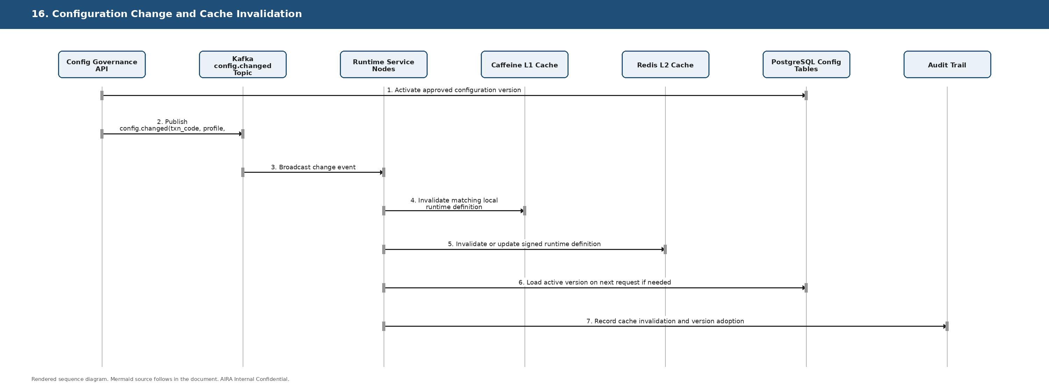
Figure 10C-16. Configuration Change and Cache Invalidation
Copy-ready Mermaid source:
sequenceDiagram
autonumber
participant API as Config Governance API
participant KAFKA as Kafka config.changed Topic
participant NODES as Runtime Service Nodes
participant L1 as Caffeine L1 Cache
participant L2 as Redis L2 Cache
participant DB as PostgreSQL Config Tables
participant AUD as Audit Trail
API->>DB: Activate approved configuration version
API->>KAFKA: Publish config.changed(txn_code, profile, version, hash)
KAFKA->>NODES: Broadcast change event
NODES->>L1: Invalidate matching local runtime definition
NODES->>L2: Invalidate or update signed runtime definition
NODES->>DB: Load active version on next request if needed
NODES->>AUD: Record cache invalidation and version adoption

6.17 Retention, Archive, Supersede, and Purge Flow
Purpose: Shows controlled lifecycle processing for documents, chunks, indexes, wiki artifacts, and audit-retained evidence.
Enterprise principle check: Before implementing or modifying this flow, validate affected SOLID duties, architecture boundaries, idempotency, fail-safe behavior, observability, testability, security, reversibility, and AVCI evidence.
Rendered sequence diagram:
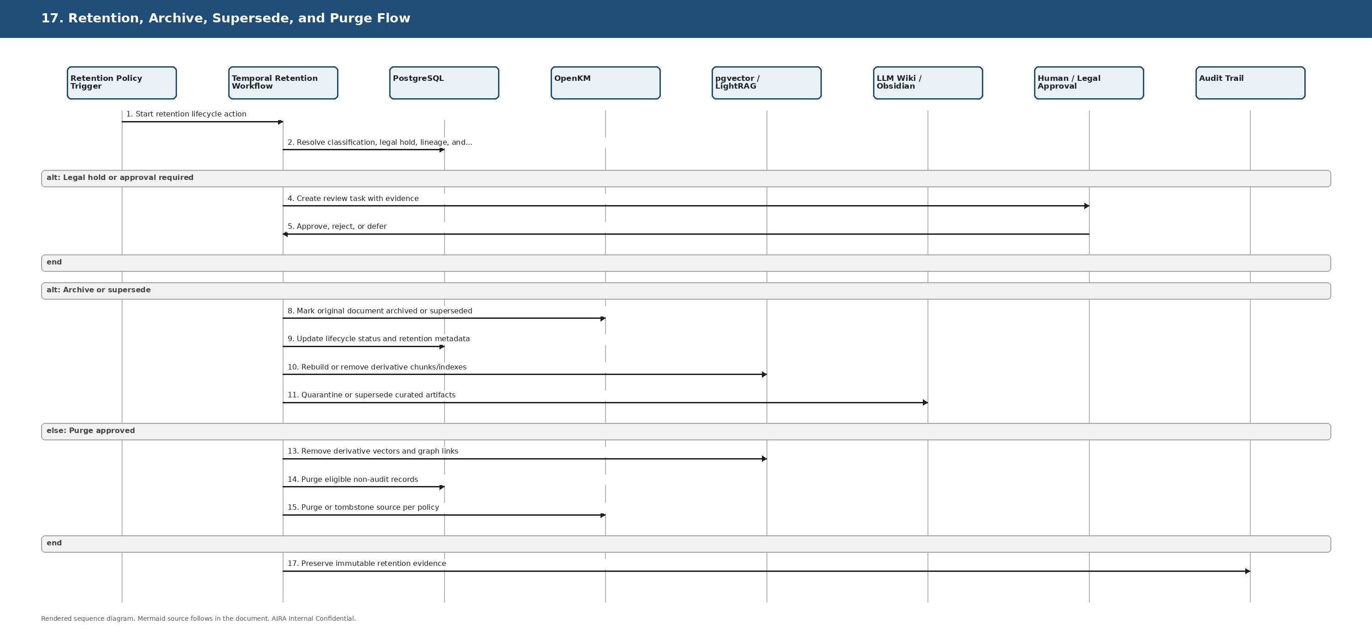
Figure 10C-17. Retention, Archive, Supersede, and Purge Flow
Copy-ready Mermaid source:
sequenceDiagram
autonumber
participant POL as Retention Policy Trigger
participant TEMP as Temporal Retention Workflow
participant DB as PostgreSQL
participant OKM as OpenKM
participant IDX as pgvector / LightRAG
participant WIKI as LLM Wiki / Obsidian
participant FLOW as Human / Legal Approval
participant AUD as Audit Trail
POL->>TEMP: Start retention lifecycle action
TEMP->>DB: Resolve classification, legal hold, lineage, and dependencies
alt Legal hold or approval required
TEMP->>FLOW: Create review task with evidence
FLOW-->>TEMP: Approve, reject, or defer
end
alt Archive or supersede
TEMP->>OKM: Mark original document archived or superseded
TEMP->>DB: Update lifecycle status and retention metadata
TEMP->>IDX: Rebuild or remove derivative chunks/indexes
TEMP->>WIKI: Quarantine or supersede curated artifacts
else Purge approved
TEMP->>IDX: Remove derivative vectors and graph links
TEMP->>DB: Purge eligible non-audit records
TEMP->>OKM: Purge or tombstone source per policy
end
TEMP->>AUD: Preserve immutable retention evidence

6.18 Observability, Audit, and Evidence Flow
Purpose: Shows how every step produces trace, metric, log, and audit evidence for AVCI, troubleshooting, and compliance.
Enterprise principle check: Before implementing or modifying this flow, validate affected SOLID duties, architecture boundaries, idempotency, fail-safe behavior, observability, testability, security, reversibility, and AVCI evidence.
Rendered sequence diagram:
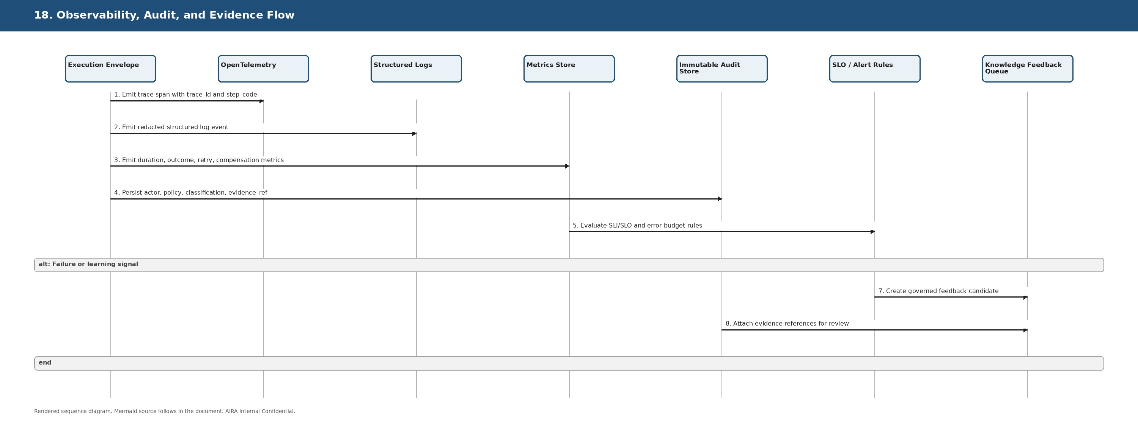
Figure 10C-18. Observability, Audit, and Evidence Flow
Copy-ready Mermaid source:
sequenceDiagram
autonumber
participant ENV as Execution Envelope
participant OTEL as OpenTelemetry
participant LOG as Structured Logs
participant MET as Metrics Store
participant AUD as Immutable Audit Store
participant SLO as SLO / Alert Rules
participant WIKI as Knowledge Feedback Queue
ENV->>OTEL: Emit trace span with trace_id and step_code
ENV->>LOG: Emit redacted structured log event
ENV->>MET: Emit duration, outcome, retry, compensation metrics
ENV->>AUD: Persist actor, policy, classification, evidence_ref
MET->>SLO: Evaluate SLI/SLO and error budget rules
alt Failure or learning signal
SLO->>WIKI: Create governed feedback candidate
AUD->>WIKI: Attach evidence references for review
end

6.19 Architecture Fitness Function CI Gate
Purpose: Shows how CI verifies SOLID, Clean Architecture, DDD, ports/adapters, testability, security, observability, and rollbackability before merge.
Enterprise principle check: Before implementing or modifying this flow, validate affected SOLID duties, architecture boundaries, idempotency, fail-safe behavior, observability, testability, security, reversibility, and AVCI evidence.
Rendered sequence diagram:
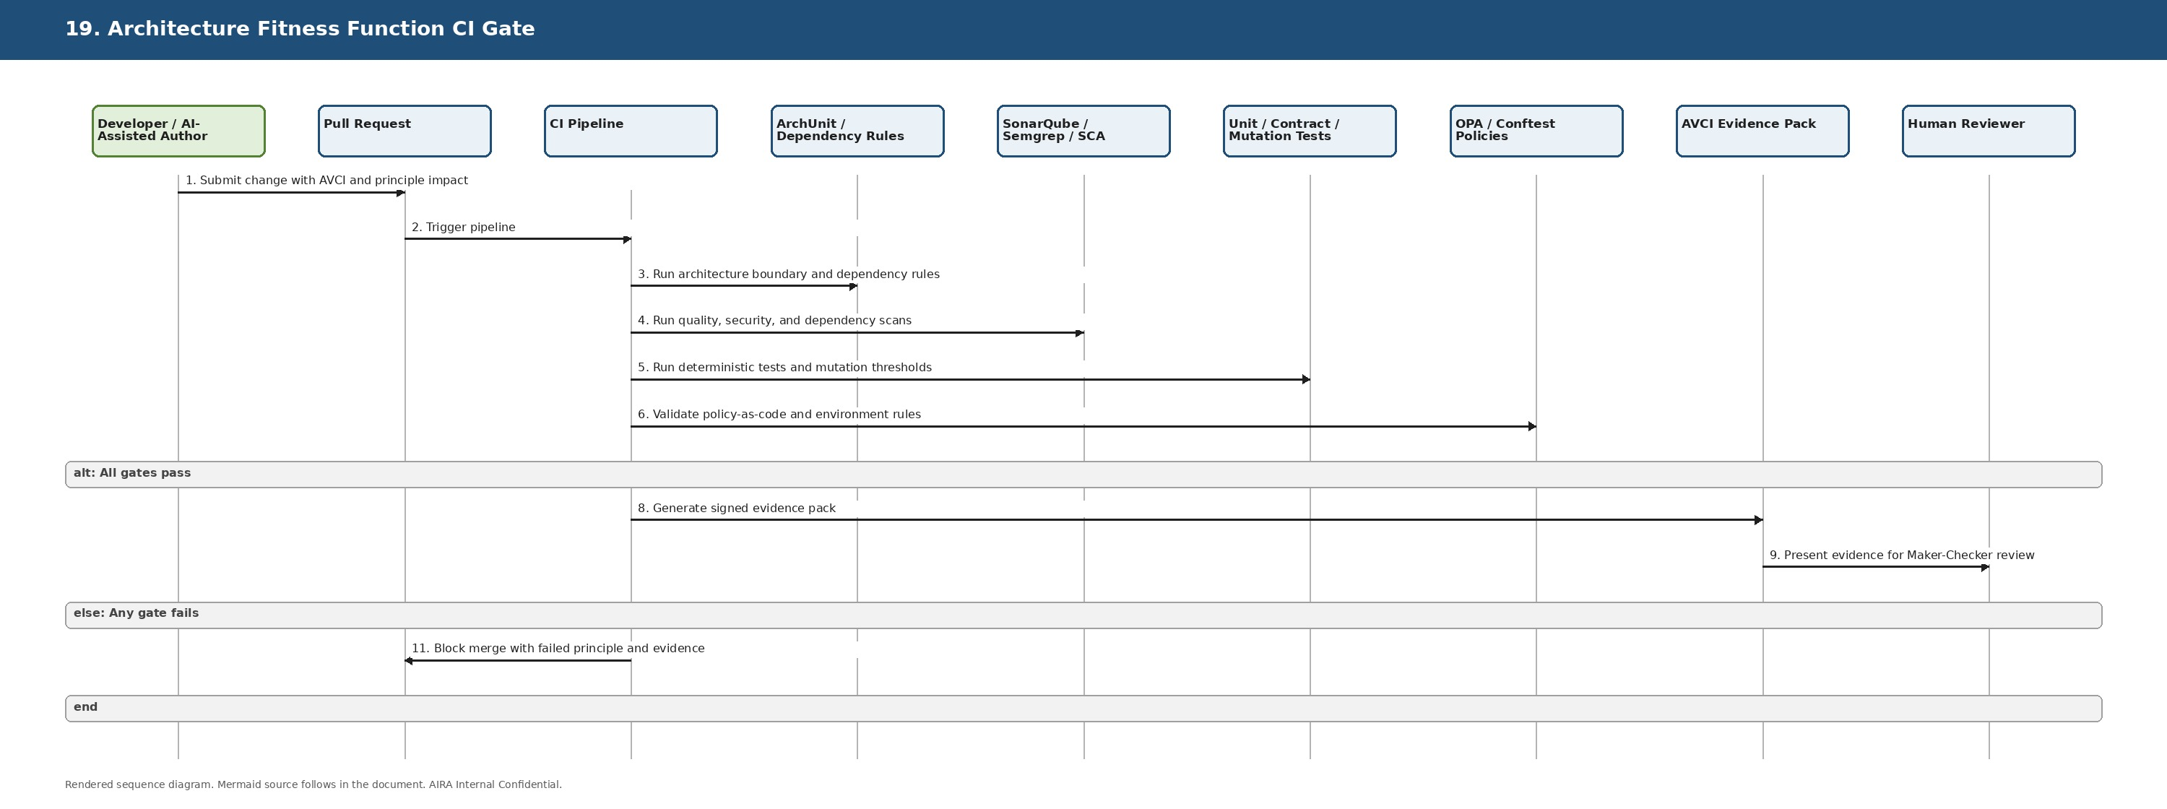
Figure 10C-19. Architecture Fitness Function CI Gate
Copy-ready Mermaid source:
sequenceDiagram
autonumber
actor DEV as Developer / AI-Assisted Author
participant PR as Pull Request
participant CI as CI Pipeline
participant ARCH as ArchUnit / Dependency Rules
participant SAST as SonarQube / Semgrep / SCA
participant TEST as Unit / Contract / Mutation Tests
participant OPA as OPA / Conftest Policies
participant EVID as AVCI Evidence Pack
participant REV as Human Reviewer
DEV->>PR: Submit change with AVCI and principle impact
PR->>CI: Trigger pipeline
CI->>ARCH: Run architecture boundary and dependency rules
CI->>SAST: Run quality, security, and dependency scans
CI->>TEST: Run deterministic tests and mutation thresholds
CI->>OPA: Validate policy-as-code and environment rules
alt All gates pass
CI->>EVID: Generate signed evidence pack
EVID->>REV: Present evidence for Maker-Checker review
else Any gate fails
CI-->>PR: Block merge with failed principle and evidence
end

6.20 SOLID and Enterprise Principle Impact Assessment
Purpose: Shows the standard review path for any AI-generated or human-authored change that affects MicroFunctions, configuration, workflows, prompts, policies, or adapters.
Enterprise principle check: Before implementing or modifying this flow, validate affected SOLID duties, architecture boundaries, idempotency, fail-safe behavior, observability, testability, security, reversibility, and AVCI evidence.
Rendered sequence diagram:
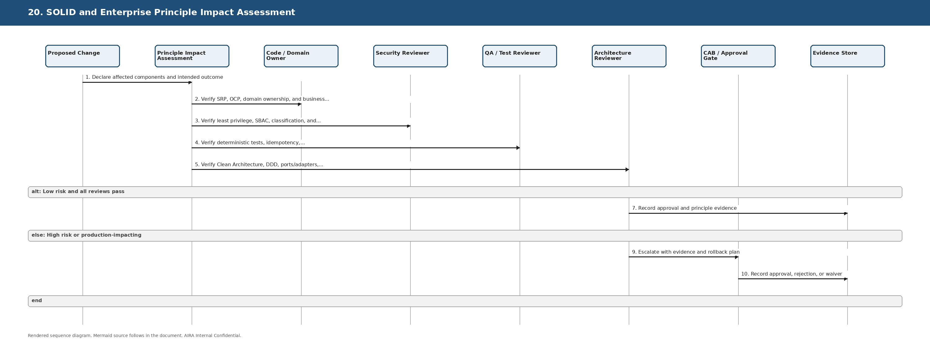
Figure 10C-20. SOLID and Enterprise Principle Impact Assessment
Copy-ready Mermaid source:
sequenceDiagram
autonumber
participant CHANGE as Proposed Change
participant ASSESS as Principle Impact Assessment
participant OWNER as Code / Domain Owner
participant SEC as Security Reviewer
participant QA as QA / Test Reviewer
participant ARCH as Architecture Reviewer
participant CAB as CAB / Approval Gate
participant AUD as Evidence Store
CHANGE->>ASSESS: Declare affected components and intended outcome
ASSESS->>OWNER: Verify SRP, OCP, domain ownership, and business correctness
ASSESS->>SEC: Verify least privilege, SBAC, classification, and fail-safe behavior
ASSESS->>QA: Verify deterministic tests, idempotency, rollback, and regression evidence
ASSESS->>ARCH: Verify Clean Architecture, DDD, ports/adapters, and reversibility
alt Low risk and all reviews pass
ARCH->>AUD: Record approval and principle evidence
else High risk or production-impacting
ARCH->>CAB: Escalate with evidence and rollback plan
CAB->>AUD: Record approval, rejection, or waiver
end

7. Developer Checklist
- Use the standard synchronous template unless the transaction is event-driven, AI-governed, document-intake, workflow-driven, or operations/reconciliation-specific.
- Do not implement logging, audit, idempotency, concurrency, cache, security, retry, compensation, or error mapping inside business code. Use standard MicroFunctions and the execution envelope.
- Business-specific Java code belongs in STP-BUS-* MicroFunctions only after configuration, DMN/rule tables, OPA policy, and existing catalog functions are insufficient.
- Every transaction definition must include error_policy_code, retry_policy_code, on_failure_step_code, timeout_ms, and compensation_step_code where applicable.
- Every state-changing transaction must be idempotent, observable, auditable, compensatable or forward-fixable, and testable.
- Every AI/RAG/tool-action flow must pass through retrieval, input, execution, and output guardrails, with LiteLLM-only model routing and Harness-mediated tool execution.
- Every diagram copied to documentation must include the Mermaid source and must identify the companion document and version used.
- Every PR/MR must include an AVCI summary and a principle impact statement when diagrams, transaction configuration, MicroFunction code, prompts, guardrails, or workflow behavior change.

8. Diagram Verification and Review Gates
Gate | Required Evidence | Reject If
Architecture boundary gate | Dependency graph, ArchUnit results, package/module review, domain ownership statement | Domain code depends on infrastructure, another bounded context is modified directly, or adapters are bypassed.
SOLID gate | Function responsibility statement, input/output contract, extension path, interface usage | Function mixes framework concerns with business logic or introduces hardcoded orchestration.
Security gate | SBAC/OPA result, classification handling, secret/PII redaction evidence, safe error behavior | Sensitive action fails open, logs leak PII/secrets, or bypasses policy/guardrail routes.
Testability gate | Unit, contract, boundary, idempotency, rollback/compensation, and negative tests | Change cannot be tested deterministically or lacks unhappy-path evidence.
Reversibility gate | Compensation, forward-fix, rollback, retry/DLQ, replay/reconcile evidence | State change has no safe recovery path.
AVCI gate | Owner, version, source, classification, verification evidence, improvement path | Any AVCI property is missing or stale.

9. RACI
Activity | Solutions Architect | Developer | QA/SDET | DevSecOps | Security | DBA | Architecture Board
Maintain diagram standard | A | C | C | C | C | C | I
Modify Mermaid source | A/R | R | C | C | C | C | I
Regenerate rendered diagram | A/R | R | C | C | C | C | I
Implement MicroFunction based on diagram | C | A/R | C | C | C | C | I
Validate tests and fitness functions | C | R | A/R | R | C | C | I
Approve architecture boundary change | R | C | C | C | C | C | A
Approve security or AI action exception | C | C | C | C | A/R | C | I
Publish updated reference | A/R | C | C | R | C | C | I

10. AVCI Compliance Summary
AVCI Property | Compliance Statement
Attributable | Each diagram has a stable title, versioned document reference, defined owner, companion documents, intended implementation audience, and rendered figure number.
Verifiable | Each diagram provides both rendered visual output and copy-ready Mermaid source so behavior can be regenerated, inspected, tested, and validated through CI and architecture review.
Classifiable | This document is Internal Confidential and intended for authorized AIRA engineering, architecture, DevSecOps, security, QA, and database roles.
Improvable | Diagram changes must be made in Mermaid source first, reviewed through MR, validated against 01A principles and fitness gates, then regenerated into DOCX/Obsidian/LLM Wiki as approved knowledge.

