pkj

pee kaluki

2023-05-26

data("airquality")  
sum(is.na(airquality))

## [1] 44

View(airquality)  
names(airquality)

## [1] "Ozone" "Solar.R" "Wind" "Temp" "Month" "Day"

ncol(airquality)

## [1] 6

summary(airquality$Ozone)

## Min. 1st Qu. Median Mean 3rd Qu. Max. NA's   
## 1.00 18.00 31.50 42.13 63.25 168.00 37

summary(airquality$Solar.R)

## Min. 1st Qu. Median Mean 3rd Qu. Max. NA's   
## 7.0 115.8 205.0 185.9 258.8 334.0 7

#get the sum of col per col  
sum(airquality$Ozone)

## [1] NA

hist(airquality$Ozone)

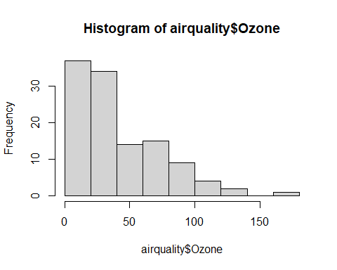

data <- data(is.na.onit)

## Warning in data(is.na.onit): data set 'is.na.onit' not found

hist(airquality$Ozone,col = "pink")

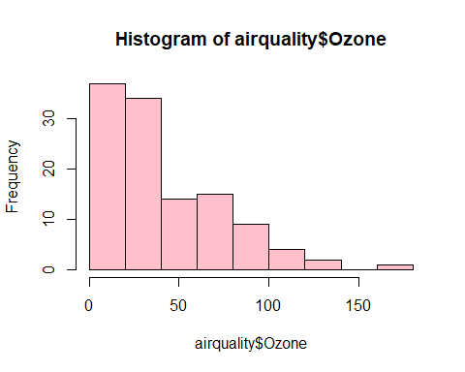

str(hist(airquality$Ozone,col = "pink"))

## List of 6  
## $ breaks : num [1:10] 0 20 40 60 80 100 120 140 160 180  
## $ counts : int [1:9] 37 34 14 15 9 4 2 0 1  
## $ density : num [1:9] 0.01595 0.01466 0.00603 0.00647 0.00388 ...  
## $ mids : num [1:9] 10 30 50 70 90 110 130 150 170  
## $ xname : chr "airquality$Ozone"  
## $ equidist: logi TRUE  
## - attr(*, "class")= chr "histogram"