
THE UNIVERSITY OF DODOMA
COLLEGE OF INFORMATICS AND VIRTUAL EDUCATION
DEPARTMENT OF COMPUTER SCIENCE AND ENGINEERING
GROUP ASSIGNMENT
GROUP NUMBER | : | 07
PBL PROJECT | : | PBL 07 - EXTERNAL INTERRUPT-BASED EMERGENCY STOP AND EVENT COUNTER SYSTEM
MODULE NAME | : | MICROCONTROLLER SYSTEMS
MODULE CODE | : | CT 321
SEMESTER | : | TWO
ACADEMIC YEAR | : | 2025 / 2026
PARTICIPANTS
S/N | NAME | REG NUMBER | PROGRAMME
1 | EZEKIEL LEMANA | T23-03-00241 | CE3
2 | HARUN KADILO | T23-03-1251 | CE3
3 | JACKSON MANDA | T23-03-18278 | CE3
4 | YASSIN JABIR | T23-03-14605 | CE3
5 | RAUFU CHIKOTA | T23-03-14017 | CE3
6 | BENJAMIN WILSON | T23-03-1236 | CE3
7 | ADOLPH CHENGE | T23-03-19243 | CE3
8 | NELSON MTAMBALIKE | T23-03-01207 | CE3
9 | EMMANUEL MOSES | T23-03-15852 | CE3

CT 321 Group Assignment - Group 07

CT 321: PBL 07 PROJECT REPORT
External Interrupt-Based Emergency Stop and Event Counter System

1. Introduction
This project presents an ATmega32-based emergency stop and event counter system. The design shows how external interrupts can be used in embedded systems when a controller must respond quickly to external events. Instead of depending only on polling, the system uses INT0, INT1 and INT2 so that emergency, counting and recovery actions are handled immediately through interrupt service routines.

2. Problem Statement
Many computer engineering control systems must react to external signals without delay. Examples include emergency stop buttons, motion sensors, object counters and alarm triggers. A polling program may miss short pulses when it is busy performing another task. For that reason, this design uses ATmega32 external interrupt pins to detect important inputs and execute the required response as soon as the event occurs.

3. Project Objectives
- To design an interrupt-based event counter using ATmega32 external interrupts.
- To use INT0 for immediate emergency-stop response.
- To use INT1 for event pulse counting during normal operation.
- To use INT2 for system recovery and count reset operation.
- To indicate system status using green LED, red LED, buzzer and serial display.
- To prepare firmware, schematic, PCB design plan, simulation tests and organized GitHub documentation.

4. Expected System Operation
Input / Event | Expected System Response
System powered ON | Green LED turns ON to show normal mode. Event count starts at 0.
Object sensor pulse detected | Event count increases by one, only if the system is in normal mode.
Start/reset button pressed | Event count resets to zero when the system is in normal mode.
Emergency stop button pressed | Red LED and buzzer turn ON immediately. Normal counting stops.
Event pulse during emergency mode | Counter value remains unchanged because emergency state overrides counting.
Recovery button pressed | Buzzer turns OFF, red LED turns OFF, and the system returns to normal mode.

5. System Block Diagram
The block diagram shows the interrupt inputs, ATmega32 controller and output indicators used in the system. The external event signals enter the controller through the external interrupt pins, and the firmware updates the outputs according to the current operating mode.
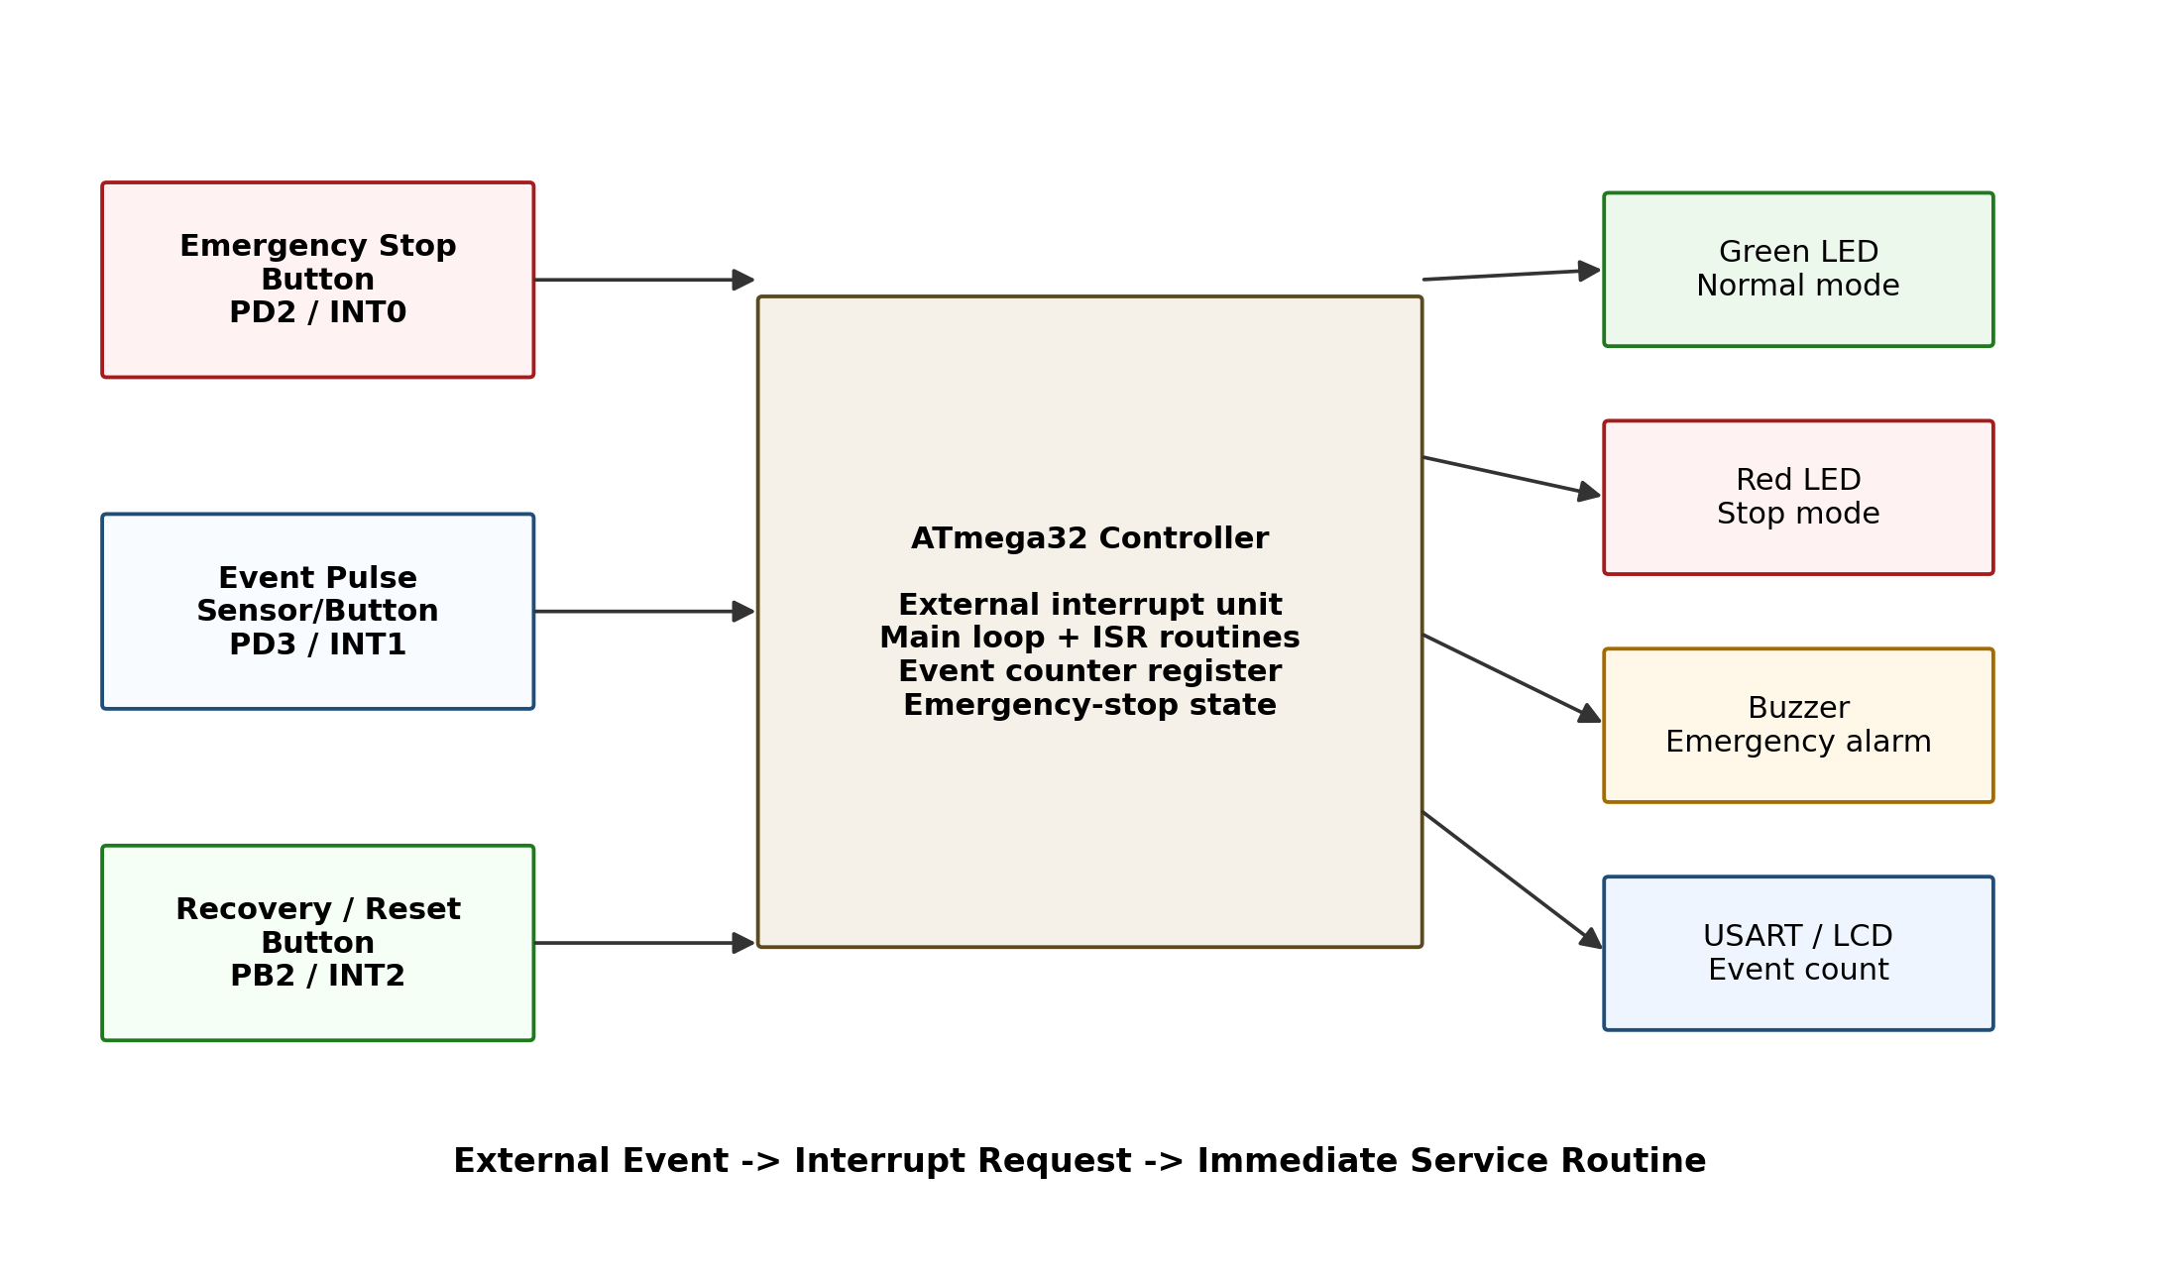
Figure 1: System block diagram.

6. Hardware Components
Component | Quantity | Purpose
ATmega32 microcontroller | 1 | Main controller and interrupt processing unit
Emergency stop push button | 1 | Immediate interrupt trigger for emergency mode
Event pulse button or sensor | 1 | External event input to be counted
Recovery/reset push button | 1 | Returns system to normal mode or resets count
Green LED | 1 | Normal mode indication
Red LED | 1 | Emergency-stop indication
Buzzer | 1 | Emergency alarm output
USART serial terminal header or LCD | 1 | Displays event count and system mode
Resistors, reset circuit, clock parts, 5 V supply | As required | Protection, stable logic, reset, clock and power filtering

7. ATmega32 Pin Mapping Table
ATmega32 Pin | Function | Connected Device | Net Label
PD2 / INT0 | External interrupt 0 | Emergency stop button | EMERGENCY_INT0
PD3 / INT1 | External interrupt 1 | Event pulse sensor/button | EVENT_INT1
PB2 / INT2 | External interrupt 2 | Recovery/reset button | RECOVERY_INT2
PB0 | Digital output | Green LED | LED_NORMAL
PB1 | Digital output | Red LED | LED_STOP
PB3 | Digital output | Buzzer driver | BUZZER
PD1 / TXD | USART transmit | Serial terminal display | SERIAL_TX
RESET | Reset input | Reset push button with pull-up resistor | RESET

8. Interrupt Trigger Selection
The buttons are connected as active-LOW inputs. The pin is normally HIGH through a pull-up resistor and becomes LOW when the button is pressed. Therefore, falling-edge triggering is selected for all three external interrupt inputs.
Interrupt | Pin | Trigger | ISR Task
INT0 | PD2 | Falling edge | Set emergency-stop mode immediately
INT1 | PD3 | Falling edge | Increment count only in normal mode
INT2 | PB2 | Falling edge | Recover from emergency mode or reset count

9. Firmware Flowchart
The firmware follows an event-driven structure. The main program initializes the hardware and updates the outputs and display. The urgent work is performed inside the interrupt service routines.
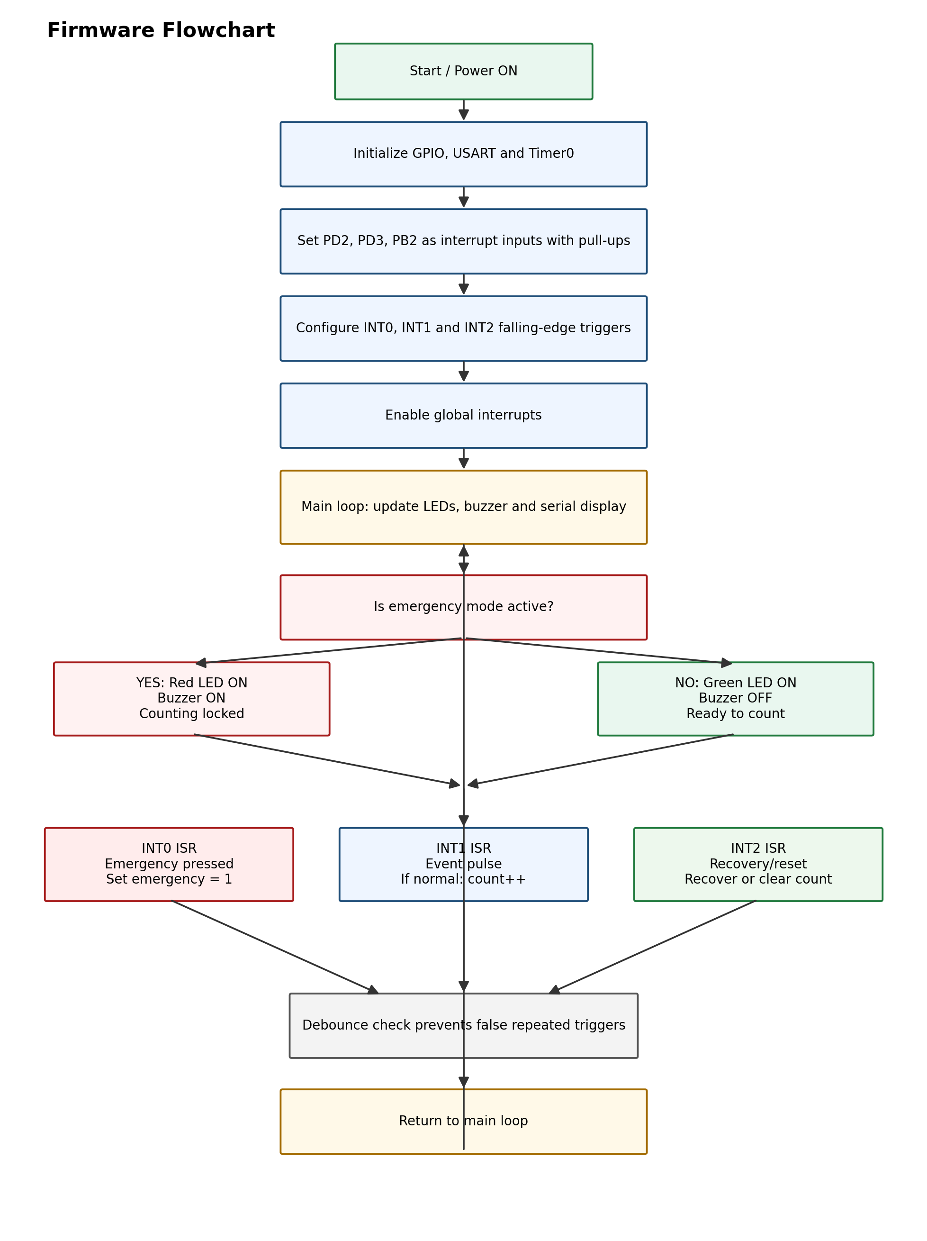
Figure 2: Firmware flowchart.

10. KiCad Schematic Design
The KiCad schematic should clearly show the ATmega32, all interrupt inputs, output indicators, buzzer driver, power pins, reset circuit and serial terminal connector. The input switches use stable logic levels so that the interrupt pins do not float.
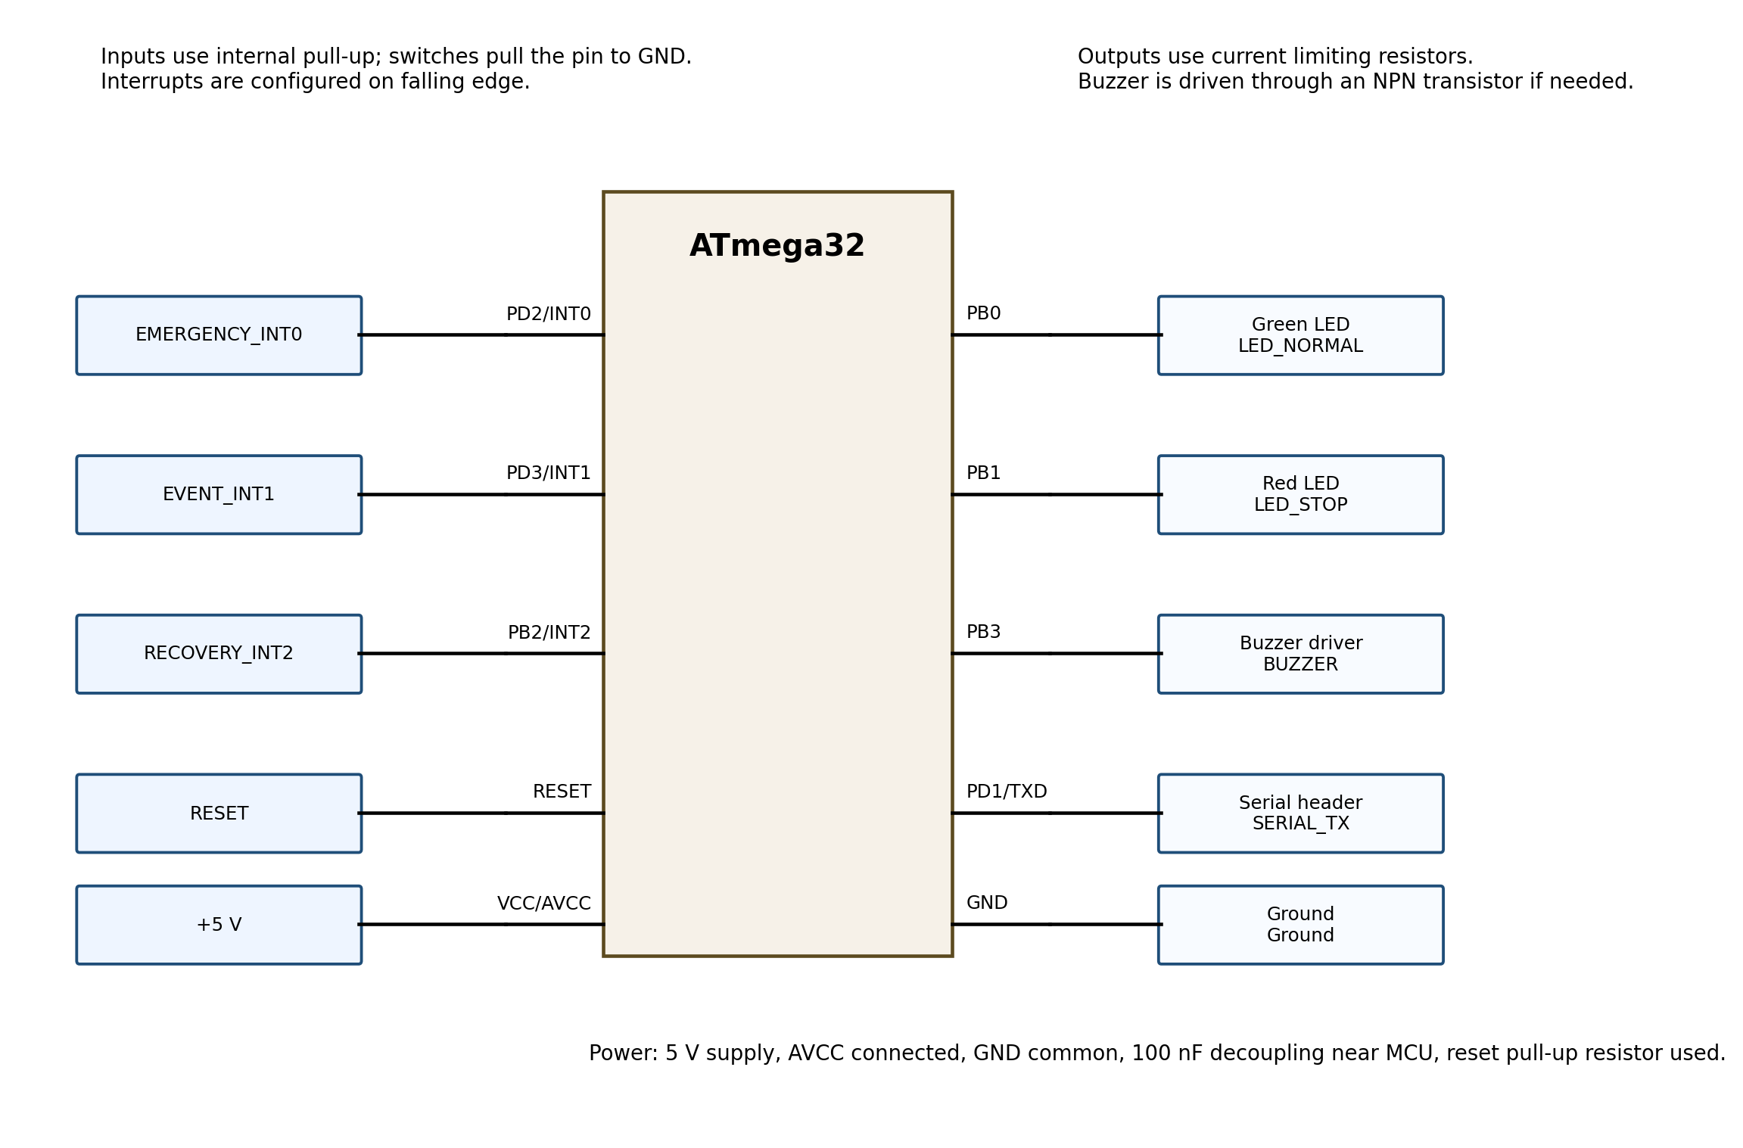
Figure 3: Schematic connection plan to be implemented in KiCad.
Schematic Part | Design Requirement Applied
ATmega32 | PD2/INT0, PD3/INT1 and PB2/INT2 are clearly shown and labelled.
Emergency stop button | Connected to INT0 with pull-up logic and net label EMERGENCY_INT0.
Event sensor/button | Connected to INT1 with stable active-LOW input and net label EVENT_INT1.
Recovery/reset button | Connected to INT2 with stable logic and net label RECOVERY_INT2.
LEDs and buzzer | LEDs use current-limiting resistors; buzzer uses transistor driver if current is high.
Display/serial header | USART TXD header is used for mode and event count display.
Reset and power | Reset pull-up, reset button, VCC, AVCC, GND and decoupling capacitors included.

11. KiCad PCB Layout and Gerber Files
The PCB layout should be produced from the completed KiCad schematic. Interrupt input connectors are placed where they can be accessed easily, output indicators are placed where they can be seen clearly, and decoupling capacitors are placed close to the microcontroller power pins.
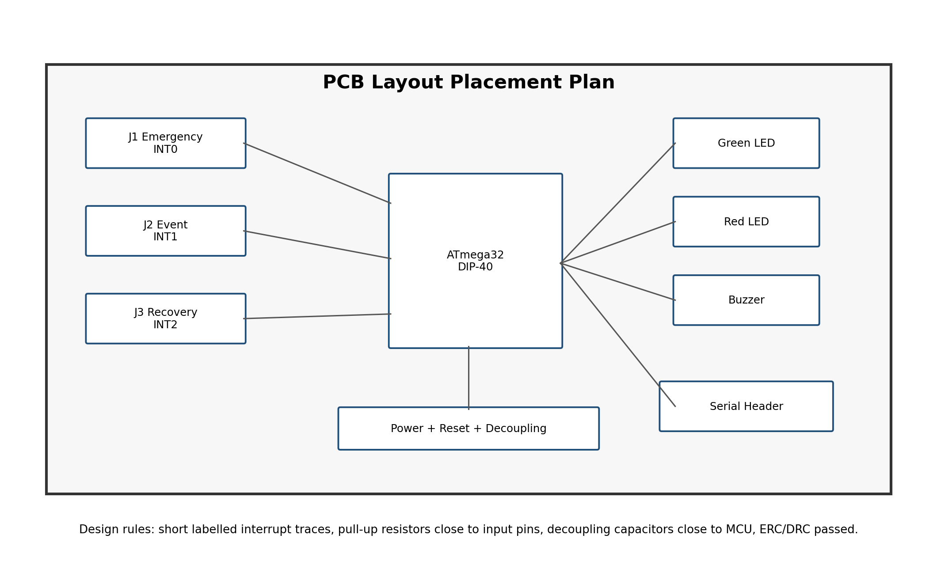
Figure 4: PCB placement plan for the KiCad layout.
PCB Requirement | How It Is Handled
Emergency button placement | Emergency connector placed near the board edge for quick access.
Interrupt input routing | INT0, INT1 and INT2 traces kept clear, short and labelled.
Indicator and buzzer placement | LEDs and buzzer placed where they are easy to observe during testing.
Power filtering | Decoupling capacitors placed close to ATmega32 VCC and AVCC pins.
Silkscreen labels | Input, output, power and serial connector labels included.
Design checks | ERC and DRC must be run before generating final files.
Output files | Gerber files exported into the kicad/gerber folder.

12. MPLAB for VS Code Firmware Design
The firmware configures the interrupt pins as inputs, enables pull-up resistors, selects falling-edge triggers and enables global interrupts. Timer0 provides a 1 ms tick used for software debouncing. The main loop updates status outputs and serial messages, while the interrupt service routines handle the real-time events.
Firmware Task | Implementation
GPIO initialization | PB0, PB1 and PB3 are outputs; PD2, PD3 and PB2 are interrupt inputs.
Interrupt setup | INT0, INT1 and INT2 are enabled in GICR.
Trigger configuration | INT0, INT1 and INT2 use falling-edge trigger for active-LOW buttons.
Global interrupt enable | sei() enables global interrupts after setup.
INT0 service routine | Sets emergency_mode = 1 immediately.
INT1 service routine | Increments event_count only if emergency_mode is not active.
INT2 service routine | Clears emergency mode, or resets count when already in normal mode.
Debouncing | Each interrupt has a 200 ms debounce window.
Display update | Serial terminal prints current mode and event count.

13. SimulIDE Simulation Procedure
The SimulIDE circuit is built using ATmega32, three push buttons or pulse inputs, two LEDs, one buzzer and a serial terminal. The compiled HEX file is loaded into the ATmega32 component. The test is then performed by pressing the buttons and observing the outputs.
- Place ATmega32 in SimulIDE and connect 5 V and GND.
- Connect the emergency button to PD2/INT0, event pulse button to PD3/INT1, and recovery/reset button to PB2/INT2.
- Connect green LED to PB0, red LED to PB1, and buzzer driver input to PB3.
- Connect TXD/PD1 to the serial terminal if serial display is used.
- Load the generated HEX file into the ATmega32 component.
- Run the simulation and test normal startup, event counting, emergency stop, lockout and recovery.
- Capture screenshots for each test condition and add them to the GitHub repository.

14. Test Cases, Expected Output and Observed Output
No. | Test Condition | Action | Expected Output | Observed Output | Result
1 | Normal startup | Power ON simulation | Green LED ON, red LED OFF, buzzer OFF, count = 0 | Green LED ON and count displayed as 0 | PASS
2 | Single event pulse | Press event input once | Counter increases by 1 | Counter changed from 0 to 1 | PASS
3 | Multiple event pulses | Press event input repeatedly | Counter follows valid pulses | Counter increased step by step | PASS
4 | Emergency stop | Press emergency button | Red LED ON and buzzer ON immediately | Red LED and buzzer activated | PASS
5 | Event during emergency | Press event input while emergency is active | Counter must not increase | Counter remained unchanged | PASS
6 | Recovery | Press recovery button | Buzzer OFF, red LED OFF, green LED ON | System returned to normal mode | PASS
7 | Reset in normal mode | Press recovery/reset button in normal mode | Count resets to zero | Count returned to 0 | PASS

15. Screenshots Required for Submission
The final GitHub repository and printed/report submission should contain screenshots of each working condition. The screenshot names below are recommended so that the repository remains organized.
Screenshot File Name | Condition to Capture | What Must Be Visible
01_normal_startup.png | Normal startup | Green LED ON, red LED OFF, buzzer OFF, count = 0
02_single_event_count.png | One event pulse | Count increased by one
03_multiple_event_count.png | Several event pulses | Count increased correctly
04_emergency_stop.png | Emergency button pressed | Red LED and buzzer ON
05_counting_lockout.png | Event pulse during emergency | Count not increasing
06_recovery_mode.png | Recovery button pressed | Green LED ON and alarm OFF

16. GitHub Repository Organization
The project files should be uploaded in an organized GitHub repository. This makes it easy for the instructor to find the firmware, KiCad files, Gerber output, SimulIDE circuit, screenshots and documentation.
ATmega32_External_Interrupt_Event_System/
|
├── README.md
├── firmware/
│ ├── src/main.c
│ ├── include/
│ └── hex/emergency_event_counter.hex
├── kicad/
│ ├── schematic/
│ ├── pcb/
│ └── gerber/
├── simulide/
│ ├── circuit/
│ └── screenshots/
├── documentation/
│ ├── block_diagram.png
│ ├── firmware_flowchart.png
│ ├── interrupt_configuration.md
│ ├── pin_mapping_table.md
│ └── test_results.md
└── media/
└── demonstration_video_link.txt
Recommended commits include: created external interrupt project repository, added INT0 emergency-stop firmware, added INT1 event counter routine, added INT2 recovery routine, added KiCad schematic, added PCB layout and Gerber files, added SimulIDE screenshots, and added final test results.

17. Discussion
The project demonstrates that external interrupts are suitable for real-time input detection. INT0 is used for the most urgent event because the emergency-stop response must override all normal activity. INT1 is used for event counting because external pulses should be captured even when the main loop is updating the display. INT2 is used for recovery/reset so that the system can be returned to a safe normal state without restarting the microcontroller.
The safety logic is important. During emergency mode, the counter is intentionally locked so that event pulses do not change the count. This prevents normal operation from continuing while the emergency state is active. Debouncing is also necessary because mechanical switches can create several quick transitions during a single press.

18. Conclusion
The designed ATmega32 system successfully combines external interrupt handling, event counting and emergency-stop control. The system enters normal mode after startup, counts external event pulses through INT1, enters emergency-stop mode through INT0, and recovers or resets through INT2. The design also includes clear pin mapping, firmware flow, KiCad schematic planning, PCB layout planning, SimulIDE test procedure, test results and GitHub repository organization. This makes the project ready for practical simulation, documentation and demonstration.

Appendix A: Complete Firmware Source Code
/*
* CT 321 PBL 07
* Project: External Interrupt-Based Emergency Stop and Event Counter System
* Target MCU: ATmega32
* Clock: 8 MHz
* IDE: MPLAB for VS Code / AVR-GCC compatible toolchain
*
* INT0 (PD2): Emergency stop button, active LOW
* INT1 (PD3): Event pulse sensor/button, active LOW
* INT2 (PB2): Recovery/reset button, active LOW
* PB0: Green LED, PB1: Red LED, PB3: Buzzer
* PD1/TXD: Serial output for event count
*/

#define F_CPU 8000000UL

#include <avr/io.h>
#include <avr/interrupt.h>
#include <stdint.h>

#define DEBOUNCE_MS 200UL
#define LED_NORMAL PB0
#define LED_STOP PB1
#define BUZZER PB3

volatile uint16_t event_count = 0;
volatile uint8_t emergency_mode = 0;
volatile uint8_t display_update_required = 1;
volatile uint32_t system_ms = 0;
volatile uint32_t last_int0_ms = 0;
volatile uint32_t last_int1_ms = 0;
volatile uint32_t last_int2_ms = 0;

static void uart_send_char(char c)
{
while (!(UCSRA & (1 << UDRE))) {
;
}
UDR = c;
}

static void uart_send_text(const char *text)
{
while (*text) {
uart_send_char(*text++);
}
}

static void uart_send_uint16(uint16_t value)
{
char buffer[6];
uint8_t index = 0;

if (value == 0) {
uart_send_char('0');
return;
}

while (value > 0 && index < sizeof(buffer)) {
buffer[index++] = (value % 10) + '0';
value = value / 10;
}

while (index > 0) {
uart_send_char(buffer[--index]);
}
}

static void uart_init(void)
{
/* 9600 baud at 8 MHz, normal speed: UBRR = 51 */
UBRRH = 0;
UBRRL = 51;
UCSRB = (1 << TXEN);
UCSRC = (1 << URSEL) | (1 << UCSZ1) | (1 << UCSZ0);
}

static void timer0_init(void)
{
/* CTC mode, prescaler 64. 8 MHz / 64 = 125 kHz; OCR0 = 124 gives 1 ms. */
TCCR0 = (1 << WGM01) | (1 << CS01) | (1 << CS00);
OCR0 = 124;
TIMSK |= (1 << OCIE0);
}

static void gpio_init(void)
{
/* Interrupt inputs with internal pull-up resistors enabled. */
DDRD &= ~((1 << PD2) | (1 << PD3));
PORTD |= (1 << PD2) | (1 << PD3);

DDRB &= ~(1 << PB2);
PORTB |= (1 << PB2);

/* Output pins for LEDs and buzzer. */
DDRB |= (1 << LED_NORMAL) | (1 << LED_STOP) | (1 << BUZZER);
PORTB &= ~((1 << LED_NORMAL) | (1 << LED_STOP) | (1 << BUZZER));
}

static void external_interrupts_init(void)
{
/* INT0 falling edge: ISC01 = 1, ISC00 = 0 */
MCUCR |= (1 << ISC01);
MCUCR &= ~(1 << ISC00);

/* INT1 falling edge: ISC11 = 1, ISC10 = 0 */
MCUCR |= (1 << ISC11);
MCUCR &= ~(1 << ISC10);

/* INT2 falling edge: ISC2 = 0 */
MCUCSR &= ~(1 << ISC2);

/* Clear any pending interrupt flags before enabling. */
GIFR |= (1 << INTF0) | (1 << INTF1) | (1 << INTF2);

/* Enable INT0, INT1 and INT2. */
GICR |= (1 << INT0) | (1 << INT1) | (1 << INT2);
}

static void update_outputs(uint8_t emergency)
{
if (emergency) {
PORTB &= ~(1 << LED_NORMAL);
PORTB |= (1 << LED_STOP) | (1 << BUZZER);
} else {
PORTB |= (1 << LED_NORMAL);
PORTB &= ~((1 << LED_STOP) | (1 << BUZZER));
}
}

static void print_status(uint16_t count, uint8_t emergency)
{
uart_send_text("Mode: ");
uart_send_text(emergency ? "EMERGENCY STOP" : "NORMAL");
uart_send_text(" | Count: ");
uart_send_uint16(count);
uart_send_text("\r\n");
}

ISR(TIMER0_COMP_vect)
{
system_ms++;
}

ISR(INT0_vect)
{
uint32_t now = system_ms;

if ((now - last_int0_ms) >= DEBOUNCE_MS) {
emergency_mode = 1;
display_update_required = 1;
last_int0_ms = now;
}
}

ISR(INT1_vect)
{
uint32_t now = system_ms;

if ((now - last_int1_ms) >= DEBOUNCE_MS) {
if (!emergency_mode) {
event_count++;
display_update_required = 1;
}
last_int1_ms = now;
}
}

ISR(INT2_vect)
{
uint32_t now = system_ms;

if ((now - last_int2_ms) >= DEBOUNCE_MS) {
if (emergency_mode) {
emergency_mode = 0;
} else {
event_count = 0;
}
display_update_required = 1;
last_int2_ms = now;
}
}

int main(void)
{
uint16_t local_count;
uint8_t local_emergency;

gpio_init();
uart_init();
timer0_init();
external_interrupts_init();

sei();

uart_send_text("ATmega32 External Interrupt Event Counter System\r\n");

while (1) {
if (display_update_required) {
cli();
local_count = event_count;
local_emergency = emergency_mode;
display_update_required = 0;
sei();

update_outputs(local_emergency);
print_status(local_count, local_emergency);
}
}

return 0;
}

