
THE UNIVERSITY OF DODOMA
COLLEGE OF INFORMATICS AND VIRTUAL EDUCATION
DEPARTMENT OF COMPUTER SCIENCE AND ENGINEERING
GROUP ASSIGNMENT REPORT
GROUP NUMBER: 07
MODULE NAME: MICROCONTROLLER SYSTEMS
MODULE CODE: CT 321
SEMESTER: TWO
ACADEMIC YEAR: 2025 / 2026
PBL TITLE: EXTERNAL INTERRUPT-BASED EMERGENCY STOP AND EVENT COUNTER SYSTEM
PARTICIPANTS
S/N | NAME | REG NUMBER | PROGRAMME
1 | EZEKIEL LEMANA | T23-03-00241 | CE3
2 | HARUN KADILO | T23-03-01251 | CE3
3 | JACKSON MANDA | T23-03-18278 | CE3
4 | YASSIN JABIR | T23-03-14605 | CE3

1. Introduction
Many embedded systems must react immediately to external events such as emergency stop buttons, object detection sensors, alarms, or motion triggers. A polling-based program may miss short input pulses if the processor is busy with another task. External interrupts solve this problem by allowing the microcontroller to stop normal execution temporarily and run a service routine when an important event occurs.
This project demonstrates how ATmega32 external interrupts can be used to build a safe event-driven system. The system counts external event pulses in normal mode, enters emergency-stop mode when the emergency button is pressed, prevents counting during emergency mode, and returns to normal operation using a recovery/reset button.

2. Problem Statement and Objectives
The problem is to design a controller that can count normal events while still responding immediately to an emergency condition. The emergency input must dominate the normal counting operation so that the system stops counting and activates alarm indicators without delay.

2.1 Objectives
- To design an ATmega32-based event counter using external interrupts.
- To implement immediate emergency-stop response using INT0.
- To count event pulses during normal mode using INT1.
- To recover from emergency mode and reset the count using INT2.
- To indicate system state using green LED, red LED, buzzer, and UART serial output.
- To design the schematic and PCB layout in KiCad and generate Gerber files.
- To verify the system using SimulIDE screenshots and a demonstration video.

3. Expected System Operation
Input / Event | Expected Response
System powered ON | Green LED ON, red LED OFF, buzzer OFF, serial shows NORMAL mode with count 0.
Object/event pulse detected | Event count increases only when the system is in normal mode.
Emergency stop button pressed | System enters EMERGENCY STOP mode; red LED and buzzer turn ON; counting stops.
Event pulse during emergency | Event count does not increase.
Recovery button pressed during emergency | System returns to NORMAL mode and keeps the current count.
Recovery/reset button pressed in normal mode | Event count resets to zero.

4. System Design

4.1 System Block Diagram
The block diagram shows the external interrupt inputs, ATmega32 controller, output indicators, buzzer, serial terminal, and 5 V power supply used in the system.
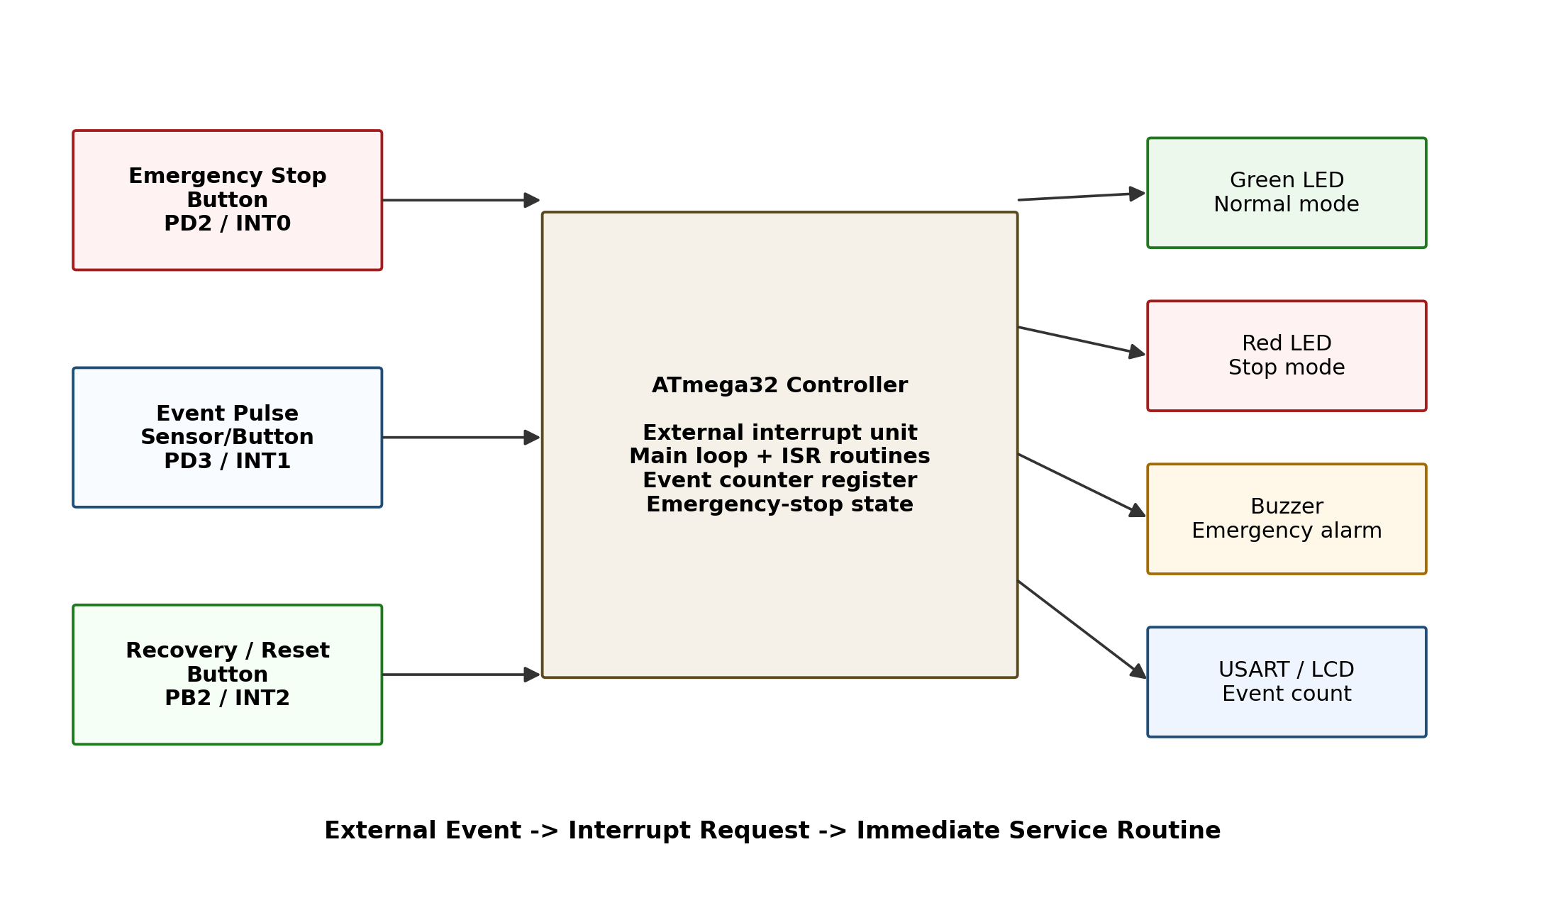
Figure 1: System block diagram.

4.2 Components Used
Component | Quantity | Purpose
ATmega32 / ATmega32A | 1 | Main microcontroller and interrupt controller.
Emergency stop push button | 1 | Triggers INT0 and starts emergency mode.
Event pulse button / sensor | 1 | Triggers INT1 and increments the event count.
Recovery/reset push button | 1 | Triggers INT2; recovers from emergency or resets count.
MCU reset button | 1 | Hardware reset for the ATmega32.
Green LED | 1 | Normal mode indicator.
Red LED | 1 | Emergency stop indicator.
Active buzzer | 1 | Emergency alarm output.
NPN transistor and 1 kOhm resistor | 1 set | Buzzer driver stage.
330 Ohm resistors | 2 | LED current limiting.
10 kOhm resistors | 4 | RESET and interrupt input pull-up resistors.
8 MHz crystal and 22 pF capacitors | 1 set | External clock circuit.
100 nF capacitors | 2 | VCC and AVCC decoupling.
3-pin serial header | 1 | +5V, serial TX, and GND connection.

4.3 ATmega32 Pin Mapping
ATmega32 Pin | DIP Pin | Direction | Net / Function | Connected Device
PB0 | 1 | Output | LED_NORMAL | R2 330 Ohm -> Green LED -> GND
PB1 | 2 | Output | LED_STOP | R3 330 Ohm -> Red LED -> GND
PB2 / INT2 | 3 | Input | RECOVERY_INT2 | SW3 -> GND, R7 10 kOhm -> +5V
PB3 | 4 | Output | BUZZER | R4 1 kOhm -> Q1 base -> Buzzer driver
RESET | 9 | Input | RESET | R1 10 kOhm -> +5V, reset button -> GND
VCC | 10 | Power | +5V | Digital supply and decoupling
GND | 11 | Power | GND | Ground zone
XTAL1 | 13 | Input | XTAL1 | 8 MHz crystal and C3 22 pF
XTAL2 | 14 | Output | XTAL2 | 8 MHz crystal and C4 22 pF
PD1 / TXD | 15 | Output | SERIAL_TX | J1 pin 2, UART 9600 baud
PD2 / INT0 | 16 | Input | EMERGENCY_INT0 | SW1 -> GND, R5 10 kOhm -> +5V
PD3 / INT1 | 17 | Input | EVENT_INT1 | SW2 -> GND, R6 10 kOhm -> +5V
AVCC | 30 | Power | +5V | Analog/digital supply and decoupling
GND | 31 | Power | GND | Ground zone

5. Interrupt and Firmware Design

5.1 Interrupt Configuration
The input buttons are wired as active-LOW inputs. The inputs are normally HIGH through pull-up resistors and become LOW when a button is pressed. Therefore, falling-edge triggering is used for INT0, INT1, and INT2.
Interrupt | MCU Pin | Trigger | Firmware Action
INT0 | PD2 | Falling edge | Set emergency_mode = 1; red LED and buzzer ON; counting locked.
INT1 | PD3 | Falling edge | Increment event_count only if emergency_mode == 0.
INT2 | PB2 | Falling edge | If emergency, recover to normal; if normal, reset count to 0.

5.2 Firmware Flowchart
The firmware initializes GPIO, UART, Timer0, and the three external interrupts. The main loop updates outputs and serial messages, while the ISRs handle urgent events.
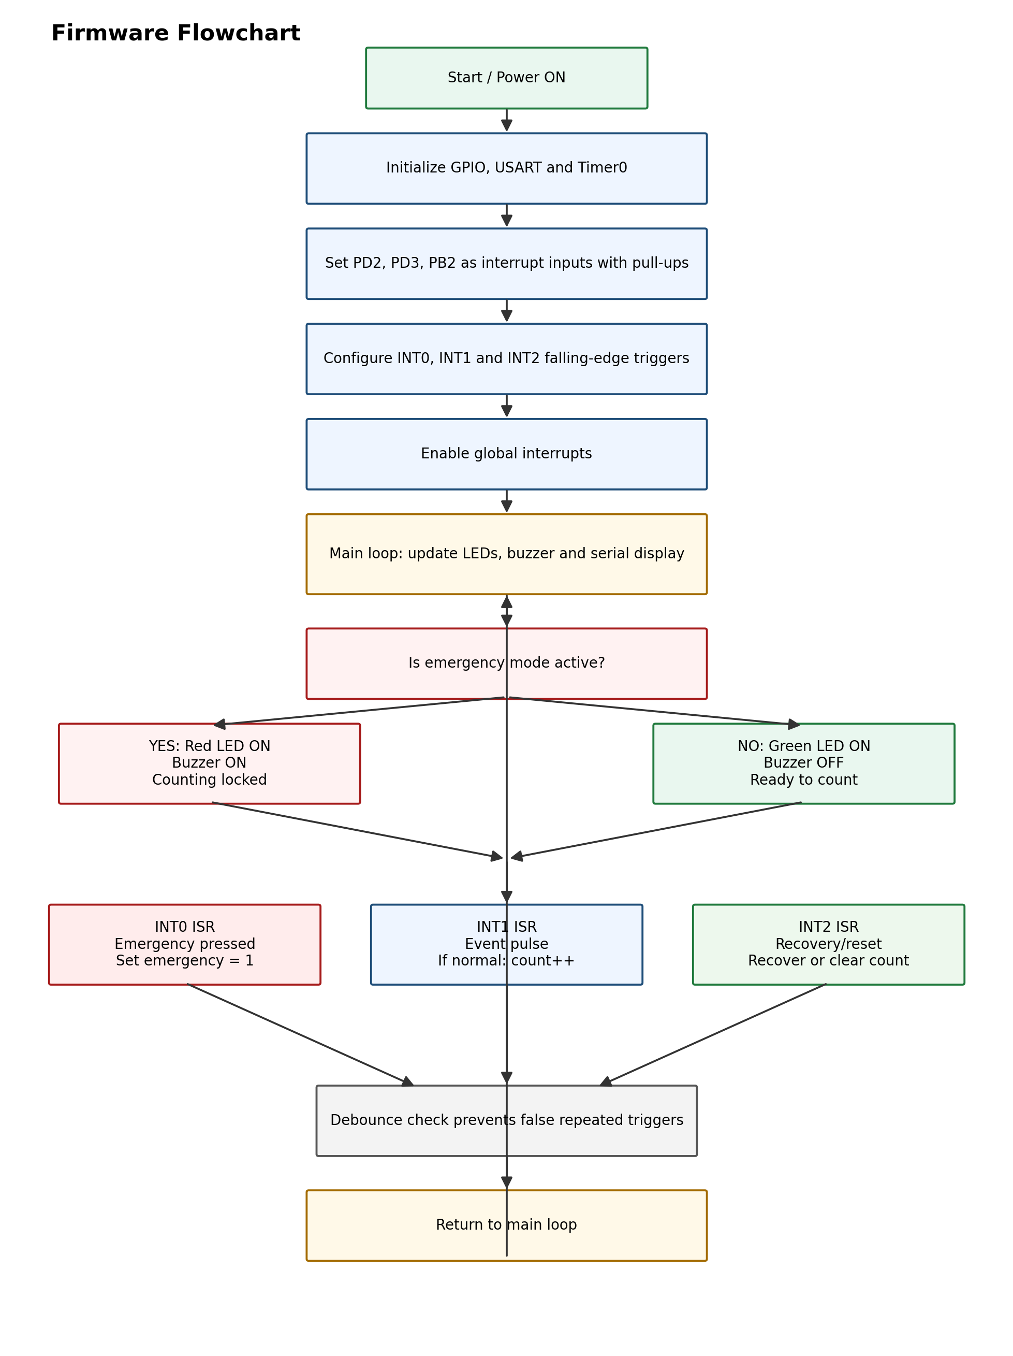
Figure 2: Firmware flowchart.

5.3 Key Firmware Logic
Timer0 generates a 1 ms system tick. A 200 ms debounce window is applied separately to each external interrupt to prevent false multiple triggers caused by mechanical button bounce.
#define DEBOUNCE_MS 200UL
#define HEARTBEAT_MS 1000UL
INT0: emergency stop
INT1: event count only in normal mode
INT2: recovery/reset

5.4 Interrupt Service Routine Summary
ISR(INT0_vect) -> emergency_mode = 1;
ISR(INT1_vect) -> if (!emergency_mode) event_count++;
ISR(INT2_vect) -> if emergency: emergency_mode = 0; else: event_count = 0;
The final compiled HEX file used in simulation is `firmware/hex/emergency_event_counter.hex`. The verified build used an 8 MHz clock and produced approximately 1403 bytes of flash use and 80 bytes of SRAM use.

6. KiCad Schematic and PCB Design
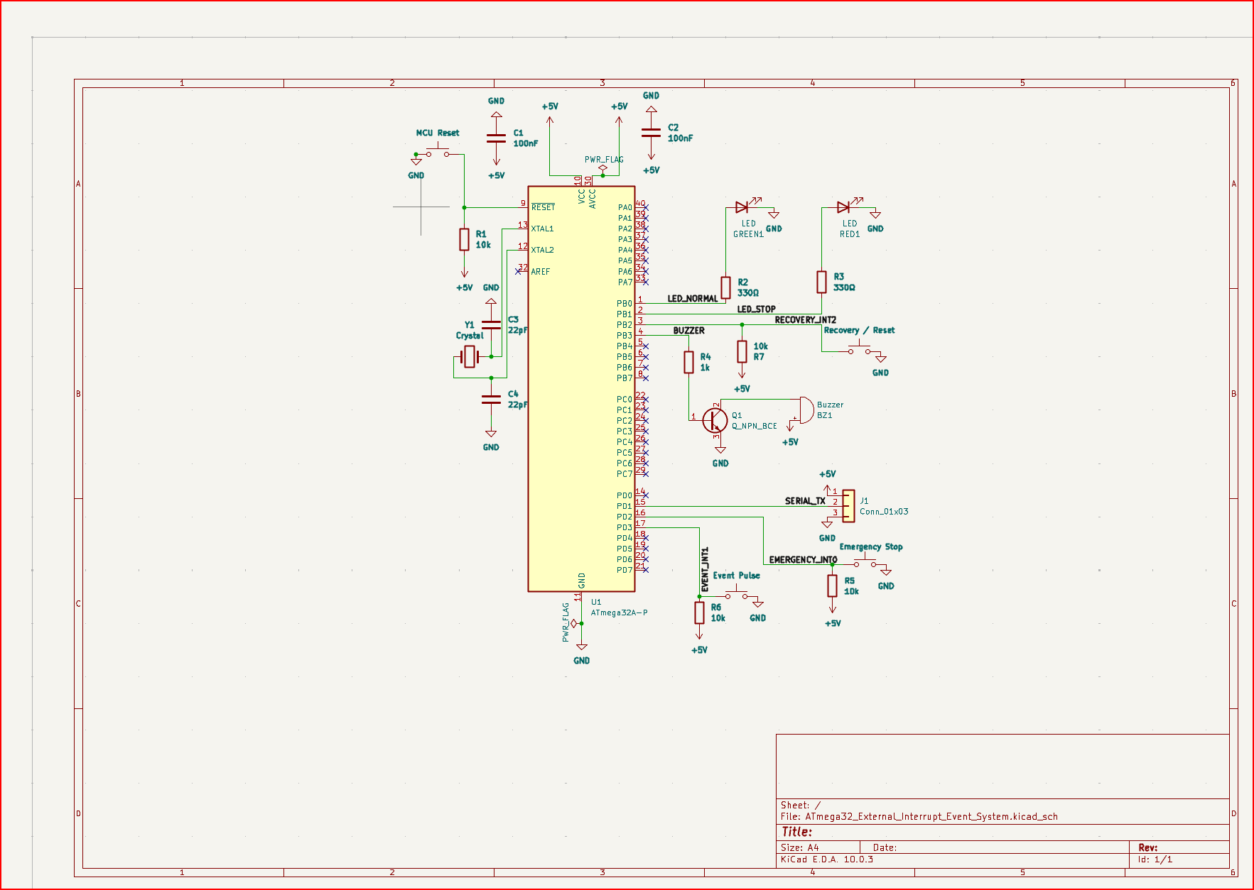
Figure 3: Final KiCad schematic.

PCB Layout
The PCB layout was routed using KiCad. A B.Cu copper zone was used for GND and an F.Cu copper zone was used for +5V. Interrupt input traces, output traces, and the serial header are labelled through the schematic net names.
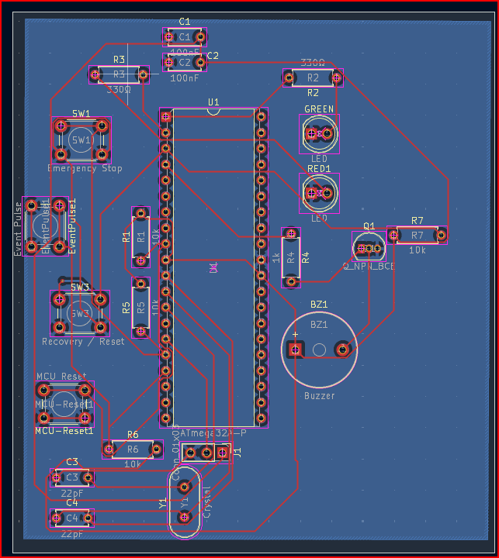
Figure 4: Final KiCad PCB layout.

Design Rule Check and Gerber Output
The final PCB passed KiCad DRC with zero violations, zero unconnected items, zero errors, and zero warnings. Gerber and drill files were exported and stored in `kicad/gerber/`.
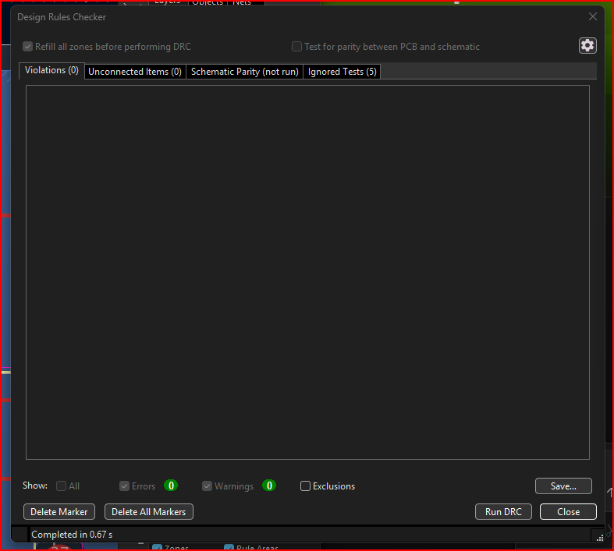
Figure 5: KiCad DRC result showing zero violations and zero unconnected items.
Gerber / Drill Output | Location
Front copper | kicad/gerber/*-F_Cu.gbr
Back copper | kicad/gerber/*-B_Cu.gbr
Solder mask and silkscreen | kicad/gerber/*-Mask.gbr and *-Silkscreen.gbr
Board outline | kicad/gerber/*-Edge_Cuts.gbr
Drill files | kicad/gerber/*-PTH.drl and *-NPTH.drl
Gerber zip | kicad/gerber/ATmega32_Gerber_Files.zip

PCB 3D-VIEW

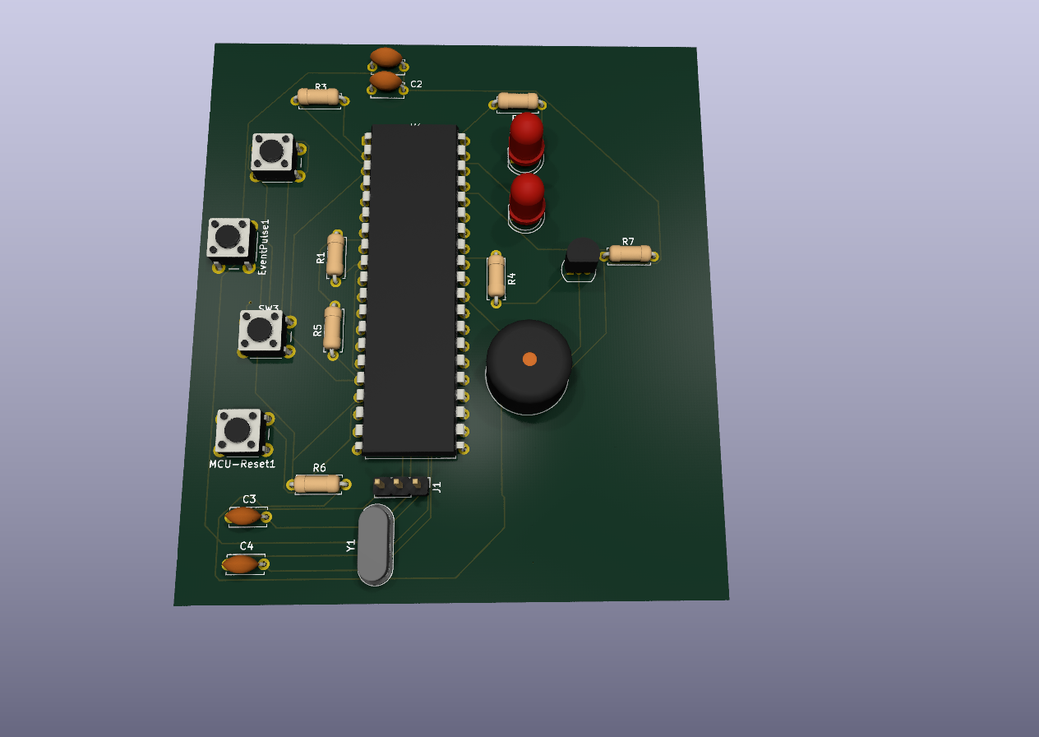

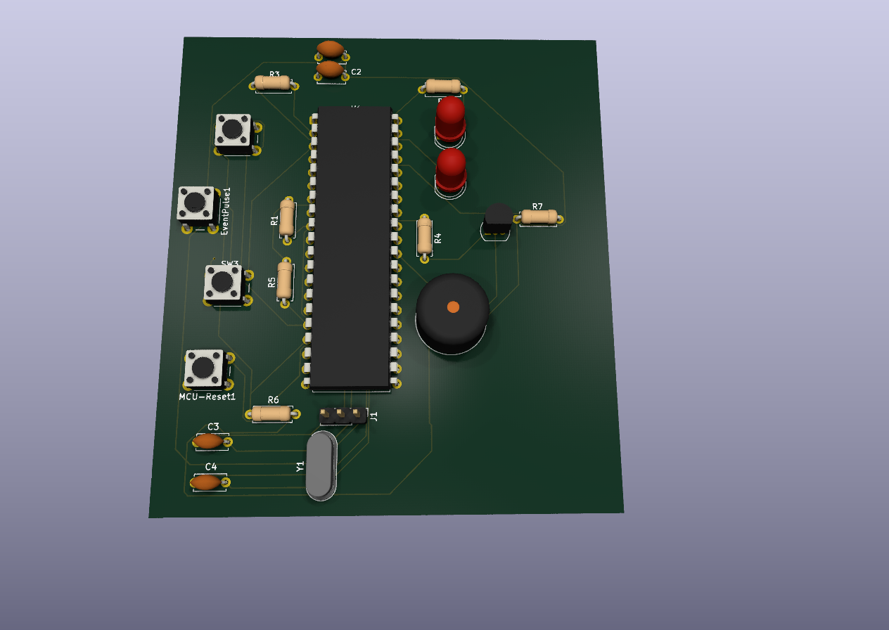

7. Simulation Screenshot Summary
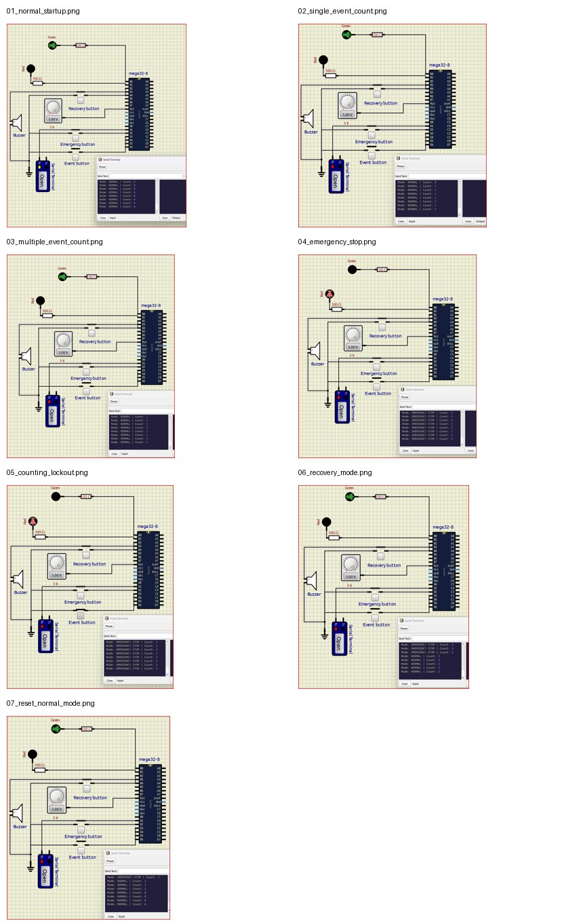
Figure 6: Contact sheet of all SimulIDE test screenshots.

8. Test Results
No. | Test Case | Expected Output | Observed Output | Result
1 | Normal startup | Green LED ON, red LED OFF, buzzer OFF, count 0. | System starts in NORMAL mode and serial output shows count 0. | PASS
2 | Single event pulse | One event pulse increments count to 1. | Serial output shows NORMAL mode with count 1. | PASS
3 | Multiple event pulses | Repeated events increase count step by step. | Count increases correctly after multiple event button presses. | PASS
4 | Emergency stop | Red LED and buzzer ON; counting stops. | System enters EMERGENCY STOP mode and alarm output is activated. | PASS
5 | Event during emergency | Count must not increase. | Count remains unchanged while emergency mode is active. | PASS
6 | Recovery mode | System returns to NORMAL mode and preserves count. | Serial output returns to NORMAL mode with previous count retained. | PASS
7 | Reset in normal mode | Pressing recovery/reset in normal mode resets count to 0. | Serial output shows NORMAL mode with count 0. | PASS

8.1 Individual Simulation Evidence
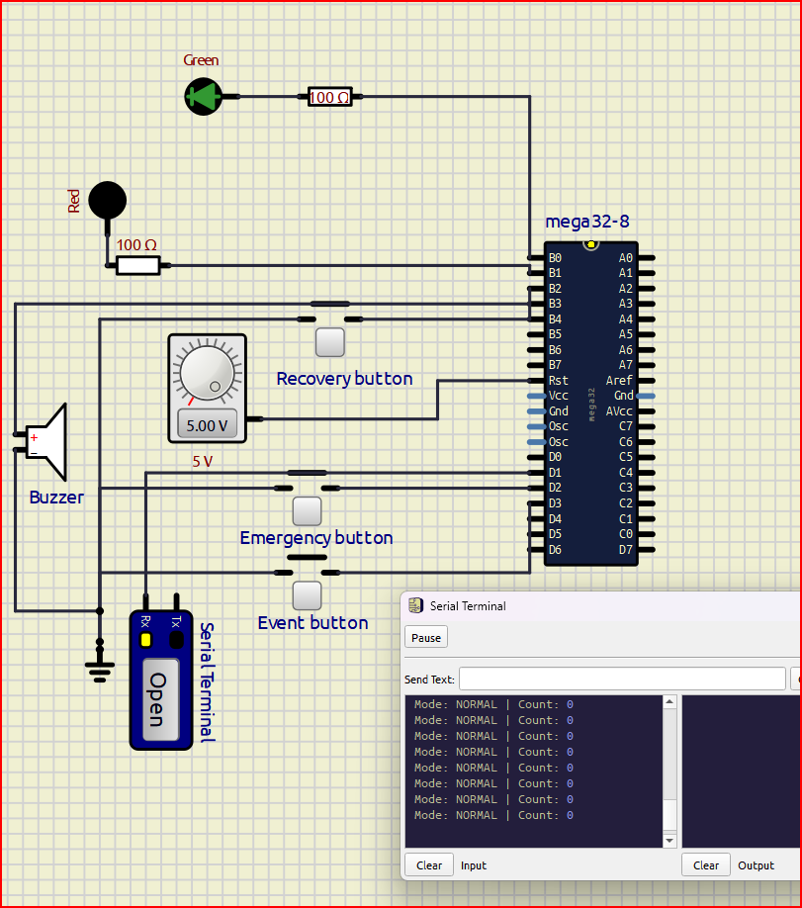
Figure 7: Normal startup - green LED ON and count 0.
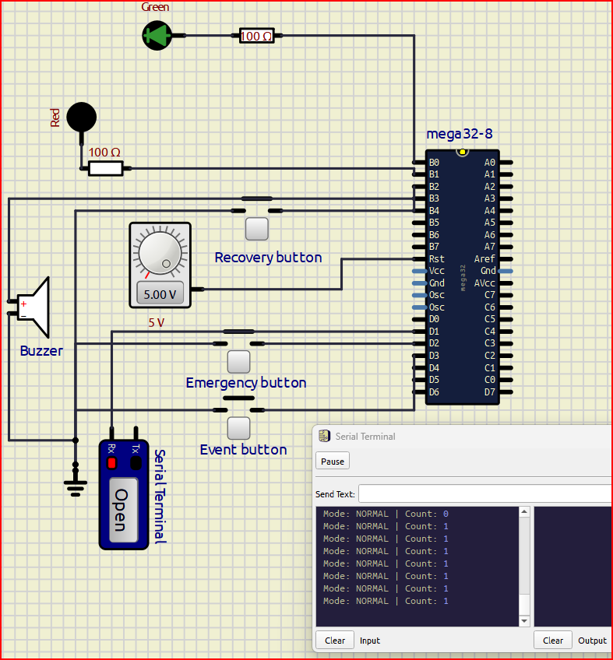
Figure 8: Single event pulse - count increases to 1.
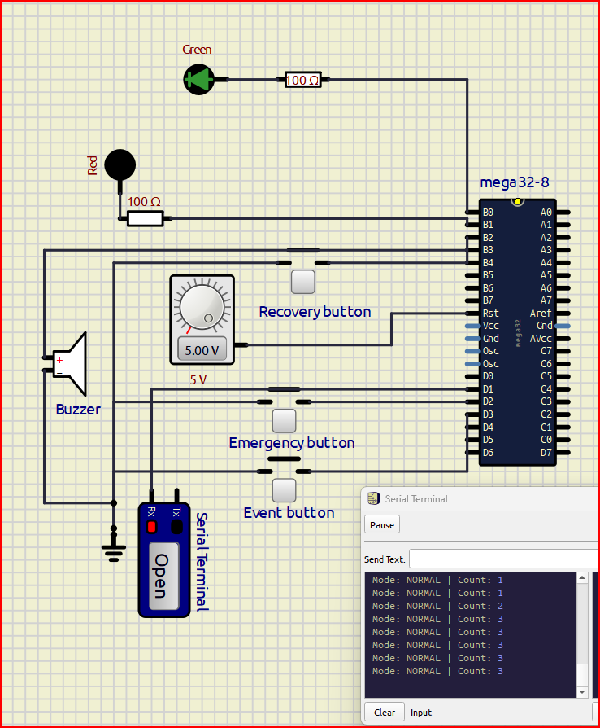
Figure 9: Multiple event pulses - count increases correctly.
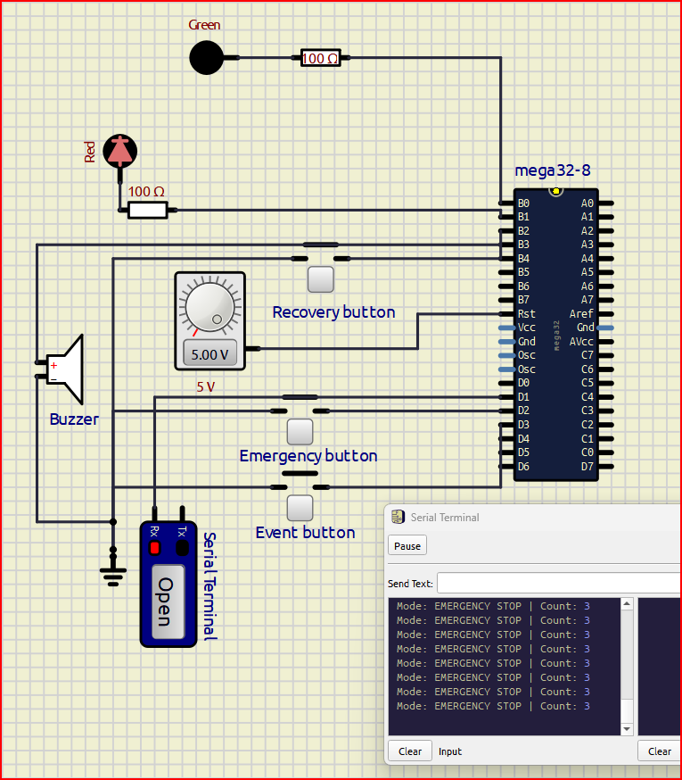
Figure 10: Emergency stop - emergency mode active.
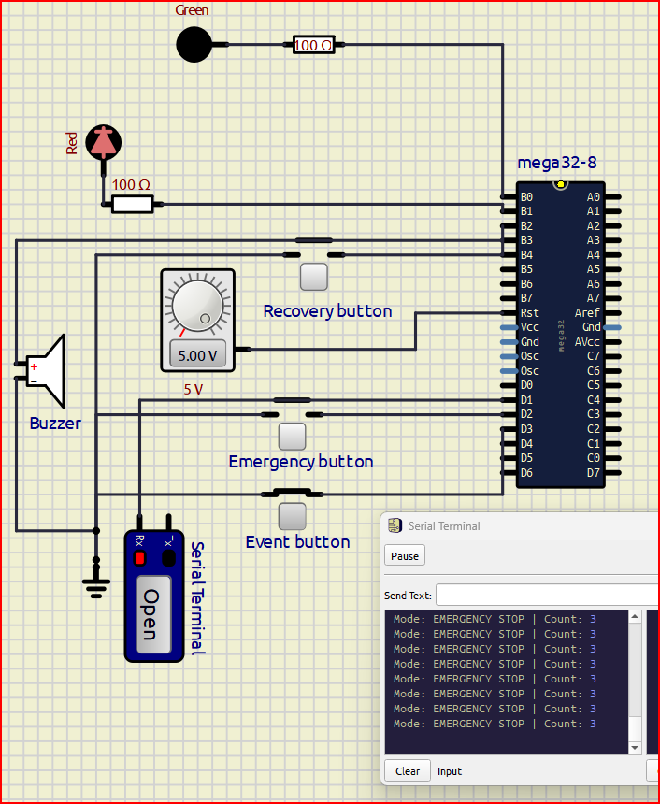
Figure 11: Event during emergency - count remains locked.
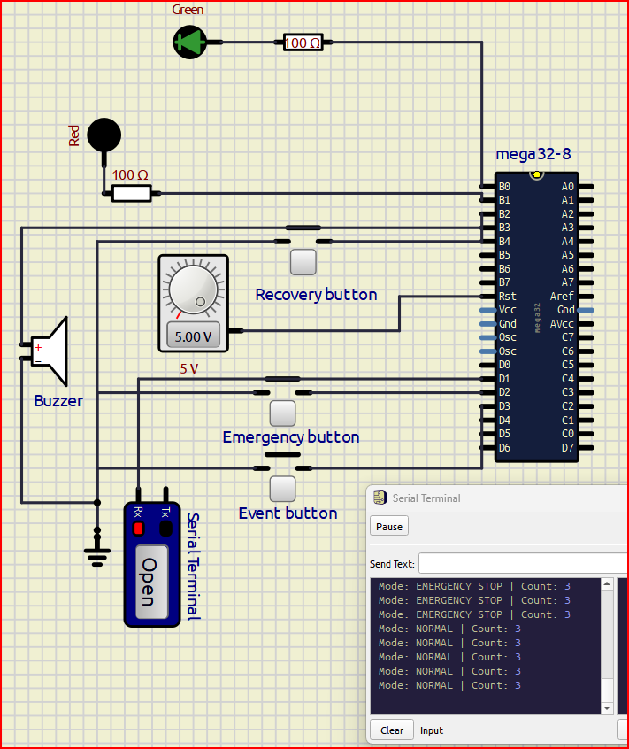
Figure 12: Recovery mode - system returns to normal mode.
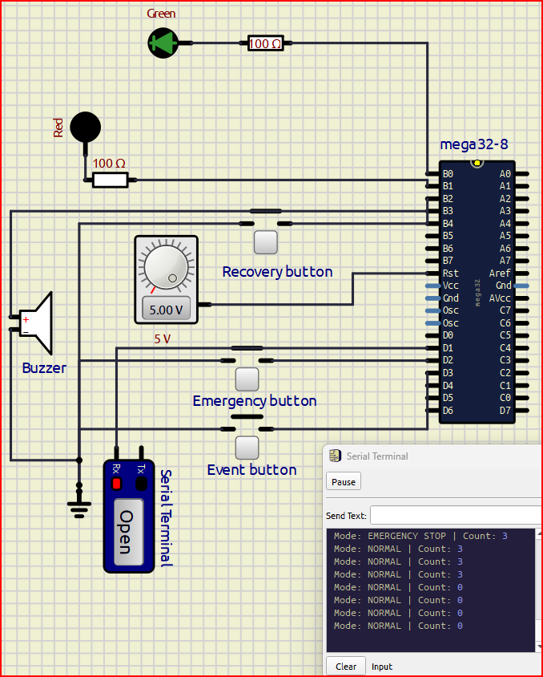
Figure 13: Reset in normal mode - count resets to 0.

9. Challenges and Solutions
Challenge | Solution
RESET pin issue in SimulIDE | The RESET pin was held HIGH using a 5 V source so the firmware could run normally.
Mechanical button bounce | Timer0 was used to create a 1 ms tick and each interrupt line uses a 200 ms debounce window.
Many GND and +5V connections on the PCB | Copper zones were used: B.Cu for GND and F.Cu for +5V.
PCB routing unconnected items | KiCad DRC was used to locate and fix each missing connection until DRC showed 0 violations.
Emergency and reset button behavior | INT2 was designed with dual behavior: recover during emergency, reset count when already in normal mode.

10. Repository and File Organization

ATmega32_External_Interrupt_Event_System/
├── README.md
├── firmware/
│ ├── src/main.c
│ └── hex/emergency_event_counter.hex
├── kicad/
│ ├── ATmega32_External_Interrupt_Event_System/
│ ├── schematic/
│ ├── pcb/
│ └── gerber/
├── simulide/
│ ├── circuit/emergency_event_counter.sim1
│ └── screenshots/
├── documentation/
│ ├── block_diagram.png
│ ├── firmware_flowchart.png
│ ├── interrupt_configuration.md
│ ├── pin_mapping_table.md
│ ├── test_results.md
│ └── final_report/
└── media/
└── demo_video.mp4

11. Conclusion
The project successfully demonstrates an ATmega32 external interrupt system for emergency stop and event counting. INT0 handles the emergency stop, INT1 handles event pulse counting, and INT2 handles recovery/reset. The system correctly locks event counting during emergency mode and returns to normal operation after recovery. The implementation also includes debounce handling, UART status display, LED and buzzer outputs, KiCad schematic and PCB design, Gerber export, SimulIDE screenshots, and a demonstration video.

