Build Tag 48:

select id, name, CROCAS_BUILD_TAG_ID from client_div where id=354 OR id=356;

"ID" "NAME" "CROCAS_BUILD_TAG_ID"

354 "SQA2014R2" 48

356 "SQA2015R1" 48

Budget 1 -Unpublished Do Not Upgrade

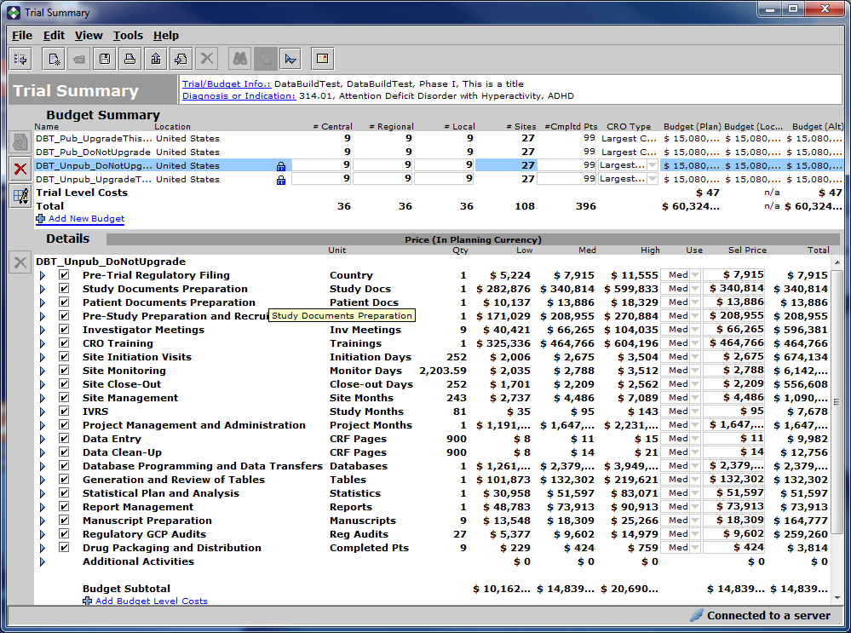

Budget 2 - Unpublished - Upgrade This One

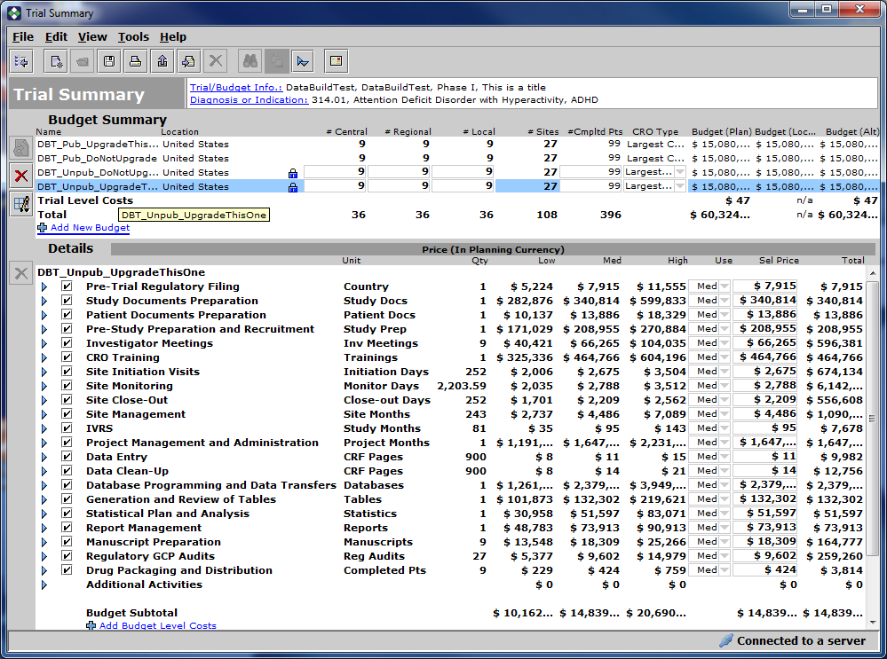

Budget 3: Published - Do Not Upgrade

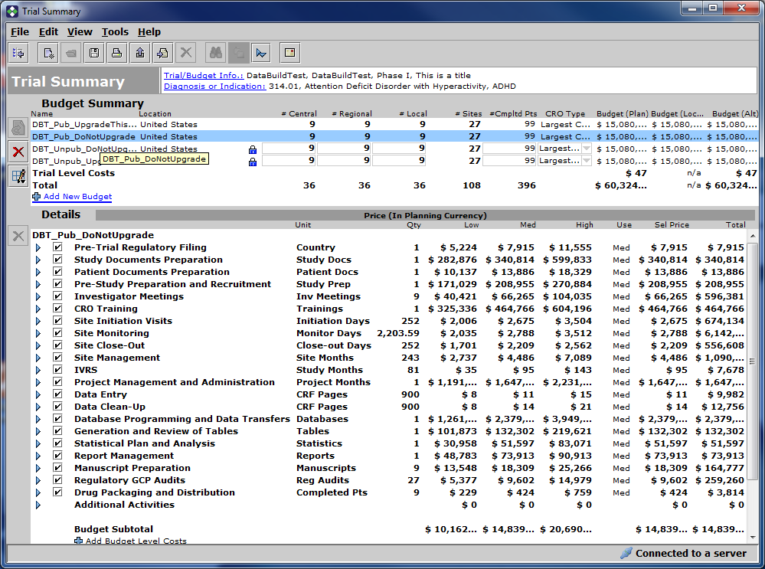

Budget 4: Published - Upgrade This One

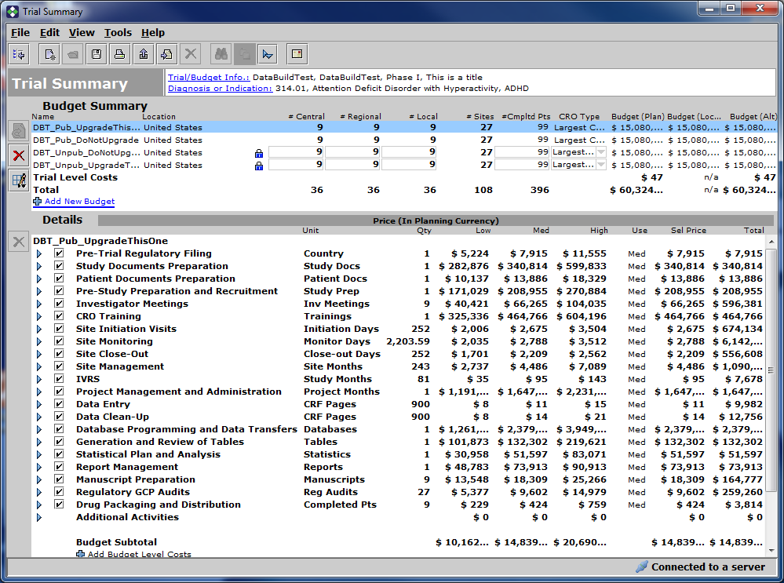

Upgrade this client division

update client_div set CROCAS_BUILD_TAG_ID=52 where ID=354;

commit;

"ID" "NAME" "CROCAS_BUILD_TAG_ID"

354 "SQA2014R2" 52

356 "SQA2015R1" 48

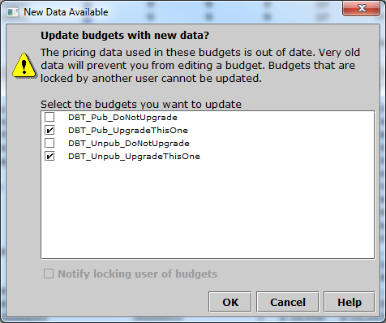

Budget 1: Unpublished Do Not Upgrade

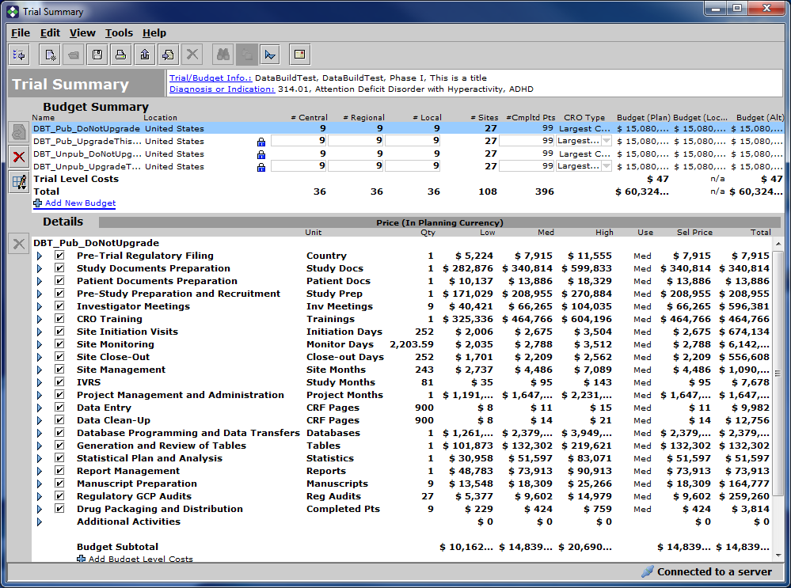

Budget 2: Published - Upgrade This (Note: it became unpublished automatically because of the upgrade)

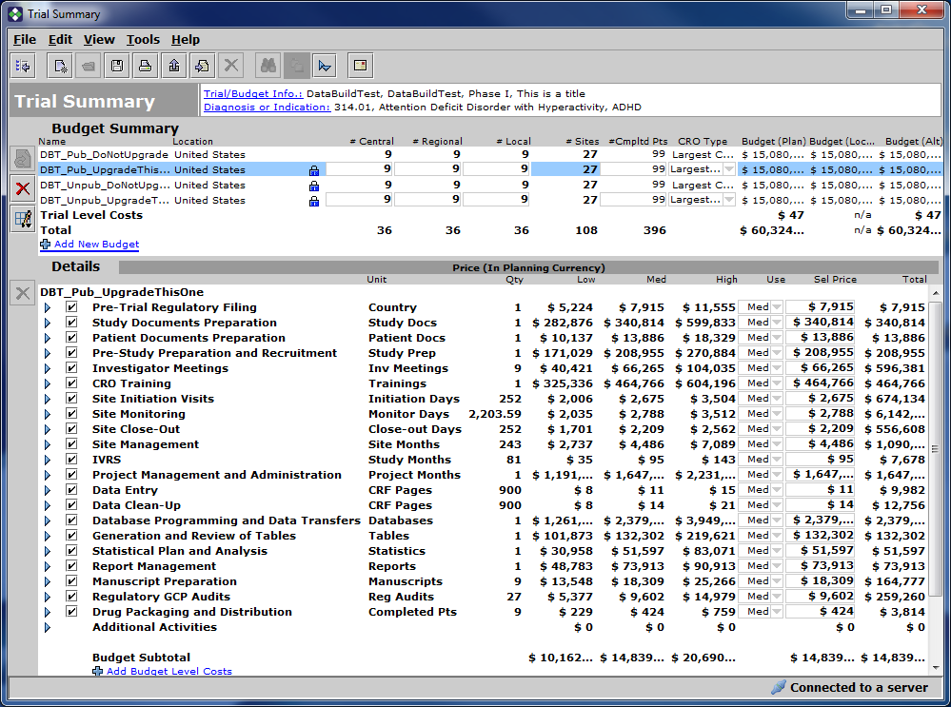

Budget 3: Unpublished Do Not Upgrade

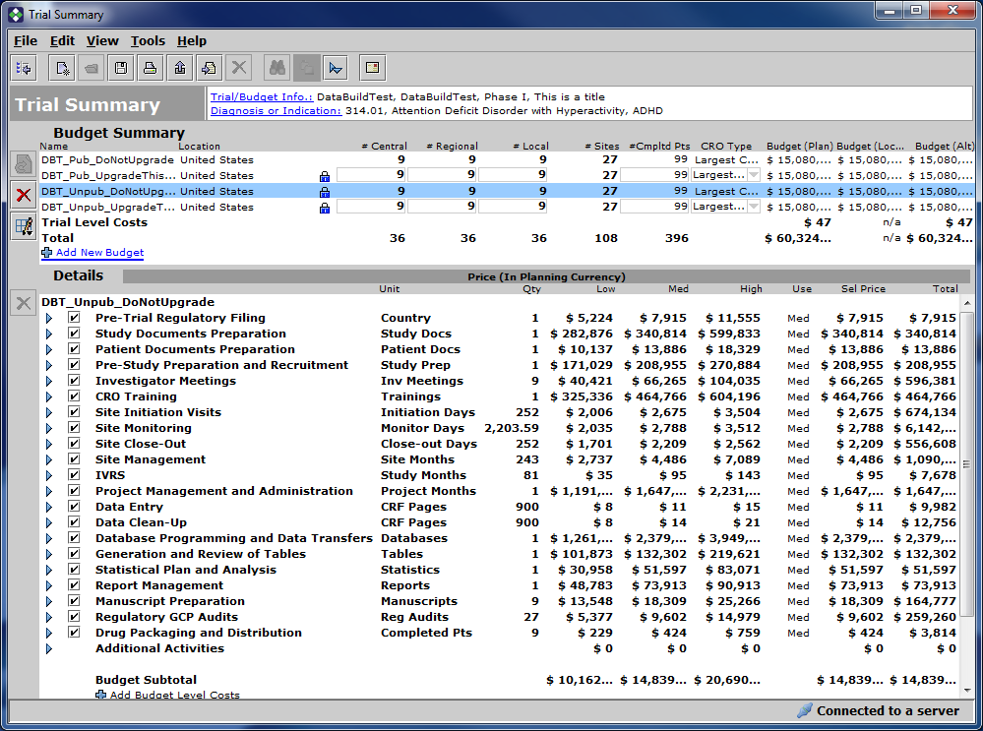

Budget 4: Unpublished - Upgrade this

Create 2 more budgets with this Data Build

Budget 5: Published

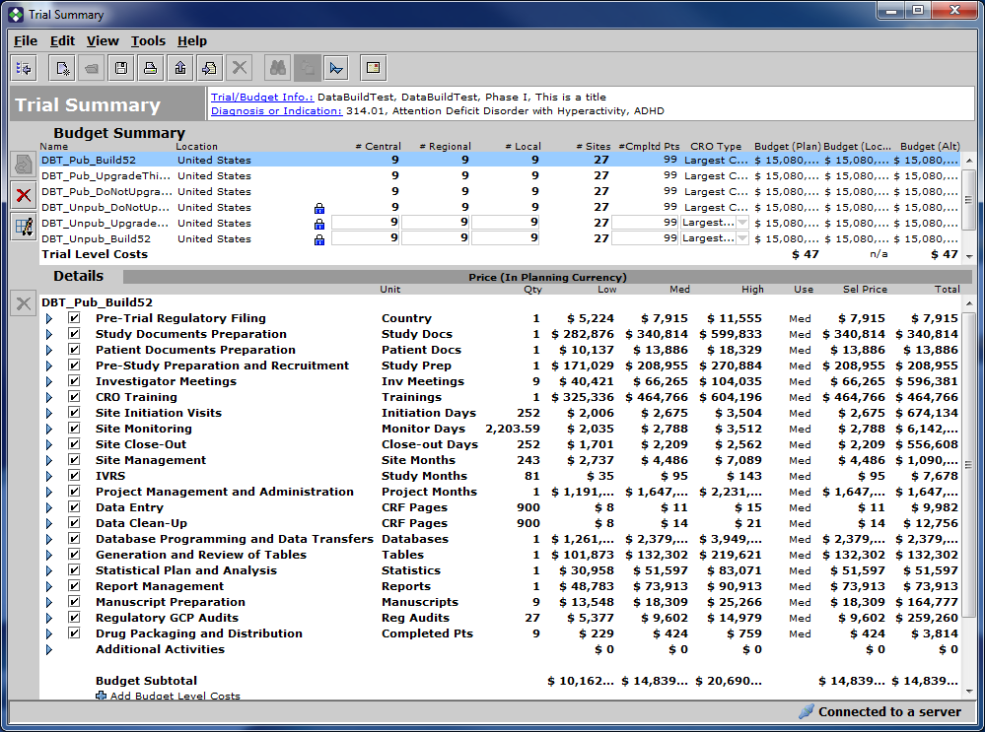

Budget 6:

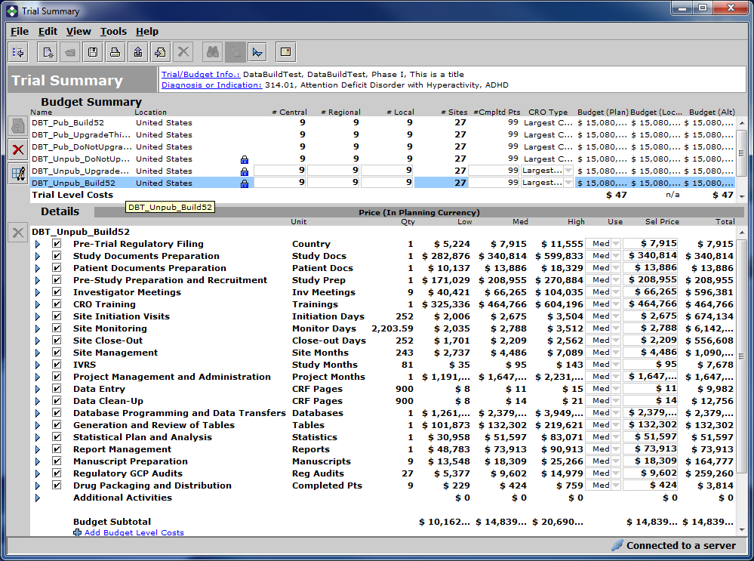

Run the CMP

old:update client_div set crocas_build_tag_id=&2 where id=&1 and crocas_build_tag_id=&3

new:update client_div set crocas_build_tag_id=48 where id=354 and crocas_build_tag_id=52

1 rows updated.

committed.

old:update cro_budget set build_tag_id=&2 where build_tag_id=&3 and cro_trial_id in (select trial_id from cro_trial,trial where cro_trial.trial_id=trial.id and trial.client_div_id=&1)

new:update cro_budget set build_tag_id=48 where build_tag_id=52 and cro_trial_id in (select trial_id from cro_trial,trial where cro_trial.trial_id=trial.id and trial.client_div_id=354)

3 rows updated.

committed.

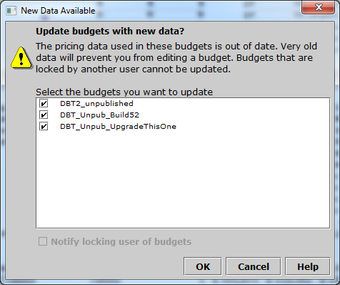

Budget 1: Unpublished Do Not Upgrade

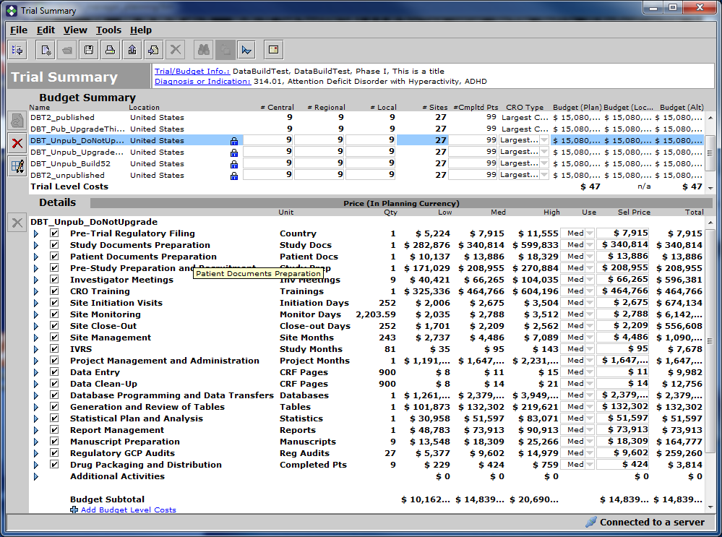

Budget 2: Unpublished Upgrade this one

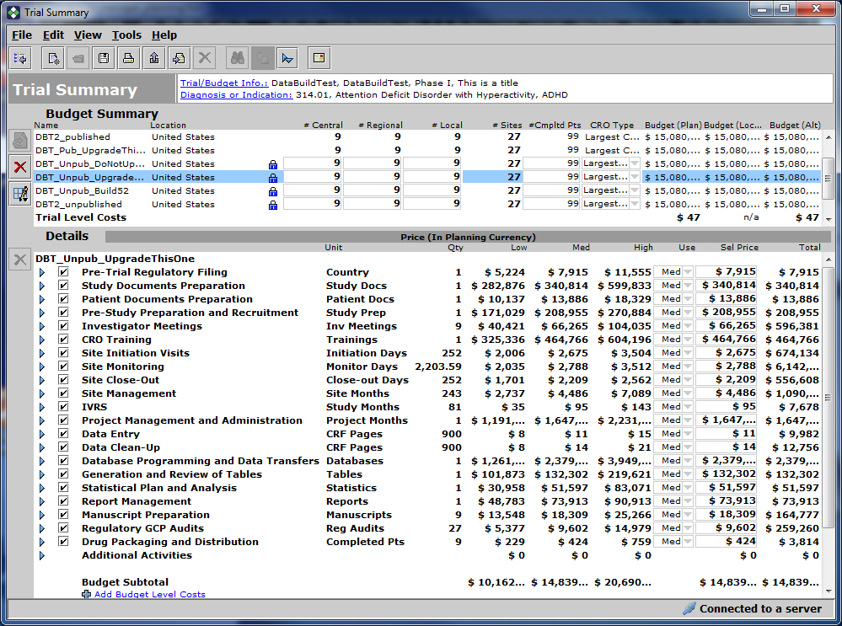

Budget 3: published Do Not Upgrade

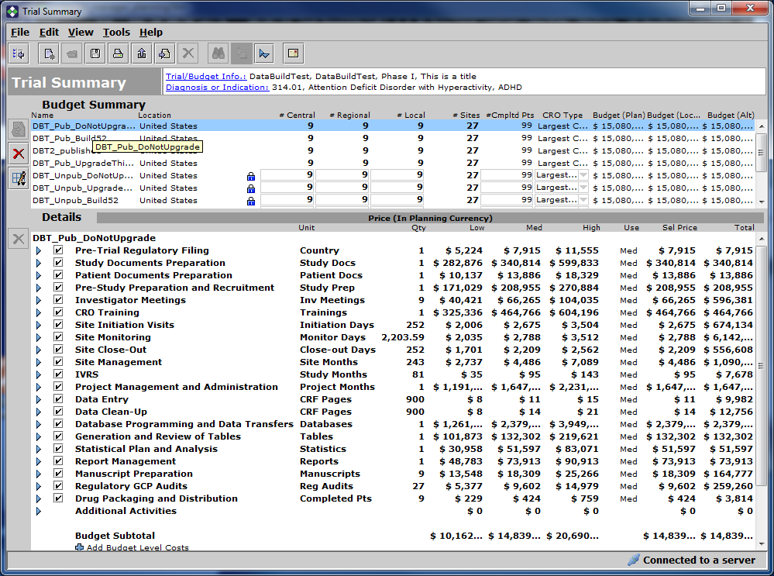

Budget 4: Published Upgrade This One

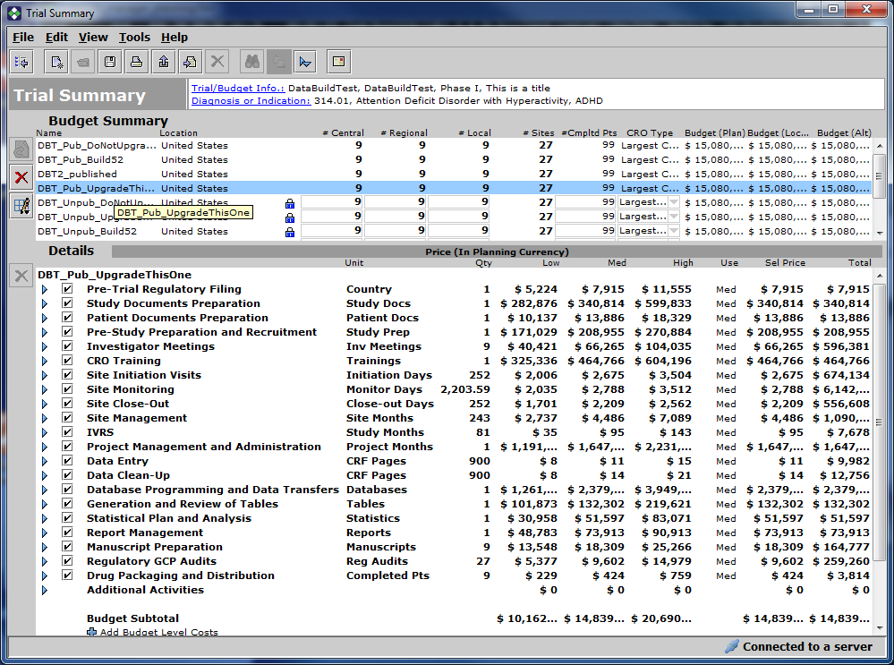

Budget 5: Unpublished - Created in Build 52

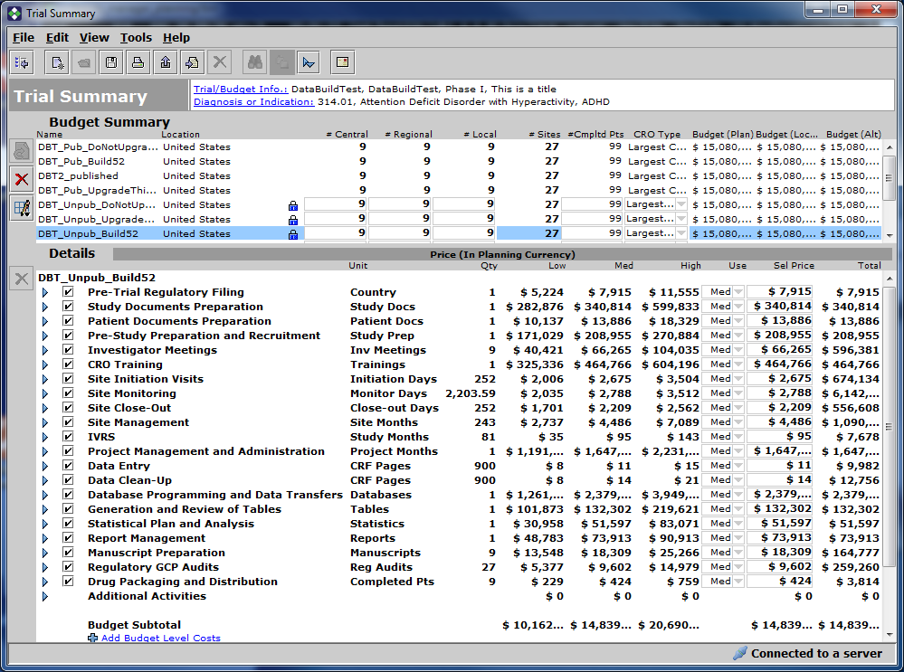

Budget 6: Published - Created in Build 52

