Build Tag 48

select id, name, CROCAS_BUILD_TAG_ID from client_div where id=354 OR id=356;

"ID" "NAME" "CROCAS_BUILD_TAG_ID"

354 "SQA2014R2" 48

356 "SQA2015R1" 48

Budget 1: Published

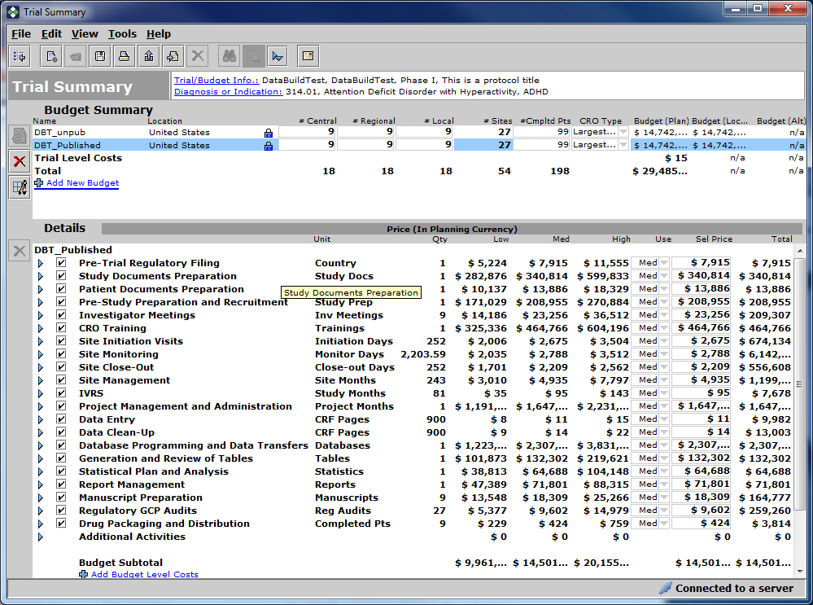

Budget 2: Unpublished

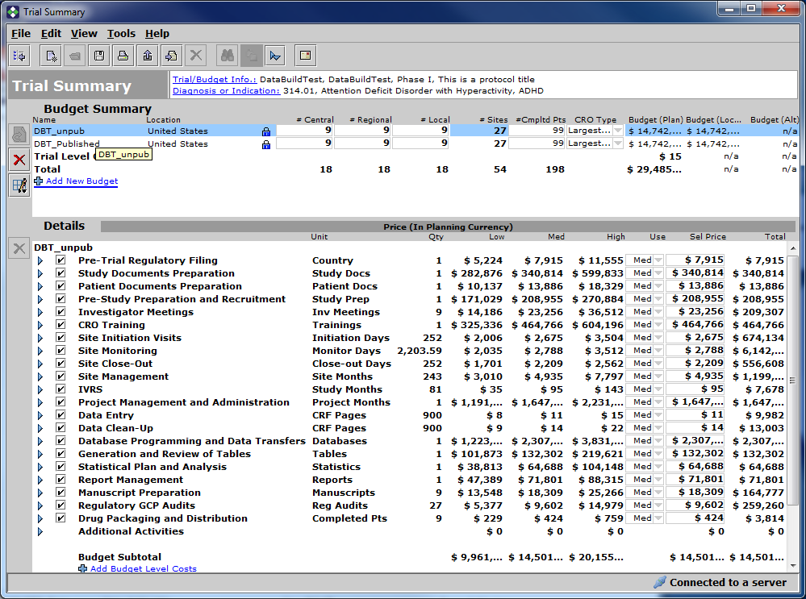

Upgrade Other Client division

update client_div set CROCAS_BUILD_TAG_ID=52 where ID=354;

commit;

"ID" "NAME" "CROCAS_BUILD_TAG_ID"

354 "SQA2014R2" 52

356 "SQA2015R1" 48

Budgets are unchanged

Budget 1: Published

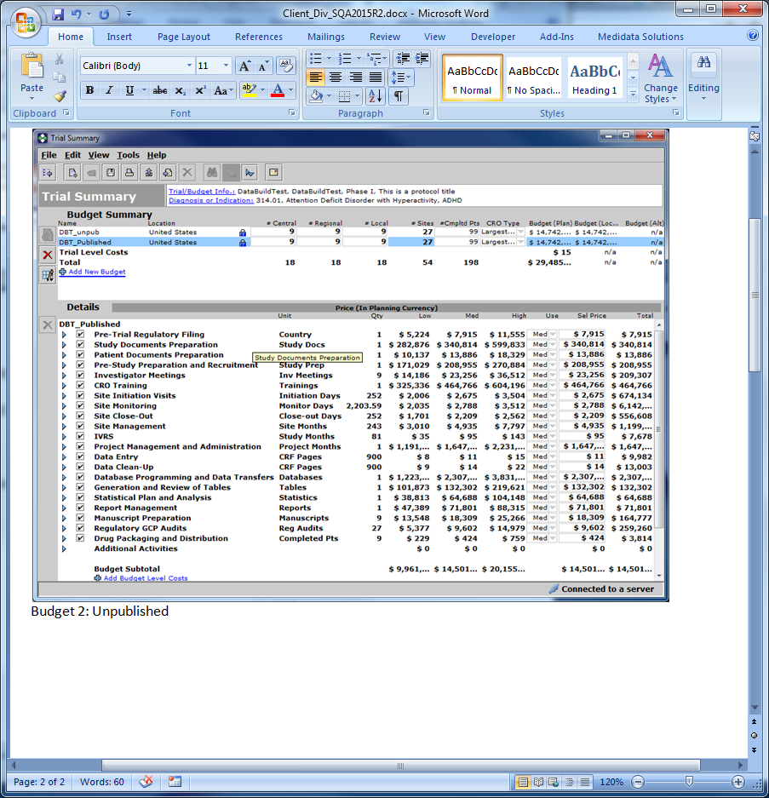

Budget 2: Unpublished

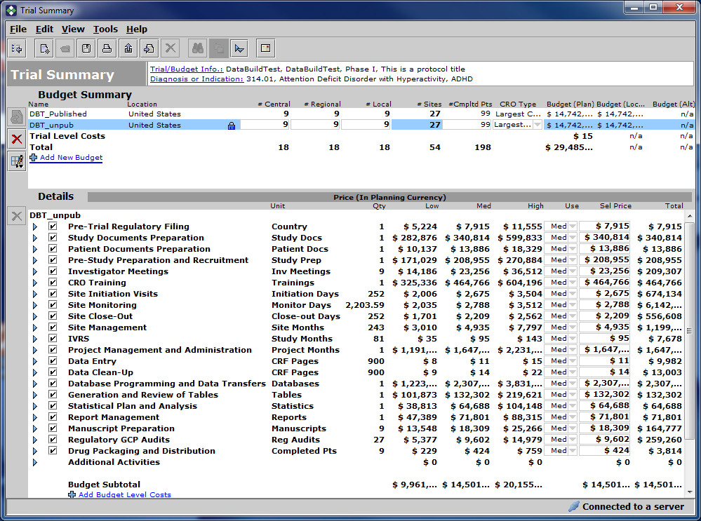

Run CMP in other client division

Budget 1 Published:

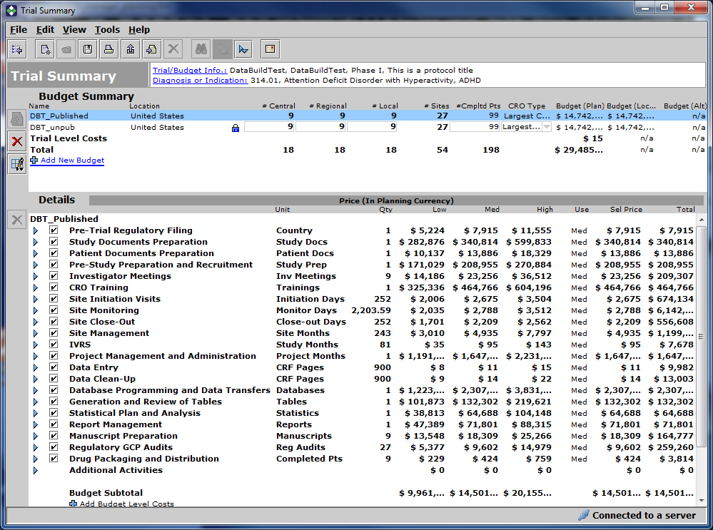

Budget 2: Unpublished

