Create a new user in FTAdmin, and set the user roles for the user to System Admin for both GM3 and CRO Contractor

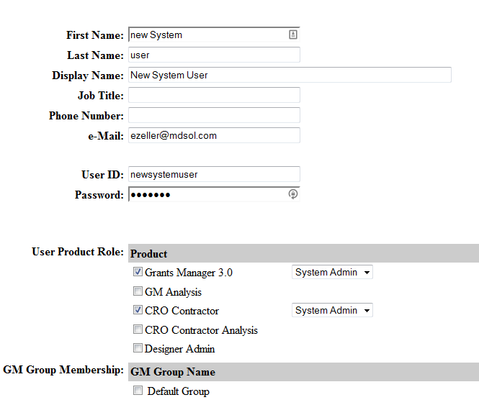

Press Save