End to End Cross platform regression testing:

Rave 2015.2.2 - conlabtesting14.mdsol.com

Designer Gateway 2014.1.1 - <https://designergateway-validation.imedidata.net/DGW/login>

Tested by Eric Zeller

**Gateway Import from Rave to Designer**

Login to Gateway, click "Import Source", and select the URL, project and CRF version to import.

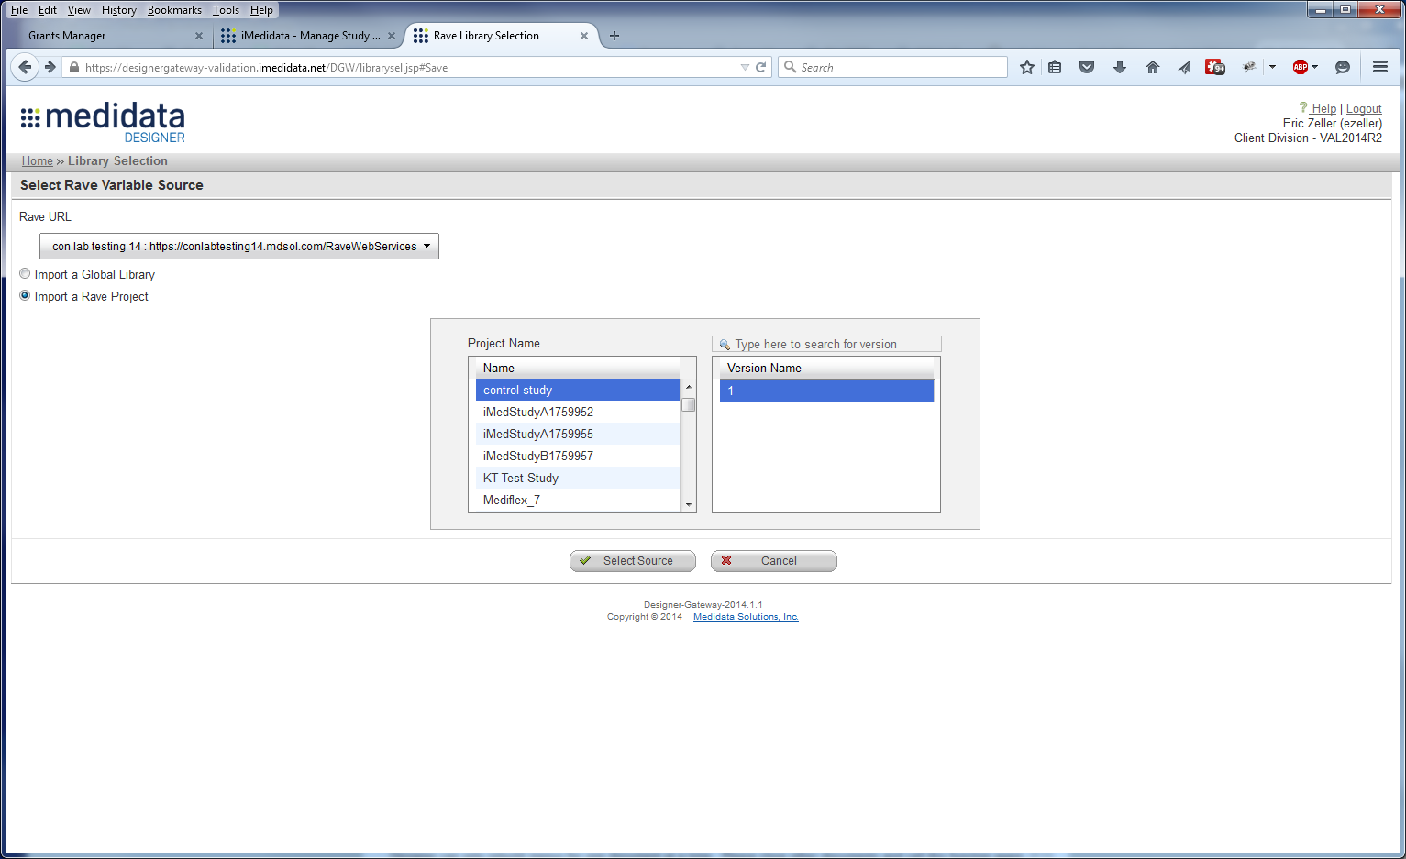

Click "Select Source" and Review the mapping status. Click on "Create a new Designer variable".

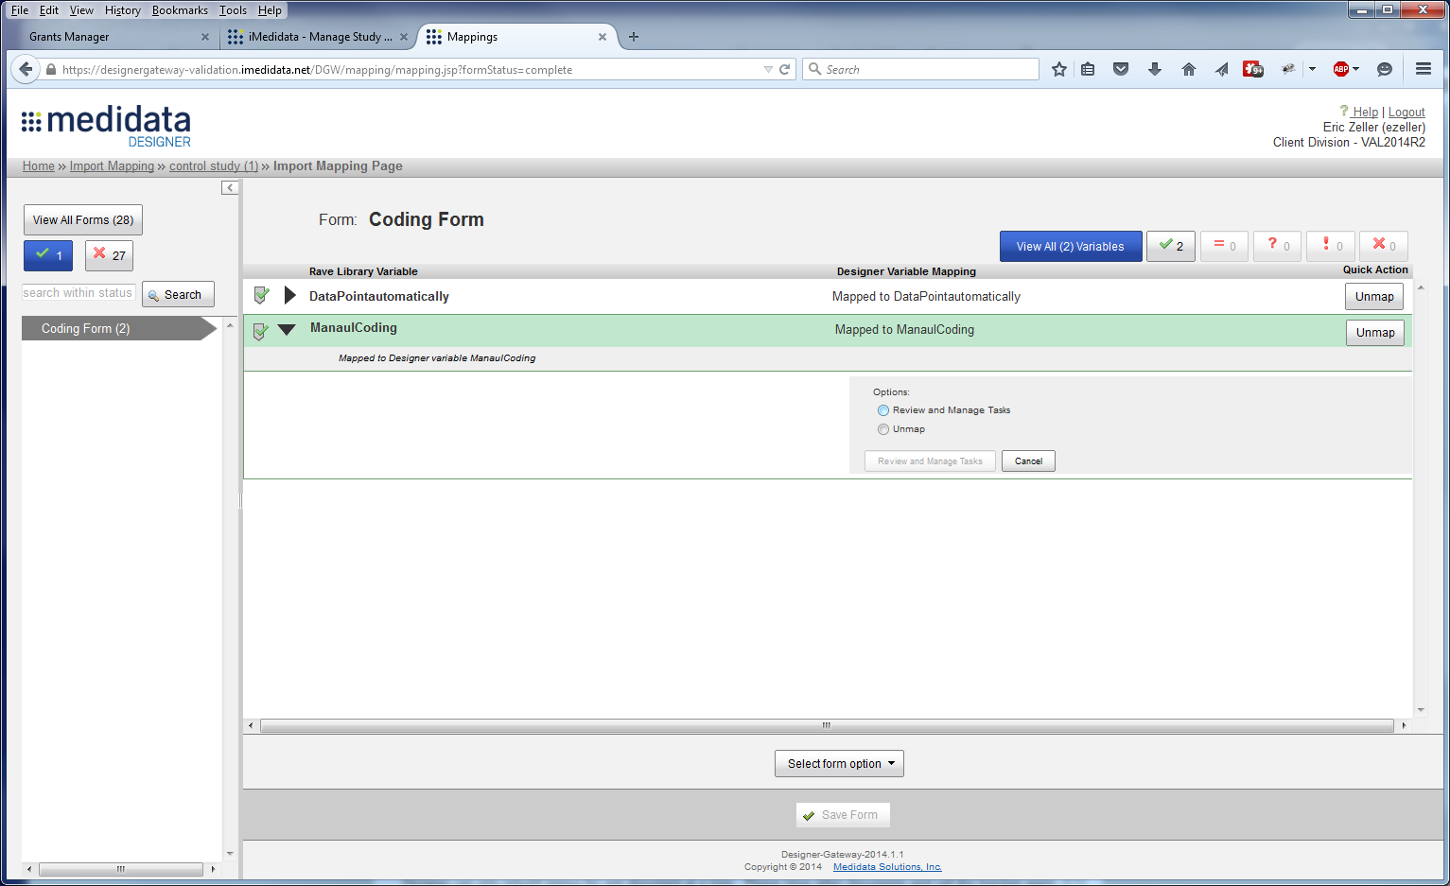

Review the Task Assignment and verify the variables are mapped to an activity in Designer.

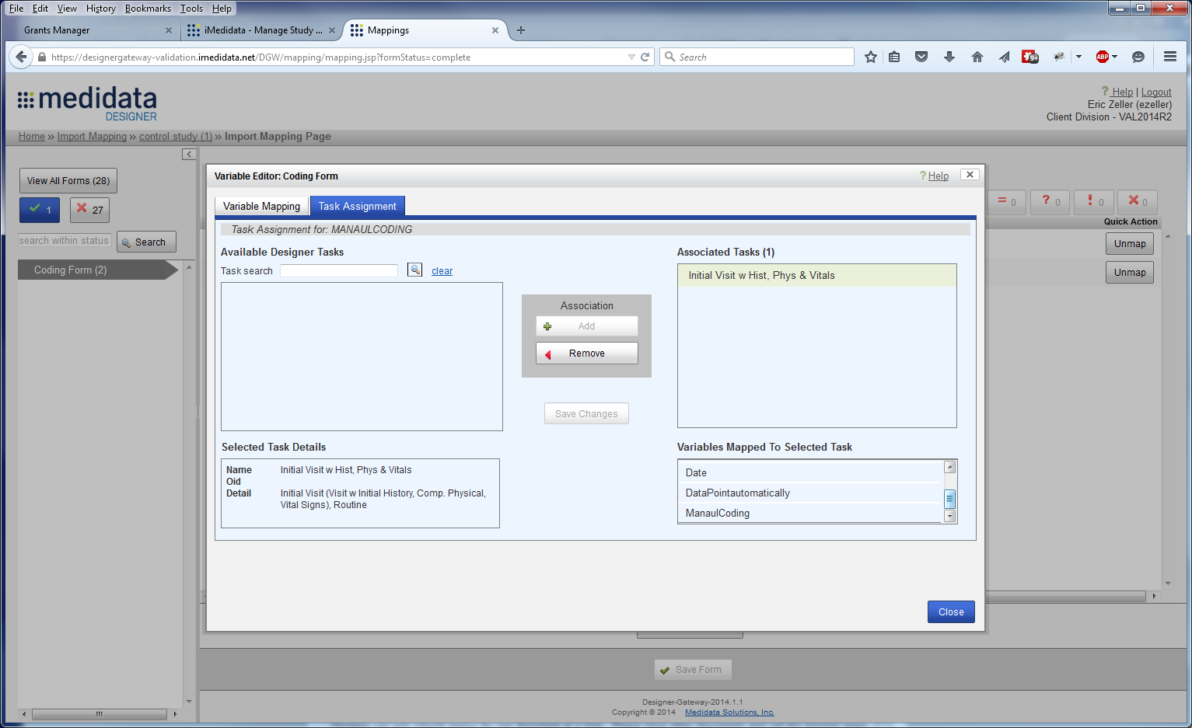

Login to Designer and verify from inside of Designer that the variables are mapped to the activity

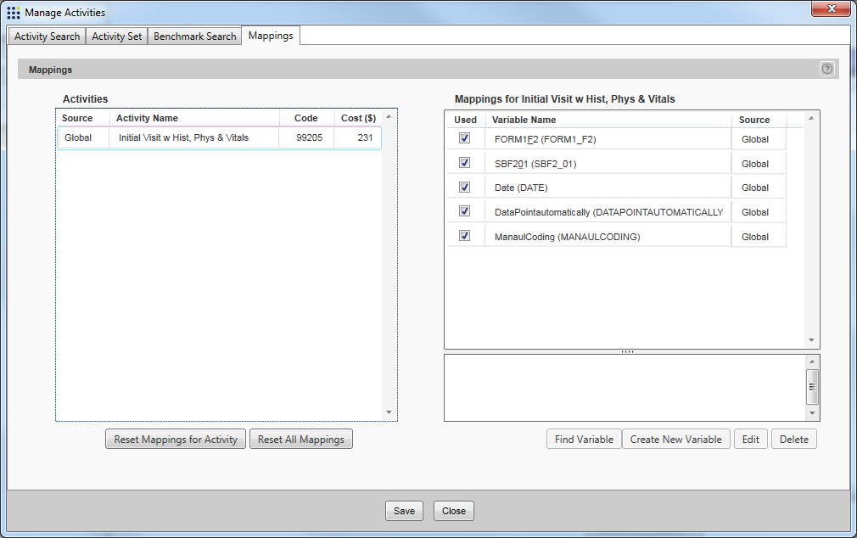

**Export from Designer to Rave**

In DGW - click on New Protocol Export and select a study that has the new variables.

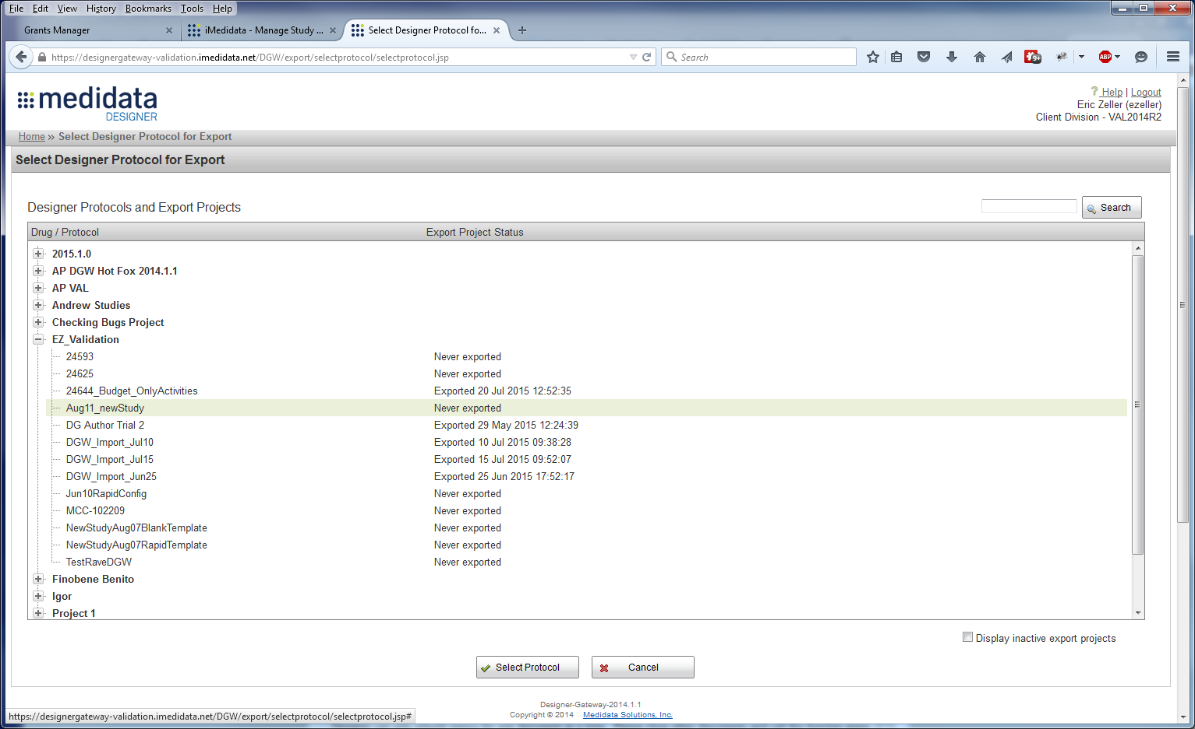

Select a version to Export and the Rave URL

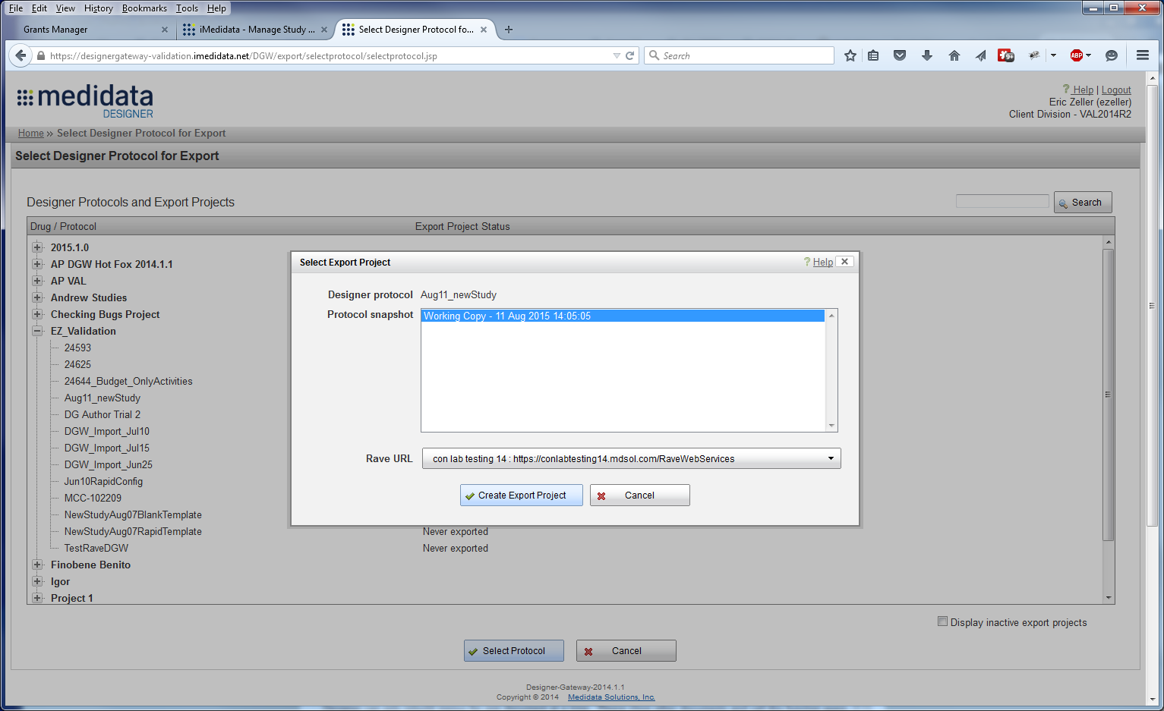

Enter a Project Name, Draft Version and Primary Form (activity in Designer)

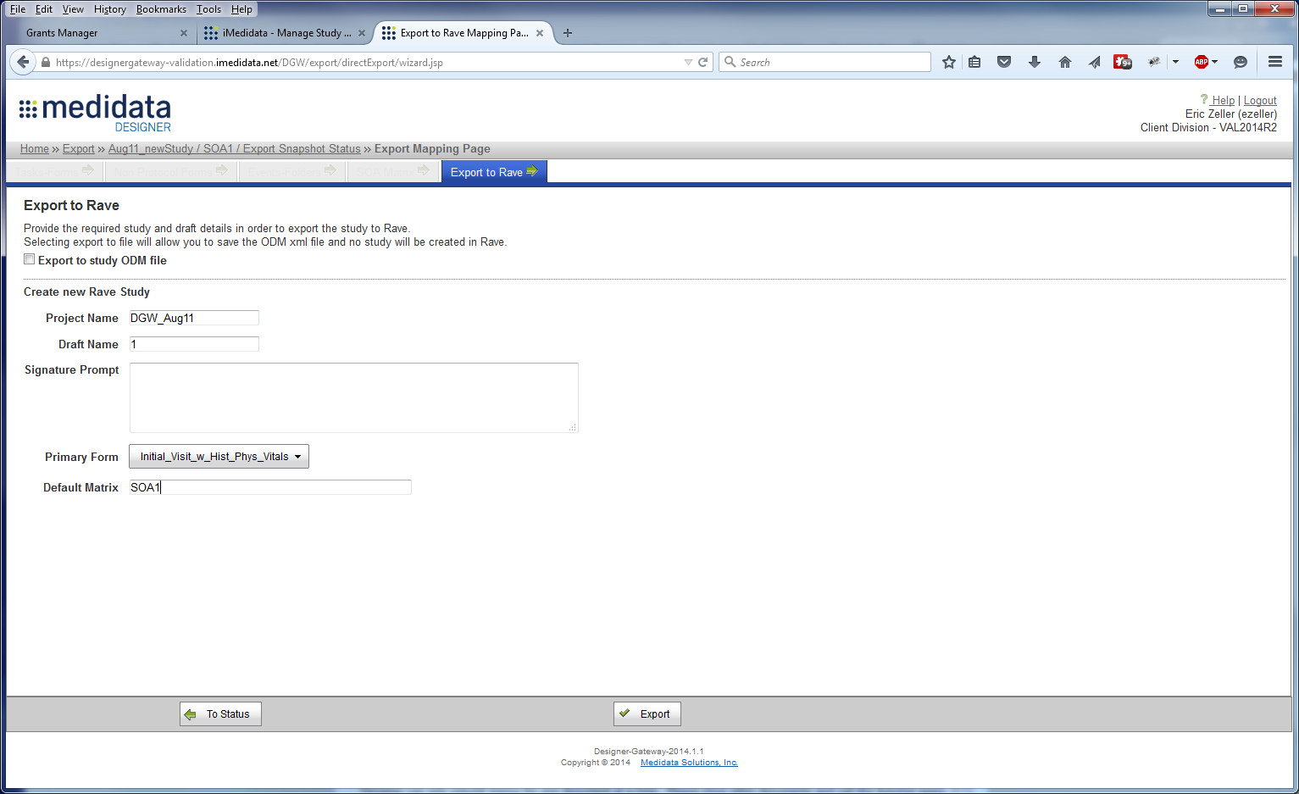

Click on Export and verify that the upload succeeded.

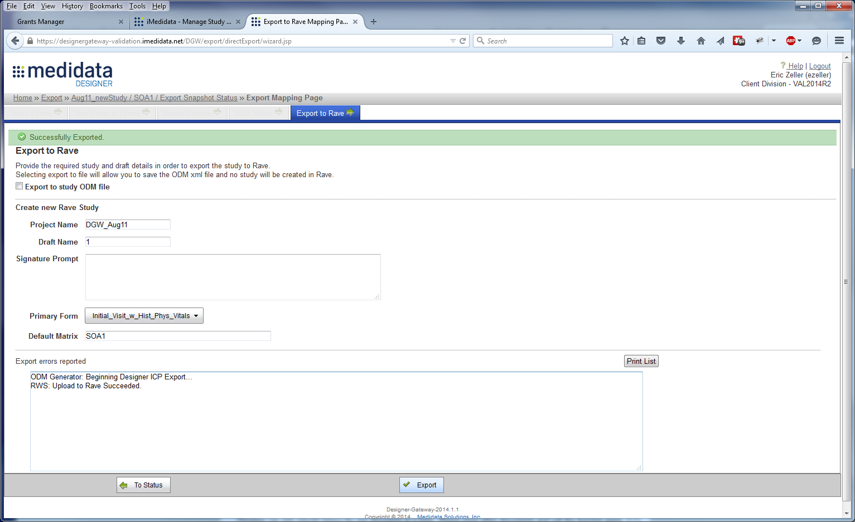

Login to Rave and open the project you just uploaded.

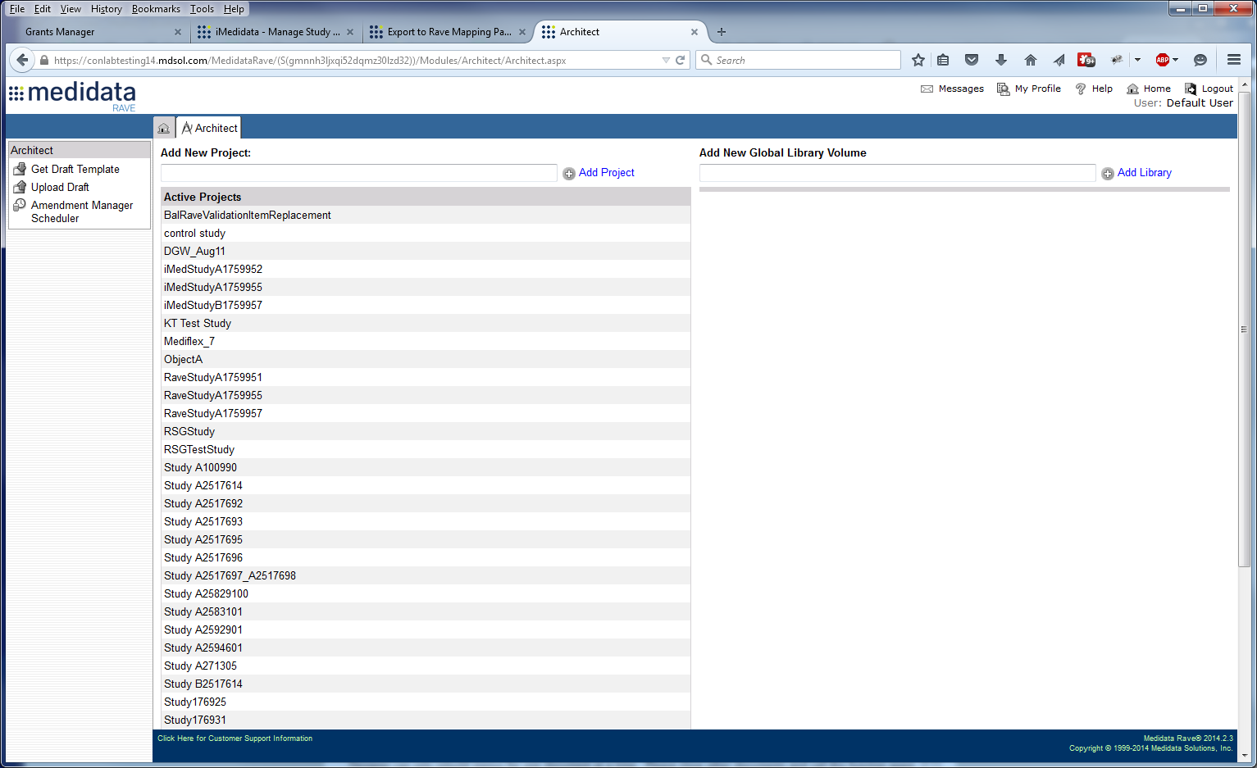

Open the forms and verify that the new variables were exported as part of the activity

