@release2015.1.3  
@PB1093a-03  
@MANUAL  
**Scenario Outline:** As a sponsor user, I can export an individual Negotiation from within the Negotiation page for all 4 statuses(Open to Sponsor, Open to Site, Completed, Canceled)and I can open the Excel spreadhseet without any error.  
**Given** I wait **1** seconds  
**And** A user "**parleytestuser**" with the role of "**parleysponsor**"  
**And** I am logged into Parley  
**And Sponsor** user have access to studies:  
 **|name |  
 |Val2015.1.3 With non-latin Chars €ƒˆ˜¡¢¤§¨×þÞß |**

**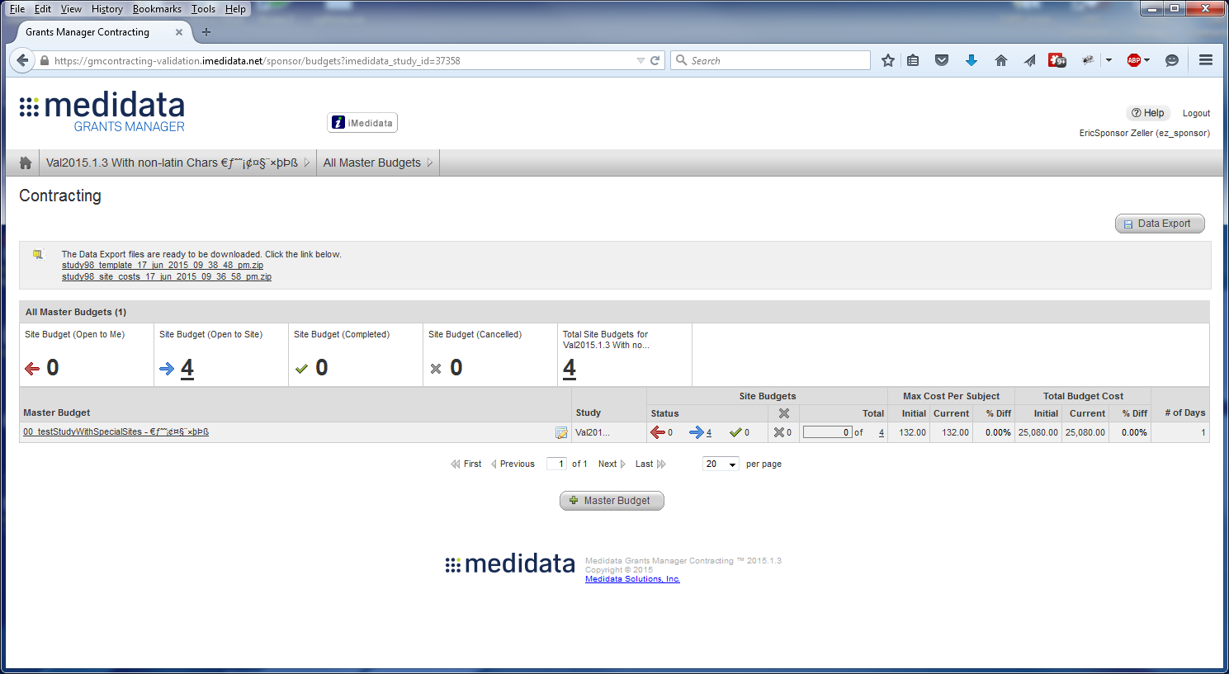  
And** study "**Val2015.1.3 With non-latin Chars €ƒˆ˜¡¢¤§¨×þÞß**" has the following sites:  
 **|name |  
 |Site 1 |  
 |BasicLatinSite¡¢£¤¥¦§ |  
 |SpeciallatinSiteƏƐƑƒ |  
 |pureUTFSiteఅఆఇఈఉ |**

**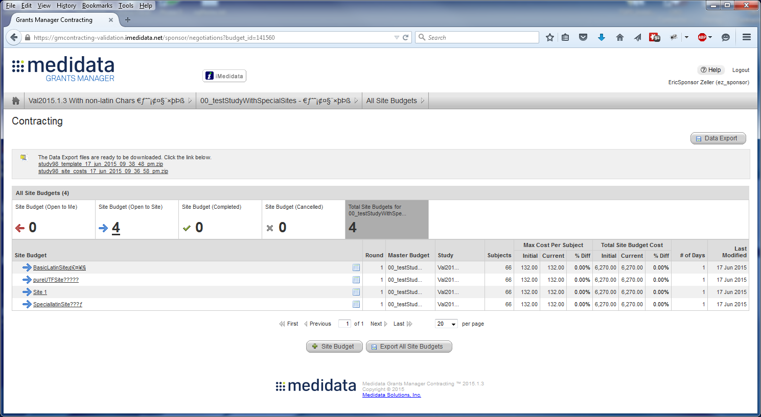  
And** study "**Val2015.1.3 With non-latin Chars €ƒˆ˜¡¢¤§¨×þÞß**" has the following budgets:  
 **|Description |OH |Location |Currency |  
 |00_testStudyWithSpecialSites - €ƒˆ˜¡¢¤§¨×þÞß | 15.00 |New York |US Dollars (USD) |  
And** budget "**00_testStudyWithSpecialSites - €ƒˆ˜¡¢¤§¨×þÞß**" has the following arms:  
 **|name | subject |  
 |BasicLatinArm - ¡¢£¤¥¦§ |11 |  
 |SpecialLatinArm - ƏƐƑƒ |22 |  
 |pureUTFArm - అఆఇఈఉ |33 |**

**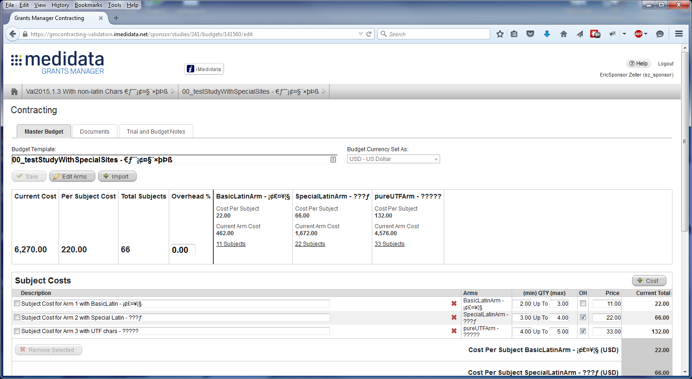  
And** budget "**00_testStudyWithSpecialSites - €ƒˆ˜¡¢¤§¨×þÞß**" has the following costs:  
 **|Description |type |Arms |min |max |OH |Current |  
 |Subject Cost for Arm 1 with BasicLatin - ¡¢£¤¥¦§ |subject |a1 |2 |3 |selected |11.00 |  
 |Subject Cost for Arm 2 with Special Latin - ƏƐƑƒ |subject |a2 |3 |4 |selected |22.00 |  
 |Subject Cost for Arm 3 with UTF chars - అఆఇఈఉ |subject |a3 |4 |5 |selected |33.00 |  
 |Site Cost with ugly unicode - ȺȐɄʤǄÅ©ח |site | |5 |6 |selected |44.00 |**

**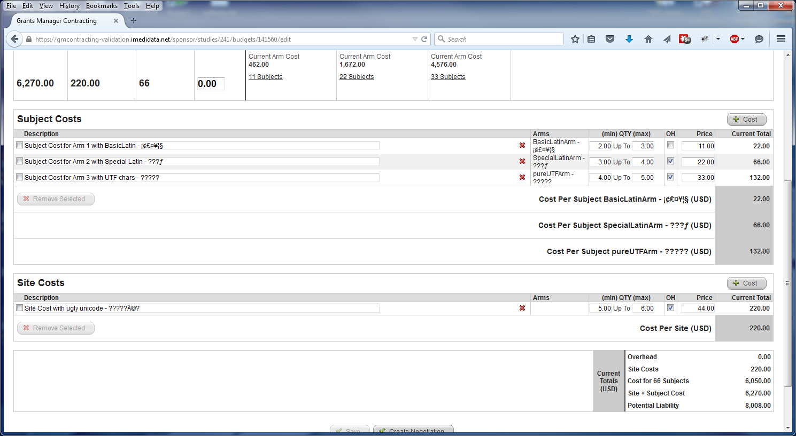  
And** the budget "**00_testStudyWithSpecialSites - €ƒˆ˜¡¢¤§¨×þÞß**" has the following negotiations:  
 **|Description |OH |Location |Currency |Status |Site |   
 |n1 |15 |New York |US Dollars (USD) |Open to Site | BasicLatinSite¡¢£¤¥¦§ |  
 |n2 |15 |New York |US Dollars (USD) |Open to Site | SpeciallatinSiteƏƐƑƒ |  
 |n3 |15 |New York |US Dollars (USD) |Open to Site | pureUTFSiteఅఆఇఈఉ |**

**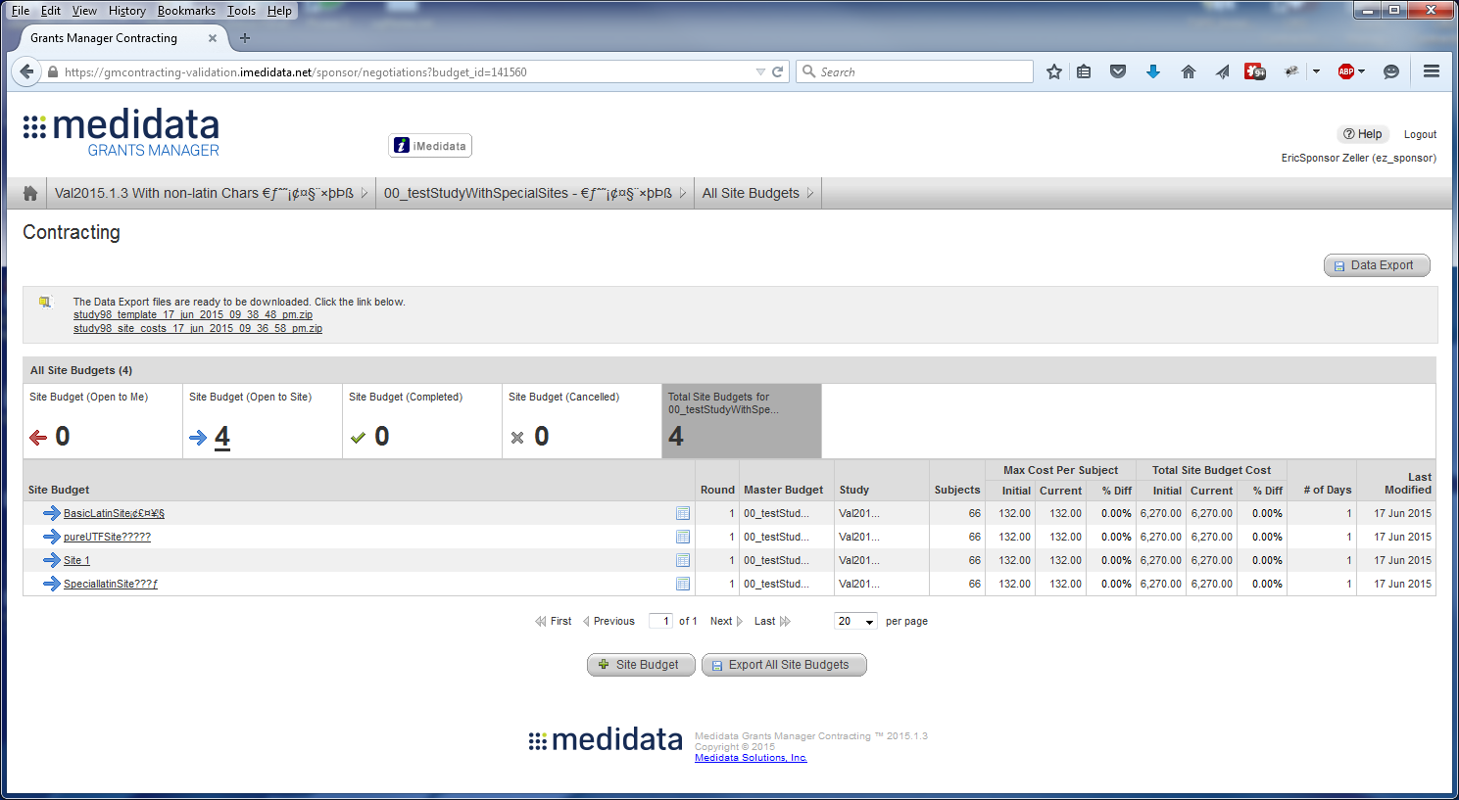  
And** I open the budget "00_testStudyWithSpecialSites - €ƒˆ˜¡¢¤§¨×þÞß"  
**And** I open the negotiation "BasicLatinSite¡¢£¤¥¦§"  
**And** I select the button labeled "**Actions**"  
**And** I select the button labeled "**Export to Excel**"

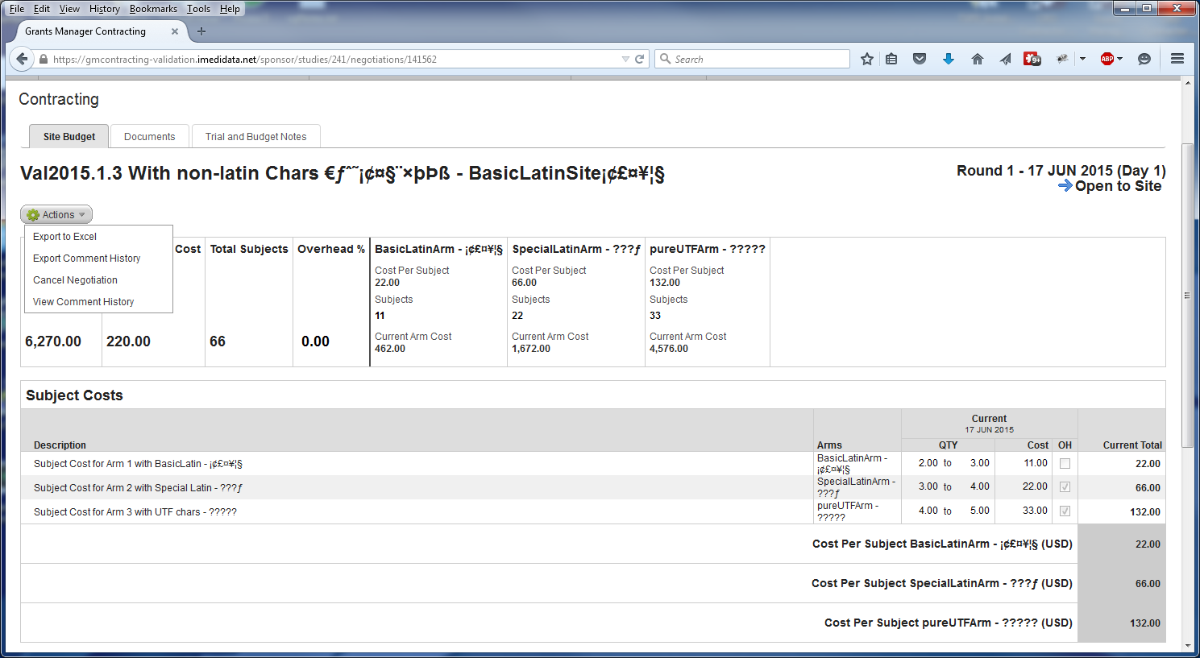  
**Then** I can open the Excel document with no errors and the latin and UTF characters look like they do in GMC

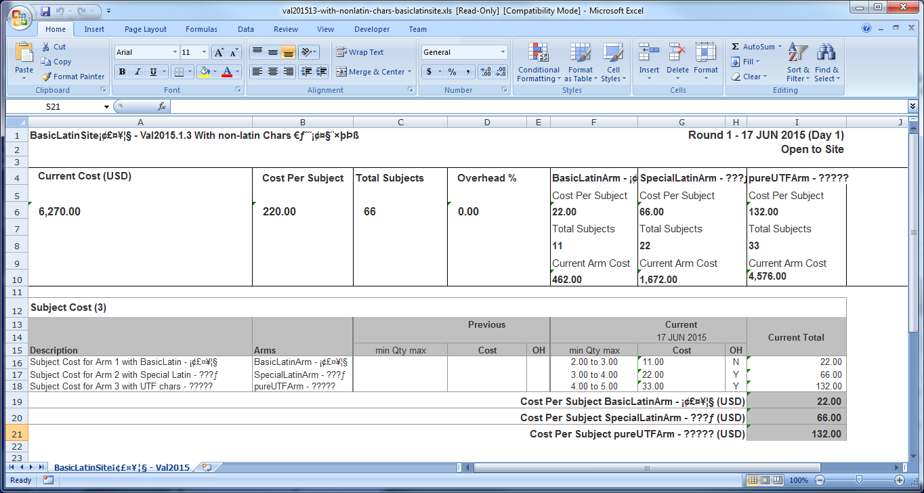

**And** I select the button labeled "**Actions**"  
**And** I select the button labeled "**Export Comment History**"   
**Then** I can open the Excel document with no errors and the latin and UTF characters look like they do in GMC

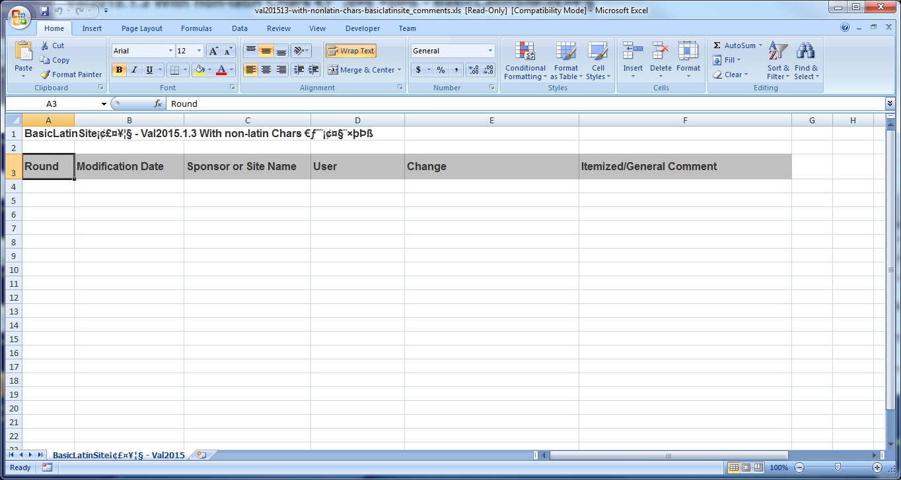  
**And** I open the negotiation "SpeciallatinSiteƏƐƑƒ"

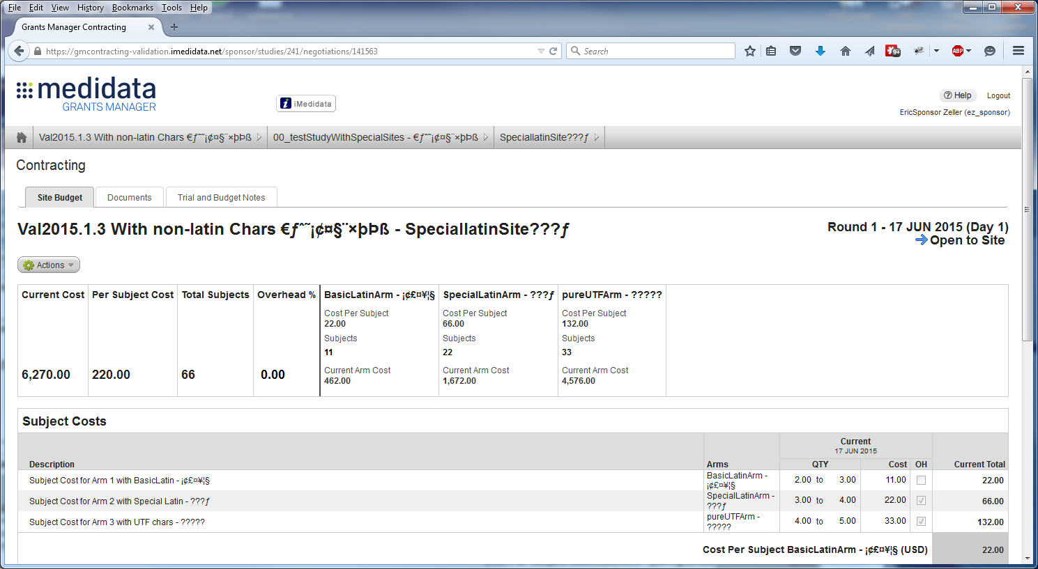  
**And** I select the button labeled "**Actions**"  
**And** I select the button labeled "**Export to Excel**"   
**Then** I can open the Excel document with no errors and the latin and UTF characters look like they do in GMC

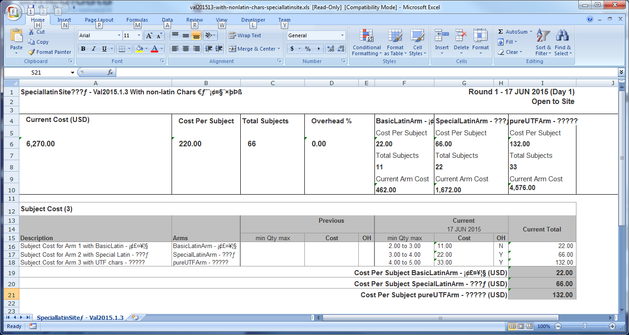  
**And** I select the button labeled "**Actions**"  
**And** I select the button labeled "**Export Comment History**"   
**Then** I can open the Excel document with no errors and the latin and UTF characters look like they do in GMC

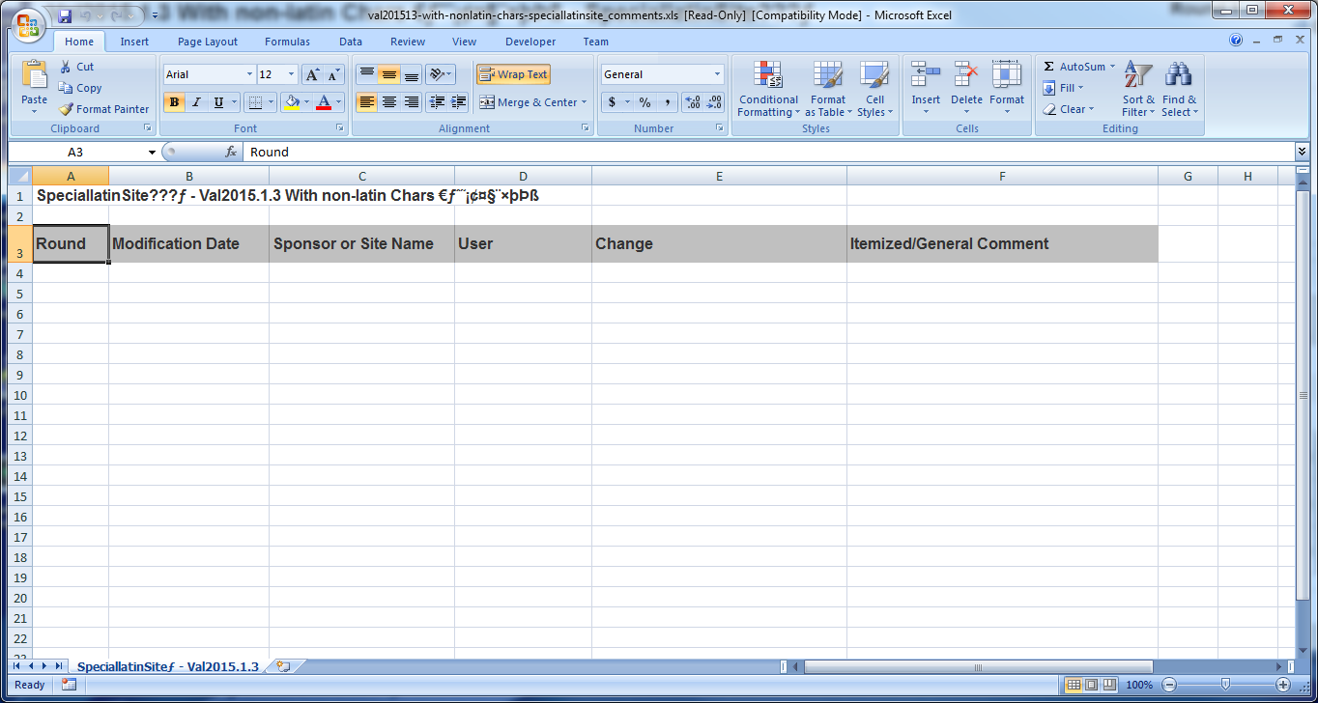  
**And** I open the negotiation "pureUTFSiteఅఆఇఈఉ"

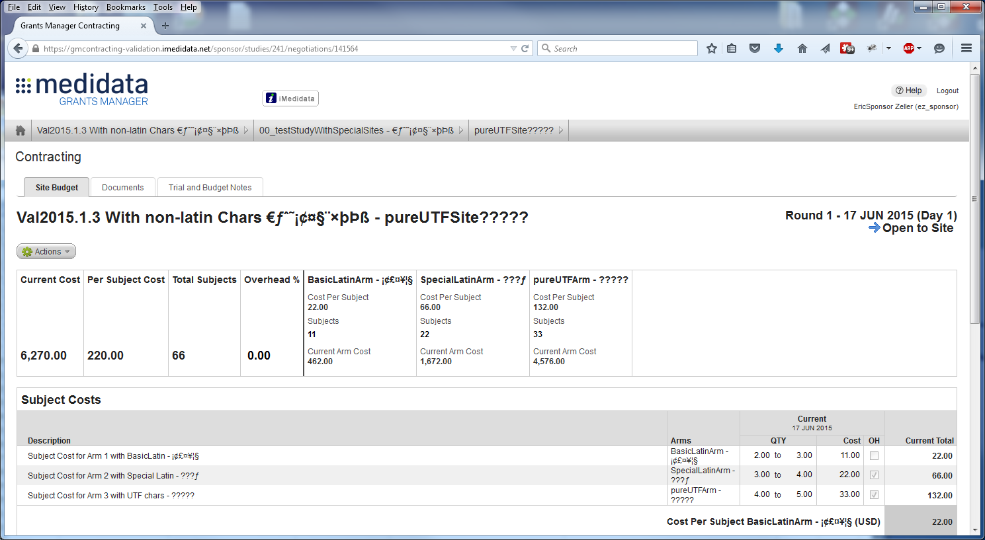  
**And** I select the button labeled "**Actions**"  
**And** I select the button labeled "**Export to Excel**"   
**Then** I can open the Excel document with no errors and the latin and UTF characters look like they do in GMC

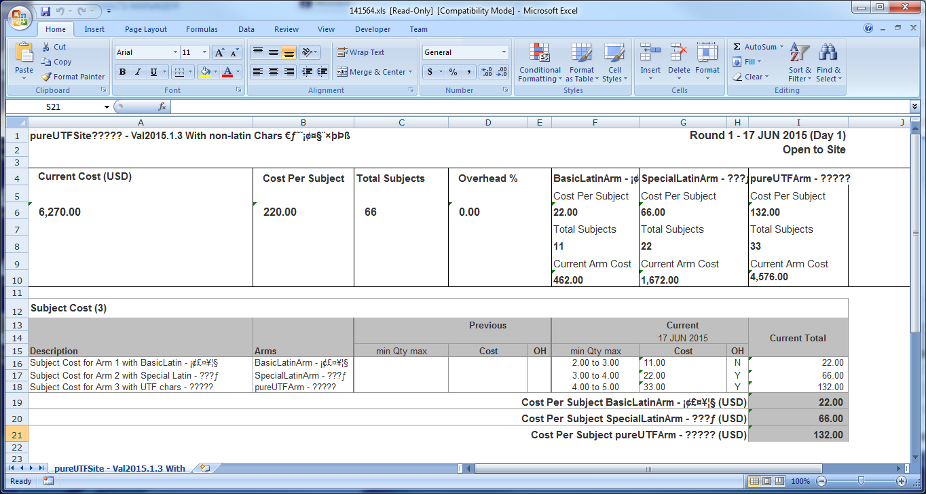  
**And** I select the button labeled "**Actions**"  
**And** I select the button labeled "**Export Comment History**"

**Then** I can open the Excel document with no errors and the latin and UTF characters look like they do in GMC

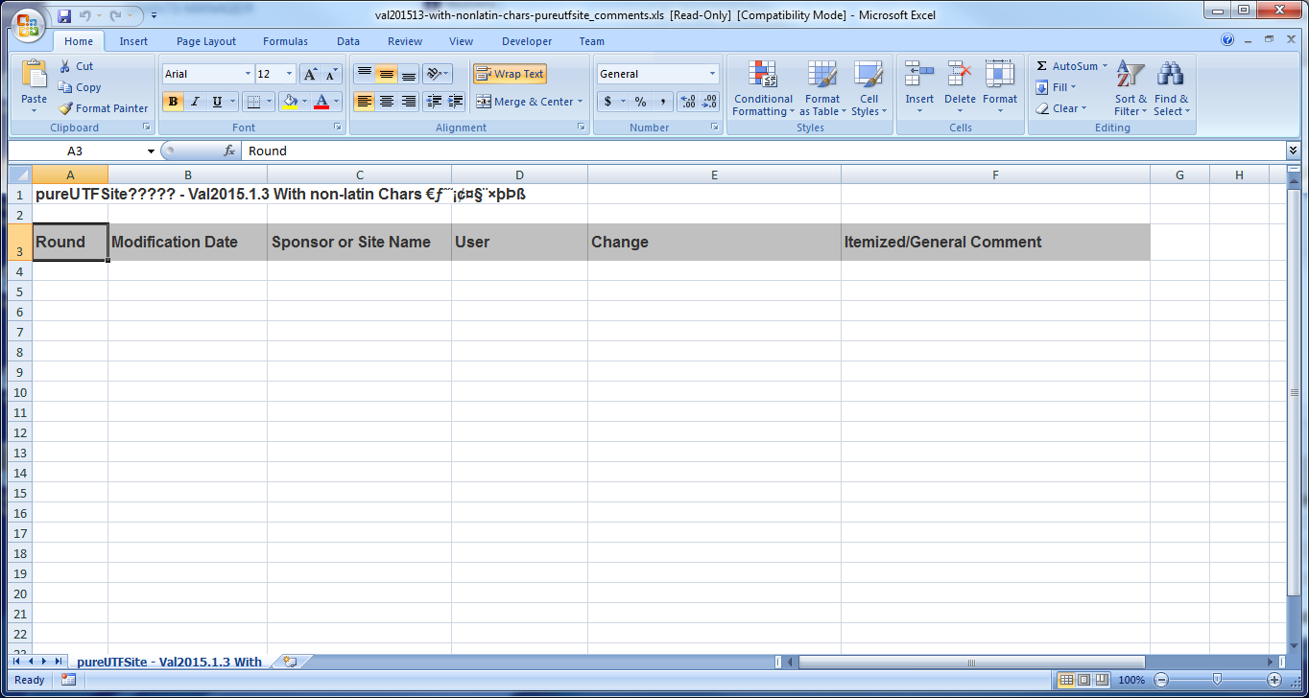

**When** I go to **the All Master Budgets Page  
And** I select Data Export -> Negotiation Data and click Next  
**And** Select the Study "Val2015.1.3 With non-latin Chars €ƒˆ˜¡¢¤§¨×þÞß"  
**And** I select all 4 checkboxes under Current Status  
**And** I select the last 2 weeks for the dates  
**And** I click "**Export**"  
**And** I click on the link in the email  
**Then** I will download and open a zip file with 3 .csv files in it.

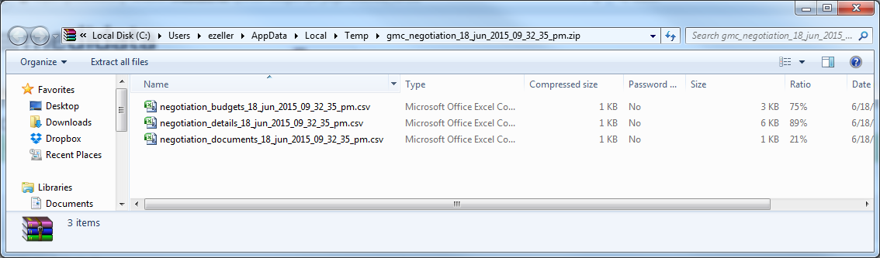  
**When** I click on the first csv file  
**Then** it will open in Excel and look the same as it did in GMC

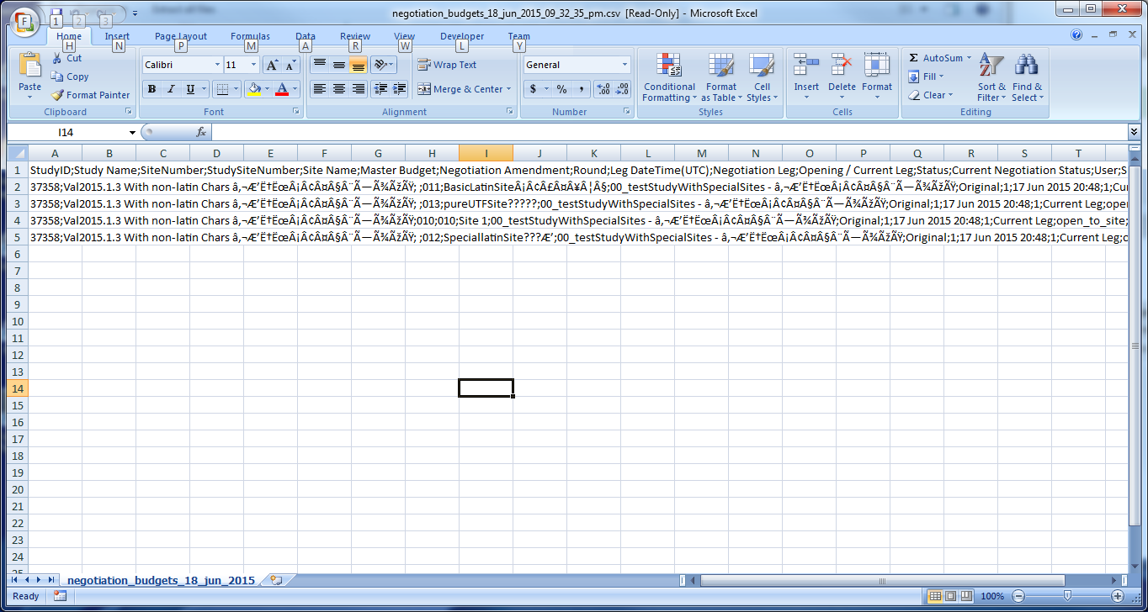  
**When** I click on the second csv file  
**Then** it will open in Excel and look the same as it did in GMC

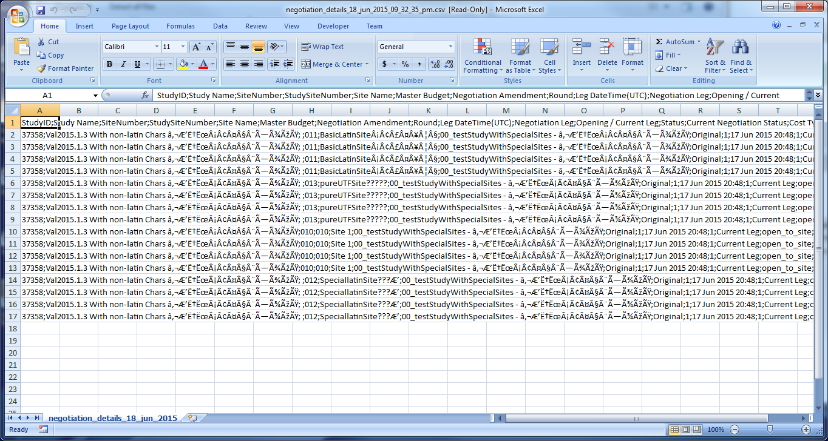  
**When** I click on the third csv file  
**Then** it will open in Excel and look the same as it did in GMC

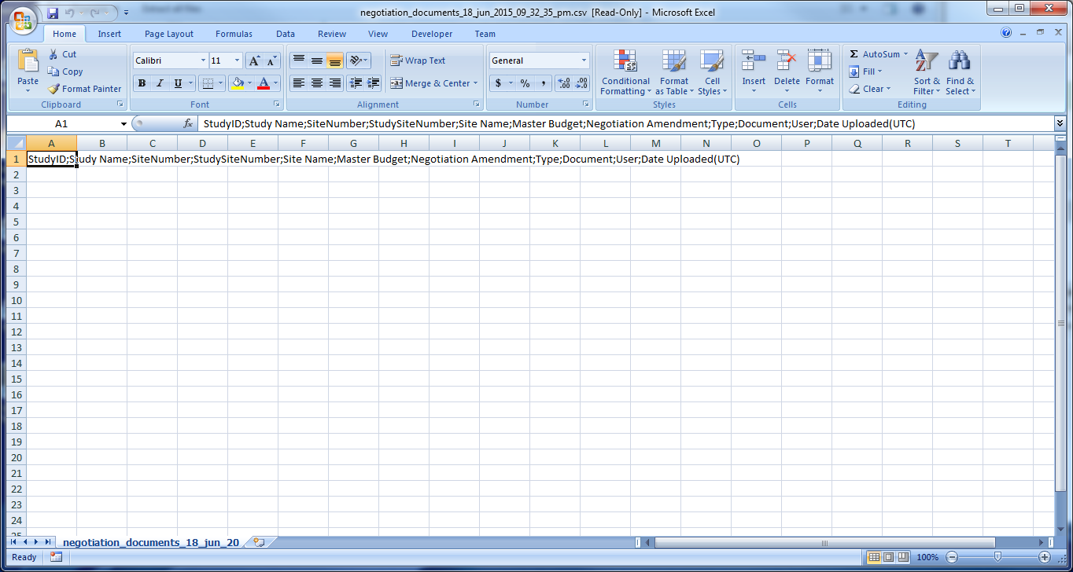  
**When** I am on **the All Site Budgets page  
And** I click on Export all Site Budgets  
**And** I click on the link that is generated  
**And** I open the zip file in Windows

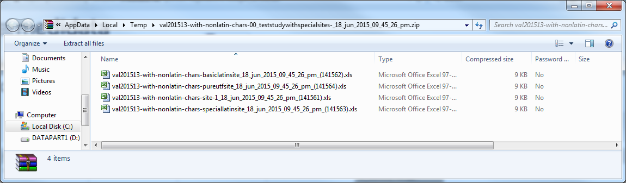  
**And** I click on each Excel spreadsheet that is in the zip file  
**Then** it will open in Excel and look the same as it did in GMC

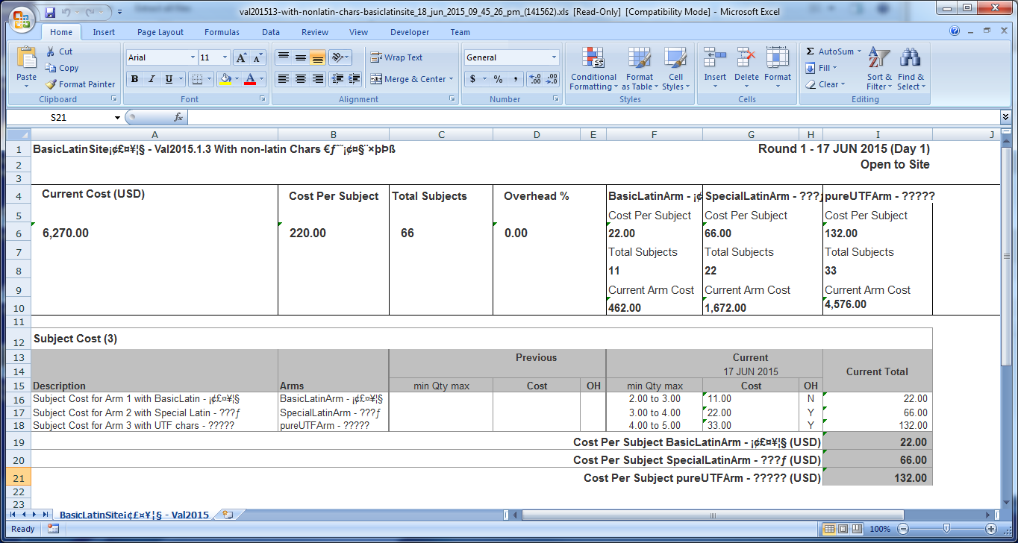

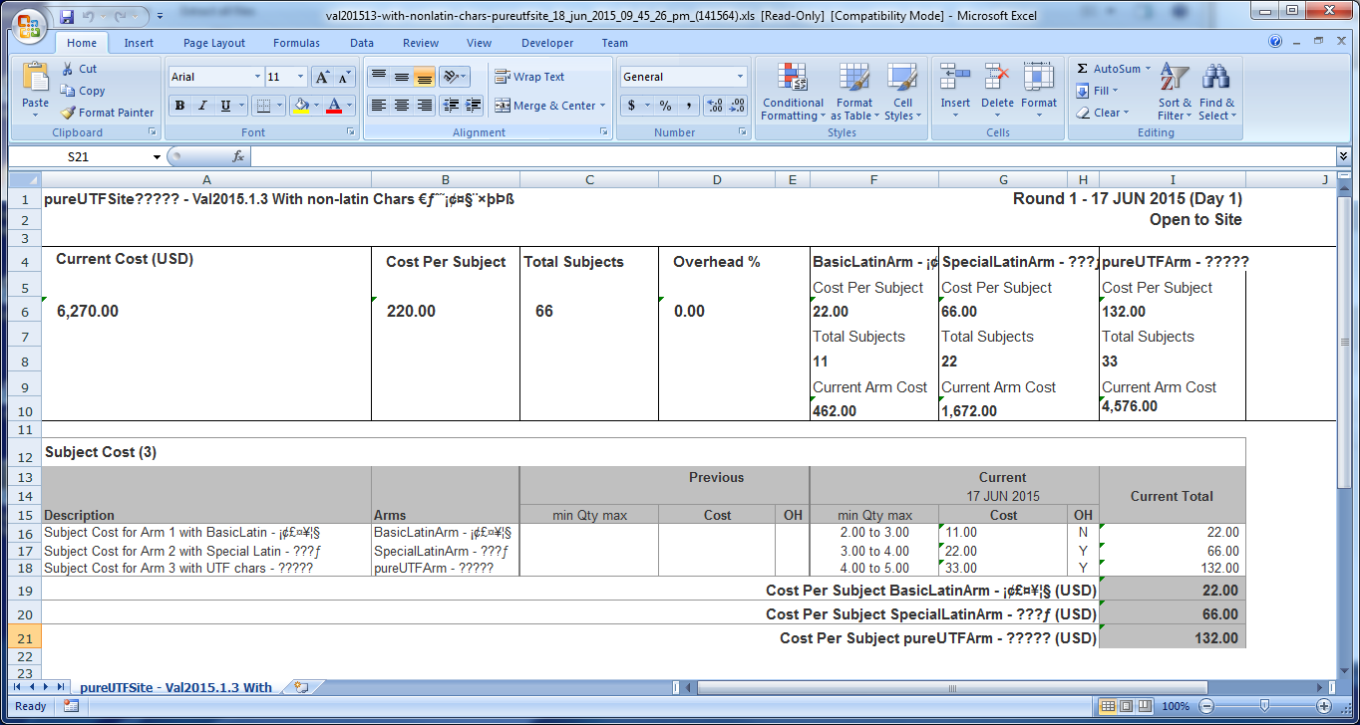

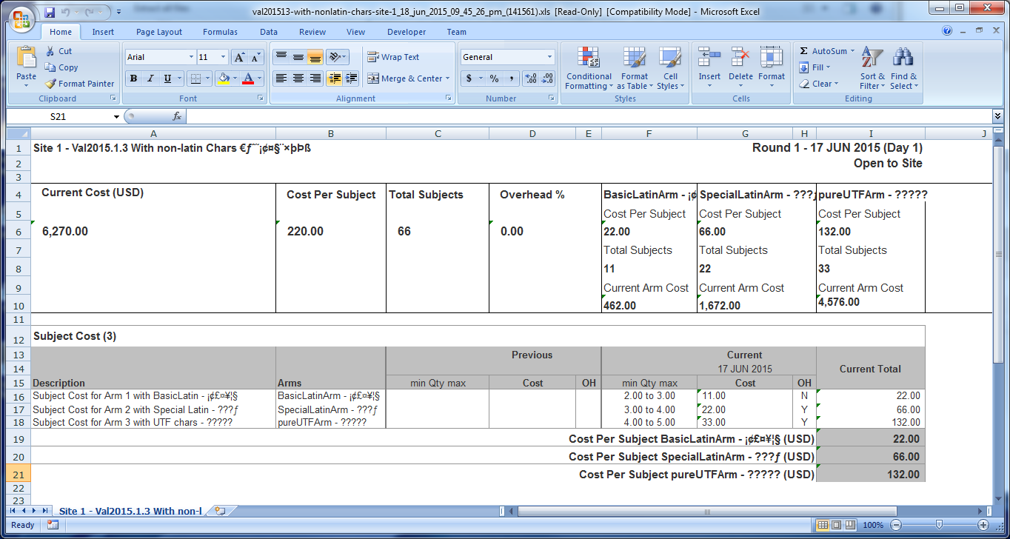

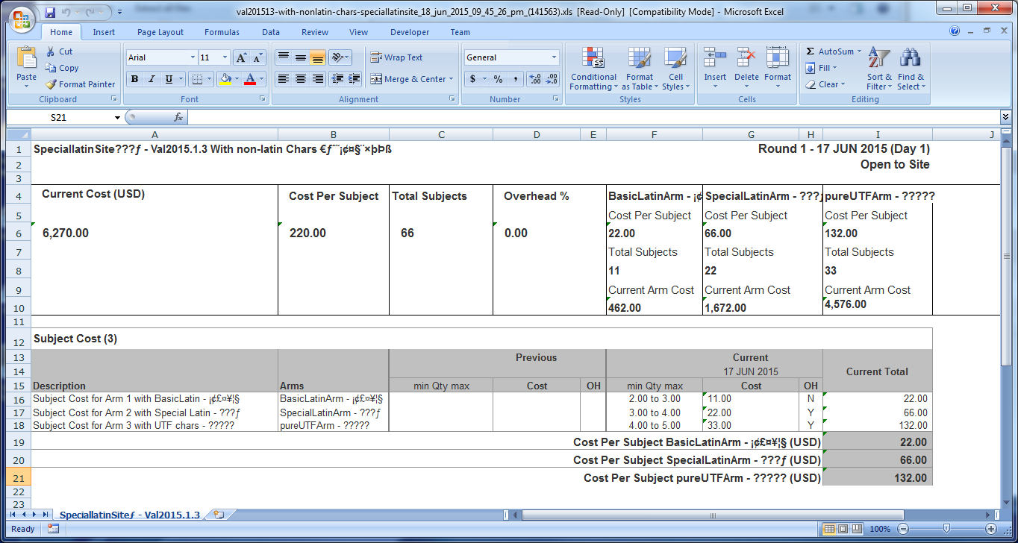

@release2015.1.3  
@PB1093a-04  
@MANUAL  
**Scenario Outline:** As a site user, I can export an individual Negotiation from within the Negotiation page and I can open the Excel spreadsheet without any error.  
**Given** I am logged as a site user  
**And** I open a negotiation that has non latin characters in the costs.

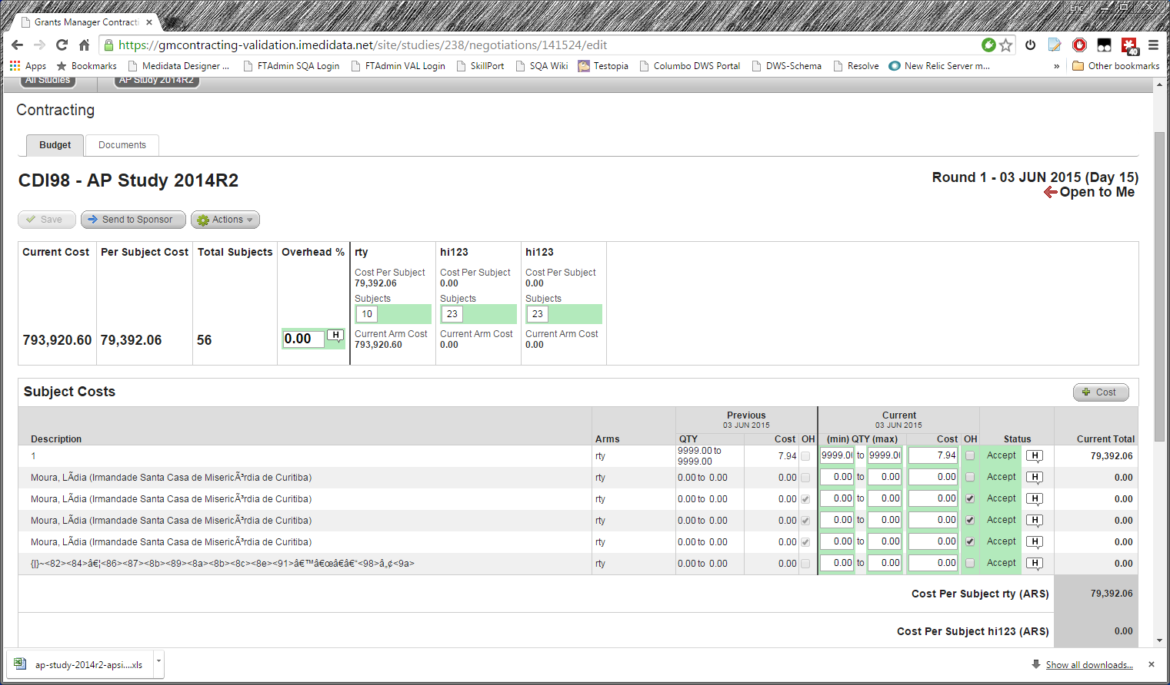  
**And** I Select Actions -> Export to Excel  
**And** I open the spreadsheet  
**Then** it should open in Excel without error and look the same as it does in GMC

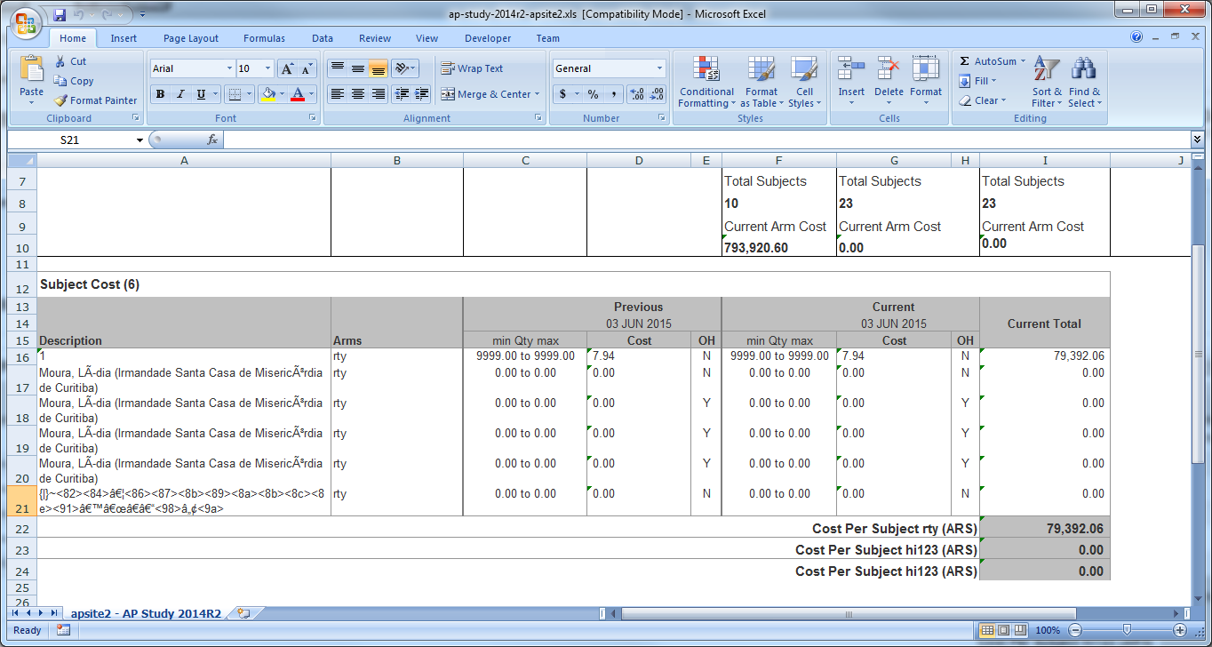  
**When** I select Actions -> Export Comment History  
**And** I open the spreadsheet  
**Then** it should open in Excel without error and look the same as it does in GMC

