Create activity without encoding in GMP

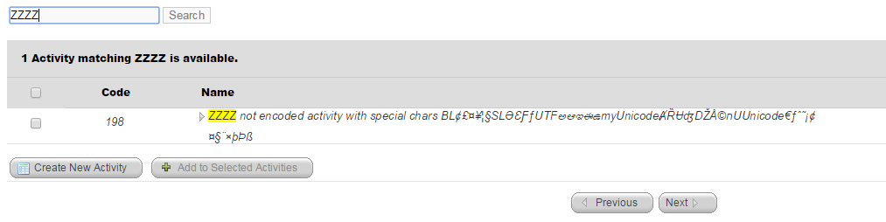

View in QPL

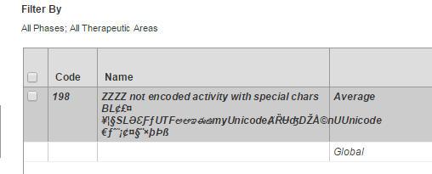

Set database to encoding

Create activity with encoding in GMP

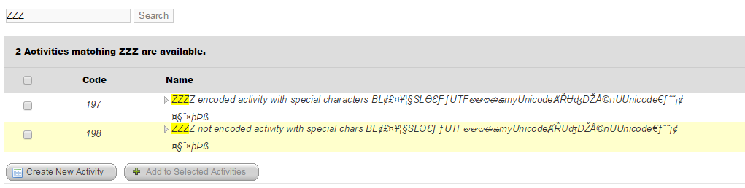

View both in QPL

