## Import as visit

Visit schedule in GMP

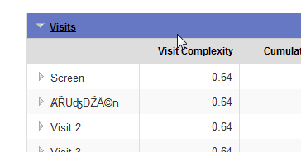

Visit Schedule in GMC

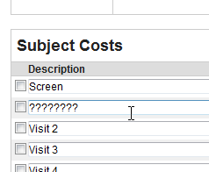

Budget and Trial Notes in GMP

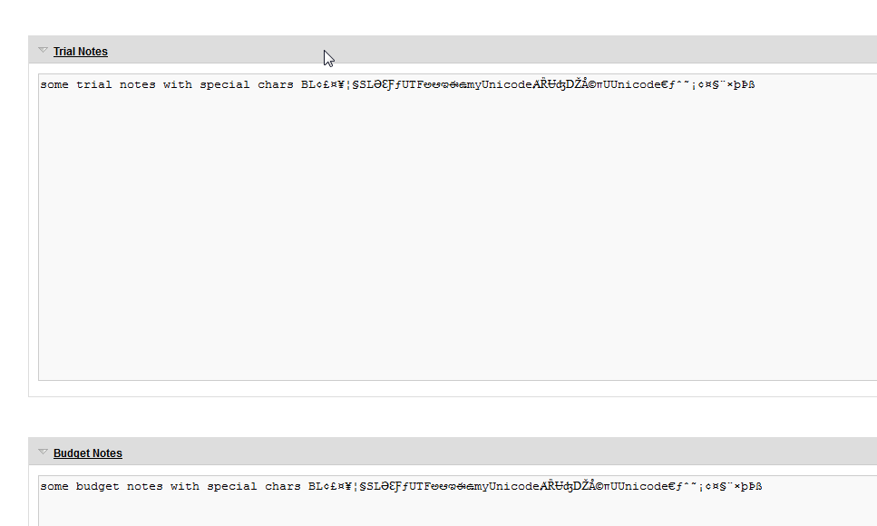

Budget and Trial Notes in GMC

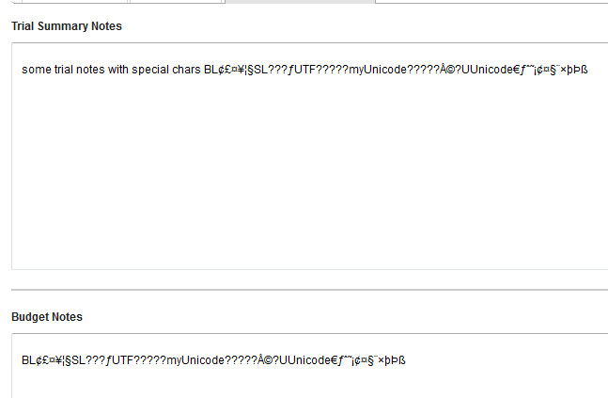

## Import as activity based

Activity Costs as seen in GMP

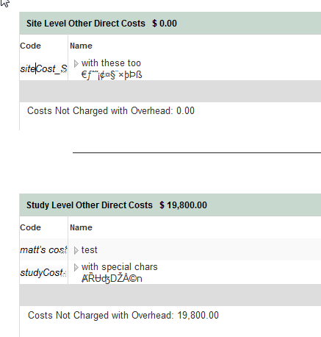

Activity Costs and seen in GMC

