1) Login as a sponsor

Open a budget that has some sites with non-latin chars in their name

From the All site Budgets screen, select Data Export -> Medidata Payments Integration File

Select Site Budgets and Next

Select the site that has non-latin characters in it's name and press Export

Select the report that was just generated and download it. Open it with Windows Explorer and double click the file inside.

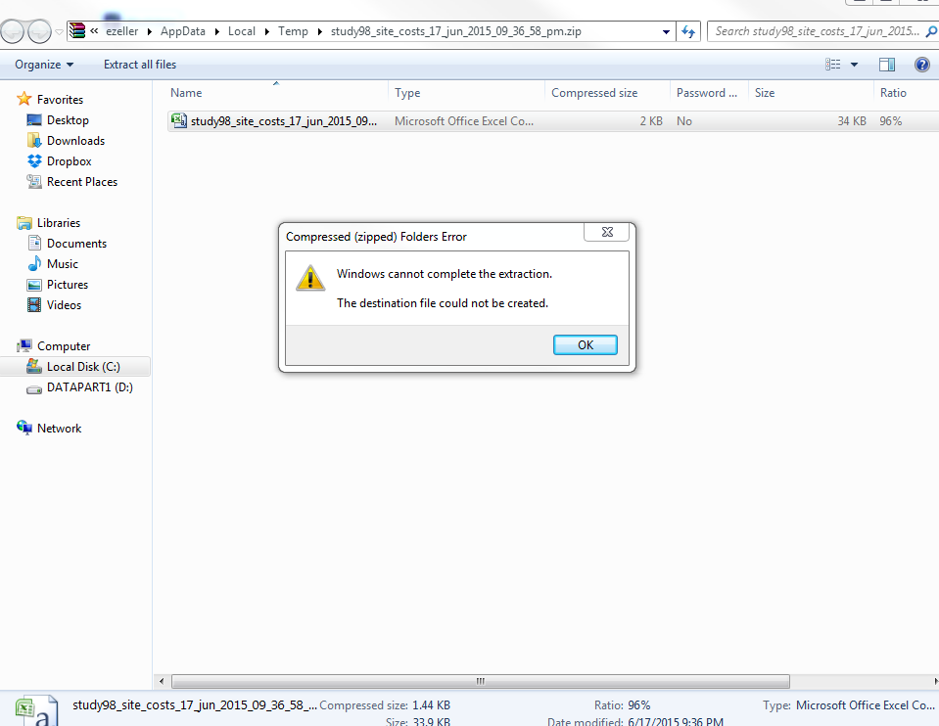

2)

From the All site Budgets screen, select Data Export -> Medidata Payments Integration File

Select Cost Template Setup and Next

Select master budget that contains the site that has non-latin characters in it's name and press Export

Select the report that was just generated and download it. Open it with Windows Explorer and double click the file inside.

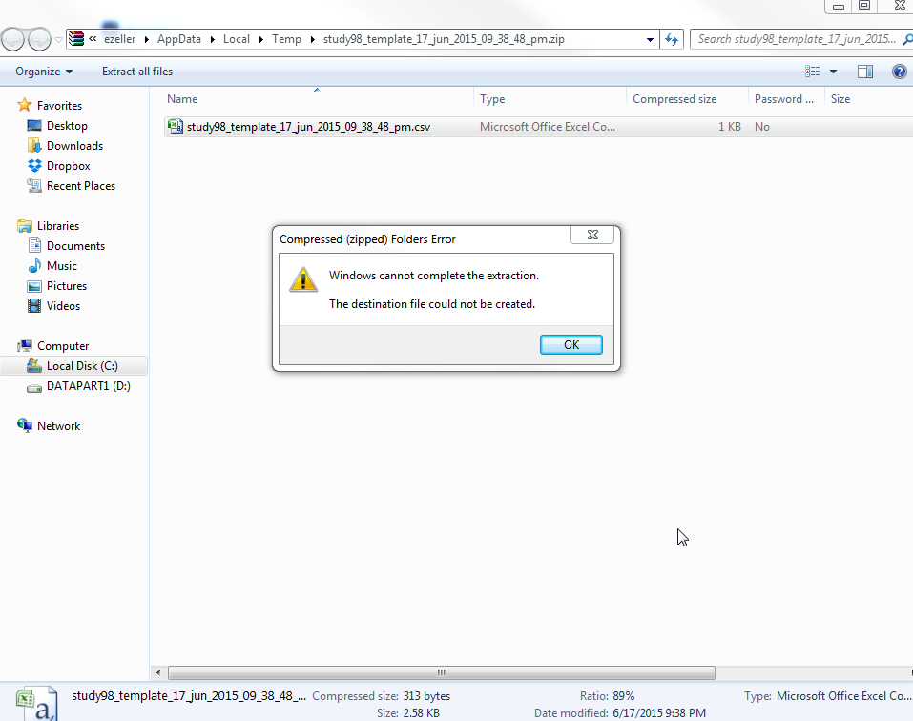

From the All site Budgets Screen - click on "Export All site Budgets"

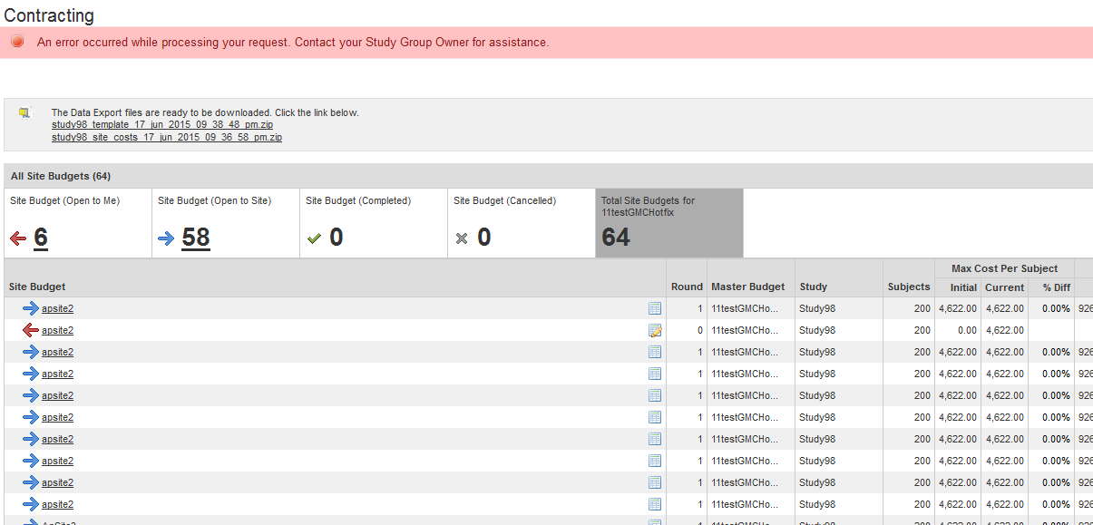

3) From the All site Budgets Screen, select Data Export. Select Negotiation Data and Next

Select a Study, all boxes under Current Status, and the last 2 weeks under Date. Select Export and wait for the email. When the email arrives, click on the link to download the report. Open the zip file and click on the first report.

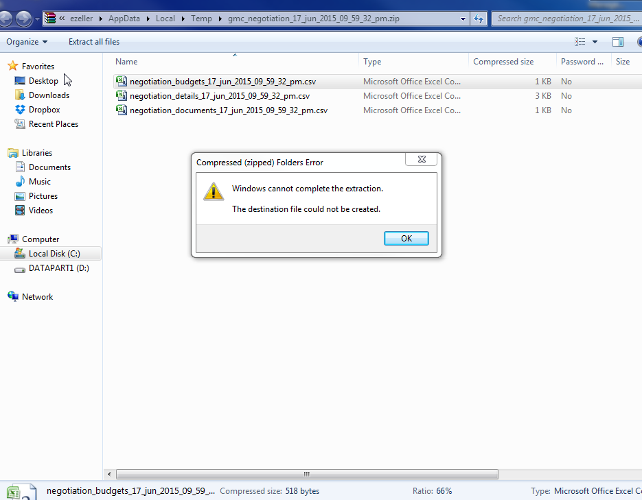

Close the error box and click on the second csv file.

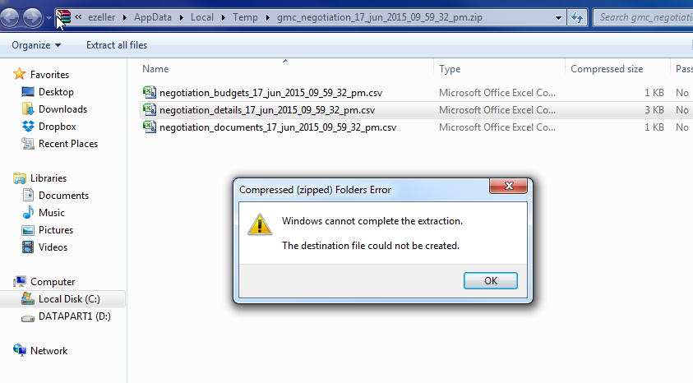

4) Login as a site user - open a negotiation that has non-latin chars in the subject costs

Click on Actions -> Export to Excel

