Drop the data build down a level in the database

select ID, client_id, name, CROCAS_BUILD_TAG_ID from client_div where client_div_identifier like 'CDI99';

Data Build shows 49

update client_div set crocas_build_tag_id=48 where id=99;

commit;

Launch CROContractor, login and create a new budget.

Exit out of CRO Contractor

Bring the data build back up to its former level

update client_div set crocas_build_tag_id=49 where id=99;

commit;

Launch CRO Contractor, login, select the budget you just created and check View -> Audit Trail

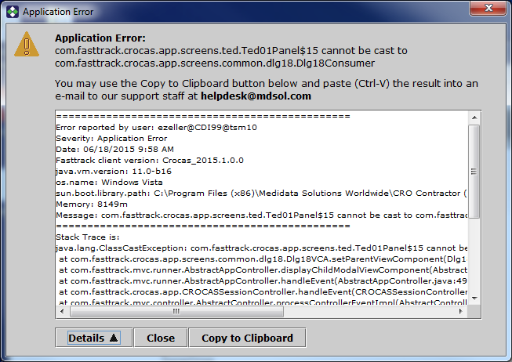

===============================================

Error reported by user: ezeller@CDI99@tsm10

Severity: Application Error

Date: 06/18/2015 9:59 AM

Fasttrack client version: Crocas_2015.1.0.0

java.vm.version: 11.0-b16

os.name: Windows Vista

sun.boot.library.path: C:\Program Files (x86)\Medidata Solutions Worldwide\CRO Contractor (VALCROCASA201510)\jre160\bin

Memory: 8149m

Message: com.fasttrack.crocas.app.screens.ted.Ted01Panel$15 cannot be cast to com.fasttrack.crocas.app.screens.common.dlg18.Dlg18Consumer

===============================================

Stack Trace is:

java.lang.ClassCastException: com.fasttrack.crocas.app.screens.ted.Ted01Panel$15 cannot be cast to com.fasttrack.crocas.app.screens.common.dlg18.Dlg18Consumer

at com.fasttrack.crocas.app.screens.common.dlg18.Dlg18VCA.setParentViewComponent(Dlg18VCA.java:56)

at com.fasttrack.mvc.runner.AbstractAppController.displayChildModalViewComponent(AbstractAppController.java:235)

at com.fasttrack.mvc.runner.AbstractAppController.handleEvent(AbstractAppController.java:490)

at com.fasttrack.crocas.app.CROCASSessionController.handleEvent(CROCASSessionController.java:226)

at com.fasttrack.mvc.controller.AbstractController.processControllerEventImpl(AbstractController.java:296)

at com.fasttrack.mvc.controller.AbstractController.processEvent(AbstractController.java:250)

at com.fasttrack.mvc.controller.AbstractController.processControllerEventImpl(AbstractController.java:308)

at com.fasttrack.mvc.controller.AbstractController.processEvent(AbstractController.java:250)

at com.fasttrack.crocas.app.screens.nav01.Nav01Controller$14$1.call(Nav01Controller.java:1258)

at com.fasttrack.mvc.controller.AbstractUICommandAction$CommandSwingWorker.construct(AbstractUICommandAction.java:123)

at com.fasttrack.mvc.controller.AbstractUICommandAction$CommandSwingWorker$1.call(AbstractUICommandAction.java:96)

at EDU.oswego.cs.dl.util.concurrent.FutureResult$1.run(FutureResult.java:150)

at com.fasttrack.mvc.controller.AbstractUICommandAction$CommandSwingWorker.run(AbstractUICommandAction.java:113)

at EDU.oswego.cs.dl.util.concurrent.PooledExecutor$Worker.run(PooledExecutor.java:378)

at java.lang.Thread.run(Thread.java:619)